**Faculty of Technology and Engineering**

**Chandubhai S. Patel Institute of Technology**

**Department of Computer Science & Engineering**

# STUDENT’S WEEKLY DIARY/ WEEKLY LOG FOR Project-III



|  |  |  |  |  |
| --- | --- | --- | --- | --- |
| **Project Group ID: CSPIT/CSE/B1/05** | | | | |
| Week No: 08 | | Date |  | |
| Project Title: Hate Speech Detection Project | | | | |
| Expected Outcome as per Timeline: | Learning Machine Learning Models | | | |
| Name of  Students(With  Roll No) | Hinal Dobaria(2cs021) | | | Juli Gopani(22cs024) |  |

**Work Done:**

**Learning ML Models:**

We focused on understanding and implementing various machine learning models relevant to hate speech detection, including

* Decision Tree
* Random Forest
* Linear SVM
* Naive Bayes
* Logistic Regression
* K-Nearest Neighbors (KNN).

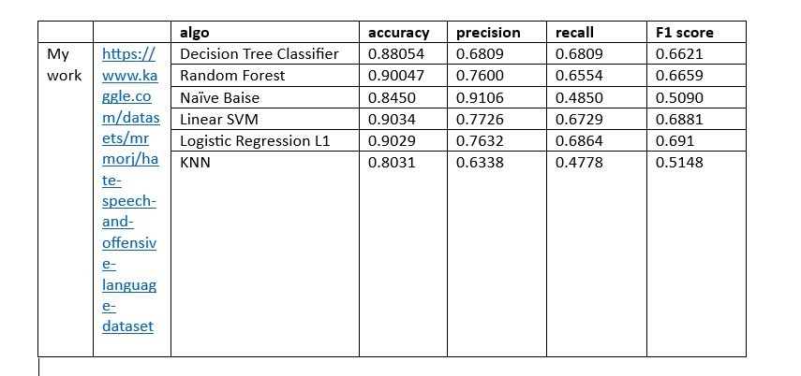

Signatures of Students:

**Assessment Rubric to evaluate Weekly Report:**

|  |  |  |  |  |  |  |  |  |  |  |  |  |
| --- | --- | --- | --- | --- | --- | --- | --- | --- | --- | --- | --- | --- |
| **Criteria** | | | | | | |  | | | | **22CS021** | **22CS024** |
|  | | Content & Progress Over | | | | | view | |  | |  |  |
|  | | | Individual Contributions | | | |  |  | | |  |  |
|  | | | | Issues and Challenges | | |  | | | |  |  |
|  | | | | Adherence to Schedule | | |  | | | |  |  |
|  | Overall Clarity and Present | | | | | | ation | | |  |  |  |
|  | | | | | Total (out of 25) |  |  | | | |  |  |

**Mentor’s Comments:**

**Mentor’s Sign:**