**Problem Statement**

Example : An owner of a hardware selling company wants clear insights on the sales data

**Project planning using AIMS grid and Data Discovery**

A meeting will be scheduled between all the stakeholders and the IT team to brainstorm on project planning using AIMS grid

Aims grid is a project management tool [VIDEO TUTORIAL](https://www.youtube.com/watch?v=6118I9HViuQ&t=0s)

1. Purpose:
2. Stakeholders: Board members, Sales team, IT team, Data team, Custom support team
3. End Result: a real time power bi dashboard
4. Success criteria: we want the cost to go down by 10%

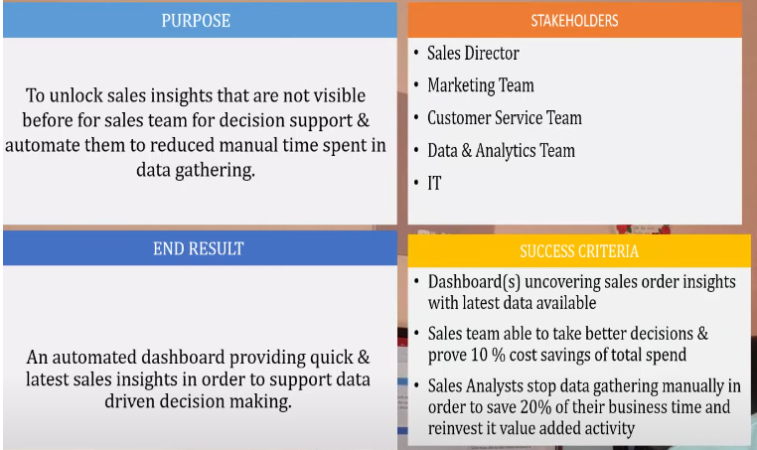

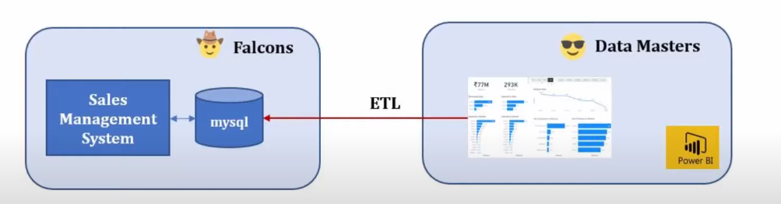

Data Warehouse: a system that stores and organizes data from multiple sources for analysis and reporting

OLTP = Online Transaction Processing System

ETL = Extract Transform and Load

Data warehouse tools: TeraData, SnowFlake

Data Extraction/Transformation Tools: Apache Nifi, Informatica, Talend, Python and Pandas

It’s the job of data engineers to maintain data and do these transformations

Data Cleaning/Analysis/Data Wrangling

Power Bi is like excel on steroid

Schema

