# Project: Online Exam Maker

## High Level Requirement Analysis

* Test specific login page allows student to enter its credentials
* Student can choose the option and submit its response
* Student can change the question by selecting in combo box and pressing GO button
* Student can submit the answer multiple times till the test is finished
* if student ends the test, a confirmation page is shown which displays total question answered
* On confirmation of Finish test, a thank you page is shown and students grade is stored in database (test_history table)

## High Level Data Model:

This project uses 8 tables, please find below table names

1. **Student** –Contains student details, such as credentials
2. **Test** – Contains test details such as test description, test title
3. **Question** – contains questions of all the test
4. **Test**_**questions** – junction table between test and question tables
5. **Options** – contains all the options of of all the questions
6. **Student_response** – contains all the responses student submitted
7. **Test_history** – contains history information of the test the student took and the grade of the student

Please find below the high level diagram

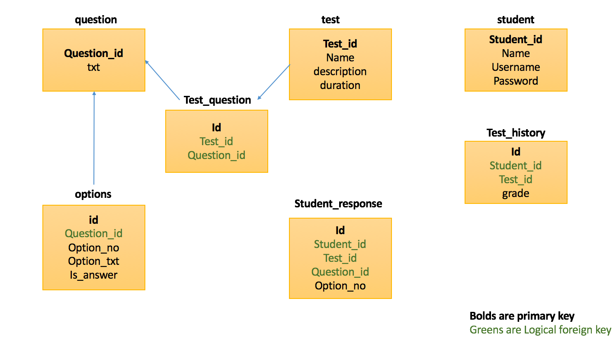

## Technologies Used

1. JDK 1.7
2. Apache tomcat 7
3. Apache Maven
4. Spring MVC
5. Mysql

## Architecture:

The code has been structured according to Spring MVC rules

* Controller class –intercepts requests from client
* Service class – Contains business logic to work on request received
* DAO class – queries databases to get the result and returns it to service

## Screen UI:

After running the project type <http://localhost:8080/online/Home>

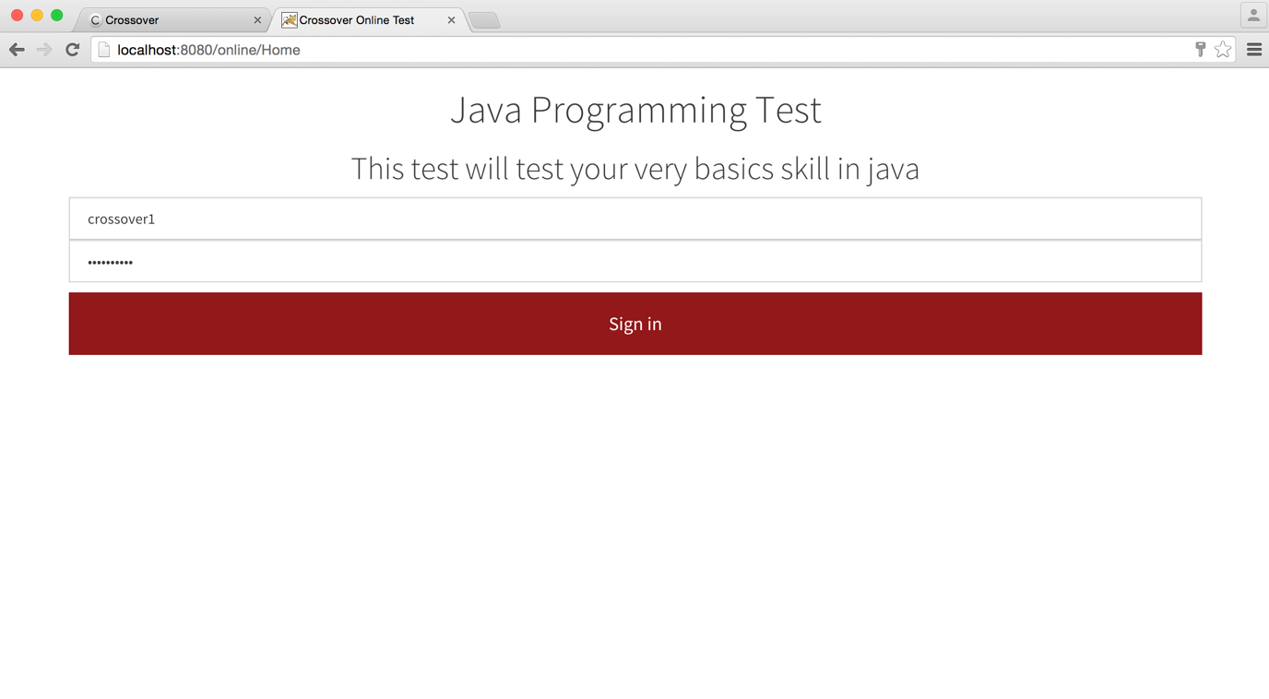

After logging in, you get questions page where you can submit your responses

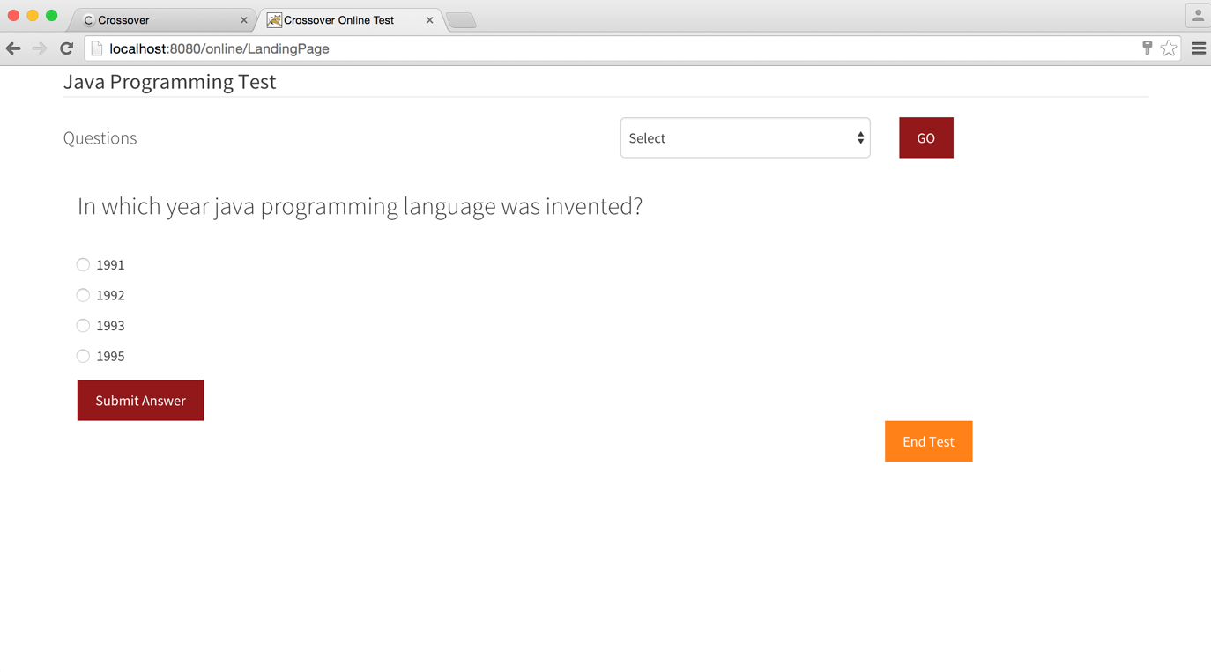

You can change submit the option

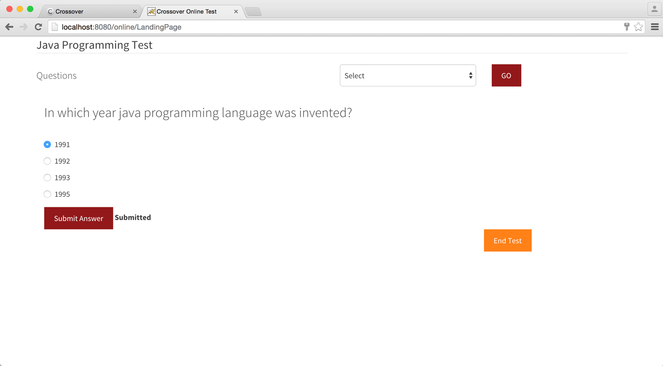

You can change the question from above combo box

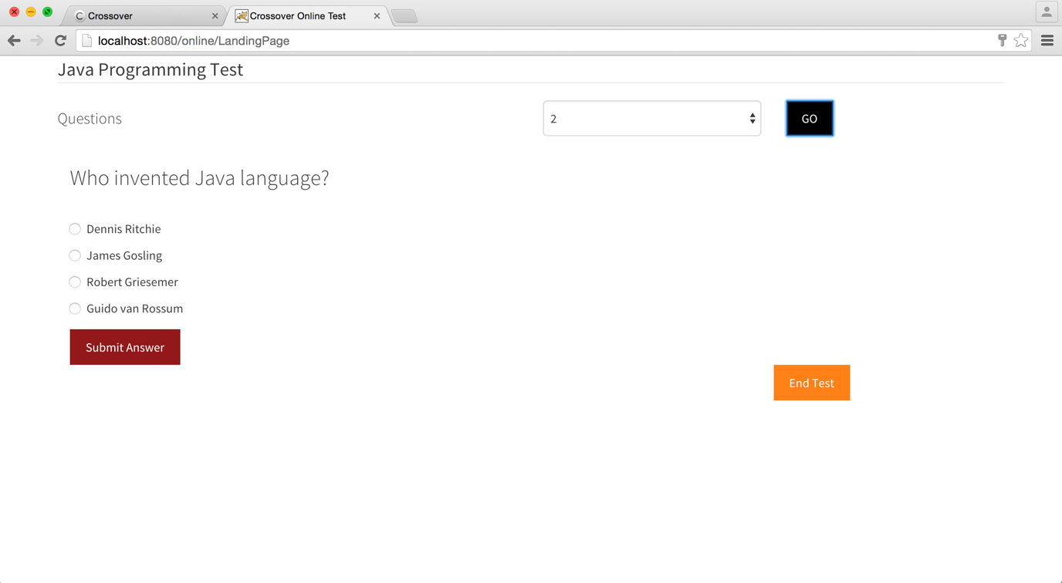

You can anytime end the test and get overview of questions answered

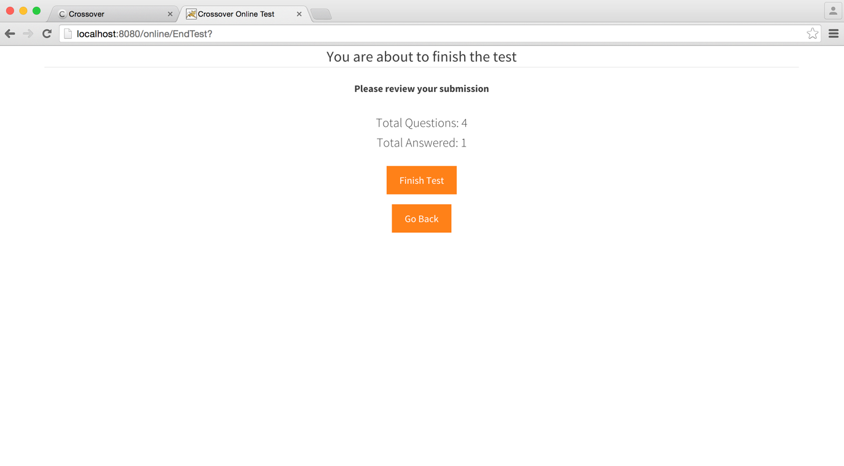

Once you finish test, your grade will be stored in database and you will get the below page

