Evidence Order Sensitivity in RAG Evaluation and Its Effects on Answer Selection, Quality, and Cost
[Author names to be confirmed]
[Affiliations and corresponding author email to be confirmed]

Abstract
An internal evaluator in retrieval augmented generation (RAG) can decide whether to retain an answer or request a rewrite. We investigate whether changing only the order of evidence changes this decision and the quality and cost of the selected answer. For each question, we fix the evidence, initial answer, and answer sentences, and compare evidence permutations with repeated evaluation of the original order. A single common rewrite separates answer selection from rewrite generation. After fixing the evaluator and experimental parameters, we collected 100 English and 100 Japanese questions in stages. A post-hoc pooled analysis includes 80 English and 68 Japanese questions with complete comparisons. Mean excess decision disagreement is 8.25 percentage points in English (95% document-group bootstrap interval 4.50–12.50) and 8.24 in Japanese (4.12–12.65). The language-difference interval includes zero. Evidence order changes decisions for 26 questions; the selected answer's binary quality label changes for 14, remains unchanged for 8, and is unresolved for 4. External AI assessment labels 51 English and 41 Japanese answers reliable under original-order evaluation, compared with 63 and 55 under always rewriting. Original-order evaluation uses 2.36 and 2.99 times as many recorded tokens as always rewriting in English and Japanese, respectively. Under this fixed configuration, evidence order affects answer selection, and internal evaluation adds cost without yielding the most reliable answers. Human-unverified AI labels, excluded refusals, and different source datasets limit the interpretation.
Keywords: retrieval augmented generation, LLM evaluation, evidence order, answer rewriting, computational cost.

1 Introduction
Retrieval augmented generation (RAG) combines a language model with retrieved information to answer questions using external sources⁽¹⁾. A system may also evaluate its initial answer and request a rewrite when the evidence appears insufficient. In this setting, the evaluator determines which answer is returned and whether additional computation is performed.
The evidence can be presented in a different order without changing its content. If that change alters the evaluation, the system may retain or rewrite the same answer for reasons unrelated to the available information. To measure this sensitivity, changes after reordering must be compared with variation from repeating the same evaluation. The resulting decisions must also be linked to answer quality: choosing a different answer does not necessarily improve it.
We address three questions. RQ1 asks whether decision disagreement across evidence orders exceeds disagreement across repetitions of the original order. RQ2 asks how these decisions affect the quality and computational cost of selecting between a fixed initial answer and a common rewrite. RQ-L asks whether the observed sensitivity differs between the English and Japanese datasets. This last comparison is descriptive because the questions are not translation pairs.
Our contribution is an audit that connects evidence-order sensitivity to answer selection, external AI quality labels, and route costs. We evaluate 200 questions after fixing the system configuration. Within each question, the initial answer and one rewrite are shared across all conditions, allowing changes in selection to be studied without generating a different rewrite for every order.

2 Related Work
Liu et al. show that the position of relevant information affects language models' use of long contexts⁽²⁾. Our intervention instead occurs after initial answer generation: we keep that answer fixed and reorder the evidence supplied to its evaluator.
Wang et al. demonstrate position bias when LLM judges rank candidate responses⁽³⁾. Shi et al. study repetition stability and position consistency in pairwise and listwise evaluation⁽⁴⁾. These studies motivate an empirical repetition control. We examine evidence order for one fixed answer, then follow the evaluator's accept-or-rewrite decision through to the selected answer and its cost.
ConsJudge uses consistency across evaluation dimensions to train RAG evaluators⁽⁵⁾, while RAGVUE diagnoses retrieval, reasoning, and grounding⁽⁶⁾. Work on evidence-locked selection also examines selection rules over fixed candidate answers⁽⁷⁾. We complement these approaches by jointly measuring order-versus-repetition disagreement, fixed-candidate selection, quality, and cost under one evaluator configuration.

3 Experimental Design

3.1 Fixed inputs and evidence orders
For question i, we generate an initial answer A_{i} and retain the evidence actually supplied to the generator. We fix the evidence text, titles, identifiers, and deterministically segmented answer sentences. The order conditions are original, reversed, and three seeded shuffles. The repetition control evaluates the original order five times. Its first trial is shared with the order conditions, giving at most nine logical trials per question. Duplicate permutations are omitted from the order comparison. Every repetition invokes the model rather than reusing a cached result. Fig. 1 summarizes the procedure.
Trial execution order is randomized with seed 43; shuffle and generation seeds are 42. We do not retrieve again, regenerate A_{i}, resegment its sentences, or truncate evidence between trials. Reference answers and reference evidence are reserved for external quality assessment and are not supplied as gold information to the internal evaluator or rewriter.
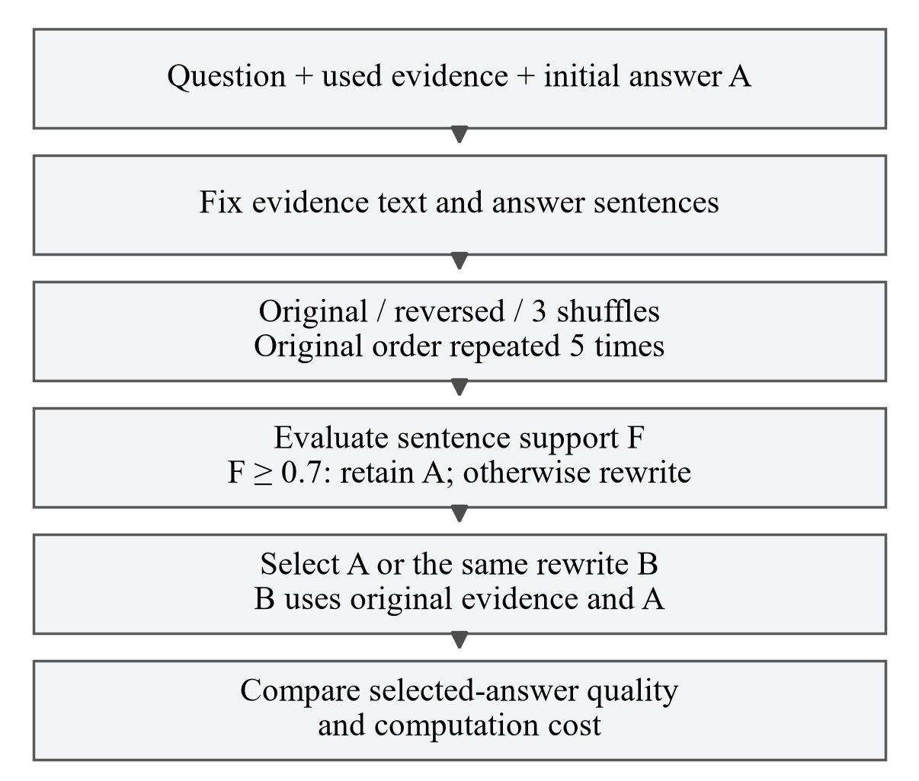
Fig. 1. Evidence-order evaluation and selection between shared answer candidates.

3.2 Evaluation and answer selection
The evaluator labels each fixed answer sentence as supported, contradicted, or unsupported by the evidence. If m_{i} is the number of sentences and s_{it} the number labeled supported in trial t, the support score is
F_{it} = s_{it} / m_{i} (m_{i} > 0) (1)
We retain A_{i} when F_{it} ≥ 0.7 and request one rewrite otherwise. F_{it} measures the evaluator's support judgments, not the probability that the whole answer is correct. A standalone refusal also requests a rewrite; other unscorable answers retain A_{i} with a separate fallback status.
For each question, a single rewrite B_{i} is generated from the question, original-order evidence, and A_{i}. The rewriter receives no evaluator scores, feedback, or reordered evidence. Every condition selects A_{i} or this same B_{i}. A failed rewrite falls back to A_{i} and retains its attempted computation cost. We compare no rewriting (NR), original-order evaluation followed by its decision (OE), and always rewriting (AR), alongside the other evaluation orders.

3.3 Disagreement, quality, and cost
Within each question, O_{i} is the proportion of unordered pairs of valid order-condition decisions that disagree, and R_{i} is the corresponding proportion for repetitions. For example, two accept and three rewrite decisions give 6 disagreements among 10 pairs, or O_{i}=0.6. The question-level excess and its mean are
D_{i} = O_{i} − R_{i}, mean D = (Σ_{i} D_{i}) / n (2)
We analyze all 200 questions in a post-hoc pooled analysis. The primary comparison uses questions with complete, scorable order and repetition trials, with equal weight per question. Document groups are resampled within language 10,000 times using seed 42 to form 95% percentile intervals. Independent language resamples give an interval for the Japanese-minus-English difference. Excluded questions are reported separately rather than assigned zero sensitivity.
External AI assessment assigns Y=1 when an answer covers the essential points, contains no major factual error, and has its factual claims supported by the used evidence. Definite failures receive Y=0; unresolved cases remain indeterminate. Y is used only to assess outcomes; rewrite decisions use F. Candidate labels are shared across routes. Selecting A when Y(A)=0 and Y(B)=1 is a missed improvement; selecting B when Y(A)=1 and Y(B)=0 is harmful rewriting. These transition counts require a successful B and known binary labels for both answers.
Route cost sums the generation, evaluation, and rewrite calls and their input/output tokens needed to return one answer. It includes a common rewrite only when that route requests it. Collecting every experimental condition and offline AI grading are separate costs. We also recompute decision disagreement at the five predefined thresholds 0.5, 0.6, 0.7, 0.8, and 0.9, retaining 0.7 as the operating threshold.

4 Experimental Settings

4.1 Evaluation questions
We use 100 answerable English questions from CLAPNQ⁽⁸⁾ and 100 answerable Japanese questions from wikipedia-human-retrieval-ja⁽⁹⁾, with revisions fixed to c508d78 and 02e85c8. The evaluation uses document-group partitions and frozen retrieval corpora. The languages differ in questions, reference structure, and corpus; they are not translation pairs.
Questions were selected by seeded identifier hashes, one per document group, excluding recorded previous use and previously selected groups. The evaluator, prompts, and threshold were fixed before collecting the evaluation questions.

4.2 Retrieval and model configuration
Table 1. Evaluation sample and experimental parameters.
Setting | Value
Evaluation questions | EN 100; JA 100; total 200
Retrieval | 50 candidates; RRF constant 60; top-k 5
Initial generation | Context 4096; temperature 0; output limit 512
Evaluation and rewriting | Context 12288; temperature 0.2; batch 128; prompt version 12
Task and reasoning limits | 6144 total; 4096 for reasoning
Trial plan per question | 5 orders; 5 repetitions; first trial shared; at most 9 trials
Seeds | Generation/shuffles 42; execution order 43
Decision thresholds | Operating 0.7; audit 0.5, 0.6, 0.7, 0.8, 0.9
Bootstrap | 10000 document-group resamples; seed 42; 95% interval
Note. EN/JA denote English/Japanese. Context, output, reasoning, and batch sizes are in tokens.
Hybrid retrieval combines BM25 and multilingual-e5-small embeddings⁽¹⁰⁾ through reciprocal-rank fusion. Initial generation uses Qwen2.5-3B-Instruct Q4_K_M⁽¹¹⁾. Table 1 lists numerical settings. Evidence is fixed after packing into the initial input.
The internal evaluator and rewriter use Qwen3.5-9B Q6_K⁽¹²⁾ with language-specific prompts. CUDA uses full offload with graphs disabled. The initial generator and internal evaluator are different models: evaluation is internal to the RAG system rather than self-grading by the initial generator.

4.3 Evaluator development and fixation
Table 2. Development diagnostics and evaluator performance.
Diagnostic | Size / result | Purpose / condition
Synthetic EN | 12 cases | Relations, scope, uncertainty
Synthetic JA | 15 cases | Relations, scope, uncertainty
Saved EN QA | 15 questions / 42 sentences | Previously observed errors
Support recall | 57/58 (98.3%) | Original + reversed evidence
Non-support specificity | 14/16 (87.5%) | Original + reversed evidence
Note. Rates pool original and reversed evidence after excluding 5 sentences with ambiguous expected labels. Non-support combines contradicted and unsupported labels.
Before collecting the 200 questions, we examined candidate models, prompts, and inference settings using development diagnostics (Table 2). Synthetic cases test relations, temporal and numerical scope, and qualified statements. Saved English question-answer traces come from earlier CLAPNQ runs and include previously observed errors. Expected labels were AI-authored and not human-verified.
The adopted evaluator completed the saved-question diagnostic⁽¹³⁾, with support recall of 98.3% and non-support specificity of 87.5% (Table 2). These figures describe its performance on the development diagnostic.

4.4 External assessment and execution
External AI assessment uses anonymized questions, candidate answers, references, and actual used evidence. Sentence-support assessment uses only the actual evidence. Condition names, scores, decisions, answer stage, and internal explanations are hidden; labels are sealed before joining them to internal outcomes. The assessor is configured as gpt-6.1-sol with high reasoning effort. No human adjudication was performed. Three Japanese reference article bodies were unavailable.
Table 3. Evaluation sample and sensitivity to evidence order.
Measure | EN | JA
Selected questions | 100 | 100
Comparable questions | 80 | 68
Excluded refusals | 20 | 31
Missing initial answers | 0 | 1
Failed rewrites | 0 | 4
Order-varying / comparable | 14/80 | 12/68
Order disagreement O (%) | 8.25 | 8.24
Repetition disagreement R (%) | 0.00 | 0.00
Mean D (pp) | 8.25 | 8.24
95% interval for D (pp) | [4.50, 12.50] | [4.12, 12.65]
Note. D=O−R; pp: percentage points. JA−EN: −0.01 pp [−5.96, 5.99] (95% interval). Failed rewrites use A.
One Japanese initial answer and four Japanese rewrites failed the length constraint. Failed rewrites retain the initial answer. Collection stages differed in length-failure stopping rules and citation-entry procedures for AI assessment; the grading rubric was unchanged. Question-level inputs and AI labels are available in the archived repository⁽¹⁴⁾.

5 Results

5.1 Evidence-order sensitivity
Complete comparisons are available for 80 English and 68 Japanese questions (Table 3). The 52 exclusions comprise 51 refusals without scorable sentences and one missing initial answer. Among comparable questions, no repetition pair disagrees. Mean excess disagreement is 8.25 percentage points (pp) in English and 8.24 pp in Japanese; both bootstrap intervals exclude zero (Fig. 2). Decisions vary across evidence orders for 14/80 English and 12/68 Japanese questions.
The Japanese-minus-English difference is −0.01 pp, with a 95% interval of [−5.96, 5.99] pp. These data show sensitivity in each language dataset but do not establish a difference between them.
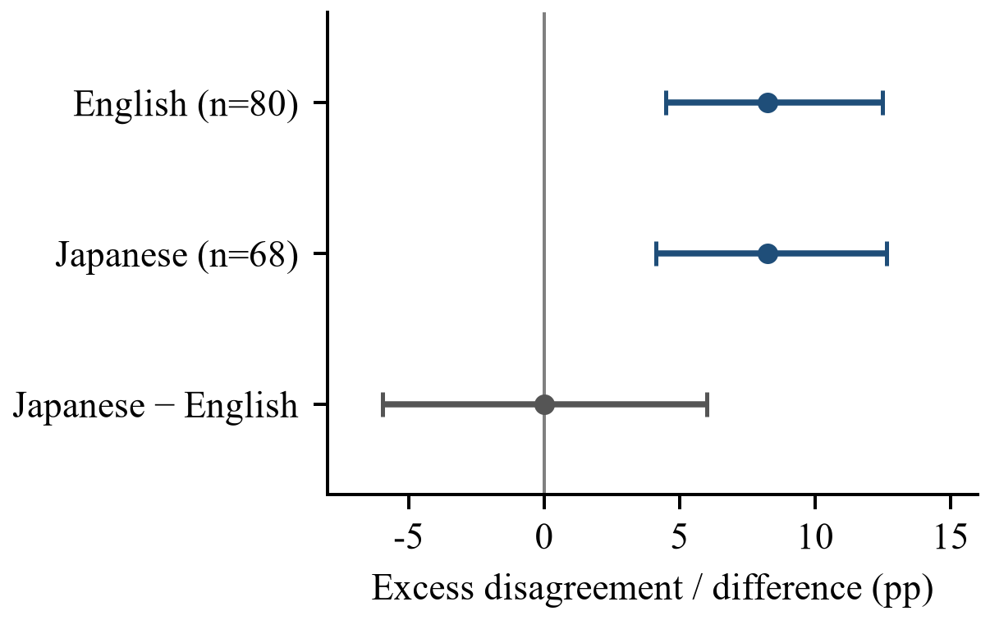
Fig. 2. Excess decision disagreement and language difference with 95% bootstrap intervals.

5.2 Selected-answer quality
Table 4. Selected-answer quality by policy.
Lang. | Policy | Y=1 | Y=0 | Unclear | Missing
EN | NR | 31 | 65 | 4 | 0
EN | OE | 51 | 43 | 6 | 0
EN | AR | 63 | 33 | 4 | 0
JA | NR | 21 | 73 | 5 | 1
JA | OE | 41 | 50 | 8 | 1
JA | AR | 55 | 38 | 6 | 1
Note. Each row totals 100 questions. NR/OE/AR: no rewriting/original-order evaluation/always rewriting. Y=1/0: reliable/unreliable.
Table 4 reports quality for all 200 selected questions. OE returns 51 reliable English and 41 reliable Japanese answers, more than NR (31 and 21) but fewer than AR (63 and 55). Japanese policies each have one missing delivery from the initial-answer failure. Indeterminate labels remain separate from unreliable answers.
Known A/B quality transitions are available for 93 English and 84 Japanese questions (Table 5). Rewriting improves 32 English and 31 Japanese answers from Y=0 to Y=1, while degrading two in each language from Y=1 to Y=0. OE misses 11/32 English and 13/31 Japanese possible improvements, and selects one harmful English rewrite. Thus evaluation avoids some harmful changes but also rejects some useful rewrites.
Table 5. Quality transitions after rewriting and original-order selection.
Transition / selection | EN | JA
Known A/B pairs | 93 | 84
Y(A)=0 → Y(B)=0 | 31 | 34
Y(A)=0 → Y(B)=1 | 32 | 31
Y(A)=1 → Y(B)=0 | 2 | 2
Y(A)=1 → Y(B)=1 | 28 | 17
OE missed / 0→1 | 11/32 | 13/31
OE harmful / 1→0 | 1/2 | 0/2
Note. Both labels are known (1: reliable; 0: unreliable). OE missed counts A selections among 0→1 pairs; OE harmful counts B selections among 1→0 pairs. Each denominator is the corresponding pair count.
Among the 26 questions with order-dependent decisions, selected binary quality changes for 14, stays the same for 8, and is unresolved for 4 (Table 6). An unresolved outcome is not evidence of unchanged quality.
Table 6. Quality and token variation among questions with order-dependent decisions.
Outcome | EN | JA | Total
Order-varying decisions | 14 | 12 | 26
Both Y=0 and Y=1 selected | 7 | 7 | 14
A and B have the same Y | 5 | 3 | 8
Includes indeterminate Y | 2 | 2 | 4
Route tokens vary | 14 | 12 | 26
Note. Values count questions. Same Y means both A and B have Y=0 (EN 3; JA 2) or both have Y=1 (EN 2; JA 1). The three quality categories are mutually exclusive; token variation is counted separately.

5.3 Examples of answers and selection outcomes
Table 7 links three cases to their selection results. A is the initial answer and B the shared rewrite. The displayed orders share the same evidence content and A/B candidates. The cases were selected after inspecting outcomes. Quoted outputs are excerpts; the Japanese case is translated into English.
Case 1 asks “how and why did the united states escalate its role in the vietnam war”. The evidence reports 5,000 additional advisers in July 1964, bringing the total to 21,000; another passage gives a general containment rationale. A connects the increase to a specific cause:
A: “The United States escalated its role in the Vietnam War due to the escalation of military advisers ordered to the Republic of Vietnam in 1964, bringing the total American troop level to 21,000. This increase was a direct response to the growing conflict and the need to support South Vietnam against North Vietnam's communist domination.”
B: “The United States escalated its role in the Vietnam War by ordering 5,000 additional military advisers to the Republic of Vietnam on July 27, 1964, bringing total American troop levels to 21,000” […] “This escalation was driven by an incentive to end growing communist domination in Vietnam and prevent a chain of neighbouring countries adopting the same ideology, which would change the balance of power throughout Southeast Asia”
The external assessor judges A's attribution of that specific increase unsupported (Y=0), while accepting B's broader explanation and supported adviser details (Y=1). Original-order evaluation selects B at F=1/3. Under shuffle_3 it retains A at F=1: the selected answer changes from B (Y=1) to A (Y=0).
Case 2 asks “What's the difference between moths and butterflies?” A starts with the Rhopalocera distinction, then mixes a figurative use of “butterfly” with biology and adds a naming explanation. The relevant evidence and outputs are:
Evidence: "The terms for both butterflies and moths are of Chinese origin."
A: “Butterflies are bilaterally symmetrical, and a shape whose ends spread out is sometimes named by likening it to a butterfly with its wings open.” […] "Moths are often called by a Chinese-derived term because their characteristics differ from those of butterflies."
Table 7. Evidence order and answer selection in the three examples.
Case | Order | F | Selected / Y
1 | original | 1/3 | B / 1
1 | shuffle_3 | 3/3 | A / 0
2 | original | 3/4 | A / 0
2 | shuffle_2 | 2/4 | B / 1
3 | original | 2/3 | B / 0
3 | reversed | 3/3 | A / 0
Note. F is supported/all fixed sentences. Y=1/0 denotes reliable/unreliable.
B: “Other species of Lepidoptera are called moths, but dividing Lepidoptera into butterflies and moths is not a natural classification” […] "The terms for both butterflies and moths are of Chinese origin."
The evidence states a naming fact about both insects but gives no causal link to their biological differences. A receives Y=0; B explains the classification and naming without this causal claim and receives Y=1. Original-order evaluation retains A at F=3/4, whereas shuffle_2 selects B at F=2/4. The selected answer changes from A (Y=0) to B (Y=1).
Case 3 asks “where did the idea of fried green tomatoes come from”. A states, “There is no mention of fried green tomatoes or their origin.” B similarly states, “None of the provided documents mention the origin of fried green tomatoes.” Both report a gap in the retrieved information rather than answer the origin question, receiving Y(A)=Y(B)=0. Original order selects B at F=2/3; reversing the order retains A at F=1. The selected text changes, while the quality label stays Y=0.

5.4 Computational cost
Table 8 reports route calls and input/output token totals. OE uses 2.36 times AR’s tokens in English and 2.99 times in Japanese, while returning fewer reliable answers. Here the cost of checking support outweighs the computation saved by selectively rewriting.
Table 8. Model calls and tokens by answer policy.
Lang. | Policy | Calls | Tokens | Tokens / AR
EN | OE | 364 | 1,669,032 | 2.36
EN | AR | 200 | 706,586 | 1.00
JA | OE | 467 | 2,964,849 | 2.99
JA | AR | 198 | 992,497 | 1.00
Note. Totals include initial generation and input/output tokens for 100 EN/99 JA deliveries. The interrupted Japanese request has unknown cost and is excluded.

5.5 Semantic audit and threshold sensitivity
The internal evaluator assigns support to 47.8% of externally non-supported sentence-by-trial observations in English and 47.4% in Japanese (Table 9). The evaluator can be stable across repetitions while disagreeing with the external AI support labels.
Mean excess disagreement ranges from 7.08 to 11.00 pp in English and 3.09 to 9.41 pp in Japanese across predefined thresholds (Table 10). All point estimates are positive, while their magnitude depends on the threshold.
Table 9. Internal false-support judgments relative to external AI labels.
Lang. | False support | External negatives | Rate
EN | 344 | 719 | 47.8%
JA | 339 | 715 | 47.4%
Note. The denominator counts externally non-supported sentence-by-trial observations; false support means the internal evaluator assigns support.
Table 10. Excess decision disagreement by support-score threshold.
Threshold | EN D (pp) | JA D (pp)
0.5 | 7.08 | 3.09
0.6 | 8.08 | 6.62
0.7 | 8.25 | 8.24
0.8 | 9.50 | 7.65
0.9 | 11.00 | 9.41
Note. Mean D (pp) for the same 80 EN/68 JA comparable questions. The operating threshold is 0.7.

6 Discussion

6.1 Evidence order and evaluation stability
The repetition control shows that repeatability under one input is insufficient to establish robust answer selection. Here, the evaluator gave consistent decisions for the original evidence order, yet changed decisions after reordering the same content. This links the observed instability to presentation under the fixed experimental conditions.
Table 9 also shows disagreement with external support labels despite stable repetition results. In Case 3, changing the selected text leaves both answers labeled Y=0. Together, these observations suggest that making decisions consistent across orders would not by itself ensure answer quality. Support judgments and selected-answer quality need to be examined alongside order stability.

6.2 Implications for answer selection and cost
In the examples, reordering improves some selections and degrades others; Table 6 also includes decision changes with unchanged binary quality. Disagreement alone therefore does not determine the direction of quality change. Selection policies should be assessed through the quality of returned answers as well as decision stability.
OE’s higher token use and lower reliable-answer count show that support checking outweighed the rewriting it saved in this configuration. Useful rewrites were also missed. An evaluator’s benefit should therefore be measured through gains in returned-answer quality and avoided harmful rewrites relative to its own computation. Lighter checks and agreement across evidence orders are candidates for this comparison.

6.3 Scope and future evaluation
The primary sensitivity analysis covers scorable initial answers, leaving order dependence for refusals unmeasured. Quality labels also lack human adjudication. Human review and comparisons across evaluator performance levels and generation seeds would test whether the observed patterns persist. A sensitivity measure that includes refusals would broaden the evaluated population.
The language-difference interval includes zero, while question content and references differ by language. Matched bilingual questions and comparable evidence lengths would help separate language effects from dataset differences. Matching generator and rewriter model sizes and budgets would additionally help isolate the effect of the rewrite instruction.

7 Conclusions
We evaluated evidence-order sensitivity using 200 questions after fixing the RAG evaluator and experimental parameters. In the pooled comparison of 148 scorable questions, excess disagreement is positive in both language datasets, while their difference remains unresolved. Shared answer candidates show that order changes can alter selected-answer quality. Original-order evaluation returns fewer AI-labeled reliable answers than always rewriting and uses more recorded calls and tokens. Under this configuration, evidence order affects final answer selection, and the evaluation-based policy has a poorer observed quality–cost trade-off than always rewriting.

References
(1) P. Lewis et al., Retrieval-Augmented Generation for Knowledge-Intensive NLP Tasks, Advances in Neural Information Processing Systems, Vol. 33, 2020. https://arxiv.org/abs/2005.11401
(2) N. F. Liu et al., Lost in the Middle: How Language Models Use Long Contexts, Transactions of the Association for Computational Linguistics, Vol. 12, pp. 157–173, 2024. https://doi.org/10.1162/tacl_a_00638
(3) P. Wang et al., Large Language Models are not Fair Evaluators, Proceedings of ACL 2024 (Volume 1: Long Papers), pp. 9440–9450, 2024. https://doi.org/10.18653/v1/2024.acl-long.511
(4) L. Shi et al., Judging the Judges: A Systematic Study of Position Bias in LLM-as-a-Judge, Proceedings of IJCNLP-AACL 2025, pp. 292–314, 2025. https://doi.org/10.18653/v1/2025.ijcnlp-long.18
(5) S. Liu et al., Judge as A Judge: Improving the Evaluation of Retrieval-Augmented Generation through the Judge-Consistency of Large Language Models, Findings of ACL 2025, pp. 5788–5807, 2025. https://doi.org/10.18653/v1/2025.findings-acl.301
(6) K. Murugaraj, S. Lamsiyah, and M. Theobald, RAGVUE: A Diagnostic View for Explainable and Automated Evaluation of Retrieval-Augmented Generation, Proceedings of EACL 2026 System Demonstrations, pp. 512–526, 2026. https://aclanthology.org/2026.eacl-demo.35/
(7) Y. Zhang, D. Goel, and H. Ahmad, When the Judge Should Not Decide: Evidence-Locked, Non-Compensatory Selection Bounds LLM-Judge Failure in Reasoning Pipelines, arXiv:2608.07813v2, author preprint, 2026. https://arxiv.org/abs/2608.07813v2
(8) S. Rosenthal, A. Sil, R. Florian, and S. Roukos, CLAPNQ: Cohesive Long-form Answers from Passages in Natural Questions for RAG systems, Transactions of the Association for Computational Linguistics, Vol. 13, pp. 53–72, 2025. https://doi.org/10.1162/tacl_a_00729
(9) Baobab, Inc., wikipedia-human-retrieval-ja, dataset card. Accessed November 4, 2026. https://huggingface.co/datasets/baobab-trees/wikipedia-human-retrieval-ja
(10) intfloat, multilingual-e5-small, model card. Accessed November 4, 2026. https://huggingface.co/intfloat/multilingual-e5-small
(11) Qwen Team, Qwen2.5-3B-Instruct-GGUF, model card. Accessed November 4, 2026. https://huggingface.co/Qwen/Qwen2.5-3B-Instruct-GGUF
(12) Qwen Team, Qwen3.5-9B, model card. Accessed November 4, 2026. https://huggingface.co/Qwen/Qwen3.5-9B
(13) Development diagnostics and fixed evaluator configuration, repository snapshot f0b7c71, 2026. https://github.com/hinattyamann/rag_research
(14) Archived evaluation inputs, AI annotations, and pooled descriptive analysis, repository snapshot 592e3c2, 2026. https://github.com/hinattyamann/rag_research

