


Master's Degree in Electrical and Computer Engineering

DIGITAL SYSTEM PROJECT

PROJECT TITLE

4-bit ALU Calculator

Mark John Ensa – 2024251008
Hina Iqbal – 2023182290

1. Introduction

The 4-bit Calculator Project is a practical digital system design aimed at demonstrating the integration of multiple hardware modules on an FPGA platform using VHDL and Quartus II. The system is designed to perform basic signed arithmetic operations (addition and subtraction) using a PS/2 keyboard for input and a VGA display for output visualization. This project not only shows foundational concepts in computer architecture and digital logic but also provides hands-on experience in modular design, finite state machines (FSMs), and real-time interaction with FPGA-based systems.

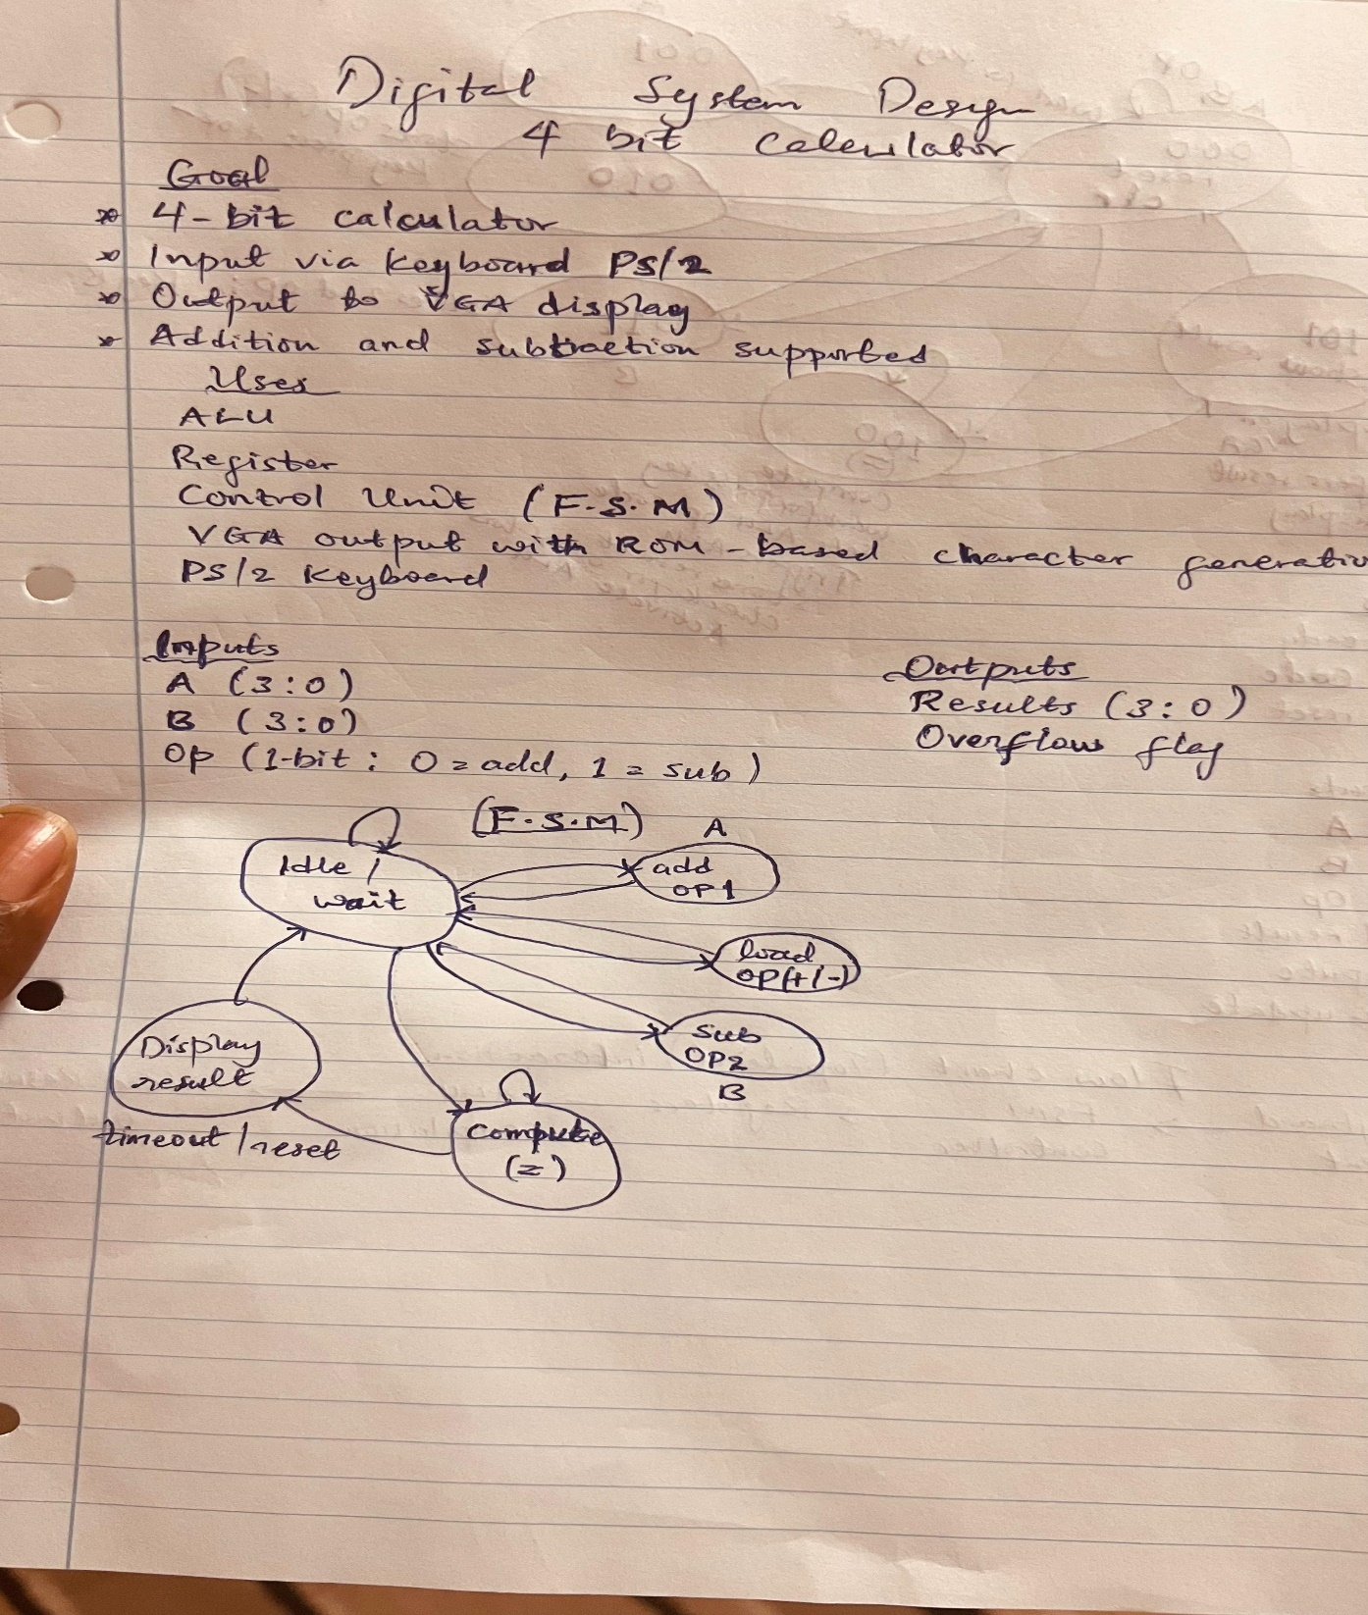

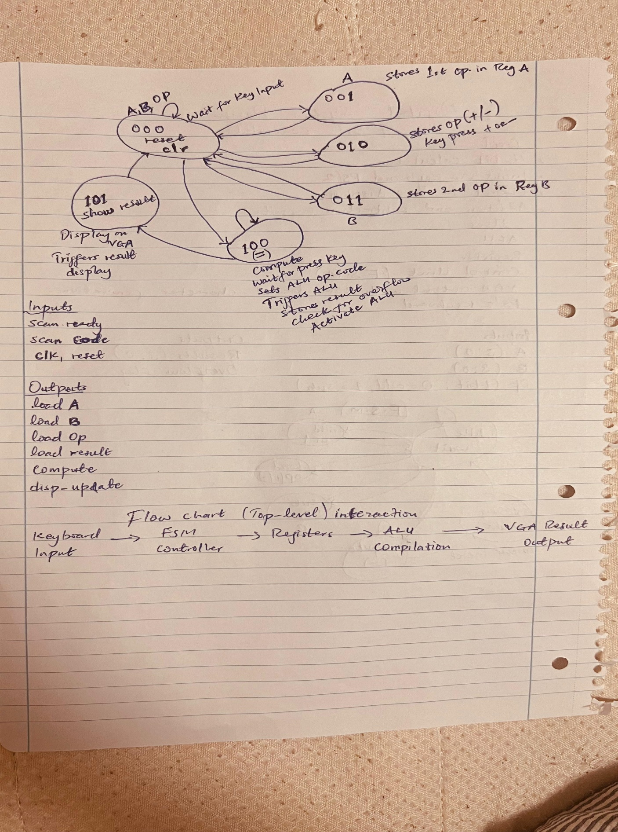

2. System Specification

2.1 Features:
4-bit operation
• Operations: Addition (+) and Subtraction (-)
• Keyboard input: PS/2 for operand and operator entry
• Visual Output: VGA monitor (text-based display)
• Modules: PS/2 interface, FSM controller, 4-bit ALU, Register set, VGA sync Character ROM

3. Design Modules and Theoretical Breakdown

3.1 PS/2 Keyboard Interface
Function: Reads key scan codes from PS/2 keyboard.
• Working:
- Samples serial data using clocked FSM.
- Generates a scan_ready pulse and scan_code when a key is pressed.
• Inputs: keyboard_clk, keyboard_data, system clock, reset
• Outputs: scan_code[7:0], scan_ready

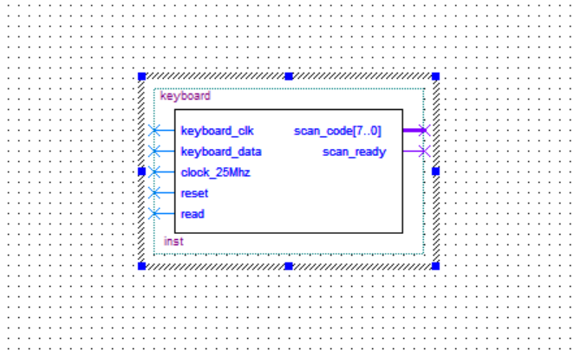

3.2 Finite State Machine (FSM) Controller
Function: Controls the sequence of operations.
• States:
1. Idle: Waits for key input.
2. Load A: Stores first operand.
3. Load Op: Stores operation (+/-).
4. Load B: Stores second operand.
5. Compute: Activates ALU.
6. Display: Triggers result display.
• Inputs: scan_ready, scan_code, clk, reset
• Outputs: load_A, load_B, load_op, load_result, compute, disp_update

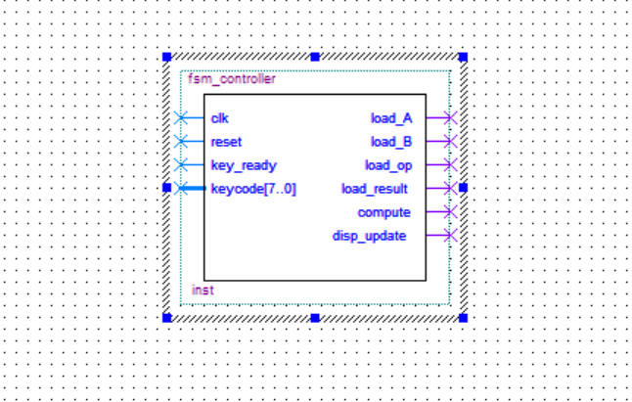

3.3 Registers (A, B, Result, OpReg)
Function: Store operands and result(s).
• Type: 4-bit synchronous registers.
• Working:
- Load signal from FSM triggers data capture.
- Data is passed to ALU or VGA depending on function.
• Inputs: clk, reset, load, data_in[3:0]
• Outputs: data_out[3:0]
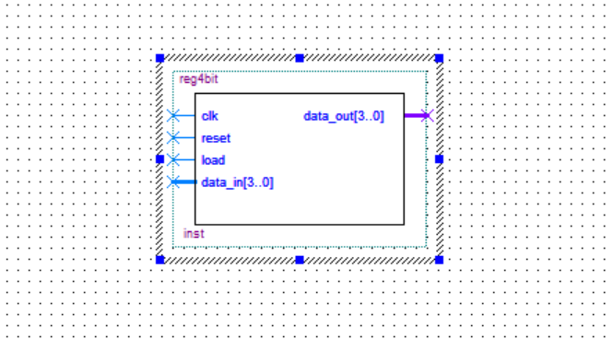

3.4 4-bit ALU
Function: Performs signed addition or subtraction.
• Operation:
- Uses 2’s complement for subtraction.
- Overflow logic included.
• Inputs: A[3:0], B[3:0], Op[1:0]
• Outputs: Result[3:0], Overflow

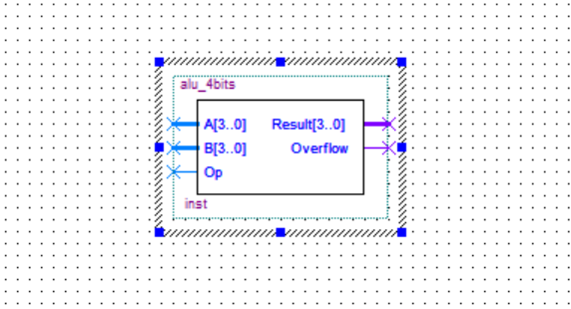

3.5 Character ROM (char_ROM)
Function: Stores 8x8 bitmap for ASCII characters.
• Working:
- Receives character code, font row and column from VGA.
- Outputs 1-bit pixel data.
• Inputs: char_address[5:0], font_row[2:0], font_col[2:0], clk
• Outputs: rom_output

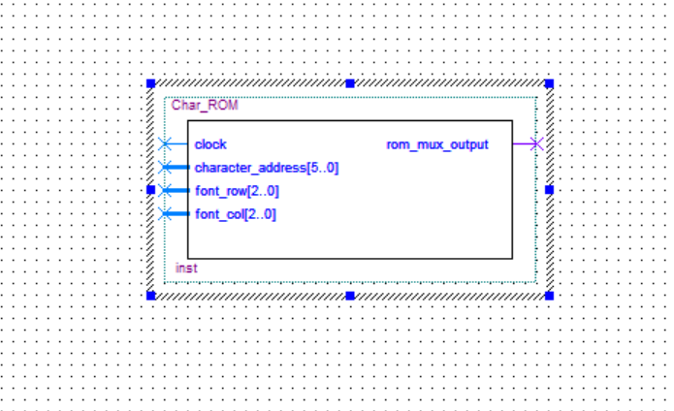

3.6 VGA Controller (vga_sync)
Function: Generates VGA timing signals and handles pixel display.
• Working:
- Generates horizontal and vertical sync pulses.
- Calculates pixel positions for character display.
- Combines with ROM output to show text.
• Inputs: clk, rom_output, character codes
• Outputs: VGA_R, VGA_G, VGA_B, HS, VS

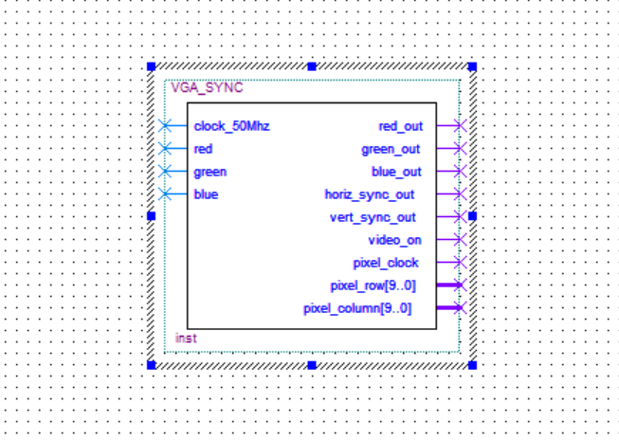

4. System Datapath and Flow
1. Input Phase:
• Keyboard sends keycode to PS/2 Interface.
• FSM waits for inputs and transitions states based on scan_code.
2. Processing Phase:
• Register A and B store operands.
• ALU performs operation based on Op-Reg.
3. Display Phase:
• FSM triggers disp_update.
• Character codes are sent to VGA screen buffer.
• VGA reads from char_ROM and generates pixel output.
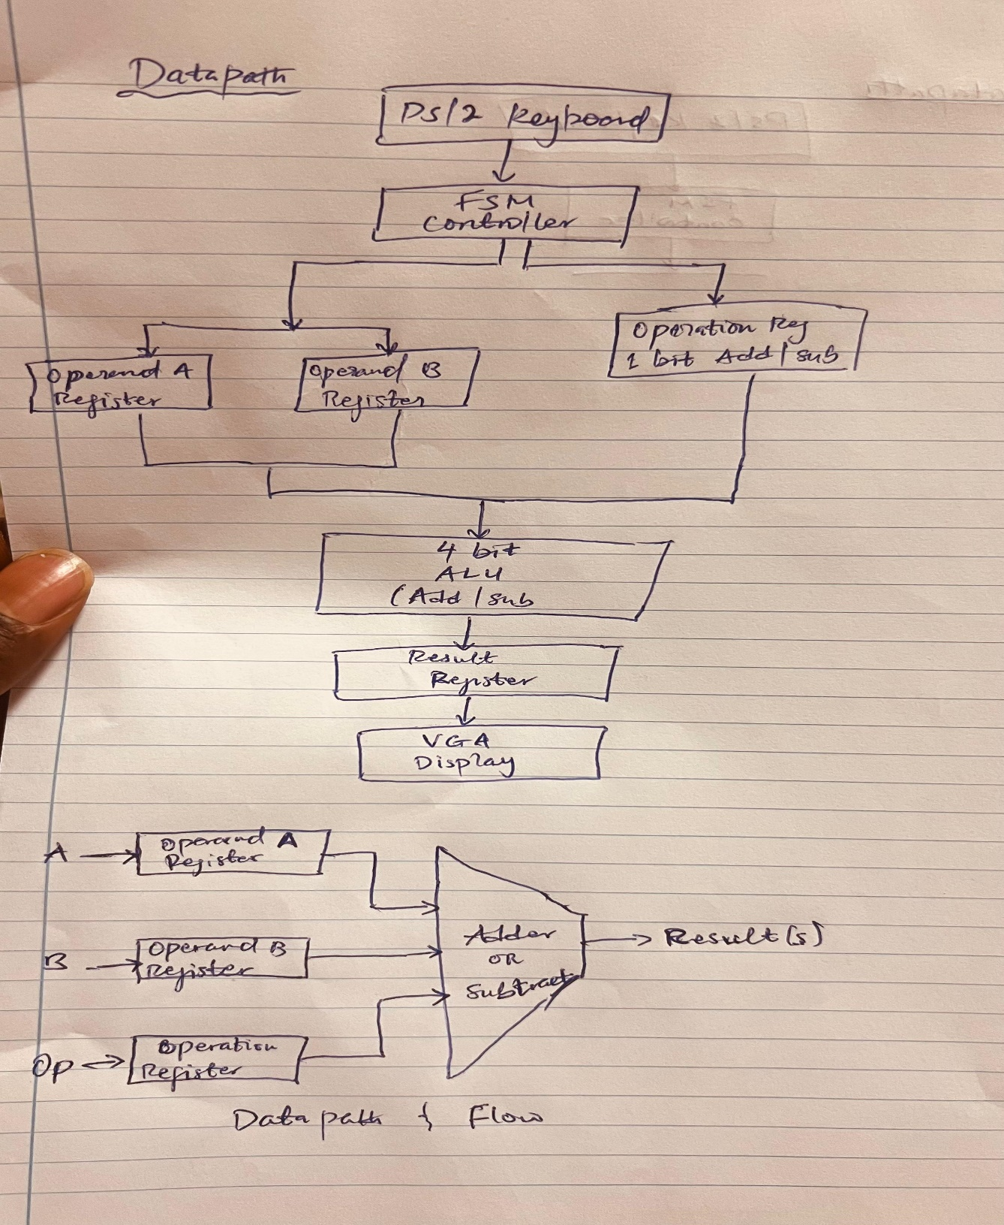

5. Block Diagram Overview

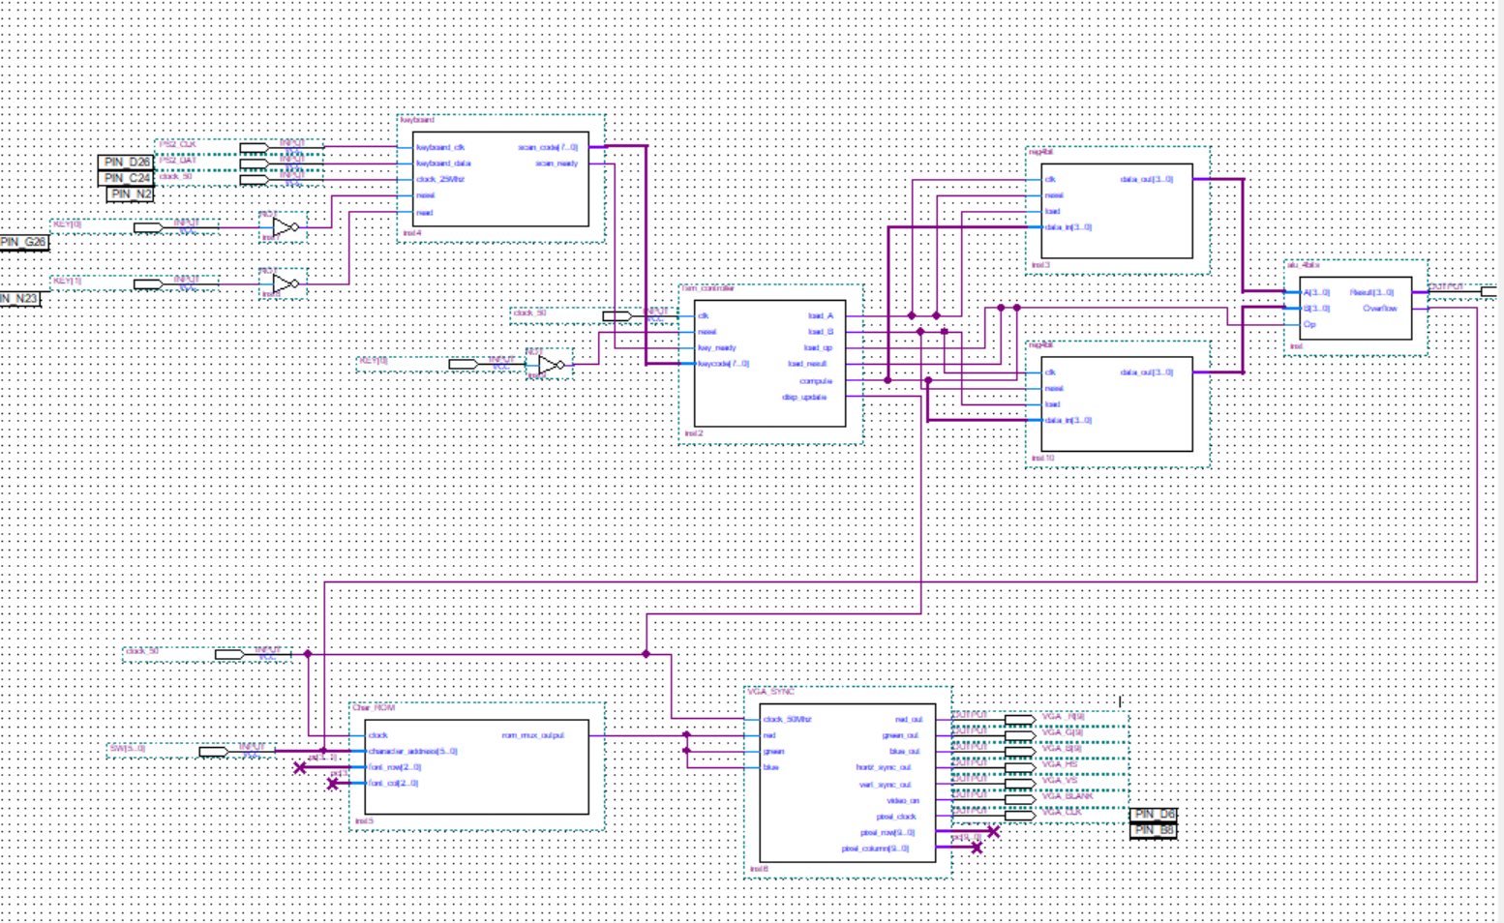

6. Conclusion

This project demonstrates a complete digital system involving input acquisition, sequential control, combinational logic, and visual output. It reflects practical understanding of:
• Hardware interfacing (PS/2, VGA)
• State machine design
• Arithmetic operations in hardware
• Memory mapping and screen display logic
The implementation of a 4-bit signed arithmetic calculator in Quartus is a comprehensive and rewarding digital design project. By integrating multiple essential components such as a PS/2 keyboard interface, finite state machine controller, 4-bit ALU, registers, a VGA display system, and a character ROM you create a fully functional embedded system that demonstrates real-time user interaction and graphical output. The project not only reinforces foundational knowledge in digital design, finite state machines, and VGA timing but also bridges the gap between theoretical logic design and practical hardware implementation on an FPGA. Through this, I gained valuable experience in full-system integration and essential skill in embedded systems, FPGA prototyping, and hardware-software co-design.

