COMPUTER VISION COURSE (2024/25)

Master in Electrical and Computer Engineering

Laboratory Assignment 3

Homographies and Geometric Camera Calibration

1. Introduction
In computer vision and photogrammetry, camera calibration is the process of determining the intrinsic and extrinsic parameters of a camera to accurately map 3D world points to 2D image points. Homography estimation is a geometric transformation used to map points from one plane to another. This report discusses the methods used for camera calibration, the resulting intrinsic matrix K, and how homography is calculated between a real-world football field image and its corresponding geometric model.
The report covers the following steps:
- Camera calibration using the Direct Linear Transformation (DLT) and Gold Standard methods.
- Calculation of the camera matrix K.
- Determining the homography matrix between the real-world and geometry images.

2. Camera Calibration Process
2.1 Initial Setup
The first step in the camera calibration process was running the camera calibration script (camcalscript). This script utilizes a set of 6 manually selected points from the calibration image to estimate the camera’s internal parameters.
- Calibration Pattern: We use a known pattern for calibration, typically a checkerboard or a grid, where the spatial relationships between points are well known. The pattern is used to calculate the intrinsic parameters (e.g., focal length and optical center) of the camera.
- Point Selection: The 6 points selected from the calibration image were carefully picked to ensure they covered a diverse set of locations across the pattern. These points correspond to known locations in the calibration setup.
- Calibration Output: After running the calibration script, the image with the 6 plotted points was produced, which correspond to the manually selected points from the calibration pattern.
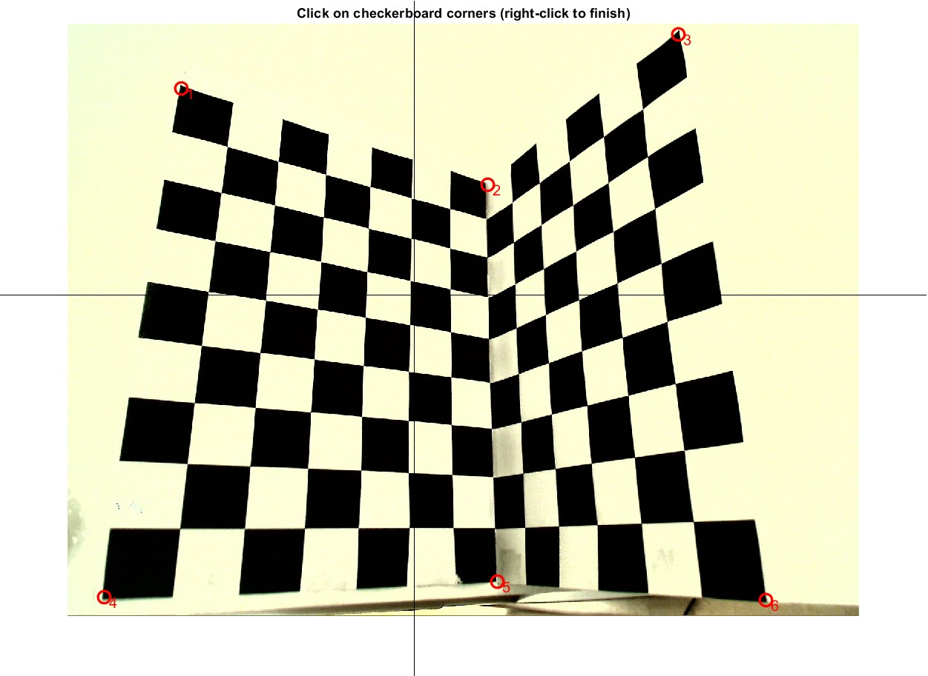
Fig. 01: Selection of points in a 3D space

2.2 Intrinsic Matrix K Calculation
After selecting the points, the next step was calculating the intrinsic matrix K. The intrinsic matrix is a fundamental camera parameter that relates the 3D world points to the 2D image points. The matrix K consists of the focal length, the optical center, and the skew of the image:
$$K= \begin{matrix}f_{x} & s & c_{x} \\ 0 & f_{y} & c_{y} \\ 0 & 0 & 1\end{matrix}$$
Where:
- f_x, f_y: The focal lengths in the x and y directions.
- s: The skew parameter, which is typically 0 in most modern cameras (meaning no skew between the x and y axes).
- c_x, c_y: The coordinates of the optical center (also called the principal point).

2.2.1 K from DLT Calibration
Using the Direct Linear Transformation (DLT) method, the camera’s intrinsic matrix K was estimated. The DLT method involves solving a system of linear equations derived from the correspondences between points in the calibration pattern and their corresponding points in the image.
The resulting K matrix from the DLT method is:
$$K_{DLT}= \begin{matrix}697.6801 & 0 & 0 \\ -83.4948 & 558.3171 & 0 \\ 625.3212 & 21.9020 & 1.0000\end{matrix}$$

- f_x = 697.6801, f_y = 558.3171: The focal lengths in the x and y directions.
- c_x = 625.3212, c_y = 21.9020: The optical center of the camera, indicating the point where the optical axis intersects the image plane.

2.2.2 K from Gold Standard Calibration
The Gold Standard method refines the camera parameters by minimizing the reprojection error (the difference between the observed and predicted positions of the calibration points). This refinement process adjusts the initial guesses for the intrinsic matrix.
The intrinsic matrix K from the Gold Standard calibration is:
$$K_{Gold Standard}= \begin{matrix}155.211 & 0 & 0 \\ -511.3879 & 135.7549 & 0 \\ 671.0883 & 454.8750 & 1.0000\end{matrix}$$
This method gives more accurate results, and the values indicate a more refined estimation of the camera's internal parameters.

2.2.3 K from Gold Standard Calibration with Distortion
In real-world scenarios, cameras often suffer from lens distortion, which affects the accuracy of the calibration. Radial distortion and tangential distortion can cause straight lines to appear curved in the image. To account for these distortions, the Gold Standard calibration was performed with distortion correction.
The resulting intrinsic matrix with distortion corrections is:
$$K_{Distorted}= \begin{matrix}197.8795 & 0 & 0 \\ -478.3390 & 143.8475 & 0 \\ 661.1628 & 465.6367 & 1.0000\end{matrix}$$
This matrix provides a better representation of the camera's behavior by compensating for lens-induced distortion.

2.3 Camera Position Relative to Calibration Points
Once we had computed the intrinsic matrix K, the camera's position relative to the calibration points was estimated. This step is important because it tells us where the camera is located in 3D space relative to the calibration pattern.
Understanding the camera position is crucial for tasks like 3D reconstruction, augmented reality, and other vision applications where precise knowledge of the camera’s orientation and location is necessary.
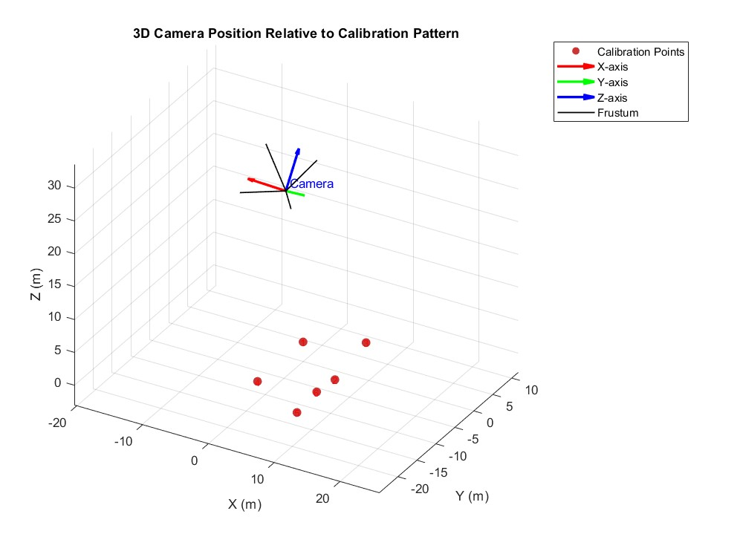
Fig. 02: Camera position relative to calibration points

3. Homography Estimation
3.1 Homography Matrix Calculation
After calibrating the camera, the next step was to estimate the homography matrix between two images: the real-world image (e.g., a football field) and the geometry image (a schematic or model of the football field). The homography matrix H is a transformation matrix that relates points in one image to corresponding points in another image.
The homography matrix is a 3x3 matrix, and it can be used to map points from one plane to another. This is particularly useful in applications like image stitching, image rectification, and measuring real-world distances.
The homography matrix H is defined as:

$$H= \begin{matrix}h_{11} & h_{12} & h_{13} \\ h_{21} & h_{22} & h_{23} \\ h_{31} & h_{32} & h_{33}\end{matrix}$$

We computed the homography matrix H using the corresponding points selected from the real-world image and the geometry image.
The resulting homography matrix H is:
$$H= \begin{matrix}3.5013 & -2.4244 & 857.5435 \\ 0.7048 & 0.6889 & 52.9152 \\ 0.0001 & -0.00004 & 1.0000\end{matrix}$$

- The matrix H transforms points from the real-world image to the geometry image by applying scaling, rotation, and translation.
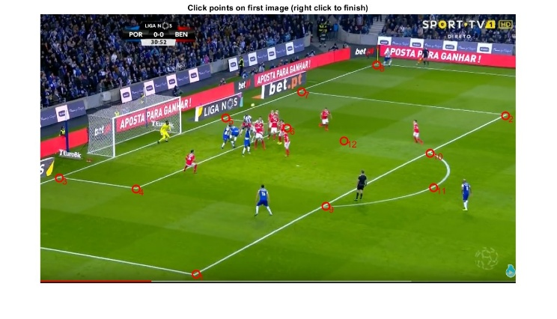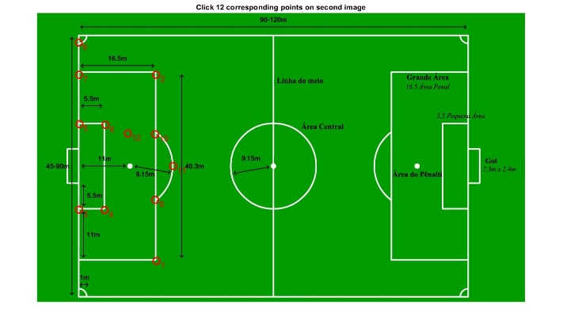
Fig. 03: Similar point selection from real world image and field geometry
3.2 Distance Measurement Between Points
After computing the homography matrix H, we used it to measure distances between points on the real-world image. By applying the homography transformation, we could map the points onto the geometry image and compute their distances in the real world.
For example, we selected two points on the real-world image, applied the homography matrix to project them onto the geometry image, and then calculated the Euclidean distance between them.
This process demonstrates how homography can be used not only for transforming points between images but also for distance measurement in real-world scenarios.
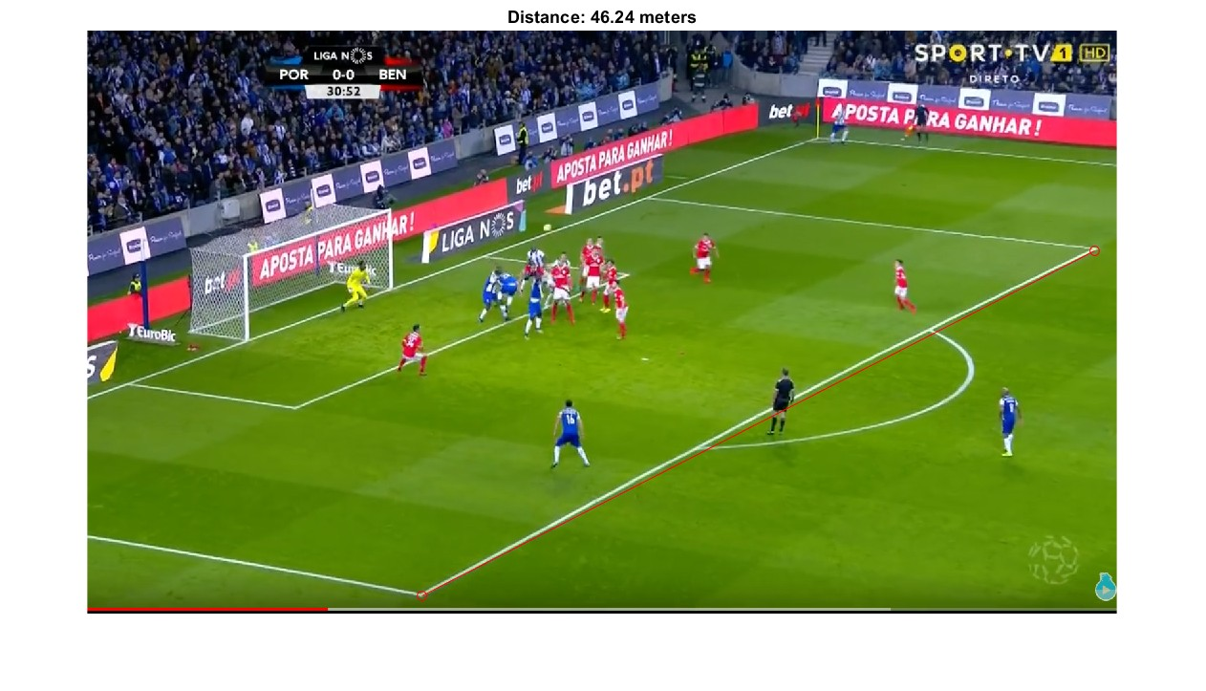
Fig. 04: Distance measurement between two selected points using homography

4. Conclusion
In this report, we performed camera calibration and homography estimation through the following detailed steps:
- Camera Calibration: The intrinsic matrix K was computed using the DLT and Gold Standard methods. The Gold Standard method provided better accuracy by minimizing the reprojection error and compensating for lens distortions.
- Homography Estimation: The homography matrix H was computed to transform points from the real-world image to the geometry image. The homography was used to measure distances between selected points, demonstrating the power of this transformation.
These processes are crucial for various computer vision tasks, such as 3D reconstruction, augmented reality, and image alignment. The calibration and homography estimation provided accurate results, enabling us to effectively map points between the real-world image and the geometry image.

