**Informed Consent Form**

Dear Participant,

thank you for your participation in the study.

In this study, you’ll be asked to perform certain tasks wearing Microsoft HoloLens and to answer some questions. The whole process will take around 30-60 minutes. You are free to stop, quit the study and retract your data at any time during the study with no further consequences. **Privacy:** Original data obtained from this study will be anonymized and only processed in aggregate. In such form, it might be published in academic journals, presentations or other media, but never in a way that would allow individual identification. One week after the study it might no longer be possible to retract your data from such aggregated analyses.

If you have any questions, please contact Jiongyan Zhang via jiongyan.zhang@tum.de.

▢ I confirm I volunteered to participate in this study.

▢ I confirm I was allowed to ask questions and that I was provided with responses.

▢ I confirm I was presented with this document prior to the beginning of the study.

▢ I confirm and I understood my right to quit the study at any time.

▢ I confirm I was informed that a conversation with researcher will be recorded after navigation during the study.

Date Signature of researcher

Signature of participant

If you would like to be informed about future studies, please let us know your email address:

Email address (optional)

**Pre-task questionnaire**

Gender: €Male €Female €Other Nationality: Age:

Country where you grew up:

Countries where you have been for more than 6 month

This questionnaire consists of several statements about your spatial and navigational abilities, preferences, and experiences. After each statement, you should circle a number to indicate your level of agreement with the statement. Circle "1" if you strongly agree that the statement applies to you, "7" if you strongly disagree, or some number in between if your agreement is intermediate. Circle "4" if you neither agree nor disagree.

1= strongly agree / none, 7 = strongly disagree / a lot of

|  |  |  |  |  |  |  |  |  |  |  |
| --- | --- | --- | --- | --- | --- | --- | --- | --- | --- | --- |
| 1 | I am very good at giving directions. | strongly agree | 1 | 2 | 3 | 4 | 5 | 6 | 7 | strongly disagree |
| 2 | I have a poor memory for where I left things. | strongly agree | 1 | 2 | 3 | 4 | 5 | 6 | 7 | strongly disagree |
| 3 | I am very good at judging distances. | strongly agree | 1 | 2 | 3 | 4 | 5 | 6 | 7 | strongly disagree |
| 4 | My “sense of direction” is very good. | strongly agree | 1 | 2 | 3 | 4 | 5 | 6 | 7 | strongly disagree |
| 5 | I tend to think of my environment in terms of cardinal directions(N, S, E, W). | strongly agree | 1 | 2 | 3 | 4 | 5 | 6 | 7 | strongly disagree |
| 6 | I very easily get lost in a new city. | strongly agree | 1 | 2 | 3 | 4 | 5 | 6 | 7 | strongly disagree |
| 7 | I enjoy reading maps. | strongly agree | 1 | 2 | 3 | 4 | 5 | 6 | 7 | strongly disagree |
| 8 | I have trouble understanding directions. | strongly agree | 1 | 2 | 3 | 4 | 5 | 6 | 7 | strongly disagree |
| 9 | I am very good at reading maps. | strongly agree | 1 | 2 | 3 | 4 | 5 | 6 | 7 | strongly disagree |
| 10 | I don’t remember routes very well while riding as a passenger in a car. | strongly agree | 1 | 2 | 3 | 4 | 5 | 6 | 7 | strongly disagree |
| 11 | I don’t enjoy giving directions. | strongly agree | 1 | 2 | 3 | 4 | 5 | 6 | 7 | strongly disagree |
| 12 | It’s not important to me to know where I am. | strongly agree | 1 | 2 | 3 | 4 | 5 | 6 | 7 | strongly disagree |
| 13 | I usually let someone else do the navigational planning for long trips. | strongly agree | 1 | 2 | 3 | 4 | 5 | 6 | 7 | strongly disagree |
| 14 | I can usually remember a new route after I have traveled it only once. | strongly agree | 1 | 2 | 3 | 4 | 5 | 6 | 7 | strongly disagree |
| 15 | I don’t have a very good “mental map” of my environment. | strongly agree | 1 | 2 | 3 | 4 | 5 | 6 | 7 | strongly disagree |
| 16 | I usually get lost indoors. | strongly agree | 1 | 2 | 3 | 4 | 5 | 6 | 7 | strongly disagree |
| 17 | I usually get lost outdoors. | strongly agree | 1 | 2 | 3 | 4 | 5 | 6 | 7 | strongly disagree |
| 18 | I have __ experience with Augmented Reality. | none | 1 | 2 | 3 | 4 | 5 | 6 | 7 | a lot of |
| 19 | I have __ experience with Virtual Reality. | none | 1 | 2 | 3 | 4 | 5 | 6 | 7 | a lot of |

**Post-task questionnaire**

# Please label the correct sizes of the area in the map.

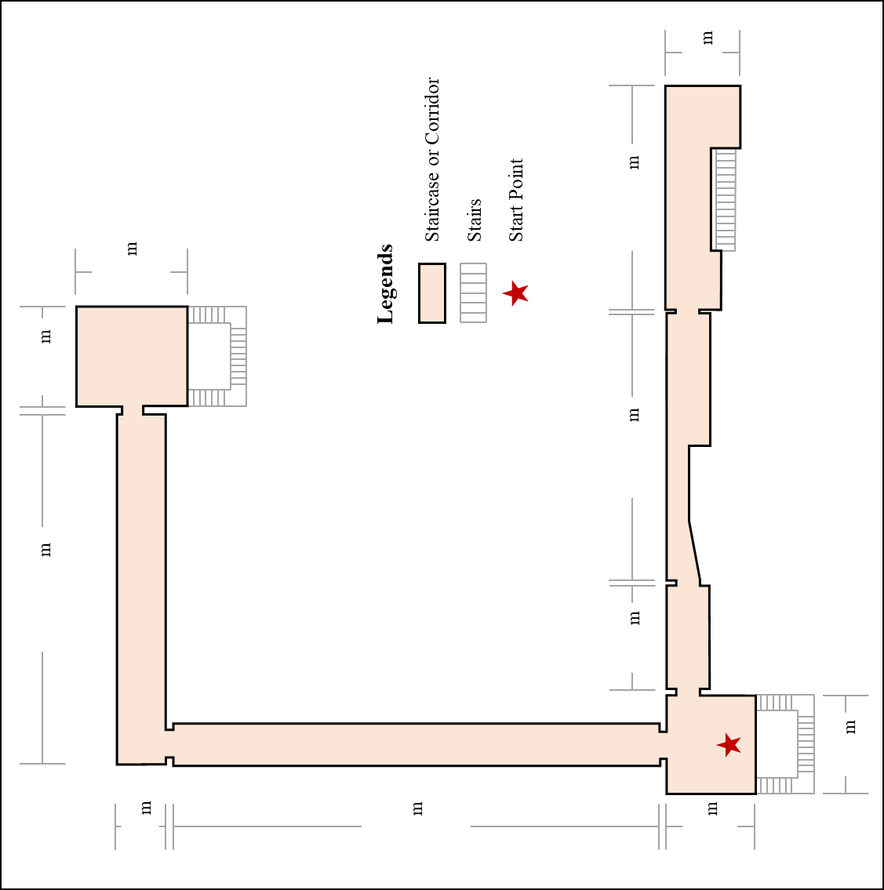



**Please use different symbols:**

Spatial Learning Section: “X”

Task Quiz Section: “O”

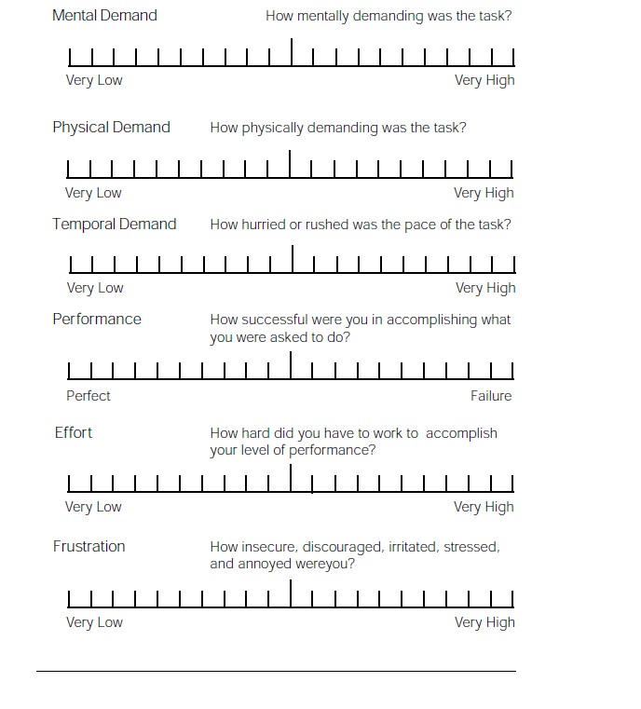

Please complete the following questionnaire (“1” = not at all, “7” = very much).

1. Before this walking, how familiar were you with the study area?

not at all 1 2 3 4 5 6 7 very much

1. How do you like the device/hardware?

not at all 1 2 3 4 5 6 7 very much

1. How do you like the interface?

not at all 1 2 3 4 5 6 7 very much

1. How do you like each element you saw?

Colors not at all 1 2 3 4 5 6 7 very much

Labels not at all 1 2 3 4 5 6 7 very much

Landmarks not at all 1 2 3 4 5 6 7 very much

1. How do you think each element helps you remember the area?

Colors not at all 1 2 3 4 5 6 7 very much

Labels not at all 1 2 3 4 5 6 7 very much

Landmarks not at all 1 2 3 4 5 6 7 very much

1. How do you think each element helps you locate your position?

Colors not at all 1 2 3 4 5 6 7 very much

Labels not at all 1 2 3 4 5 6 7 very much

Landmarks not at all 1 2 3 4 5 6 7 very much

1. How do you think each element helps you identify your orientation?

Colors not at all 1 2 3 4 5 6 7 very much

Labels not at all 1 2 3 4 5 6 7 very much

Landmarks not at all 1 2 3 4 5 6 7 very much

1. How do you think each element helps you identify and remember the sizes of the entire area?

Numbers of Grid Cells not at all 1 2 3 4 5 6 7 very much

Coordinate Values not at all 1 2 3 4 5 6 7 very much

1. How do you think each element helps you identify and remember the sizes of the local area (e.g. width of a corridor)?

Numbers of Grid Cells not at all 1 2 3 4 5 6 7 very much

Coordinate Values not at all 1 2 3 4 5 6 7 very much

1. How do you think each element helps you build a map of the area?

Transparency not at all 1 2 3 4 5 6 7 very much

Colors not at all 1 2 3 4 5 6 7 very much

Labels not at all 1 2 3 4 5 6 7 very much

Landmarks not at all 1 2 3 4 5 6 7 very much

1. Which type of the grid do you prefer to use?

Small Blue Grid not at all 1 2 3 4 5 6 7 very much

Large Red Grid not at all 1 2 3 4 5 6 7 very much

The combination of the two not at all 1 2 3 4 5 6 7 very much

Please rate the following strategies that you might use in the tasks.

|  |  |
| --- | --- |
| **Task 1** | **Task 2** |

1. How do you think each strategy helps you find the position of the target landmarks?

Strategy ①: Find the target landmark directly based on the offsets related to the given landmarks or scenes without thinking about the whole picture of the area.

Strategy ②: Find a landmark that you like to use or are very familiar with as an anchor point (e.g. starting point), and then find the target landmark based on the position of the anchor point and its offsets related to the anchor point.

Strategy ③: Match the given landmarks or scenes with your mental map (the map or layout of the area based on your point of view), and then find the target landmark in the mental map and find its position in the pictures of the tasks.

(please see options on the next page)

Task 1:

Strategy ① not at all 1 2 3 4 5 6 7 very much

Strategy ② not at all 1 2 3 4 5 6 7 very much

Strategy ③ not at all 1 2 3 4 5 6 7 very much

Other strategies (please tell the experimenter after you finish the questionnaire).

Task 2:

Strategy ① not at all 1 2 3 4 5 6 7 very much

Strategy ② not at all 1 2 3 4 5 6 7 very much

Strategy ③ not at all 1 2 3 4 5 6 7 very much

Other strategies (please tell the experimenter after you finish the questionnaire).

1. How do you think each strategy helps you determine the exact location of the target landmarks?

Task 1:

Distance-Angle strategy not at all 1 2 3 4 5 6 7 very much

X-Y strategy not at all 1 2 3 4 5 6 7 very much

Other strategies (please tell the experimenter after you finish the questionnaire).

Task 2:

Distance-Angle strategy not at all 1 2 3 4 5 6 7 very much

X-Y strategy not at all 1 2 3 4 5 6 7 very much

Other strategies (please tell the experimenter after you finish the questionnaire).

|  |  |
| --- | --- |
|  |  |
| Distance-Angle strategy | X-Y strategy |

# If you can design the interface of the AR system for learning and remembering the space, how would you do it or how would you improve the current one? Please write down your advices.

# Please draw your own interface from the first-person-view (i.e. what you see when you wear the AR device).

# Please confirm the authenticity of data in this document (including pre-task questionnaire, post task questionnaire and task quiz).

▢ I confirm the authenticity of all data in the document (including pre-task questionnaire, post task questionnaire and task quiz).

Date Signature of researcher

Signature of participant