MasterWide

Enrico Indiogine

March 6, 2016

In this document I show a possible way to analyze the MasterWide data from the file *MasterWide_StudyVI_TestScores_Sample.xlsx*. Also, for now I will only analyze the pre-test data. The code for the data management and these analyses is found in the file *TAMU.R*.

## Step 1 - General settings and load libraries

## Step 2 - Load and clean data

Then we load the data from the xlsx file and prepare the data. We remove the missing data rows and convert the original coding of "-1", "0", and "1" to "incorrect", "unknown", and "correct".

## Step 3 - Summary of raw data

Here we see a table with summaries of the data:

## [1] "Pre-test data"

##   
## MetaTutor MetaTutorC MetaTutorMC   
## 92 99 94

## [1] "Post-test data"

##   
## MetaTutor MetaTutorC MetaTutorMC   
## 92 99 94

## Step 4 - Create and Plot the Likert objects

The Likert plots are grouped by Condition. There are too many rows for all items, thus I break up the Likert object by the 3 problems, "Problem1", "Problem2", and "Eq_Problem". In addition, I shorten the variable names for the sake of legibility. 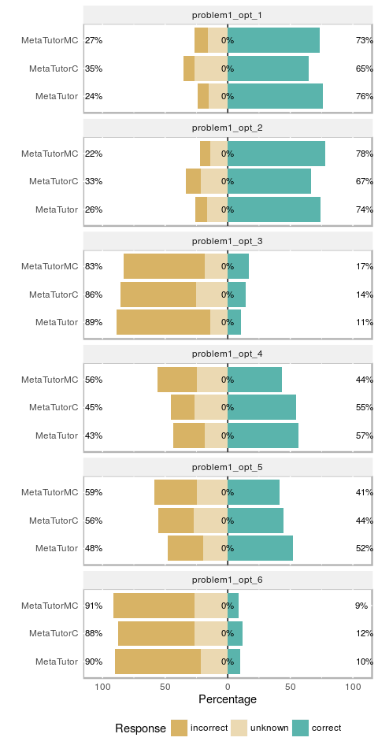

## Saving 5 x 10 in image

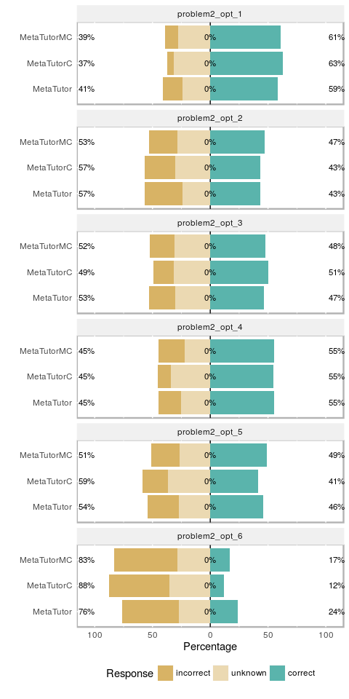

## Saving 5 x 10 in image

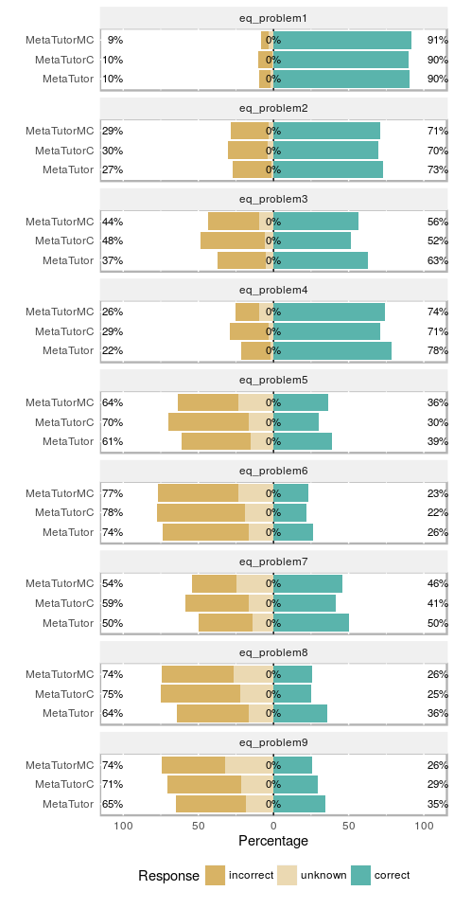

## Saving 5 x 10 in image

## Step 5 - Statistical test for equality of proportions

Since we are looking at the pre-test data, we need to assure that they are fairly homogeneous among conditions before the treatment. Because the number of rows is unequal between conditions we should not use ANOVA or something similar. We should convert the data to proportions and test for equality of proportion. I do this using the Beta regression test, see: <https://cran.r-project.org/web/packages/betareg/vignettes/betareg.pdf>

For this analysis I convert the "unknown" and "incorrect" responses to zero and "correct" to one.

For ease of interpretation I also perform a two-way test of equality of proportion using the Chi-square test.

##   
## Call:  
## betareg(formula = value ~ Condition - 1, data = data_pre_proportion,   
## hessian = TRUE)  
##   
## Standardized weighted residuals 2:  
## Min 1Q Median 3Q Max   
## -2.1532 -0.6020 0.0120 0.6342 2.4236   
##   
## Coefficients (mean model with logit link):  
## Estimate Std. Error z value Pr(>|z|)  
## ConditionMetaTutor -0.02286 0.18430 -0.124 0.901  
## ConditionMetaTutorC -0.18322 0.18482 -0.991 0.322  
## ConditionMetaTutorMC -0.11163 0.18449 -0.605 0.545  
##   
## Phi coefficients (precision model with identity link):  
## Estimate Std. Error z value Pr(>|z|)  
## (phi) 4.4641 0.7223 6.181 0.000000000637  
##   
## Type of estimator: ML (maximum likelihood)  
## Log-likelihood: 10.33 on 4 Df  
## Pseudo R-squared: 0.006065  
## Number of iterations in BFGS optimization: 12

## [1] "MetaTutor vs. MetaTutorC"

## [1] "problem1_opt_1"  
##   
## 2-sample test for equality of proportions with continuity  
## correction  
##   
## data: c(metatutor_sums[i], metatutorc_sums[i]) out of c(metatutor_count, metatutorc_count)  
## X-squared = 2.4596, df = 1, p-value = 0.1168  
## alternative hypothesis: two.sided  
## 95 percent confidence interval:  
## -0.02439818 0.25320802  
## sample estimates:  
## prop 1 prop 2   
## 0.7608696 0.6464646   
##   
## [1] "problem1_opt_2"  
##   
## 2-sample test for equality of proportions with continuity  
## correction  
##   
## data: c(metatutor_sums[i], metatutorc_sums[i]) out of c(metatutor_count, metatutorc_count)  
## X-squared = 0.8749, df = 1, p-value = 0.3496  
## alternative hypothesis: two.sided  
## 95 percent confidence interval:  
## -0.06714882 0.21207635  
## sample estimates:  
## prop 1 prop 2   
## 0.7391304 0.6666667   
##   
## [1] "problem1_opt_3"  
##   
## 2-sample test for equality of proportions with continuity  
## correction  
##   
## data: c(metatutor_sums[i], metatutorc_sums[i]) out of c(metatutor_count, metatutorc_count)  
## X-squared = 0.21455, df = 1, p-value = 0.6432  
## alternative hypothesis: two.sided  
## 95 percent confidence interval:  
## -0.13678009 0.07134311  
## sample estimates:  
## prop 1 prop 2   
## 0.1086957 0.1414141   
##   
## [1] "problem1_opt_4"  
##   
## 2-sample test for equality of proportions with continuity  
## correction  
##   
## data: c(metatutor_sums[i], metatutorc_sums[i]) out of c(metatutor_count, metatutorc_count)  
## X-squared = 0.016619, df = 1, p-value = 0.8974  
## alternative hypothesis: two.sided  
## 95 percent confidence interval:  
## -0.1317247 0.1712504  
## sample estimates:  
## prop 1 prop 2   
## 0.5652174 0.5454545   
##   
## [1] "problem1_opt_5"  
##   
## 2-sample test for equality of proportions with continuity  
## correction  
##   
## data: c(metatutor_sums[i], metatutorc_sums[i]) out of c(metatutor_count, metatutorc_count)  
## X-squared = 0.85253, df = 1, p-value = 0.3558  
## alternative hypothesis: two.sided  
## 95 percent confidence interval:  
## -0.07461163 0.22920100  
## sample estimates:  
## prop 1 prop 2   
## 0.5217391 0.4444444   
##   
## [1] "problem1_opt_6"  
##   
## 2-sample test for equality of proportions with continuity  
## correction  
##   
## data: c(metatutor_sums[i], metatutorc_sums[i]) out of c(metatutor_count, metatutorc_count)  
## X-squared = 0.081099, df = 1, p-value = 0.7758  
## alternative hypothesis: two.sided  
## 95 percent confidence interval:  
## -0.12229292 0.07552085  
## sample estimates:  
## prop 1 prop 2   
## 0.09782609 0.12121212   
##   
## [1] "problem2_opt_1"  
##   
## 2-sample test for equality of proportions with continuity  
## correction  
##   
## data: c(metatutor_sums[i], metatutorc_sums[i]) out of c(metatutor_count, metatutorc_count)  
## X-squared = 0.16609, df = 1, p-value = 0.6836  
## alternative hypothesis: two.sided  
## 95 percent confidence interval:  
## -0.1883738 0.1097615  
## sample estimates:  
## prop 1 prop 2   
## 0.5869565 0.6262626   
##   
## [1] "problem2_opt_2"  
##   
## 2-sample test for equality of proportions with continuity  
## correction  
##   
## data: c(metatutor_sums[i], metatutorc_sums[i]) out of c(metatutor_count, metatutorc_count)  
## X-squared = 0.0000000000000000000000000000027886, df = 1, p-value  
## = 1  
## alternative hypothesis: two.sided  
## 95 percent confidence interval:  
## -0.1406930 0.1415714  
## sample estimates:  
## prop 1 prop 2   
## 0.4347826 0.4343434   
##   
## [1] "problem2_opt_3"  
##   
## 2-sample test for equality of proportions with continuity  
## correction  
##   
## data: c(metatutor_sums[i], metatutorc_sums[i]) out of c(metatutor_count, metatutorc_count)  
## X-squared = 0.14095, df = 1, p-value = 0.7073  
## alternative hypothesis: two.sided  
## 95 percent confidence interval:  
## -0.1898978 0.1145794  
## sample estimates:  
## prop 1 prop 2   
## 0.4673913 0.5050505   
##   
## [1] "problem2_opt_4"  
##   
## 2-sample test for equality of proportions with continuity  
## correction  
##   
## data: c(metatutor_sums[i], metatutorc_sums[i]) out of c(metatutor_count, metatutorc_count)  
## X-squared = 0.0000000000000000000000000000014186, df = 1, p-value  
## = 1  
## alternative hypothesis: two.sided  
## 95 percent confidence interval:  
## -0.1411945 0.1589811  
## sample estimates:  
## prop 1 prop 2   
## 0.5543478 0.5454545   
##   
## [1] "problem2_opt_5"  
##   
## 2-sample test for equality of proportions with continuity  
## correction  
##   
## data: c(metatutor_sums[i], metatutorc_sums[i]) out of c(metatutor_count, metatutorc_count)  
## X-squared = 0.19742, df = 1, p-value = 0.6568  
## alternative hypothesis: two.sided  
## 95 percent confidence interval:  
## -0.1087265 0.1934872  
## sample estimates:  
## prop 1 prop 2   
## 0.4565217 0.4141414   
##   
## [1] "problem2_opt_6"  
##   
## 2-sample test for equality of proportions with continuity  
## correction  
##   
## data: c(metatutor_sums[i], metatutorc_sums[i]) out of c(metatutor_count, metatutorc_count)  
## X-squared = 3.7614, df = 1, p-value = 0.05245  
## alternative hypothesis: two.sided  
## 95 percent confidence interval:  
## -0.0008741395 0.2367107666  
## sample estimates:  
## prop 1 prop 2   
## 0.2391304 0.1212121   
##   
## [1] "eq_problem1"  
##   
## 2-sample test for equality of proportions with continuity  
## correction  
##   
## data: c(metatutor_sums[i], metatutorc_sums[i]) out of c(metatutor_count, metatutorc_count)  
## X-squared = 0.0000000000000000000000000000053399, df = 1, p-value  
## = 1  
## alternative hypothesis: two.sided  
## 95 percent confidence interval:  
## -0.08490398 0.09127201  
## sample estimates:  
## prop 1 prop 2   
## 0.9021739 0.8989899   
##   
## [1] "eq_problem2"  
##   
## 2-sample test for equality of proportions with continuity  
## correction  
##   
## data: c(metatutor_sums[i], metatutorc_sums[i]) out of c(metatutor_count, metatutorc_count)  
## X-squared = 0.10068, df = 1, p-value = 0.751  
## alternative hypothesis: two.sided  
## 95 percent confidence interval:  
## -0.1074845 0.1700668  
## sample estimates:  
## prop 1 prop 2   
## 0.7282609 0.6969697   
##   
## [1] "eq_problem3"  
##   
## 2-sample test for equality of proportions with continuity  
## correction  
##   
## data: c(metatutor_sums[i], metatutorc_sums[i]) out of c(metatutor_count, metatutorc_count)  
## X-squared = 2.1376, df = 1, p-value = 0.1437  
## alternative hypothesis: two.sided  
## 95 percent confidence interval:  
## -0.03455806 0.26512459  
## sample estimates:  
## prop 1 prop 2   
## 0.6304348 0.5151515   
##   
## [1] "eq_problem4"  
##   
## 2-sample test for equality of proportions with continuity  
## correction  
##   
## data: c(metatutor_sums[i], metatutorc_sums[i]) out of c(metatutor_count, metatutorc_count)  
## X-squared = 1.058, df = 1, p-value = 0.3037  
## alternative hypothesis: two.sided  
## 95 percent confidence interval:  
## -0.057995 0.209071  
## sample estimates:  
## prop 1 prop 2   
## 0.7826087 0.7070707   
##   
## [1] "eq_problem5"  
##   
## 2-sample test for equality of proportions with continuity  
## correction  
##   
## data: c(metatutor_sums[i], metatutorc_sums[i]) out of c(metatutor_count, metatutorc_count)  
## X-squared = 1.276, df = 1, p-value = 0.2587  
## alternative hypothesis: two.sided  
## 95 percent confidence interval:  
## -0.05689847 0.23344656  
## sample estimates:  
## prop 1 prop 2   
## 0.3913043 0.3030303   
##   
## [1] "eq_problem6"  
##   
## 2-sample test for equality of proportions with continuity  
## correction  
##   
## data: c(metatutor_sums[i], metatutorc_sums[i]) out of c(metatutor_count, metatutorc_count)  
## X-squared = 0.20685, df = 1, p-value = 0.6492  
## alternative hypothesis: two.sided  
## 95 percent confidence interval:  
## -0.09331914 0.17061383  
## sample estimates:  
## prop 1 prop 2   
## 0.2608696 0.2222222   
##   
## [1] "eq_problem7"  
##   
## 2-sample test for equality of proportions with continuity  
## correction  
##   
## data: c(metatutor_sums[i], metatutorc_sums[i]) out of c(metatutor_count, metatutorc_count)  
## X-squared = 1.0923, df = 1, p-value = 0.296  
## alternative hypothesis: two.sided  
## 95 percent confidence interval:  
## -0.06552865 0.23724582  
## sample estimates:  
## prop 1 prop 2   
## 0.5000000 0.4141414   
##   
## [1] "eq_problem8"  
##   
## 2-sample test for equality of proportions with continuity  
## correction  
##   
## data: c(metatutor_sums[i], metatutorc_sums[i]) out of c(metatutor_count, metatutorc_count)  
## X-squared = 2.0647, df = 1, p-value = 0.1507  
## alternative hypothesis: two.sided  
## 95 percent confidence interval:  
## -0.03442739 0.24676819  
## sample estimates:  
## prop 1 prop 2   
## 0.3586957 0.2525253   
##   
## [1] "eq_problem9"  
##   
## 2-sample test for equality of proportions with continuity  
## correction  
##   
## data: c(metatutor_sums[i], metatutorc_sums[i]) out of c(metatutor_count, metatutorc_count)  
## X-squared = 0.43269, df = 1, p-value = 0.5107  
## alternative hypothesis: two.sided  
## 95 percent confidence interval:  
## -0.08790892 0.19770251  
## sample estimates:  
## prop 1 prop 2   
## 0.3478261 0.2929293

## [1] "MetaTutor vs. MetaTutorMC"

## [1] "problem1_opt_1"  
##   
## 2-sample test for equality of proportions with continuity  
## correction  
##   
## data: c(metatutor_sums[i], metatutormc_sums[i]) out of c(metatutor_count, metatutormc_count)  
## X-squared = 0.063608, df = 1, p-value = 0.8009  
## alternative hypothesis: two.sided  
## 95 percent confidence interval:  
## -0.1087281 0.1623821  
## sample estimates:  
## prop 1 prop 2   
## 0.7608696 0.7340426   
##   
## [1] "problem1_opt_2"  
##   
## 2-sample test for equality of proportions with continuity  
## correction  
##   
## data: c(metatutor_sums[i], metatutormc_sums[i]) out of c(metatutor_count, metatutormc_count)  
## X-squared = 0.18088, df = 1, p-value = 0.6706  
## alternative hypothesis: two.sided  
## 95 percent confidence interval:  
## -0.17126881 0.09633819  
## sample estimates:  
## prop 1 prop 2   
## 0.7391304 0.7765957   
##   
## [1] "problem1_opt_3"  
##   
## 2-sample test for equality of proportions with continuity  
## correction  
##   
## data: c(metatutor_sums[i], metatutormc_sums[i]) out of c(metatutor_count, metatutormc_count)  
## X-squared = 0.9964, df = 1, p-value = 0.3182  
## alternative hypothesis: two.sided  
## 95 percent confidence interval:  
## -0.17135320 0.04831897  
## sample estimates:  
## prop 1 prop 2   
## 0.1086957 0.1702128   
##   
## [1] "problem1_opt_4"  
##   
## 2-sample test for equality of proportions with continuity  
## correction  
##   
## data: c(metatutor_sums[i], metatutormc_sums[i]) out of c(metatutor_count, metatutormc_count)  
## X-squared = 2.6025, df = 1, p-value = 0.1067  
## alternative hypothesis: two.sided  
## 95 percent confidence interval:  
## -0.02422446 0.28231881  
## sample estimates:  
## prop 1 prop 2   
## 0.5652174 0.4361702   
##   
## [1] "problem1_opt_5"  
##   
## 2-sample test for equality of proportions with continuity  
## correction  
##   
## data: c(metatutor_sums[i], metatutormc_sums[i]) out of c(metatutor_count, metatutormc_count)  
## X-squared = 1.7244, df = 1, p-value = 0.1891  
## alternative hypothesis: two.sided  
## 95 percent confidence interval:  
## -0.04652559 0.26021662  
## sample estimates:  
## prop 1 prop 2   
## 0.5217391 0.4148936   
##   
## [1] "problem1_opt_6"  
##   
## 2-sample test for equality of proportions with continuity  
## correction  
##   
## data: c(metatutor_sums[i], metatutormc_sums[i]) out of c(metatutor_count, metatutormc_count)  
## X-squared = 0.0021635, df = 1, p-value = 0.9629  
## alternative hypothesis: two.sided  
## 95 percent confidence interval:  
## -0.08090244 0.10634185  
## sample estimates:  
## prop 1 prop 2   
## 0.09782609 0.08510638   
##   
## [1] "problem2_opt_1"  
##   
## 2-sample test for equality of proportions with continuity  
## correction  
##   
## data: c(metatutor_sums[i], metatutormc_sums[i]) out of c(metatutor_count, metatutormc_count)  
## X-squared = 0.014532, df = 1, p-value = 0.904  
## alternative hypothesis: two.sided  
## 95 percent confidence interval:  
## -0.1711668 0.1323139  
## sample estimates:  
## prop 1 prop 2   
## 0.5869565 0.6063830   
##   
## [1] "problem2_opt_2"  
##   
## 2-sample test for equality of proportions with continuity  
## correction  
##   
## data: c(metatutor_sums[i], metatutormc_sums[i]) out of c(metatutor_count, metatutormc_count)  
## X-squared = 0.095452, df = 1, p-value = 0.7574  
## alternative hypothesis: two.sided  
## 95 percent confidence interval:  
## -0.1870116 0.1204066  
## sample estimates:  
## prop 1 prop 2   
## 0.4347826 0.4680851   
##   
## [1] "problem2_opt_3"  
##   
## 2-sample test for equality of proportions with continuity  
## correction  
##   
## data: c(metatutor_sums[i], metatutormc_sums[i]) out of c(metatutor_count, metatutormc_count)  
## X-squared = 0.000062349, df = 1, p-value = 0.9937  
## alternative hypothesis: two.sided  
## 95 percent confidence interval:  
## -0.1655869 0.1429227  
## sample estimates:  
## prop 1 prop 2   
## 0.4673913 0.4787234   
##   
## [1] "problem2_opt_4"  
##   
## 2-sample test for equality of proportions with continuity  
## correction  
##   
## data: c(metatutor_sums[i], metatutormc_sums[i]) out of c(metatutor_count, metatutormc_count)  
## X-squared = 0.0000000000000000000000000000044831, df = 1, p-value  
## = 1  
## alternative hypothesis: two.sided  
## 95 percent confidence interval:  
## -0.1428861 0.1451988  
## sample estimates:  
## prop 1 prop 2   
## 0.5543478 0.5531915   
##   
## [1] "problem2_opt_5"  
##   
## 2-sample test for equality of proportions with continuity  
## correction  
##   
## data: c(metatutor_sums[i], metatutormc_sums[i]) out of c(metatutor_count, metatutormc_count)  
## X-squared = 0.090982, df = 1, p-value = 0.7629  
## alternative hypothesis: two.sided  
## 95 percent confidence interval:  
## -0.1870227 0.1213428  
## sample estimates:  
## prop 1 prop 2   
## 0.4565217 0.4893617   
##   
## [1] "problem2_opt_6"  
##   
## 2-sample test for equality of proportions with continuity  
## correction  
##   
## data: c(metatutor_sums[i], metatutormc_sums[i]) out of c(metatutor_count, metatutormc_count)  
## X-squared = 0.96758, df = 1, p-value = 0.3253  
## alternative hypothesis: two.sided  
## 95 percent confidence interval:  
## -0.05746156 0.19529690  
## sample estimates:  
## prop 1 prop 2   
## 0.2391304 0.1702128   
##   
## [1] "eq_problem1"  
##   
## 2-sample test for equality of proportions with continuity  
## correction  
##   
## data: c(metatutor_sums[i], metatutormc_sums[i]) out of c(metatutor_count, metatutormc_count)  
## X-squared = 0.0021635, df = 1, p-value = 0.9629  
## alternative hypothesis: two.sided  
## 95 percent confidence interval:  
## -0.10634185 0.08090244  
## sample estimates:  
## prop 1 prop 2   
## 0.9021739 0.9148936   
##   
## [1] "eq_problem2"  
##   
## 2-sample test for equality of proportions with continuity  
## correction  
##   
## data: c(metatutor_sums[i], metatutormc_sums[i]) out of c(metatutor_count, metatutormc_count)  
## X-squared = 0.0051887, df = 1, p-value = 0.9426  
## alternative hypothesis: two.sided  
## 95 percent confidence interval:  
## -0.1242157 0.1552055  
## sample estimates:  
## prop 1 prop 2   
## 0.7282609 0.7127660   
##   
## [1] "eq_problem3"  
##   
## 2-sample test for equality of proportions with continuity  
## correction  
##   
## data: c(metatutor_sums[i], metatutormc_sums[i]) out of c(metatutor_count, metatutormc_count)  
## X-squared = 0.60271, df = 1, p-value = 0.4375  
## alternative hypothesis: two.sided  
## 95 percent confidence interval:  
## -0.08478501 0.21799500  
## sample estimates:  
## prop 1 prop 2   
## 0.6304348 0.5638298   
##   
## [1] "eq_problem4"  
##   
## 2-sample test for equality of proportions with continuity  
## correction  
##   
## data: c(metatutor_sums[i], metatutormc_sums[i]) out of c(metatutor_count, metatutormc_count)  
## X-squared = 0.1901, df = 1, p-value = 0.6628  
## alternative hypothesis: two.sided  
## 95 percent confidence interval:  
## -0.09478464 0.17064033  
## sample estimates:  
## prop 1 prop 2   
## 0.7826087 0.7446809   
##   
## [1] "eq_problem5"  
##   
## 2-sample test for equality of proportions with continuity  
## correction  
##   
## data: c(metatutor_sums[i], metatutormc_sums[i]) out of c(metatutor_count, metatutormc_count)  
## X-squared = 0.070375, df = 1, p-value = 0.7908  
## alternative hypothesis: two.sided  
## 95 percent confidence interval:  
## -0.1203654 0.1795698  
## sample estimates:  
## prop 1 prop 2   
## 0.3913043 0.3617021   
##   
## [1] "eq_problem6"  
##   
## 2-sample test for equality of proportions with continuity  
## correction  
##   
## data: c(metatutor_sums[i], metatutormc_sums[i]) out of c(metatutor_count, metatutormc_count)  
## X-squared = 0.064527, df = 1, p-value = 0.7995  
## alternative hypothesis: two.sided  
## 95 percent confidence interval:  
## -0.1079312 0.1615853  
## sample estimates:  
## prop 1 prop 2   
## 0.2608696 0.2340426   
##   
## [1] "eq_problem7"  
##   
## 2-sample test for equality of proportions with continuity  
## correction  
##   
## data: c(metatutor_sums[i], metatutormc_sums[i]) out of c(metatutor_count, metatutormc_count)  
## X-squared = 0.18841, df = 1, p-value = 0.6642  
## alternative hypothesis: two.sided  
## 95 percent confidence interval:  
## -0.1116629 0.1967693  
## sample estimates:  
## prop 1 prop 2   
## 0.5000000 0.4574468   
##   
## [1] "eq_problem8"  
##   
## 2-sample test for equality of proportions with continuity  
## correction  
##   
## data: c(metatutor_sums[i], metatutormc_sums[i]) out of c(metatutor_count, metatutormc_count)  
## X-squared = 1.8767, df = 1, p-value = 0.1707  
## alternative hypothesis: two.sided  
## 95 percent confidence interval:  
## -0.03919186 0.24594487  
## sample estimates:  
## prop 1 prop 2   
## 0.3586957 0.2553191   
##   
## [1] "eq_problem9"  
##   
## 2-sample test for equality of proportions with continuity  
## correction  
##   
## data: c(metatutor_sums[i], metatutormc_sums[i]) out of c(metatutor_count, metatutormc_count)  
## X-squared = 1.4767, df = 1, p-value = 0.2243  
## alternative hypothesis: two.sided  
## 95 percent confidence interval:  
## -0.04955521 0.23456908  
## sample estimates:  
## prop 1 prop 2   
## 0.3478261 0.2553191

## [1] "MetaTutorC vs. MetaTutorMC"

## [1] "problem1_opt_1"  
##   
## 2-sample test for equality of proportions with continuity  
## correction  
##   
## data: c(metatutorc_sums[i], metatutormc_sums[i]) out of c(metatutorc_count, metatutormc_count)  
## X-squared = 1.3417, df = 1, p-value = 0.2467  
## alternative hypothesis: two.sided  
## 95 percent confidence interval:  
## -0.22774126 0.05258545  
## sample estimates:  
## prop 1 prop 2   
## 0.6464646 0.7340426   
##   
## [1] "problem1_opt_2"  
##   
## 2-sample test for equality of proportions with continuity  
## correction  
##   
## data: c(metatutorc_sums[i], metatutormc_sums[i]) out of c(metatutorc_count, metatutormc_count)  
## X-squared = 2.3718, df = 1, p-value = 0.1235  
## alternative hypothesis: two.sided  
## 95 percent confidence interval:  
## -0.24565001 0.02579185  
## sample estimates:  
## prop 1 prop 2   
## 0.6666667 0.7765957   
##   
## [1] "problem1_opt_3"  
##   
## 2-sample test for equality of proportions with continuity  
## correction  
##   
## data: c(metatutorc_sums[i], metatutormc_sums[i]) out of c(metatutorc_count, metatutormc_count)  
## X-squared = 0.12474, df = 1, p-value = 0.7239  
## alternative hypothesis: two.sided  
## 95 percent confidence interval:  
## -0.1415562 0.0839589  
## sample estimates:  
## prop 1 prop 2   
## 0.1414141 0.1702128   
##   
## [1] "problem1_opt_4"  
##   
## 2-sample test for equality of proportions with continuity  
## correction  
##   
## data: c(metatutorc_sums[i], metatutormc_sums[i]) out of c(metatutorc_count, metatutormc_count)  
## X-squared = 1.8875, df = 1, p-value = 0.1695  
## alternative hypothesis: two.sided  
## 95 percent confidence interval:  
## -0.04133734 0.25990600  
## sample estimates:  
## prop 1 prop 2   
## 0.5454545 0.4361702   
##   
## [1] "problem1_opt_5"  
##   
## 2-sample test for equality of proportions with continuity  
## correction  
##   
## data: c(metatutorc_sums[i], metatutormc_sums[i]) out of c(metatutorc_count, metatutormc_count)  
## X-squared = 0.072377, df = 1, p-value = 0.7879  
## alternative hypothesis: two.sided  
## 95 percent confidence interval:  
## -0.1204667 0.1795684  
## sample estimates:  
## prop 1 prop 2   
## 0.4444444 0.4148936   
##   
## [1] "problem1_opt_6"  
##   
## 2-sample test for equality of proportions with continuity  
## correction  
##   
## data: c(metatutorc_sums[i], metatutormc_sums[i]) out of c(metatutorc_count, metatutormc_count)  
## X-squared = 0.34382, df = 1, p-value = 0.5576  
## alternative hypothesis: two.sided  
## 95 percent confidence interval:  
## -0.05979316 0.13200463  
## sample estimates:  
## prop 1 prop 2   
## 0.12121212 0.08510638   
##   
## [1] "problem2_opt_1"  
##   
## 2-sample test for equality of proportions with continuity  
## correction  
##   
## data: c(metatutorc_sums[i], metatutormc_sums[i]) out of c(metatutorc_count, metatutormc_count)  
## X-squared = 0.018446, df = 1, p-value = 0.892  
## alternative hypothesis: two.sided  
## 95 percent confidence interval:  
## -0.1277350 0.1674943  
## sample estimates:  
## prop 1 prop 2   
## 0.6262626 0.6063830   
##   
## [1] "problem2_opt_2"  
##   
## 2-sample test for equality of proportions with continuity  
## correction  
##   
## data: c(metatutorc_sums[i], metatutormc_sums[i]) out of c(metatutorc_count, metatutormc_count)  
## X-squared = 0.10639, df = 1, p-value = 0.7443  
## alternative hypothesis: two.sided  
## 95 percent confidence interval:  
## -0.1844980 0.1170146  
## sample estimates:  
## prop 1 prop 2   
## 0.4343434 0.4680851   
##   
## [1] "problem2_opt_3"  
##   
## 2-sample test for equality of proportions with continuity  
## correction  
##   
## data: c(metatutorc_sums[i], metatutormc_sums[i]) out of c(metatutorc_count, metatutormc_count)  
## X-squared = 0.049124, df = 1, p-value = 0.8246  
## alternative hypothesis: two.sided  
## 95 percent confidence interval:  
## -0.1251021 0.1777564  
## sample estimates:  
## prop 1 prop 2   
## 0.5050505 0.4787234   
##   
## [1] "problem2_opt_4"  
##   
## 2-sample test for equality of proportions with continuity  
## correction  
##   
## data: c(metatutorc_sums[i], metatutormc_sums[i]) out of c(metatutorc_count, metatutormc_count)  
## X-squared = 0.0000000000000000000000000000032103, df = 1, p-value  
## = 1  
## alternative hypothesis: two.sided  
## 95 percent confidence interval:  
## -0.1559072 0.1404333  
## sample estimates:  
## prop 1 prop 2   
## 0.5454545 0.5531915   
##   
## [1] "problem2_opt_5"  
##   
## 2-sample test for equality of proportions with continuity  
## correction  
##   
## data: c(metatutorc_sums[i], metatutormc_sums[i]) out of c(metatutorc_count, metatutormc_count)  
## X-squared = 0.81908, df = 1, p-value = 0.3655  
## alternative hypothesis: two.sided  
## 95 percent confidence interval:  
## -0.22568503 0.07524445  
## sample estimates:  
## prop 1 prop 2   
## 0.4141414 0.4893617   
##   
## [1] "problem2_opt_6"  
##   
## 2-sample test for equality of proportions with continuity  
## correction  
##   
## data: c(metatutorc_sums[i], metatutormc_sums[i]) out of c(metatutorc_count, metatutormc_count)  
## X-squared = 0.58016, df = 1, p-value = 0.4462  
## alternative hypothesis: two.sided  
## 95 percent confidence interval:  
## -0.15889545 0.06089416  
## sample estimates:  
## prop 1 prop 2   
## 0.1212121 0.1702128   
##   
## [1] "eq_problem1"  
##   
## 2-sample test for equality of proportions with continuity  
## correction  
##   
## data: c(metatutorc_sums[i], metatutormc_sums[i]) out of c(metatutorc_count, metatutormc_count)  
## X-squared = 0.017462, df = 1, p-value = 0.8949  
## alternative hypothesis: two.sided  
## 95 percent confidence interval:  
## -0.10816084 0.07635341  
## sample estimates:  
## prop 1 prop 2   
## 0.8989899 0.9148936   
##   
## [1] "eq_problem2"  
##   
## 2-sample test for equality of proportions with continuity  
## correction  
##   
## data: c(metatutorc_sums[i], metatutormc_sums[i]) out of c(metatutorc_count, metatutormc_count)  
## X-squared = 0.0068228, df = 1, p-value = 0.9342  
## alternative hypothesis: two.sided  
## 95 percent confidence interval:  
## -0.1548588 0.1232663  
## sample estimates:  
## prop 1 prop 2   
## 0.6969697 0.7127660   
##   
## [1] "eq_problem3"  
##   
## 2-sample test for equality of proportions with continuity  
## correction  
##   
## data: c(metatutorc_sums[i], metatutormc_sums[i]) out of c(metatutorc_count, metatutormc_count)  
## X-squared = 0.28477, df = 1, p-value = 0.5936  
## alternative hypothesis: two.sided  
## 95 percent confidence interval:  
## -0.1995538 0.1021972  
## sample estimates:  
## prop 1 prop 2   
## 0.5151515 0.5638298   
##   
## [1] "eq_problem4"  
##   
## 2-sample test for equality of proportions with continuity  
## correction  
##   
## data: c(metatutorc_sums[i], metatutormc_sums[i]) out of c(metatutorc_count, metatutormc_count)  
## X-squared = 0.17962, df = 1, p-value = 0.6717  
## alternative hypothesis: two.sided  
## 95 percent confidence interval:  
## -0.17370521 0.09848493  
## sample estimates:  
## prop 1 prop 2   
## 0.7070707 0.7446809   
##   
## [1] "eq_problem5"  
##   
## 2-sample test for equality of proportions with continuity  
## correction  
##   
## data: c(metatutorc_sums[i], metatutormc_sums[i]) out of c(metatutorc_count, metatutormc_count)  
## X-squared = 0.50756, df = 1, p-value = 0.4762  
## alternative hypothesis: two.sided  
## 95 percent confidence interval:  
## -0.20182041 0.08447676  
## sample estimates:  
## prop 1 prop 2   
## 0.3030303 0.3617021   
##   
## [1] "eq_problem6"  
##   
## 2-sample test for equality of proportions with continuity  
## correction  
##   
## data: c(metatutorc_sums[i], metatutormc_sums[i]) out of c(metatutorc_count, metatutormc_count)  
## X-squared = 0.00057653, df = 1, p-value = 0.9808  
## alternative hypothesis: two.sided  
## 95 percent confidence interval:  
## -0.1406494 0.1170088  
## sample estimates:  
## prop 1 prop 2   
## 0.2222222 0.2340426   
##   
## [1] "eq_problem7"  
##   
## 2-sample test for equality of proportions with continuity  
## correction  
##   
## data: c(metatutorc_sums[i], metatutormc_sums[i]) out of c(metatutorc_count, metatutormc_count)  
## X-squared = 0.21279, df = 1, p-value = 0.6446  
## alternative hypothesis: two.sided  
## 95 percent confidence interval:  
## -0.1935223 0.1069115  
## sample estimates:  
## prop 1 prop 2   
## 0.4141414 0.4574468   
##   
## [1] "eq_problem8"  
##   
## 2-sample test for equality of proportions with continuity  
## correction  
##   
## data: c(metatutorc_sums[i], metatutormc_sums[i]) out of c(metatutorc_count, metatutormc_count)  
## X-squared = 0.0000000000000000000000000000019337, df = 1, p-value  
## = 1  
## alternative hypothesis: two.sided  
## 95 percent confidence interval:  
## -0.1284465 0.1228587  
## sample estimates:  
## prop 1 prop 2   
## 0.2525253 0.2553191   
##   
## [1] "eq_problem9"  
##   
## 2-sample test for equality of proportions with continuity  
## correction  
##   
## data: c(metatutorc_sums[i], metatutormc_sums[i]) out of c(metatutorc_count, metatutormc_count)  
## X-squared = 0.17962, df = 1, p-value = 0.6717  
## alternative hypothesis: two.sided  
## 95 percent confidence interval:  
## -0.09848493 0.17370521  
## sample estimates:  
## prop 1 prop 2   
## 0.2929293 0.2553191

We can see that none of the Chi-square test gives a p-value below 5%. By visually inspecting the Likert plots we can also deduce that there are no obvious differences between the conditions as we expected because these are pre-treament data.

## Step 6 - Calculate, show and assess the effect of the conditions

One way to show the effects of the different conditions is to calculate the "shift", that is, the difference between the post- and the pre-test. Hence we can measure the effect of the treatment. Also this shift can be represented by Likert plots.

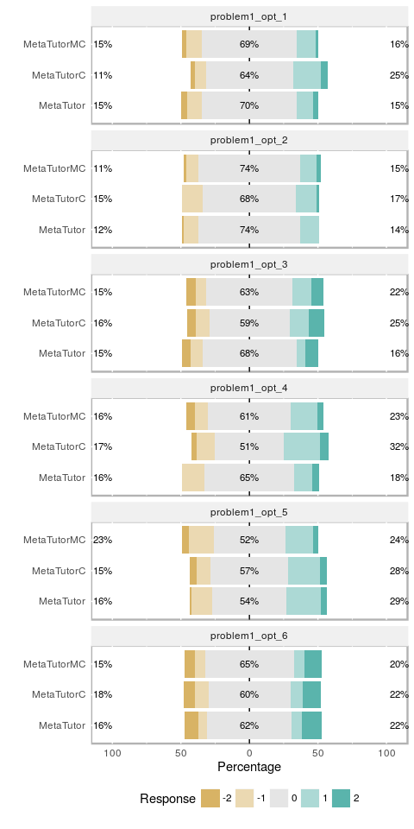

## Saving 5 x 6 in image

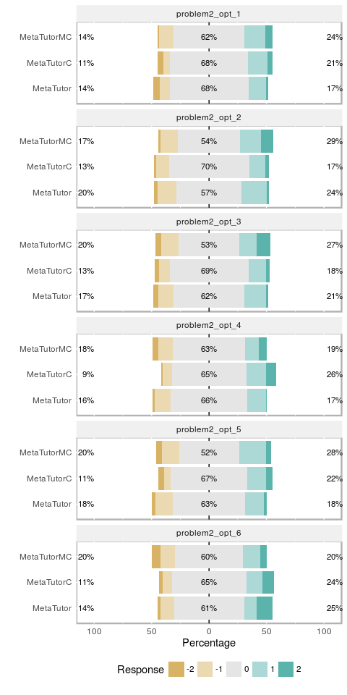

## Saving 5 x 6 in image

## Saving 5 x 9 in image