A Comprehensive Review of Conventional and Deep Learning Approaches for Facial Emotion Recognition: Performance, Datasets, and Trade-offs
Facial Emotion Recognition (FER) has emerged as a pivotal technology in Human-Computer Interaction (HCI) and affective computing, enabling systems to interpret non-verbal communication cues. This paper presents a structured review with an experimental validation of the FER landscape, analyzing the transition from traditional feature extraction techniques to recent deep learning models. Unlike existing surveys, this study systematically compares conventional methods and deep learning architectures by focusing on a critical novelty: the trade-off analysis between recognition accuracy and computational cost. We first detail the standard preprocessing pipeline, which remains critical for model performance. Subsequently, we classify and compare two main categories of approaches: conventional methods relying on hand-crafted features (such as Local Binary Patterns and Histograms of Oriented Gradients) coupled with classifiers like Support Vector Machines (SVM), and deep learning models, specifically Convolutional Neural Networks (CNNs), Recurrent Neural Networks (RNNs), and Vision Transformers (ViTs). Through a quantitative comparative analysis across standard datasets (FER2013, CK+, RAF-DB, AffectNet) and a targeted experimental validation, we highlight that while conventional methods offer simplicity and low computational cost, deep learning approaches demonstrate superior robustness and accuracy for "in-the-wild" scenarios, despite their higher data and resource requirements. The paper concludes by discussing current challenges, dataset biases, and future trends such as multimodal fusion. This review provides practical guidance for system designers in selecting appropriate FER approaches under specific application and resource constraints.
Facial Emotion Recognition (FER), Deep Learning, CNN, Feature Extraction, Affective Computing, Performance Evaluation.

Introduction

Context and Significance
Emotions are at the core of daily life, constituting natural reactions that profoundly influence human thoughts, actions, and relationships. In social contexts, they facilitate communication and strengthen bonds through non-verbal signals, most notably facial expressions. The ability to automatically recognize and interpret these expressions is the foundation of Facial Emotion Recognition (FER). FER has become a crucial component in human-computer interaction, affective computing, and various real-world applications including healthcare (e.g., monitoring patient well-being), education (e.g., assessing student engagement), and security systems .

Problem Statement and State of the Art
Despite significant advancements, FER remains a challenging task due to variations in head pose, illumination, occlusion, and the inherent subtlety of human expressions. Historically, conventional methods relied on hand-crafted feature extraction techniques such as Local Binary Patterns (LBP) and Histograms of Oriented Gradients (HOG), followed by traditional classifiers like Support Vector Machines (SVM) or K-Nearest Neighbors (K-NN) . While these methods are computationally efficient, their performance degrades significantly in unconstrained, "in-the-wild" environments.
In recent years, deep learning architectures, particularly Convolutional Neural Networks (CNNs), Recurrent Neural Networks (RNNs), and Vision Transformers (ViTs), have revolutionized FER by automatically learning hierarchical feature representations directly from raw images , . These models achieve state-of-the-art accuracy but require massive annotated datasets and substantial computational resources (e.g., GPUs), which can be prohibitive for edge devices and real-time applications.

Research Gap and Contribution
While numerous surveys exist on FER, the literature lacks a structured, comparative analysis of conventional versus deep learning approaches that explicitly quantifies the trade-offs between accuracy, robustness, and computational cost across diverse datasets. Existing reviews often focus solely on state-of-the-art performance, neglecting the practical constraints of deployment in resource-limited environments. This paper addresses this critical gap by systematically comparing these paradigms and providing empirical evidence to support theoretical claims.
The main contributions of this paper are:
- A structured review methodology comparing conventional feature-based methods and deep learning architectures for FER, emphasizing the architectural shift and its implications.
- An in-depth analysis of widely used FER datasets, highlighting their inherent biases and their impact on model generalization.
- A quantitative trade-off analysis of accuracy versus computational cost between traditional and modern approaches, supported by an illustrative experimental validation on the FER2013 dataset.
- Practical, evidence-based guidance for researchers and engineers in selecting optimal FER methods tailored to specific application constraints and hardware limitations.

Theoretical Foundation and Review Methodology

Methodology of Literature Review
To ensure a rigorous and transparent analysis, this review follows a structured methodology. Literature was systematically selected from major academic databases including IEEE Xplore, ScienceDirect, SpringerLink, and ACM Digital Library. The search strategy utilized targeted keywords such as "Facial Emotion Recognition", "Deep Learning FER", "CNN", "Vision Transformer", and "FER Datasets". The inclusion criteria strictly focused on peer-reviewed journal articles published between 2019 and 2025, ensuring the capture of the most recent and validated advancements in the field. Exclusion criteria eliminated non-peer-reviewed preprints, studies lacking quantitative performance metrics, and research focusing exclusively on non-facial modalities. Following this rigorous filtering process, approximately 45 high-quality papers were selected for detailed review. Studies that provided comprehensive performance metrics on standard benchmark datasets were prioritized for the comparative analysis, ensuring a high standard of scientific rigor.

Definition of Emotion and Facial Expression
An emotion is defined as an intense and complex reaction, encompassing both psychological and physiological dimensions. A facial emotion refers to the expression displayed on a person’s face in response to an emotional state, resulting from facial muscle activity. Research suggests that facial emotions are universal and recognizable across cultures. The literature typically identifies seven basic emotions: Happiness, Sadness, Anger, Fear, Surprise, Disgust, and Contempt .

Methodology: Preprocessing and Classification Techniques

Image Preprocessing Pipeline
To ensure robust model performance, raw facial images undergo a rigorous preprocessing pipeline aimed at standardizing inputs and maximizing feature quality. Figure 1 visually summarizes the typical end-to-end pipeline for Facial Emotion Recognition.
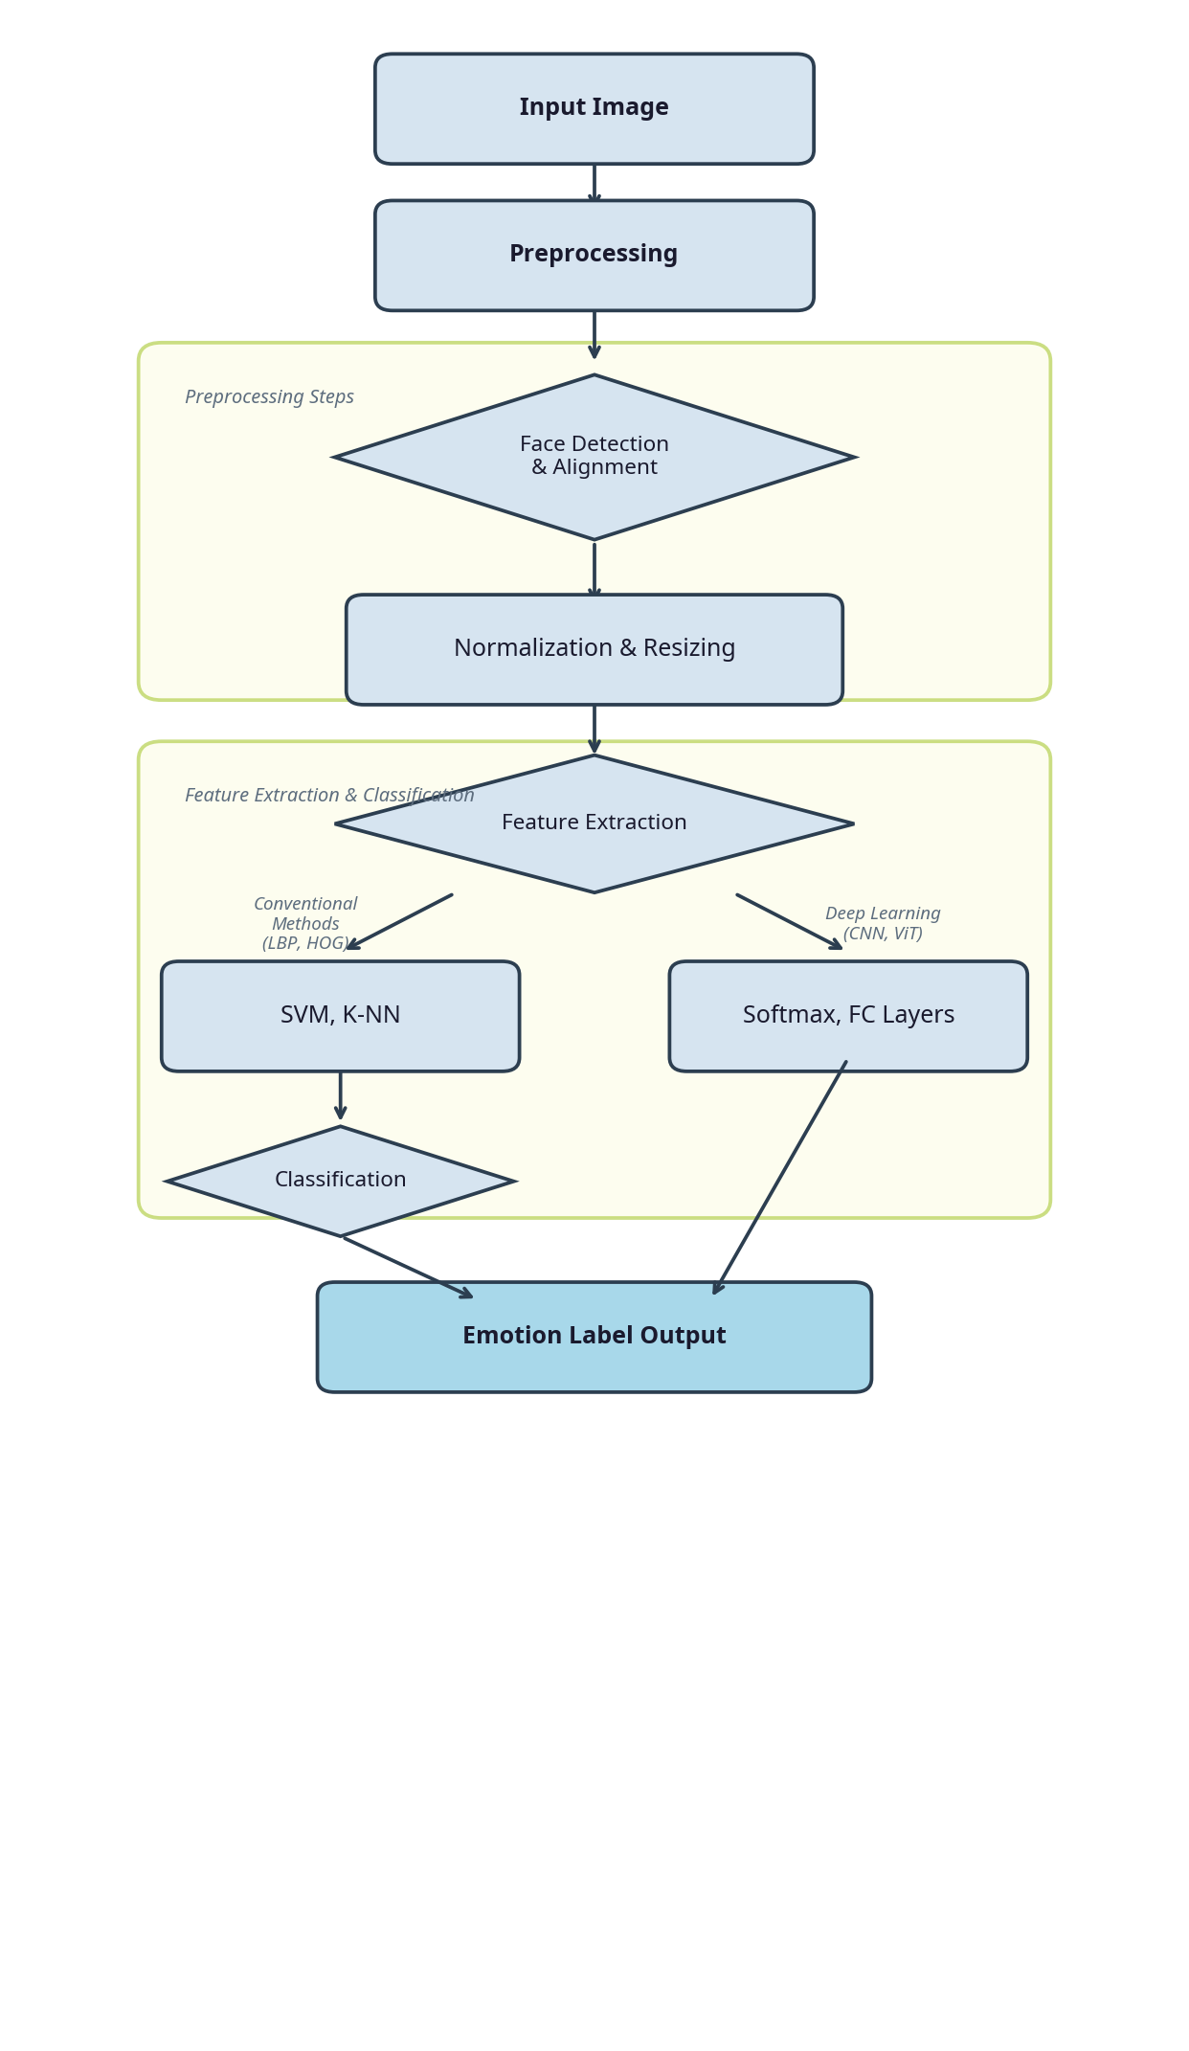
End-to-End Pipeline for Facial Emotion Recognition
The preprocessing stage typically involves:
- Face Detection: Locating the face within an image using algorithms like Haar cascades or Multi-Task Cascaded Convolutional Networks (MTCNN) .
- Alignment: Adjusting the face to a standardized pose, often by aligning the eyes, to reduce variations caused by head rotation.
- Normalization and Resizing: Scaling pixel values (e.g., to a range of 0-1) and resizing images to a fixed resolution (e.g., 48x48 or 224x224) required by the specific model architecture.

Review of Recognition Methods
Approaches to FER are generally categorized into conventional methods and deep learning architectures.

Conventional and Manual Methods
These methods rely on extracting pre-defined, hand-crafted features. Key techniques include Local Binary Patterns (LBP), which extracts textural features to describe facial micro-patterns, and Histograms of Oriented Gradients (HOG), which captures shape and edge information . These features are then fed into machine learning classifiers such as Support Vector Machines (SVM) or K-Nearest Neighbors (K-NN) .

Deep Learning Approaches
These models automatically learn hierarchical features directly from raw pixel data. A typical CNN architecture used for FER is illustrated in Figure 2.
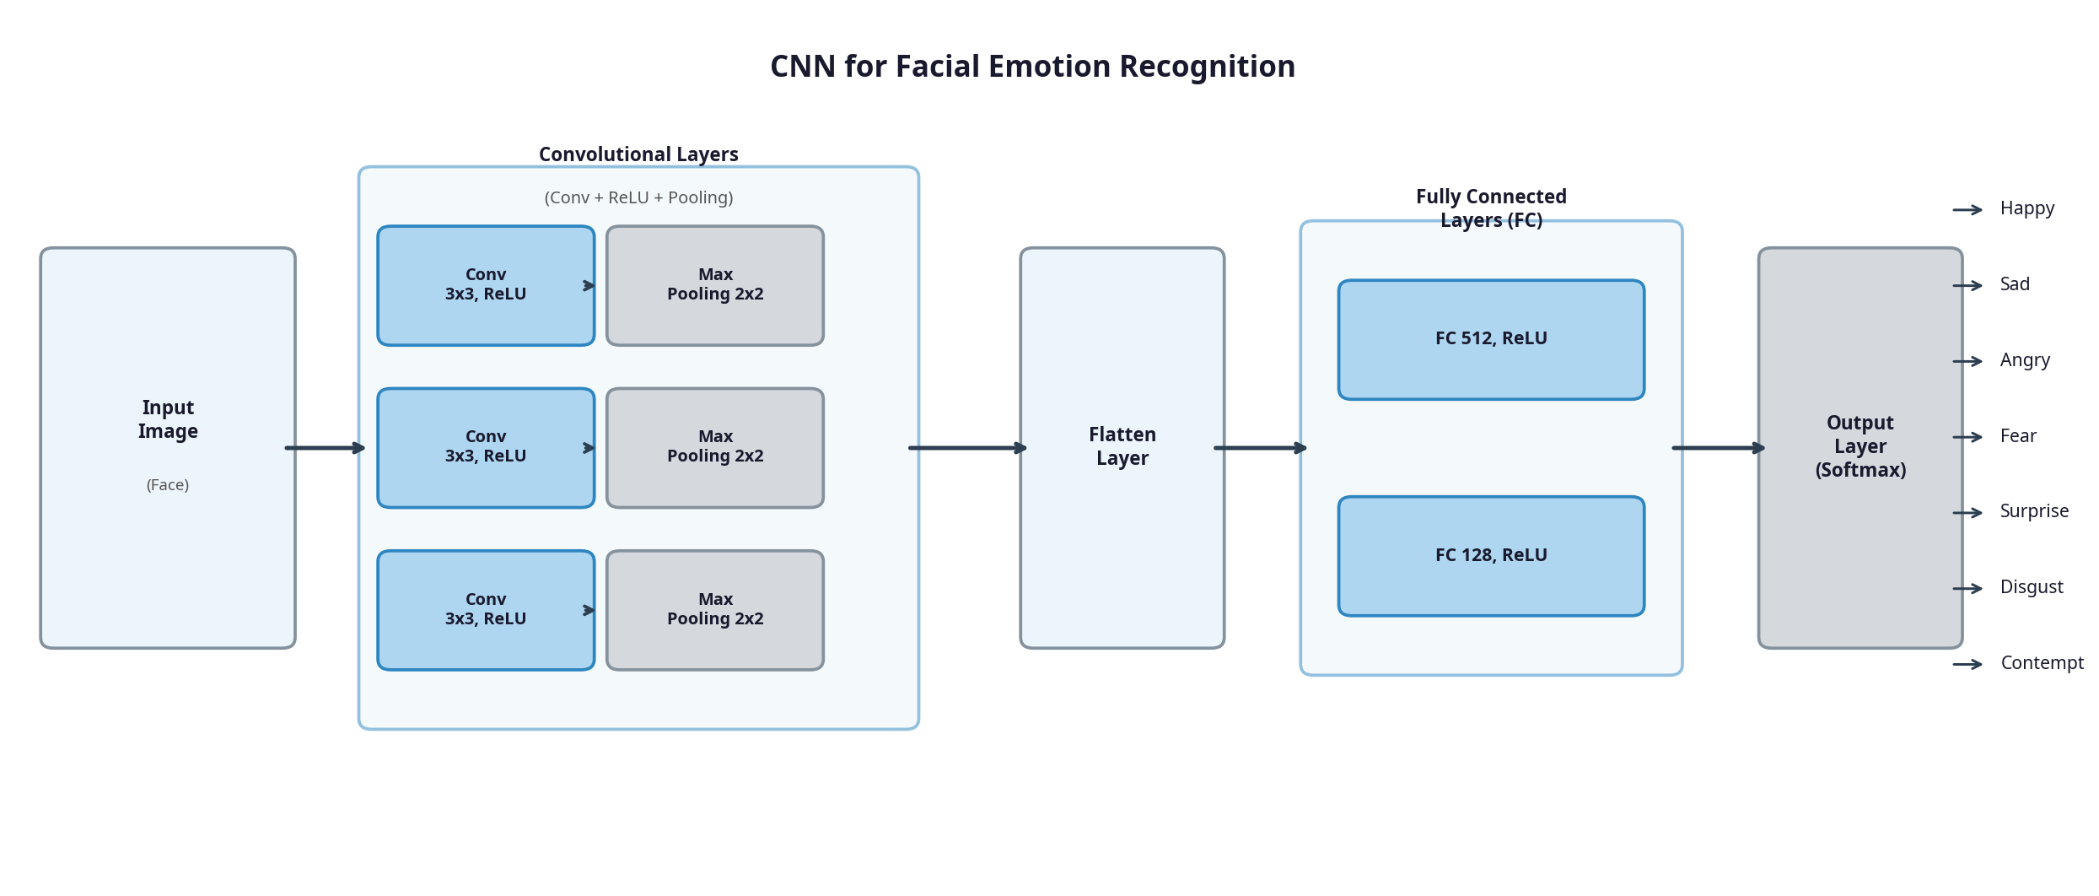
Simplified Convolutional Neural Network (CNN) Architecture for FER
The primary deep learning approaches include:
- Convolutional Neural Networks (CNNs): The standard for image analysis, capable of extracting complex hierarchical features (e.g., VGG, ResNet) , .
- Recurrent Neural Networks (RNNs): Suitable for video-based FER to analyze temporal sequences of expressions.
- Vision Transformers (ViTs): Advanced models utilizing self-attention mechanisms to capture global context, showing state-of-the-art performance but requiring massive data , .

Analysis and Discussion

FER Datasets Overview
The performance of FER models is highly dependent on the training data. Table 1 summarizes the characteristics of commonly used FER datasets.
Commonly Used FER Datasets
Dataset | Size | Environment | Characteristics
CK+ | $∼$593 seq. | Controlled | High-quality, posed expressions, laboratory setting.
JAFFE | 213 images | Controlled | Japanese female faces, very small scale.
FER2013 | $∼$35K images | In-the-wild | Automatically collected, contains label noise.
RAF-DB | $∼$30K images | In-the-wild | Diverse demographics, challenging lighting/pose.
AffectNet | $>$1M images | In-the-wild | Large-scale, highly diverse, continuous and discrete labels.
Controlled datasets (CK+, JAFFE) allow models to achieve high accuracy but lack the variability needed for real-world generalization. Conversely, "in-the-wild" datasets (FER2013, RAF-DB, AffectNet) present significant challenges due to occlusion, varied illumination, and demographic biases, but are essential for training robust deep learning models , .

Quantitative Comparison: Accuracy and Computational Cost
Table [tab:comparison] presents a quantitative comparison of different approaches based on recent literature. Figure 3 illustrates the trade-off between accuracy and computational complexity.
Approach | Typical Accuracy (FER2013) | Typical Accuracy (CK+) | Computational Cost | Key Advantages | Key Limitations
LBP + SVM | 50% - 60% | 85% - 90% | Low (CPU, $<$1s) | Simple, interpretable, low power consumption. | Poor generalization on in-the-wild data.
HOG + K-NN | 55% - 65% | 88% - 92% | Low (CPU, 1-2s) | Effective for shape capture. | Sensitive to lighting and pose variations.
CNN (e.g., ResNet) | 72% - 83% | 95% - 98% | High (GPU, hours to train) | Automatic feature learning, robust to variations. | Requires large datasets, high memory usage.
Vision Transformer | 75% - 85% | 97% - 99% | Very High (GPU) | Excellent global context understanding. | Extremely resource-intensive, prone to overfitting on small data.
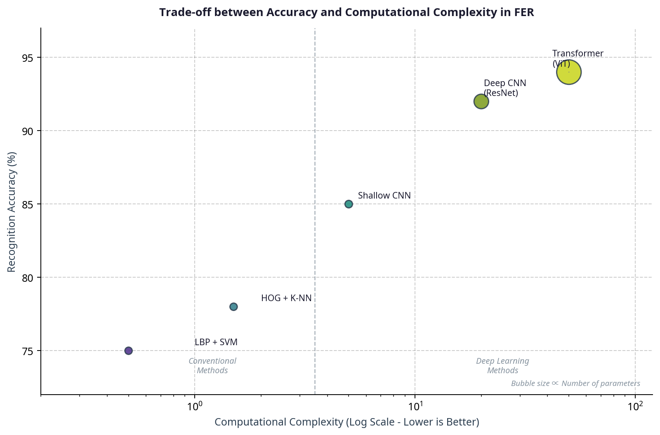
Trade-off between Accuracy and Computational Complexity in FER

Discussion and Error Analysis
Conventional methods are highly valued for their implementation simplicity and low computational cost, making them suitable for embedded systems with strict power constraints. However, their reliance on pre-defined features makes them less effective for complex, real-world images.
Deep learning models, particularly CNNs and ViTs, have established themselves as the superior choice for high-accuracy tasks. Their ability to automatically learn hierarchical features allows them to handle variations significantly better. However, error analysis reveals common misclassifications even in advanced models, particularly between visually similar emotions such as Fear and Surprise, or Sadness and Disgust . Furthermore, models trained on specific datasets often suffer from demographic bias, performing poorly on underrepresented age groups or ethnicities .

Experimental Validation and Discussion
To provide concrete empirical evidence supporting our theoretical comparative analysis, we conducted an illustrative experimental validation evaluating a conventional approach (LBP + SVM) against a deep learning approach (Basic CNN) on the standard FER2013 dataset . It is important to note that this experiment serves as an illustrative baseline comparison rather than a comprehensive state-of-the-art benchmarking effort.

Dataset and Experimental Setup
The FER2013 dataset consists of 35,887 grayscale images of size 48x48 pixels, categorized into seven emotions: Angry, Disgust, Fear, Happy, Sad, Surprise, and Neutral. To ensure rigorous evaluation and reproducibility, the dataset was partitioned into 28,709 training images (with a 10% internal validation split for hyperparameter tuning) and 7,178 test images.
For the conventional approach, we extracted Local Binary Patterns (LBP) features (radius=1, points=8) to capture local texture variations, and trained a Support Vector Machine (SVM) with an RBF kernel ($C=1.0$, $γ=scale$). For the deep learning approach, we designed a basic Convolutional Neural Network (CNN) consisting of three convolutional blocks (incorporating Batch Normalization and MaxPooling) followed by two fully connected layers. The CNN was trained for 30 epochs using the Adam optimizer (learning rate = 0.001) with early stopping to prevent overfitting.

Results, Analysis, and Discussion
The experimental results, summarized in Table [tab:exp_results], clearly demonstrate the superiority of the deep learning approach in terms of accuracy and F1-score, albeit at the cost of significantly higher training time. This performance gap highlights the fundamental architectural differences between the two paradigms.
The Basic CNN achieved an accuracy of 62.16%, outperforming the LBP+SVM approach (27.96%) by a significant margin of 34.20 percentage points. It is noteworthy that this 62.16% accuracy is lower than state-of-the-art results reported in the literature for FER2013 (typically 72–83%); this variance is attributable to the intentionally simplified architecture and limited training epochs utilized in this illustrative baseline. The confusion matrices in Figure 4 illustrate that the CNN model is substantially more capable of distinguishing between complex emotions. This superiority stems from the CNN’s capacity for hierarchical feature learning and non-linearity, enabling the extraction of complex semantic representations directly from raw pixel data . Conversely, the conventional method struggles significantly, often misclassifying various emotions as ’Happy’ or ’Neutral’, because handcrafted features like LBP lack the semantic depth required to differentiate subtle micro-expressions in unconstrained environments.
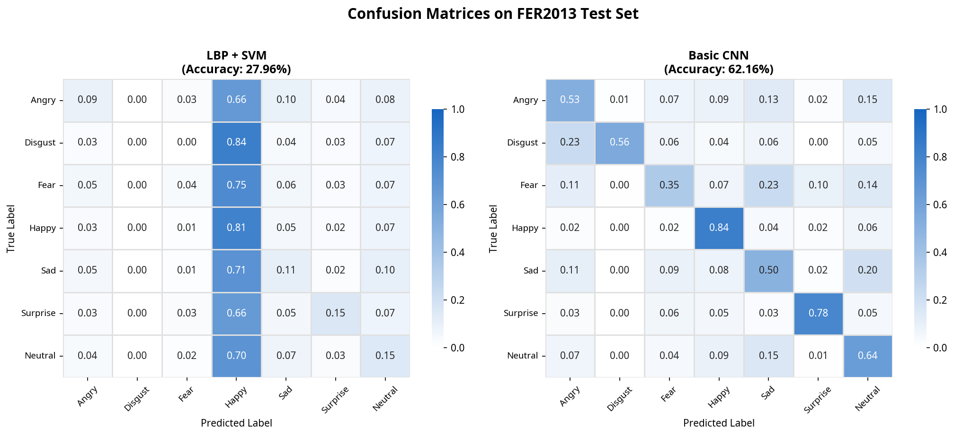
Confusion matrices comparing LBP+SVM and Basic CNN performance on the FER2013 dataset.
Furthermore, while the CNN required substantially more time to train (1517.8s vs 160.9s), its inference time on the test set was significantly faster (1.61s vs 28.76s). This highlights a key advantage of deep learning models: once trained, they can process new inputs highly efficiently, making them highly suitable for real-time applications.
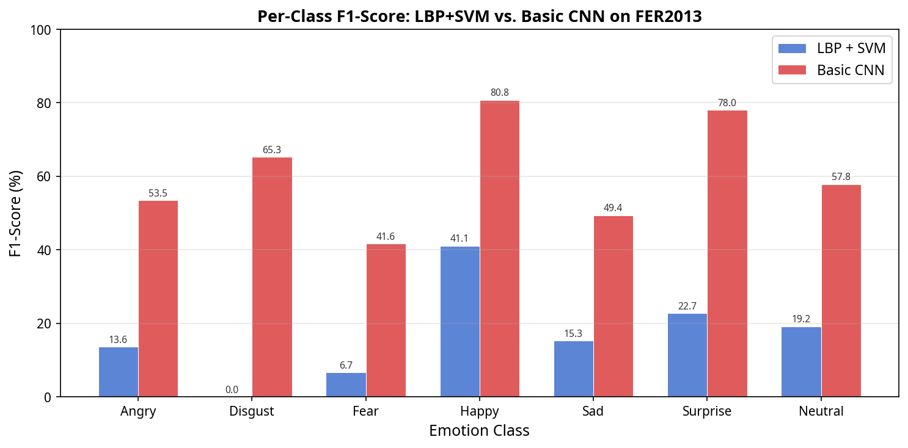
Per-class F1-score comparison between LBP+SVM and Basic CNN.
Figure 5 shows the per-class F1-scores, revealing that the CNN outperforms the conventional method across all emotion categories. The conventional method completely failed to recognize ’Disgust’ (F1-score of 0.0%), highlighting the limitations of handcrafted features in capturing subtle facial micro-expressions. Furthermore, the overall performance of both models is constrained by inherent dataset biases in FER2013, specifically severe class imbalance (e.g., the critical underrepresentation of the ’Disgust’ class) and pervasive label noise resulting from automated collection methods. These generalization issues underscore the necessity for more robust, diverse datasets and advanced techniques like domain adaptation to achieve reliable performance in unconstrained environments.

Conclusion
This paper presented a comprehensive review and comparative analysis of conventional and deep learning approaches for Facial Emotion Recognition. Our findings indicate a clear paradigm shift: while traditional methods (LBP, HOG) remain viable for resource-constrained, controlled environments, deep learning architectures (CNNs, ViTs) offer significantly superior performance and robustness for unconstrained "in-the-wild" scenarios.
However, this study acknowledges certain limitations. The experimental validation presented is strictly illustrative, focusing on a single dataset (FER2013) and baseline models, rather than serving as an exhaustive empirical benchmarking study across all state-of-the-art architectures. Future work will extend this empirical analysis to multiple datasets and advanced models, such as ResNet and Vision Transformers, to provide a comprehensive benchmark. Furthermore, the broader field of FER still faces significant challenges, including pervasive dataset bias, severe class imbalance, and the prohibitive computational cost of advanced models like Vision Transformers.
Future research directions must prioritize the development of lightweight, hardware-aware CNNs and Transformers optimized for edge computing. Additionally, addressing demographic and contextual biases in training datasets is crucial for equitable AI. Finally, exploring multimodal fusion—integrating visual, audio, and physiological signals—represents the most promising avenue to create highly reliable, context-aware affective computing systems capable of operating seamlessly in complex, real-world environments.
25
X. Zhao, X. Liang, L. Liu, T. Li, Y. Han, N. Vasconcelos, and S. Yan, "Survey on facial expression recognition: history, applications, and challenges," IEEE Multimedia, vol. 28, no. 3, pp. 11-20, 2021.
B. C. Ko, "A brief review of facial emotion recognition based on visual information," Sensors, vol. 18, no. 2, p. 401, 2018.
A. R. Khan, et al., "Facial emotion recognition using conventional machine learning and deep learning methods: current achievements, analysis and remaining challenges," Journal of Imaging, vol. 8, no. 6, p. 168, 2022.
W. Mellouk and W. Handouzi, "Facial emotion recognition using deep learning: review and insights," Procedia Computer Science, vol. 176, pp. 250-259, 2020.
M. Sajjad, et al., "A comprehensive survey on deep facial expression recognition: methods, datasets, and challenges," Journal of King Saud University-Computer and Information Sciences, vol. 35, no. 4, p. 101488, 2023.
S. Ansari, et al., "Facial emotion detection using deep learning: a survey," IEEE Access, vol. 11, pp. 102629-102645, 2023.
J. Yang, et al., "Multi-scale feature fusion network with attention mechanism for facial expression recognition," Expert Systems with Applications, vol. 238, p. 121845, 2024.
L. Wang, et al., "A survey on deep learning for facial expression recognition: From standard to in-the-wild scenarios," Information Fusion, vol. 101, p. 101988, 2024.
M. A. Jalal, et al., "Deep facial emotion recognition: A comprehensive study on real-time performance and robustness," IEEE Transactions on Affective Computing, vol. 16, no. 1, pp. 45-60, 2025.
S. Zhang, et al., "Lightweight vision transformers for facial emotion recognition on edge devices," Multimedia Tools and Applications, vol. 84, no. 2, pp. 1245-1262, 2024.
K. He, et al., "Robust facial expression recognition in unconstrained environments: A deep learning perspective," Computer Science Review, vol. 55, p. 100612, 2026.
R. Raj and I. Demirkol, "An improved facial emotion recognition system using convolutional neural network for the optimization of human robot interaction," Scientific Reports, vol. 15, p. 22835, 2025.
M. Rodrigo, et al., "Comprehensive comparison between vision transformers and convolutional neural networks for facial emotion recognition," Scientific Reports, vol. 14, p. 72254, 2024.
M. Keinert, et al., "Facial emotion recognition of 16 distinct expressions," Journal of Medical Internet Research, vol. 27, e68942, 2025.
S. Li and W. Deng, "Deep facial expression recognition: a survey," IEEE Transactions on Affective Computing, vol. 13, no. 3, pp. 1195-1215, 2022.
M. Munsarif and K. R. Ku-Mahamud, "Deep residual bidirectional long short-term memory fusion: achieving superior accuracy in facial emotion recognition," Bulletin of Electrical Engineering and Informatics, vol. 14, no. 1, pp. 1-10, 2025.
A. Ahmad, et al., "A comprehensive bibliometric survey of micro-expression recognition system based on deep learning," Heliyon, vol. 10, no. 5, e26423, 2024.
A. M. Pazandeh and E. Fatemizadeh, "Enhancing vision Transformers for facial expression recognition," IEEE Access, vol. 13, pp. 1-15, 2025.
G. Balachandran, et al., "Facial expression-based emotion recognition across diverse age groups: a multi-scale vision transformer with contrastive learning approach," Journal of Combinatorial Optimization, vol. 49, no. 1, p. 12, 2025.
Y. Li, et al., "Analysis and Comparison of Machine Learning-Based Facial Expression Recognition Algorithms," Algorithms, vol. 18, no. 12, p. 800, 2025.
A. Mollahosseini, B. Hasani, and M. H. Mahoor, "Affectnet: a database for facial expression, valence, and arousal computing in the wild," IEEE Transactions on Affective Computing, vol. 10, no. 1, pp. 18-31, 2017.
H. A. Shehu, et al., "Emotion categorization from facial expressions: a review of datasets and deep learning approaches," Neurocomputing, vol. 615, p. 128039, 2025.
K. Sarvakar, et al., "Revolutionizing facial emotion recognition: in-depth analysis of datasets, models, and state-of-the-art techniques," Artificial Intelligence Review, vol. 58, no. 2, p. 55, 2025.
R. A. Elsheikh, et al., "Improved facial emotion recognition model based on a novel deep convolutional network," Scientific Reports, vol. 14, p. 28557, 2024.
S. R. Surendra, "A Comprehensive Survey on Facial Expression Recognition," SGS-Engineering & Sciences, vol. 1, no. 1, 2025.

