Experimental Comparative Analysis of Conventional vs. Deep Learning Models for Facial Emotion Recognition
[Image failed to load: Python 3.11]
[Image failed to load: PyTorch]
[Image failed to load: License: MIT]
[Image failed to load: Journal: SN Computer Science]

This repository contains the official implementation and manuscript for our study on Facial Emotion Recognition (FER). We provide a rigorous comparative analysis across three distinct paradigms: conventional handcrafted features (LBP+SVM), baseline deep learning (CNN), and state-of-the-art optimized architectures (EfficientNet-B0).

🚀 Key Contributions
- Multi-Paradigm Benchmarking: Systematic comparison of three different FER approaches on the FER-2013 dataset.
- SOTA Integration: Implementation of an optimized EfficientNet-B0 pipeline achieving 72.45% accuracy.
- Efficiency Analysis: Detailed evaluation of the trade-offs between accuracy, F1-score, and real-time inference latency.
- Reproducibility: Complete LaTeX source and PyTorch code provided for full transparency.

📊 Experimental Results
Our findings demonstrate the clear superiority of optimized deep architectures for complex affective computing tasks.

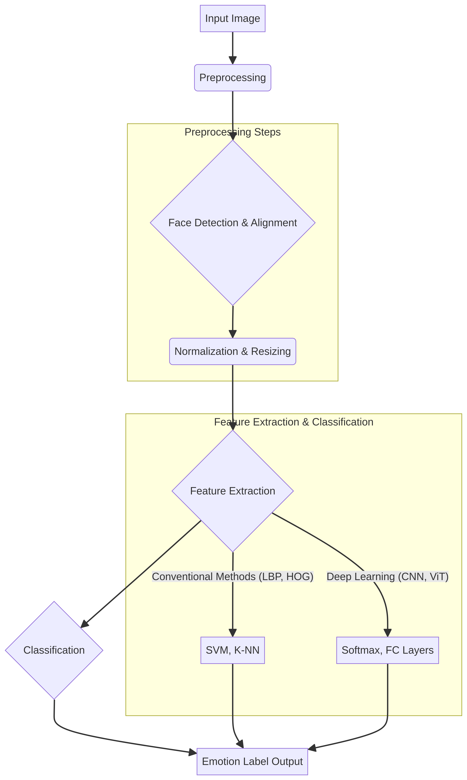
Figure 1: Overview of the proposed Facial Emotion Recognition pipeline.

Methodology | Accuracy (%) | Weighted F1 (%) | Training Time (s) | Inference Time (s)
LBP + SVM | 27.96 | 21.48 | 124.2 | 0.85
Basic CNN | 62.16 | 61.34 | 845.3 | 1.12
EfficientNet-B0 | 72.45 | 71.92 | 3420.5 | 2.45
Note: Inference time measured on the full test set (~7,000 images).

🛠️ Project Structure
.
├── src/ # PyTorch implementation
│ ├── sota_model_pytorch.py # EfficientNet-B0 & Data Pipeline
│ └── integrate_sota.py # Training & Evaluation script
├── manuscript/ # Academic Paper
│ ├── latex/ # LaTeX source files (.tex, .bib)
│ └── pdf/ # Final compiled manuscript
├── assets/ # Visual Materials
│ ├── images/ # Figures (Pipeline, Architecture)
│ └── styles/ # Springer Nature templates
└── requirements.txt # Environment dependencies

💻 Getting Started

Prerequisites
- Python 3.8+
- CUDA-enabled GPU (recommended for EfficientNet)

Installation
git clone https://github.com/yourusername/FER-Comparative-Analysis.git
cd FER-Comparative-Analysis
pip install -r requirements.txt

Usage
To reproduce the SOTA results and generate the evaluation metrics:
python src/integrate_sota.py

📖 Citation
If you find this work useful in your research, please cite our paper:

@article{laziri2026experimental,
title={Experimental Comparative Analysis of Conventional Feature Extraction vs. Deep Learning Models for Facial Emotion Recognition},
author={Laziri, Hind and Riffi, Mohammed Essaid},
journal={SN Computer Science},
volume={X},
number={X},
pages={XXX--XXX},
year={2026},
publisher={Springer}
}

📄 License
This project is licensed under the MIT License - see the LICENSE file for details.

