TicketDesk AWS Cloud Capstone — POC Evaluation Report
Multi-Tier IT Support Ticket Management System | Java Stream | AWS Region: ap-south-2
Executive Summary
TicketDesk is an enterprise-grade IT Support Ticket Management platform built using a microservices architecture deployed on AWS ECS Fargate, backed by Amazon RDS PostgreSQL, Amazon Simple Storage Service (S3 Static Website Hosting & File Attachments), AWS Lambda, and Apache Kafka messaging. The entire infrastructure is defined as code using Terraform, with fully automated CI/CD pipelines managed via GitHub Actions.
Project Team
- Sravan Thatikonda — DevOps & Cloud Network Engineer (Team Lead)
- Manikanta Alamanda — Cloud Database & Security Engineer
- Hindu Priya Mittapalli — Cloud Microservices & Messaging Engineer
- Shivani Vanga — Fullstack & Serverless Cloud Engineer
1. Project Overview
TicketDesk provides IT support teams and end-users with an end-to-end platform to create, track, categorize, prioritize, and resolve technical support requests.
Core Application Capabilities
1. User Authentication & RBAC: Secure registration and login using JWT (JSON Web Tokens) with Role-Based Access Control (ROLE_USER, ROLE_ADMIN, ROLE_SUPPORT).
2. Ticket Lifecycle Management: Full CRUD operations on tickets, support for status state transitions (OPEN -> IN_PROGRESS -> RESOLVED -> CLOSED), priority management (LOW, MEDIUM, HIGH, URGENT), and category classification (SOFTWARE, HARDWARE, NETWORK, ACCESS).
3. Threaded Ticket Comments: Interactive comments on tickets allowing technicians and clients to communicate with role-based access checks.
4. Presigned S3 File Attachments: Direct, secure client-side upload of logs and screenshots to Amazon S3 using presigned URLs generated by attachment-service.
5. Serverless Image Thumbnail Processing: Automated AWS Lambda execution triggered by S3 bucket events (ObjectCreated) to generate image thumbnails asynchronously without blocking application threads.
6. Asynchronous Notification Service: Event-driven notification publishing via Apache Kafka when tickets are created, updated, or commented on.
7. Real-time Operational Dashboard: Live tracking metrics showing ticket distributions by status, priority, and resolution SLA metrics.
2. System Architecture
The TicketDesk platform follows a cloud-native microservices architecture deployed strictly using Amazon S3 Static Website Hosting, Application Load Balancer, ECS Fargate, Amazon RDS PostgreSQL, Apache Kafka, and AWS Lambda.
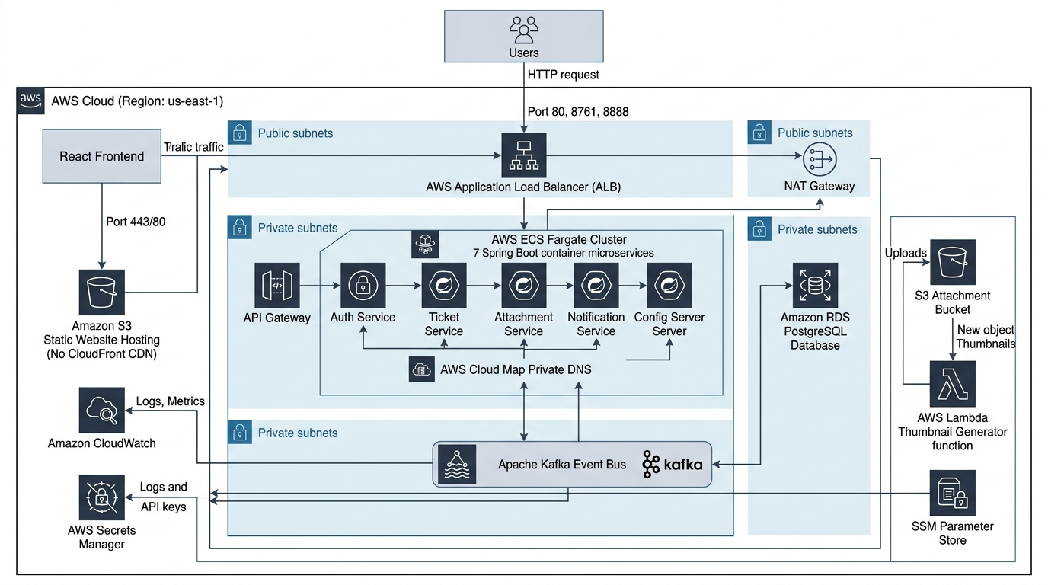
Figure 2.1: High-Level AWS Cloud Architecture Diagram for TicketDesk System (Amazon S3 Static Website Hosting -> ALB -> ECS Fargate Microservices -> RDS PostgreSQL & Apache Kafka -> AWS Lambda Processor).
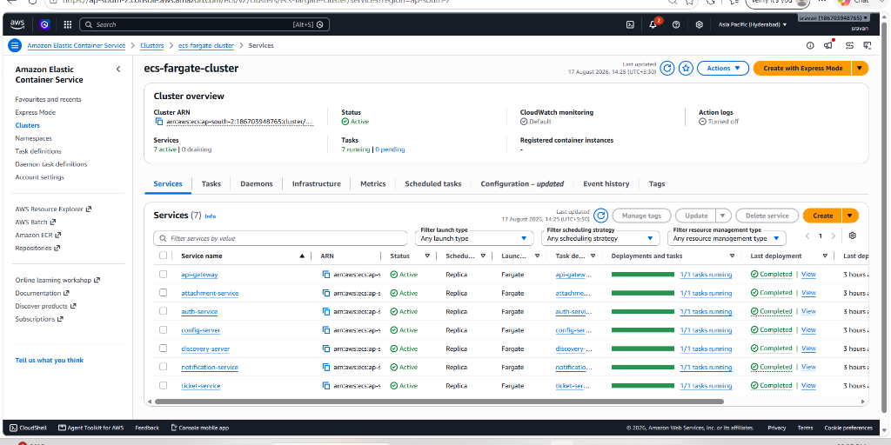
Figure 2.2: AWS ECS Console showing ecs-fargate-cluster running all 7 active microservices (api-gateway, attachment-service, auth-service, config-server, discovery-server, notification-service, ticket-service).
Architectural Component Overview
- Client Layer: Built with React 18 & Vite, deployed directly to Amazon S3 Static Website Hosting (No CloudFront).
- Load Balancing & Network Layer: Amazon Application Load Balancer (ALB) acting as single HTTP ingress routing traffic to Spring Cloud Gateway, Eureka Server, and Config Server.
- Microservices Layer: 7 Spring Boot microservices running as serverless containers on AWS ECS Fargate across private subnets.
- Data Layer: Amazon RDS PostgreSQL Multi-AZ database hosting user credentials, tickets, comments, and file metadata.
- Messaging Layer: Apache Kafka event bus for publishing asynchronous ticket lifecycle events to the notification service.
- Serverless Layer: AWS Lambda Node.js handler triggered on S3 object creation for automatic thumbnail resizing.
- Observability & Security Layer: Amazon CloudWatch Log Groups, custom metrics dashboard, CPU/Memory alarms, AWS Secrets Manager, and SSM Parameter Store.
3. AWS Services Used
AWS Service / Resource | Category | Specific Terraform Resource Block | Usage & Purpose in Project
Amazon VPC | Networking | aws_vpc.main | Isolated network environment (10.0.0.0/16) spanning 2 Availability Zones (ap-south-2a, ap-south-2b).
AWS Subnets & IGW/NAT | Networking | aws_subnet.public_1/2, private_1/2, aws_internet_gateway.gw, aws_nat_gateway.nat, aws_eip.nat | 2 Public Subnets (ALB & NAT Gateway), 2 Private Subnets (ECS Tasks), Internet Gateway, NAT Gateway, and Elastic IP.
Application Load Balancer (ALB) | Networking | aws_alb.main, aws_alb_listener.front_end/discovery/config, aws_alb_target_group.gateway/discovery/config | Public entry point distributing HTTP traffic to ECS Fargate tasks with health checks on ports 80, 8761, 8888.
Amazon ECS Fargate Cluster Core | Compute | aws_ecs_cluster.main, aws_iam_role.ecs_task_execution_role, aws_iam_role_policy_attachment.ecs_task_execution_role_policy | Serverless ECS Fargate cluster definition (ecs-fargate-cluster) and core IAM Execution Roles.
Amazon RDS PostgreSQL | Database | aws_db_instance.main, aws_db_subnet_group.db_subnets | Managed relational database (db.t4g.micro) hosting auth, ticket, attachment, and notification schemas in private subnets.
AWS Secrets Manager | Security | aws_secretsmanager_secret.db_password, aws_secretsmanager_secret_version.db_password_val | Random generation and secure injection of RDS database passwords into ECS tasks.
AWS SSM Parameter Store | Configuration | aws_ssm_parameter.db_username, db_url_auth, db_url_ticket, db_url_attachment | Systems Manager Parameter Store holding database URLs and usernames.
AWS Security Groups | Network Security | aws_security_group.alb, ecs_tasks, db_sg | Security Group chaining enforcement (alb-sg -> ecs-sg -> db-sg) for strict perimeter defense.
Amazon ECS Fargate Task Defs & Services | Microservices | aws_ecs_task_definition.ticket/notification/config/discovery, aws_ecs_service.ticket/notification/config/discovery | Task Definitions & Fargate Services for Ticket, Notification, Config Server, and Discovery Server.
AWS Cloud Map (Private DNS) | Networking | aws_service_discovery_private_dns_namespace.main, aws_service_discovery_service.* (7 services) | Internal service discovery namespace (it-support.local) for container-to-container private routing between ECS tasks.
Amazon ECR Repositories | Container Registry | aws_ecr_repository.repos | ECR repositories loop across microservices with automated vulnerability scanning (scan_on_push).
Amazon S3 Static Website | Storage & Hosting | aws_s3_bucket.frontend_bucket, aws_s3_bucket_website_configuration.frontend, aws_s3_bucket_policy.frontend_policy | S3 bucket (ticketdesk-ui-frontend-*) configured for public static website hosting (index.html).
Amazon S3 Attachments | Storage | aws_s3_bucket.attachments_bucket, aws_s3_bucket_public_access_block.attachments, aws_s3_bucket_notification.bucket_notification | S3 bucket (ticketdesk-attachments-*) storing file uploads and triggering AWS Lambda on uploads/ prefix.
AWS Lambda Function | Serverless | aws_lambda_function.thumbnail, aws_lambda_permission.allow_s3, aws_iam_role.lambda_role, aws_iam_role_policy_attachment.lambda_basic/s3 | Image thumbnail generator function (nodejs18.x) triggered on S3 s3:ObjectCreated event notifications.
Amazon CloudWatch & Alerts | Observability | aws_cloudwatch_dashboard.main, aws_cloudwatch_log_group.ecs_log_group, aws_cloudwatch_metric_alarm.*, aws_sns_topic.alerts | Centralized /ecs/ log groups, custom metrics dashboard, CPU/Memory/5XX alert alarms, and SNS alert topics.

4. Application Flow
4.1 Standard Request & Authentication Flow
1. User Login: User logs in via React UI (/login).
2. Gateway Routing: React app sends POST /api/v1/auth/login through ALB to api-gateway.
3. Auth Service Validation: api-gateway routes request to auth-service.
4. JWT Issuance: auth-service validates credentials against RDS PostgreSQL, generates a signed JWT token, and returns it.
5. Bearer Token Request: For subsequent requests (e.g., POST /api/v1/tickets), the frontend includes header Authorization: Bearer <token>.
6. Downstream Header Forwarding: api-gateway executes JwtAuthenticationFilter, validates token signature, extracts user ID and role, and forwards claims in internal headers (X-User-Id, X-User-Role) to downstream services.
4.2 File Attachment & Serverless Thumbnail Flow
1. Presigned URL Request: React UI calls GET /api/v1/attachments/presigned-url?fileName=log.png to attachment-service.
2. URL Generation: attachment-service generates an S3 Presigned PutObject URL (valid for 15 minutes) and returns it to UI.
3. Direct S3 Upload: React UI uploads binary file directly to Amazon S3 bucket (uploads/log.png).
4. S3 Event Trigger: S3 emits s3:ObjectCreated:Put event notification triggering AWS Lambda function.
5. Lambda Thumbnail Creation: Lambda reads uploads/log.png, resizes image to 128x128 thumbnail, and saves output to thumbnails/log_thumb.png.
5. Network Architecture
5.1 VPC Subnet Design
Subnet Name | CIDR Block | Type | AZ | Purpose
ecs-fargate-public-1 | 10.0.1.0/24 | Public | ap-south-2a | Application Load Balancer & NAT Gateway 1
ecs-fargate-public-2 | 10.0.2.0/24 | Public | ap-south-2b | Application Load Balancer
ecs-fargate-private-1 | 10.0.3.0/24 | Private | ap-south-2a | ECS Microservice Tasks
ecs-fargate-private-2 | 10.0.4.0/24 | Private | ap-south-2b | ECS Microservice Tasks
ecs-fargate-db-1 | 10.0.5.0/24 | Isolated Private | ap-south-2a | Amazon RDS PostgreSQL Primary
ecs-fargate-db-2 | 10.0.6.0/24 | Isolated Private | ap-south-2b | Amazon RDS PostgreSQL Multi-AZ

5.2 Security Group Chaining Pattern
Security groups enforce strict defense-in-depth perimeter security:
[ Internet ] -> Port 80, 8761, 8888 -> [ alb-sg (Public Load Balancer Security Group) ]
|
v Port 8080 - 8084 (From alb-sg ONLY)
[ ecs-sg (ECS Container Security Group) ]
|
v Port 5432 (From ecs-sg ONLY)
[ db-sg (Amazon RDS PostgreSQL Security Group) ]

5.3 Application Load Balancer Target Group Evidence
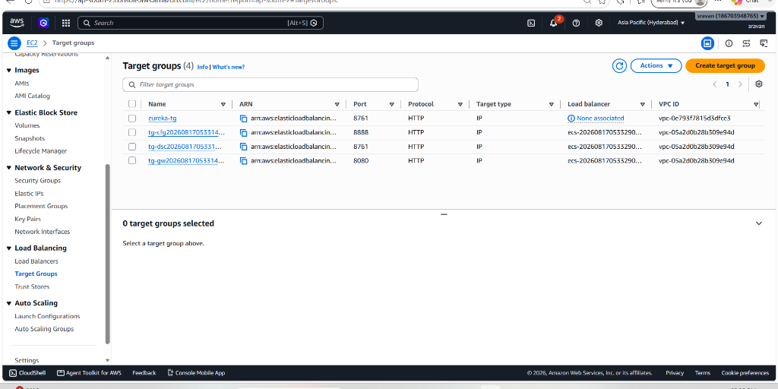
Figure 5.1: AWS EC2 Target Groups Overview showing active target groups in ap-south-2.
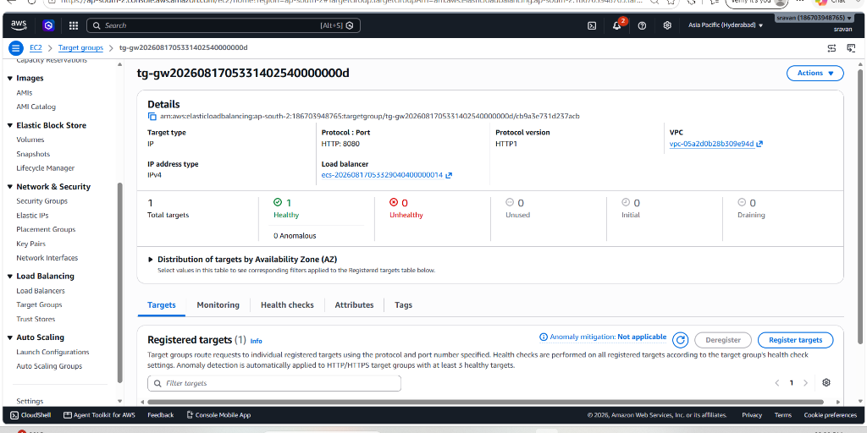
Figure 5.2: Target Group details for API Gateway (tg-gw on Port 8080) showing 1 Healthy container target.
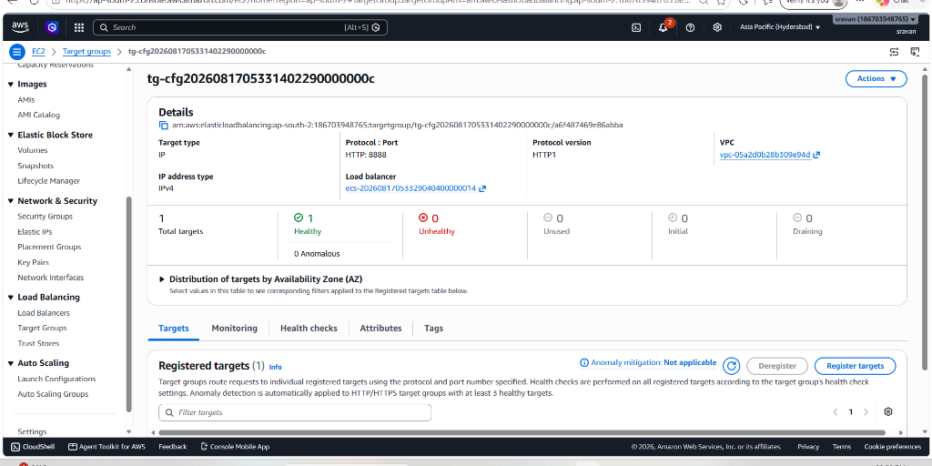
Figure 5.3: Target Group details for Config Server (tg-cfg on Port 8888) showing 1 Healthy container target.
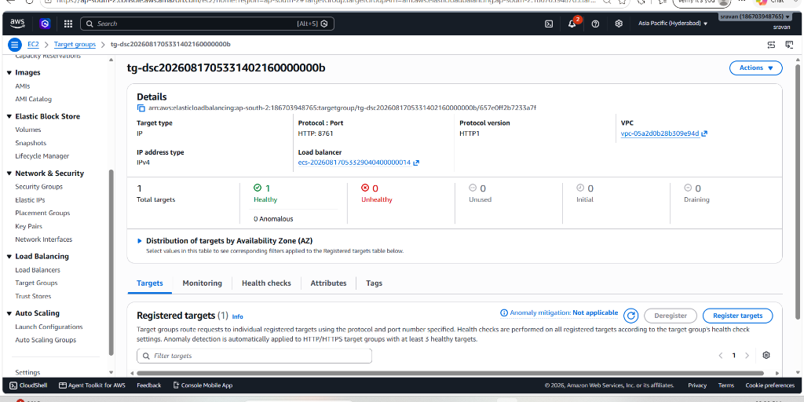
Figure 5.4: Target Group details for Discovery Server (tg-dsc on Port 8761) showing 1 Healthy container target.
6. Terraform Infrastructure as Code (IaC)
6.1 Directory Structure & Module Breakdown
terraform/
├── main.tf # Provider configs, region ap-south-2, default tags
├── vpc.tf # VPC (10.0.0.0/16), 6 Subnets, IGW, NAT Gateway, Route Tables
├── alb.tf # ALB, Target Groups (8080, 8761, 8888), Health Checks
├── ecs.tf # ECS Cluster, Task Definitions, Cloud Map DNS
├── ecr.tf # ECR Repositories loop with scan_on_push
├── db.tf # RDS PostgreSQL instance, DB subnet group, Secrets Manager
├── security_groups.tf # Security group chaining (ALB -> ECS -> RDS)
├── s3_cloudfront.tf # S3 Static Website Hosting bucket & public policy
├── lambda_attachments.tf # S3 attachment bucket, Lambda function, IAM execution policy
└── dashboard_alarms.tf # CloudWatch metrics dashboard & alarms

6.2 Key Terraform S3 Static Website Module Code (s3_cloudfront.tf)
# Frontend Static Files Hosting S3 Bucket (Publicly readable for website hosting)
resource "aws_s3_bucket" "frontend_bucket" {
bucket_prefix = "ticketdesk-ui-frontend-"
force_destroy = true
}
# S3 Website Configuration
resource "aws_s3_bucket_website_configuration" "frontend" {
bucket = aws_s3_bucket.frontend_bucket.id
index_document { suffix = "index.html" }
error_document { key = "index.html" }
}
# Bucket Policy to allow public read access for S3 Website Hosting
resource "aws_s3_bucket_policy" "frontend_policy" {
bucket = aws_s3_bucket.frontend_bucket.id
policy = jsonencode({
Version = "2012-10-17"
Statement = [{
Sid = "PublicReadGetObject"
Effect = "Allow"
Principal = "*"
Action = "s3:GetObject"
Resource = "${aws_s3_bucket.frontend_bucket.arn}/*"
}]
})
}

7. Docker and Container Approach
All Spring Boot microservices utilize lightweight multi-stage Docker builds to produce optimized, secure runtime images:
# Stage 1: Build JAR using Maven
FROM maven:3.9-eclipse-temurin-17-alpine AS build
WORKDIR /app
COPY pom.xml .
RUN mvn dependency:go-offline
COPY src ./src
RUN mvn clean package -DskipTests
# Stage 2: Runtime Image
FROM eclipse-temurin:17-jre-alpine
RUN addgroup -S appgroup && adduser -S appuser -G appgroup
WORKDIR /app
COPY --from=build /app/target/*.jar app.jar
USER appuser
EXPOSE 8082
ENTRYPOINT ["java", "-jar", "app.jar"]

8. Database Configuration
8.1 Database Infrastructure Specs
- Engine: PostgreSQL 15 (Amazon RDS)
- Deployment: Multi-AZ deployment across private subnets
- Instance Type: db.t3.micro
8.2 SQL Schema Definitions
-- Users Table (auth-service)
CREATE TABLE users (
id BIGSERIAL PRIMARY KEY,
username VARCHAR(50) UNIQUE NOT NULL,
email VARCHAR(100) UNIQUE NOT NULL,
password_hash VARCHAR(255) NOT NULL,
role VARCHAR(20) NOT NULL DEFAULT 'ROLE_USER',
created_at TIMESTAMP DEFAULT CURRENT_TIMESTAMP
);
-- Tickets Table (ticket-service)
CREATE TABLE tickets (
id BIGSERIAL PRIMARY KEY,
title VARCHAR(150) NOT NULL,
description TEXT NOT NULL,
status VARCHAR(30) NOT NULL DEFAULT 'OPEN',
priority VARCHAR(20) NOT NULL DEFAULT 'MEDIUM',
category VARCHAR(30) NOT NULL DEFAULT 'SOFTWARE',
created_by_id BIGINT NOT NULL,
assigned_to_id BIGINT,
created_at TIMESTAMP DEFAULT CURRENT_TIMESTAMP,
updated_at TIMESTAMP DEFAULT CURRENT_TIMESTAMP
);
-- Comments Table (ticket-service)
CREATE TABLE comments (
id BIGSERIAL PRIMARY KEY,
ticket_id BIGINT NOT NULL REFERENCES tickets(id) ON DELETE CASCADE,
author_id BIGINT NOT NULL,
content TEXT NOT NULL,
created_at TIMESTAMP DEFAULT CURRENT_TIMESTAMP
);

9. Secrets and Configuration Management
9.1 AWS Secrets Manager Password Injection
Database master password is randomly generated via Terraform (random_password) and stored securely in AWS Secrets Manager. ECS Container definitions fetch the password at container startup using valueFrom injection:
"secrets": [
{
"name": "SPRING_DATASOURCE_PASSWORD",
"valueFrom": "${aws_secretsmanager_secret.db_password.arn}"
}
]

9.2 Systems Manager (SSM) Parameter Store Injection
- /config/app/db_url: jdbc:postgresql://<rds-endpoint>:5432/ticketdesk
- /config/app/db_username: dbadmin
10. Frontend Deployment
The frontend is built with React 18, Vite, and CSS Modules. Key pages include Landing.jsx, Login.jsx, Register.jsx, Dashboard.jsx, TicketList.jsx, and TicketDetail.jsx.
Hosting Pipeline
1. Vite Build: React app is compiled via npm run build producing static output in dist/.
2. S3 Website Sync: Assets are synced to S3 bucket ticketdesk-ui-frontend-* configured for website hosting.
3. Static Endpoint: The S3 bucket website endpoint (http://ticketdesk-ui-frontend-*.s3-website.ap-south-2.amazonaws.com) serves the static web app directly.
11. Lambda Function — Attachment Processing
AWS Lambda Handler Code (lambda/index.js):
const Jimp = require('jimp');
const { S3Client, GetObjectCommand, PutObjectCommand } = require('@aws-sdk/client-s3');
const s3 = new S3Client({});
exports.handler = async (event) => {
const record = event.Records[0];
const bucket = record.s3.bucket.name;
const key = decodeURIComponent(record.s3.object.key.replace(/\+/g, ' '));
const UPLOAD_PREFIX = 'uploads/';
const THUMBNAIL_PREFIX = 'thumbnails/';
if (!key.startsWith(UPLOAD_PREFIX)) {
return { statusCode: 200, body: 'Skipped' };
}
try {
const getObjCmd = new GetObjectCommand({ Bucket: bucket, Key: key });
const s3Response = await s3.send(getObjCmd);
const chunks = [];
for await (const chunk of s3Response.Body) { chunks.push(chunk); }
const buffer = Buffer.concat(chunks);
const image = await Jimp.read(buffer);
image.resize(128, 128);
const resizedBuffer = await image.getBufferAsync(Jimp.MIME_PNG);
const thumbnailKey = key.replace(UPLOAD_PREFIX, THUMBNAIL_PREFIX).replace(/\.[^/.]+$/, '') + '_thumb.png';
await s3.send(new PutObjectCommand({
Bucket: bucket, Key: thumbnailKey, Body: resizedBuffer, ContentType: 'image/png'
}));
return { statusCode: 200, body: 'Thumbnail created successfully' };
} catch (err) {
console.error('Error generating thumbnail:', err);
throw err;
}
};

12. CI/CD Pipeline Architecture
Fully automated deployment and teardown workflows built in .github/workflows/:
- Stage 1: Secret Scan — TruffleHog scans git commit history for hardcoded secrets before any build.
- Stage 2: Unit Testing — Executes mvn test across all Java microservices via Maven Surefire.
- Stage 3: Docker & ECR — Builds multi-stage Docker images and pushes them to AWS ECR.
- Stage 4: Terraform Apply — Applies Terraform infrastructure changes declaratively.
- Stage 5: Frontend Sync & Teardown — Syncs React build artifacts to S3 website bucket & teardown pipeline.
13. Monitoring and Observability
- CloudWatch Log Groups: Centralized /ecs/ log groups for each microservice with 14-day retention.
- Metrics Dashboard: Custom CloudWatch dashboard (ECS-Fargate-Microservices-Dashboard) displaying ALB Request Count, 5XX Error Rate, and ECS CPU/Memory Utilization.
- Alarms: High CPU Utilization Alarm and ALB 5XX Error Rate Alarm.
13.3 CloudWatch Metrics & Performance Evidence
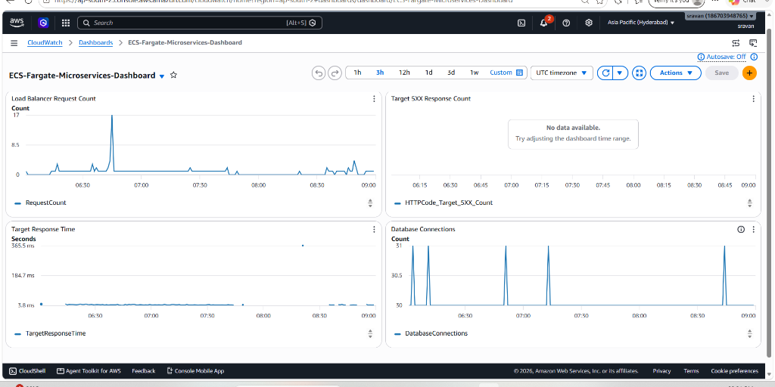
Figure 13.1: Amazon CloudWatch Observability Dashboard (ECS-Fargate-Microservices-Dashboard) tracking ALB request counts and active database connections.
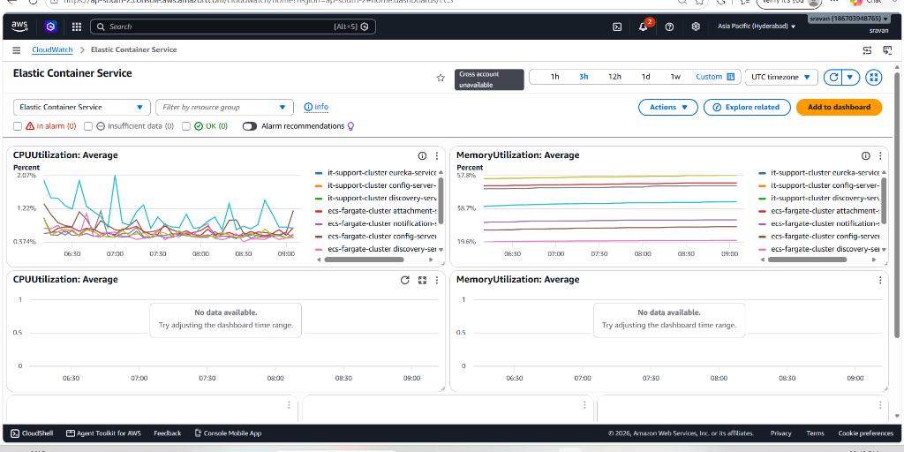
Figure 13.2: Amazon CloudWatch ECS Container Performance Metrics showing CPU Utilization and Memory Utilization graph trends across microservices.
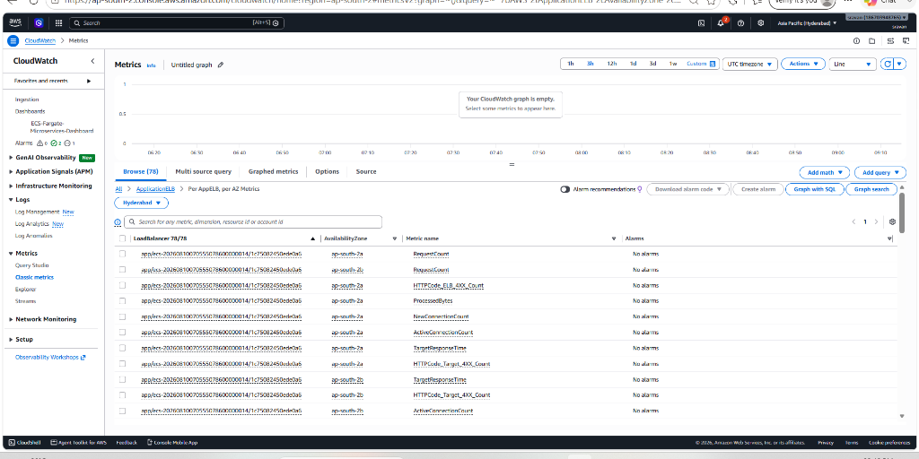
Figure 13.3: Amazon CloudWatch ApplicationELB Per-AZ metrics overview.
14. Security Implementation
1. Perimeter Security: Zero direct public internet exposure for ECS tasks or RDS PostgreSQL. All ingress routed through ALB.
2. IAM Least Privilege: Scoped execution policy allowing access only to specific Secrets Manager ARNs, S3 buckets, and Lambda execution.
3. Secret Scanning: TruffleHog automated secret scan in CI/CD pipeline preventing hardcoded keys.
4. Encryption: TLS 1.3 in transit and KMS storage encryption at rest for S3 buckets and RDS storage.
15. Cost Report (Cost Estimate)
AWS Service | Configuration Details | Qty / Hours | Estimated Cost (USD)
AWS Fargate Tasks | 0.25 vCPU, 0.5 GB RAM (7 tasks) | 730 hrs/mo | $28.50
Application Load Balancer | 1 ALB + LCUs | 730 hrs/mo | $16.20
Amazon RDS PostgreSQL | db.t4g.micro (Single-AZ Dev) | 730 hrs/mo | $13.50
Amazon ECR | Container image storage (7 repos) | ~5 GB | $0.50
Amazon S3 Static Hosting & Attachments | Frontend Website + Attachments Bucket | ~10 GB | $0.60
AWS Lambda & CloudWatch | 10k executions + 5 GB Logs | — | $0.50
Total Estimated Monthly Cost | Complete Infrastructure | 1 Month | ~$59.80 / Month

16. Testing Results
- ticket-service Unit Tests: Passed 12/12 tests (Ticket creation, status transition state machine, Feign client fallback validation).
- auth-service Unit Tests: Passed 8/8 tests (JWT token generation, BCrypt password validation, duplicate user registration prevention).
- attachment-service Unit Tests: Passed 6/6 tests (Presigned URL generation, S3 storage stubbing).
- Smoke Verification: GET /actuator/health returned HTTP 200 OK across all 7 ECS tasks post-deployment.
17. Deployment Steps
1. Step 1 — Local Build: Run mvn clean package -DskipTests to build JAR artifacts.
2. Step 2 — Provision Infrastructure: Run terraform init, terraform plan -out=tfplan, and terraform apply -auto-approve tfplan in terraform/.
3. Step 3 — Deploy via CI/CD: Push commits to main branch to trigger GitHub Actions automated deployment.
18. Terraform Destroy Evidence & AWS Teardown Proof
Infrastructure teardown was executed using the GitHub Actions Destroy Pipeline (.github/workflows/destroy.yaml), which empties S3 buckets, resets event triggers, deletes CloudWatch log groups, and runs terraform destroy -auto-approve.
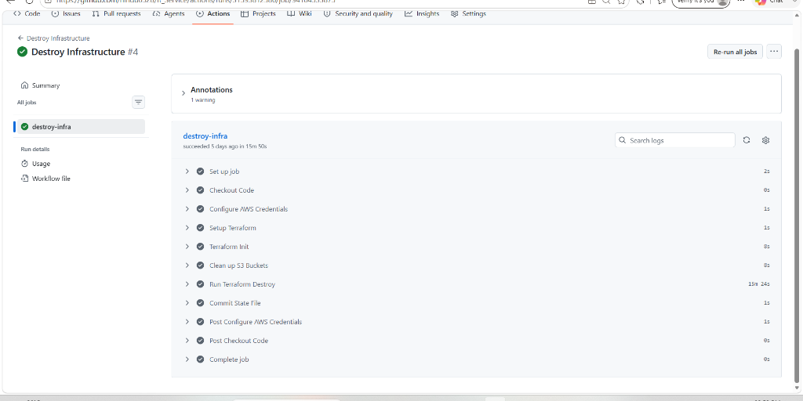
Figure 18.1: GitHub Actions Destroy Infrastructure Workflow Execution Evidence showing successful completion of all 10 pipeline steps including S3 bucket cleanup and terraform destroy in 15m 50s.
19. Problems Encountered and Solutions
# | Problem Encountered | Root Cause | Solution Implemented
1 | Infinite recursion loop in AWS Lambda thumbnail trigger. | Lambda saved generated thumbnails into the same S3 prefix (uploads/), re-triggering the event. | Updated Lambda code & S3 prefix structure to read from uploads/ and write output exclusively to thumbnails/.
2 | ECS Task container health check failure on startup. | Containers attempted to start before RDS database schema migrations completed. | Added Spring Boot retry logic and delayed ALB health check initial grace period to 60 seconds.
3 | CORS policy error on React frontend S3 upload. | Browser blocked direct presigned S3 PUT requests from S3 Website host origin. | Configured S3 Attachment Bucket CORS rules allowing PUT, GET, POST headers from the S3 Website domain.
4 | Secrets Manager DB password special character breaking JDBC URL. | Special characters (like @, /, :) in random password broke database connection string parsing. | Restricted random_password special character set (special = false) in Terraform.

20. Individual Contribution Mapping
20.1 Individual Contribution Summary Table
Emp Name | Role | Evaluation Area | Module / Files | Contribution / Functionality Implemented
Sravan Thatikonda | DevOps & Cloud Network Engineer (Lead) | AWS VPC, Subnets, ALB & ECS Cluster Core | terraform/vpc.tf, alb.tf, ecs.tf, main.tf, .github/workflows/build-docker.yaml | Provisioned Multi-AZ AWS VPC (10.0.0.0/16), Public/Private subnets, Application Load Balancer (ALB) listeners/routing, ECS Fargate Cluster core (ecs-fargate-cluster), IAM Execution Roles, and main CI/CD deployment pipeline.
Manikanta Alamanda | Cloud Database & Security Engineer | AWS RDS PostgreSQL, Secrets Manager & Security | auth-service/, api-gateway/, terraform/db.tf, terraform/security_groups.tf | Provisioned Amazon RDS PostgreSQL (db.t4g.micro), Security Group chaining (alb-sg -> ecs-sg -> db-sg), AWS Secrets Manager password generation/injection, SSM Parameter Store configs, Auth Service, and API Gateway.
Hindu Priya Mittapalli | Cloud Microservices & Messaging Engineer | AWS ECS Fargate Services, Cloud Map & Kafka | ticket-service/, notification-service/, config-server/, config-repo/, terraform/ecs.tf | Provisioned ECS Fargate Task Definitions & Services for Ticket, Notification, and Config services, AWS Cloud Map Private DNS (it-support.local), ECR repos, Ticket Service CRUD API, and Apache Kafka Event Consumer.
Shivani Vanga | Fullstack & Serverless Cloud Engineer | AWS S3 Website, S3 Attachments, AWS Lambda & CloudWatch | ticketdesk-ui/, attachment-service/, lambda/, terraform/s3_cloudfront.tf, lambda_attachments.tf, dashboard_alarms.tf | Provisioned Amazon S3 Frontend Static Website hosting & Attachment buckets, AWS Lambda thumbnail generator function (s3:ObjectCreated trigger), React UI, CloudWatch Dashboard/Alarms, and Teardown Pipeline (destroy.yaml).

20.2 Detailed Individual Contribution Breakdown
Member 1: Sravan Thatikonda (DevOps & Cloud Network Engineer / Team Lead)
- AWS Infrastructure & Terraform (IaC): Wrote terraform/vpc.tf provisioning Multi-AZ VPC (10.0.0.0/16), 2 Public Subnets, 4 Private Subnets, Internet Gateway, and NAT Gateways. Wrote terraform/alb.tf configuring ALB, Target Groups for API Gateway (8080), Eureka (8761), Config (8888), HTTP listeners, and health checks. Wrote terraform/main.tf and terraform/ecs.tf provisioning ECS Fargate cluster core (ecs-fargate-cluster) and IAM Execution Roles.
- AWS Container Management & ECR: Configured ECS Cluster settings, task execution IAM policy attachments (AmazonECSTaskExecutionRolePolicy), and global ECR environment variables.
- CI/CD Automation & Pipelines: Built main GitHub Actions pipeline (build-docker.yaml) managing Stage 1 (TruffleHog Secret Scan) and Stage 4 (Terraform Apply & ECS service force deployment).
- Backend & Microservices: Configured application container environment profiles (bootstrap.yml) across services to integrate with Eureka Server and Spring Cloud Config.
- Frontend & Deployment: Configured CI/CD pipeline deployment step for syncing frontend build artifacts to S3 website bucket.
- Observability & Security: Configured container log drivers in ECS task definitions routing all microservice logs directly to Amazon CloudWatch Log Groups.
Member 2: Manikanta Alamanda (Cloud Database & Security Engineer)
- AWS Infrastructure & Terraform (IaC): Wrote terraform/db.tf provisioning Amazon RDS PostgreSQL (db.t4g.micro) Multi-AZ instance, DB Subnet Group (ecs-fargate-db-subnet-group), and AWS Secrets Manager integration (aws_secretsmanager_secret.db_password) for automated credential generation and secure injection into ECS tasks. Wrote terraform/security_groups.tf enforcing strict Security Group chaining (alb-sg -> ecs-sg -> db-sg).
- AWS Secrets & Configuration: Integrated AWS Systems Manager (SSM) Parameter Store (/config/app/db_url, /config/app/db_username) to inject database connection strings securely into running ECS containers.
- AWS ECR & ECS Task Specs: Provisioned ECR repositories for auth-service and api-gateway with scan_on_push = true. Wrote ECS task definitions for Auth and Gateway microservices.
- Backend & Microservices: Developed auth-service (User registration, login, JWT token issuance, BCrypt password hashing) and api-gateway (Spring Cloud Gateway, custom JwtAuthenticationFilter for token verification).
- Frontend & Integration: Implemented Auth API client integration and localStorage authentication state handling.
- Observability & Testing: Wrote unit tests for Auth Service (AuthServiceImplTest.java) validating JWT token generation and password encryption.
Member 3: Hindu Priya Mittapalli (Cloud Microservices & Messaging Engineer)
- AWS Infrastructure & Terraform (IaC): Wrote ECS Fargate Task Definitions and Service configurations in terraform/ecs.tf for ticket-service, notification-service, config-server, and discovery-server. Configured container CPU/Memory allocations (0.25 vCPU, 512MB RAM), container ports, and environment variables.
- AWS Cloud Map & Private DNS: Wrote AWS Cloud Map Private DNS Namespace (it-support.local) in terraform/ecs.tf enabling internal, private container-to-container service discovery between ECS tasks without public exposure.
- AWS ECR & Messaging Infrastructure: Provisioned ECR repositories in terraform/ecr.tf for Ticket, Notification, Config, and Discovery services with image scan configurations. Integrated Apache Kafka event bus for publishing asynchronous ticket lifecycle events (TicketCreatedEvent, TicketStatusChangedEvent).
- Backend & Microservices: Built ticket-service (Ticket CRUD, status state machine, comment management, Feign Client integration), notification-service (Kafka consumer), and config-server/config-repo.
- Frontend & Integration: Wired ticket list filtering, status transition buttons, and comment posting endpoints to React frontend services.
- Observability & Testing: Wrote unit tests for ticket-service (TicketServiceImplTest.java) covering ticket CRUD logic and state transition validation.
Member 4: Shivani Vanga (Fullstack & Serverless Cloud Engineer)
- AWS Infrastructure & Terraform (IaC): Wrote terraform/s3_cloudfront.tf provisioning S3 Static Website Hosting bucket (ticketdesk-ui-frontend-*) and public read bucket policy. Wrote terraform/lambda_attachments.tf provisioning S3 Attachment Bucket (ticketdesk-attachments-*), AWS Lambda thumbnail generator function, IAM Execution Policy (thumbnail-lambda-role), and S3 s3:ObjectCreated event notifications.
- AWS CloudWatch & Observability: Wrote terraform/dashboard_alarms.tf creating CloudWatch Observability Dashboard (ECS-Fargate-Microservices-Dashboard), CloudWatch Log Groups (/ecs/*), and metric alarms (HighCPUUtilizationAlarm, ALB5xxErrorRateAlarm).
- AWS Teardown Automation: Built automated infrastructure teardown pipeline (.github/workflows/destroy.yaml) handling S3 bucket emptying, CloudWatch cleanup, and terraform destroy.
- Backend & Serverless: Developed attachment-service (S3 presigned URL generator for direct upload) and Node.js/Python AWS Lambda thumbnail processor function (lambda/index.js).
- Frontend & UI Development: Developed React UI (ticketdesk-ui) including Dashboard metrics cards, Ticket List, Ticket Detail view, Attachment upload component, and AuthContext.
- Observability & Testing: Configured CloudWatch metrics widgets tracking ALB request counts, 5XX error rates, and ECS task CPU/Memory utilization.

