DIGITAL WELLBEING ANALYTICS
Analyzing the Relationship Between Digital Habits,
Lifestyle and Student Productivity

IBM SkillsBuild Internship Project Report






Prepared by: Hinduja
September 2026

- Introduction
Digital technology is an important part of student life, but patterns of phone use, social-media consumption, sleep, study time and other lifestyle behaviors may be associated with how students manage their time and maintain focus. This project uses a student productivity and digital distraction dataset to explore these relationships through data analysis and machine-learning techniques.
The project follows an end-to-end workflow across two versions. Version 1 establishes the exploratory and initial modeling foundation, while other section extends the analysis through target forensics, formula-pattern investigation, machine-learning benchmarking, feature engineering, productivity classification and explainable AI.

2. Problem Statement
The objective is to analyze how digital habits and lifestyle variables are associated with student productivity and to determine whether productivity can be modeled from measurable behavioral and wellbeing variables.

3. Objectives
- Examine the distribution of digital-use variables such as phone, social-media, YouTube and gaming hours.
- Study relationships between phone usage, sleep and focus.
- Identify variables most strongly associated with the supplied productivity score.
- Compare lifestyle and academic characteristics across low-, medium- and high-productivity groups.
- Examine the relationship between behavioral variables and final grade.
- Build and evaluate an initial NumPy-based linear regression model.
- Investigate the structure of the supplied productivity score using target forensics.
- Compare multiple regression and classification models using validation metrics.
- Evaluate whether engineered features improve predictive performance.
- Interpret an individual classification using model-based feature contributions.

4. Dataset Description
The analysis uses the Student Productivity & Digital Distraction Dataset from Kaggle. The dataset contains 20,000 student records and 18 variables covering demographics, digital habits, lifestyle factors, academic behavior, focus, stress, final grade and productivity.
Dataset: https://www.kaggle.com/datasets/sehaj1104/student-productivity-and-digital-distraction-dataset
File used in the project: student_productivity_distraction.csv
Category | Variables | Purpose
Digital habits | Phone, social media, YouTube, gaming hours | Measure digital activity
Lifestyle | Sleep, exercise, coffee, breaks | Represent wellbeing/routine
Academic behavior | Study hours, assignments, attendance | Represent academic engagement
Wellbeing | Stress level, focus score | Represent psychological/attention factors
Targets | Productivity score, final grade | Outcome variables

5. Tools and Technologies
- Python
- Pandas
- NumPy
- Matplotlib
- Seaborn
- Scikit-learn
- Jupyter Notebook

6. Methodology
- Load the CSV dataset using Pandas.
- Inspect dimensions, data types, missing values and duplicate records.
- Perform exploratory analysis using distributions and scatter plots.
- Use correlation analysis to identify linear relationships.
- Divide students into Low, Medium and High productivity groups using productivity-score tertiles.
- Compare digital, lifestyle, wellbeing and academic variables across productivity groups.
- Analyze the relationship between the measured variables and final grade.
- Build a NumPy-based multiple linear regression model using an 80/20 train-test split.
- Perform target forensics using six core variables.
- Investigate a simplified mathematical weight pattern.
- Benchmark Linear, Ridge, Random Forest, Gradient Boosting and HistGradient Boosting regression models.
- Create engineered behavioral features and compare them with the original feature set.
- Classify students into Low, Medium and High productivity groups.
- Use Logistic Regression contributions for an explainable individual prediction.

7. Data Quality Assessment
The dataset contains 20,000 records with 18 columns. No missing values and no duplicate rows were found. The observed numerical values fall within plausible ranges for the variables represented. Therefore, no aggressive data-cleaning transformation was required before analysis.
Check | Result | Interpretation
Rows | 20,000 | Large structured dataset
Columns | 18 | Includes digital, lifestyle, academic and outcome variables
Missing values | 0 | No missing-value treatment required
Duplicate rows | 0 | No duplicate records detected

EXPLORATORY & INITIAL ANALYSIS

8. Exploratory Data Analysis

8.1 Digital Usage Distributions
The project examines the distributions of phone usage, social-media hours, YouTube hours and gaming hours. These plots provide an initial view of the range and spread of digital activity in the dataset.

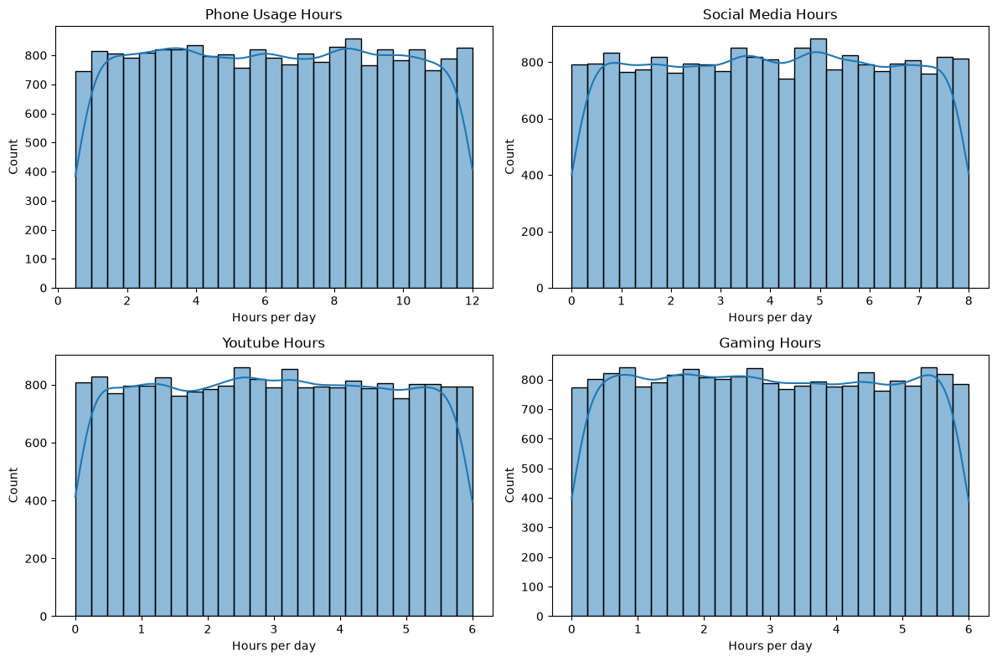Figure 1: Digital Usage Distributions

8.2 Phone Usage vs Sleep
A scatter plot with a fitted regression line is used to examine the relationship between phone usage and sleep hours. The fitted relationship is relatively weak in the supplied dataset.
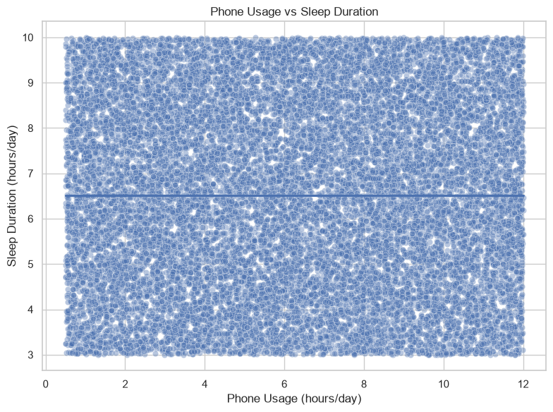
Figure 2: Phone Usage vs Sleep

8.3 Phone Usage vs Focus
Phone usage is compared with focus score to examine whether higher phone use is associated with lower measured focus. The visual relationship is weak, although phone usage has a negative association with the overall productivity score.
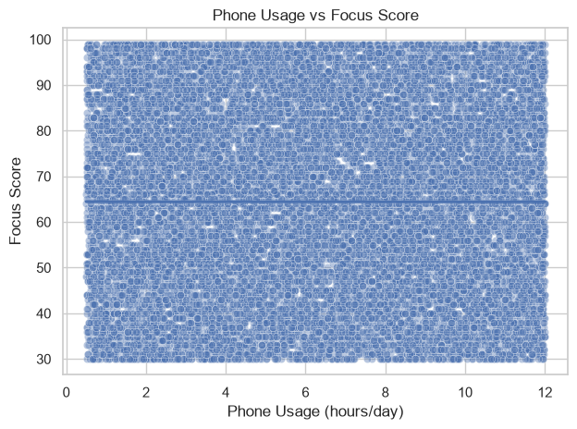
Figure 3: Phone Usage vs Focus

9. Correlation Analysis
Correlation analysis was used to identify linear associations with the supplied productivity score. The strongest positive associations were study hours, focus score, sleep hours and attendance. Phone usage and stress showed negative associations.
Variable | Correlation with productivity
study_hours_per_day | +0.73
focus_score | +0.41
sleep_hours | +0.34
phone_usage_hours | −0.33
stress_level | −0.20
attendance_percentage | +0.18

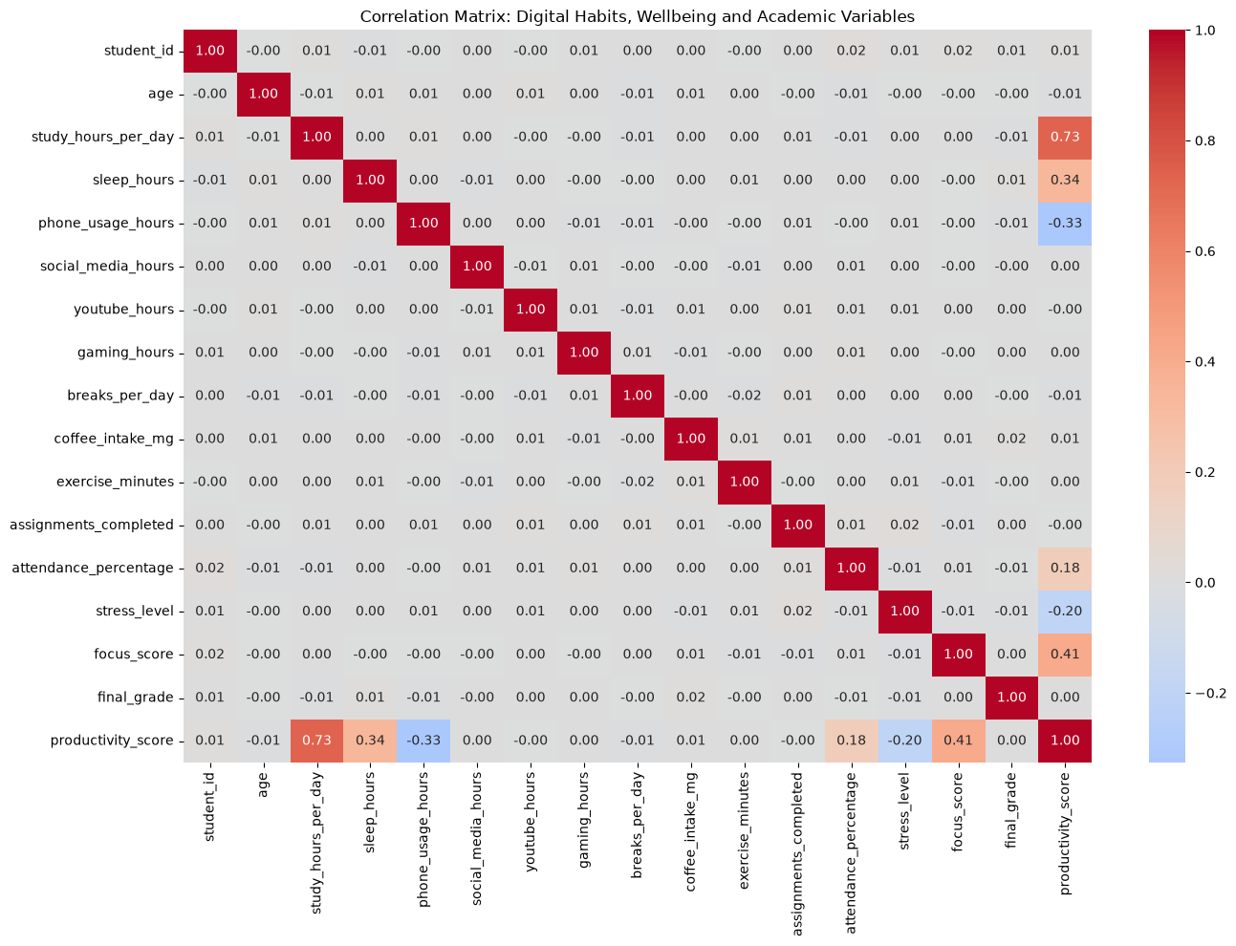Figure 4: Correlation Heatmap

10. Productivity Group Analysis
Students were divided into Low, Medium and High productivity groups using tertiles of the productivity score. The group comparison highlights how study time, sleep, phone use, stress, focus and attendance vary across the groups.
Variable | Low | Medium | High
Study hours/day | 2.92 | 5.27 | 7.57
Sleep hours | 5.79 | 6.53 | 7.24
Phone usage hours | 7.40 | 6.26 | 5.10
Stress level | 6.09 | 5.42 | 4.93
Focus score | 55.78 | 64.22 | 73.34
Attendance % | 66.75 | 70.04 | 73.05
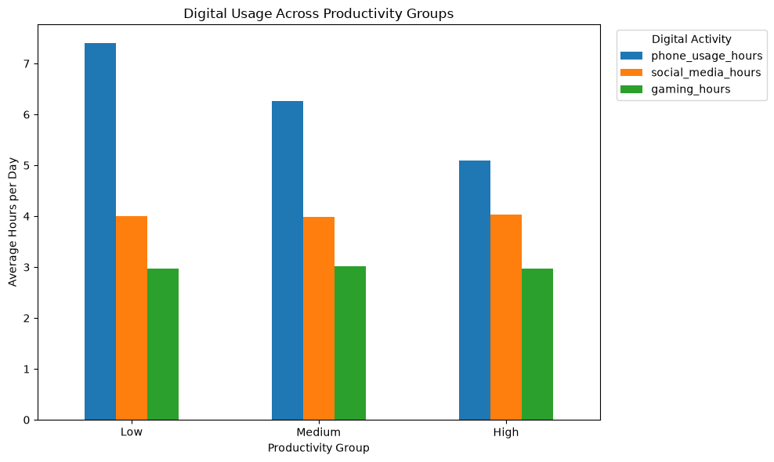
Figure 5: Digital Behavior by Productivity Group
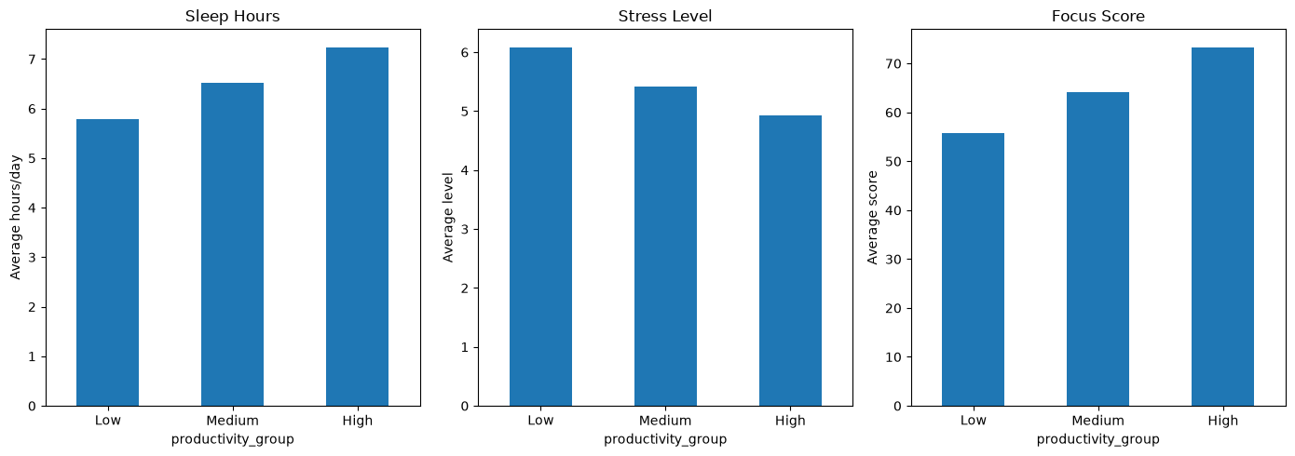

Figure 6: Wellbeing by Productivity Group
.
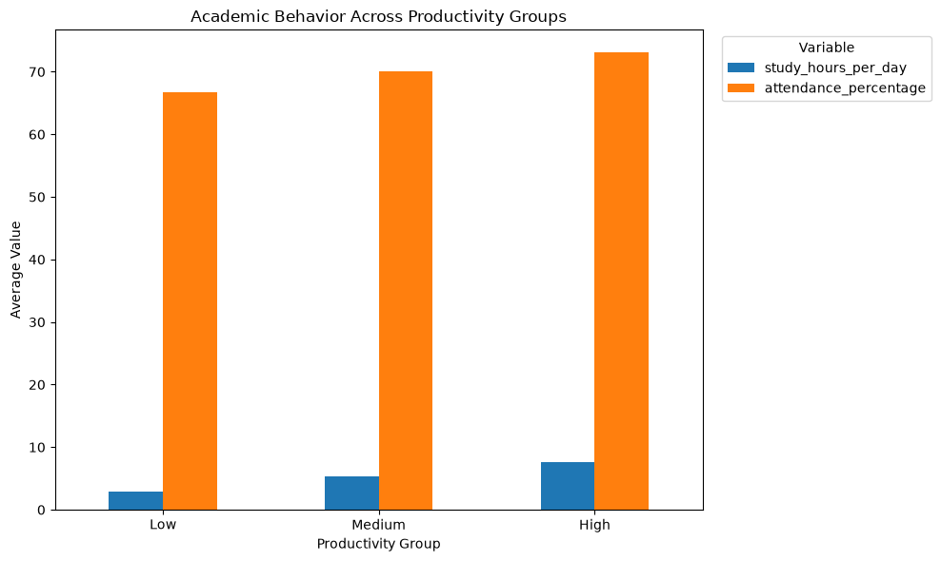Figure 7: Academic Behavior by Productivity Group

11. Digital Behavior Analysis
Phone usage has a moderate negative linear correlation with productivity (approximately −0.33). Social-media, YouTube and gaming hours have negligible linear correlations with productivity in this dataset. Because these variables behave differently, a combined digital-distraction index was not constructed by simply adding them.

12. Final Grade Analysis
The relationship between the measured behavioral/productivity variables and final grade is very weak in the supplied dataset. For example, productivity score has a correlation of approximately 0.002 with final grade. This means the analysis does not support treating the productivity score as a linear predictor of final grade for this dataset.

13. Machine Learning Model
A multiple linear regression model was implemented using NumPy to predict the supplied productivity score. The features included study hours, sleep, phone usage, social media, YouTube, gaming, breaks, coffee intake, exercise, assignments completed, attendance, stress and focus score.
- Train-test split: 80% training and 20% testing
- Random seed: 42
- Feature standardization: training-set mean and standard deviation
- Regression fitting: NumPy least-squares solution using np.linalg.lstsq

13.1 Model Performance
Metric | Result
MAE | 0.003
RMSE | 0.003
R² | 1.000
The near-perfect result should be interpreted cautiously. It likely reflects the highly structured construction of the supplied productivity score rather than evidence of perfect real-world prediction. The model should therefore be understood primarily as a reconstruction of the dataset's measured productivity score.
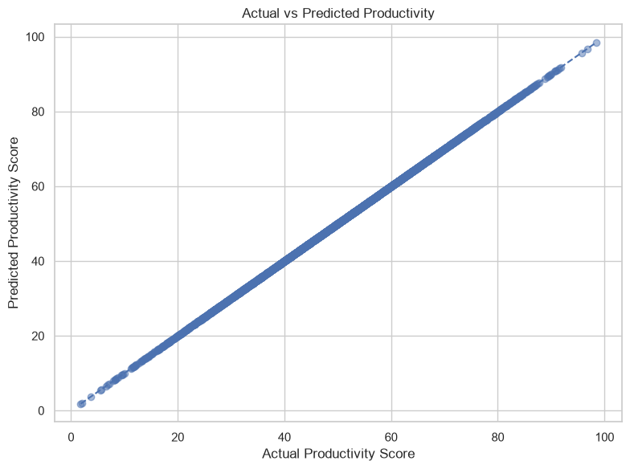Figure 8: Actual vs Predicted Productivity

13.2 Standardized Regression Coefficients
Because the predictors were standardized, the coefficients can be compared on a common scale. The largest positive coefficients are associated with study hours, focus, sleep and attendance, while phone usage and stress have negative coefficients. Several other variables have coefficients close to zero.
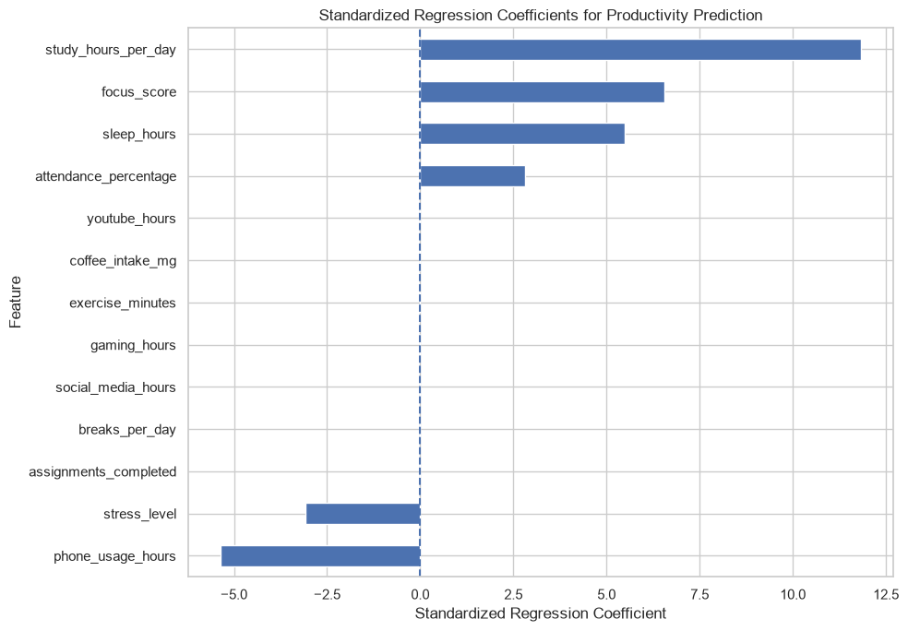Figure 9: Standardized Regression Coefficients

14. Key Findings
- Study hours have the strongest positive linear association with the supplied productivity score.
- Focus score, sleep hours and attendance also show positive associations with productivity.
- Phone usage has a negative association with productivity.
- Higher-productivity groups show higher study hours, sleep, focus and attendance, along with lower phone usage and stress.
- Social media, YouTube and gaming show negligible linear associations with productivity in the supplied dataset.
- The measured behavioral/productivity variables have very weak linear relationships with final grade in this dataset.
- The regression model reconstructs the supplied productivity score with near-zero error, which should be interpreted cautiously.

ADVANCED ANALYSIS
This section extends the exploratory analysis by investigating the structure of the supplied productivity score, benchmarking multiple machine-learning models, testing engineered features, classifying productivity levels and examining model-based feature contributions.

15. Target Forensics
Six variables were selected for target forensics: study hours per day, sleep hours, phone usage hours, attendance percentage, stress level and focus score. A linear model using these six variables produced R² = 0.9999999682, MAE = 0.002487 and RMSE = 0.002869. Removing individual variables substantially reduced the ability to reconstruct the target, especially when study hours were removed.
Feature | Learned coefficient
study_hours_per_day | 4.3163868
sleep_hours | 2.6977480
phone_usage_hours | −1.6186366
attendance_percentage | 0.1618635
stress_level | −1.0790967
focus_score | 0.3237288
Intercept | −6.2387546
The resulting approximate relationship is: Productivity Score ≈ −6.2388 + 4.3164(study hours) + 2.6977(sleep) − 1.6186(phone usage) + 0.1619(attendance) − 1.0791(stress) + 0.3237(focus).
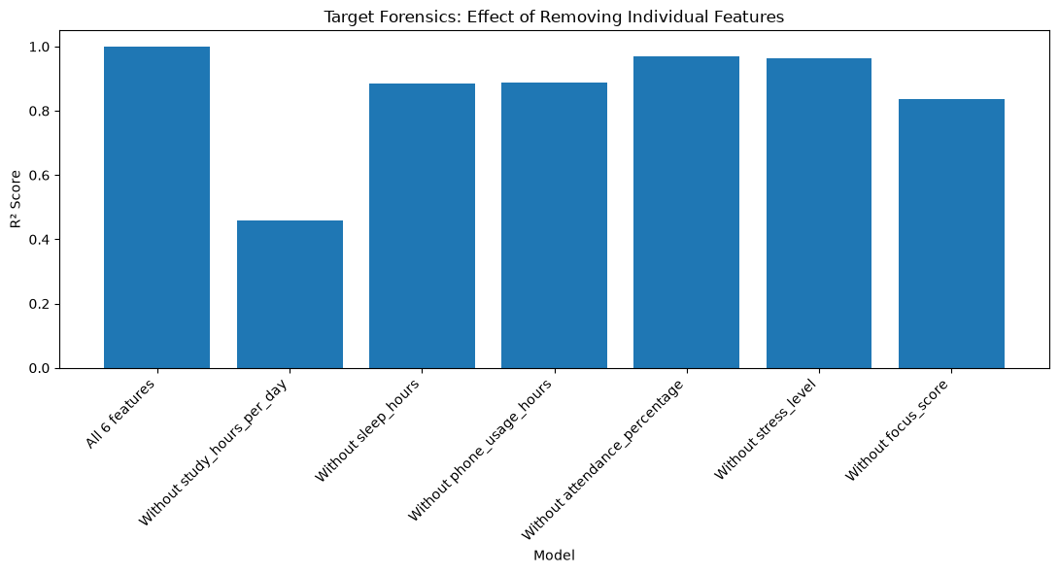
Figure 10: Target Forensics -Effect of Individual Features
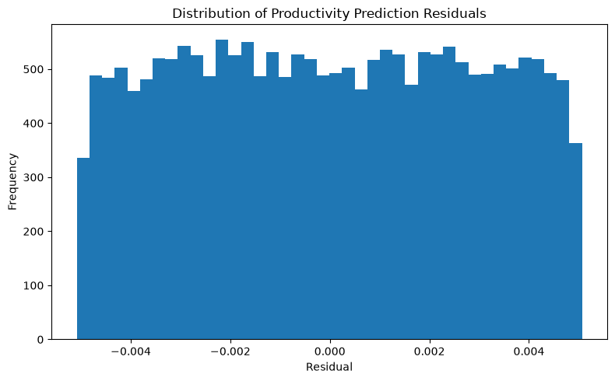Figure 11: Target Forensics — Residual Distribution

16. Hidden Formula Investigation
The learned relative coefficients were compared with a simple tested weight pattern. Relative to attendance, the approximate weights were study = 80/3, sleep = 50/3, phone = −10, attendance = 1, stress = −20/3 and focus = 2.
The simplified tested structure reproduced the supplied target extremely closely, with R² = 0.9999999677, MAE = 0.002499 and RMSE = 0.002892. This provides strong evidence that the target has a highly structured mathematical relationship with the six variables. It does not prove that the dataset creator used the exact tested formula.
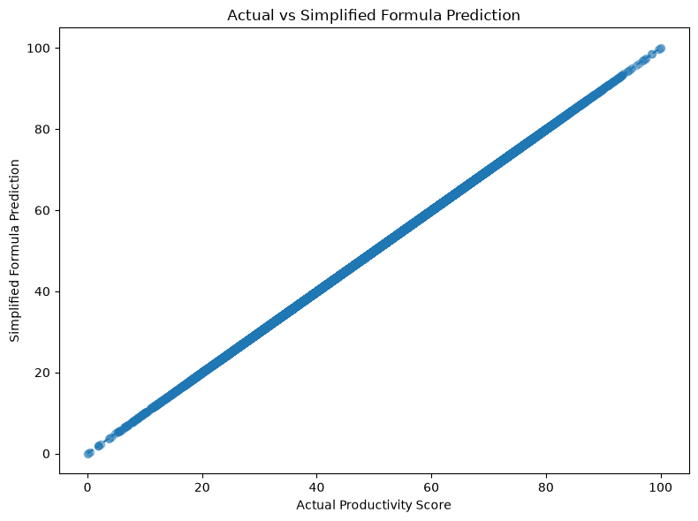
Figure 12: Actual vs Simplified Formula Prediction

17. Machine Learning Benchmark
Five regression models were compared using an 80/20 train-test split and five-fold cross-validation. The purpose was to determine whether more complex nonlinear models provide meaningful improvement over the simple linear structure identified during target forensics.
Model | Test R² | MAE | RMSE | CV R²
Linear Regression | 1.000000 | 0.002484 | 0.002874 | 1.000000
Ridge Regression | 1.000000 | 0.002605 | 0.003063 | 1.000000
Random Forest | 0.982744 | 1.647887 | 2.108304 | 0.982750
Gradient Boosting | 0.993224 | 1.040231 | 1.321107 | 0.993137
HistGradient Boosting | 0.996390 | 0.761361 | 0.964293 | 0.996501
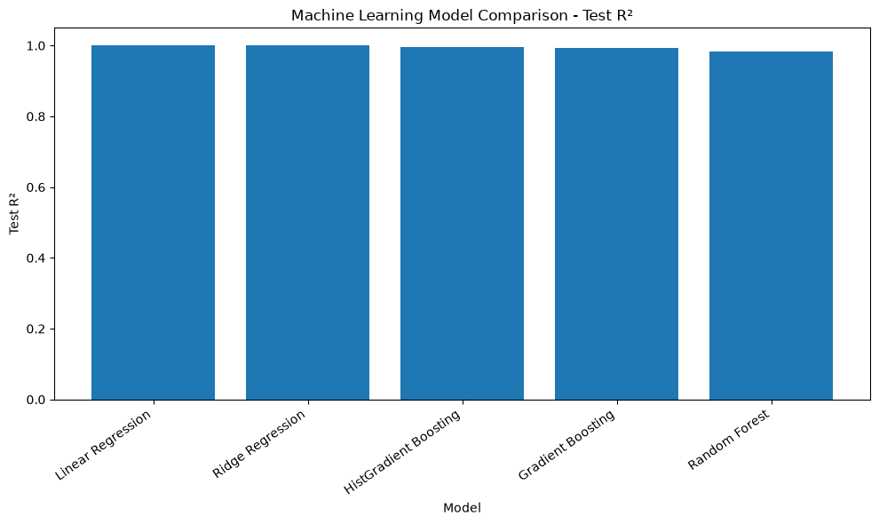Figure 13: ML Model Comparison
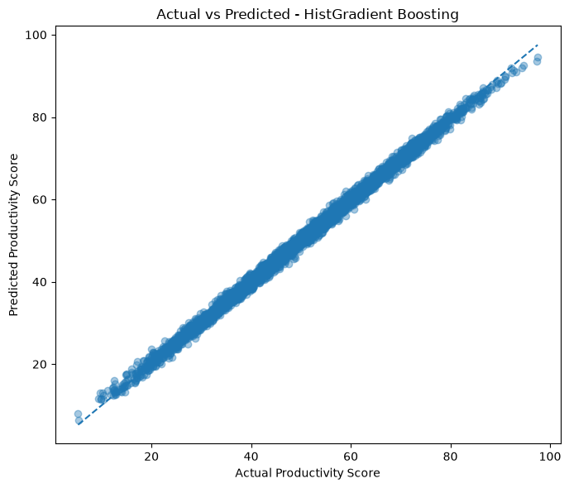
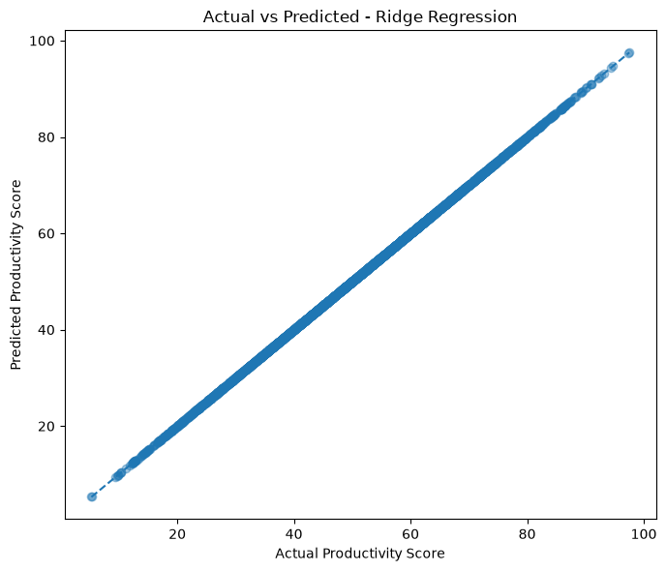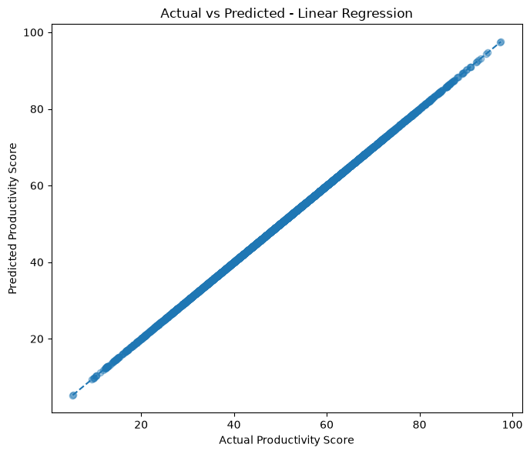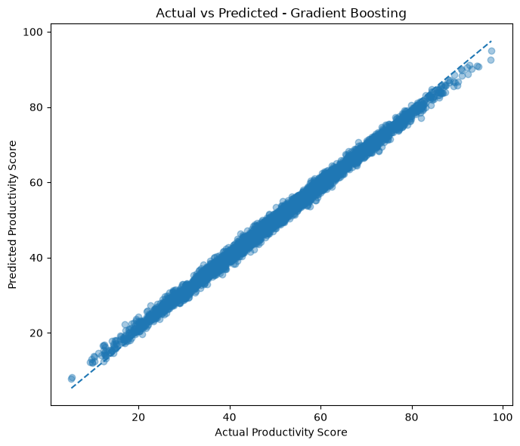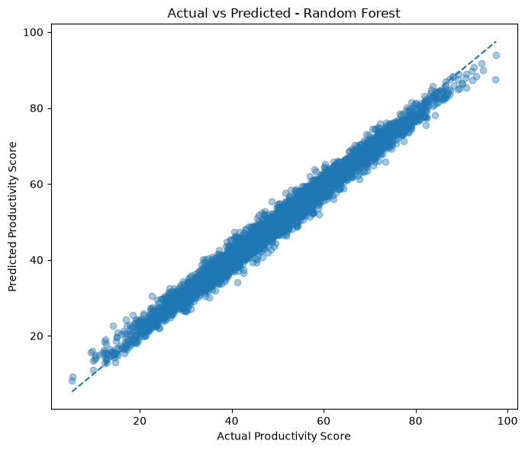
Figure 14: Actual Vs Predicted model plots

18. Feature Engineering

Six derived features were created: phone-to-study ratio, study-to-phone ratio, focus per study hour, sleep-study balance, digital wellbeing balance and study-focus index. The engineered features showed useful descriptive relationships, but adding them to the original six predictors did not provide meaningful predictive improvement. The original six variables already encode the supplied target very strongly.
Feature | Correlation with productivity
study_focus_index | 0.8101
digital_wellbeing_balance | 0.6265
phone_to_study_ratio | −0.5994
study_to_phone_ratio | 0.5061
focus_per_study_hour | −0.3888
sleep_study_balance | −0.3866
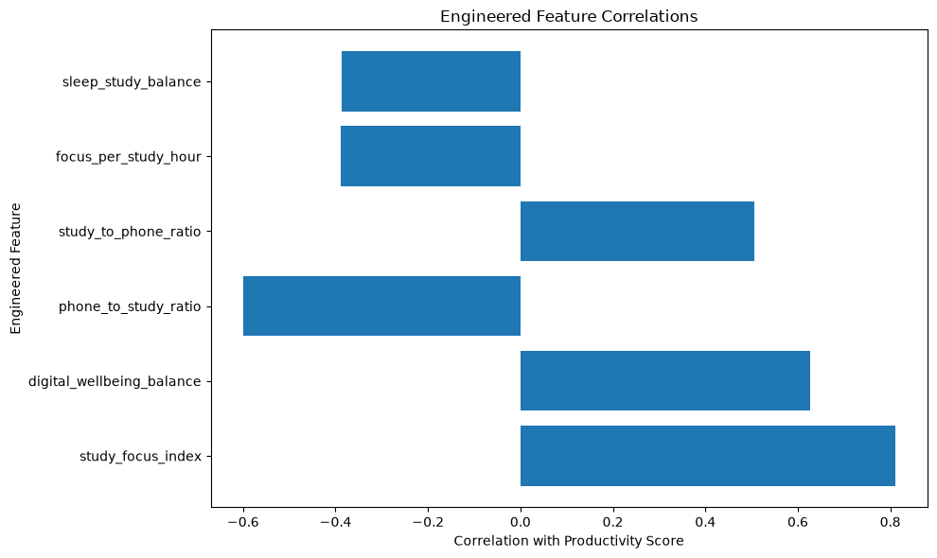Figure 15: Feature Engineering Comparison

19. Productivity Classification
The supplied productivity score was divided into Low, Medium and High groups using tertiles. The resulting distribution was 6,672 Low, 6,664 Medium and 6,664 High records.
Model | Accuracy | Precision | Recall | F1
Logistic Regression | 0.9975 | 0.9975 | 0.9975 | 0.9975
Random Forest | 0.9250 | 0.9259 | 0.9250 | 0.9253
Gradient Boosting | 0.9200 | 0.9226 | 0.9200 | 0.9207
HistGradient Boosting | 0.9517 | 0.9525 | 0.9517 | 0.9520
Because the class labels are derived from the supplied productivity score, these classification results should be understood as reproduction of the dataset's productivity grouping rather than proof of general real-world classification performance.
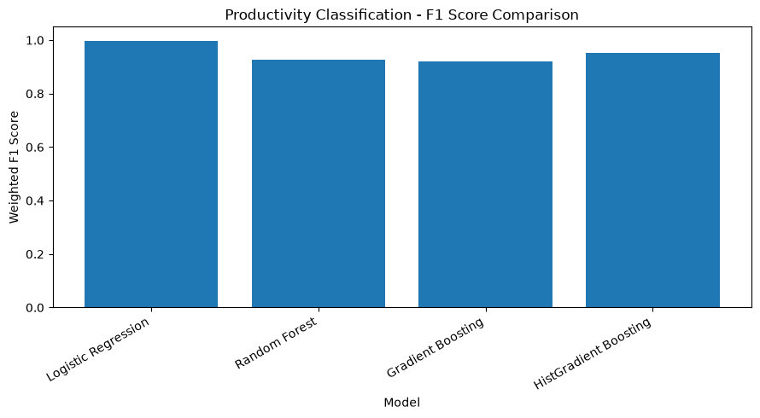
Figure 16: Classification F1 Comparison
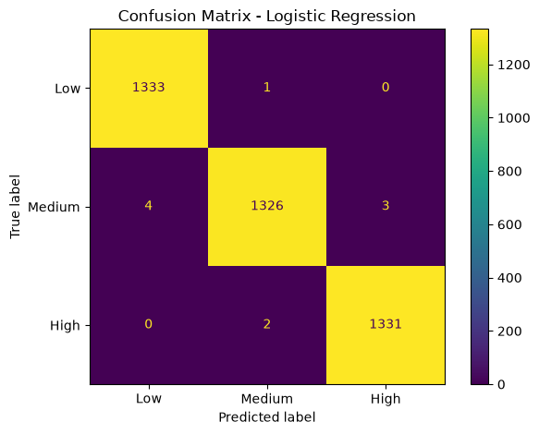
Figure 17: Confusion Matrix (Logistics Regression)

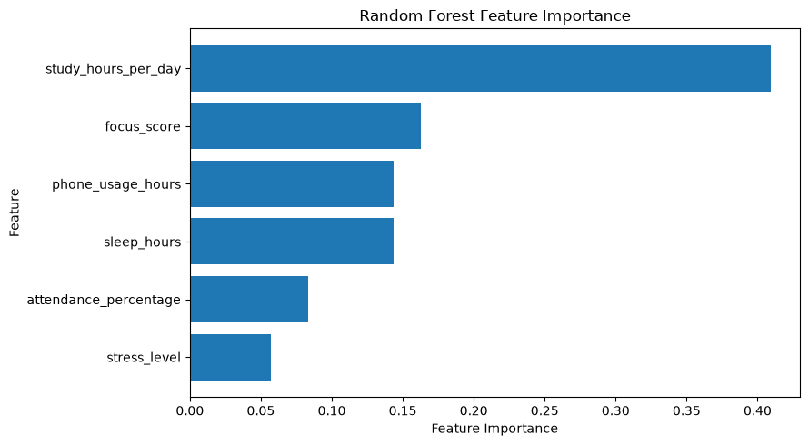Figure 18: Random Forest Feature Importance

20. Explainable AI
A standardized Logistic Regression classifier was used to calculate feature contributions for an example test student. The contributions indicate how the fitted model combines the input variables for a prediction. They represent model behavior and are not causal effects.
For the example student, the actual and predicted class was High. The model contributions toward the High class included positive contributions from study hours, focus and other model terms, while phone usage contributed negatively. The example demonstrates how the classifier combines individual input variables rather than establishing that any variable causes productivity.
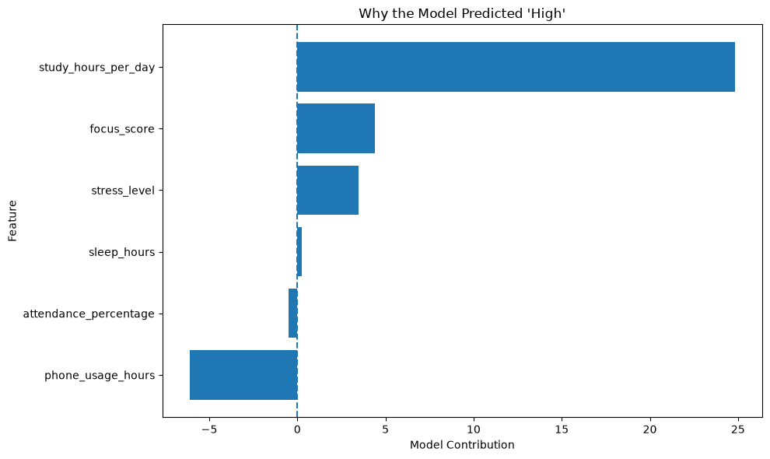Figure 19: Individual Student Prediction / Contributions

21. Integrated Findings
- Study hours, focus, sleep and attendance show positive associations with the supplied productivity score, while phone usage and stress show negative associations.
- The supplied productivity score is almost perfectly reconstructible from six variables in this dataset.
- The tested simple weight pattern closely matches the learned coefficient structure.
- More complex nonlinear regression models do not improve upon the simple linear structure in this experiment.
- Engineered features add essentially no predictive information beyond the original six variables.
- Classification performance is high because the labels are derived from the same highly structured productivity score.
- The productivity score has a very weak linear relationship with final grade in the supplied dataset.

22. Limitations
- Correlation and regression analysis do not establish causation.
- The unusually high predictive performance may reflect the structured construction of the target variable.
- The classification labels are derived from the supplied productivity score.
- The findings are specific to the supplied dataset.
- Independent real-world data are required to assess generalization.
- The empirical formula reconstruction does not prove the original data-generation formula.

23. Conclusion
This project demonstrates an end-to-end data analytics and machine-learning workflow for studying digital habits, lifestyle, wellbeing and student productivity. Version 1 established data-quality assessment, exploratory analysis, visualization, correlation analysis, productivity-group analysis, final-grade analysis and initial regression modeling.
Version 2 added target forensics, formula-pattern investigation, regression benchmarking, feature engineering, classification and explainable AI. The analysis showed that the supplied productivity score is highly structured and nearly perfectly reconstructible from six variables. The findings should therefore be interpreted as dataset-specific mathematical relationships and associations rather than causal evidence or evidence of perfect real-world productivity prediction.

24. Future Scope
- Validate the findings using an independently collected real-world student dataset.
- Investigate nonlinear relationships and interaction effects on an independent dataset.
- Assess whether additional variables improve generalization.
- Explore more robust explainability methods on independently validated models.
- Extend the analysis to longitudinal student behavior data.

25. Project Files
- Digital_Wellbeing_Analytics.ipynb — final notebook.
- README.md — combined project overview and execution instructions.
- requirements.txt — combined Python libraries required to run both versions.
- student_productivity_distraction.csv — dataset used for analysis.
- Digital_Wellbeing_Analytics_FINAL_Report.docx — project report.

26. Dataset Reference
Student Productivity & Digital Distraction Dataset — Kaggle
https://www.kaggle.com/datasets/sehaj1104/student-productivity-and-digital-distraction-dataset

