**Career Ladders**

**Overview**

The concept of career ladders is to provide process and direction for employees to plan their future in the company. This document will provide the various career paths where opportunities will arise and the process and eligibility criteria to govern it.

**Principles of Career Ladders**

Career ladders are career progression paths that outline the skills and competencies required for each job level within a job family.HTL has identified general characteristics that define each level, consistent throughout the company

The concept of career growth is not just promotion! It is driven on the principles and represents GROW:

a) G = Goal: What do YOU want?  
b) R - Reality: Where are YOU now?  
c) O - Options: What could YOU do?  
e) W - Will: What will YOU do?

At the entry level, an employee’s key focus is on developing technical competence. Almost for the first five years of one’s career it is expected that the employee will develop and demonstrate his/her technical expertise. Post this period, often the job entails providing guidance to other juniors and helping Management in supervision of juniors. As the natural progression evolves, focus shifts to assuming more managerial job content and the shift from technical expertise becomes evident.

The principle of Natural Career Progression illustrated:

Technical Skill

Managerial Skill

Jr Management (5 yrs experience)

Ex Management (20+ yrs experience)

Mid to Sr. Management (10 yrs experience)

**There are three main Career Ladder goals:**

* To help employees better understand career growth opportunities
* To provide managers with a tool to guide employees in their skill development and to use in promotion and development discussions with their direct reports
* To provide the organization with consistent guidelines and expectations for job levels to assist with organizational design and workforce planning

**Benefits of Career Ladders**

***Compensation*** – ensures alignment to same levels used in competitive compensation benchmarking and consistent, market-based pay

***Internal Equity*** – promotes consistency among peers in job levels and pay for skill sets

***Performance Management*** - provides a tool for promotion readiness discussions

***Employee Development*** – clarifies job opportunities to an employee’s current role

***Defined Organizational Structure*** – enables leaders to rationalize and communicate the appropriate structure for their organizations

***Role Definition*** – clarifies established roles within HTL; ensures consistency and reduces levelling issues

**Career Path Descriptors and Job Matching Framework**

There are 3 Career Paths that are present in the HTL job matching framework. These 3 broad career paths will encompass different grades & job families that are present in the Hi-Tech industry. A brief description of these 3 paths is given below:

**A. Individual Contributor (IC) Career Path:**

These are roles where the incumbents are professionally qualified and have exercised the option to progress in the individual career path. Though they have chosen the individual career path, roles at certain levels may be responsible for managing a few people. However the primary responsibility of these roles would be to contribute as subject matter experts in their chosen area of specialization.

E.g.: Technology Architects, Technology Subject Matter Experts.

**B. People Management (PM) Career Path:**

These are roles where the incumbents are professionally qualified and have responsibilities to manage people, allocate work, conduct performance appraisals, build capability within the team etc. Certain roles in this level will have P/L

***C. Enabling Functions (EF) Career Path:***

*Typically functions like HR, Admin, Finance, IT Help desk would have roles in these levels. These are roles where the career progression is not available in most situations.*

**Career Ladder Structure & Job Matching**

**Individual Contributor (M3)**

**Individual Contributor (M2)**

**Individual Contributor (M1)**

**Individual Contributor (L2)**

**Individual Contributor (L1)**

**Managerial (M3)**

**Managerial (M2)**

**Managerial (M1)**

**Managerial (L2)**

**Managerial (L1)**

**Individual Contributor (A2)**

**Individual Contributor (A1,GET)**

**SVP/VP (E3, E2)**

**Chief Executive Officer (EX)**

**Managerial (E1)**

**Architect/SME**

**Managerial Track**

**Career Ladder Job – Specific Criteria**

*Career Levelling Guide – Evolution within a level:*

|  |  |  |  |  |
| --- | --- | --- | --- | --- |
|  |  |  |  |  |
|  | **PROFESSIONAL 1** | **PROFESSIONAL 2** | **PROFESSIONAL 3** | **PROFESSIONAL 4** |
| **Title:** | **PES / DE / PDEL 1** | | | |
| **Career Level** | Basic | Practitioner | Experienced | Expert |
| **Type of Role** | ~ Engineers who are in an early career stage as an individual contributor and are developing their general knowledge and skills | ~ Engineers who apply their knowledge, skills, and abilities to projects in their technical field and who are building a professional reputation within the PES BU | ~ Experienced engineers with a solid understanding of one or more technical fields and have built a strong reputation within the PES BU | ~ Engineers who demonstrate a full competency and comprehensive knowledge of one or more technical fields ~ Represents the full professional career level for some engineers |
|  |  |  | ~ May represent a career level for some |  |

*Career Levelling Guide within a Track*

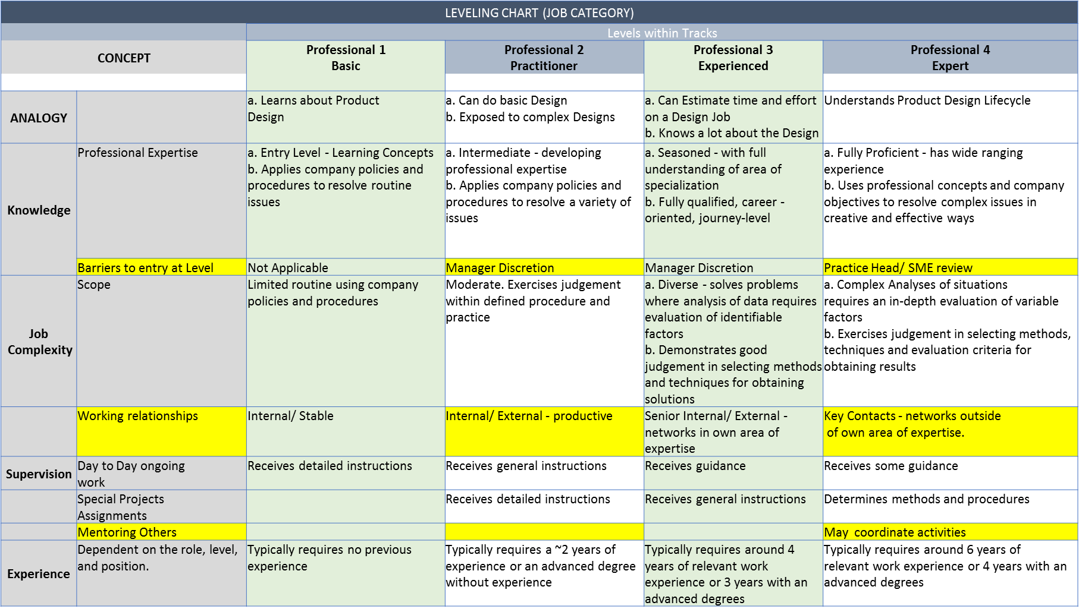

**Role Descriptions**

**Individual Contributors**

**Individual Contributor IC (A1, GET)**



* + - Generally the most common point entry point into the organization
    - Position requiring professional qualifications, resulting in theoretical knowledge of work area
    - Works under general guidance with periodic review of accomplished objectives
    - Expected to learn on the job towards developing domain knowledge along with technical skills
    - Works on problems of limited scope, through usage of standard concepts and principles.

**Individual Contributor IC (A2)**



* + - Position requiring professional qualifications with a few years of work experience, resulting in working knowledge of work area
    - Works as a fully contributing team member, under broad guidance
    - Expected to further build upon domain knowledge and technical/ proprietary skills to reach levels of expertise
    - Works on problems of relatively complex scope, through general usage of standard concepts and principles and application of own judgment
    - May guide new members in the team to help them scale up faster

**Individual Contributor IC (L1)**



* + - Position requiring professional qualifications with many years of work experience, resulting in specialized knowledge of work area
    - Works as a fully contributing team member, under broad guidance with independent planning & execution responsibilities
    - Expected to continue to build upon domain knowledge and technical/ proprietary skills to reach levels of expertise, while adapting standard principles to new or changed conditions in day to day work. Has the ability to respond to detailed queries
    - Works on problems of complex scope, through extensive usage of standard concepts & principles
    - Applies own judgment to independently determine a course of action, which is then executed independently post review
* Responsible for coaching, guiding and mentoring junior members in the team to help them scale up faster

**Individual Contributor IC (L2)**



* Position requiring professional qualifications with a few years of work experience, resulting in working knowledge of work area
* Works as a fully contributing team member, under broad guidance
* Expected to further build upon domain knowledge and technical/ proprietary skills to reach levels of expertise
* Works on problems of relatively complex scope, through general usage of standard concepts and principles and application of own judgment
* Guide new members in the team to help them scale up faster

**Individual Contributor IC (M1)**



* + - Position requiring extensive work experience, resulting in advanced knowledge of several disciplines/ expert knowledge of a few disciplines
    - Expected to continue to build upon domain knowledge and technical/ proprietary skills to reach levels of industry acknowledgement
    - Works as a guide and independently sets directions for large sized projects of high complexity
    - Works on problems of highly complex scope, through expert usage of non-standard concepts & principles requiring expert levels of judgment & interpretation
    - Determines a course of action, which is then executed by lower level team members.
    - Can offer multiple solutions to problems through existing and new methodologies and then exercises judgment to determine most appropriate solution
    - Responsible for coaching, guiding and mentoring junior members in the team to help them scale up faster
    - The role has sufficient expertise to write and present white papers and articles in recognized magazines and industry forums
    - Applies advanced knowledge and experience to the development of new methods, programs and procedures
    - Is responsible for capability development of the team/ unit
    - The role would offer expertise cutting across units and would make tactical decisions which will have an impact on the business
    - Manages divergent interest and perspectives.
    - Advises Sr. Management on specialized technical issues
    - Conducts, supports and reports research in one’s own area of expertise

**Individual Contributors**

**Individual Contributor IC (M2)**



* + - Position requiring extensive work experience, resulting in expert knowledge of several disciplines/ pioneering knowledge of a few disciplines
    - Expected to develop new concepts and principles. Problems that generally have limited or no precedent
    - Reviews directions for large sized projects of high complexity, as set by lower level team members
    - Is able to integrate knowledge of own discipline with knowledge of other disciplines in order to develop integrated solutions and help in setting organizational road-map
    - The role is expected to write & present white papers & articles in recognized magazines and industry forums. Serves as an external spokesperson for the organization
    - Applies advanced knowledge and experience to the development of new methods, programs and procedures
    - Is responsible for capability development of the team/ unit and contributes to development plans for the entire organization
    - The role would offer expertise cutting across units and would make strategic decisions which will have an impact on the business
    - Is recognized as an expert and manages divergent interest and perspectives through significant persuasion skills
    - Advises Sr. Management on specialized technical issues

**People Managers**

**Managerial Track PM (L1) [Team Size upto 6]**



* + - Position requiring professional qualifications with at least 6 years of work experience, resulting in specialized knowledge of work area
    - The role supervises the day to day work of lower level individual contributors usually managing upto 6 team members
    - Would be treated as a one point contact by the junior team members. May provide inputs on appraisals, feedback to employees and handling work allocations
    - Responsible for assigning coaches for guiding and mentoring junior members in the team to help them scale up faster
    - Knowledge of relevant policies & procedures, determines a course of action based on these guidelines
    - Affects related activities within the department
    - Good project management skills are required. Works on developing people management skills
    - Requires some analysis of facts and selection of existing courses and procedures based on past experience and manager’s guidance. Some judgment is required in selecting the alternate courses of action
    - Sets own work schedule for the team to meet established objectives
    - Contacts are inter/intra-organizational and outside the company to provide or obtain information on specific project operations.

**Managerial Track PM (L2) [Team size : upto 8]**



* + - Position requiring professional qualifications with 8 years of work experience, resulting in specialised knowledge of work area and good people management/ interpersonal skills
    - Includes application of knowledge to practical issues often relating to more than one functional area
    - Provides overall direction for complex activities -providing guidance and inputs for a medium size project or multiple small sized projects. Resolution of problems require analysis of facts and general principles. Manages up to 8 members
    - Has a significant impact on a small department/function. The role manages work activities of team through lower level individual contributors
    - Responsible for conducting appraisals, feedback to employees and handling team work allocations
    - Ability to adapt to various communication styles and interpret non-routine and conflicting information
    - Knowledge of relevant policies & procedures, determines a course of action based on these guidelines
    - Good project and people management skills are required
    - Interacts with internal and/or external clients and customers to negotiate and interpret information on projects and unit operations. May consult with senior management

**Managerial Track PM (M1) [Team Size: 12 to 20]**



* + - Position requiring professional qualifications with around 10 years of work experience, resulting in advanced people management/interpersonal skills
    - Applies advanced knowledge and experience to the development of new methods, programs and procedures and includes a comprehensive understanding of the practical issues of at least one major functional area where the knowledge e is applied
    - The role manages work activities of lower level people managers/ individual contributors
    - Responsible for conducting appraisals, feedback & handling work allocations for direct reports and reviewing the same for indirect reports. End to end people management responsibilities for the assigned group
    - Drives the application of principles, theories and concepts and determines the best course of action
    - Resolves complex problems of department wide operations
    - Extensive latitude to work independently and the outcomes have abroad effect on overall achievement of organization wide objectives
    - Ability to advise others and manage divergent interests and perspectives
    - The role would make tactical decisions which will have an impact on the business unit
    - Advanced project and people management skills are required

**Managerial Track PM (M2) [Team Size : 15 to 30]**



* + - The role will have budgetary responsibilities
    - Position requiring professional qualifications with extensive work experience, resulting in advanced people management/ interpersonal skills
    - A leadership position, responsible for identifying its functions linkages across the organization and develop appropriate processes and road map for the function
    - The role manages work activities of a department/ function through lower level managers
    - Responsible for conducting appraisals, feedback & handling work allocations for direct reports and approving the same for indirect reports
    - Drives the application of principles, theories and concepts and determines the best course of action
    - Resolves critical and complex issues impacting overall organization direction and results
    - Implements policies at a department level
    - Use skill of persuasion in communication and ability to develop effective communication strategy
    - Expert project and people management skills are required

**Managerial Track PM (M3) [Team Size: 40 to 100]**



* + - The role will have budgetary responsibilities
    - Position requiring professional qualifications with extensive work experience, resulting in expert people management/ interpersonal skills
    - A leadership role which is the senior most role in a medium sized Business vertical/ practice
    - Requires extensive knowledge of major segments in the organization and a knowledge of several disciplines and ability to integrate critical information from many diverse areas
    - Participates in resolving critical issues impacting overall organization direction and results. The impact can be medium to long term in nature
    - Has a major impact on the achievement of overall organization goals
    - Decisions are strategic and impact overall business unit results and direction
    - Ability to persuade key decision makers and manage strategic communication
    - Final authority on all people related decisions for the practice

**Managerial Track PM (E1) [Team Size: 100 to 250]**



* + - The role will have budgetary responsibilities
    - Position requiring professional qualifications with extensive work experience, resulting in expert people management/ interpersonal skills
    - A leadership role which is the senior most role in a large Vertical/ Practice
    - Requires extensive knowledge of major segments in the organization and a knowledge of several disciplines and ability to integrate critical information from many diverse areas
    - Course of actions are guided by corporate goals and strategy only
    - Resolves critical issues impacting overall Unit direction and results. The impact can be long term in nature
    - Organizes organization wide and cross business unit programs
    - Has a major impact on the achievement of overall organization goals
    - Decisions are strategic and impact overall organization results and direction
    - Ability to persuade key decision makers and manage strategic communication

VP/ SVP (E2, E3) [Team Size : 100 to 250]



* + - Advise the CEO on strategic business development and key corporate planning issues and make recommendations on major business decisions
    - Keep the CEO informed about business activities, potential threats, opportunities, and recommended actions
    - Help determine resource allocation among Practice Units
    - Shape and develop Unit strategy and organization
    - Help identify opportunities and potential threats to each Practice Unit
    - Ensure proper reporting structure within teams/ practices/ sub practices
    - Encourage managers to evaluate and take actions that are consistent with the overall strategy which will lead to high performance
    - Act as a sounding board for Practice Unit managers
    - Set performance goals which are tailored to each division
    - Develop operational goals for each division which are tied to long-term goals
    - Monitor Unit performance against performance goals to ensure that progress is being made and collective action -if necessary -is taken
    - Ensure adherence to annual budgets
    - Build an organization culture by communicating effectively
    - Lead programs to build organizational capabilities
    - Develop a group of well-rounded, capable managers in each division
    - Oversee (with HR BP/ Head) the implementation of effective HR programs and to build critical core competencies and organizational values.

**Job Match Flow and Methodology**

Job matching should flow as per the process flow illustrated below

Identify Sub Class

Identify Career Path

Identify Job Level

Identify Job Family

Individual Contributor

L1 - ASERIC 1

Individual Contributor

ERP

Application Software Development

Managerial Track

Identify Sub Class

Managerial Track

L1 - ASERPM 3

|  |  |  |  |  |  |  |
| --- | --- | --- | --- | --- | --- | --- |
| **Job Family** | **Application Software (ERP)** | |  |  |  |  |
| **Name** |  |  |  |  |
|  |  |  |  |  |  |
|  | Professionals in this role design, develop and support application solutions with a focus on SAP / Peoplesoft to meet client requirements. They may | | | | | |
|  | design, develop and/or re-engineer highly complex application components, and integrate software packages, programs and reusable objects residing | | | | | |
|  | on multiple platforms. Assist clients in the selection & implementation of SAP Enterprise Mgt - all Modules (FICO, MM, SD, HR, PP, PS, PM, WM, | | | | | |
| **Job Family** | SRM, SEM, BW, ABAP, NW, XI IS Modules) & SubModule areas using skills like SAP Basis, Netweaver etc .Incumbents may work on Peoplesoft | | | | | |
| modules (CRM, CS, FS, HCM, SA) using Peoplesoft tools (Application Designer, Data Mover, Process Scheduler & PSADMIN, Peoplecode, AE, | | | | | |
| **Description** |
| SQRs, IB, CI). This role uses consulting skills, business knowledge, and packaged solution expertise to effectively integrate packaged technology into | | | | | |
|  |
|  | the clients business environment in order to achieve client expected business results. Expert knowledge required in C++, C#, VC++, Java, PL/SQL | | | | | |
|  | etc. |  |  |  |  |  |
|  |  |  |  |  |  |  |
| **Sub - Class** | **ERP** |  |  |  |  |  |
| **Aon Hewitt** |  |  |  | **Indicative Job** | **Indicative** | **Indicative** |
| **Position Description** | |  | **Qualification &** | **Reporting** |
| **code** |  |  |  | **Titles** | **Years of Exp & Salary** | **Relationship** |
|  |  |  |  |  |
|  |  | |  |  |  |  |
| **Career Path 1 - Individual Contributor** | | |  |  |  |  |
|  |  | | |  |  |  |
|  | Responsible for development, support, maintenance and implementation of small to medium | | | Software |  |  |
|  | non-complex components of a project module. Works on problems of limited scope, through | | | Engineer, |  |  |
| **ASERIC 1** | usage of standard programming concepts and principles. Works under high supervision/ | | | Programmer, | BE/ Btech/ MCA | ASERPM 4/5 |
| guidance with frequent review of accomplished objectives. Requires theoretical knowledge of | | | Developer, | 0-3 years |
|  |  |
|  | C++, VC++, Java and is expected to learn the different modules of the ERP package. Expected | | | Programmer | **( 3 to 7.5L)** |  |
|  | to learn on the job towards developing domain knowledge along with technical/ proprietary skills. | | | Analyst |  |  |
|  |  | | |  |  |  |
|  | Responsible for development, support, maintenance and implementation of complex | | |  |  |  |
|  | components of | a project module. Works on problems of | relatively complex scope, through | Sr Software |  |  |
|  | general usage | of standard programming concepts and | principles and application of own |  |  |
|  | Engineer, Sr |  |  |
|  | judgment. Works as a fully contributing team member, under broad supervision/ guidance. | | |  |  |
|  | Programmer, Sr | BE/ Btech/ MCA |  |
| **ASERIC 2** | Requires expert knowledge of C++, C#, VC++, Java and must have working knowledge of 2-3 | | | ASERPM 4/5 |
|  | modules of ERP package and expert in one module. Expected to learn on the job towards | | | Developer, Sr | 2-5 years |  |
|  | Programmer | **( 5 to 10 L)** |  |
|  | developing domain knowledge along with technical/ proprietary skills. Expected to further build | | |  |  |
|  | Analyst |  |  |
|  | upon domain knowledge and technical/ proprietary skills to reach levels of expertise. May guide | | |  |  |
|  |  |  |  |
|  | new members in the team to help them scale up faster. | |  |  |  |  |
|  |  |  |  |  |  |  |

**SAMPLE DESCRIPTION OF JOB MATCHING**

**PROMOTIONS AND LATERAL MOVEMENT:**

**Promotions Overview**  
Promotions from within the organization are encouraged as they are an important part of retaining and developing our employees. Team members and managers play a key role in the potential for individual advancement.  
  
Promotions indicate that the company has a need for a role with expanded responsibility and complexity and that the employee has developed a breadth of skill and expertise that will allow him/her to work effectively in that expanded role.   
  
**Promotion Cycles**  
There are two types of promotions that can occur: In-cycle promotions and Out-of-cycle promotions.

*In-cycle promotions:*Coincides with the annual performance review process.   
Note: The majority of promotions take place at this time.   
  
*Out-of-cycle promotions:*Promotions normally occur during the In-cycle promotion periods. However, a business need may arise during the year that supports an out-of-cycle promotion, such as filling an open position.

To be eligible for promotion, there must be a business need. Promotions are encouraged to come from within the company as it is an important part of retaining and developing key talent. Each domain has their own specific criteria for promotion eligibility.  
  
**Manager Responsibility**  
Managers play a key role in supporting, guiding and developing their respective team members. Managers are responsible for:

* Outlining goals and objectives to achieve.
* Defining expectations to achieve results.
* Assessing the skill level and development needs.
* Providing on-going, specific and timely feedback on progress in achieving his/her objectives

There should be no verbal communications regarding promotions until final approval has been received from Human Resources.   
  
**Promotion Criteria and Process**

*The in-cycle promotions up to M1 Band:​*

*Criteria:*

1. The team member should have spent reasonable amount of time in the current role.
2. He/she must have demonstrated influence and command over the current role and is seen to be stretching to the next level.
3. He/she must be comparably superior amongst peers (if any) or should have exceeded expectations during two performance cycles at least.
4. The opportunity should exist in the next level to which the promotion is being done.
5. He/she must possess the technical skill proficiency level of a beginner at the next level.

*Process:*

* The RM must document the need for this promotion capturing the above in the Performance Review form and it must be discussed and endorsed by the Reviewer and BUH.

*Promotions above to M1 Band:​*

The process and criteria is different for promotions in this category:

*Criteria:*

* 1. The need and opportunity must exist at the proposed next level
  2. The incumbent must have exceeded expectations in minimum 3 appraisal cycles
  3. The incumbent must have demonstrated on-the-job proficiency and capability in the next level
  4. The incumbent must be comparably the best pick for the position amongst his/her peer group
  5. He/ she must have the capability to interact across various functions like TA, RMG, HR, Finance, Tech Support, Sales and BD and other intra domains.
  6. He/she must not have any adverse remarks/ comments from clients

*Process:*

* The RM must document the need for this promotion capturing the above in the Performance Review form and it must be discussed and endorsed by the Reviewer and BUH
* The BUH will need to present it at the ELT meeting during the Promotion discussion session and substantiate the case there off.
* The ELT will evaluate based on the contribution and cultural fit
* Decision is made: To be or not to be at the ELT meeting

*The Out-of-cycle promotions (All):*

* The dire need for this role and position must be substantiated by the RM to the BUH
* BUH to evaluate and ascertain the need and the business impact.
* Decision is also guided by the above criteria in the “in-cycle promotions”

*Level Wise Hierarchy with Titles and Progression Streams:*

|  |  |  |  |  |
| --- | --- | --- | --- | --- |
| **Band** | **Band Name** | **Work Experience (in Yrs)** | **Designation** | **Progression  Stream** |
| AT 2, 4 | AT2 (4) | 0-1 years | Graduate Engineer Trainee | IC |
|  |  |  | MANAGEMENT TRAINEE | IC |
|  |  |  | Quality Executive Trainee | IC |
|  |  |  | Young Software Professional Trainee | IC |
| A 2, 14 | A1(6) | 2-4 years | Engineer | IC |
|  |  |  | Executive | IC |
|  |  |  | Functional Consultant | IC |
|  |  |  | Software Engineer | IC |
|  |  |  | Support Engineer | IC |
|  |  |  | Technical Consultant | IC |
|  | A2 (8) | 4 - 8 years | Senior Associate Consultant | IC |
|  |  |  | Senior Consultant | IC |
|  |  |  | Senior Engineer | IC |
|  |  |  | Senior Executive | IC |
|  |  |  | Senior Functional Consultant | IC |
|  |  |  | Senior Software Engineer | IC |
|  |  |  | Senior Support Engineer | IC |
|  |  |  | Senior Test Engineer | IC |
| L 2, 9 | L1 (4) | 5 - 10 years | Assistant Manager | IC/ PM |
|  |  |  | Lead | IC/ PM |
|  |  |  | Lead Consultant | IC/ PM |
|  |  |  | Lead Engineer | IC/ PM |
|  | L2 (5) | 7 - 12 years | Deputy Manager | IC/ PM |
|  |  |  | PROJECT LEADER | IC/ PM |
|  |  |  | Senior Lead | IC/ PM |
|  |  |  | Senior Lead Engineer | IC/ PM |
|  |  |  | Senior Tech Lead | IC/ PM |
| M 3, 5 | M1 (1) | 9 - 14 years | MANAGER | IC/ PM |
|  |  |  | Project Manager | PM |
|  | M2 (3) | >14 years | Deputy General Manager | PM |
|  |  |  | Senior Manager/ Solution Architech | PM/ IC |
|  | M3 (1) | >15 years | General Manager/ Sr. Architech | IC/ PM |
| E 3, 3 | E1 (1) | >15 years | Asst. Vice President | PM |
|  | E2 (1) | >18 years | Vice President | PM |
|  | E3 (1) | >20 years | Sr. Vice President | PM |

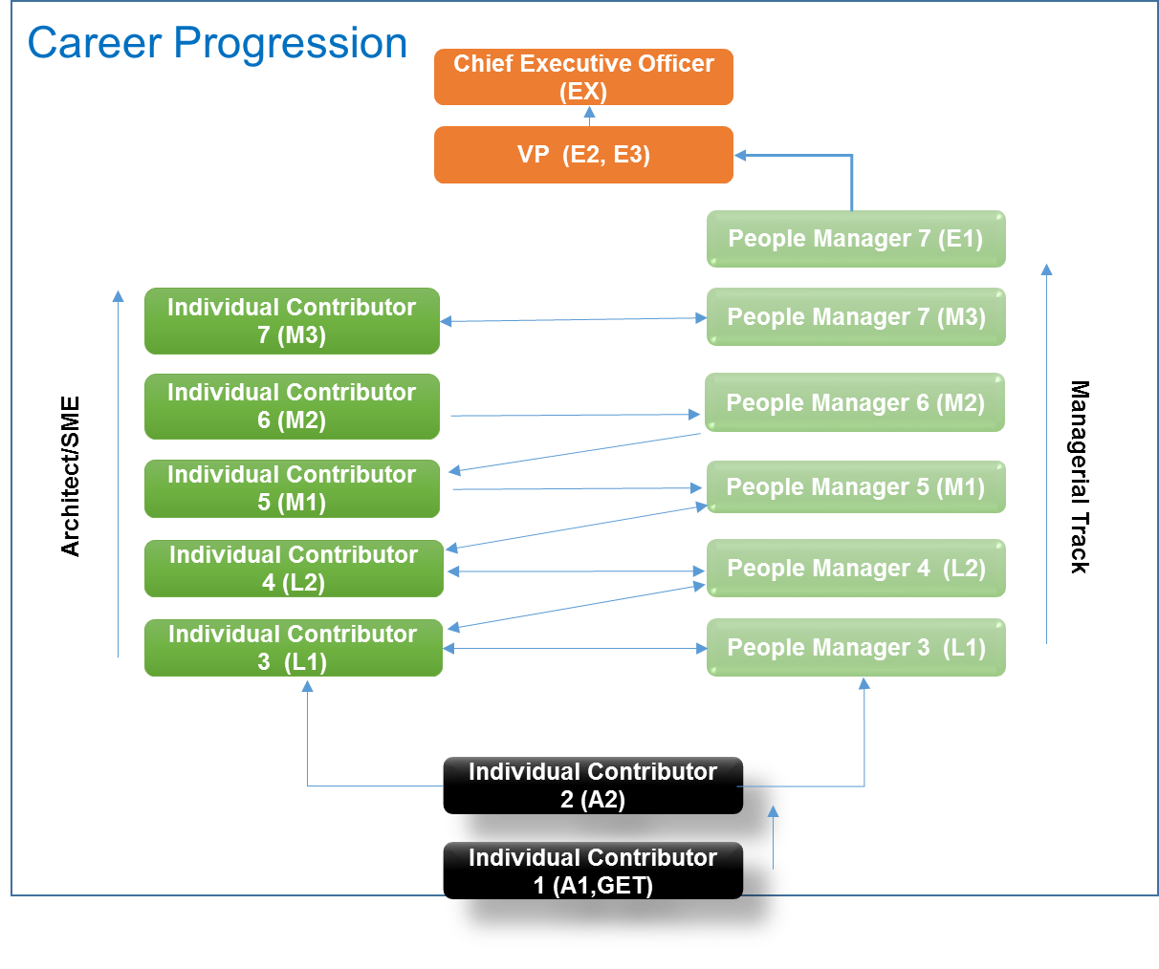

**Building Effective Career Partnerships**

What Is a Career Partnership?

HTL is committed to developing the employee skills and capabilities necessary for future success. It provides tools to help employees determine their career aspirations and grow their careers through experiences. Employees and managers also play an important role in making career partnerships work. Below is a short summary of their responsibilities.

|  |  |
| --- | --- |
| Employee | Manager |
| Own Your Career Development Conversations  Initiate and prepare for career development conversations with your manager. | Support Career Development Conversations  Encourage employees to own career development conversations. |
| Be Open About Your Career Aspirations and Goals  Understand your strengths and career interests, and ask your manager for feedback. | Be Transparent About Career Development Opportunities  Provide constructive feedback on employees’ goals and aspirations, and manage career expectations. |
| Identify the Skills and Experiences You Need to Advance Your Career  Identify and complete projects, tasks, or training to gain the experiences needed to pursue career aspirations. | Focus Employees on Experiences, Not Positions  Encourage employees to identify experiences and capabilities they want to develop and the organization needs, and not just focus on a specific upward position. |
| Learn About the Skills and Experiences the Organization Needs  Understand where your organization is growing and how your industry is developing. | Communicate Future Organizational Capability Needs  Help employees understand the skills and experiences the organization is looking to build in the future. |
| Search Out Development Opportunities  Actively look for opportunities or experiences that further your career growth. | Help Employees Find Development Opportunities, Even Outside of Your Team or Business Unit  Use your network, HR business partner, or HR Generalist to identify and share opportunities that align with employees, career interests. |
| Build Your Network Within the Organization  Network with peers, other managers, and senior leaders to inform your aspirations, learn more about available opportunities and growth areas, and understand the skills and experiences to focus on. | Help Employees Expand Their Internal Networks  Help employees connect with peers, other managers, senior leaders, and networks that match their area of career interest. |
| Understand and Communicate Your Employability  Understand and be prepared to articulate your strengths and career aspirations, internally and externally, to build your personal brand. | Help Employees Evaluate and Communicate Their Employability  Help employees develop and articulate the key factors that distinguish them from their peers. Evaluate their chances of promotion within the organization and their external market value, and be transparent about the results. |

FAQs

After building the entire doc need to list down FAQs here