# ***Phase III A – Billing System***

1. When Creating bill from Sales Module

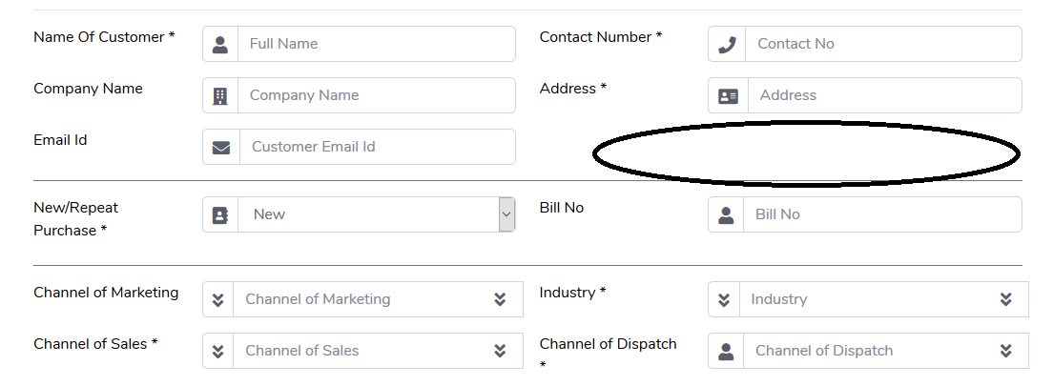

1. Add a new Field of Customer GST Number. This field becomes compulsory when the GST box is clicked. In some cases the customer doesnot have a GST number. In that case, “A” should be entered in this box.
2. If Channel of Dispatch is Franchisee Store, then the Address will be taken from The Customer Information Address,
   1. If the channel of Dispatch is anything other than that, the Address will be taken from Billing Address field
   2. If Billing and Shipping address is different, then both of them is printed on the Bill. Shipping address is mandatory if anything except Franchisee Store
3. P&F is printed on the bill.
4. Discount Calculation is done in the bill
5. Payment Mode and its details have to be printed in the Bill
6. Sales person Name has to be printed
7. If there is a PO number, then PO number has to be printed on the bill
8. On clicking on Add product it will go on the next page from where the billing description, etc will be generated.
9. Once the user enters all the products, the page will show the customer number and the transaction number. On that Page two options should come – Edit and Bill
10. If print Bill is clicked, the next step it should ask is – Sales or Scales. Also, if the GST number starts with 27 or A, then CGST/SGST has to be applied, in all other cases IGST has to be applied. and number box of Discount.
11. The data will be populated from the previous inputs and all fields (except description field) are disabled. If the user wants to edit something, it can be done here through an Edit button. Edit Customer Details or Edit Product Details. If Edit customer details it will take back to the customer page where customer details on the first half is editable. If products page then it will take on the products page where all the products have to be added again and steps 9-11 have to be repeated. The user can only edit the default Sub Sub Model that is auto populated by free flowing text.
12. Add a notes section in the Bill that is 1024 Characters. This will be saved in the bill but will have no impact on the system or database
13. At the end of the page, there would be a “Edit” OR “Submit & Print” button. Once the button is clicked a new window with the final copy of the bill will come out. The user can download this copy or print it. This is the copy which will be saved in the database and everywhere else.
14. The final bill will have the following fields (Excel form is sent to you
    1. Company Name
    2. Contact Person
    3. Address/State
    4. Phone Number
    5. Date
    6. GST Invoice number
    7. Customer GST Number
    8. Sales Person
    9. PO Number
    10. Dispatched through
    11. Qty/HSN/Sub Sub Model number/Rate/Total
    12. Total
    13. P&F
    14. Discount
    15. Tax
    16. Round Up – To the next higher number
    17. Grand Total
    18. Payment Details – If credit is mentioned then mention that too.
    19. All other std Disclosures, etc as mentioned in the bill
    20. At the very end of the disclosure mention the Sales Id so that the customer feels that its just an error but our guys can make out the sales txn number

There will be an additional Bills tab created where all the bills will be stored. The access is given by default to all the people who have been assigned the Sales/Dispatch/Lead management module.

For the employee who has made the bill the following fields will be shown in the Bills module

1. Date
2. Invoice Number
3. Sales Id
4. Company Name
5. Contact Number

Besides each bill there will be the following options (or you can provide a radio button and at the start of the page these 5 options)

1. Print
2. Download
3. Edit
4. Delete
5. Return

If the entry is clicked in the list view the transaction page opens where all details are shown.

On clicking the print – a new window will open with the details and from there the bill can be printed

On clicking Download the bill will be downloaded in the PDF format (asking the user where to save) with the name of the fill as “Bill No-Date.pdf”

On clicking Edit – it will take to the txn id page where the person can change the respective fields and then the product details (if the product is edited, there should be a change in the stock module as well on that particular date of that item number)

On Clicking Delete, a new page has to pop up asking for the reason for deletion of bill. The bill has to be deleted. The Stock entries has to be adjusted on that date. The bill should still be saved in the system with a cancelled flag. In all the lists and reports, etc, all line items will appear as cancelled, and all the print/download/edit/cancel/return buttons will appear as disabled. However, the CRM entry of the customer stays in the system but the flagged as bill deleted. The record of who deleted the bill has to be stored as a part of the sales form hereafter. The employee can see if the manager has deleted the bill if its in his hierarchy

On clicking on the Return Tab, the bill has to be first deleted. The use has to enter

1. Exchanged for another product
2. Faulty and Returned
3. Misc

If it’s the first option then the user has to be taken on the customer tab, where the customer information is pre-filled and then the user has to press the add product, and make the bill all over again using the previous mentioned steps. If its faulty and returned and Misc then take no action

The difference in the amount has to be adjusted in the day’s revenue and the stock entries have to be adjusted accordingly.

For the Manager/Admin and Super Admin the following fields have to come in the list view

1. Date
2. Invoice Number
3. Sales Id
4. Company Name
5. Contact Number
6. Basic Amount
7. P&F
8. Discount
9. CGST
10. SGST
11. IGST
12. Grand Total
13. Feedback

This will be followed by a radio button and at the start of the page the 5 options of

1. Print
2. Download
3. Edit
4. Delete
5. Return

(The options will work exactly as mentioned above)

1. When Creating Bill from the PI Module

It is very much the same, except the difference that the GST number, PO number, etc is auto-populated in the sales module

1. Reports

The entire billing details are saved in a list form on the cloud.

The super admin/Admin/Manager should have the rights to download the whole report, which consists of the List + there should be a cell in which the description is compressed and given. It should follow the standard hierarchy of the ERP System.

In the bill Report of the Super Admin, there is one more option for both companies

1. Next bill Number which is disable. There is an edit button besides it. If that button is clicked, then the next number is entered and the auto numbering will start from that number onwards.
2. The bill number has to be a 10 digit number with the leading zeros suppressed.

ADD AN OPTION FOR RETURN OF PRODUCT.

Create a new section – Returns

When this is clicked, then the computer will prompt for the txn number. Once entered the txn will open with dropdown box having the following options and a Notes option

1. Exchanged for another product
2. Faulty and Returned
3. Misc

If product is exchanged for another product then the customer page should be opened with the details auto populated and the normal routine will continue but raise a flag of product exchanged)

If Product is exchanged for a new one then the products page should open and the stock, revenue reports, etc should be adjusted accordingly. The sale will be considered a sale today, the previous will be a returned product, and the difference in the amount will be the revenue for today. If it’s a –ve difference then the amount will get subtracted from today’s entry.

# ***Phase III B – Expense System***

Payments Module

The module will capture all the payments of HSCo of Hindustan Scale Co. It will have a Express Expense and a detailed expense.

Detailed Expense.

Just like in the sales module it will have 2 pages. Page 1 will capture the vendor details and page 2 will be the expense type

The entries on page 1 will be as follows

1. Expense type Master
2. Expense type Sub Master
3. Expense Type Sub Sub Master
4. Name of the vendor – Dropdown from Vendor Master
5. Company – Hindustan Scale Company/Hindustan Sales and Consultancy (Compulsory and auto populated from last time)
6. Packing and Forwarding
7. Bill No
8. Bill Date
9. GST Percentage
10. TDS Applicable – Y/N (Auto populated from last Page)
11. Total Amount –
12. GST Amount
13. GST Check Box – If This is checked then Bill number becomes mandatory
14. Payment type - Cash/Cheque/NEFT/Credit Card/Paytm/Google Pay/Misc
    1. If cash then GST is clickable. If any other payment mode then GST becomes mandatory
    2. If Cheque is selected then the Cheque number, Bank and date of cheque becomes mandatory
    3. If NEFT is selected, then the date of the NEFT, Bank, Reference number and date becomes mandatory.
    4. If any other Payment Model make Bank, Reference Number and date optional
15. Date of Payment – Today’s Date
16. Name of the Payee – Login Id of the person
17. PO issued – If Any – (5MB Limit)
18. One more field to attach all the bills as an attachment – 5 MB limit
19. If the Expense type is “Purchase” then will go to the next page else will save and exit

**(Each Expense type will be given a serial number)**

Page 2

IF THE Expense TYPE IS PURCHASE THEN

1. Expense type will be auto-populated from the last page and is editable in a dropdown fashion
2. If the Expense type is Purchase type then the following details have to appear
   1. Type of Scale
   2. Model of Purchase
   3. Sub Model
   4. Sub Sub Model
   5. Brand
   6. Unit
   7. Capacity
   8. Rate
   9. Quantity
   10. Amount (Auto Calculated)
   11. Serial Number
   12. Godown
   13. Last Product – Y/N
   14. (All this has to be auto populated from the product master and can be changed)
3. If yes is then add to database and exit
4. If No then new page with Pts 1 to 5 will again appear

Vendor Master

1. Expense type Master
2. Expense Head
3. Name
4. Phone Number
5. Company Name
6. Detailed Address
7. Email Id
8. GST Details
9. HSN Code
10. GST Percentage
11. Notes (2048 characters)
12. TDS Applicable – Y/N
13. IGST – CGST/SGST

Expense type Master

1. Expense Type Master
   1. Purchase of Goods
   2. Not Purchase

Expense type Sup Master

1. Expense type Master
2. Expense type Sub Master
3. Notes – 2048 characters

Expense type Sub Sub Master

1. Expense type Sub Master
2. Expense type Sub Sub Master
3. Notes – 2048 Characters

Reports

Exactly the same logic as Sales Reports. The person who is entering it and everybody above can view. The following fields should show up in the lower level

1. Date
2. Expense Id -
3. Vendor Name –
4. Expense type Sub Sub Master -
5. Mode of Payment
6. Name of the person making the Payment
7. Amount of Payment (Including GST if any)

The above will be clickable and when clicked will take to the respective transaction.

Super Admin, Admin and manager can download. Select all fields + individual fields

Expense should be shown as a bar Graph as day Wise. And day wise and month wise.

It’s a separate module so can be assigned to employees as and when required.

# ***Phase III C – Additions***

Reports for the system

1. Date range wise Sales of GST Vs Cash Sales
2. Date range wise Top Customers in Descending order/Asending Order (By Mobile Number)
3. Maps where the scales have been sold which has to be run on google or AI platform.
4. Maps where the AMC is sold
5. Maps where the Restamping is sold
6. Sales of All types of Scales Vs Billing Sales

In points 3, 4 and 5, make sure of the following

1. Date range can be selected

Addition to previous modules

1. When a product is added then an SMS has to be triggered to the Person whose mobile number is in the Godown mentioned. Also the mobile number can be the same for 2 or more godown.
2. Add an option for Transfer of Stock. In this transfer, to whomever the module is assigned the stock can just be transferred from one to another without goods request.
3. In the Sales entry when we enter the product – If system performance is not hindered have a photo of the product that is being added.
4. SMS when someone logs into the system to the Super Admin. The contents of the login must be
   1. User name
   2. Google Location of Login
   3. Login By OS system
5. The dropdowns of the following need to be made dynamic. In all dropdown, only from the Dropdown. No other entries can be typed
   1. Channel of Marketing
   2. Channel of Sales
   3. Industry
   4. Channel of Dispatch
6. Add an option of who all are at present in the system
   1. Desktop/Mobile
   2. Google Location
   3. User Name
   4. User id
7. Add a flush button to log off everybody connected to the system
8. Add a check box for SMS and Email for whenever someone logs into the system (email id) (Mobile Number)

Phase III D – This will have the AMC components of the previous modules