TargetPath AI-Enabled Account Scoring Workflow
Process Map
Team Gamma | Auburn University MBA Capstone Project | September 2026
Visual Process Flow Diagram Overview
The following text-based flowchart illustrates the end-to-end operational sequence for TargetOrate's AI-enabled account scoring workflow. It integrates automated AI data processing with structured human validation gates to ensure enterprise-grade accuracy and auditability.
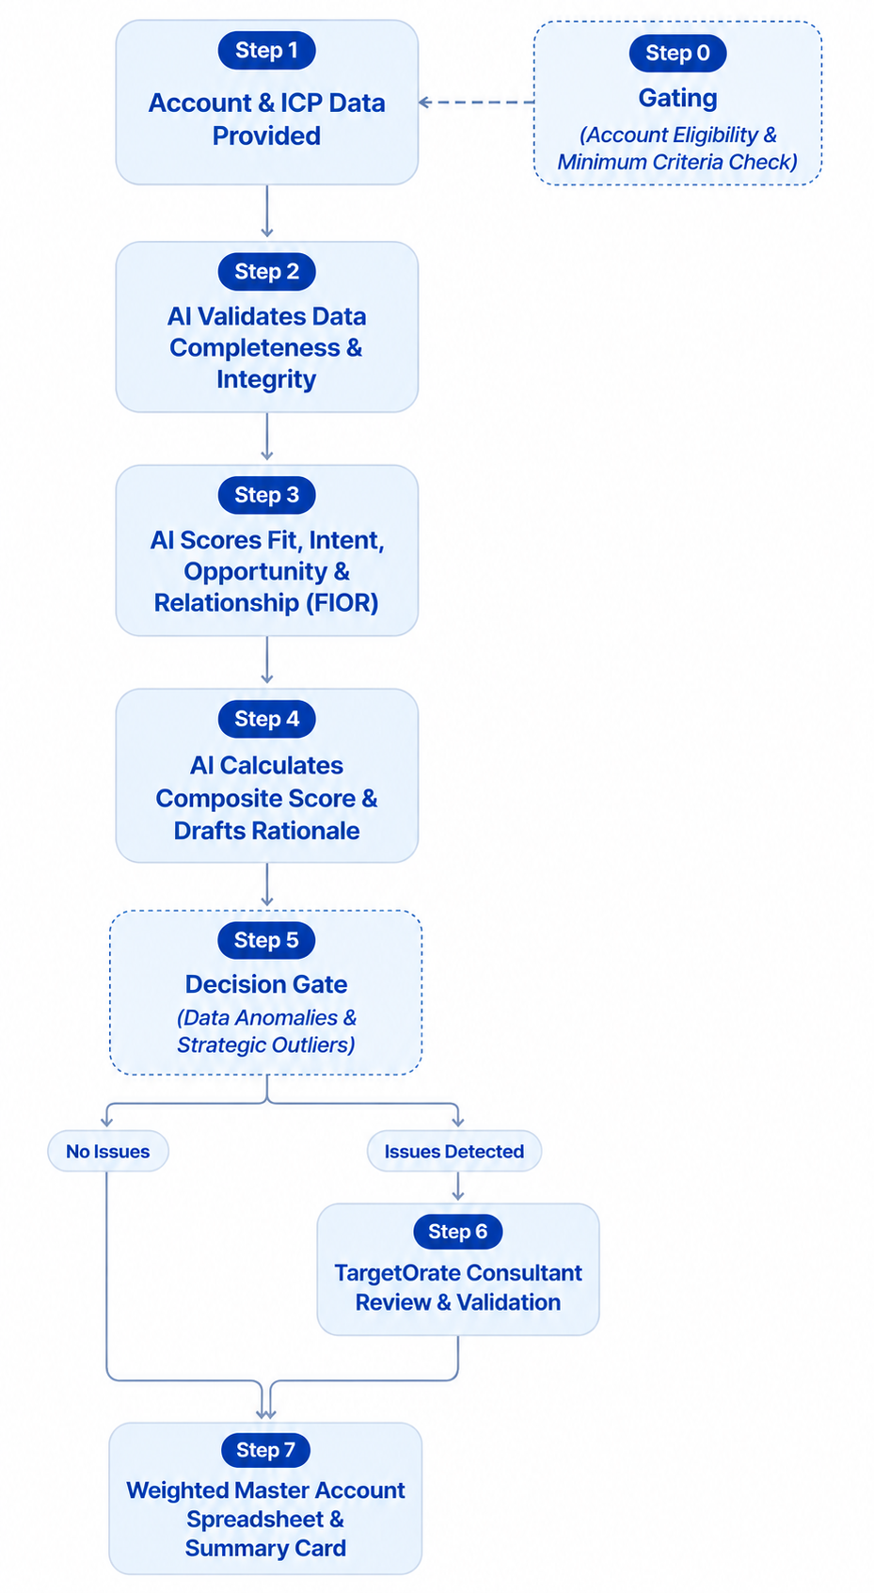
Step 1: Account & ICP Data Provided (Step 0 Gating)
Actor / Owner: Human Consultant / Data Ingest Layer
The process initiates when raw company records, firmographics, CRM exports, and third-party intent signals are ingested into the secure AI environment. Concurrently, accounts are checked against the qualitative Ideal Customer Profile (ICP) criteria to ensure basic eligibility (industry match, revenue range, geography) before heavy scoring begins, preventing wasted analytical cycles on bad-fit accounts.
Step 2: AI Validates Data Completeness & Integrity
Actor / Owner: AI Engine (Claude / ChatGPT)
The LLM scans the ingested datasets to normalize account records, check for missing fields, and flag potential data gaps or inconsistencies across firmographic, technographic, and intent sources. This ensures the foundational data is robust enough for quantitative scoring.
Step 3: AI Scores Fit, Intent, Opportunity & Relationship (FIOR)
Actor / Owner: AI Engine (Claude / ChatGPT)
Utilizing TargetOrate's FIOR framework, the AI evaluates and scores the account across all four weighted dimensions—Fit (35%), Intent (25%), Opportunity (30%), and Relationship (10%)—using structured 1-10 criteria and sub-scores grounded in historical data and research.
Step 4: AI Calculates Composite Score & Drafts Rationale
Actor / Owner: AI Engine (Claude / ChatGPT)
The AI aggregates the weighted sub-scores into a final composite score (0-100), maps the account to its preliminary ABM Tier (Tier 1: 80-100, Tier 2: 60-79, Tier 3: 40-59, Nurture: <40), and drafts structured justification notes detailing key strengths, gaps, and recommended next actions.
Step 5: Decision Gate (Data Anomalies & Strategic Outliers)
Actor / Owner: Workflow Control Logic
A conditional quality control check evaluates AI output confidence and data flags. If data is missing, sparse, contradictory, or if an account represents a high-priority strategic override (e.g., existing executive relationships or brand value), it is systematically routed for mandatory human inspection.
Step 6: TargetOrate Consultant Review & Validation
Actor / Owner: Human Consultant & Sales Leadership
Human-in-the-loop oversight takes place. Consultants review score reasonableness against market realities, validate data integrity, apply strategic overrides, and adjust scores if the AI misinterpreted external signals or market context. This gate protects against algorithmic drift and hallucinations.
Step 7: Weighted Master Account Spreadsheet & Summary Card
Actor / Owner: Joint AI & Human Hand-Off
The finalized, human-validated scores are locked into the Weighted Master Account Spreadsheet. The system outputs the official Account Summary Card and tier assignment, completing the Account Scoring workflow and establishing the controlling dataset for downstream Buying Committee Mapping (Step 2).

