AI Job Market Salary Prediction
Technical Output Report · 12-stage data-quality-first, leakage-safe and deployable workflow

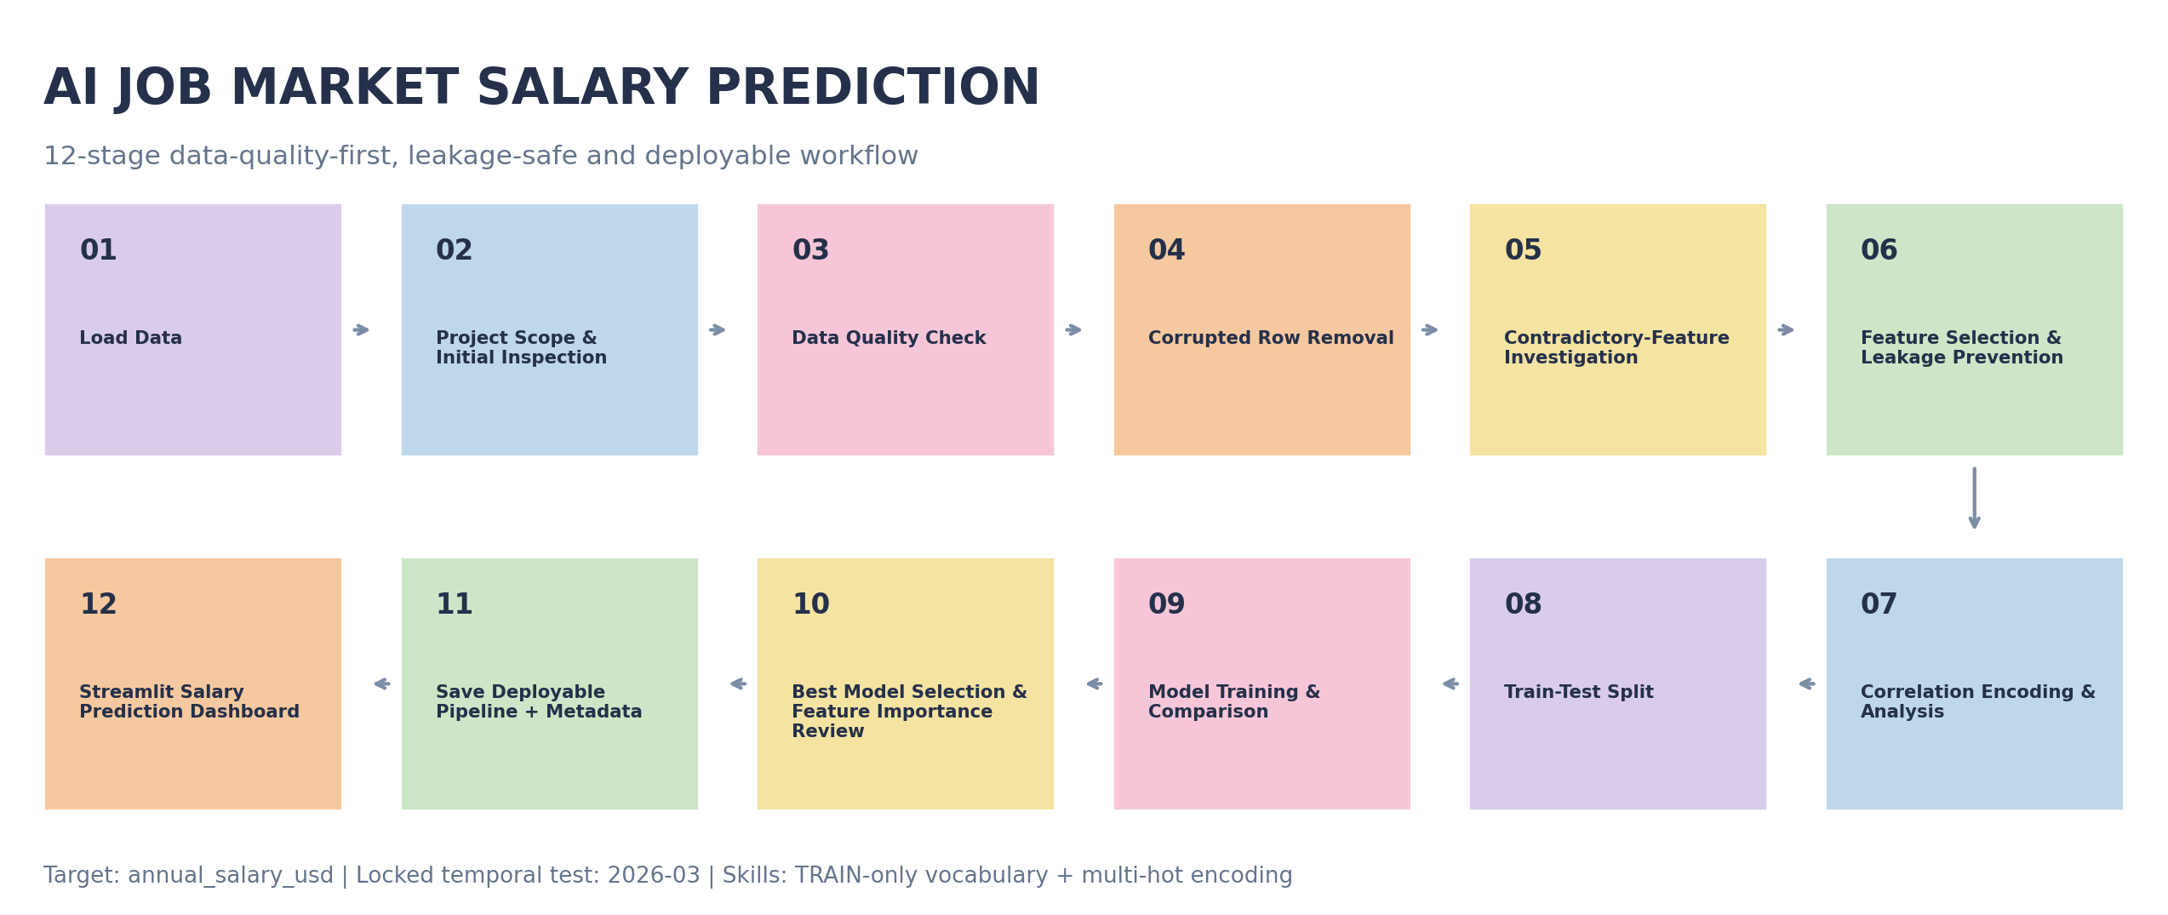
1,500  Raw rows | 1,499  Clean rows | 1,201  TRAIN / DEV | 298  Locked TEST | Random Forest  Best model

Report basis
All statistics, charts and conclusions on this report are generated from the delivered CSV and current pipeline artifacts. Model selection is output-driven, not hard-coded.

1. Project Scope & 12-Stage Architecture
- Task: supervised regression; target = annual_salary_usd; modelling unit = one valid AI job posting.
- Primary validation: March 2026 locked final test. Feature/model development uses earlier data only.
- Skills: split on |, trim/de-duplicate, DEV/fold-only vocabulary, multi-hot encoding + skill_count.
- Serving: one scikit-learn Pipeline serializes preprocessing + estimator; Streamlit uses that same bundle.

Figure 1. Implemented 12-stage project pipeline.
Stage | Name
1 | Load Data
2 | Scope & Initial Inspection
3 | Data Quality Check
4 | Corrupted Row Removal
5 | Contradictory Features
6 | Leakage Prevention
7 | Correlation Encoding & Analysis
8 | Train-Test Split
9 | Model Training & Comparison
10 | Best Model & Importance
11 | Save Pipeline + Metadata
12 | Streamlit Dashboard

2. Data Basic Clean — Stages 01–04
1,500  Rows | 25  Columns | 0  Missing cells | 0  Duplicates | 1  Corrupted row

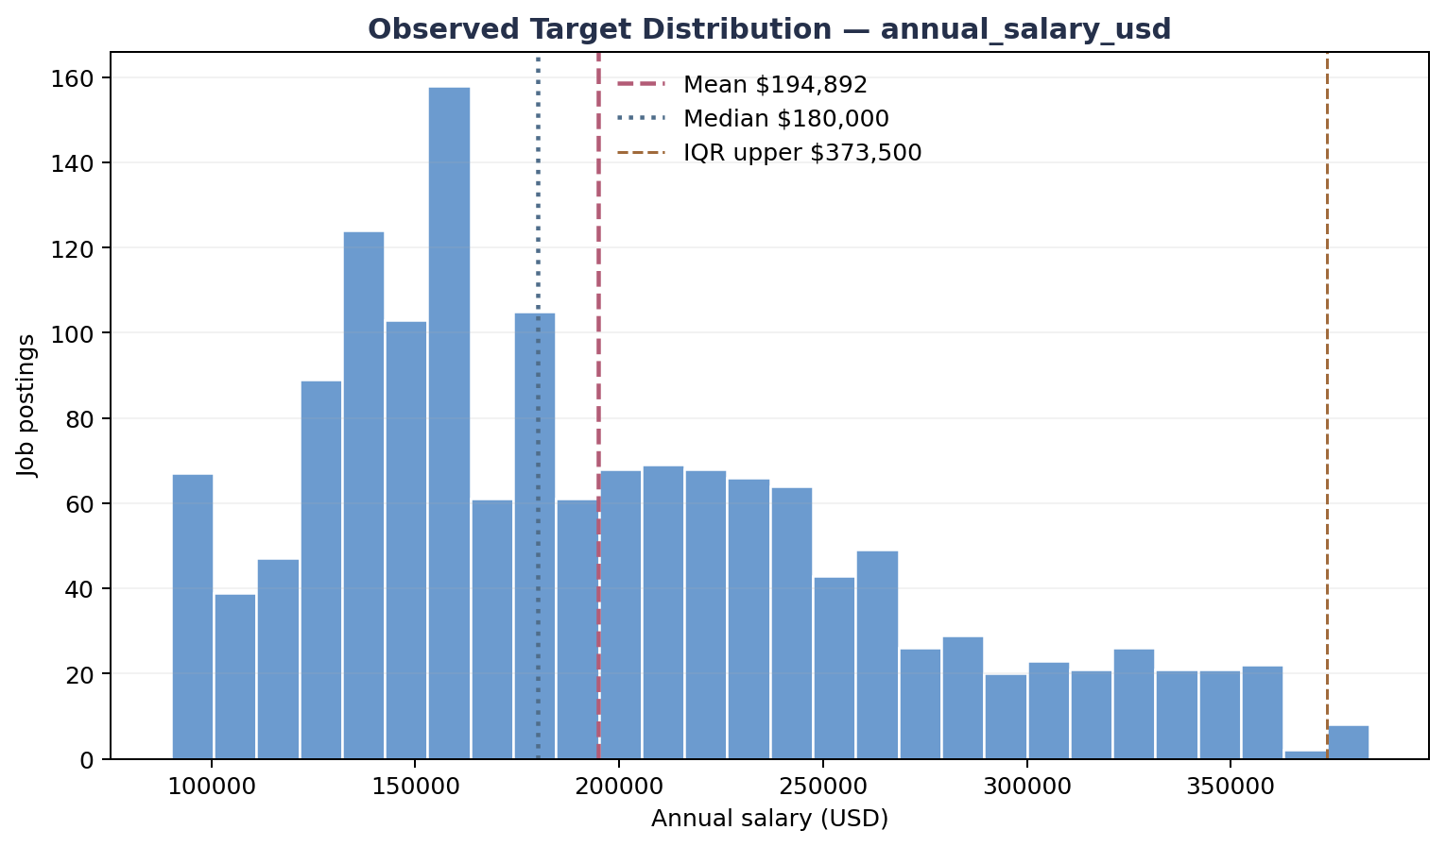
Figure 2. Raw target distribution with mean, median and IQR review threshold.
Target profile: range $90,000–$384,000; mean $194,892; median $180,000; standard deviation $66,507; IQR flags 8 high-end records.
Data-quality conclusion
The dataset has 0 missing cells and 0 duplicate rows, yet category-level auditing finds one literal header token ('job_category') inside AI Engineering. Stage 04 removes only this confirmed row, leaving 1,499 canonical rows.

3. Contradictory-Feature Investigation — Stage 05
74.2%  Experience mismatch | 40.8%  Salary outside min/max | 72.4%  Salary-tier mismatch | 7.9%  Duplicate-skill rows

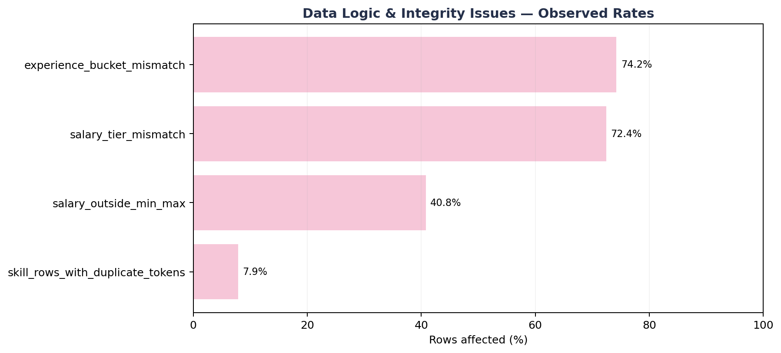
Figure 3. Observed logic/integrity issue rates.
Decision
experience_level is quarantined because its semantics disagree with years_of_experience in 74.2% of clean rows. salary_min_usd, salary_max_usd and salary_tier are blocked as target-adjacent/leakage-prone fields. years_of_experience is retained only with ablation evidence and cautious interpretation.

4. Data Ready for Machine Learning — Stages 06–08
1201  TRAIN / DEV | 298  Locked TEST | 93  Skill vocabulary | 185  Encoded features

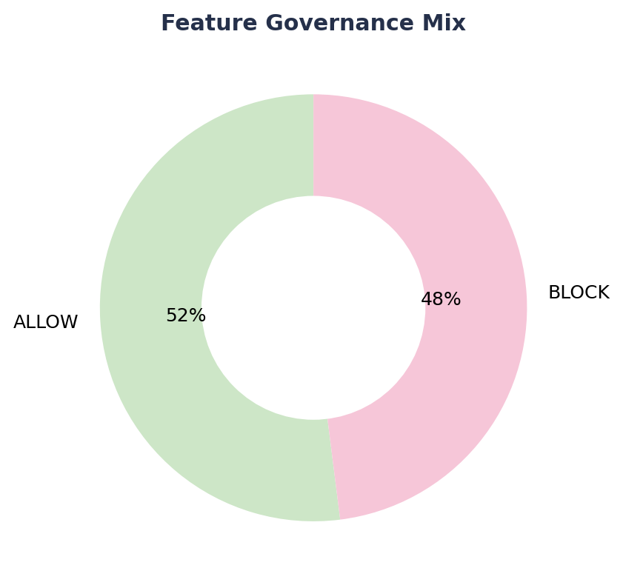
Figure 5. Feature governance mix.
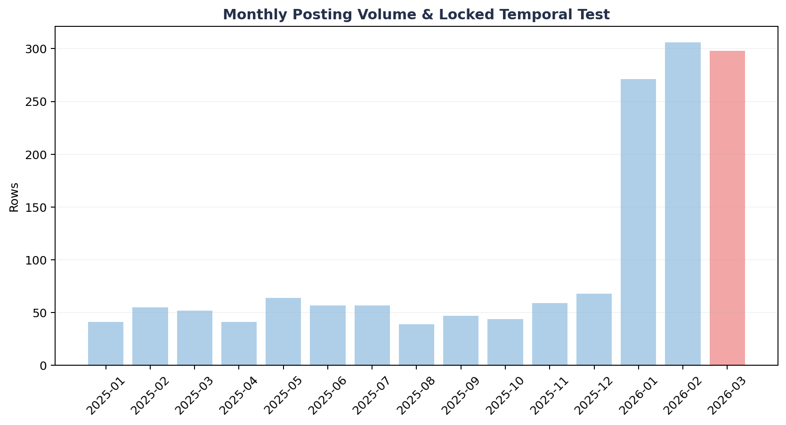
Figure 6. Monthly temporal split; March 2026 is locked.
Allowed serving feature families: job_title, job_category, years_of_experience, education_required, city, country, remote_work, company_size, industry, demand_score, benefits_score_10, required_skills (multi-hot), and skill_count.
Leakage-safe preprocessing
Preprocessing fit scope: TRAIN/DEV only; locked test transformed only. The locked test is transformed only after DEV fitting and is never used for Stage-09 comparison/tuning.

5. Correlation, VIF & Skill Analysis — Stage 07
185  Encoded fields | 0.807  Strongest |Pearson| | 93  Skill tokens | 63  Skills <50 records

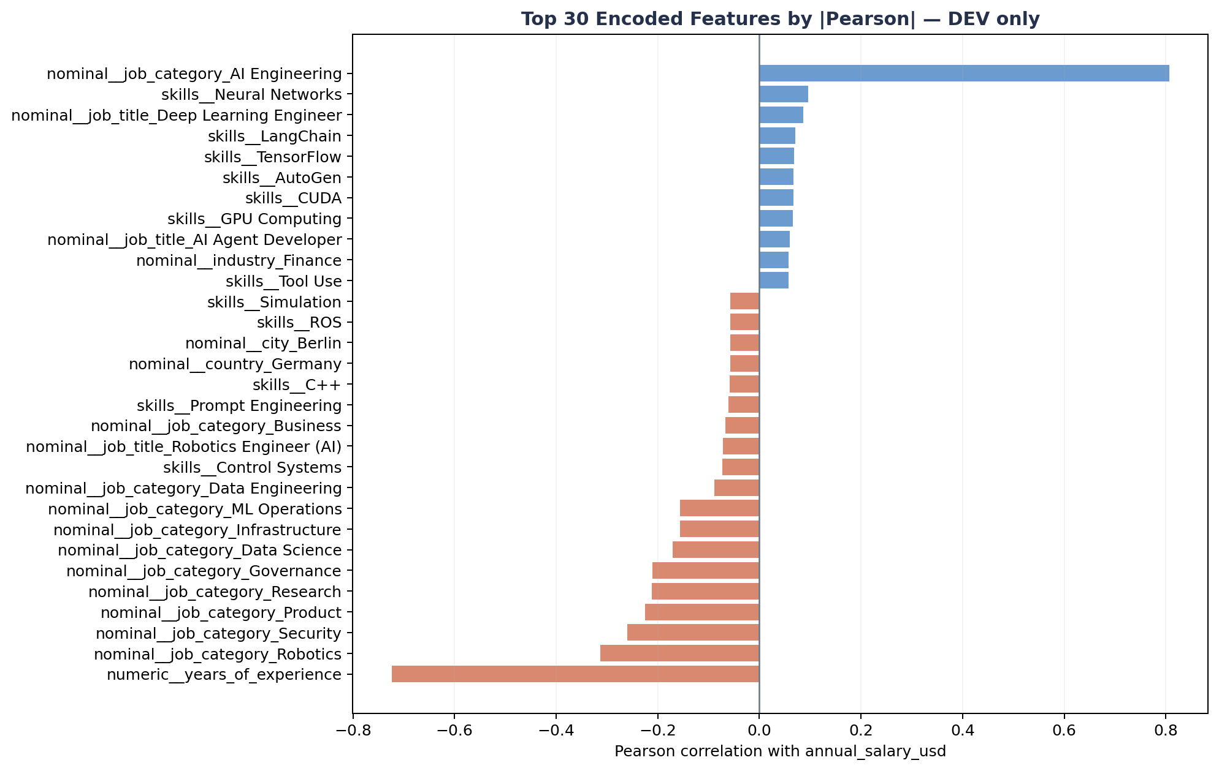
Figure 7. Top encoded features by absolute Pearson correlation — DEV only.
Interpretation
Pearson/Spearman and VIF are diagnostic tools, not automatic keep/drop rules. Correlation is association, not causality; multi-hot skill vocabulary is learned only from DEV/fold training data.

6. Model Training & Comparison — Stage 09
Random Forest  Selected family | $12,594  CV MAE | $22,923  CV RMSE | 0.878  CV R² | $2,887  CV MAE std

Model | CV MAE | CV RMSE | CV R² | MAE std
Random Forest | $12,594 | $22,923 | 0.878 | $2,887
Gradient Boosting | $14,408 | $25,587 | 0.853 | $1,498
Ridge Regression | $25,489 | $35,236 | 0.718 | $3,220
Linear Regression | $28,827 | $38,680 | 0.658 | $3,380
SVR (RBF) | $53,564 | $67,916 | -0.040 | $5,117
Dummy Median | $54,177 | $68,493 | -0.058 | $5,071

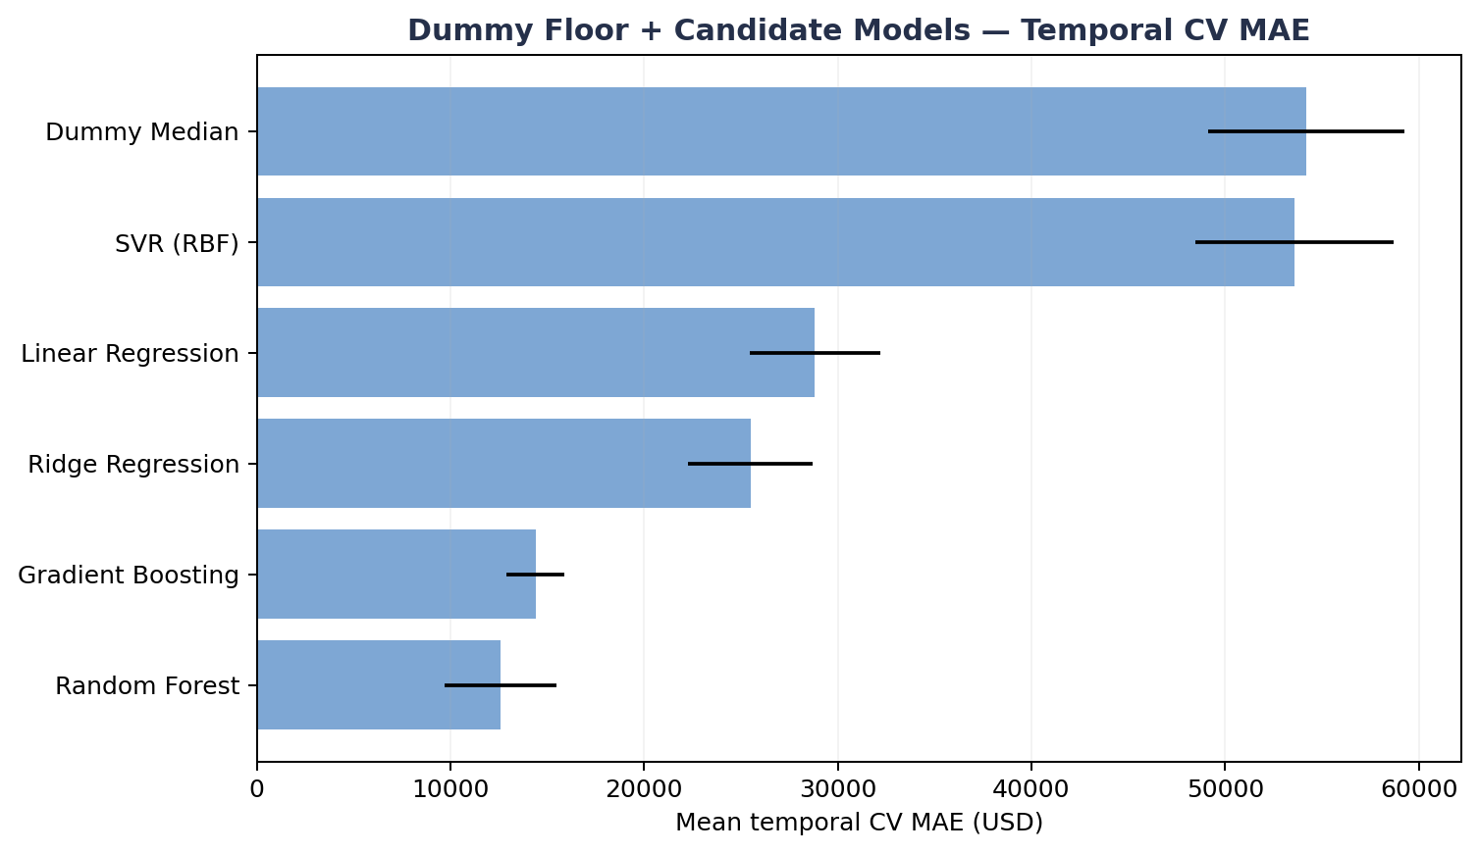
Figure 9. Dummy floor + five candidate models by mean temporal-CV MAE.
Selection rule
Random Forest is selected using the lowest mean temporal-CV MAE on the development period. The locked March-2026 test is not used to choose the model family.

7. Best Model & Importance Review — Stage 10
Random Forest  Best model | $15,054  MAE | $29,993  RMSE | 0.801  R² | $4,440  MedAE

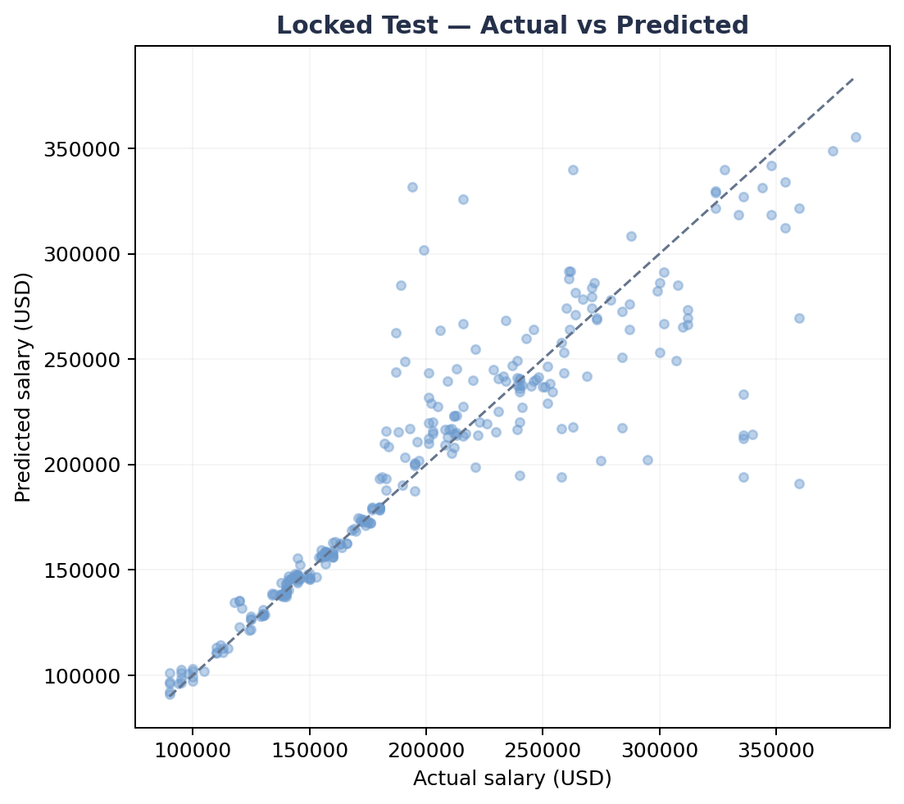
Figure 11. Locked-test actual versus predicted salary.
Scientific boundary
Strong R²/importance is evidence of fit to this supplied dataset, not proof that the learned relationships are faithful real-world salary economics. The source contains strong contradictory and synthetic-looking signals.

8. Deployment & Salary Prediction — Stages 11–12
PASS  Bundle reload | $197,798  Mean prediction | $194,000  Median prediction | $33,464  90% half-width | Random Forest  Model

Artifact | Purpose
model_bundle.joblib | Full preprocessing + estimator serving bundle
preprocessor.pkl | Fitted preprocessing object
model.pkl | Final fitted estimator
feature_columns.json | Exact raw serving feature contract
metadata.json | Categories, ranges, skills, interval and limitations
11_bundle_equivalence.json | Reload-equivalence gate

Deployment gate
Bundle reload equivalence = PASS; max absolute prediction difference = 0.0. Streamlit uses the exact saved bundle and metadata.

The empirical interval is based on the 90th percentile of absolute out-of-fold development residuals; it is a practical error band, not a formal confidence guarantee. Cost-of-living adjustment is not implemented because the supplied data contains no verified cost-of-living index.

9. Overall Conclusion, Limitations & Run Guide
- Data basic clean: 1,500 raw rows → 1,499 canonical rows after one confirmed corrupted categorical row is removed.
- Data ready for ML: 1,201 DEV rows, 298 March-2026 locked-test rows, 93 DEV-only skill tokens, 185 encoded features.
- Model comparison: Random Forest selected by lowest mean temporal-CV MAE ($12,594).
- Final locked test: MAE $15,054, RMSE $29,993, R² 0.801, MedAE $4,440.
- Prediction interval: empirical ±$33,464; deployment reload-equivalence = PASS.
Do not over-claim
This project is suitable for supervised-regression learning, data-quality and ML-system design, and controlled scenario exploration. External verified job-posting data is required before operational compensation decisions.

Run guide
1. pip install -r requirements.txt
2. python pipeline.py (or python pineline.py)
3. pytest -q
4. streamlit run streamlit.py

Streamlit structure
1. Data basic clean (Stages 01–05) | 2. Data ready for ML (06–08) | 3. Model comparison (09) | 4. Best model (10–11) | 5. Salary prediction (12) | 12-stage pipeline

References
• Supplied Technical Specification Design — Document_QD Project KHDL&AI.
• Supplied ai_jobs_market_2025_2026.csv.
• Chip Huyen (2022), Designing Machine Learning Systems.
• Cranes Varsity course materials on ML, regression/classification, and feature engineering/data analysis.

