Fönn

Hinrik Frank

Story:
you've crash landed in snowy mountains and with only a small cabin in the vicinity.
You need to cut down trees to get firewood so you don't freeze.
There's a radio but it doesn't have power, you have to fix the generator.
The radio doesn't have signal, you need to fix the antenna.
After you fix the radio you call for help and the game ends.

Mechanics:
Starting a fire in the cabin
Cutting down wood to keep the fire going
Fixing the generator with parts from the plane
Fixing the antenna with parts form the plane

Environment:
snowy mountains
cabin
generator
trees
volumetric snow
snowfall
plane

Plan:
1. Terrain
2. Basic Player
3. Environment
4. Mechanics
5. Better Player
6. Graphics
7. Audio
8. Polish

Tools:
Godot
Terrain3D
Jolt Physics
Blender

Atriði svör
1. An axe and fire starters would be at the cabin but parts to fix things would be gotten from the plane.
2. The game takes place on one mountain which is fairly large.

Skilaverkefni 2 Progress

- Created snowy mountain terrain with terrain3d.
- Created snow that compacts when you walk on it.
- Made basic cabin, fireplace and radio tower models in blender.
- Made a basic first person player character controller.
- Added basic climbing functionality to the player

I've mainly been setting up the environment and creating models which takes quite a lot of time so i haven't started on any of the mechanics.

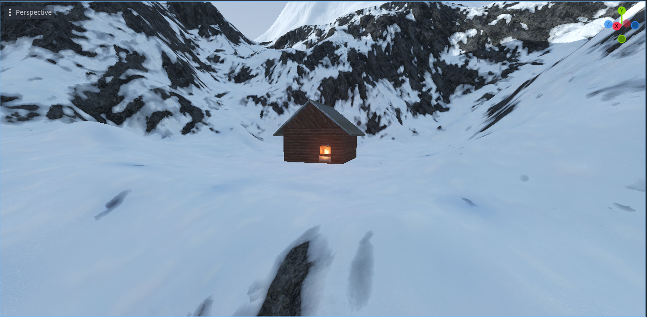
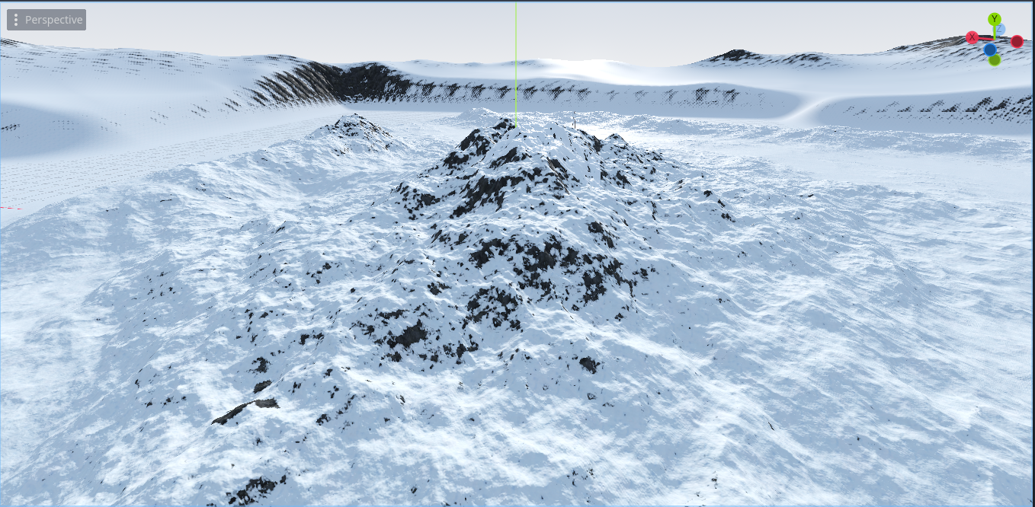

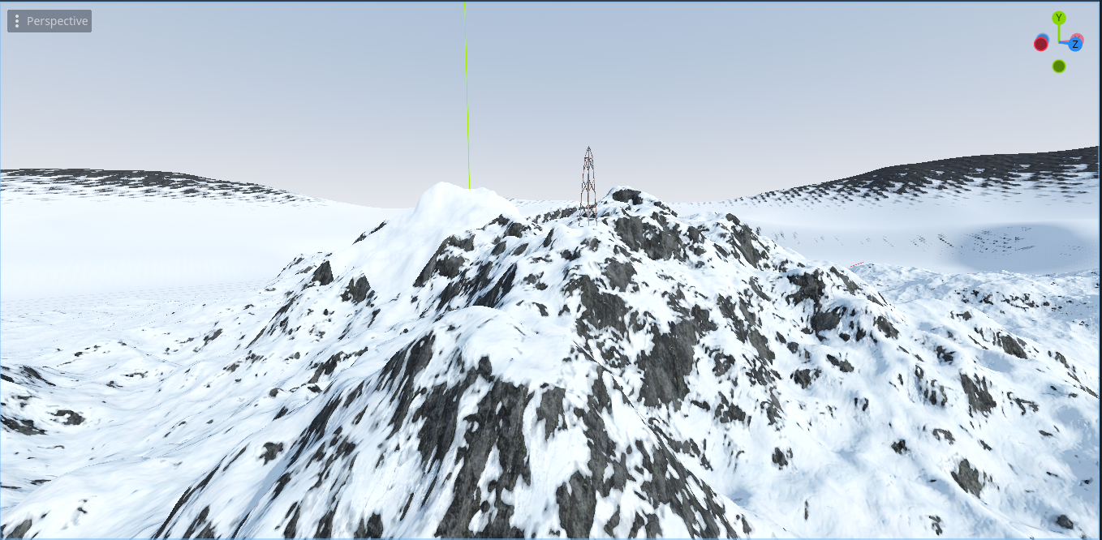
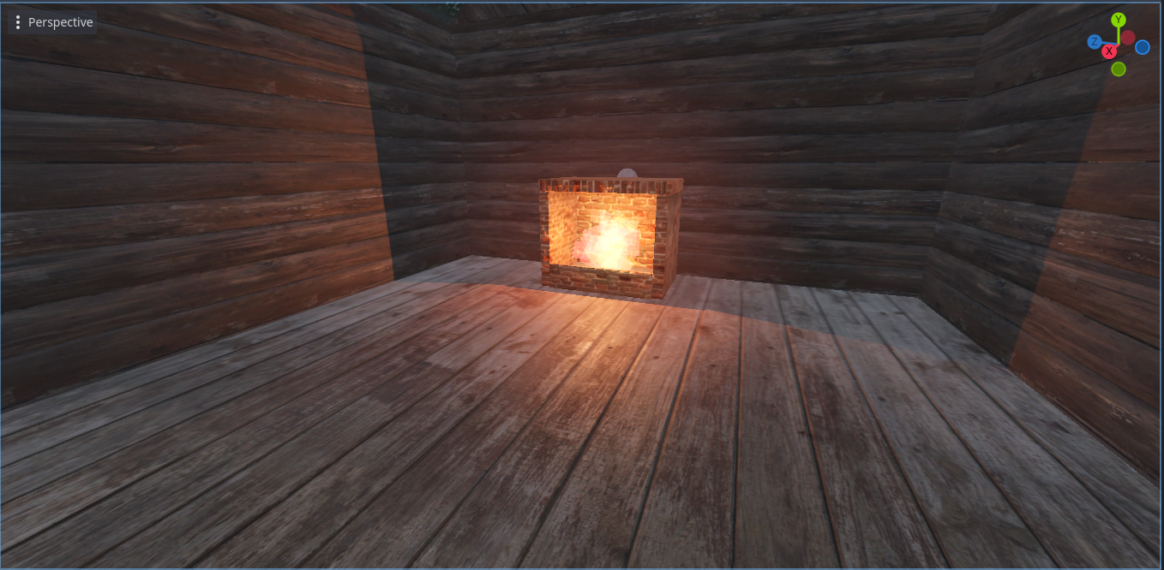

Skilaverkefni 3 Progress

- Created tree models
- Added Trees you can cut down to get wood
- Added a generator that you can fix with parts and then turn on
- Worked on mechanics like cabin warmth
- Tried to fix some performance issues
I need to continue with the mechanics to get it playable and create a model for the plane crash to get parts from. I also need to add audio and maybe some visual effects for atmosphere.
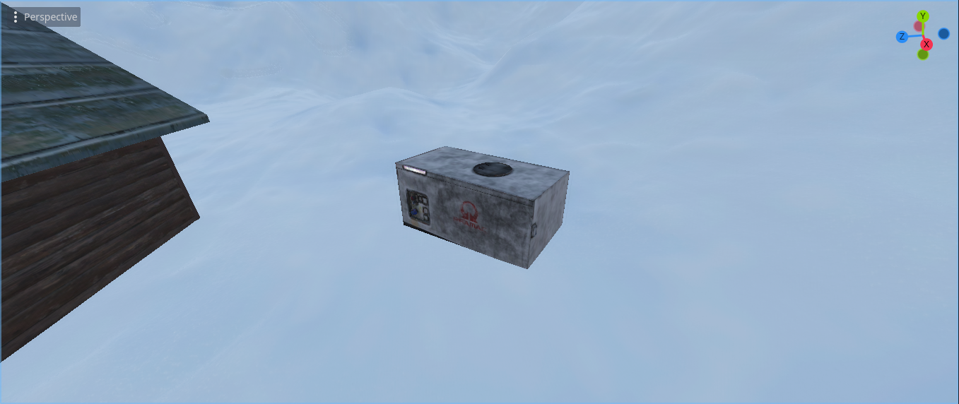
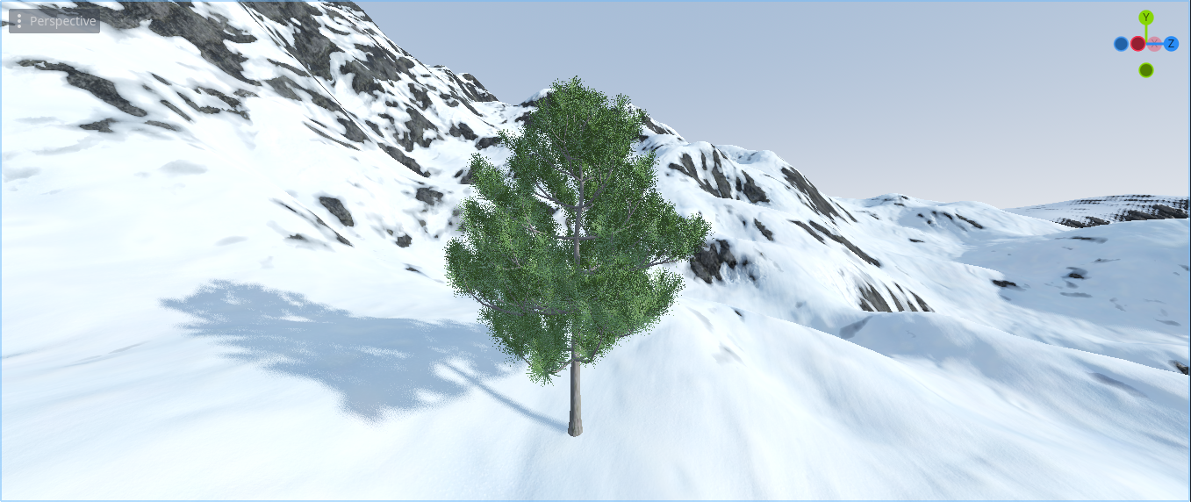

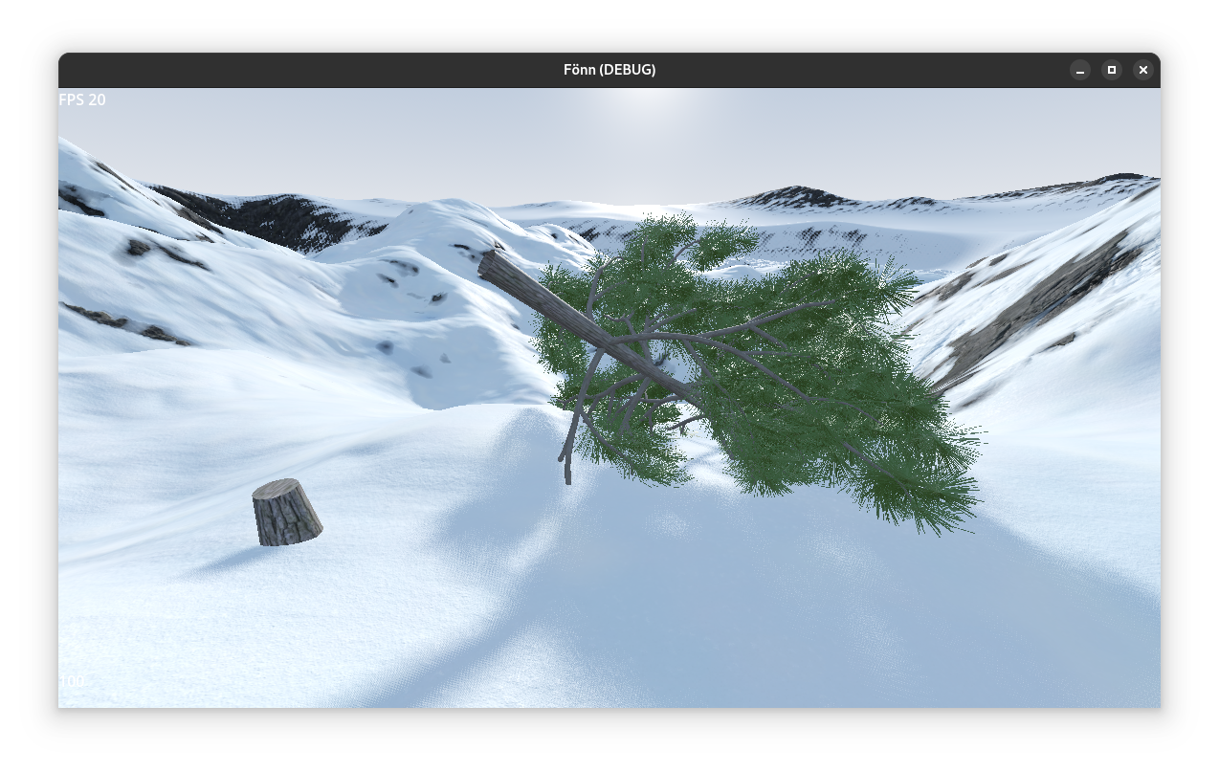

Skilaverkefni 4 Progress

- added radio and table models to cabin
- made the fireplace interactable so you can light a fire if you have wood
- added a placeholder plane where you get parts from
- made it so that you need to fix the radio tower and turn on the generator to use the radio
- added sounds to the generator and fireplace
- added ui for interactables
- improved the look of the sky and added daytime progression

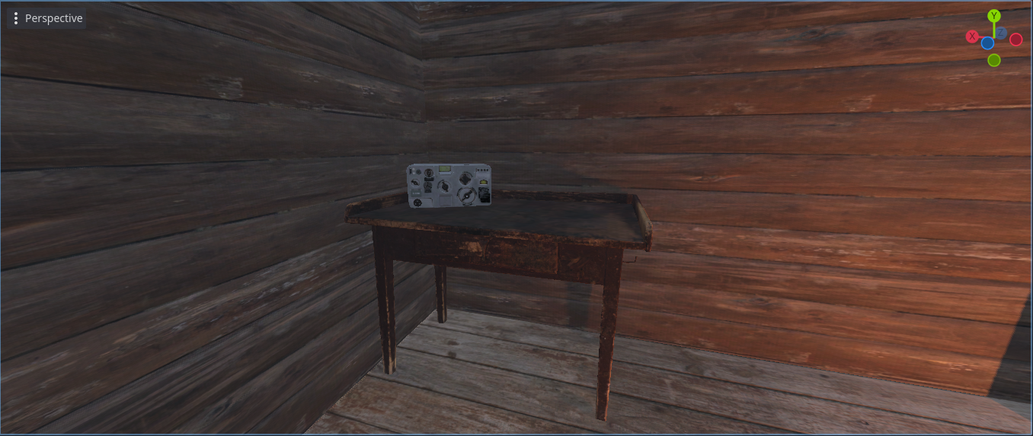
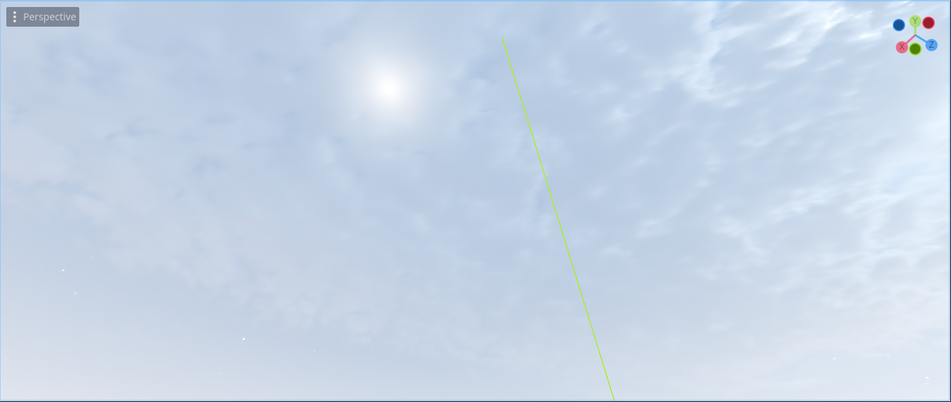

By the end of the project I'm hoping to have finished all the functionality for the current mechanics and to add a few more such as sleeping to pass the night. I also want to add some ambient sounds such as wind and improve the visuals a bit with stars at night and different weather. i also need to model the plane crash wreckage and possibly a player model if i have time.

