E-commerce Customer Analytics
Analysing purchasing behaviour, revenue drivers and service quality for a Southeast-Asian online retailer using Python and Pandas
Project Report
Prepared by: Sak
September 2026
Tools: Python 3 · Pandas · NumPy · Matplotlib · Seaborn · SciPy · Jupyter · Git/GitHub

Table of Contents

1. Problem Definition and Project Scope

1.1 Business problem
An online retailer selling across seven Southeast-Asian markets (Cambodia, Thailand, Vietnam, Singapore, Malaysia, the Philippines and Indonesia) has grown quickly but has never analysed its order history systematically. Management does not know which products, customer groups and markets actually drive revenue, whether customers come back after their first purchase, or why some customers leave poor reviews and return products. Marketing budget is spread evenly across channels and product categories, and inventory and logistics decisions are made on intuition.
This project converts the raw order log into evidence-based answers to those questions, so that the business can focus its marketing, inventory and logistics efforts where they will have the most impact.

1.2 Project scope
In scope.
- Order-level transaction data from 1 January 2024 to 30 June 2025 (18 months): 2,045 raw records, 1,972 after cleaning.
- Customer attributes attached to every order: age, gender, country, city, sign-up date, loyalty segment and acquisition channel.
- Order attributes: product category, quantity, unit price, discount, shipping cost, payment method, device, delivery time, order status and review rating.
- Data preparation (missing values, duplicates, validation, feature engineering), descriptive and statistical analysis, and visualisation with Pandas, Matplotlib and Seaborn.
Out of scope.
- Product-level (SKU) analysis — data is aggregated at category level.
- Cost of goods, profit margin and marketing spend — not available in the dataset, so results are expressed in revenue terms.
- Predictive or machine-learning modelling — this project is descriptive and diagnostic.
- Web-analytics events such as page views and cart abandonment — only completed orders are analysed.

2. Objectives and Analytical Questions

2.1 Measurable objectives
# | Objective | Success measure
O1 | Identify the main revenue drivers across product categories, customer segments, countries and acquisition channels. | Revenue share (%) per group; identification of the groups that together produce at least 80 % of revenue.
O2 | Measure customer retention and value concentration. | Repeat-purchase rate (%); share of revenue from the top 20 % of customers; share of customers flagged as churn-risk.
O3 | Diagnose service-quality problems by testing whether delivery speed and returns relate to satisfaction. | Correlation coefficient between delivery days and review rating (with p-value); mean rating by delivery-time band; return rate per category.

2.2 Analytical questions
# | Question | Pandas technique
Q1 | Which product categories generate the most revenue, and which have the highest return rates? | groupby + agg, sorting
Q2 | How do customer segments (New / Regular / VIP) differ in order frequency, order value and total spend? | groupby, customer-level table
Q3 | How do orders and revenue trend month by month — is there seasonality? | time-series groupby, pivot_table
Q4 | Which countries and acquisition channels bring the most valuable customers? | groupby, pivot_table with margins
Q5 | Does delivery time affect the review rating customers give? | filtering, pd.cut, correlation
Q6 | What share of customers are repeat buyers, and how many are at risk of churning? | customer aggregation, RFM-style flags
Q7 | Do device usage and payment preferences differ across age groups? | crosstab

3. Dataset Preparation
The dataset was produced by the reproducible script src/generate_dataset.py (random seed 42). It simulates 2,000 orders from roughly 720 active customers with realistic structure: seasonal demand peaking in November–December, purchase frequency that depends on loyalty segment (VIP customers order more often), category-specific price levels and return rates, free shipping above $120, and a review rating that deteriorates as delivery time grows. The script then deliberately injects the kinds of data-quality problems found in real exports: missing values in several columns, 45 exact duplicate rows, 25 out-of-range numbers (negative ages, quantities of zero, discounts above 100 %, ratings of 0 or 7), and inconsistent spelling of categories (lower-case, extra whitespace, F/M abbreviations).
The raw file data/raw/ecommerce_orders_raw.csv therefore contains 2,045 rows and 20 columns; after cleaning, data/processed/ecommerce_orders_clean.csv contains 1,972 rows and 31 columns (20 original plus 11 derived). This comfortably exceeds the 1,000-row target and provides enough volume for segment-level analysis.

4. Data Dictionary
Each row represents one order. Customer attributes are repeated on every order placed by the same customer.
Field | Type | Description | Example
order_id | string | Unique order identifier | ORD100305
order_date | date | Date the order was placed | 2024-04-25
customer_id | string | Unique customer identifier (repeats across orders) | C1122
age | integer | Customer age in years (valid 18–100) | 36
gender | category | Female / Male | Male
country | category | Customer's country (7 markets) | Cambodia
city | category | Customer's city | Phnom Penh
signup_date | date | Account registration date | 2024-03-21
customer_segment | category | Loyalty tier: New, Regular, VIP | VIP
acquisition_channel | category | Organic Search, Social Media, Email, Paid Ads, Referral | Referral
product_category | category | Electronics, Fashion, Home & Kitchen, Beauty, Sports, Books, Toys | Beauty
quantity | integer | Units ordered (valid 1–50) | 1
unit_price | float | Price per unit in USD (> 0) | 37.40
discount_pct | float | Discount applied (0–100 %) | 5.0
shipping_cost | float | Shipping fee in USD; 0 above $120 basket | 9.99
payment_method | category | Credit Card, E-Wallet, Bank Transfer, Cash on Delivery, PayPal | Credit Card
device_type | category | Mobile, Desktop, Tablet | Desktop
delivery_days | float | Days to delivery (0–30); blank if cancelled | 7.0
order_status | category | Delivered, Cancelled, Returned | Returned
review_rating | float | Star rating 1–5; blank if no review | 3.0

Derived columns (created in Section 9)
Field | Type | Formula / description | Example
gross_amount | float | quantity × unit_price | 37.40
discount_amount | float | gross_amount × discount_pct / 100 | 1.87
total_amount | float | gross_amount − discount_amount + shipping_cost | 45.52
net_revenue | float | total_amount if Delivered, otherwise 0 | 0.00
customer_tenure_days | integer | order_date − signup_date, in days | 35
age_group | category | 18-24, 25-34, 35-44, 45-54, 55+ | 35-44
order_value_tier | category | Low (<$50), Medium ($50-150), High ($150-400), Premium (>$400) | Low (<$50)
order_month | string | YYYY-MM of order_date | 2024-04
order_weekday | string | Day of week | Thursday
is_returned | 0/1 | 1 if order_status is Returned | 1
has_review | 0/1 | 1 if review_rating is present | 1

5. Loading and Exploring the Dataset with Pandas
The raw CSV was loaded with pd.read_csv(), parsing order_date and signup_date as dates. The structure was examined with df.head(), df.shape, df.columns, df.info() and df.describe().
Command | Result
df.shape | (2045, 20)
df.columns | 20 columns as listed in the data dictionary
df.info() | 2 datetime, 6 float, 1 integer and 11 text columns; non-null counts reveal gaps in age (1,984), city (2,015), unit_price (2,025), payment_method (2,004), delivery_days (1,907) and review_rating (1,264)
df.describe() | age min −5 / max 210; quantity min −2; discount_pct max 150; unit_price min −100; delivery_days −3 to 60; review_rating 0 to 7
df.describe(include='object') | product_category shows more than the 7 expected unique values; gender shows 4 values instead of 2
Interpretation. The exploration step immediately exposes every category of data-quality problem: missing values, impossible numeric values and inconsistent categorical spelling. It also shows that the two most 'missing' columns — delivery_days and review_rating — are missing for structural reasons (cancelled orders and customers who chose not to review), which shapes the handling strategy in the next section.

6. Identifying and Handling Missing Values
Missing data was audited with df.isnull().sum() and df.isna().mean(). A crosstab of order_status against whether review_rating is missing showed that 100 % of cancelled orders have no rating and no delivery time, while about one third of delivered and returned orders have no rating.
Column | Missing (raw) | Handling method | Rationale
review_rating | 781 (38.2 %) | Keep as NaN | Structural — no review was left. Imputing would fabricate opinions; analyses of rating use only rated orders.
delivery_days | 138 (6.7 %) | Keep NaN for cancelled orders; median for the 3 non-cancelled gaps | A cancelled order is never delivered, so a value would be meaningless.
age | 61 (3.0 %) | Median imputation | Numeric with outliers; the median is robust to the extreme invalid ages.
payment_method | 41 (2.0 %) | Mode imputation | Categorical; the most frequent value is the best single guess and only 2 % of rows are affected.
city | 30 (1.5 %) | Mode within country | City depends on country, so the most common city of the same country is more accurate than a global mode.
unit_price | 20 (1.0 %) | Row removal | Price is needed to compute revenue; imputing it would invent revenue. Loss of 1 % of rows is acceptable.
Interpretation. The key decision is to distinguish structural blanks (which are information) from accidental blanks (which are errors). Imputation was applied after de-duplication and validation so that duplicate rows and impossible values could not distort the medians and modes used for filling. After processing, the only remaining NaNs are the structural ones.

7. Identifying and Handling Duplicate Records
Before checking for duplicates, product_category was normalised with .str.strip().str.title() and gender abbreviations F/M were expanded, so that rows differing only in capitalisation or whitespace would be recognised as the same record. df.duplicated() then found 45 exact duplicate rows, and df.duplicated(subset='order_id') found the same 45 order IDs — confirming they were pure double-exports rather than genuine repeat orders.
Metric | Value
Rows before de-duplication | 2,045
Exact duplicate rows found | 45
Duplicate order_id values found | 45
Rows remaining after drop_duplicates() | 2,000
Rows remaining after validation (Section 8) | 1,972
Interpretation. Removing the 45 duplicates prevents double-counting of roughly 2 % of revenue. The check that order_id is unique after cleaning is enforced with an assert statement so the notebook fails loudly if the problem ever reappears.

8. Data Validation
Validation covered four aspects: data types (df.dtypes), categorical domains (isin() against the allowed lists), numeric ranges against explicit business rules, and a logical rule that an order cannot be placed before the customer's sign-up date.
Column | Allowed range | Observed min | Observed max | Invalid rows
age | 18 – 100 | −5 | 210 | 6
quantity | 1 – 50 | −2 | 5 | 5
unit_price | 0.01 – 5000 | −100.00 | ≈ 830 | 3
discount_pct | 0 – 100 | −10 | 150 | 4
shipping_cost | 0 – 100 | 0 | 9.99 | 0
delivery_days | 0 – 30 | −3 | 60 | 3
review_rating | 1 – 5 | 0 | 7 | 4

Category domains were valid after text normalisation (0 invalid categories, statuses or genders) and no order was dated before its customer's sign-up. The 25 out-of-range values are physically impossible, so they were treated as missing. Rows with an unusable quantity or unit_price (28 rows, including the 20 originally missing prices) were dropped because revenue cannot be computed for them; the remaining gaps were imputed as described in Section 6, invalid discounts were set to 0 (no discount), and columns were cast to their proper types (integer for age and quantity, category for all categorical fields).
Interpretation. After validation the dataset contains 1,972 orders with values that all fall inside their business rules. The validation report is produced programmatically so it can be re-run on any future export.

9. Derived and Calculated Columns
Eleven new columns were created (see the data dictionary). The most important are total_amount — the amount actually paid, computed as quantity × unit_price − discount + shipping — and net_revenue, which equals total_amount for delivered orders and 0 for cancelled or returned orders, because those are refunded. customer_tenure_days measures how long the customer had been registered when ordering; age_group and order_value_tier bin continuous variables into readable bands with pd.cut(); order_month supports time-series grouping; and is_returned / has_review are 0/1 flags that make rates easy to compute with .mean().
A customer-level table was also built with groupby('customer_id') (function build_customer_table in src/data_cleaning.py), containing total orders, total spend, average order value, return rate, average rating, recency in days, a repeat-buyer flag and a churn-risk label (High if no order in more than 180 days, Medium for 91–180 days, Low otherwise).

10. Data Analysis with Pandas

10.1 Overview KPIs
KPI | Value
Total valid orders | 1,972
Unique customers | 721
Delivered orders | 1,629 (82.6 %)
Net revenue | $227,155
Average order value | $136.47
Median order value | $75.73
Return rate | 10.8 %
Cancellation rate | 6.6 %
Average review rating | 3.55 / 5
Review response rate | 62 %
Interpretation. The mean order ($136) is almost double the median ($76), signalling a right-skewed distribution driven by a minority of large Electronics orders. About 17 % of orders (returned plus cancelled) produce no revenue — a leakage worth investigating.

10.2 Q1 — Revenue and returns by product category (groupby, sorting)
Category | Orders | Net revenue | Avg order value | Revenue share | Return rate | Avg rating
Electronics | 466 | $122,245 | $303.56 | 53.8 % | 10.1 % | 3.60
Home & Kitchen | 332 | $32,603 | $121.05 | 14.4 % | 10.5 % | 3.59
Fashion | 397 | $27,946 | $88.92 | 12.3 % | 13.6 % | 3.54
Sports | 203 | $18,471 | $110.59 | 8.1 % | 12.3 % | 3.52
Beauty | 262 | $12,468 | $56.59 | 5.5 % | 10.7 % | 3.38
Toys | 144 | $8,605 | $63.07 | 3.8 % | 6.2 % | 3.67
Books | 168 | $4,817 | $34.58 | 2.1 % | 8.3 % | 3.51
Interpretation. Electronics alone produces 54 % of net revenue from 24 % of orders because its average order is 2.5–9 times larger than other categories'. Electronics, Home & Kitchen and Fashion together deliver about 80 % of revenue (objective O1). Fashion has the highest return rate (13.6 %) followed by Sports (12.3 %), while Toys and Books are returned least. Fashion's combination of meaningful revenue and the highest return rate makes it the priority for product-page and sizing improvements.

10.3 Q2 — Customer segments (groupby, derived ratios)
Segment | Customers | Orders | Orders / customer | Net revenue | Revenue share | Revenue / customer | Avg discount
VIP | 167 | 807 | 4.83 | $90,016 | 39.6 % | $539 | 9.2 %
Regular | 325 | 795 | 2.45 | $94,706 | 41.7 % | $291 | 7.3 %
New | 229 | 370 | 1.62 | $42,433 | 18.7 % | $185 | 8.0 %
Interpretation. VIP customers are 23 % of the customer base but generate 40 % of revenue, placing 4.8 orders each versus 1.6 for New customers. Average order value is almost identical across segments, so the difference in lifetime value comes from purchase frequency rather than basket size. VIPs also receive the largest average discount, which should be monitored to protect margin.

10.4 Q3 — Monthly trend (time-series groupby, pivot_table)
Month | Orders | Net revenue | Month | Orders | Net revenue
2024-01 | 75 | $7,360 | 2024-10 | 103 | $13,683
2024-02 | 66 | $6,958 | 2024-11 | 172 | $18,854
2024-03 | 75 | $8,069 | 2024-12 | 183 | $28,225
2024-04 | 101 | $13,645 | 2025-01 | 96 | $10,500
2024-05 | 125 | $13,576 | 2025-02 | 77 | $8,310
2024-06 | 113 | $15,271 | 2025-03 | 95 | $11,048
2024-07 | 110 | $12,102 | 2025-04 | 93 | $8,263
2024-08 | 137 | $12,444 | 2025-05 | 109 | $12,371
2024-09 | 119 | $16,058 | 2025-06 | 123 | $10,417
Interpretation. Orders grew through 2024 and peaked in November–December: December 2024 produced 183 orders and $28.2 k, roughly 2.4 times the monthly average of the first quarter. Revenue fell 63 % month-on-month in January 2025 — the post-holiday trough — and then recovered to slightly above the same months of 2024. A month × category pivot table shows the December spike is driven mainly by Electronics.

10.5 Q4 — Countries and acquisition channels (groupby, pivot_table with margins)
Country | Customers | Orders | Net revenue | Revenue share | Avg order value | Revenue / customer
Cambodia | 231 | 616 | $78,455 | 34.5 % | $148.39 | $340
Thailand | 124 | 361 | $44,490 | 19.6 % | $142.20 | $359
Vietnam | 133 | 389 | $37,344 | 16.4 % | $118.90 | $281
Singapore | 78 | 209 | $23,714 | 10.4 % | $133.01 | $304
Malaysia | 66 | 170 | $17,143 | 7.5 % | $119.24 | $260
Philippines | 52 | 141 | $14,095 | 6.2 % | $132.77 | $271
Indonesia | 37 | 86 | $11,913 | 5.2 % | $155.01 | $322

Acquisition channel | Customers | Net revenue | Revenue / customer
Social Media | 198 | $65,929 | $333
Email | 110 | $35,737 | $325
Paid Ads | 134 | $43,208 | $322
Organic Search | 210 | $65,956 | $314
Referral | 69 | $16,324 | $237
Interpretation. Cambodia is the core market with 32 % of customers and 35 % of revenue; Thailand and Vietnam add another 36 %. Indonesia is the smallest market but has the highest average order value ($155), suggesting untapped potential. Social Media and Organic Search each bring about 200 customers and $66 k, while Referral customers are the least valuable at $237 each — 29 % below the average — indicating that the referral programme attracts low-spending customers.

10.6 Q5 — Delivery time versus review rating (filtering, pd.cut)
Delivery band | Reviews | Mean rating | Median rating | Std dev
1–3 days | 338 | 3.96 | 4.0 | 0.75
4–6 days | 356 | 3.65 | 4.0 | 0.80
7–9 days | 318 | 3.34 | 3.0 | 0.86
10+ days | 211 | 3.02 | 3.0 | 0.89
Interpretation. Satisfaction falls monotonically with delivery time: orders delivered within three days average 3.96 stars but those taking ten days or more average 3.02 — almost a full star lower. Returned orders are rated far worse (2.57) than delivered ones (3.69). Section 11 confirms the relationship is statistically significant (objective O3).

10.7 Q6 — Repeat purchase and churn risk (customer-level aggregation)
Segment | Customers | Repeat rate | Avg orders | Avg total spent | Avg recency (days)
VIP | 167 | 96 % | 4.83 | $539 | ≈ 100
Regular | 325 | 71 % | 2.45 | $291 | ≈ 200
New | 229 | 40 % | 1.62 | $185 | ≈ 300
All | 721 | 67.1 % | 2.74 | $315 | —
Interpretation. Two thirds of customers have ordered more than once and the top 20 % of customers account for 57 % of revenue (objective O2). However, 45 % of customers have not ordered in more than 180 days and are flagged as high churn risk, with New customers the most inactive. Win-back campaigns should target this group, while VIPs mainly need protection from lapsing.

10.8 Q7 — Device and payment preferences by age group (crosstab)
Age group | Mobile | Desktop | Tablet | Credit Card | E-Wallet | Bank Transfer | Cash on Delivery | PayPal
18-24 | 61 % | 32 % | 7 % | 33 % | 30 % | 15 % | 17 % | 4 %
25-34 | 56 % | 34 % | 10 % | 35 % | 29 % | 14 % | 18 % | 5 %
35-44 | 58 % | 34 % | 8 % | 34 % | 29 % | 17 % | 15 % | 5 %
45-54 | 64 % | 27 % | 9 % | 38 % | 25 % | 18 % | 15 % | 4 %
55+ | 60 % | 31 % | 10 % | 27 % | 38 % | 23 % | 8 % | 4 %
Interpretation. Mobile dominates every age band (56–64 % of orders) and there is no sign that older customers avoid it. Payment behaviour is more age-dependent: customers aged 55+ prefer E-Wallet and Bank Transfer and rarely use Cash on Delivery (8 % versus 15–18 % in younger groups), while Cash on Delivery is most popular among the youngest customers.

11. Statistical Analysis

11.1 Descriptive statistics
Variable | Mean | Median | Mode | Min | Max | Std dev | Variance | Skewness
total_amount ($) | 136.47 | 75.73 | 12.99 | 5.24 | 1,773.79 | 177.62 | 31,549 | 3.38
unit_price ($) | ≈ 84 | ≈ 55 | — | 3.00 | ≈ 830 | ≈ 92 | ≈ 8,500 | > 2
quantity | 1.79 | 1 | 1 | 1 | 5 | 1.05 | 1.10 | 1.4
discount_pct (%) | ≈ 8 | 5 | 0 | 0 | 35 | ≈ 9 | ≈ 80 | 1.0
delivery_days | 5.96 | 6 | — | 1 | 11 | 3.16 | 10.0 | ≈ 0
review_rating | 3.55 | 4 | 4 | 1 | 5 | 0.89 | 0.80 | −0.4
age | 34.44 | 34 | 34 | 18 | 66 | 10.03 | 100.66 | 0.2
Interpretation. total_amount is strongly right-skewed (skewness 3.4): the mean is almost double the median and the standard deviation exceeds the mean, so a few very large orders dominate the spread and the median is the better 'typical order' figure. Ratings cluster around 4, delivery takes a median of 6 days, and age is roughly symmetric around 34 years. (Values marked ≈ are approximate; exact figures are printed in the notebook.)

11.2 Correlation and hypothesis tests
Test | Result | Conclusion
Pearson correlation: delivery_days vs review_rating | r = −0.378, p ≈ 1e-42 (Spearman ρ = −0.378) | Strong, highly significant negative relationship: slower delivery → lower rating.
One-way ANOVA: rating across four delivery bands | F = 63.8, p ≈ 3e-38 | Mean ratings differ significantly between delivery-time bands.
Welch t-test: order value VIP vs New | VIP $131.61 vs New $137.24; t = −0.53, p = 0.60 | No significant difference — VIP value comes from frequency, not basket size.
Chi-square: return status vs product category | χ² = 8.18, dof = 6, p = 0.23 | Not significant at 5 %; category differences in return rate are indicative only.
Correlation matrix (9 numeric variables) | total_amount ~ unit_price 0.78, ~ quantity 0.41; all demographic correlations |r| < 0.07 | Order value is mechanical (price × quantity); age, tenure and discount do not explain spending.
Interpretation. The only substantive behavioural relationship in the data is between delivery time and satisfaction, and it is both large and statistically robust. The non-significant VIP-versus-New test and the near-zero demographic correlations are equally useful findings: they rule out basket size and age as levers and point the business toward purchase frequency and delivery speed instead.

12. Data Visualisations and Interpretation
Nine charts were produced with Matplotlib and Seaborn; each has a title and labelled axes and is interpreted below. The images are saved in outputs/figures/.
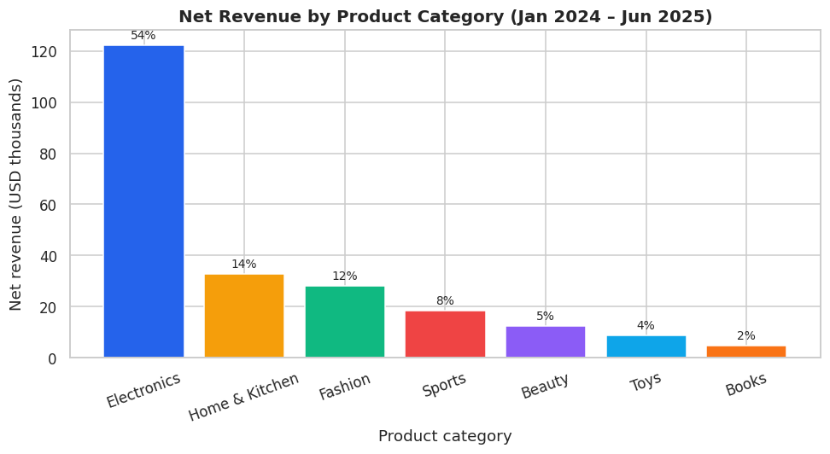
Figure 1 — Bar chart: net revenue by product category
Interpretation. Electronics towers over every other category at about $122 k (54 % of revenue); the remaining six categories share the other 46 %. Books and Toys are almost negligible in revenue terms even though they account for 16 % of orders.
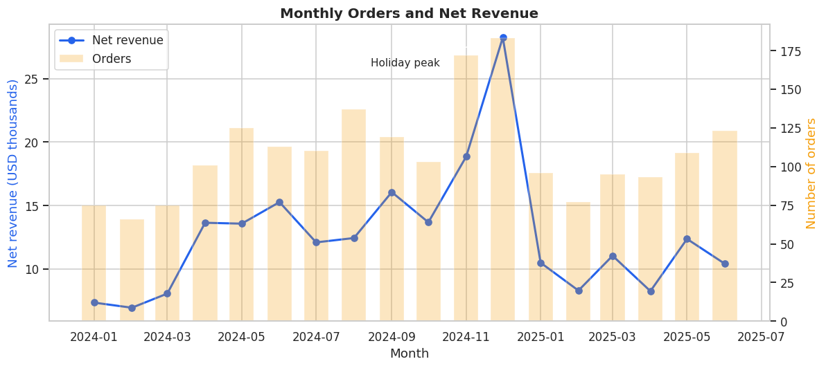
Figure 2 — Line chart: monthly orders and net revenue
Interpretation. Orders (bars) and revenue (line) rise through 2024 and spike in November–December, with December revenue roughly double a normal month. The January–February drop is the post-holiday trough, after which activity recovers slightly above the previous year's level. Revenue is more volatile than order count because a few high-value Electronics orders can swing a month.
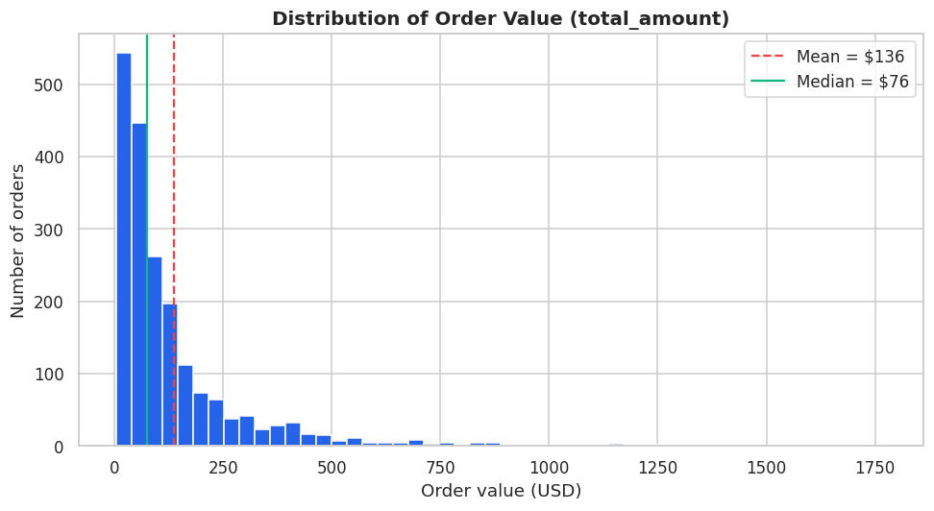
Figure 3 — Histogram: distribution of order value
Interpretation. The distribution is strongly right-skewed with a long tail: most orders are under $150, but a few exceed $500 and reach almost $1,800. The mean ($136) sits well to the right of the median ($76). Free-shipping thresholds and pricing decisions should be based on the $20–$100 range where most orders sit.
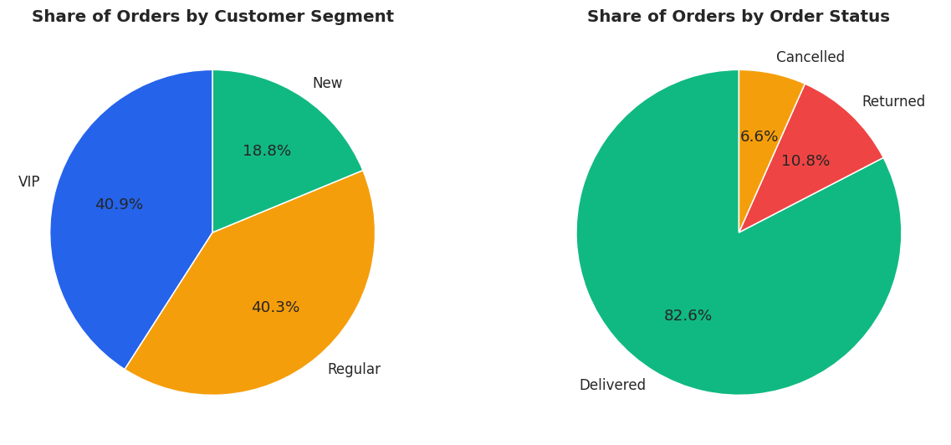
Figure 4 — Pie charts: share of orders by customer segment and by order status
Interpretation. VIPs are the smallest segment by headcount but place 41 % of all orders — as many as the much larger Regular segment — while New customers place under 19 %. The right-hand pie quantifies the revenue leakage: 17 % of orders end up returned or cancelled.
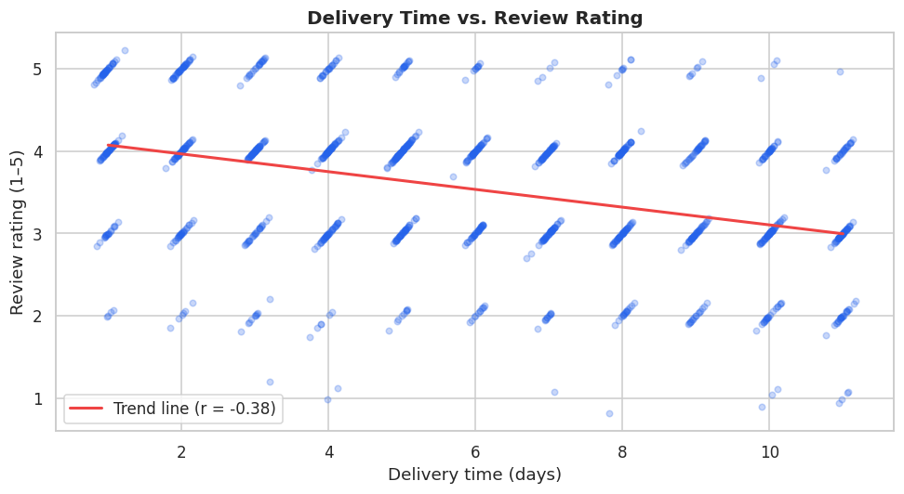
Figure 5 — Scatter plot: delivery time versus review rating
Interpretation. Each point is a reviewed order (with small jitter so overlaps are visible). The point cloud shifts from 4–5 stars at short delivery times to 2–3 stars at long delivery times, and the trend line has slope of roughly −0.1 star per day (r = −0.38). Cutting a 10-day delivery to 3 days would be expected to lift the rating by almost a full point.
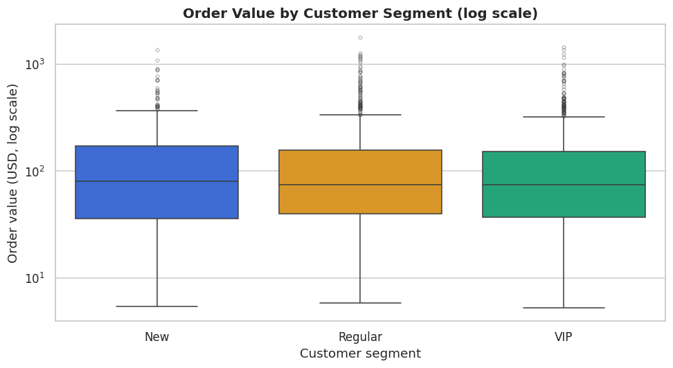
Figure 6 — Box plot: order value by customer segment (log scale)
Interpretation. The three boxes overlap almost completely: medians and inter-quartile ranges of order value are very similar for New, Regular and VIP customers. This visually confirms the t-test result — VIPs do not spend more per order; their higher lifetime value comes purely from ordering more often.
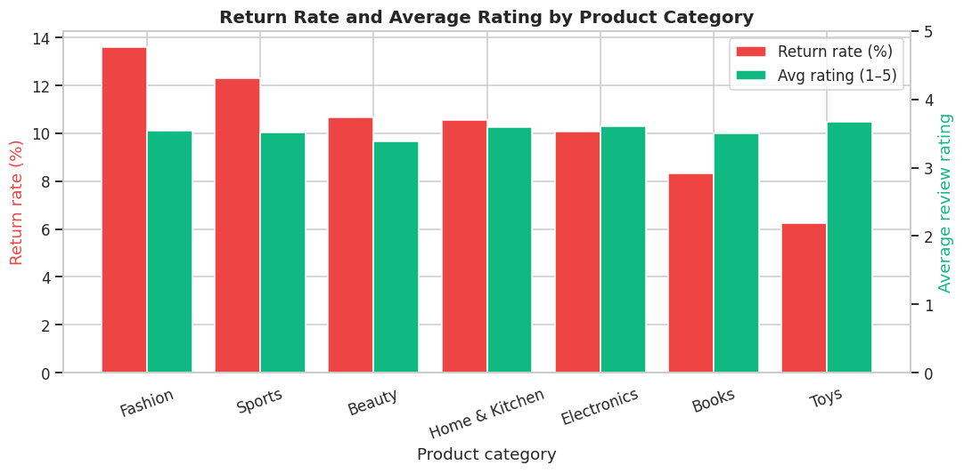
Figure 7 — Grouped bar chart: return rate and average rating by category
Interpretation. Fashion (13.6 %) and Sports (12.3 %) are returned most often, about twice the rate of Toys (6.2 %). Average ratings are fairly flat (3.4–3.7) across categories, so satisfaction differences between categories are smaller than differences in return behaviour. Fashion is the clearest operational target.
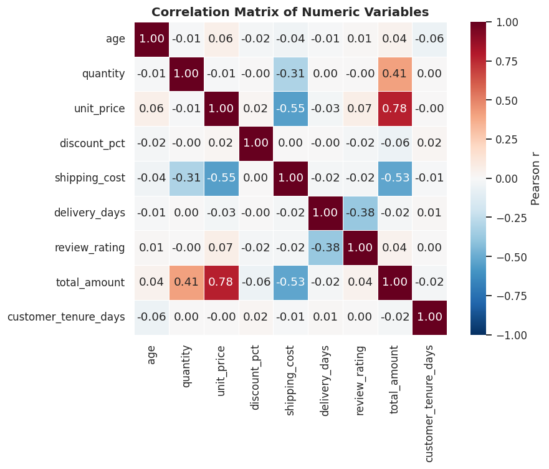
Figure 8 — Heatmap: correlation matrix of numeric variables
Interpretation. Warm cells are positive and cool cells negative correlations. The strongest relationships are mechanical (total_amount with unit_price 0.78 and quantity 0.41). The only notable behavioural correlation is delivery_days × review_rating (−0.38). Everything else is near zero — age, tenure and discount are not related to spending or satisfaction.
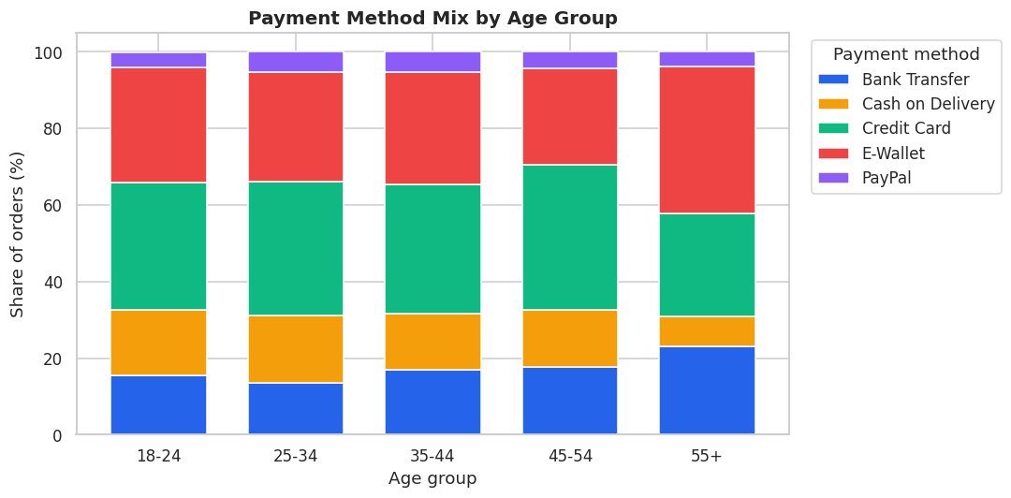
Figure 9 — Stacked bar chart: payment method mix by age group
Interpretation. Credit Card and E-Wallet cover 60–65 % of orders in every age group, but Cash on Delivery shrinks from 17 % among 18–24-year-olds to 8 % among the 55+ group, who lean on E-Wallet and Bank Transfer instead. PayPal is marginal everywhere. E-Wallet is the single option that satisfies the widest range of customers.

13. Key Findings and Recommendations

13.1 Key findings
# | Finding | Evidence
F1 | Revenue is highly concentrated in Electronics; three categories produce about 80 % of revenue. | Electronics = 54 % of net revenue from 24 % of orders; AOV $304 vs $35–$121 elsewhere (§10.2, Fig. 1).
F2 | VIP customers drive value through purchase frequency, not basket size. | 23 % of customers, 40 % of revenue, 4.8 orders each vs 1.6 for New; AOV difference not significant (p = 0.60) (§10.3, §11, Fig. 6).
F3 | Slow delivery measurably hurts customer satisfaction. | Rating 3.96 for 1–3-day delivery vs 3.02 for 10+ days; r = −0.38, p < 0.001; ANOVA significant (§10.6, §11, Fig. 5).
F4 | Almost one in five orders produces no revenue. | 10.8 % returned + 6.6 % cancelled = 17.4 %; Fashion return rate 13.6 % is the highest (§10.1–10.2, Figs. 4 & 7).
F5 | Strong year-end seasonality followed by a post-holiday slump. | December 2024: 183 orders / $28.2 k ≈ 2.4× Q1 monthly average; January revenue −63 % MoM (§10.4, Fig. 2).
F6 | Retention is good, but a large share of customers has gone quiet. | 67 % repeat rate; top 20 % = 57 % of revenue; 45 % of customers inactive > 180 days; New customers only 40 % repeat (§10.7).
F7 | Referral brings the least valuable customers; Email and Social the most. | Revenue per customer: Social $333, Email $325, Referral $237 — 29 % below average (§10.5).

13.2 Recommendations
# | Recommendation | Finding | How to measure impact
R1 | Set a delivery SLA of at most 5 days in Cambodia, Thailand and Vietnam (renegotiate courier contracts / add a regional hub) and show estimated delivery dates at checkout. | F3 | Average rating from 3.55 to at least 3.9 within two quarters; share of 10+-day deliveries below 5 %.
R2 | Launch a second-purchase programme: automated voucher 14 days after a New customer's first delivered order, plus a win-back campaign for customers inactive more than 180 days. | F2, F6 | New-customer repeat rate from 40 % toward 70 %; high-churn-risk share below 30 %.
R3 | Reduce Fashion and Sports returns with size guides, fit-based reviews, more product photos and return-reason tracking. | F4 | Fashion return rate from 13.6 % to about 10 %; refunded revenue tracked monthly.
R4 | Diversify revenue: cross-sell Home & Kitchen and Sports bundles to Electronics buyers; promote Beauty in high-AOV markets (Cambodia, Indonesia). | F1 | Electronics share below 50 % while total revenue grows; category share reviewed quarterly.
R5 | Plan inventory and marketing around the seasonal curve: build Electronics stock and ad budget for Nov–Dec; run a January promotion to soften the trough. | F5 | Jan/Feb revenue drop reduced from −63 % to at most −40 % MoM.
R6 | Rebalance acquisition spend from Referral toward Email and Social Media; pay referral rewards only after the referred customer's second order. | F7 | Revenue per Referral-acquired customer above $300.
R7 | Protect VIP margin: cap discounts at about 10 % and replace extra discounts with non-price perks such as free express shipping (which also supports R1). | F2 | VIP order frequency maintained at ≈ 4.8 orders while average VIP discount falls below 8 %.

13.3 Limitations and next steps
- The dataset is synthetic (generated to mimic realistic patterns) and contains no cost or margin data, so recommendations are framed around revenue rather than profit.
- Differences in return rate between categories were not statistically significant at n ≈ 2,000; return-reason data or a larger sample would strengthen R3.
- Next steps: build a churn-prediction model on the customer table, add SKU-level and marketing-spend data, and schedule the notebook as an automated monthly report.

14. Project Organisation on GitHub and Live Demonstration
The project is organised as a self-contained Git repository with the following structure:
Path | Contents
data/raw/ | ecommerce_orders_raw.csv — 2,045 rows including the deliberate quality issues
data/processed/ | ecommerce_orders_clean.csv — 1,972 rows × 31 columns after cleaning
notebooks/ | ecommerce_customer_analytics.ipynb — the executed analysis notebook
src/ | generate_dataset.py (data generator) and data_cleaning.py (reusable cleaning pipeline)
outputs/figures/ | Nine PNG charts exported from the notebook
docs/ | data_dictionary.md, project_report.docx, presentation.pptx
README.md | Problem, objectives, structure, how to run, methodology, findings, recommendations
requirements.txt / .gitignore | Dependencies and ignored files (virtual environments, checkpoints, caches)

The commit history is organised in logical steps — project scaffold, data generator, cleaning pipeline, notebook, documentation — so that reviewers can follow how the project was built. To reproduce: clone the repository, pip install -r requirements.txt, optionally run python src/generate_dataset.py and python src/data_cleaning.py, then open the notebook and choose Restart & Run All (about 15 seconds).

Suggested live-demonstration script (about 8 minutes)
- Show the repository structure and README (1 min).
- Run python src/generate_dataset.py and display df.describe() to reveal the bad values (1 min).
- Walk through notebook sections 6–8: missing-value audit, duplicate removal, validation report (2 min).
- Show two or three analysis tables — category revenue, segment comparison, delivery versus rating (2 min).
- Show the charts and finish on the findings and recommendations table (2 min).

