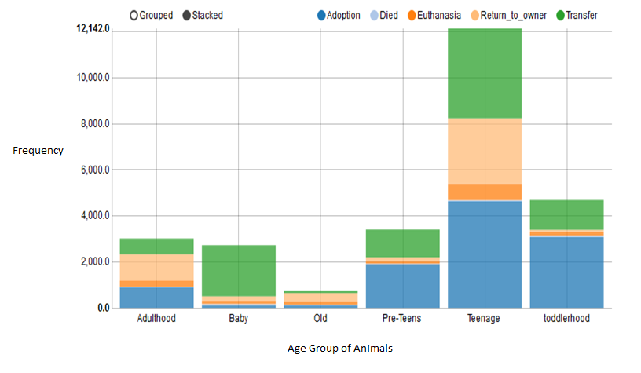Figure 1, For training data of 26,729 animals, Frequency versus Age Group Of Animals.

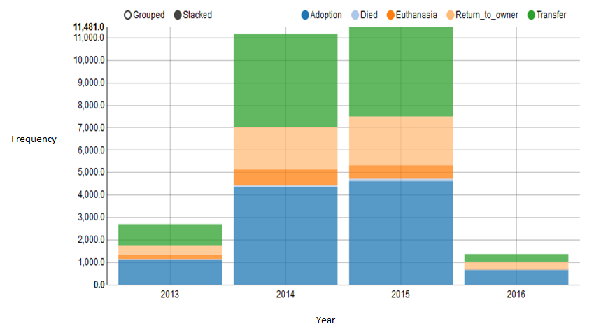 Figure 2, For training data of 26,729 animals, Frequency versus Per Year animals residing into shelter.

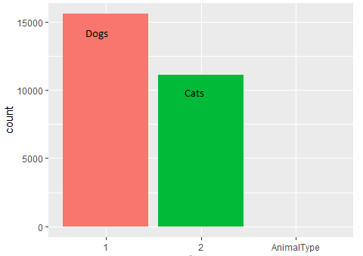

Figure 3, For training data of 26,729 animals, Frequency versus Animal Type

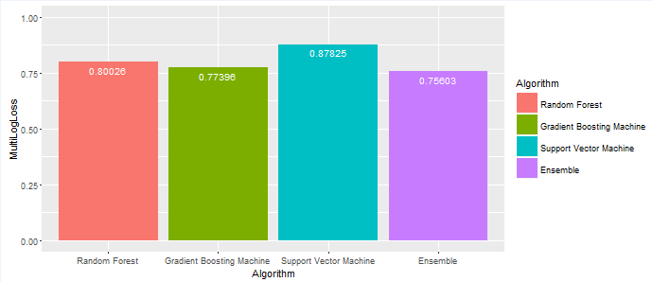 Figure 4, Bar chart of multi-class log loss error of all predictors