

Nova Hub
Antivirus Procedure

Title: Nova Hub - 100-04000-80

Revision History and Authorization
Rev | Date | ECO# | Description | Name & Position
 |  |  |  | Editing | Approval
00 | Xx/xx/xx |  | First Release | Daniel. E | I approval
This document is valid from the date of this issue. The signatures table control the entire document.
The master document is generated and maintained by the Technical Writing/Quality Dept and is updated on the company intranet.
Any other paper print from this document is considered an uncontrolled copy unless attached to this signed page.
© Hiper Global Ltd. All rights reserved – see Copyright at the end of this document.
Contents
Contents
1. Safety 4
1.1. Safety Conventions 4
1.2. Handling and safety instructions 4
2. McAfee Stinger, KVRT & KK 8
removing McAfee Services 17
3. Kaspersky Security Center Scan 22
Windows Based Servers 22
Linux Based Servers 45
4. Antivirus certificates 58
Windows servers certificate 58
Section 1: Rack Details 58
Section 2: Device Details 59
Section 3: Inspector Details 62
Section 4: System Information 63
Section 5: Device Storage & I/O & Windows Updates 64
Linux servers certificate 65
Section 1: Rack Details 65
Section 2: Device Details 66
Section 3: Inspector Details 67
Section 4: System Information 68
Section 5: Device Storage & I/O 68
5. Antivirus Approval 69

Safety
Before performing the procedure documented in this guide, read the safety instructions in:

Safety Conventions
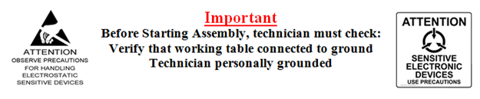

Handling and safety instructions
        - During all tests and inspections handling and safety instructions must be followed.
- Before operating, ensure the power cable and wall outlet have a proper grounding.
- Unit assembly/disassembling is done when the power cable is not connected to the unit.
- Features and unit inspection are done only when the cover is open and the power cable is not connected to the unit.
- Repairs or testing under power are done only by a qualified HIPER technician who is familiar and qualified with this unit.
- Anti-static provisions are done as described below.
- The unit must be under the operating specifications described in the technical specification document.
- Make sure that the ventilation inlet and outlet are not blocked.
Figure ‎1-1
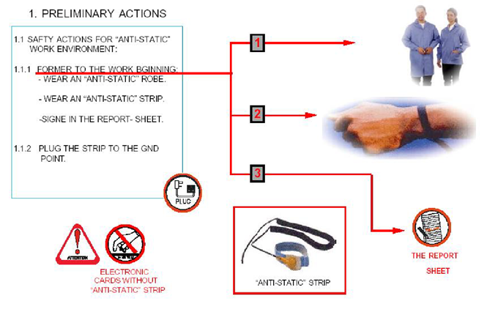

 | DANGER
 | DANGER: This is the signal word used to indicate an imminently hazardous situation, which if not avoided, will result in death or severe injury. This signal word is limited to the most extreme situations.
 | WARNING
 | WARNING: This symbol warns of situations that could result in loss of life or severe injury. Be sure to read and follow all information presented.
 | CAUTION
 | CAUTION: This is the signal word used to indicate a potentially hazardous situation, which if not avoided, may result in minor or moderate injury. It may also be used to alert against unsafe practices.

Nova Hub

Antivirus Procedure

Hiper Global
Daniel Epshtein 19-07-2026

Contents
No table of contents entries found.

McAfee Stinger, KVRT & KK

- From your laptop, download latest McAfee Stinger:
https://www.trellix.com/downloads/free-tools/stinger/

- Download latest KVRT:
https://www.kaspersky.com/downloads/free-virus-removal-tool
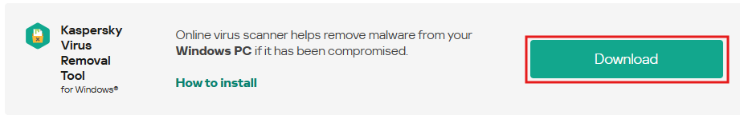
- Download net worm kido remover:
https://www.softpedia.com/get/Antivirus/Net-Worm-Win32-Kido-Remover.shtml
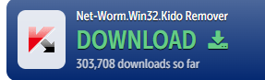
- Copy all 3 (stinger64.exe, KVRT.exe and kidokiller.zip) to desktop of all windows servers on the rack:

- Double click on stinger64.exe from the desktop:
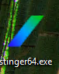

- Click I Accept
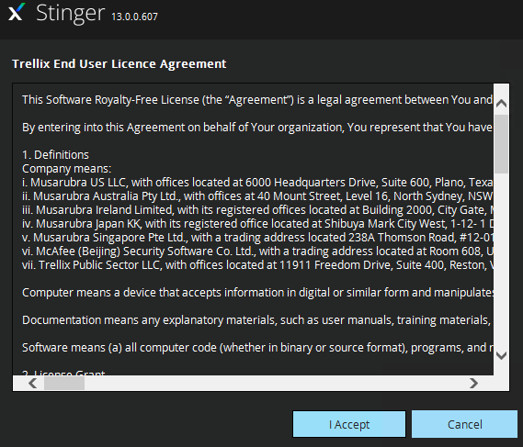
- Click Customize my scan
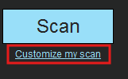
- on Management server, select Disk C:
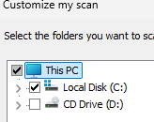
- on FM servers uncheck: Disk D
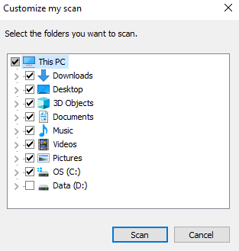
- on APP servers uncheck disk D, MSMQ Disk, Automatic_Spectra and witness, under disk C:\ – uncheck Nova, IPP:
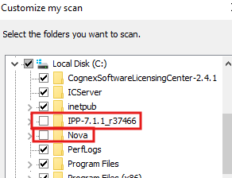
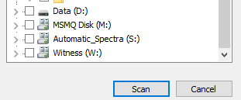
- on DB1 server, under disk C:\ - uncheck Clusterstorage
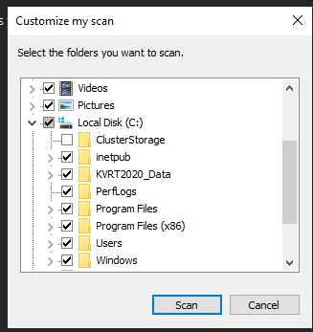
- on DB2 server, uncheck MSSQL_Data, MSSQL_Backups, MSSQL_Reports, Witness. Under disk C:\ - uncheck ClusterStorage, Nova and TempSSRS
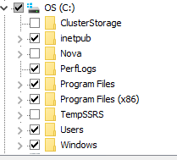
- when scan completed:
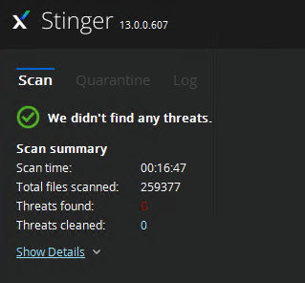
- open command prompt:
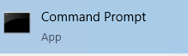
- run: ipconfig /all:
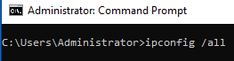

- click on start (inside the OS), type snipping tool and press enter:
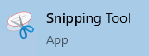
- click on mode and select Full screen snip:
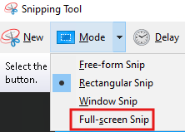
- click on Save button:

- set the filename to: McAfee_Stinger and save it on the Desktop:
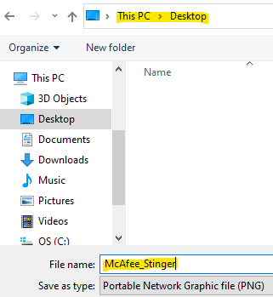
- click on Done:
- close stinger:

- unzip kidokiller.zip and run the kidokiller:
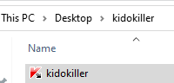
- when completed – verify no worms were found:
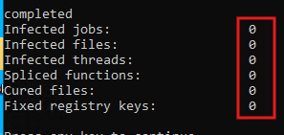
- take a full screen snip, rename to kk_tool_log and save on the desktop:
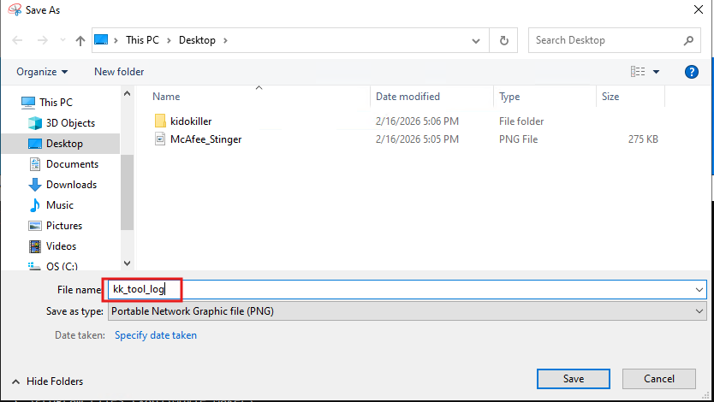
- click on KVRT from the Desktop

- tick all three checkboxes and click Accept:
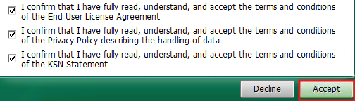

- click on Skip
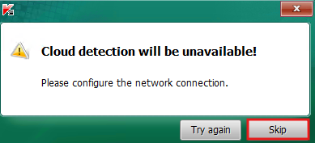
- click Change parameters
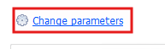
- select as follow (uncheck drive D):
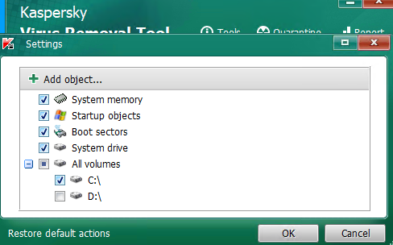
- on APP servers: select all. Under all volumes – check only C:\
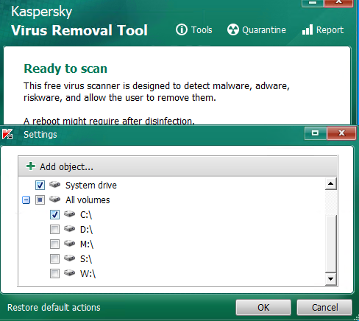

- click ok and Start Scan:
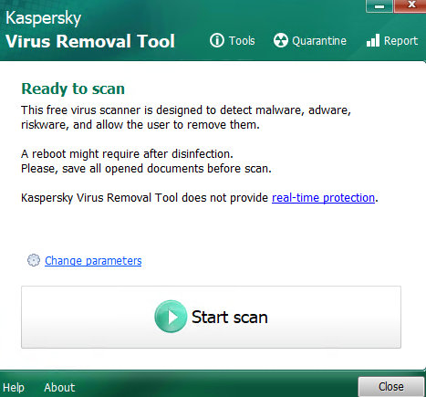
- on DB servers: select all. Under all volumes – check only C:\
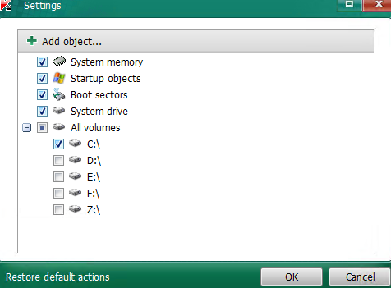
- when scan completed, verify nothing is found:
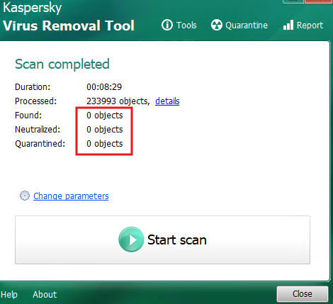

- take a full screen snip, rename to k_removal_tool_report and save on the desktop:
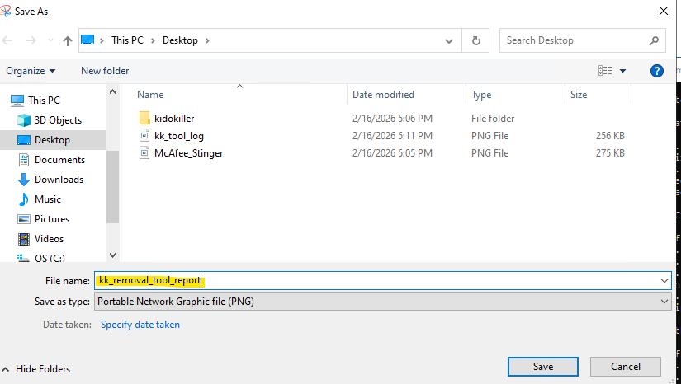
- delete from desktop stinger64, KVRT and Kidokiller:

- verify on each desktop there are 4 files:
  - Stinger_DD/MM/YYYY_Lognumber.html
  - kk_tool_log.PNG
  - McAfee_Stinger.PNG
  - kk_removal_tool_report.PNG

Rremoving McAfee Services
- from Google Drive\NOVA\Nova Docs\Nova\Anti-Virus\McAfee removal
copy MCPR.exe to each windows-based server on the rack

- Copy MCPR.exe to each windows machine desktop:
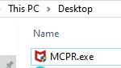
- Hold shift + right click on MCPR.exe > choose Run as Administrator:
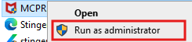
- Click next
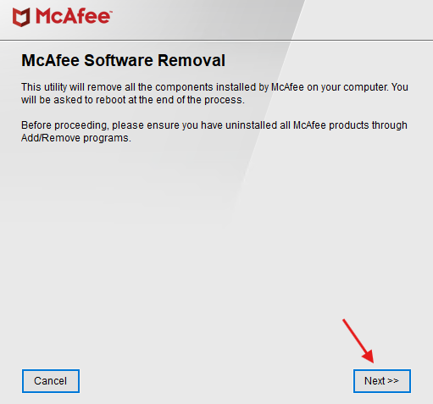
- Check Agree and click Next:
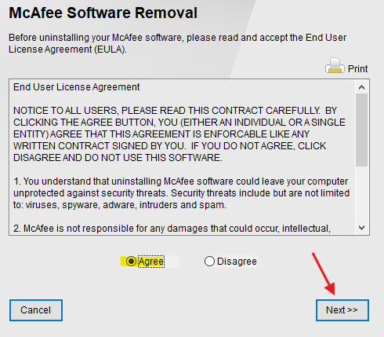
- enter the security validation and click Next:
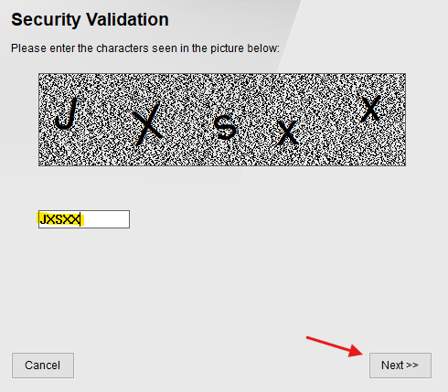
- wait for removal to complete
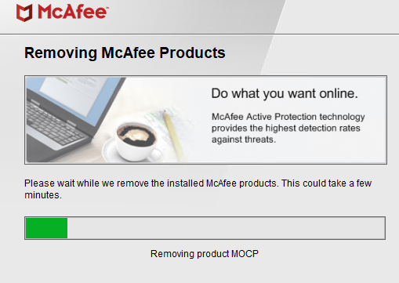
- In case uninstallation is not complete
login with Administrator user (without domain credentials) and run MCPR.exe again
- click Restart
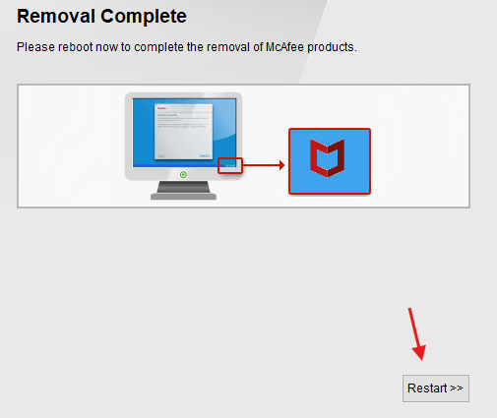
- click No
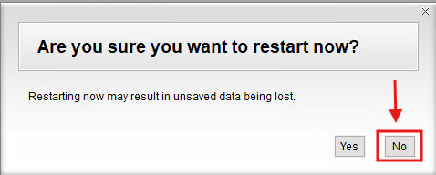

- shutdown DB1, DB2, APP2, APP1 from the OS
- from FM1 and FM2, click start, type hyper-v and press enter
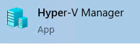
- make sure VMs are turned off on each FM server
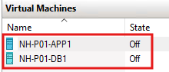
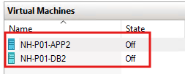
- reboot both FM server from the OS
- reboot Management server from the OS
- After reboot, open powershell:
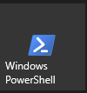
- Check McAfee services removed successfully:
get-service | Where-Object {$_.DisplayName -ilike "*mcafee*"}

No results = services removed
- from FM1 and FM2, click start, type hyper-v and press enter

- start APP1, APP2, DB1, DB2
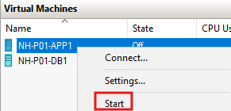
- open powershell:


- Check McAfee services removed successfully:
get-service | Where-Object {$_.DisplayName -ilike "*mcafee*"}

No results = services removed

- Delete MCPR.exe from Desktop and from recycle bin.

Kaspersky Security Center Scan

Windows Based Servers
The instructions below dedicated to all windows based machines – Management, FM1, FM2, APP1, APP2, DB1 and DB2.
- Connect rack’s management switch to Dell Switch on Kaspersky rack.
- From Management server, Check connectivity to Kaspersky server.
Click start, type terminal and press enter:
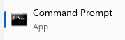
- Test ping to Kaspersky FAB Address: ping 192.168.10.15
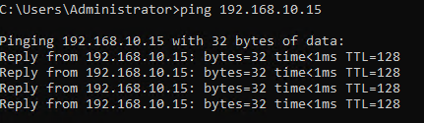
- Click start, type mstsc and press enter:
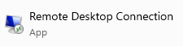
- Type Kaspersky FAB address (192.168.10.15) and press enter:
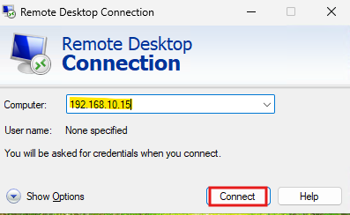
- Login using credentials: User: administrator, Password: P@ssw0rd
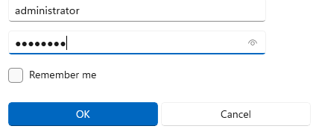
- Click Yes:
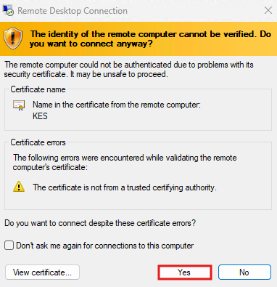
- Click start and select Kaspersky Security Center:

- Expand Advanced > IP Ranges
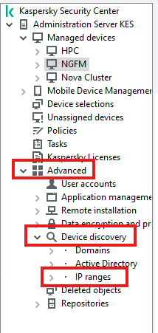
- Click on Poll Now:
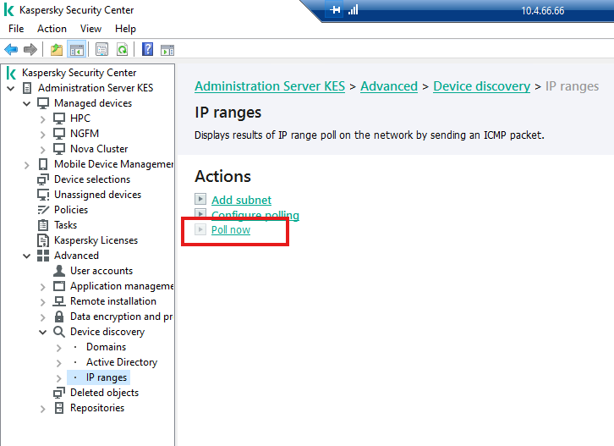
- Wait for poll to finish:
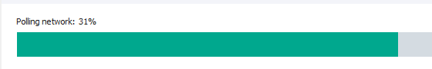
- Click on Unassigned Devices:

- Select all windows-based servers (management server, APP1, APP2, DB1, DB2, FM1, FM2) :
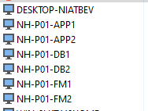
- Click Move to Group:
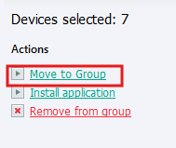
- Expand Managed Devices and select NovaHub-windows group:
- Click on NovaHub-windows group:
- Click on Devices tab and verify all 7 servers present:
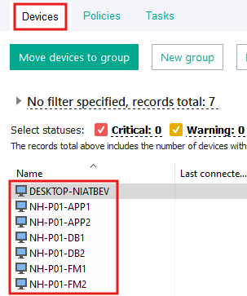
- Click on Tasks tab:
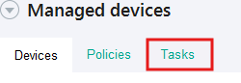
- click on latest Install Network Agent Remotely task:
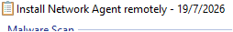
- click on Start:
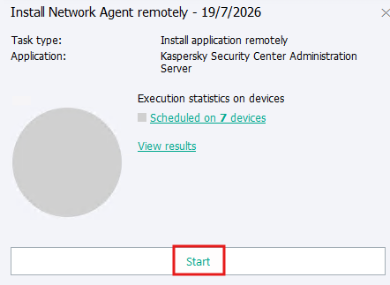
- click on View Results:
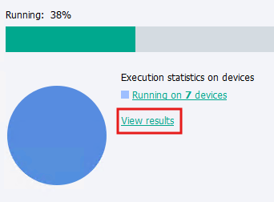
- wait for network agent installed successfully (click Refresh button)
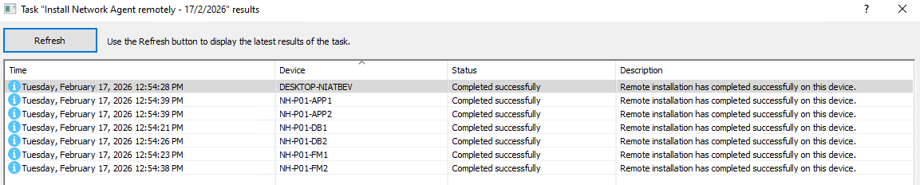
- from each windows-based server on the rack, open terminal:
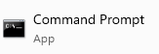
- run connectivity check to Kaspersky server:
"C:\Program Files (x86)\Kaspersky Lab\NetworkAgent\klmover.exe" -address 192.168.10.15
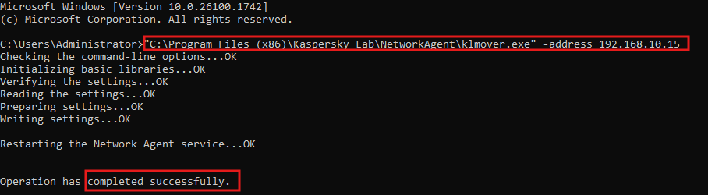
- send heartbeat to Kaspersky Server from each windows-based server:
"C:\Program Files (x86)\Kaspersky Lab\NetworkAgent\klnagchk.exe" -sendhb
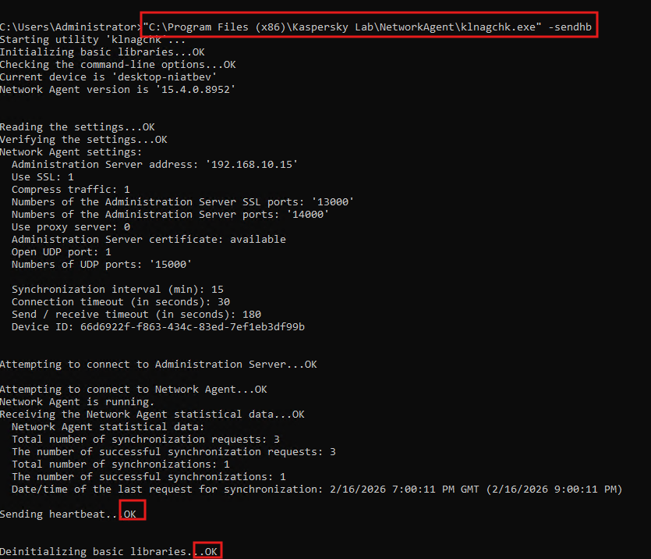
- get back to Kaspersky Remote Desktop connection
- click on latest Install Endpoint Security remotely task
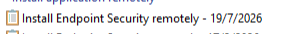
- click on Start:
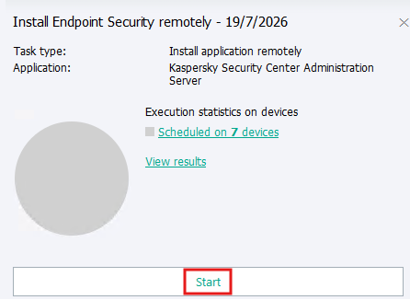
- click on View Results to track installation progress:
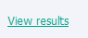
- wait for endpoint security to install successfully (click on refresh button):
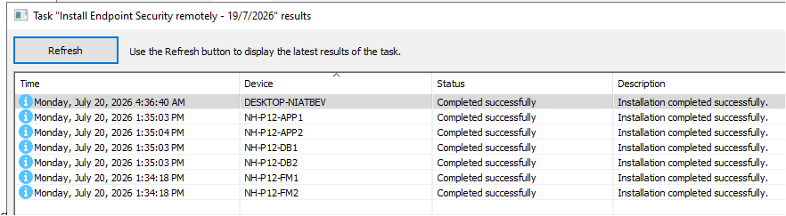 click on Malware Scan-windows:
- click start:
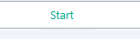
- click View Results

- from each windows-based server: click start, tupe Kaspersky and press enter:
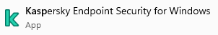
- click on Tasks:

- make sure scan is running:
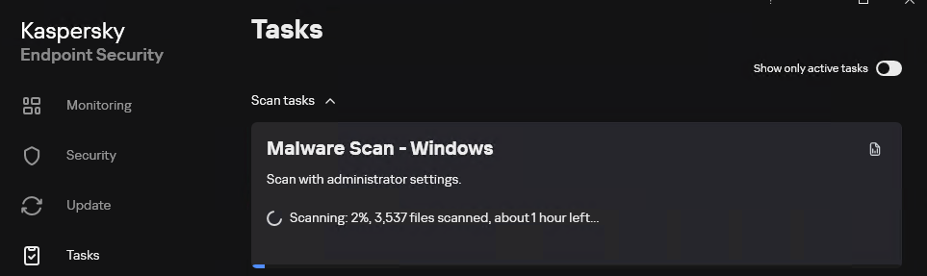
- when scan completes, make sure No threats were found:
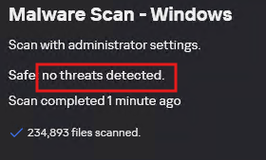
- click on start (inside the OS), type snipping tool and press enter:

- click on mode and select Full screen snip:


- click on Save button:

- set the filename to: kes_malware_scan and save it on the Desktop:
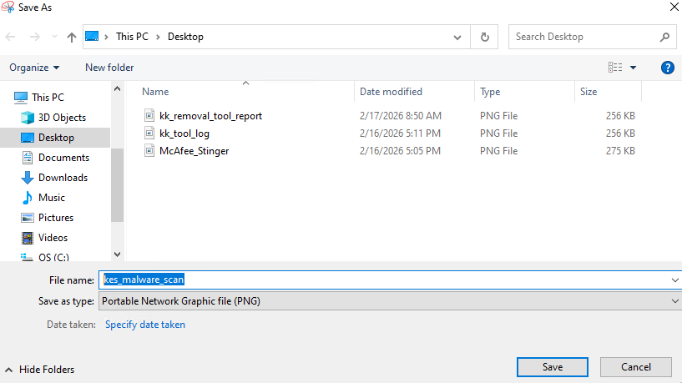
- click on Log icon:
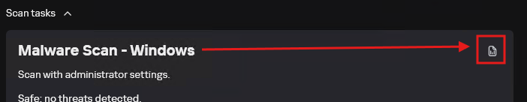
- click on System Audit:
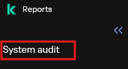
- click Save Report:

- click on Desktop and save the file in the following format: “hostname”_malware_scan:
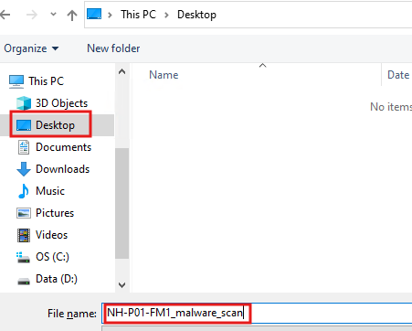
- after all servers’ finish scan, see in Kaspersky Server that all completed successfully:
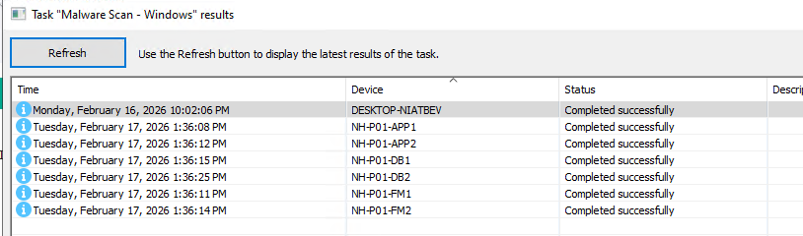
- from all servers, copy reports to Google Drive\NOVA\ATP APPROVAL\2026\100-04000-80 Nova Hub\100-04000-80 Nova Hub POxxxx_SOxxxx_SNxxxx\Antivirus\Malware Scans:
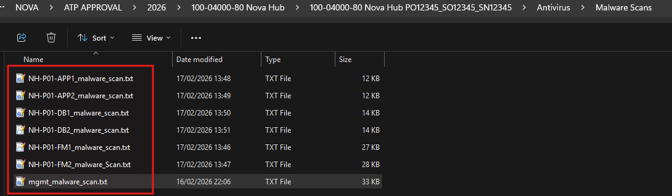
- click on Administration Server KES:
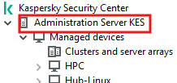
- click ok:
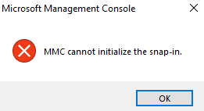
- click on Reports tab:

- Right click on “Report on threats” and click on Properties
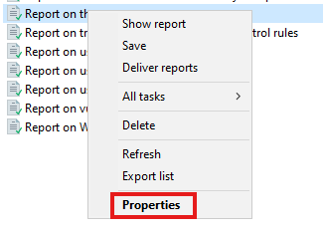
- Select group
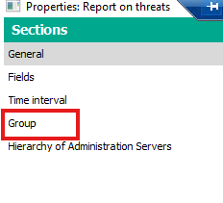
- Click on Browse:
- Select NovaHub-windows and click ok
- Click Apply:
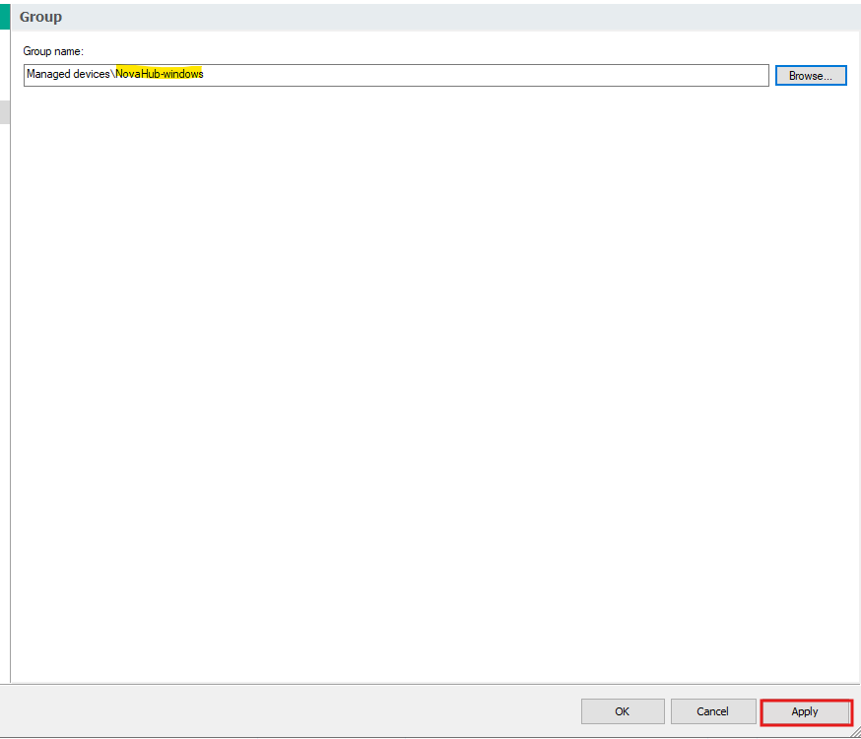

- Click OK
- Double click on Report on threats:
- Click on Save to disk:
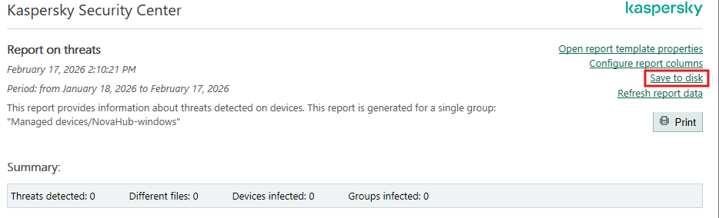
- Click next:
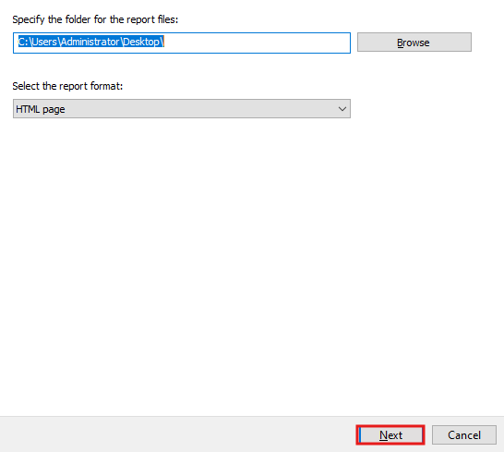
- Click finish
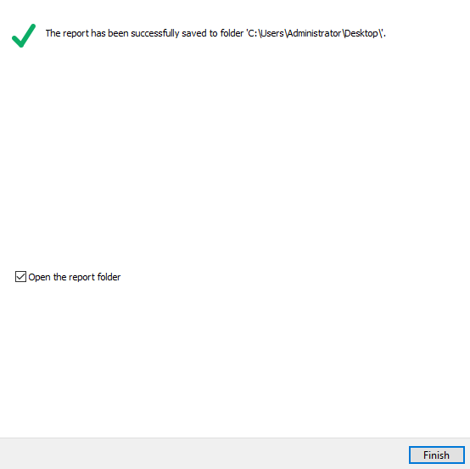

- Copy the report to Google drive Backup folder\Antivirus\Reports
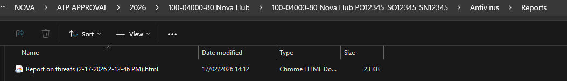
- Edit the report name – add FM to the beginning:
- Click on Tasks:
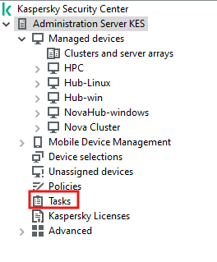

- Right Click on uninstall application remotely-endpoint Agent 12.8 -Windows and select Properties:
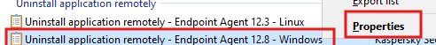
- Click on Devices:
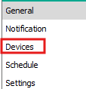
- Click on Add:
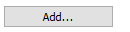
- Select all devices in NovaHub-windows:
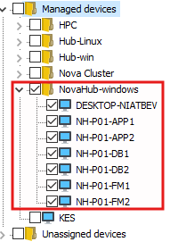
- Click Apply and OK
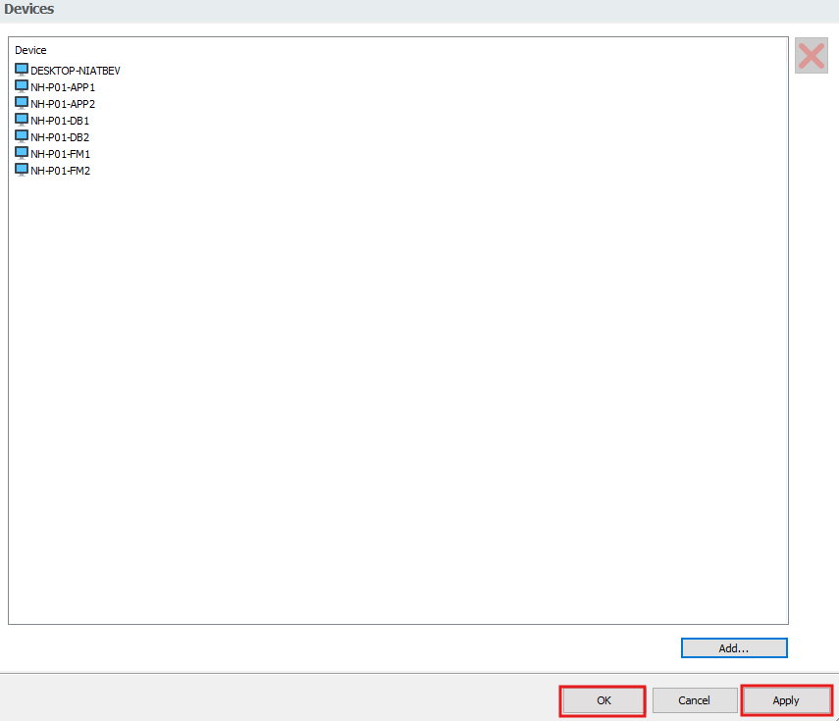

- Click start:
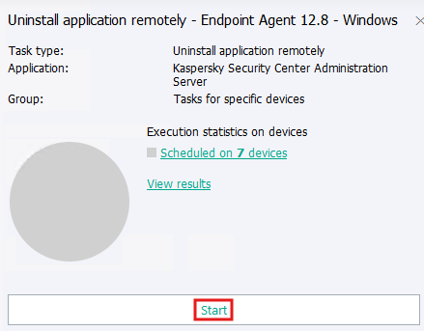
- Click on view results:
- wait for uninstallation completed seuccessfull message:
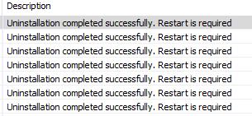
- do not click restart

- shutdown DB1, DB2, APP2, APP1 from the OS
- from FM1 and FM2, click start, type hyper-v and press enter

- make sure VMs are turned off on each FM server


- reboot both FM server from the OS
- reboot Management server from the OS
- after reboot, connect to management server
- from management server, open mremoteng from Cluster Apps fodler:
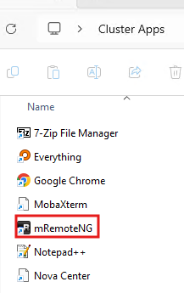
- connect to both FM servers:
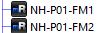

- from FM1 and FM2, click start, type hyper-v and press enter

- start APP1, APP2, DB1, DB2

- click start, type mstsc and press enter
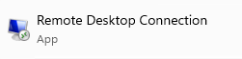
- type 192.168.10.15 and click connect
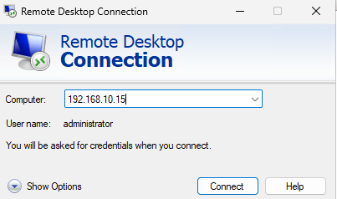
- enter Administrator password: P@ssw0rd
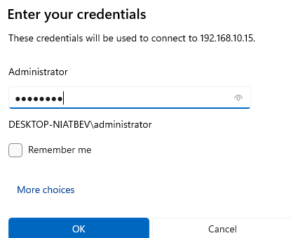
- click Yes:
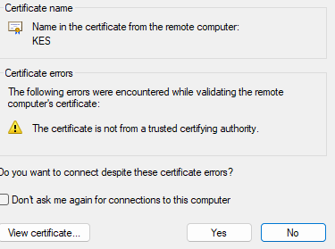
- on task results windows, click refresh and wait for all servers to report “Completed Successfully”:
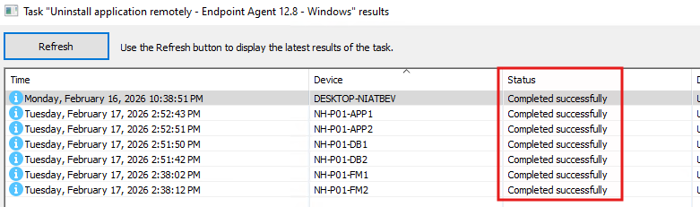

- from Tasks, right click on Uninstall application remotely – Network Agent 15.1-Windows and select Properties:
- click Devices:
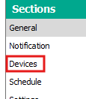
- click Add:
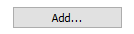
- Select all devices in NovaHub-windows:

- Click Apply and OK

- Click Start:
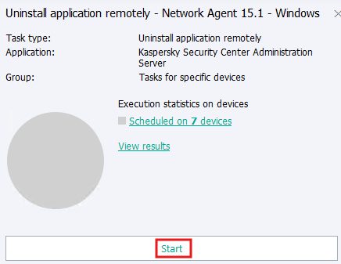
- Click View results:
- Wait a couple of minutes and click on Refresh button:
- Wait for completed successfully.

Linux Based Servers
The instructions below dedicated to all Linux physical servers – K8S1, K8S2, K8S3 and NGINX
- From Kaspersky server (192.168.10.15) C:\Users\Administrator\Desktop\Nova Hub-linux copy latest kesl and klnagent files to management server Desktop:
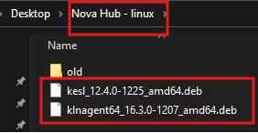
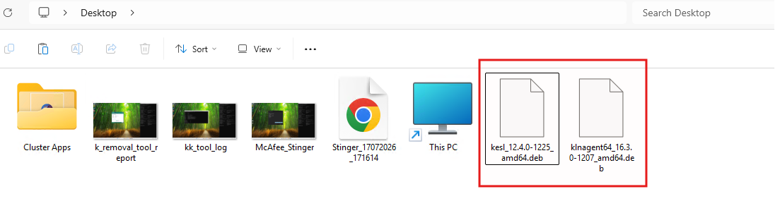
- Open MobaXterm from Cluster Apps folder on the Desktop:
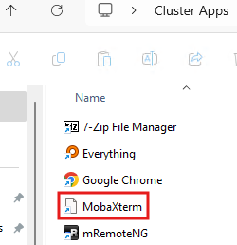

- Open ssh session to all 3 masters and NGINX:
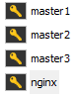
- On each server, switch to root user: sudo -i:
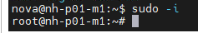
- Change directory to home: cd /home
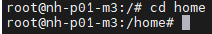
- Create kes directory: mkdir kes
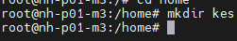
- Give permissions to kes directory: chmod 777 kes
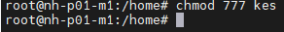
- Cd directory to kes: cd kes:
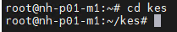
- On file browser of each server navigate to /home/kes
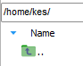
- From management server desktop, copy kesl and klnagent to /home/kes on each server:
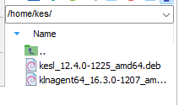

- Give execute permissions to the files: chmod +x /home/kes/*

- Install network agent: sudo dpkg -i klngagent64_x.x.x-xxxx_amd64.deb
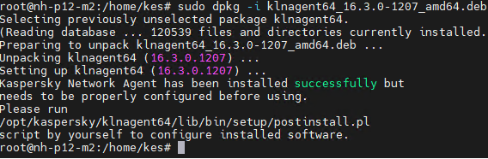
- Run post install script: /opt/kaspersky/klnagent64/lib/bin/setup/postinstall.pl

- Press space:
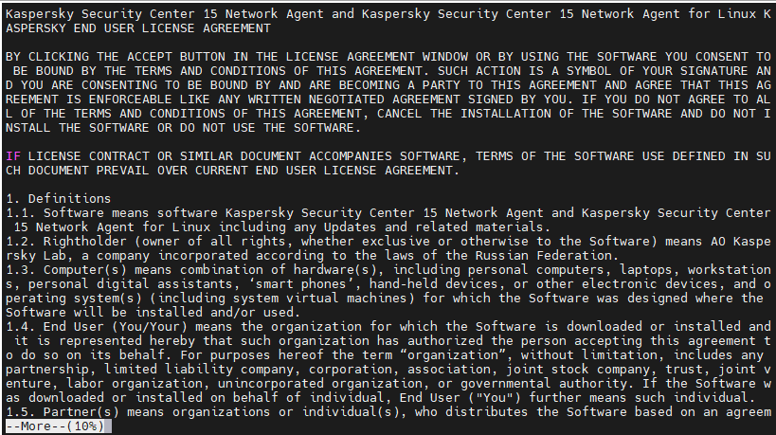
- Press Y and enter
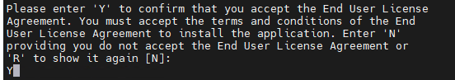
- Enter Kaspersky ip address: 192.168.10.15 and press enter:
- Press enter:

- Press enter:
- Type Y and press Enter:
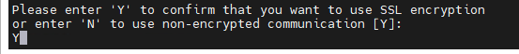
- Select 2 and press enter:
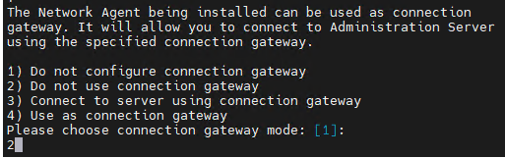
**wait for all servers to finish – nginx may take some time.
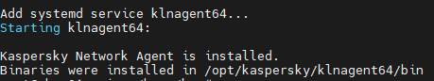
- Check connectivity to Kaspersky server:/opt/kaspersky/klnagent64/bin/klnagchk
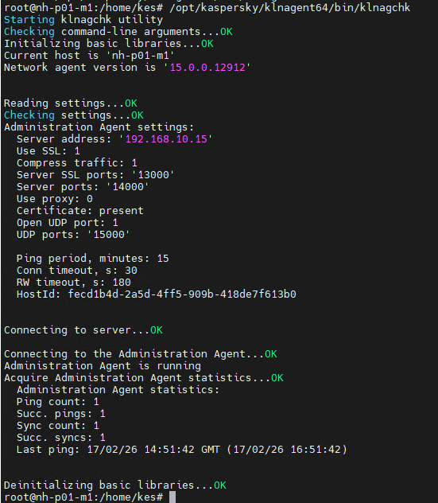
Note: nginx takes few moments to finish.
- Run klmover script to KES Server:
/opt/kaspersky/klnagent64/bin/klmover -address 192.168.10.15
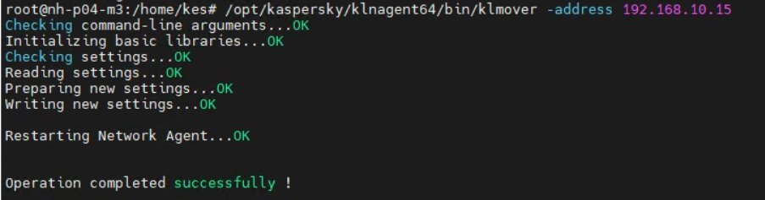

- In Kaspersky server, click on Unassigned Devices:
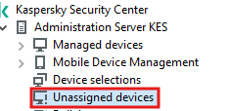
- See that all 4 servers: master1, master2, master3 and nginx:
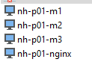
In case nginx does not appear, reboot nginx.
- Select all 4 linux server and click on Move To Group:
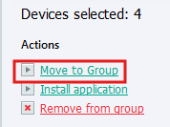
- Select NovaHub-linux group:
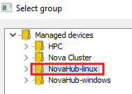
- From managed devices, click on NovaHub-linux and verify server added to group:
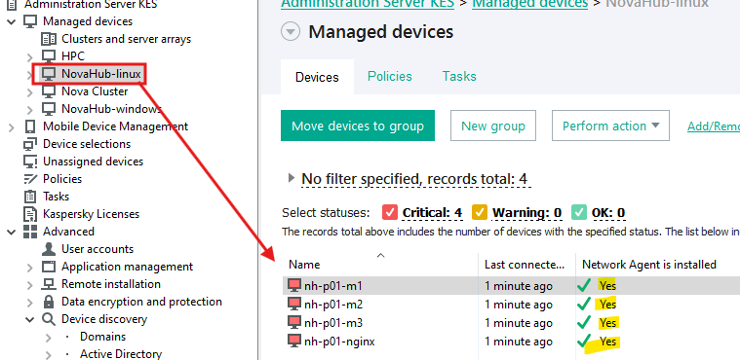

- Back in management server, ssh session of each server – install endpoint security: sudo dpkg -i kesl_xx.x.x-xxxx_amd64.deb
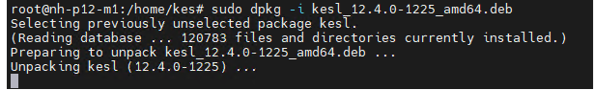
- Run post install script: sudo /opt/kaspersky/kesl/bin/kesl-setup.pl
Press enter
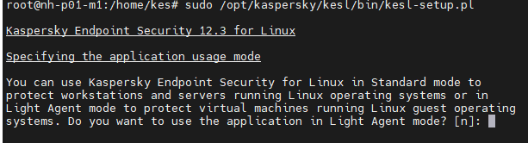
- Press eneter:
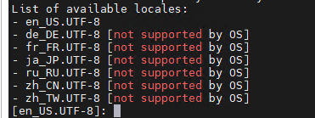
- Press enter:
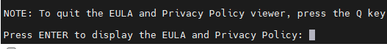
- Press spacebar
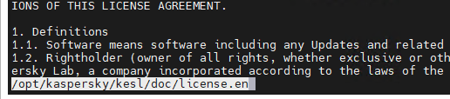
- Press y and press enter:

- Press y and press enter:
- Press y and press enter:
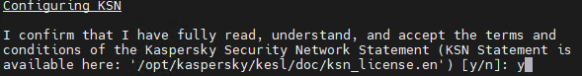
- Press enter:
- Press enter:
- Wait for setup completed. **nginx may take few moments to finish:
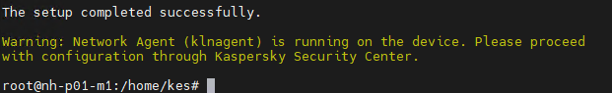
***In case nginx fails:
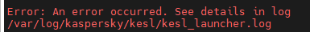

Run: mv /var/run /var/run.backup
Then run: ln -s /run /var/run
Start kesl service: systemctl start kesl.service
Check kesl service running: systemctl status kesl.service
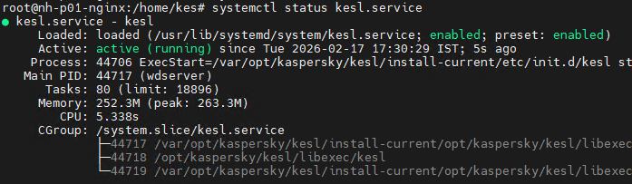

- On Kaspersky server, verify all servers network agent is detected and realtime protection is running:
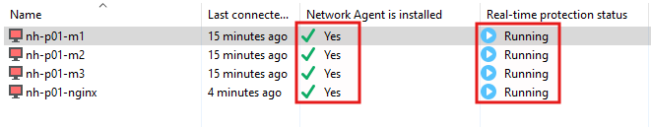

- Click on Tasks tab under the group:
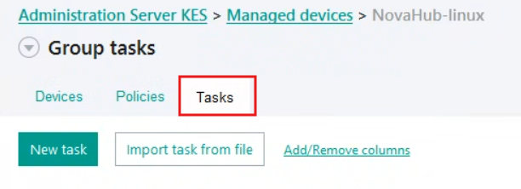
- Click on malware Scan-Hub-Linux12.4:
- Click on start
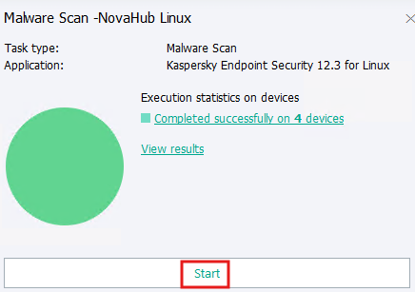
- Wait for al servers to report completed successfully
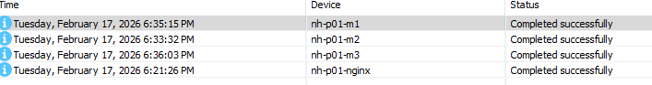

- Click on Administration Server KES
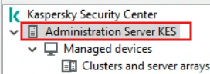
- click on Reports tab:

- Right click on “Report on threats” and click on Properties

- Select group

- Click on Browse:
- Select NovaHub-linux and click ok
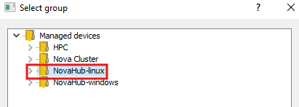
- Click Apply and OK
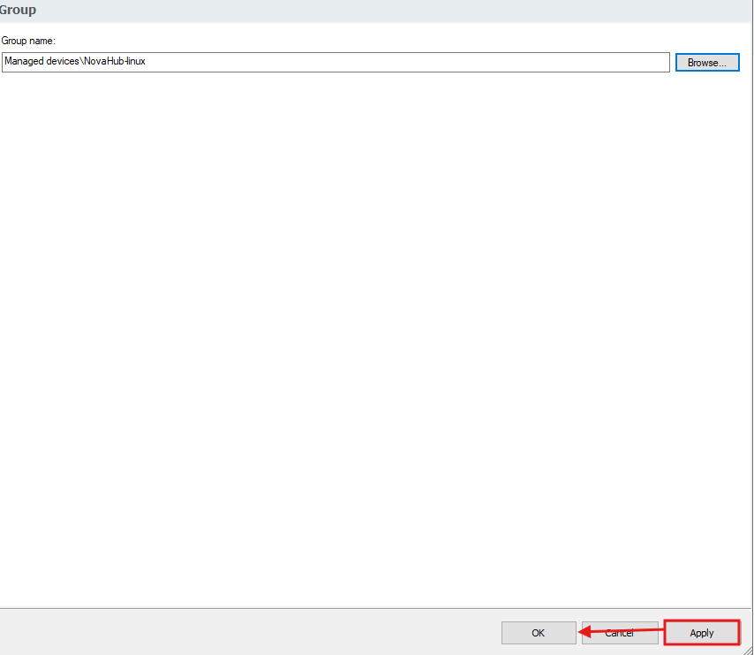
- Double click on Report on threats:
- Click Save to disk:
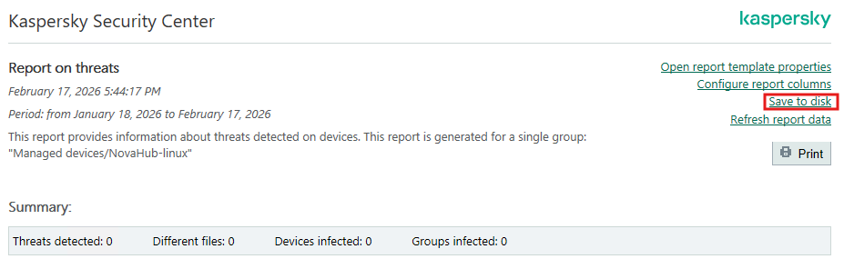
- Click next:

- Click finish

- Copy the report to Google drive Backup folder\Antivirus\Reports
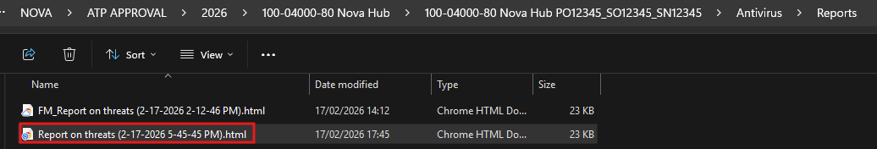

- Edit the name of the report by adding “Linux” to the start of the report name:
- From each server, stop kesl service:systemctl stop kesl
- From each server, stop klnagent64: systemctl stop klnagent64.service
- From each server, disable kesl service: systemctl disable kesl
- from each server, disable klnagent64: systemctl disable klnagent64.service
- uninstall endpoint agent: sudo apt-get remove kesl
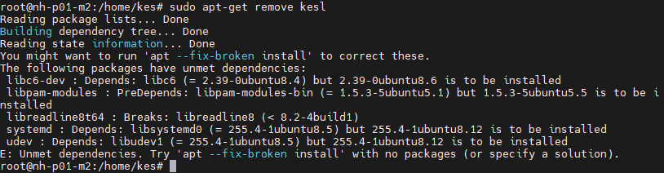
On nginx type Y and press enter:
- Uninstall network agent: sudo apt-get purge klnagent
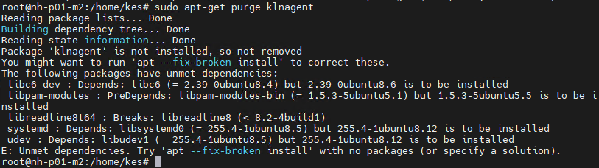
- Delete kaspersky directories
sudo rm -rf /opt/kaspersky /etc/opt/kaspersky /var/opt/kaspersky

- Purge kesl server: sudo dpkg -P kesl
- Purge klnagent64: sudo dpkg -P klnagent64
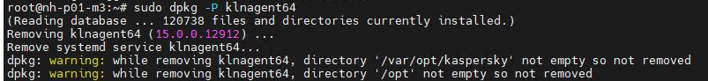
- Change directory to home: cd ..
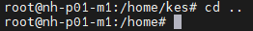
- Delete files in kes directory: rm kes/*
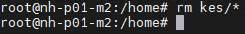
- Delete kes directory: rmdir kes:
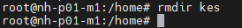
- Reboot servers
- Verify kesl deleted from server: systemctl status kesl
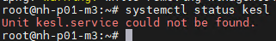

From KES Remove from NovaHub-windows and NovaHub-Linux all 7 servers.

Antivirus certificates

Windows servers certificate
From Google Drive\NOVA\ATP APPROVAL\2026\100-04000-80 Nova Hub\<current Rack>\Antivirus open Hub_Anti_Virus_PO_SO_SN.docx
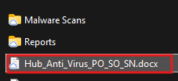

Section 1: Rack Details
- add the following fields:
  - Inspection Date = date of antivirus scan
  - Costumer PO = according to Configuration Guide
  - Nova SO = according to Configuration Guide
  - Serial Number = Serial number of current rack
  - Product Part Number = 100-04000-80 or 100-04000-85
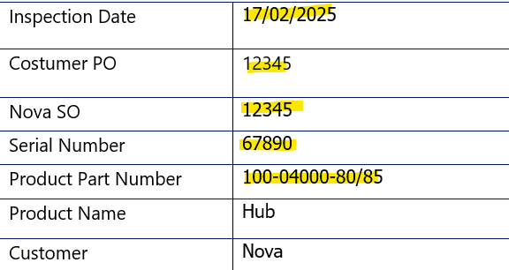

Section 2: Device Details
The section describes each Windows-based device of the rack:
  - Device 1 = Management Server
  - Device 2 = FM1
  - Device 3 = FM2
  - Device 4 = APP1
  - Device 5 = APP2
  - Device 6 = DB1
  - Device 7 = DB2

- In each section edit the values according to current rack:
  - Computer Name = hostname of server
  - MAC address (internal) = Private Network card MAC
  - MAC address (External) = FAB Network card MAC
  - Operating system version = OS version including Build
  - McAfee = Stinger tool used for scan.
  - Kaspersky= KVRT tool used for scan
  - KK = kidokiller tool used for scan.
  - KES = windows endpoint agent used for scan.

- to obtain hostname : run hostname in terminal of relevant server:
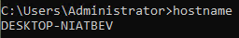
- to obtain Private MAC address: run getmac /v | findstr Private in terminal of relevant server:
- to obtain FAB mac address: run getmac /v | findstr FAB in terminal of relevant server:
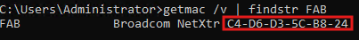
- on FM only: vEthernet (FAB) Hyper-V Virtual
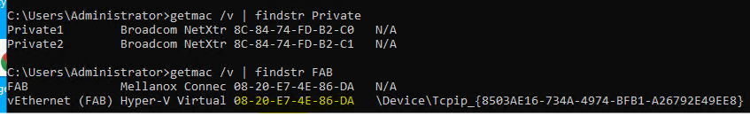
- to obtain os version: run
management: Get-ItemProperty "HKLM:\SOFTWARE\Microsoft\Windows NT\CurrentVersion" | ForEach-Object { "Windows 11 Version $($_.DisplayVersion) (OS Build $($_.CurrentBuild).$($_.UBR))" }

windows server: Get-ItemProperty "HKLM:\SOFTWARE\Microsoft\Windows NT\CurrentVersion" | ForEach-Object {
"$($_.ProductName) Version $($_.DisplayVersion) (OS Build $($_.CurrentBuild).$($_.UBR))"
}

in powershell terminal of relevant server:

- to obtain Stinger tool version: open McAfee_Stinger screenshot from relevant server:
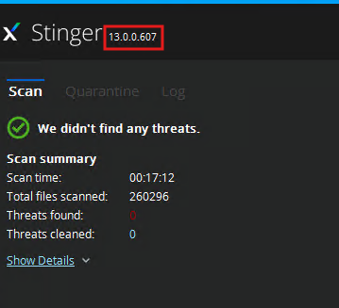
- to obtain KVRT tool version: open KVRT tool downloaded on your laptop:
- click about:

- see version:
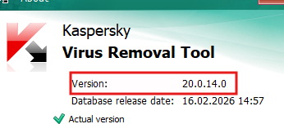
- to obtain kk tool version: open kk_tool_log screenshot from relevant server:
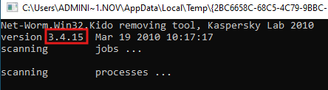

- to obtain KES version: open malware_scan screenshot from relevant server:
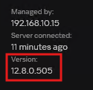
- For example:
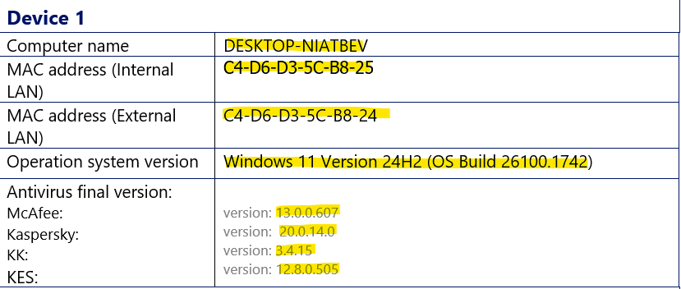

Section 3: Inspector Details
- Enter the following details:
  - Stamp = inspector Signature
  - Date = the date when the scans were performed
  - Print Name = Inspector Full Name
  - Title = Inspector Job Title
- For example:
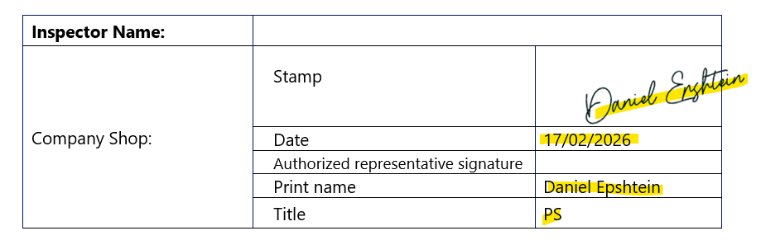

Section 4: System Information
- Place systeminfo output in each respective Device:
For each device, run systeminfo command in terminal, take screenshot and place in appropriate place
- Example:
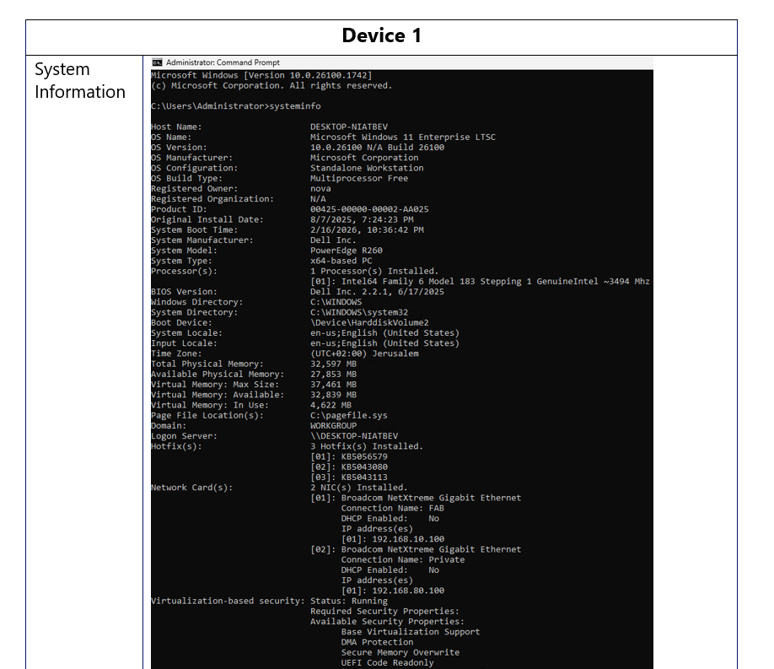

Section 5: Device Storage & I/O & Windows Updates
First section describes the physical hardware of each server.
Verify details.
Second section (Additional Information) describes latest windows update installed on each device. Verify latest update from the systeminfo output of each device.
example:
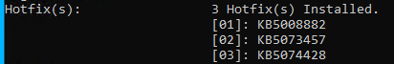
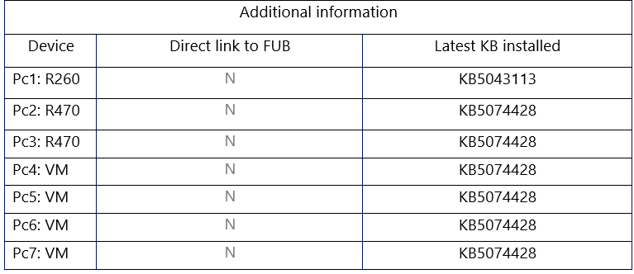

Linux servers certificate

From Google Drive\NOVA\ATP APPROVAL\2026\100-04000-80 Nova Hub\100-04000-80 Nova Hub PO12345_SO12345_SN12345\Antivirus open Linux_Anti_Virus_PO_SO_SN.docx
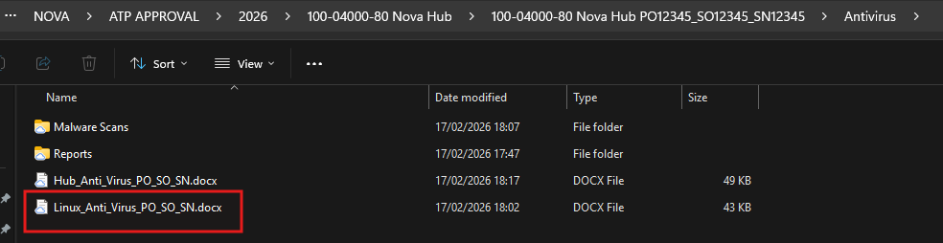

Section 1: Rack Details
- add the following fields:
  - Inspection Date = date of antivirus scan
  - Costumer PO = according to Configuration Guide
  - Nova SO = according to Configuration Guide
  - Serial Number = Serial number of current rack
  - Product Part Number = 100-04000-80 or 100-04000-85


Section 2: Device Details
The section describes each Windows-based device of the rack:
- Device 1 = PMC1 Server
- Device 2 = PMC2 Server
- Device 3 = PMC3 Server
- Device 4 = RPROX Server

- In each section edit the values according to current rack:
  - Computer Name = hostname of server
  - MAC address (External) = FAB Network card MAC
  - Operating system version = OS version including Build
  - Kaspersky Endpoint Security = Endpoint Security Agent used for scan.

- To obtain Computer Name: run hostname on each server:
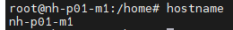

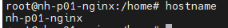
- To obtain FAB Network Card MAC address: run
cat /sys/class/net/$(ip -br addr show | grep "192.168.10." | awk '{print $1}')/address

- To obtain OS version: cat /etc/os-release
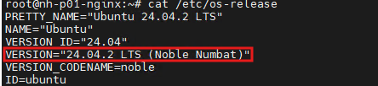
- To obtain Kaspersky Endpoint Security version: from kaspersky server > desktop > Nova Hub – linux:
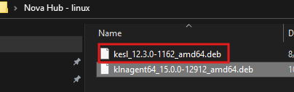

Section 3: Inspector Details
- Enter the following details:
  - Stamp = inspector Signature
  - Date = the date when the scans were performed
  - Print Name = Inspector Full Name
  - Title = Inspector Job Title
- For example:


Section 4: System Information
- Place hostnamectl output in each respective Device:
For each device, run hostnamectl command in terminal, take screenshot and place in appropriate place
- Example:
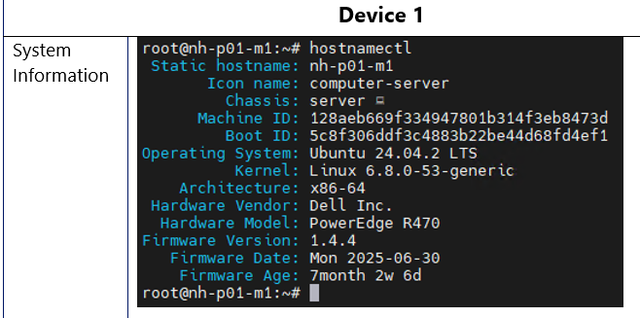

Section 5: Device Storage & I/O
The section describes the physical hardware of each server.
Verify details using iDRAC inventory.
example:
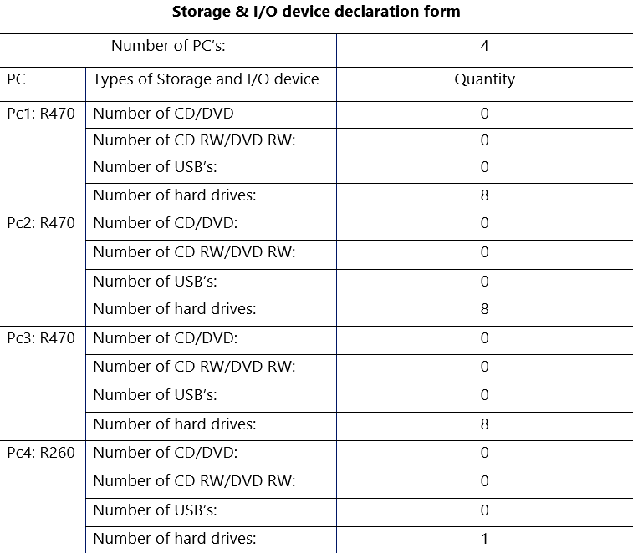

Antivirus Approval

