 Universidad Nacional Autónoma de México

Facultad de Ingeniería

Ingeniería en Computación

Compiladores

Grupo 04

Proyecto Final: C compiler made with Elixir

Equipo: Talisman

Integrantes:

* Acosta Hernández Horacio
* Sánchez Bautista Alan Ulises

Ciudad Universitaria, March 17th 2020

Ciudad Universitaria, March 17th 2020

**Content**

1. **Introduction**……………………………………………………………………………..3

2. **Stakeholders Information**…………………………………………………………….4

3. **Restrictions**……….…………………………………………………………………….6

4. **Delivery Protocol**……………………………………………………..………………..7

5. **Objective**………………………………………………………………………………...7

6. **Requirements**…………………………………………………………………………..8

7. **Schedule**………………………………………………………………………………...9

# **Introduction**

A compiler is a program (Software) that works as a translator, it converts a code from a programming language into another, in this case that language will be machine language.

A compiler has two states:

1.Analysis: It is the state that approves the correctness of the code to translate. It makes a Lexical Analysis phase (lexical components of the source code), a Syntactic Analysis phase (grouping of the lexical components into grammatical phrases) and a Semantic Analysis phase (approval of the semantic value made in the Syntactic Analysis phase).

2.Synthesis: It makes the output expressed in object code and makes it as optimizable as possible to not lose efficiency.

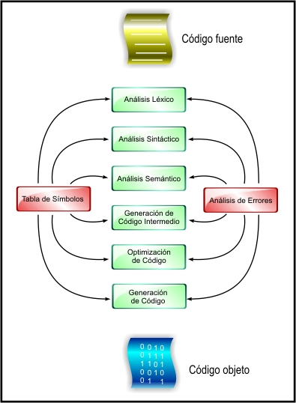

# **Stakeholders Information**

The stakeholders are students currently taking the Compilers group four course, all of them have experience managing complete projects using Software Engineering a Project Administration tools.

This project will be presented by the Talisman team.

|  |
| --- |
| **Acosta Hernández Horacio**  *Developer- Ingeniero en Computación* |
| Professional Experience |
| 8th semester student of the engineering faculty, with knowledge and main interest in programming, oriented to creating applications on Android devices. Basic level courses for mastering different programming languages. |
| Project Expectatives |
| This project is quite a challenge since it requires the gathering of great theoretical knowledge observed within the course, in addition to the introduction to a new language which also presents a great challenge. The aim is to obtain an arduous knowledge of new topics, thus further developing our capacity for work. |

|  |
| --- |
| **SÁNCHEZ BAUTISTA ALAN ULISES**  *Tester - Ingeniero en Computación* |
| Professional Experience |
| Student from the faculty of engineering of the UNAM 2017 generation, with different knowledge in various programming languages focused on objects and numerical analysis. Complete domain of four skills in English (FCE certificate by the British Council on December 2017) y knowledge in teaching English as a second language (TKT certificate). Experience working in different projects for groups such as USECAD, IUDI, among others. |
| Project Expectatives |
| This project will complement my knowledge with the Compilers class and will teste my skills in the creation of a professional project, as if it was for an important company and such. |

|  |  |  |  |  |  |
| --- | --- | --- | --- | --- | --- |
| Teamwork | | | | | |
| **Rol** | **Name** | **Sourname** | **Phone** | **Addres** | **Mail** |
| Developer | Horacio | Acosta Hernández | 5535897523 |  |  |
| Tester | Alan Ulises | Sánchez Bautista | 5513827432 | Tulipán 597 Geovillas de Santa Bárbara, Ixtapaluca, Edo. Méx. | alanes@comunidad.unam.mx |

|  |  |
| --- | --- |
| To deliver | |
| **Product** | **Type** |
| Phase 1 | |
| Documentation | Item |
| Phase 1 | |
| Program | Code |

## 

## **Restrictions**

The restrictions made by the client are shown next:

|  |  |
| --- | --- |
| RESTRICTION NUM. 1 | |
| Name | Number of team members |
| Description | The project must be made by a maximum of 4 people. |
| Origin | External |
| Type | Institutional |
| Limits to | Create a teamwork with no more than 4 people. |

|  |  |
| --- | --- |
| RESTRICTIÓN NUM. 2 | |
| Name | Core of the compiler |
| Description | The compiler must be done with the Elixir programming language. |
| Origin | External |
| Type | Institutional |
| Limits to | Only use Elixir as the main language, avoiding other alternatives. |

|  |  |
| --- | --- |
| RESTRICTIÓN NUM.3 | |
| Name | Delivery |
| Description | Because of the health secure of the team members, in order to prevent COVID-19 spreading, the delivery will be made via online. |
| Origin | External |
| Type | Temporal |
| Limits to | Present the first delivery via online meeting. |

## **Delivery Protocol**

|  |  |
| --- | --- |
| Delivery Protocol | |
| Responsable | Acosta Henández Horacio,  Sánchez Bautista Alan Ulises |
| Destinatary | Ortigoza Márquez Norberto Jesús |
| Date | 17/03/2020 |
| Max. duration | No indicated |
| Place | Video call |
| Communication media | Zoom |
| Elements  delivered | Documentation and  Code |

1. **Objetive**

According to the syllabus of the compilers subject, we (as students) have to create from scratch a compiler as the subject´s final project.

The objective of this project is to create a functional C compiler using the Elixir language as the core; not only that, we will try out all the knowledge we have got about Software Engineering and Project Development.

1. **Requirements**

|  |  |
| --- | --- |
| Concept | Description |
| Warning messages | The compiler has to send messages about problems during or after compilation, such as syntax mistakes or compilation errors. |
| Machine code generator | The compiler must use the proper Elixir commands to translate high level language into machine code understandable for the processor. |
| C language compilation | The compiler must translate C code into machine code, |

## **Schedule**

|  |  |  |  |  |
| --- | --- | --- | --- | --- |
| Title | Beginning | End | Duration  (days) | Description |
| Analysis | 10/02/2020 | 12/02/2020 | 2 | Analysis of the project and  requirements made by de client, creation of repositories and work plan. |
| Preliminary study | 12/02/2020 | 13/02/2020 | 1 | Study made for the complexity of the Elixir language. |
| Planning | 13/02/2020 | 15/02/2020 | 2 | We created a schedule for the activities for every  development team member |
| Detailed analysis & development | 15/02/2020 | No date |  | Using the Nora source as an example, we extended our analysis to include the necessary steps for creating a functional C compiler using the Elixir language.    Creating the structure of the project files using the GitHub tool as support was accorded between the development team, an the roles were given to each member. |
| First delivery | 17/03/2020 | 17/03/2020 | 1 | First delivery of the project  (Could be online) |
| Second delivery | *April | * |  | Dates can change according to the client |
| Third delivery | *May | * |  | Dates can change according to the client |