# 安装

1.安装器

composer global require laravel/installer

2.新建项目

laravel new blog

3.秘钥

php artisan key:generate

.env.example 文件重命名为 .env 文件

# 路由

Get post match amy group 别名 群组 视图 自定义参数

<?php  
  
use function foo\func;  
  
  
Route::get('/post', function () {  
 return 'post';  
});  
  
Route::match(['get', 'post'], 'match', function () {  
 return 'match';  
});  
  
  
Route::any('any', function () {  
 return 'any';  
});  
  
Route::get('para/{id}', function (*$id*) {  
 return "para/{*$id*}";  
});  
  
//自定义的默认参数  
Route::get('para/i/{name2?}', function (*$name2* = 'sun') {  
 return "para/i/{*$name2*}";  
})->where('name2', '[A-Za-z]+');  
  
//自定义的参数  
Route::get('para/name/{name2?}', function (*$name2* = 'sun') {  
 return "para/name/{*$name2*}";  
})->where('name2', '[A-Za-z]+');  
  
//自定义两个参数  
Route::get('para/name2/{name2?}/{id?}', function (*$name2* = 'sun', *$id* = '111') {  
 return "para/name/{*$name2*}/{*$id*}";  
})->where(['name2' => '[A-Za-z]+', 'id' => '[0-9]+']);  
  
  
//路由别名:就是把别名加入了route组件中  
Route::get('route/direct', ['as' => 'tion', function () {  
 return array("tion", route('tion'));  
}]);  
  
//路由群组:目的是简化前缀一样的  
Route::group(['prefix' => 'group'], function () {  
 Route::get('route/1', ['as' => '1', function () {  
 return array("1", route('1'));  
 }]);  
 Route::get('route/2', ['as' => '2', function () {  
 return array("2", route('2'));  
 }]);  
});  
  
// 路由中输出视图  
Route::get('/', function () {  
 return view('welcome');  
});  
  
  
// 代码中会使用到  
Route::get('member/info', 'MemberController@info');  
  
//返回route的url  
Route::get('member/info2', [  
 'uses' => 'MemberController@info2',  
 'as' => 'memberinfo2'  
]);

# 视图

public function info3()  
{  
 return view('member/info3', [  
 'id' => '我是1岁',  
 'age' => '20岁'  
 ]);  
}

# 模型

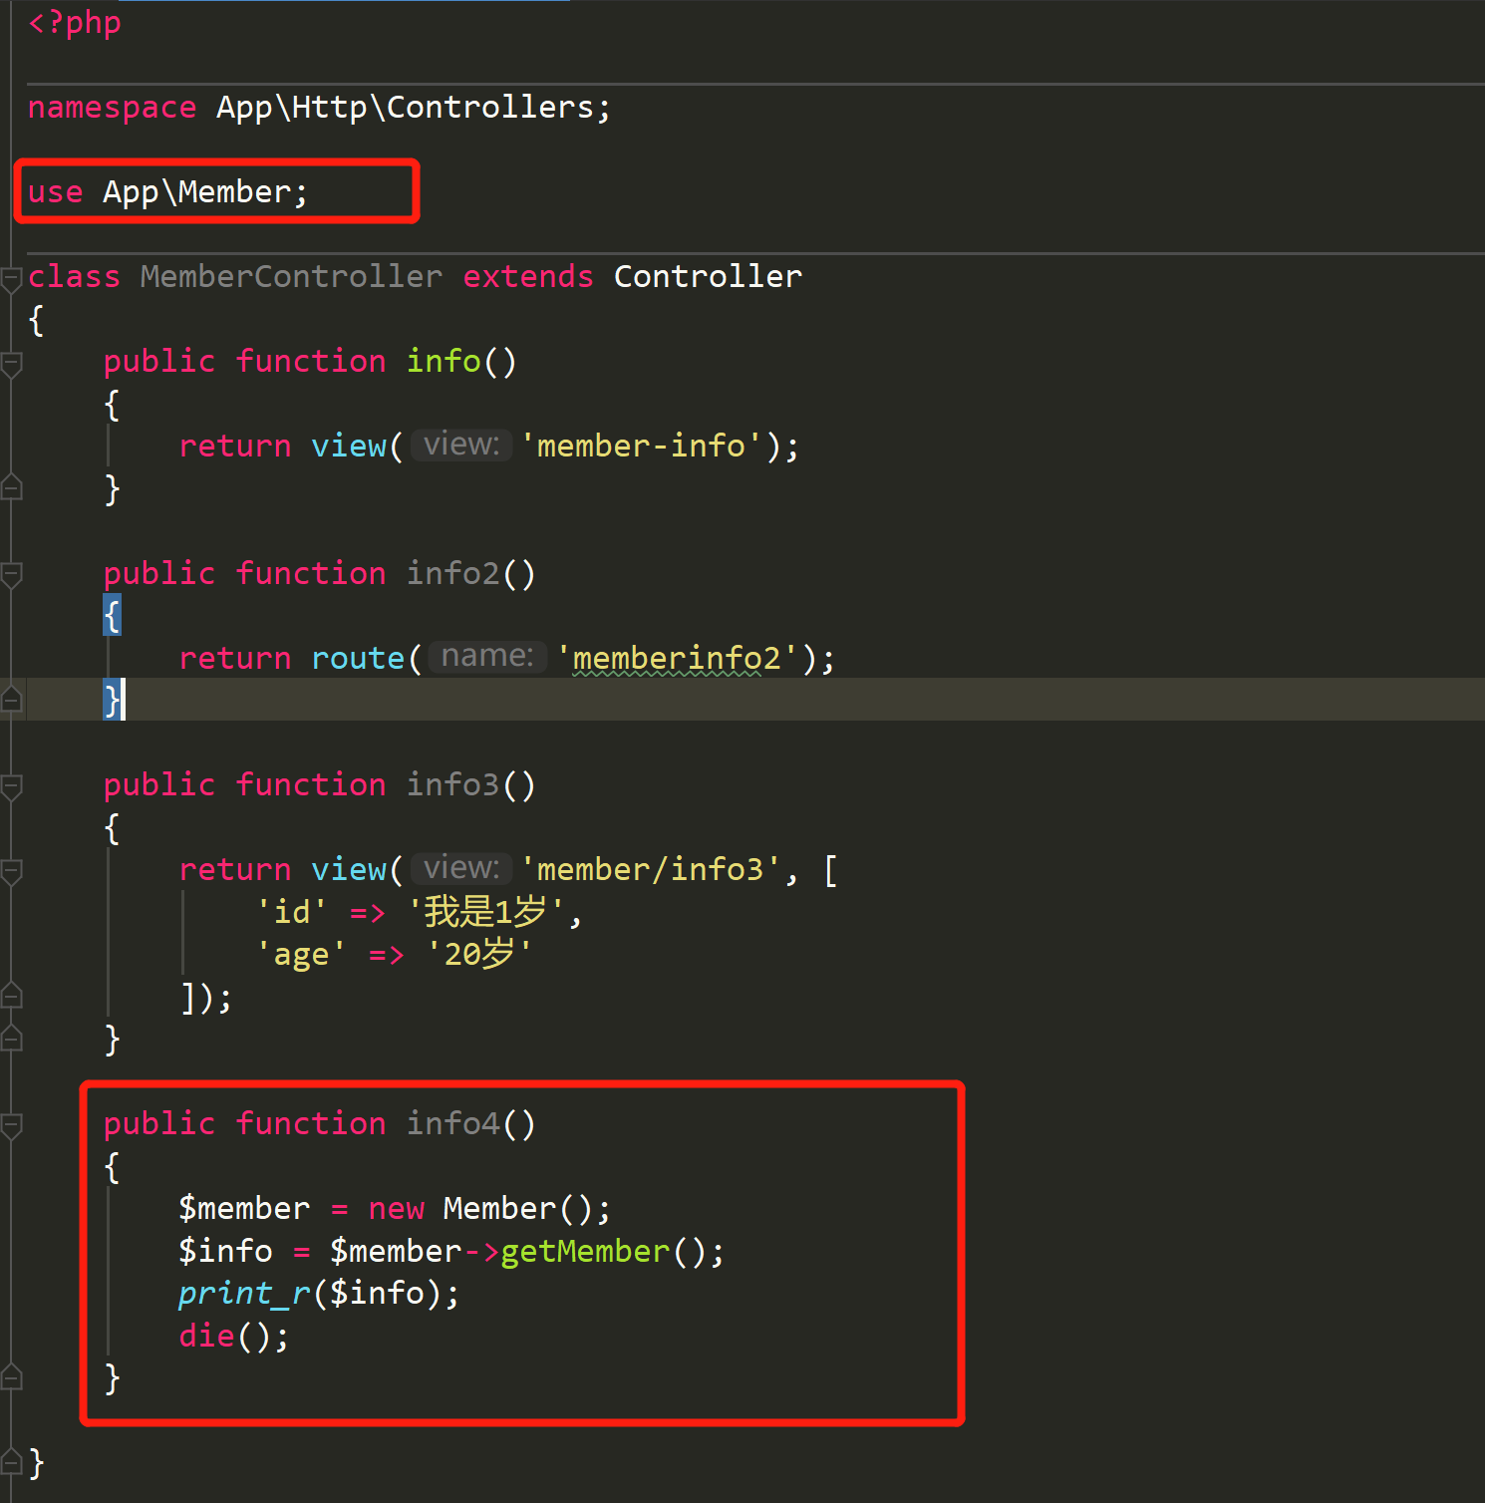

# 原始sql

<?php  
namespace App\Http\Controllers;  
use Illuminate\Support\Facades\DB;  
class StudentController extends Controller  
{  
 public function info5()  
 {  
 $students = DB::select('select * from student');  
 DB::insert("insert into student (id,name,age,sex) values (*?*,*?*,*?*,*?*)", ['2', '猪八戒', 20, 50]);  
 DB::update("update student set name=*?* where id=*?*", ['唐僧', 2]);  
 DB::delete("delete from student where id=*?*", [2]);  
 }  
}

# 查询构建器

//查询构建器  
public function info6()  
{  
 //增加  
 // $bool = DB::table('student')->insert(['id' => '2', 'name' => '沙僧']);  
  
 // $id = DB::table('student')->insertGetId(  
 // ['id' => '6', 'name' => '沙僧']);  
  
 //更新  
 // DB::table('student')->where('id',6)->update(['age'=>50]);  
  
 //自增  
 // $num = DB::table('student')->increment('age');  
 // $num = DB::table('student')->decrement('age',3);  
 // print_r($num);  
  
 //删除  
 DB::table('student')->where('id','>=',6)->delete();  
 // DB::table('student')->truncate();  
  
}

public function info7()  
{  
 $count=DB::table('student')->count();  
 *print_r*($count);  
 $age=DB::table('student')->max('age');  
 *print_r*(" ");  
 *print_r*($age);  
 $min=DB::table('student')->min('age');  
 *print_r*(" ");  
 *print_r*($min);  
 $avg=DB::table('student')->avg('age');  
 *print_r*(" ");  
 *print_r*($avg);  
  
}

# ORM