# 语法

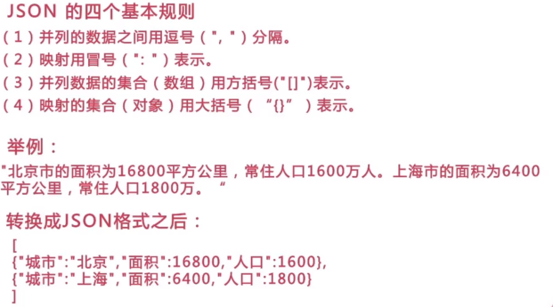

# 知识

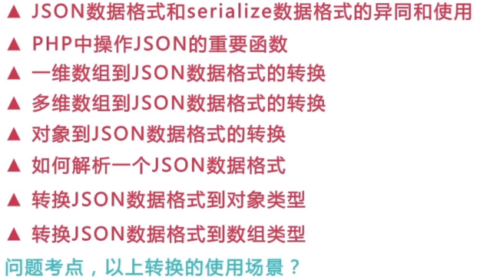

# json与serialize

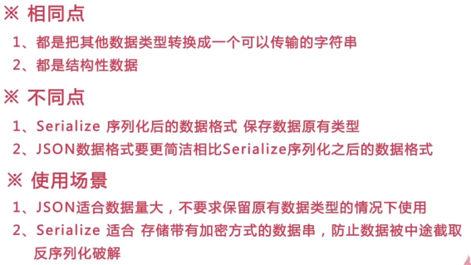

<?php  
// {"a":1,"b":2,"c":3}  
// a:3:{s:1:"a";i:1;s:1:"b";i:2;s:1:"c";i:3;}  
$a = array(  
 "a" => 1,  
 "b" => 2,  
 "c" => 3,  
);  
echo *json_encode*($a);  
echo "-----";  
echo *serialize*($a);  
  
// [{"a":1,"b":2,"c":3}]  
// a:1:{i:0;a:3:{s:1:"a";i:1;s:1:"b";i:2;s:1:"c";i:3;}}  
echo "<br>";  
$a = array(  
 array(  
 "a" => 1,  
 "b" => 2,  
 "c" => 3,  
 )  
);  
echo *json_encode*($a);  
echo "-----";  
echo *serialize*($a);  
// [[{"a":1,"b":2,"c":3}]]  
// a:1:{i:0;a:1:{i:0;a:3:{s:1:"a";i:1;s:1:"b";i:2;s:1:"c";i:3;}}}  
echo "<br>";  
$a = array(  
 array(  
 array(  
 "a" => 1,  
 "b" => 2,  
 "c" => 3,  
 )  
 )  
);  
echo *json_encode*($a);  
echo "-----";  
echo *serialize*($a);



# json_decode

<?php  
  
$a='{"a":"1","b":"2"}';  
echo $a;  
$b=*json_decode*($a);  
*var_dump*($b);  
echo "<br>";  
$a=*json_decode*($a,true);  
*var_dump*($a);  
  
  
// {"a":"1","b":"2"}  
// D:\phpstudy\PHPTutorial\WWW\PHPCollection\PHPJSON\2.reeasy.php:6:  
// object(stdClass)[1]  
// public 'a' => string '1' (length=1)  
// public 'b' => string '2' (length=1)  
//  
// D:\phpstudy\PHPTutorial\WWW\PHPCollection\PHPJSON\2.reeasy.php:9:  
// array (size=2)  
// 'a' => string '1' (length=1)  
// 'b' => string '2' (length=1)

# 例子

Eval的作用是给转化为对象，为了避免混绕，拼接上()

<!DOCTYPE html>  
<html>  
<head>  
 <script src**="https://code.jquery.com/jquery-3.3.1.min.js"**></script>  
</head>  
<body>  
 <button>**按钮**</button>  
</div>  
</body>  
</html>  
  
<script type**="text/javascript"**>  
 $("button").click(function(){  
 var url = "6.demo2.php";  
 var data = {};  
 jQuery.post(url, data, function(*response*) {  
 //eval是转化为对象了  
 var obj = eval("(" + *response* + ")");  
 *document*.write(obj.username);  
 *document*.write(*response*);  
 });  
 })  
</script>

<?php  
$memberInfo = array();  
$memberInfo['username'] = "eric";  
$memberInfo['truename'] = "袁明贺";  
$memberInfo['age'] = 25;  
$memberInfo['imooc'] = "http://www.imooc.com";  
$memberInfo['hobby']['one'] = "developer";  
$memberInfo['hobby']['two'] = "coding";  
$memberInfo['hobby']['three'] = "学习";  
echo *json_encode*($memberInfo);