# 异步思路

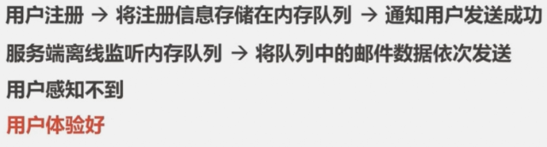

# 队列步骤

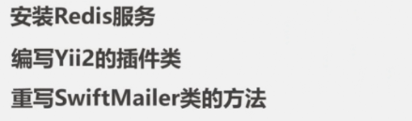

## Redis安装

<https://blog.csdn.net/fujian9544/article/details/104273534>