# 例子



# 思路

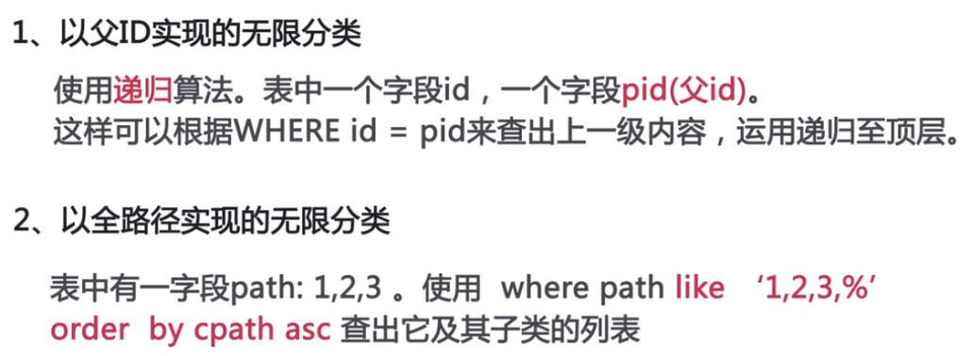

# 用处

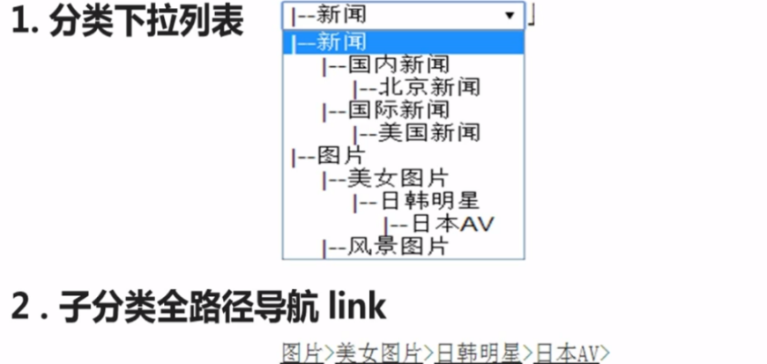

# 递归

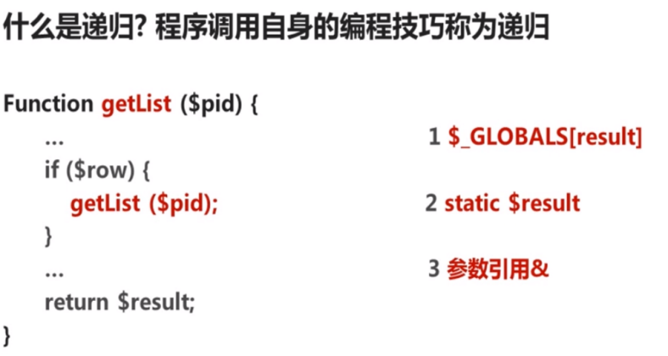

# 原理



# SQL

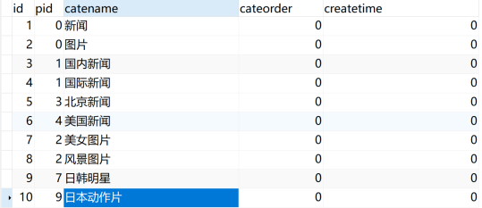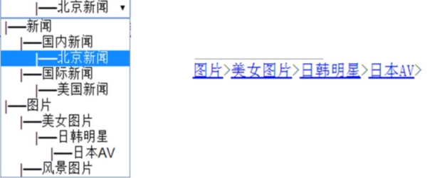

/*  
 Navicat Premium Data Transfer  
  
 Source Server : 127.0.0.1  
 Source Server Type : MySQL  
 Source Server Version : 50553  
 Source Host : localhost:3306  
 Source Schema : test1  
  
 Target Server Type : MySQL  
 Target Server Version : 50553  
 File Encoding : 65001  
  
 Date: 09/10/2019 23:29:59  
*/  
  
SET NAMES utf8mb4;  
SET FOREIGN_KEY_CHECKS = 0;  
  
-- ----------------------------  
-- Table structure for sessions  
-- ----------------------------  
DROP TABLE IF EXISTS `sessions`;  
CREATE TABLE `sessions` (  
 `session_id` int(11) NULL DEFAULT NULL,  
 `session_data` varchar(255) CHARACTER SET utf8 COLLATE utf8_general_ci NULL DEFAULT NULL,  
 `session_expires` varchar(255) CHARACTER SET utf8 COLLATE utf8_general_ci NULL DEFAULT NULL  
) ENGINE = MyISAM CHARACTER SET = utf8 COLLATE = utf8_general_ci ROW_FORMAT = Dynamic;  
  
-- ----------------------------  
-- Records of sessions  
-- ----------------------------  
INSERT INTO `sessions` VALUES (0, 'use|s:3:\"sun\";age|i:233;email|s:11:\"sun@fox.com\";', '1570630054');  
  
-- ----------------------------  
-- Table structure for sort  
-- ----------------------------  
DROP TABLE IF EXISTS `sort`;  
CREATE TABLE `sort` (  
 `id` int(11) NOT NULL,  
 `pid` int(11) NULL DEFAULT NULL,  
 `catename` varchar(255) CHARACTER SET utf8 COLLATE utf8_general_ci NULL DEFAULT NULL,  
 `cateorder` int(11) NULL DEFAULT NULL,  
 `createtime` int(11) NULL DEFAULT NULL,  
 PRIMARY KEY (`id`) USING BTREE  
) ENGINE = MyISAM CHARACTER SET = utf8 COLLATE = utf8_general_ci ROW_FORMAT = Dynamic;  
  
-- ----------------------------  
-- Records of sort  
-- ----------------------------  
INSERT INTO `sort` VALUES (1, 0, '新闻', 0, 0);  
INSERT INTO `sort` VALUES (2, 0, '图片', 0, 0);  
INSERT INTO `sort` VALUES (3, 1, '国内新闻', 0, 0);  
INSERT INTO `sort` VALUES (4, 1, '国际新闻', 0, 0);  
INSERT INTO `sort` VALUES (5, 3, '北京新闻', 0, 0);  
INSERT INTO `sort` VALUES (6, 4, '美国新闻', 0, 0);  
INSERT INTO `sort` VALUES (7, 2, '美女图片', 0, 0);  
INSERT INTO `sort` VALUES (8, 2, '风景图片', 0, 0);  
INSERT INTO `sort` VALUES (9, 7, '日韩明星', 0, 0);  
INSERT INTO `sort` VALUES (10, 9, '日本动作片', 0, 0);  
INSERT INTO `sort` VALUES (0, NULL, NULL, NULL, NULL);  
  
SET FOREIGN_KEY_CHECKS = 1;

# 下拉树形

<?php  
*define*("host","localhost");  
*define*("user","root");  
*define*("pwd","root");  
*define*("db","test1");  
*define*("port",3306);  
  
$conn=new mysqli(*host*,*user*,*pwd*,*db*,*port*);

<?php  
  
include "conn.php";  
  
function getTree(*$pid*,&*$result*=[],*$spac*=0){  
 global $conn;  
 *$spac*=*$spac*+2;  
 $sql="select * from sort where pid=*{$pid*}";  
 $res=*mysqli_query*($conn,$sql);  
 while($row=*mysqli_fetch_assoc*($res)){  
 $id=$row['id'];  
 $row['catename']=*str_repeat*('&nbsp;&nbsp;',*$spac*).$row['catename'];  
 *$result*[]=$row;  
 getTree($id,*$result*,*$spac*);  
 }  
 return *$result*;  
}  
  
function display(*$sid*=0){  
 $res=getTree(0);  
 echo "<select name='cate'>";  
 foreach($res as $k=>$v){  
 if(*$sid*==$v['id']){  
 echo "<option selected>{$v['catename']}</option>";  
 }else{  
 echo "<option >{$v['catename']}</option>";  
 }  
 }  
 echo "</select>";  
}  
  
echo "<br>";  
display(3);

# 下拉线形

<?php  
*define*("host","localhost");  
*define*("user","root");  
*define*("pwd","root");  
*define*("db","test1");  
*define*("port",3306);  
  
$conn=new mysqli(*host*,*user*,*pwd*,*db*,*port*);

<?php  
include "conn.php";  
  
function getList(*$cid*=0,&*$result*=[]){  
 global $conn;  
 $sql="select * from sort where id=*{$cid*}";  
 $res=*mysqli_query*($conn,$sql);  
 $row=*mysqli_fetch_assoc*($res);  
  
 if($row){  
 *$result*[]=$row['catename'];  
 getList($row['pid'],*$result*);  
 }  
 *krsort*(*$result*);  
 return *$result*;  
}  
  
function display(*$id*=10){  
 $res=getList(*$id*);  
 $str="";  
 foreach ($res as $k=>$v){  
 if($k==0){  
 $str.="<a href='conn.php'>"."{$v}".'</a>';  
 }else{  
 $str.="<a href='conn.php'>"."{$v}".'</a>'.'>';  
 }  
 }  
  
 return $str;  
}  
  
$str=display(10);  
echo $str;