# 设置时区

## 说明



## 代码

<?php  
*header*('content-type:text/html;charset=utf-8');  
  
// date_default_timezone_set("Asia/Shanghai");  
*ini_set*('date.timezone','Asia/Shanghai');  
$zone=*date_default_timezone_get*();  
echo *date*("ymd his");  
*var_dump*($zone);

# 时间函数

**date:*第一个参数是样式，第二个参数是时间戳*strtotime:*第一个参数是改变，第二个参数是时间戳*mktime:*参数分别为时分秒日月年 返回时间戳*microtime:*返回微秒  有true的时候，是返回的微秒时间戳的浮点数形式*time:*返回时间戳  
getdate*():*返回当前的时间信息  
gettimeofday*():*返回当前的时间信息  
checkdate*(11,11,2011)*：参数是月日年***

# 日期控件

## 说明

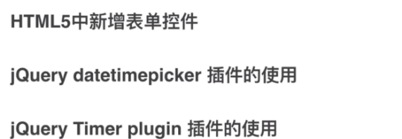

## H5

<!DOCTYPE html>  
<html>  
<head>  
 <title>**h5 时间控件**</title>  
</head>  
<body>  
 <form action**="11.action.php"** method**="post"**>  
 <input type**="date"** name**="datetime"** id**="time"**>  
 <input type**="datetime"** name**="datetime1"** id**="time1"**>  
 <input type**="datetime-local"** name**="datetime2"** id**="time2"**>  
 <input type**="month"** name**="month"** id**="month"**>  
 <input type**="week"** name**="week"** id**="week"**>  
 <input type**="time"** name**="time"** id**="time"**>  
 <input type**="submit"** value**="提交"**>  
 </form>  
</body>  
</html>

## Timepicker

<!DOCTYPE html>  
<html lang**="en"**>  
<head>  
 <meta http-equiv**="content-type"** content**="text/html; charset=utf-8"**/>  
 <link rel**="stylesheet"** type**="text/css"** href**="./datetimepicker/jquery.datetimepicker.css"**/>  
 <script src**="./datetimepicker/jquery.js"**></script>  
 <script src**="./datetimepicker/build/jquery.datetimepicker.full.js"**></script>  
</head>  
<body>  
<input type**="text"** value**=""** id**="datetimepicker"**/>  
</body>  
<!--http://www.jq22.com/jquery-info332-->  
<script>  
 $.datetimepicker.setLocale('ch');  
 $('#datetimepicker').datetimepicker({  
 dayOfWeekStart: 1,  
 lang: 'en',  
 timepicker:false,   
 disabledDates: ['2020/04/15'],  
 startDate: '2020/04/15'  
 });  
 $('#datetimepicker').datetimepicker({value: '2020/04/15 12:00', step: 10});  
  
  
</script>  
</html>

## Flipdown

<!DOCTYPE html>  
<html>  
<head>  
 <meta http-equiv**="Content-Type"** content**="text/html; charset=gb2312"** />  
 <title>**复古翻牌时钟效果**</title>  
 <link href**="./flipcountdown/css/fliptimer.css"** rel**="stylesheet"** type**="text/css"** />  
</head>  
<body>  
  
<a href**="15.fliptimer.html"**>**时钟效果**</a>  
<a href**="16.daojishi.html"**>**倒计时**</a>  
<a href**="17.10second.html"**>**十秒倒计**</a>  
  
<div class**="dowebok"**>  
 <div class**="hours"**></div>  
 <div class**="minutes"**></div>  
 <div class**="seconds"**></div>  
</div>  
</body>  
</html>  
<!--http://www.jq22.com/jquery-info277-->  
<script src**="./flipcountdown/js/jquery-1.11.3.min.js"**></script>  
<script src**="./flipcountdown/js/jquery.fliptimer.js"**></script>  
<script>  
 $(function(){  
 $('.dowebok').flipTimer({});  
 });  
</script>