Comparision between logistic regression

and

2-layered net

2016025423 박주언

# Abstraction

For this assignment, task1, task2, and task3 were made. Task1 is binary classification using logistic regression, task2 is binary classification using 2-layered net, and task3 is the one using 2-layered net with three nodes in layer 1.

# Results

|  |  |  |  |
| --- | --- | --- | --- |
|  | Task1 | Task2 | Task3 |
| Train cost | 0.3465819821417099 | 0.35118438720777506 | 0.2447017231338518 |
| Train accuracy (%) | 81.7 | 80.5 | 92.2 |
| Test cost | 0.03509194600150019 | 0.029241388290971414 | 0.23169634311473414 |
| Test accuracy (%) | 80 | 85 | 93 |
| Learning rate | 1 | 1 | 1 |

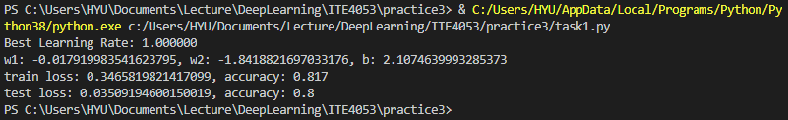

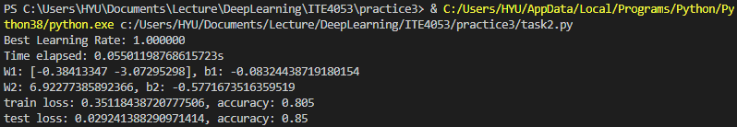

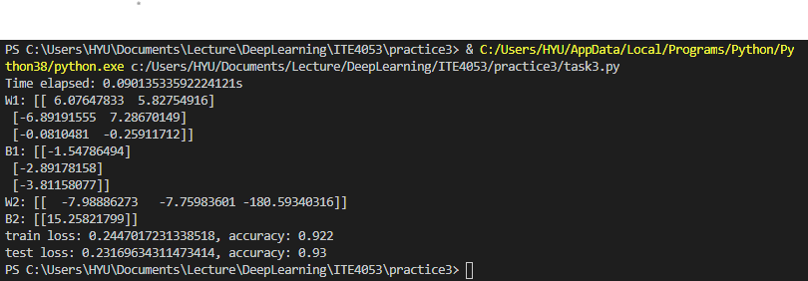

# Conclusion

With this assignment, we can see that as the neural net gets deeper and deeper, the learning gets more accurate. Moreover, while finding appropriate learning rate alpha, I tried to find alpha value with a strategy smarter than brute-force. However, the method I have tried failed, and with the brute force, the learning rate’s value reached 1.0 as the best-performing learning rate. Moreover, the initial value of W and b had a little impact on result, but not as much as learning rate alpha.