Personal Spending Analysis

This currently interprets the CSV format downloaded from Natwest UK Online banking service.
I plan to extend the tool to be configurable.

You basically download your transactions using a web browser, import them (don't worry duplicates will be ignored so don't worry about importing the same thing twice).

You can then set up your categories and category search strings, then press “Autocategorize”. Tailor your search strings to make things really easy.

The search strings are insensitive to case and terms are separated by a comma for example you make have a category food with search string of greggs,tesco,waitrose.

Once categorised, you can chart the summary:

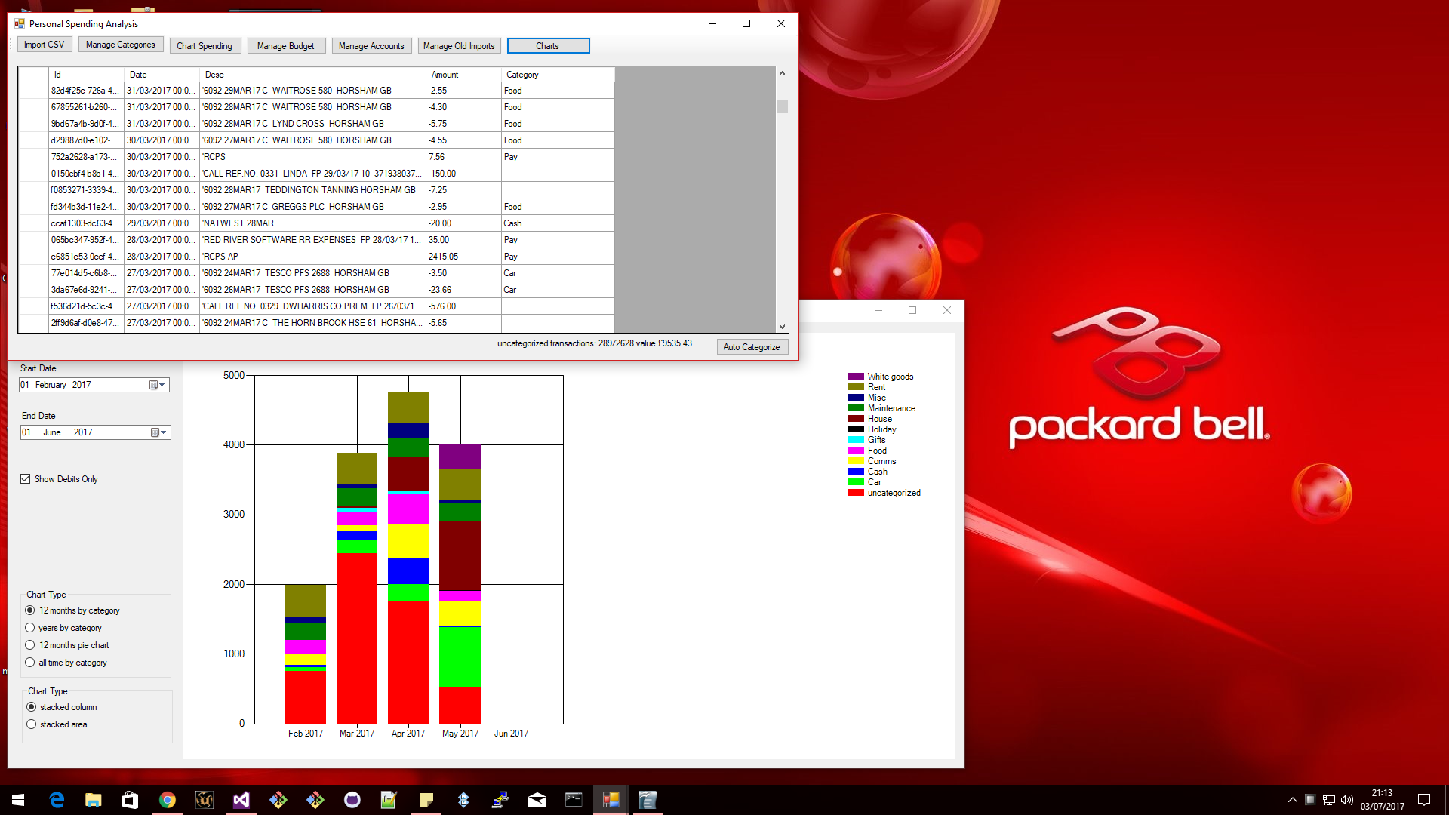
The program is written in C# with windows forms.
The intention is to make an Android Version, iOS version, browser version, sync to REST server.

