Low Noise Power Supply Documentation

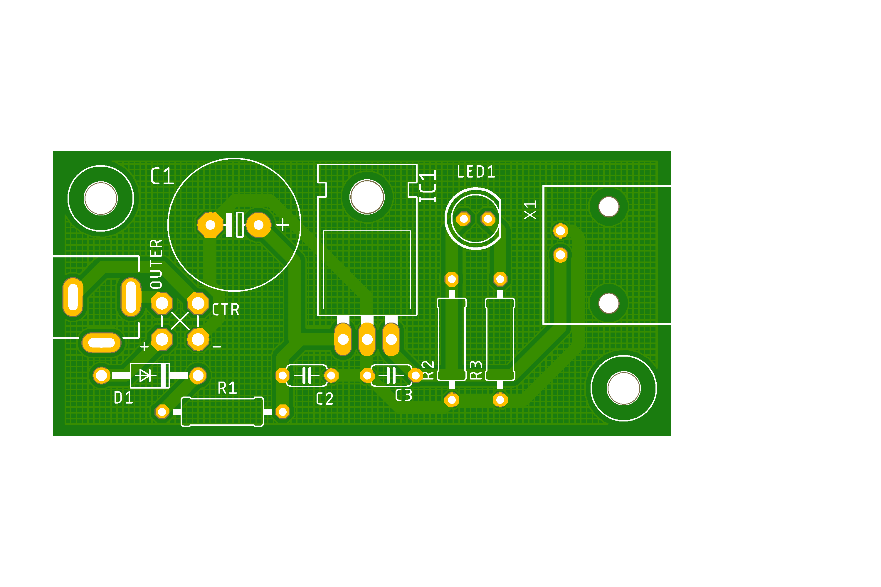

This PCB contains an RC lowpass filter followed by a linear regulator IC. Its purpose is to generate a stable 5 V from the noisy switch mode power supply input. It is suited to supply 5 V to the photocurrent sampling PCB (Version Jan. 2023 & Dec. 2023) and the XUV photodiode amplifier PCB Version Sep. 2023.

The maximum current that can be supplied by the LM7805 linear regulator is 500 mA. The RC lowpass filter has to be adapted to the actual current consumption of the attached device.

Calculation of R and C depending on the minimal input Voltage $U_{in}$ and the maximum output current $I_{out}$ : $$R≤\frac{U_{in}-5.7 V}{I_{out}⋅2}$$

$$C≥\frac{0.01 s}{R}$$

Recommendation: R=10 Ω, C=1000µF, for $U_{in}>$ 9 V and $I_{out}$ < 100 mA

The circuit is protected against revers polarity by a 1N4007 diode (D1). To match the polarity of the switch mode power supply and the barrel jack input, bridges can be inserted between OUTER and +,- as well as CTR and +,-. The naming OUTER and CTR is not well suited, because not all barrel jacks use the same pinout. It is advised to measure actual the connections.

# Bill of Materials

| Part | Name on PCB | Availability at IEP TU Graz |
| --- | --- | --- |
| BNC-Jack | X1 | Elektroniker – Lager / |
| LM7805 | IC1 | Elektroniker – Lager / |
| Electrolytic Cap. e.g. 1000 µF 25 V | C1 | Elektroniker - Lager / |
| Ceramic Cap. 100 nF, 50 V | C2, C3 |  |
| Resistor R1, e.g. 10Ω ¼ W | R1 | Elektroniker - Lager / |
| Resistor approx. 500Ω ¼ W | R2 | Elektroniker - Lager / |
| Resistor 1kΩ ¼ W (optional) | R3 | Elektroniker - Lager / |
| LED 5mm (optional) | LED1 | Elektroniker - Lager / |
| Diode 1N4004 or 1N4007 | D1 | Elektroniker - Lager / |
| Barrel Jack | None (Leftmost part) | Bei Platinen / Neuhold |
| Screw M3x5 up to M3x9 | None | Werkstatt |
| Screws (2x) M3x15 or M3x20 | None | Werkstatt |
| 3D printed housing | None |  |

# Manufacturing

PCBs can be ordered at JLC PCB for less than 1€ per piece if 10 or more are ordered. (08.2023)  
The necessary Eagle / Gerber files are supplied along with this document on Github (<https://github.com/hippdani/PhotocurrentAmplifier/LowNoisePSU/LowNoisePSU_2023-09-27.zip>)

Add the parts according to the BOM. LED1 and R3 are optional and only necessary if you want a power on indicator.

If less than 100 mA are supplied, bend the legs of IC1 and screw it down when assembling the PCB in the housing. If more than 100 mA are supplied, add heat conducting paste and / or a heatsink.

For mechanical robustness it is advised to glue BNC Jack X1 to the PCB (with CA glue for example). Solder in two bridges according to the polarity of the switch mode power supply used and the specific pinout of the barrel jack. Positive voltage should arrive at the hole marked + and negative at - . Configuration A and B in the following image illustrate the options.



Print the housing according to the [.3mf files](https://github.com/hippdani/PhotocurrentAmplifier/LowNoisePSU/3DPrints) supplied with this document. For better visibility of the power on indicator LED, leave the leads long above the PCB and put a diffuse transparent material onto the hole (e.g. hot glue).

Screw for fastening the PCB and IC1 to the housing: M3x5 up to M3x9

Screws for clamping the two housing halves 2 pcs..: M3x15 or M3x20

It is helpful to mark the finished Device with input voltage and polarity as well as output voltage, current and polarity.

# Electrical Characteristics

* Output voltage: 5 V ±1%, Noise < 600 µVrms typ. If attached to a switch mode PSU, < 300 µVrms typ. If attached to a Battery.
* Minimum input voltage: min. 8 V but more depending on the RC lowpass. Min 9 V if R=10 Ω, C=1000µF, $I_{out}$ < 100 mA
* Maximum input voltage: Max. rating of capacitors or 25 V, whichever is lower.
* Maximum output current: Dictated by lowpass or max. 500 mA dictated by LM7805

# Circuit Diagram

