新闻浏览手机服务器端接口说明

说明

手机客户端的功能配置由读取服务器端的配置文件完成，手机客户端提供功能导航功能，其业务逻辑由服务器端的网页、WEBService及脚本等对象完成，客户端不负责任何业务逻辑。

界面
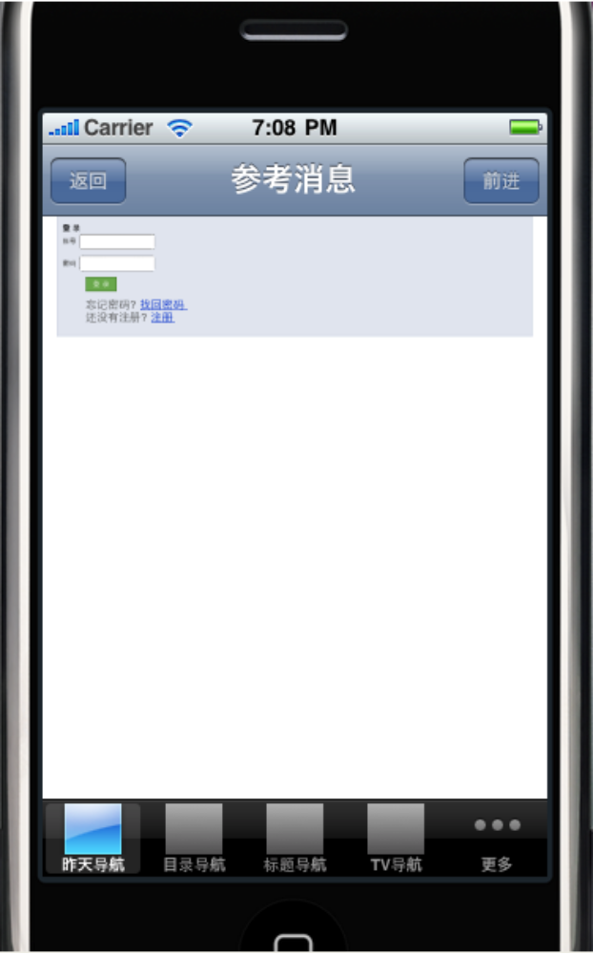

配置文件定义

XML Schema

<?xml version="1.0" encoding="UTF-8"?>
<!-- edited with XMLSpy v2006 U (http://www.altova.com) by lang (EMBRACE) -->
<xs:schema xmlns:xs="http://www.w3.org/2001/XMLSchema" elementFormDefault="qualified" attributeFormDefault="unqualified">
<xs:element name="interface">
<xs:annotation>
<xs:documentation>接口根目录</xs:documentation>
</xs:annotation>
<xs:complexType>
<xs:sequence maxOccurs="unbounded">
<xs:element name="functionitem">
<xs:complexType>
<xs:attribute name="text">
<xs:annotation>
<xs:documentation>功能名称</xs:documentation>
</xs:annotation>
</xs:attribute>
<xs:attribute name="url">
<xs:annotation>
<xs:documentation> 功能实现网页路径</xs:documentation>
</xs:annotation>
</xs:attribute>
<xs:attribute name="imgurl">
<xs:annotation>
<xs:documentation>功能图标</xs:documentation>
</xs:annotation>
</xs:attribute>
</xs:complexType>
</xs:element>
</xs:sequence>
</xs:complexType>
</xs:element>
</xs:schema>

配置文件样例

<?xml version="1.0" encoding="UTF-8"?>
<interface xmlns:xsi="http://www.w3.org/2001/XMLSchema-instance" xsi:noNamespaceSchemaLocation="E:\company\doc\iphone\通信协议XML schame\interfaceset.xsd">
<functionitem text="昨天导航" imgurl="http://192.168.200.230/pagerror.gif" url="http://192.168.200.54/rn"/>
<functionitem text="目录导航" imgurl="http://192.168.200.230/pagerror.gif" url="http://www.hgzp.com.cn"/>
<functionitem text="标题导航" imgurl="http://192.168.200.230/pagerror.gif" url="http://www.sina.com"/>
<functionitem text="TV导航" imgurl="http://192.168.200.230/pagerror.gif" url="http://www.hgzp.com.cn"/>
<functionitem text="VV导航" imgurl="" url="http://www.sina.com"/>
<functionitem text="更多" imgurl="more" url="http://www.sohu.com"/>
<functionitem text="CCTV" imgurl="" url="http://www.cctv.com"/>
<functionitem text="投稿" imgurl="" url="http://www.sohu.com"/>
<functionitem text="CCTV" imgurl="" url="http://www.cctv.com"/>
<functionitem text="投稿" imgurl="" url="http://www.sohu.com"/>
<functionitem text="CCTV" imgurl="" url="http://www.cctv.com"/>
<functionitem text="投稿" imgurl="" url="http://www.sohu.com"/>
<functionitem text="CCTV" imgurl="" url="http://www.cctv.com"/>
</interface>

