## Installation of UCS image to synchronize Active Directory accounts with passwords

* We will need an ISO image of UCS which we need to get it from Univention by ordering a subscription of UCS server with the license file.
* Once we get the image we will need to upload it to Data store of SDH so that it can uploaded later while creating a VM using vshpere client.
* Launch the vsphere client (thick client since you will need access to VM console to deploy UCS image) and create a new virtual machine on any of the available host.
* Select Custom installation

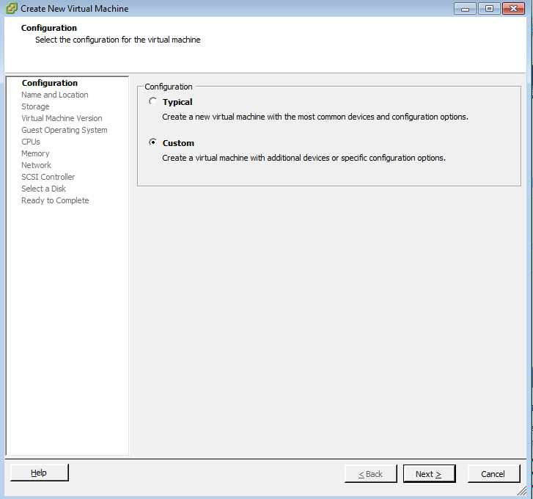

* Specify a name for UCS VM.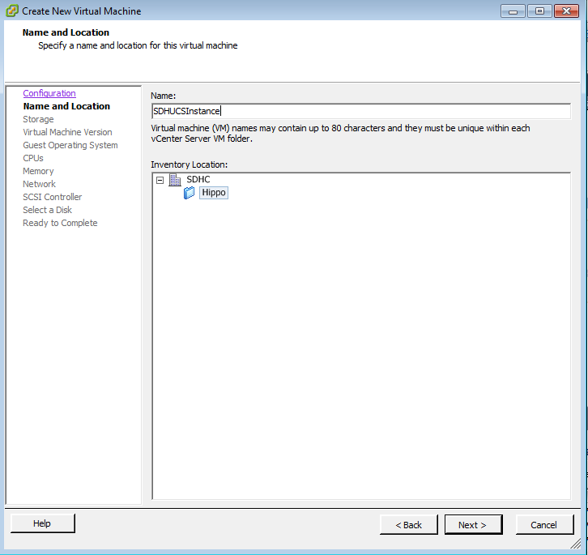
* Select destination storage for the UCS VM.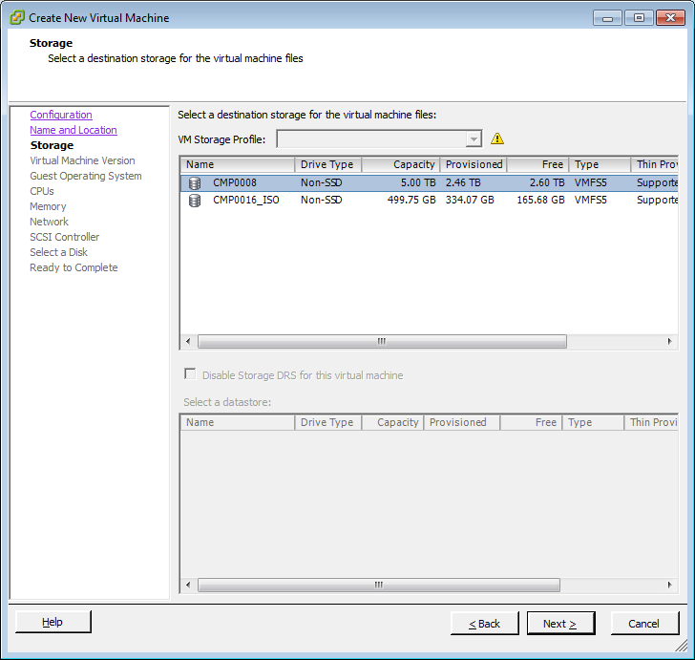
* Select VM version(you can select version 8 which is the latest)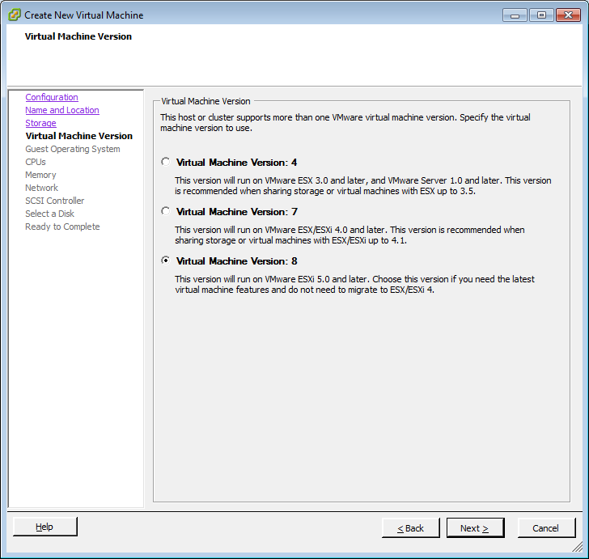
* Select Guest operating system as Linux 64 bit and version as Other Linux(64-bit) as UCS is a Linux-based server operating system.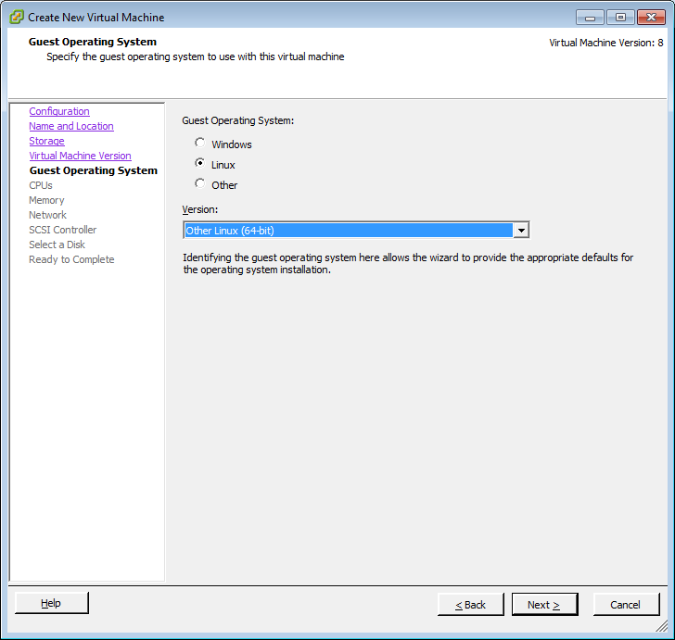
* Select number of virtual sockets a 1 and no of cores as 2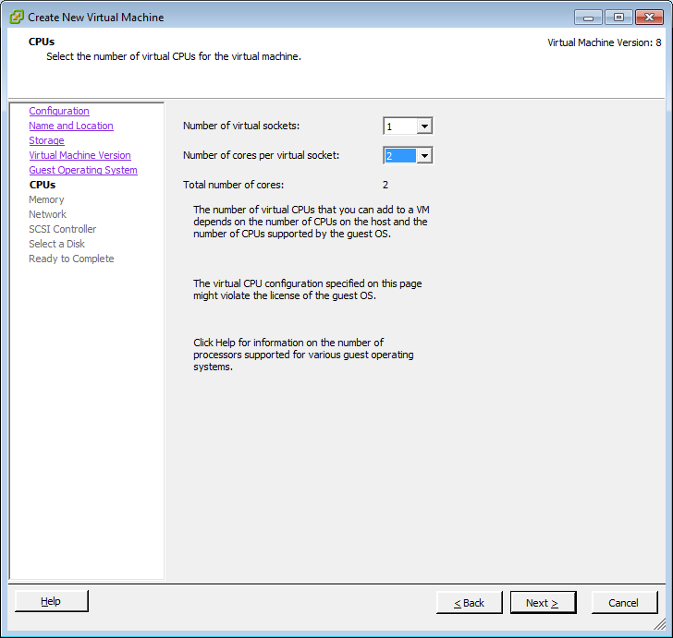
* Select atleast 2GB of RAM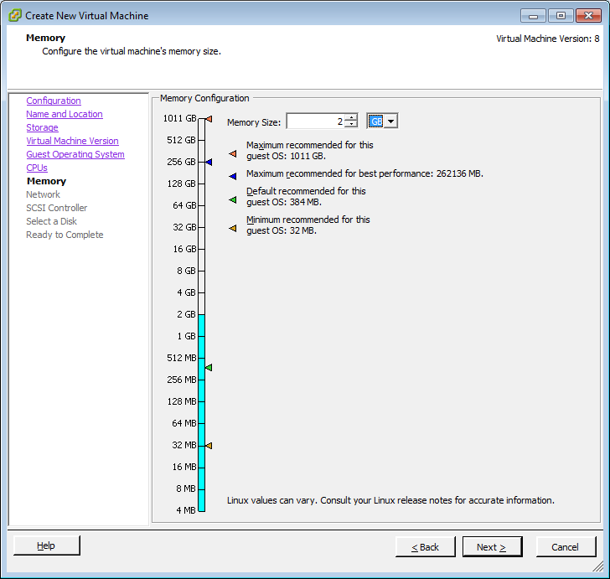
* Select the network connection as shown in below screenshot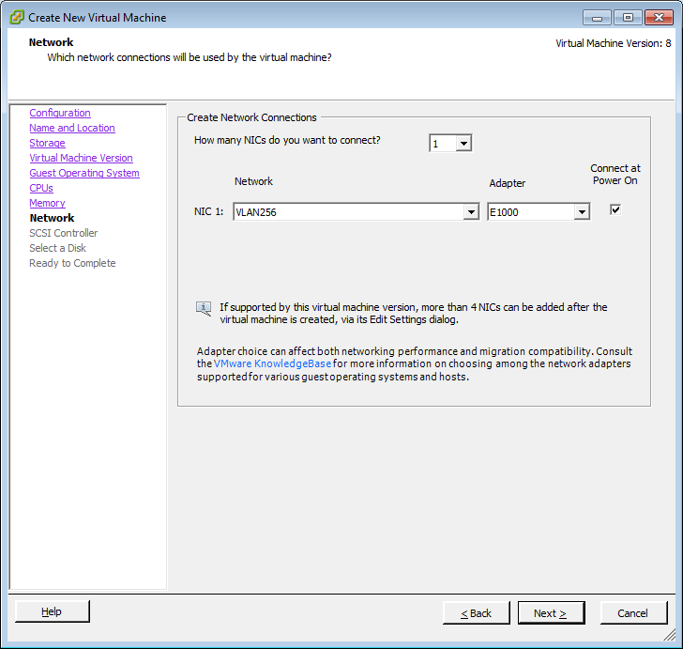
* Select the SCSI controller as shown below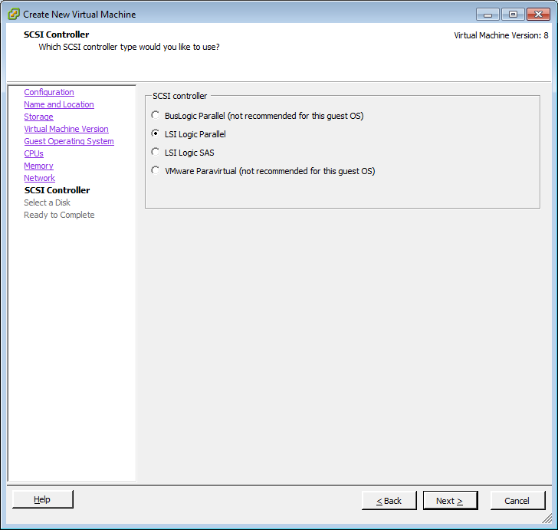
* Select a new disk or choose an existimng one depending on which option best suits your requirements 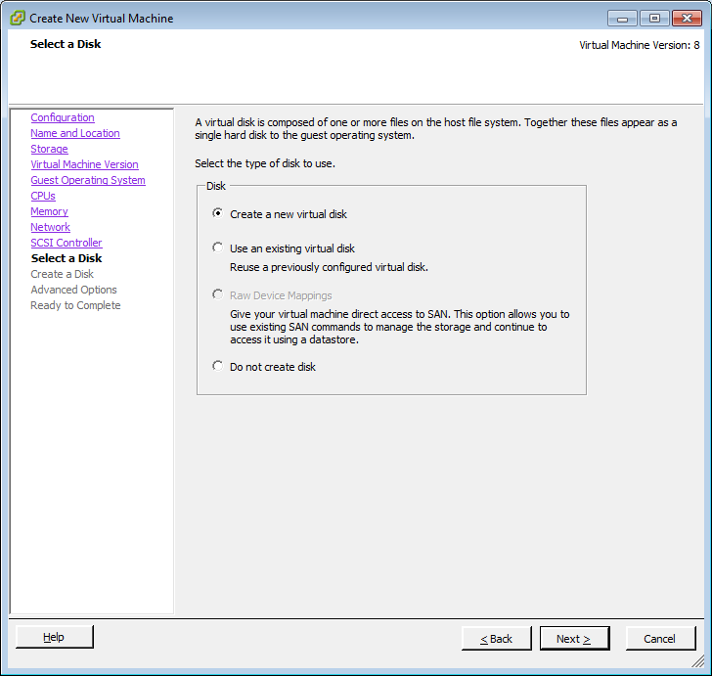
* Configure advanced settings if required else keep the defaults as shown below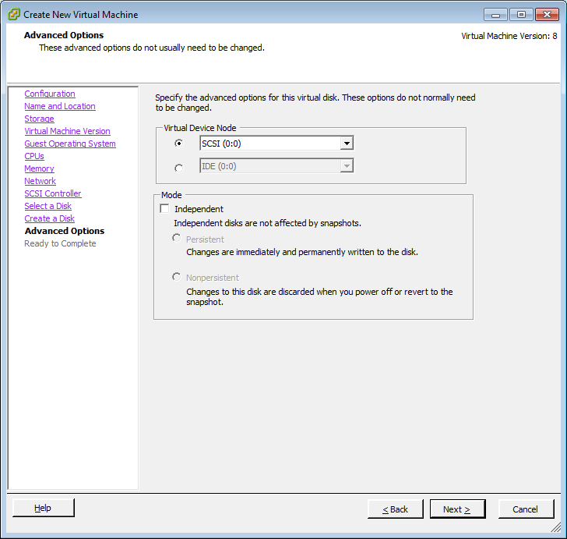
* Confirm whether all the options selected are as per requirements mentioned in above steps and also select the checkbox to edit virtual machine settings.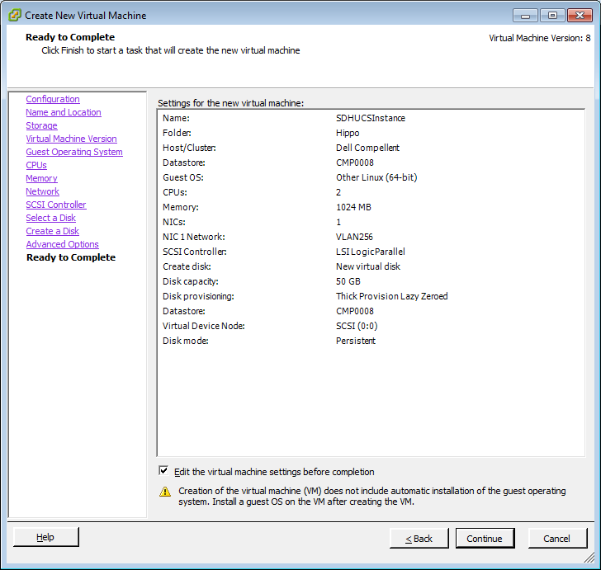
* Browse the UCS ISO image uploaded to the datastore as below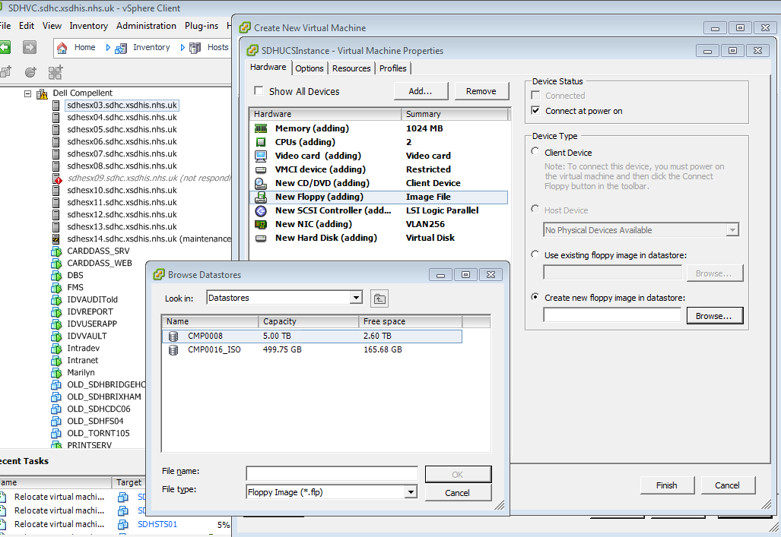
* Power on the VM and right click on the VM to launch the console.

## Selecting the installation mode

## Select “Start with manual network setting” option as we will need to manually specify the host IP, DNS server and gateway configuration.

## Start with manual network settings performs a standard installation, where the network is not configured automatically through DHCP. This is practical on systems, where the network must be setup manually.

* Selecting the installation language
  + English
* Selecting the location
  + United Kingdom
* Selecting the keyboard layout
  + British English
* Network configuration

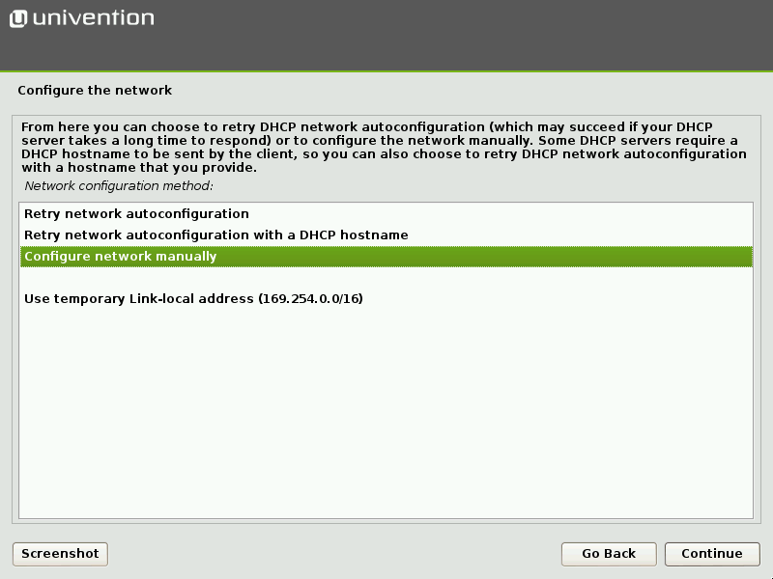

* Specify the IP address(10.181.28.96),Default Gateway IP(10.181.28.254),Name Server IP(10.181.8.111) for UCS server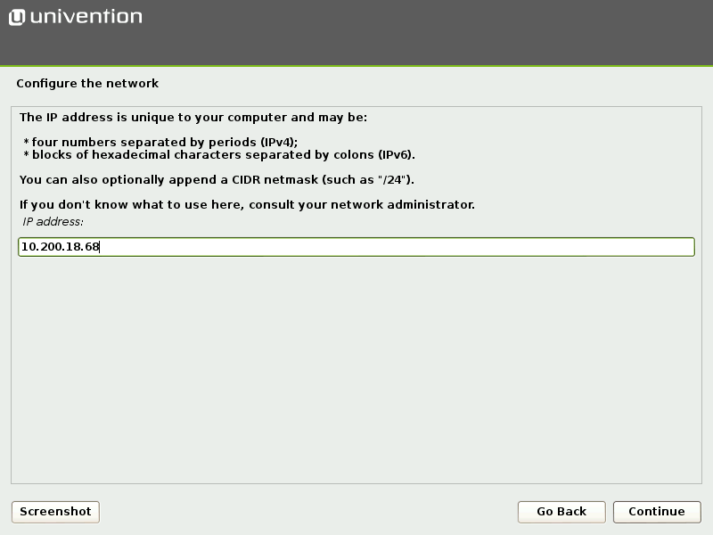
* Specify a root Password for UCS server.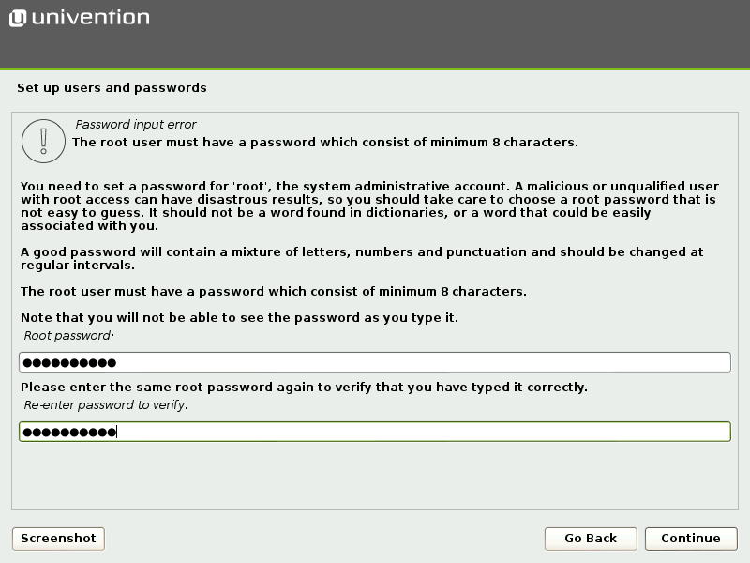
* Partitioning the hard drive-**Use Guided - Use entire disk and set up LVM**

There are three schemes available for selection for guided partitioning:

* **Guided - Use entire disk**: In this scheme, an individual partition is created for each file system. Abstraction layers like LVM are not used. During the following step the number of filesystems/partitions is assigned. The size of the partitions is restricted to the size of the respective hard drive.
* **Guided - Use entire disk and set up LVM**: If the second scheme is selected, an LVM volume group is set up on the selected hard drive first. A separate logical volume is then created within the volume group for each file system. In this scheme, the size of the logical volume is restricted by the size of the volume group, which can also be subsequently enlarged with additional hard drives. In case of doubt, select this partitioning scheme.
* **Guided - Use entire disk with encrypted LVM**: This version is the same as the previous version, with the addition that the LVM volume group is also encrypted. Consequently, the password for the encrypted volume group has to be entered every time the system is started up.

The next step is to select a hard drive from the list of those detected to which the partitioning version should be applied.

There are three subversions for each partitioning version, which differ in the number of file systems created:

* **All files in one partition**: In this version, just one partition or logical volume is created and the / file system saved there.
* **Separate /home partition**: In addition to a file system for /, an additional file system is also created for /home/.
* **Separate /home, /usr, /var and /tmp partition**: In addition to a file system for /, an additional file system is also created each for /home/, /usr/, /var/ and /tmp/.

We can go with “**All files in one partition”** option unless there are specific requirements.

Before every active change to the hard drive, the change is displayed again in an additional dialogue and must be confirmed explicitly.

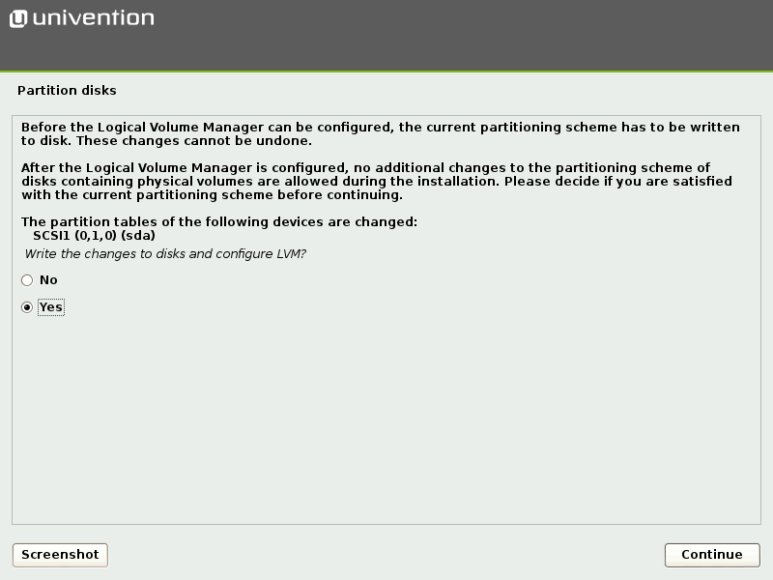

## Domain settings

**Create a new UCS domain**; the first system in a new UCS domain is configured: a UCS system with the *master domain controller* system role. A UCS domain can comprise one single or several UCS systems.

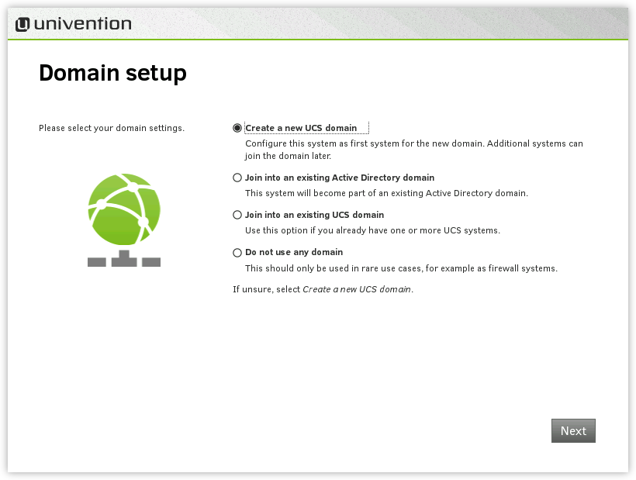

Once the **Create a new UCS domain** mode has been selected, an *organization name*, an *e-mail address*, a *fully qualified domain name* and an *LDAP base* are requested in the following two steps.

Specification of an organization name is optional and it is used in the second step to generate a domain name and the LDAP base automatically.

If a valid e-mail address is specified, this is used to activate a personalized license, which is required for the use of the Univention App Center. The license is generated automatically and sent to the specified e-mail address immediately. The license can then be imported via the Univention Management Console license dialog.

The name of the UCS system to be configured and the name of the DNS domain are determined from the fully qualified domain name (host name including domain name) entered here. A suggestion is generated automatically from the organization name entered in the previous step. It is recommended not to use a publicly available DNS domain, as this can result in problems during the name resolution.

A LDAP base needs to be specified for the initialization of the directory service. A suggestion is also derived here automatically from the fully qualified domain name. This value can usually be adopted without any changes.

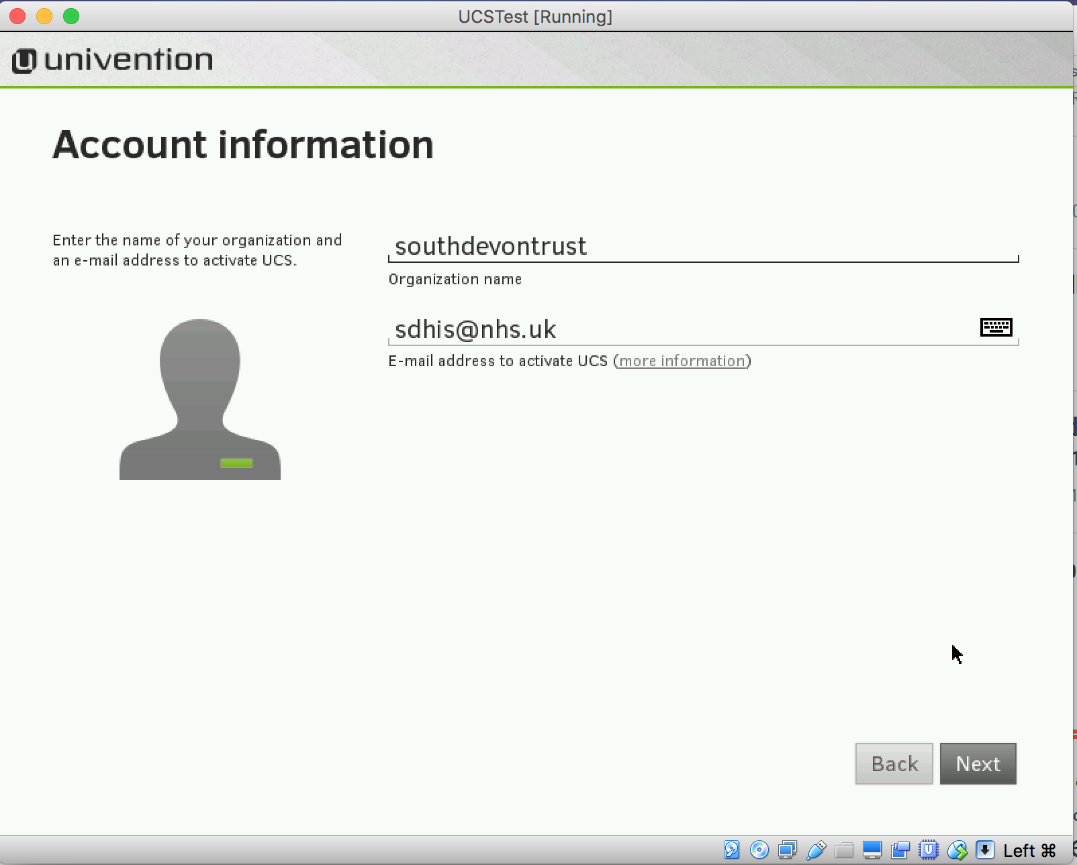

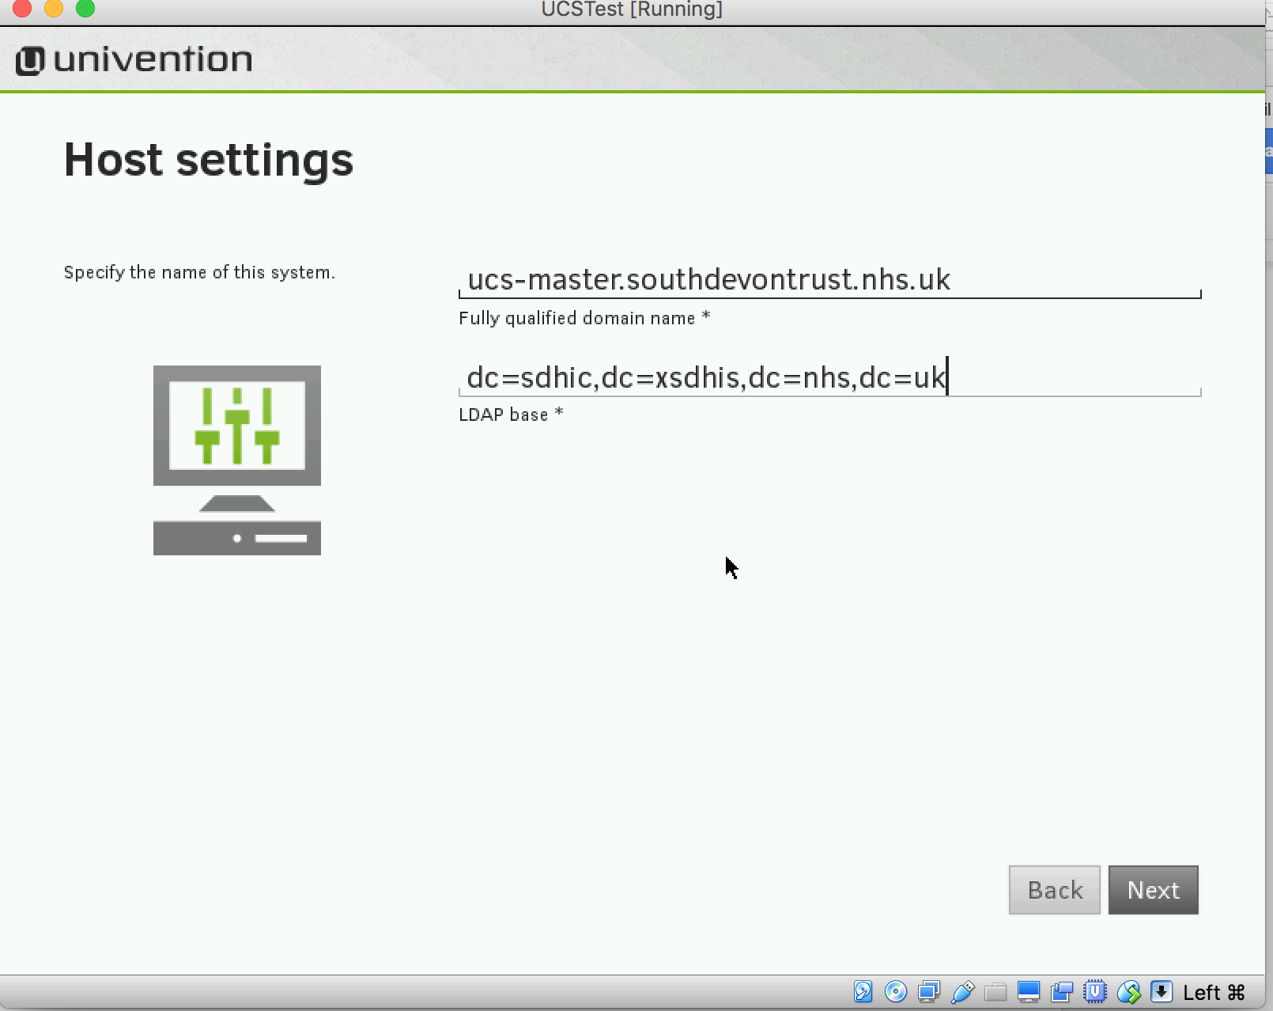

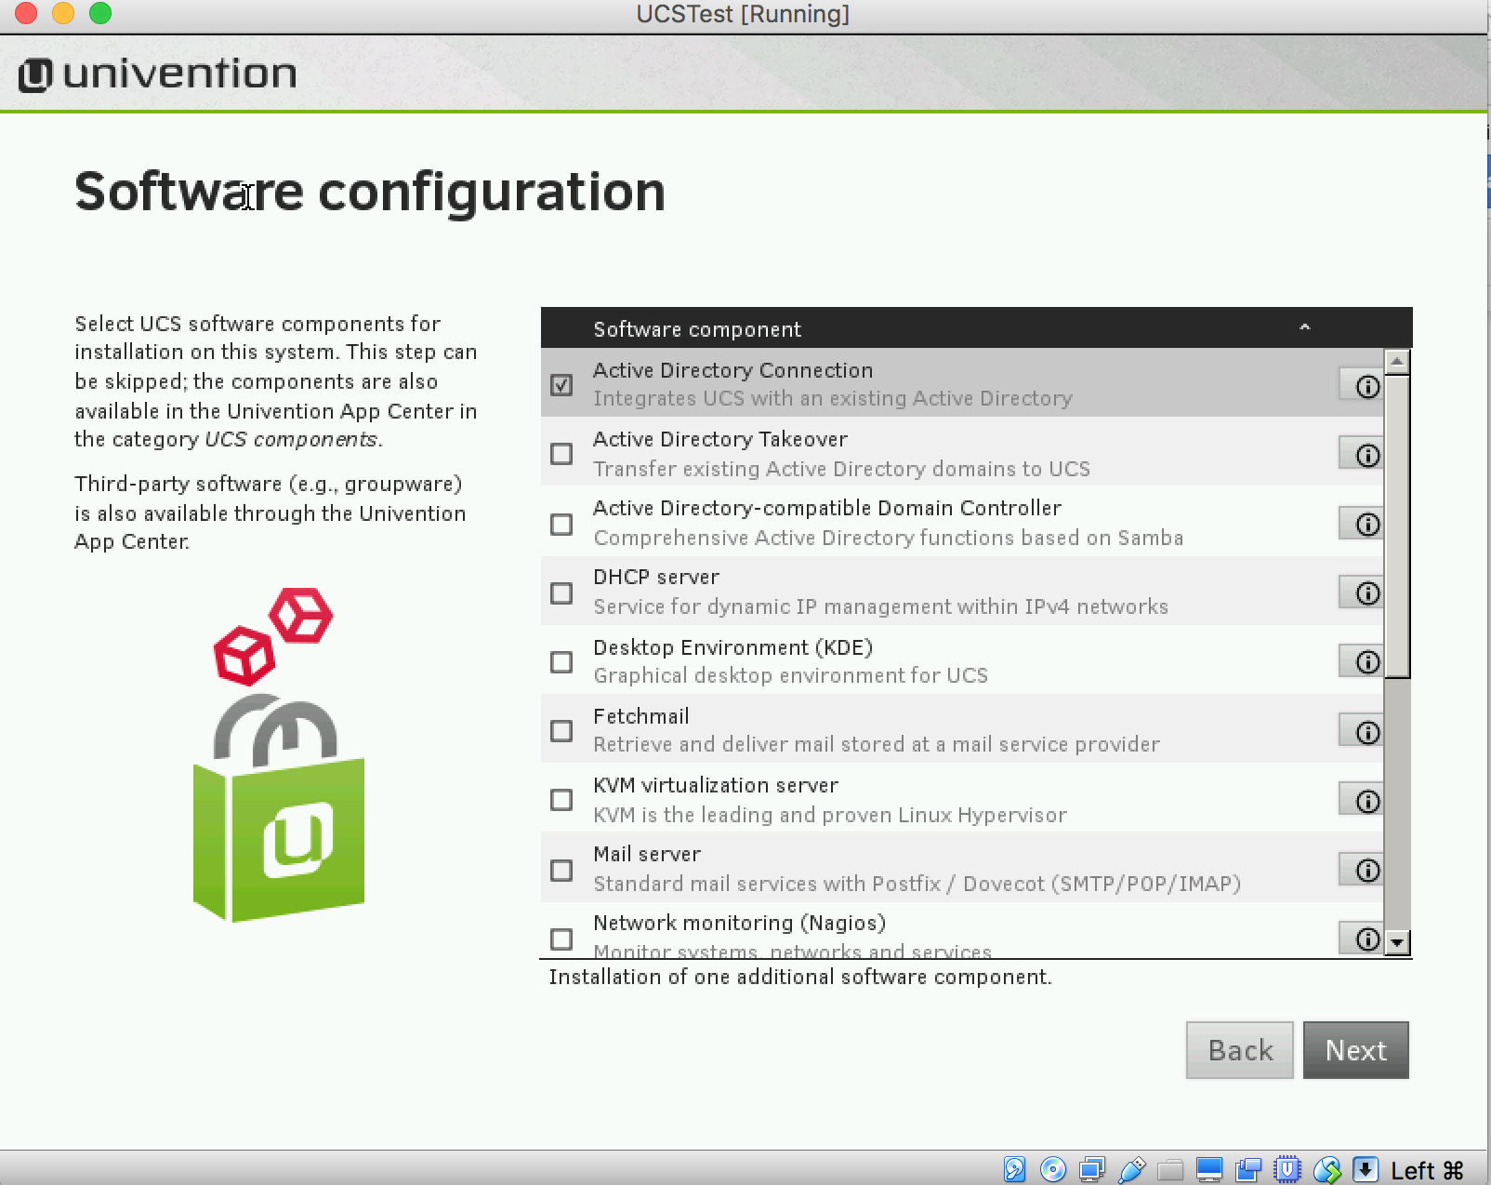

## Confirming the settings

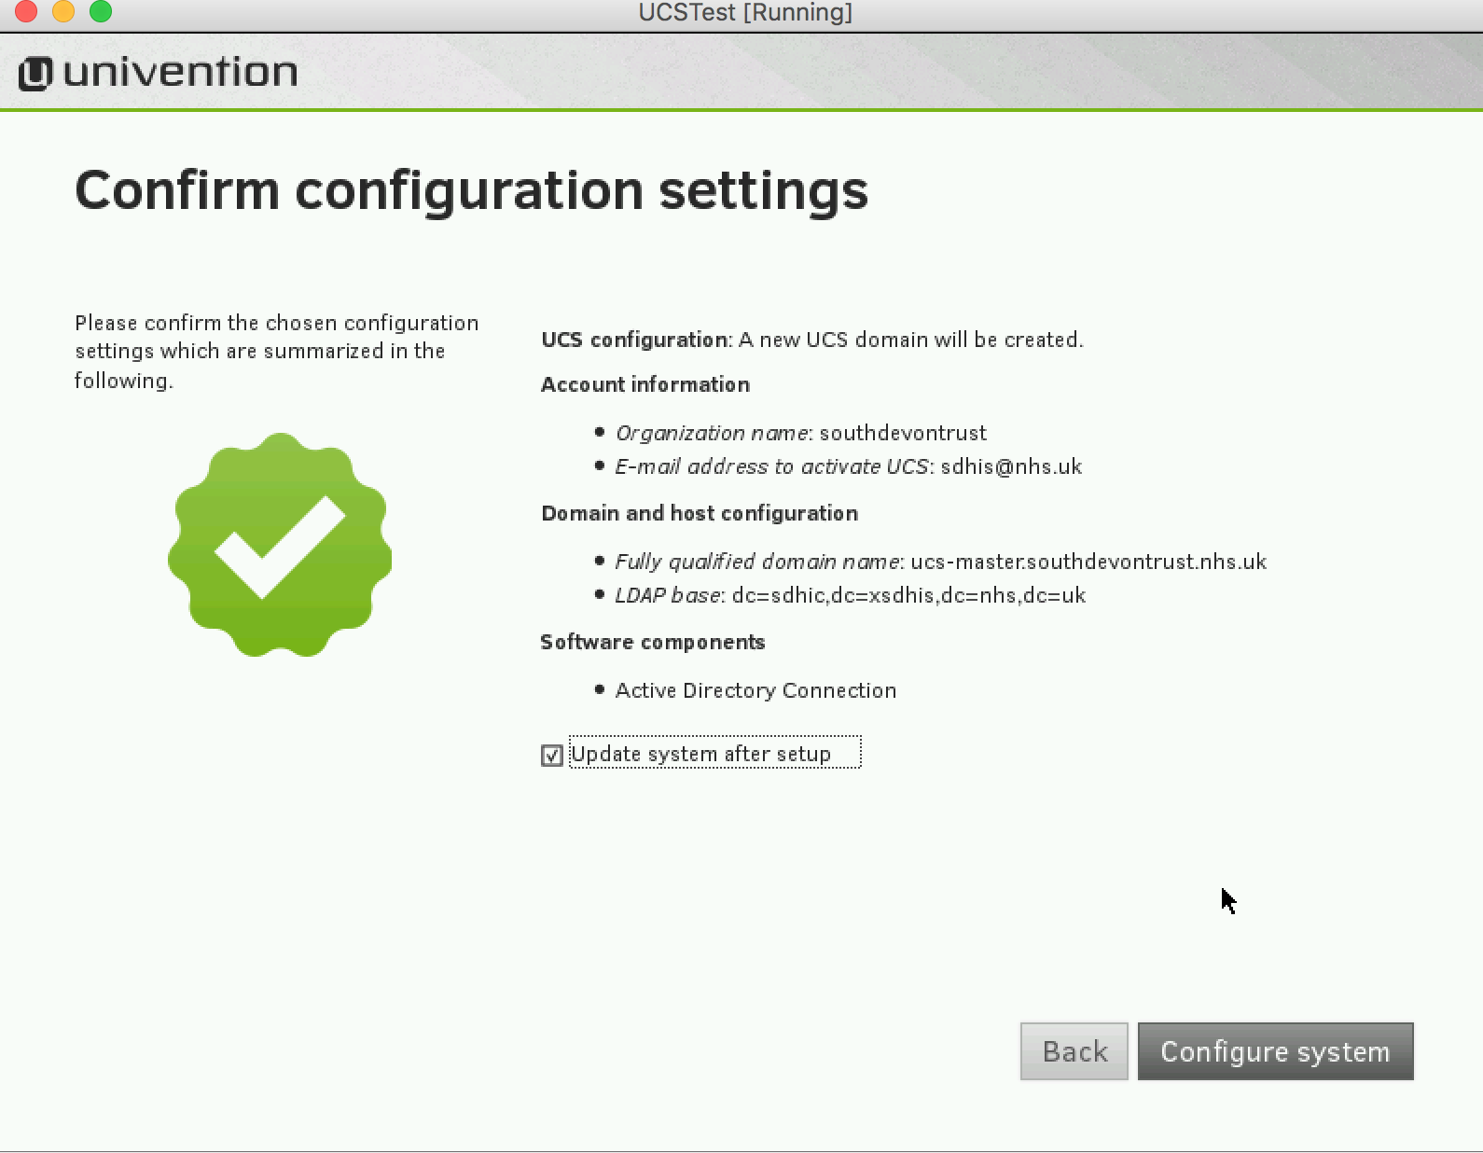

During the configuration, a progress bar displays the progress of the installation.

The installation protocol of the Univention Installer is saved in the following files:

* /var/log/installer/syslog
* /var/log/univention/management-console-module-setup.log

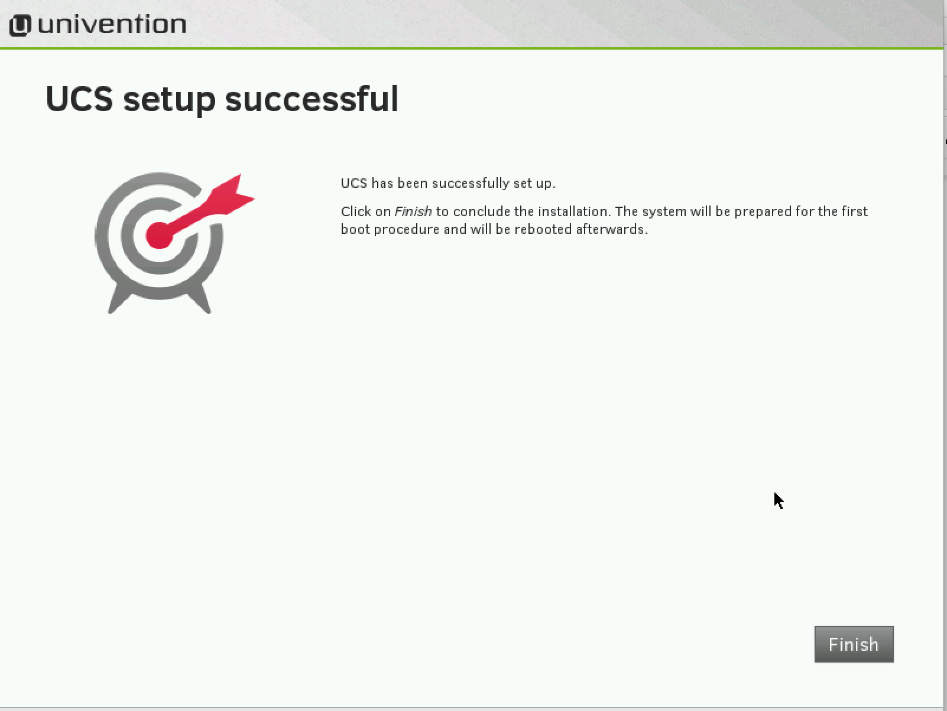

Completion of the configuration must be confirmed with the **Finish** button. The UCS system is then prepared for the first booting procedure and restarted.

The system will then boot from the hard drive.

Once the VM is up and running go to the browser and launch the administrative web interface for UCS by visiting URL <https://10.181.28.96>

10.181.28.96 is the IP address configured while deploying UCS.Enter the username as Administrator and password configured during deployment.

**Importing of License file for activation of UCS**

Refer UCS docs for details[**https://docs.software-univention.de/manual-4.1.html#central:license**](https://docs.software-univention.de/manual-4.1.html#central:license)**.**

**Installation of Active Directory Connection without DNS role in Active Directory domain controller**

In case there is is no DNS role installed on the domain controller then below code changes needs to be done on UCS server.

1. Bypass this method by returning True

**CODE:**

def check_ad_account(ad_domain_info, username, password, ucr=None).

This method does kerberized LDAP lookup with the AD DC which fails for not having DNS since kerberos realm is not properly set.

This method checks if AD account user is an Administrator or account is just a member of Domain Admins or other user.

1. Avoid dig command check

check_dns is changed to false else dig command will fail

**CODE:** def lookup_adds_dc(ad_server=None, ucr=None, check_dns=False):

**Configure filters in UCS so that all the branches in AD are not synchronised to UCS.**

Replace the file under **/etc/univention/connector/ad/mapping.py** with

[**https://github.com/nitinprabhu/TotaraLMSADIntegration/blob/master/mapping.py**](https://github.com/nitinprabhu/TotaraLMSADIntegration/blob/master/mapping.py)

Restart the UCS server once all the above steps are performed.

**Active Directory Connection**

Refer UCS docs for configuring synchronisation of user accounts and password.

[**https://docs.software-univention.de/manual-4.1.html#ad-connector:ad-connector-einrichtung**](https://docs.software-univention.de/manual-4.1.html#ad-connector:ad-connector-einrichtung)

Select “Synchronization of account data between an AD domain and a UCS domain**” while configuring the connector.**

You will need an account which is a member of AD Domain users group to configure synchronization.

**Importing the SSL certificate of the Active Directory**

Refer UCS docs for establishing encrypted communication between UCS and Active Directory domain controller.

<https://docs.software-univention.de/manual-4.1.html#ad-connector:ad-zertifikat>

Once the SSL configuration is in place and active directory connection service is up and running it will synchronize all the users except those specified in the filter(mappings.py)