Diagrams 1

Wireframes 5

Colour Scheme 6

Typography 9

Icon’s 10

Dimensions 10

Account Status/Sessions 11

Significant Pages 13

Algorithm /Flowchart 14

Register 14

Login 14

Booking System 15

Database Structure 16

Datatypes: 17

Users Table 17

Ticket Table 18

Booking Table 18

Design Doc – Task 1

This Document will contain various diagram which will be used to represent features within the solution, the first two diagrams will be site map/hierarchy diagram and use case diagram. The Use case diagram is representing all the different type of interactions within the website with the user, this can be different based on Role based access for example, the admin will have different permissions and interactions compared to the “normal” user. The Hierarchy Diagram will be used to portray the connections between pages while also showing all the different pages with brief description on what it is.

After the Diagrams I want to implement wireframe models which will be used to show the base design of the final solution stripped down into multiple segments which I will call the style guide. The segments will be called:

* Colour Theme
* Typography
* Icon’s/symbol
* Dimensions

I will be going into more detail about these segments within their own areas of this document as this part of the document is only briefing on what will be put within the document. The web pages will use the same main themes to keep consistency which will be said in more detail further on in the document.

The roles within the digital solution will be presented as User which is a registered user as normal and a VIP user which has additional access to certain things and Admin user which will have its own permissions shown in the use case diagram.

The reason I chose to implement diagrams is because it makes it easier to present details to stakeholders without making it complex with technical terms; each section will have a details description/paragraph to show my ideas and point of view making this solution.

I may provide simplistic flowcharts using the well-known flowchart rules to present functionality of the solution to make it clear to technical user while also making it not necessarily complex for non-technical users.

The main purpose of this document is to plan and provide a design for the upcoming development and to make it as detailed as possible to make it as easy as possible to develop without compromising quality and time.

# Diagrams

In the following section I will be provide the diagrams I discussed in the previous section of the document.

The use case diagram which contains all possible interactions with all different types of users as stated in the previous section

* User
* Admin
* VIP

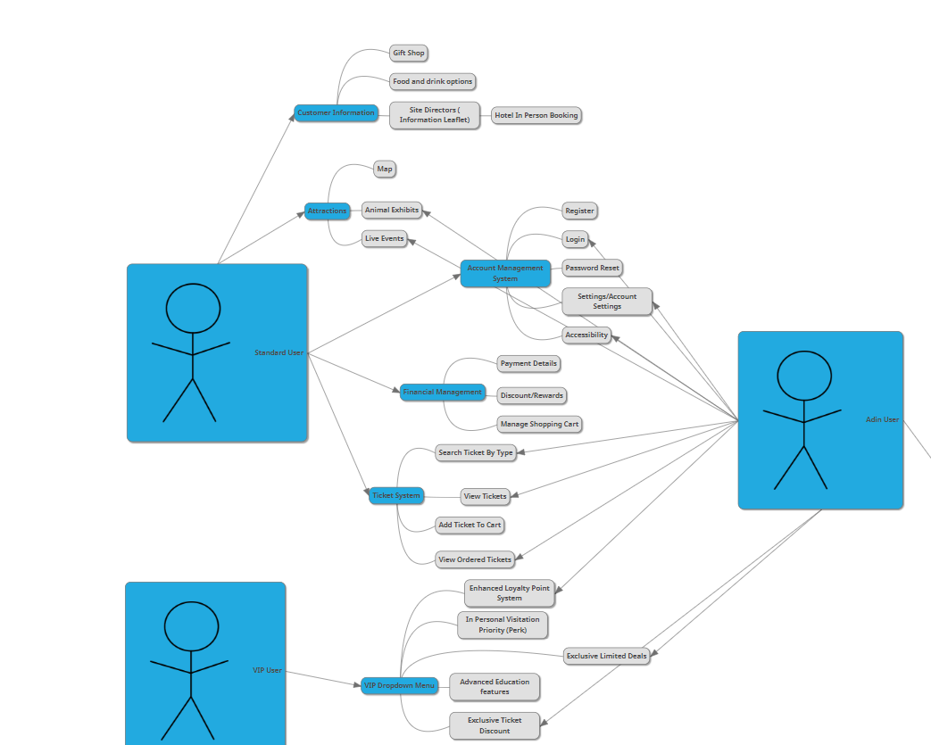

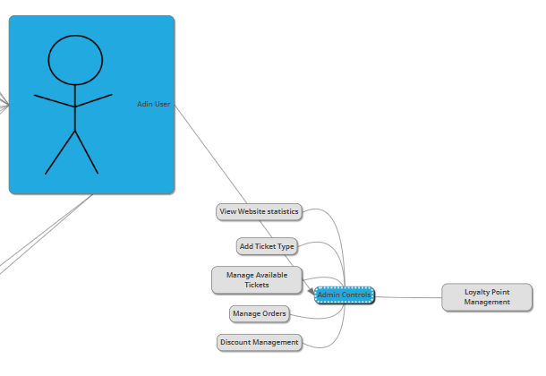

The Images above contain all user interactions and permissions within the website including admin controls.

**DIAGRAM NOTE: VIP USERS HAVE SAME FEATURES AS NORMAL USERS + THEVIP FEATURES**

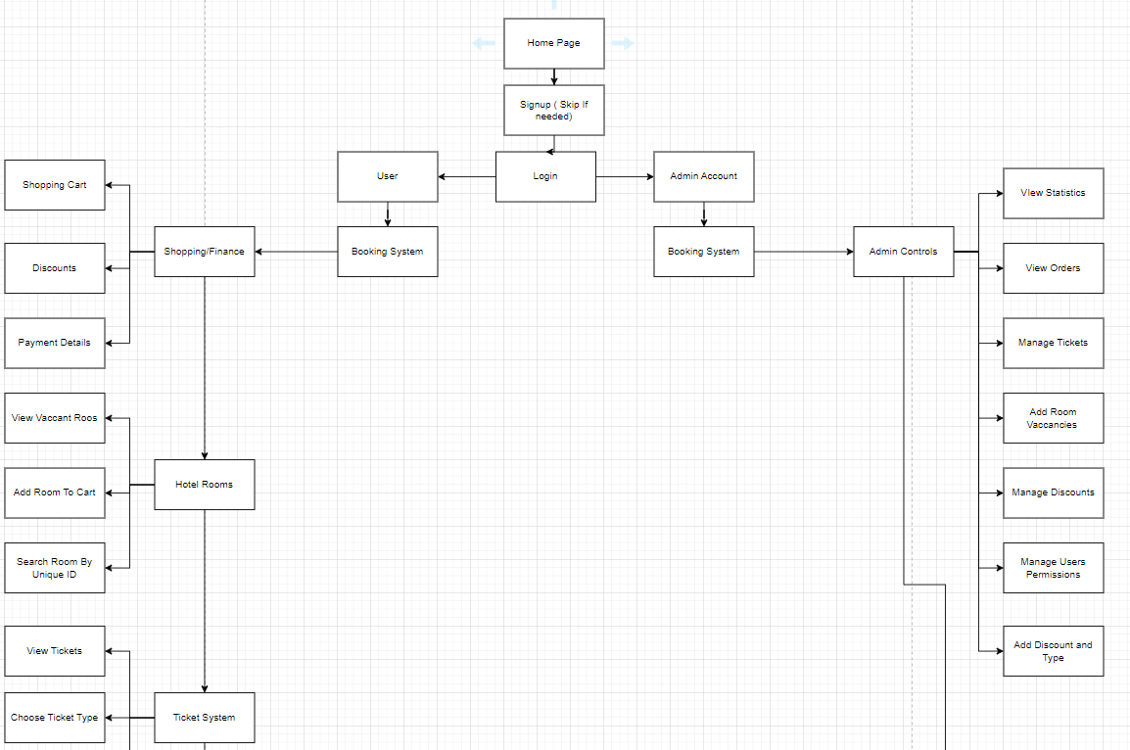

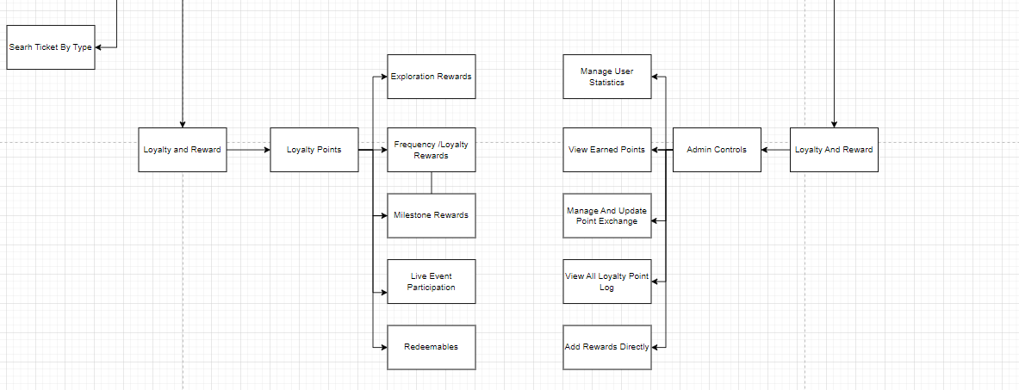

The Diagram Above is called hierarchy diagram which shows all connections from one singular point from the home page when the user signs up for the first time or logins in.

The left side shows what the user is allowed to manage and view, and the right is what the admin only can view and do but it's all linked to the same sections to make it easier for the development of the diagram.

# Wireframes

This section of the document will contain multiple sections which will plan and show the colour scheme, Font Layout, Icons and relative design information.

## Colour Scheme

The colour scheme in this section will contain a various combination of colours which I will be using in the development of solution; planning out the colour scheme will be beneficial because it helps improve the consistency of the website and keep things relative but slightly unique.

When choosing the colour scheme, no real method went into it, it was just personal choice and making sure the colours are simplistic and easy to see considering accessibility guidelines.

Green

Black

Green and black will be the primary colouration of the developed solution with grey being complimentary, I will be using shades based on these colours or variations and to prevent the website from looking bland.

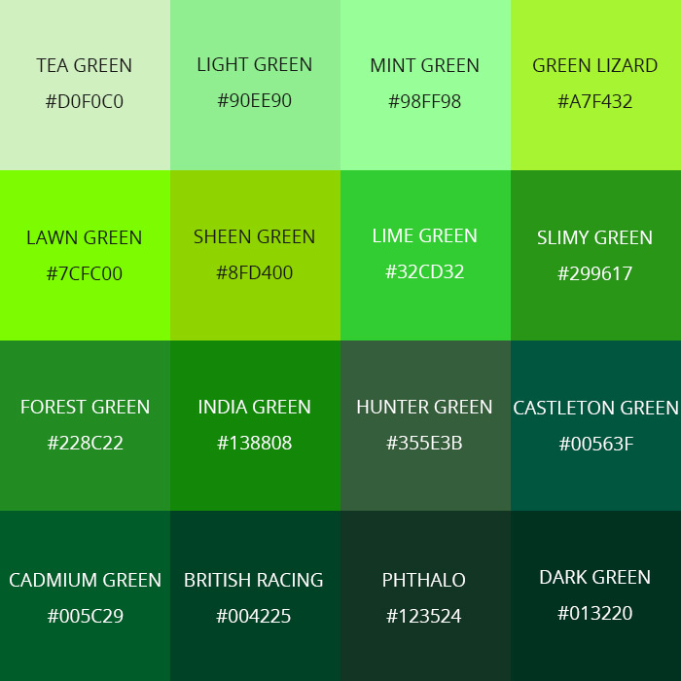

These different kinds of shades will be used throughout the website to make it seem less basic with just one shade.

138808

299617

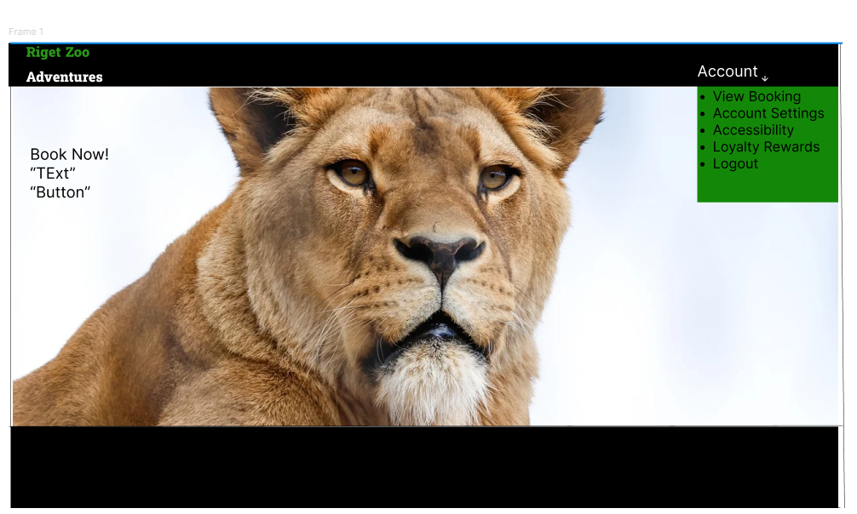Simplistic Idea of how the home page will look, using the same colour scheme and methodologies I mentioned. The image as the center of the page.

I want to keep the home page simple but also not too basic, so I want to add some details on what the website is on the home page

I used the Slimy green Colour for the logo and India green for the drop down.

138808

299617

## Typography

This section will go over the different types of font sizes I can use in specific areas of the website to help keeps things more consistent.

Headline/Title - Super large

* weight = Bold
* Size = 96-100
* Font = Lato

Headline - Extra large

* Weigt = Bold
* Size = 70
* Font = Lato

Body/Base

* Weight = Regular or Italic
* Size = 16-18
* Font = Forum or Times New Roman

Small Body/Secondary

* Weight = Regular
* Size = 14
* Font = Forum or Times new roman

Button

* Weight = Bold or Regular
* Size = 14-18
* Font = Cooper or Forum

Logo

* Weight = Bold
* Size = 40-50
* Font = **Britannic**

## Icon’s

This section of the document contains the various icon that will be used in the development process. Planning the icons before the development keeps things consistent throughout.

There will be a vast number of icons which will have its different purpose.

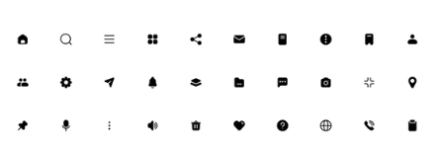

## Dimensions

This section will go over the pages dimensions since keeping things consistent means making sure all the pages are similar or the same dimensions. If the pages are very inconsistent the website wont flow and wont be visually good.

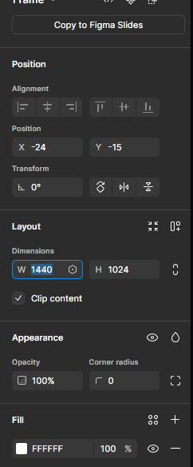

I went with the 1440 by 1024 because it looked the best, It may vary up to 1920 by 1080 however that depends on the page.

# Account Status/Sessions

Within this section I will show wireframe designs which differentiate the logged in page and logged out page. The Navigation bar at the top would change depending on if the users logged in or not. The sessions system will help with this because it will allow me to detect and use people's cookies to show if they are logged in or not, I will implement a dropdown “Account” menu which will replace the regular sign up and login buttons.

This feature will also allow me to add additional navigation bar options which are only available for logged in users.

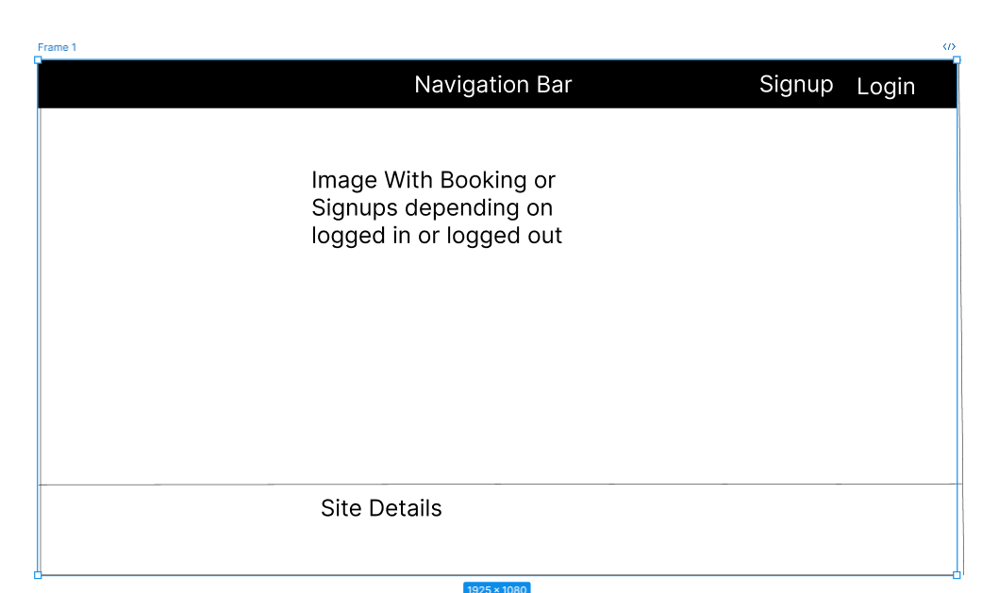Logged out State

**NO COLOUR INCLUDED JUST TO REPRESENT THE SIGNUP AND LOGIN LOCATION**

The drop-down menu for the account section will contain:

* View Booking
* Account Settings
* Accessibility
* Loyalty Rewards
* Logout
* 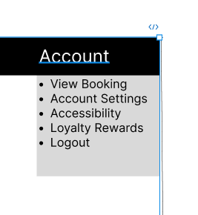

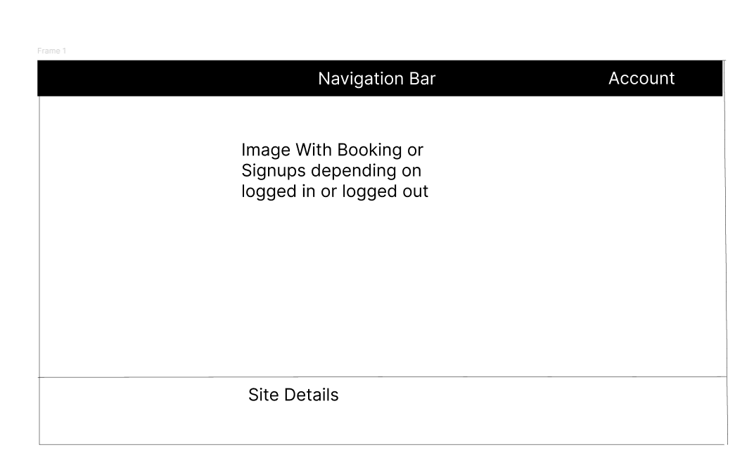

# Significant Pages

Below this section contains the Home, Signup and Login page wireframes and a summary of what's included, and the thought process involved. These pages will generally stay the same throughout with the only changes being if the users logged in or not.

The home page will be the first page you will see when you visit the website which means it's extremely important to make sure it's designed well visually by containing eye catching features and colours. The home page should have a relevant aesthetic which means something animal related which interests the user.

The home page will have small differences as stated before when the users logged in or logged out, these differences will be on home page primarily. The Login and signup buttons will be hidden for those logged in and replaces with an account feature.

The home page will have a few additional features implemented into the navigation bar which allows them to view and manage their perks and “Improved” Reward system.

# Algorithm /Flowchart

This section will contain various algorithmic designs which will be implemented in the final development, I have chosen to use flow charts because it provides a simplistic way of presenting an algorithm to non-technical and technical users and its extremely effective in doing so.

## Register

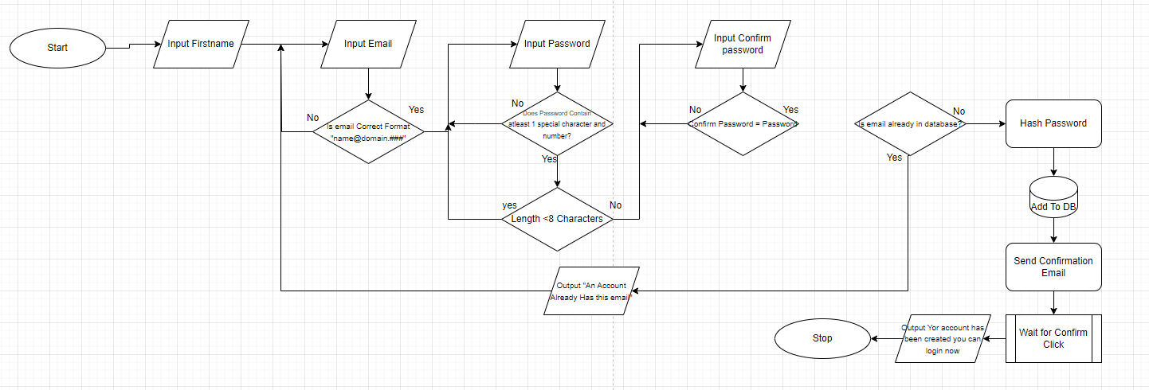

The Register system Is like any other generic registering system, It asks for first name, email and password with validation to protect accounts. This flowchart takes the email and confirms its not being used and is correct format and continues with the flow chart, if the conditions aren't met it resets the process until it is correct. The Confirm password feature is a simple feature which asks the user to re-type the password again to make sure they didn't do a typo themselves and prevents them from having to go through “Forgotten Account”

## Login

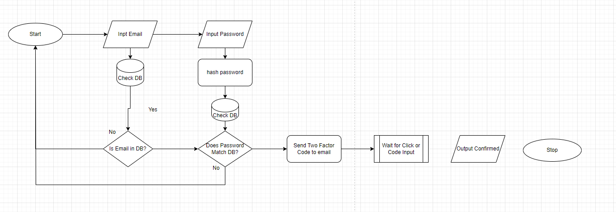

The login system only takes in the email and checks it against the database, if the database recognises the email the password validation is next. The Password is hashed and compared to the database if it matches it sends a multi factor authentication code or click which provides an extra layer of security on top. The Flowchart ends with a confirmation output message.

## Booking System

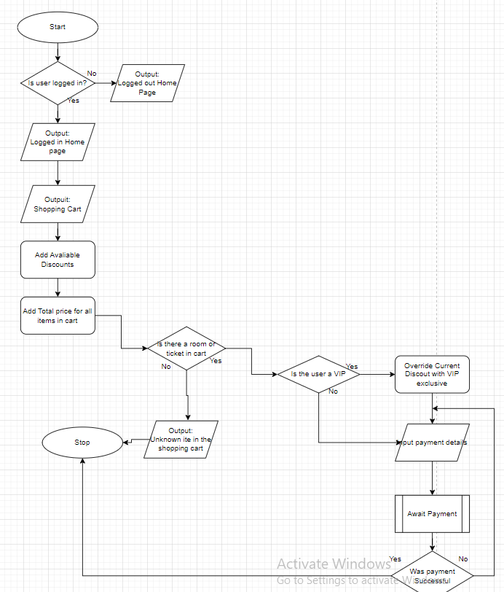

# Database Structure

THis section of the document will go over the different types of data and also using them to help structure the database. This solution will contain a variety of databases including the booking system and the login and signup system which are combined.

## Datatypes:

Char, ( Nm) A string of characters that must be the length of the number within the parameters.

Varchar (Num1, Num2), A string of characters that must be within the rage of parameters given.

Int, A integer value means a value which is a **WHOLE NUMBER (No decimals)**

Float on the contrary means a value with a decimal.

Boolean is a value which can either be one or two of two possible states which means Yes or NO true or false.

### Users Table

PK = Primary Key, A unique identifier of a database table.

|  |  |  |  |  |
| --- | --- | --- | --- | --- |
| Colum Name | Data Type | Rules | Reason | Example |
| ID | Varchar | Can't be Null  Must be Unique | Each user within a database must have a unique ID so It can be found.  **Primary Key (PK)** | Random String of characters or a number |
| Email | Varchar |  | A email can vary in data types |  |
| Username | Varchar |  | A Unique name that cannot be copied. |  |
| Password Hash | Varchar |  | The user's password hashed turns into a big string of characters which is random |  |
| Phone Number | varchar |  | The user has the option in giving us the phone number which adds as an extra layer of security |  |
| TwoFactorEnabled | BOOL | TRUE OR FALSE | Changed depending on if MFA is activated. |  |

### Ticket Table

|  |  |  |  |  |
| --- | --- | --- | --- | --- |
| Colum Name | Data Type | Rules | Reason | Example |
| Ticket_ID | VarChar | Must be Unique  (PK) | ID should be unique because each ticket type is unique to each other |  |
| Type | VarChar | Can be Null | This is to easily identify each type of ticket selected. This can can be done via naming conventions. |  |
| Price | Float | Cant be Null (Discounts are different) | Price is stored as GBP which can take float values. | £2.35 |
| Status | BOOL | True of False | This is to identify the status of the ticket; the admin can control which tickets are available to purchase and this displays that. | TRUE |

### Booking Table