Module 12 is a note-taking application. When the Note Taker open, it will direct to a landing page with a link to a notes page

When the notes page is clicked, it will direct forward to the notes taker page.

The existing notes listed in the left-hand column and empty fields to enter a new note title and the note’s text in the right-hand column.

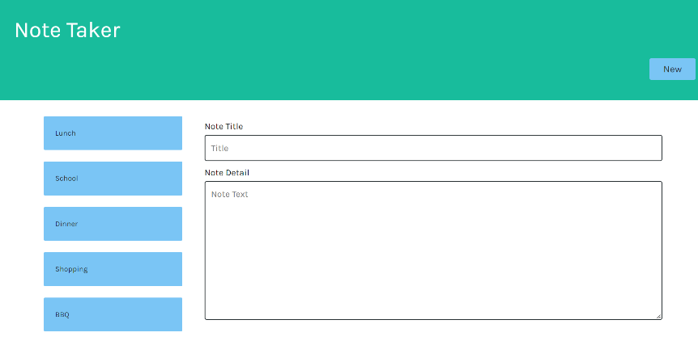

When the new note title and the note’s text is inputted, the Save button appears in the navigation at the top of the page. Once the Save button is clicked, the data will be saved in the db file and appear in the left hand column.

When the new button is clicked fields in the right-hand column will be cleared and ready the user input

Select the note title in the left column and the selected note title and detail will be display in the right hand column. The user can edit & save it or delete the selected note. 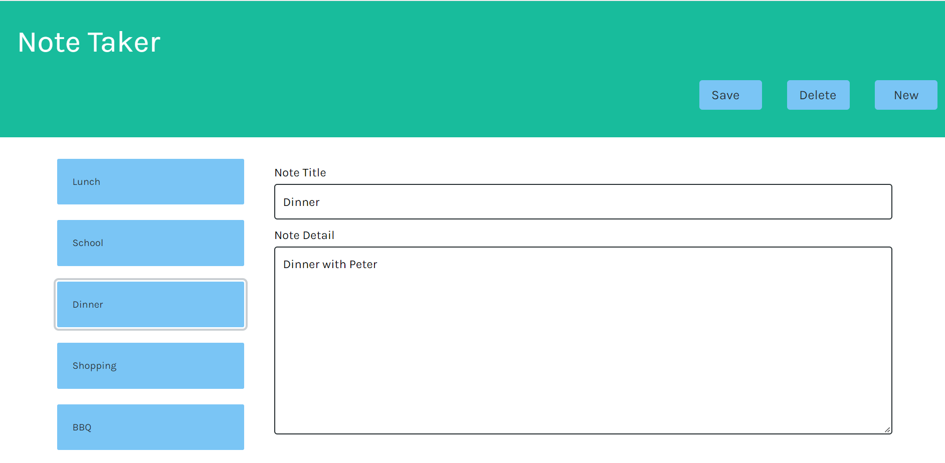

The source code: https://github.com/hippobb/Module_11

The video Link : <https://drive.google.com/file/d/1OcXSDhEQ5q10a4JlMOi8t2YKjX8D9_q1/view>

Or <https://github.com/hippobb/Module_11/blob/main/Module_11.mp4>

The Web URL <http://99.254.124.173:3001>