For the module 5, a daily planner is requested. The requirement only requests for one day and only for the business hours. The module that I was created is a little bit more like a calendar.
Basically, it fulfilled the below basic requirement.
- a daily planner to create a schedule
- the current day is displayed at the top left corner
- time blocks of the selected date for standard business hours
- time block is color-coded to indicate whether it is in the past, present, or future
- create an event of the selected time slot
- the events is saved in local storage

The date can be selected at the top left corner, once it is selected the page will show the selected day’s event. You can selected all the past day but the table and buttons are disable and read only.
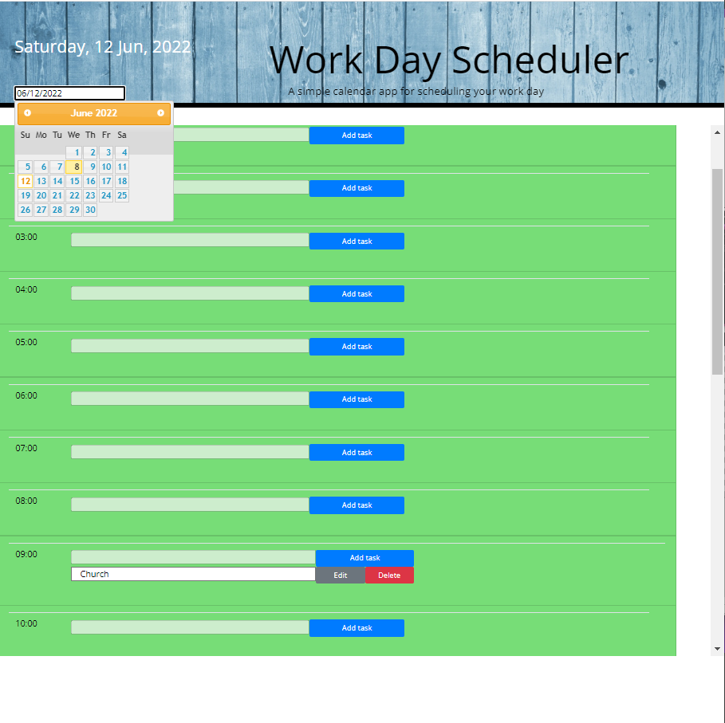
You can add the new task or edit/ delete existing task. As request the time slot will be displayed the status past, present, or future.
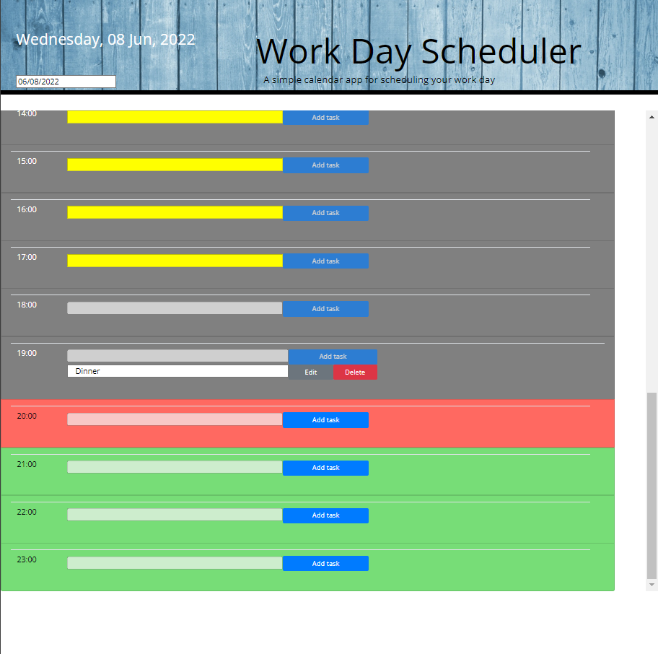
You can edit the task and re-schedule to other day, once the save button is pressed the data will be store in local storage.
