For the module 6, Using the OpenWeather One Call API and retrieve weather data for cities. The history will be created at the left-hand size and easy for the user to retrieve. A city name has to be inputted in the search text box. Once the search button is clicked, the current weather conditions and 5 days forecasting will be show on the screen. The current weather information such as city name, Temperature, Wind speed , Humidity and UV index will be shown. At the same time, a map will be shown at the right hand side for a reference. The UV index of today will be displayed and color that indicates whether the conditions are favorable, moderate, or severe. The icon representation of weather conditions will be shown on each day of the 5 days forecasting. Consider the user feeling and avoid a long history list. The software will only keep 10 past record and the data will be first in first out. Once the city in the search history is clicked and the city weather condition will be displayed. 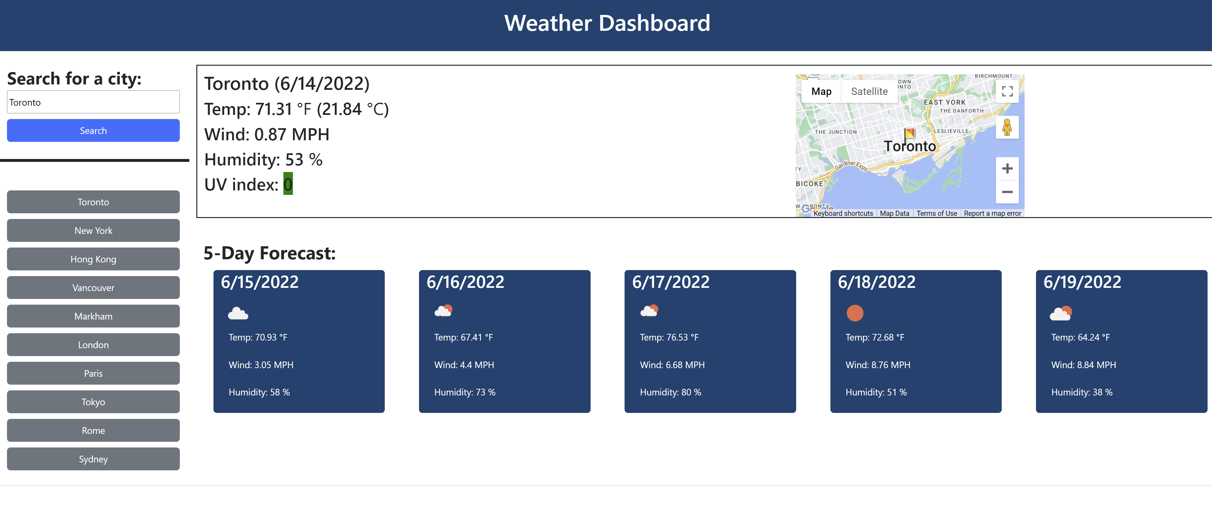
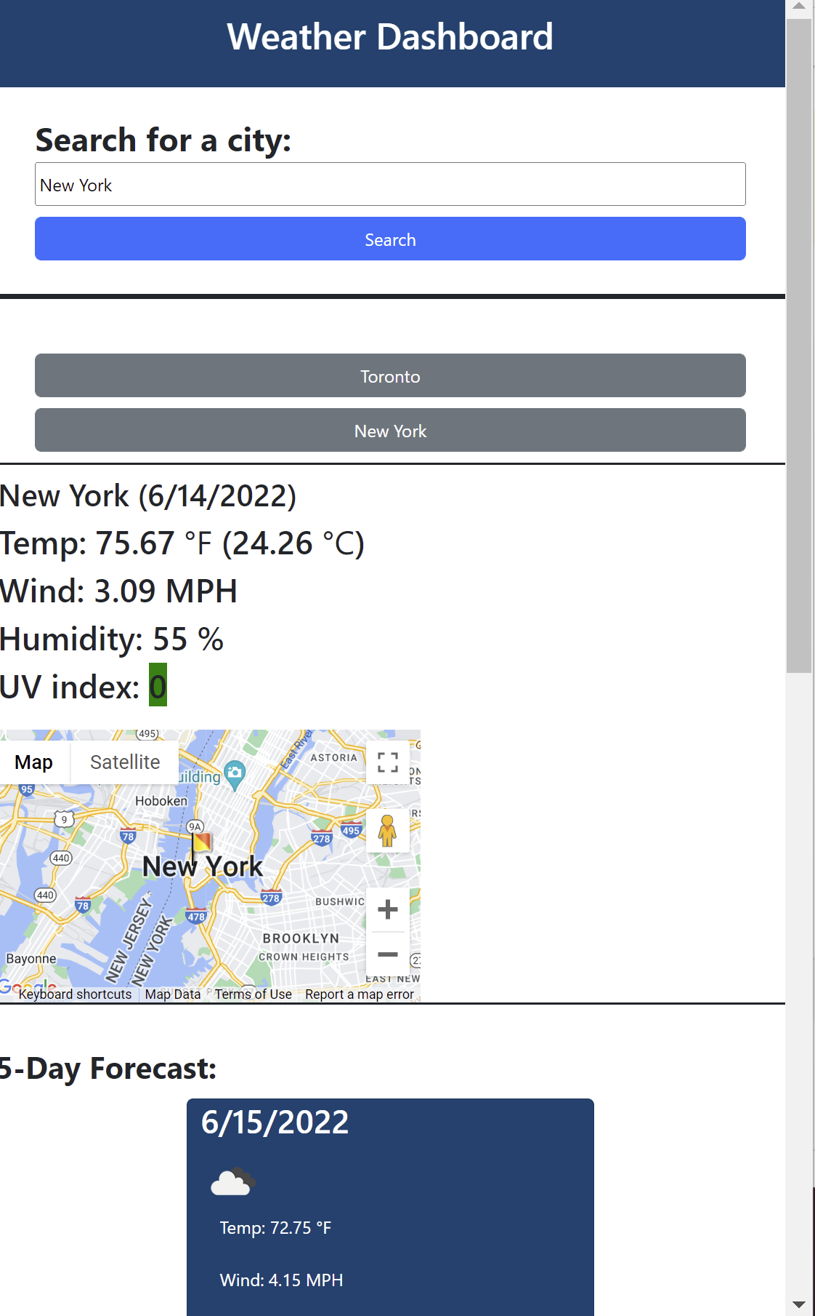
The outlook will be changed when the screen size becomes small.
The source code: https://github.com/hippobb/Module_6
The Web Link : https://hippobb.github.io/Module_6/

