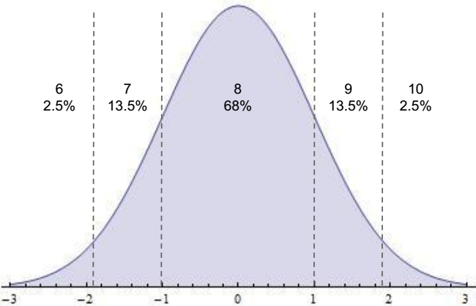

6 2.5%

7 13.5%

8 68%

9 13.5%

10 2.5%