Creating a Persistent Bodhi Linux USB with Ventoy

Contents

Part 1

1. Create a Working Environment
2. Download Ventoy
3. Install Ventoy
4. Create a File Structure
5. Create a File System
6. Create a Json File
7. Final Step

Part 2

Ventoy is a powerful tool for creating live USBs. Linux has the ‘dd’ function which is a really simple way to create a standard live USB, but Ventoy takes this to the next level and beyond. The very basics are simple and the defaults are generally fit for purpose, however it is highly configurable and allows for a lot of user control. Not only can it create live USBs it can be used to create persistent USBs. Further still, it has the ability to create live USBs with more than one distro on the one stick.

The first part of this tutorial will cover downloading and installing Ventoy, and creating a live USB of Bodhi linux. The second part will cover creating a persistent USB with both Bodhi Linux and Enlightenment OS.

Create a Working Environment

Before we begin, in order to keep everything tidy and less confusing, I have made it a habit to create a new working directoy to work within. This ensures that all the files we need to create and use are all in one place. We will be primarily using the command line, but feel free to use a file manager if you prefer. (PCManFM/Thunar etc). Create a directory in your home folder called ventoy.

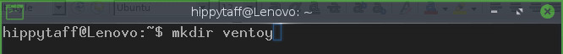
Change to the working directory we called ventoy.

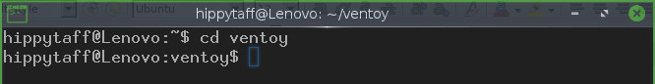

Download

To download Ventoy you can either navigate to the download page of the projects github using your perefered browser, or using the command line. (Version number correct at the time of writing, however this has most likely changed by now, so double check on the downloads page)

You should see something like this if the download was a success.

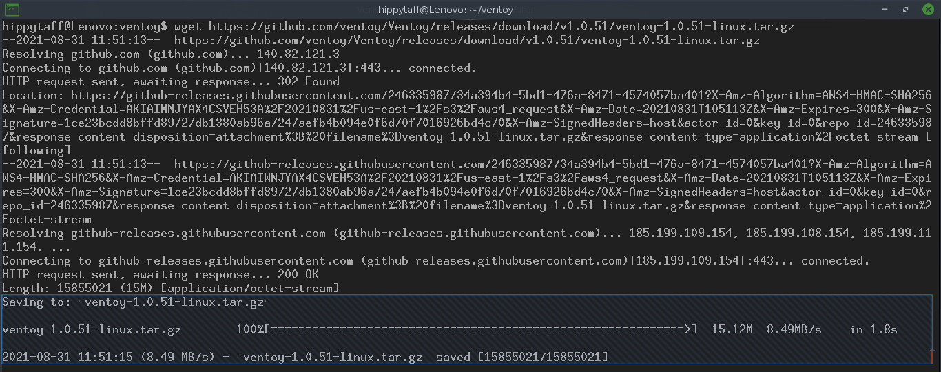

Install Ventoy

The file we downloaded is a tar.gz file. This is a compressed file so will need to be uncompressed for us to access it’s contents.

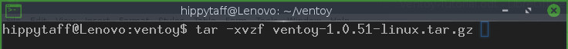
This will output a list of all the files an folders from the compressed tar.gz file

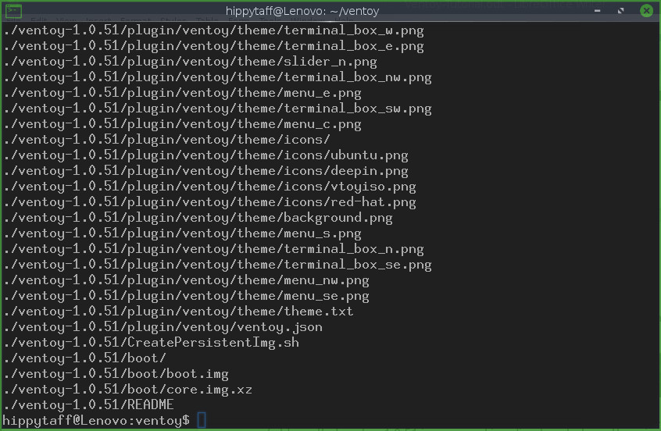
and create a folder called ventoy-1.0.51 in your working directory to keep them in. Your working directory should now contain the tar.gz file we downloaded and a folder with the contents of the compresssed file.

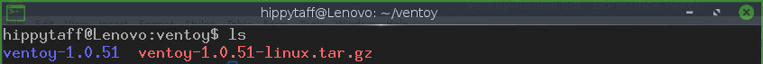
The newly created ventoy-1.0.51 conatains the following files and folders.

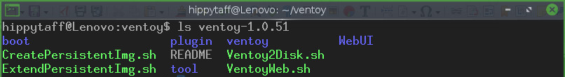

Next we will install ventoy on to a USB using the Ventoy2Disk.sh script. In order to do this, we need to find out the path to the USB by using the df command with the -h flag so that it is readable. You should see something like this.

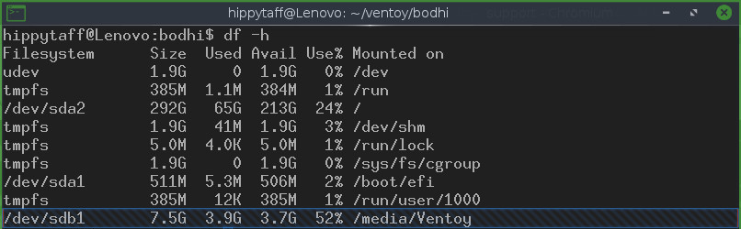
The highlighted line shows that the path to the USB is /dev/sdb1. Here we see the USB is mounted on media and is called Ventoy.

Run the Ventoy2Disk.sh script and point it to the USB using the path we found by using the df command in the previous step. (note we only need the letters sdb. Any numbers that follow should be ommited from the path)

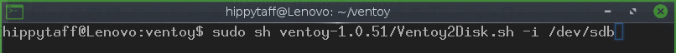
You should see the following warning.

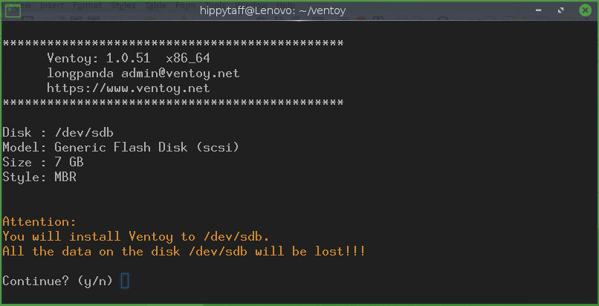
It will ask again to make sure. Then after running through it’s processes you should be greeted with a success message.
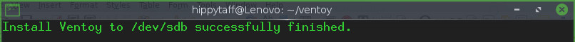
Create File Structure

Now that we have ventoy succesfully installed on the USB, next we need to create a file structure on it. Create three folders named ISO, persistence and ventoy. It should look like this. (Note upper and lower case letters. Linux is case sensitive)

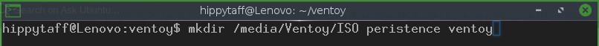

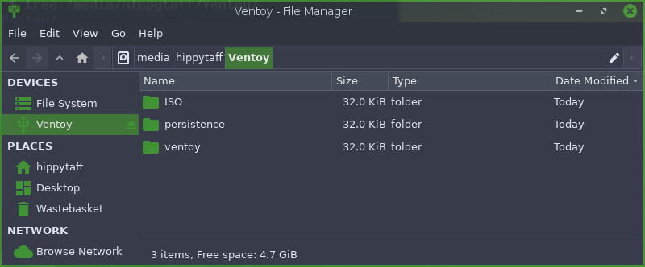

Create a File System

In the Ventoy folder that was created when the tar.gz file was decompressed is a file called CreatePeristentImage.sh. This script will generate a .dat file that is a filesystem that will hold the persistent data. Properties of the .dat file can be set using flags, however for our puposes, the default setup will be fine. Default persistence.dat files are created with size=1GB fs=ext4 label=casper-rw. Simply run the script by doing.

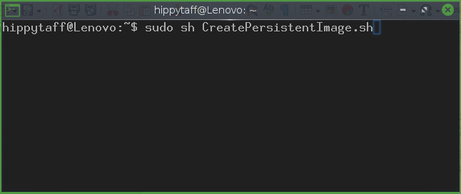

This should return something like the following.

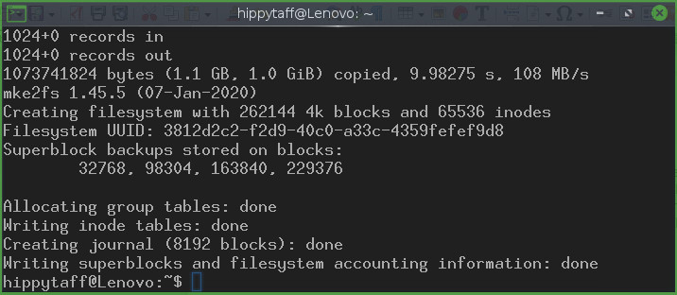

And it should have generate a persistence.dat file in your working directory. The .dat file generated will be called persistence.dat. Rename it bodhi-6.0.0-64.dat

json File
Another file is required for persistence to work. Copy and paste the following into leafpad or your favorite text editor and save it as ventoy.json.

{
"persistence": [
{
"image": "/ISO/bodhi-6.0.0-64.iso",
"backend": "/persistence/bodhi-6.0.0-64.dat"
}
]
}

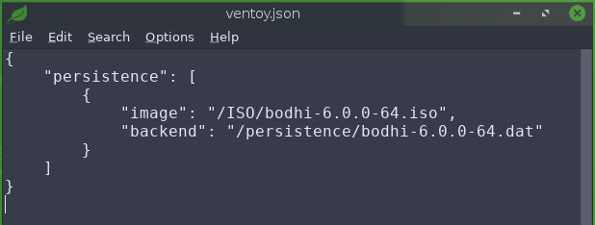

Finally

The last stage is to put the generated bodh-6.0.0-64.dat, bodhi-6.0.0-64.iso and ventoy.json to the relevant folders as shown.

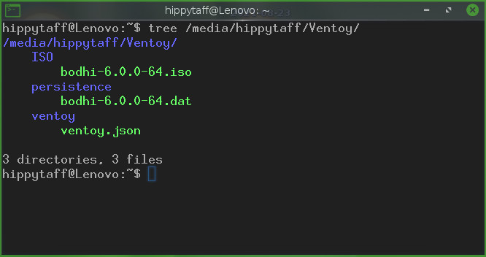
Reboot, and you should have a persistence BL6.0.0-64 USB

