Final Report

**GOAL**:

* To analyses the Edison township in NJ state and identify the best restaurant type that can be opened.
* To recommend the alternative option as well

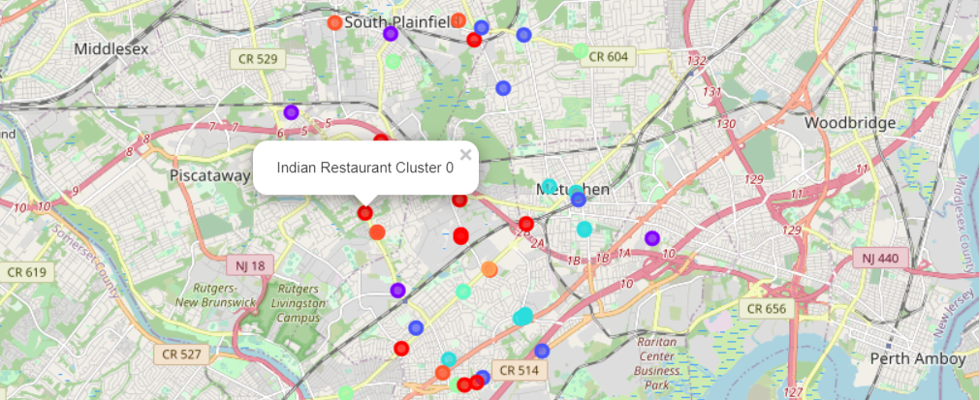

CLUSTER EDISON CENTERS’ RESTAURANT

CANDIDATE LOCATION

RESTAURANT TYPES AT

EDISON CENTER

* There are a lot of different restaurants in Edison.
* Maybe there is different character at each area
* Analyze the cluster character can help the stake holders: location
* Cluster and restaurant type
* Cluster the candidate location for helping operation team:
* Analyze the current restaurant type
* Cluster the different restaurant type in each cluster

DATA ACQUISITION AND

CLEANING

**Foursquare API:**

• Get the restaurants information by using Foursquare API

**Government Site**:

* Get demographic data from NJ govt site

**Data flow:**

* Get the Edison geometry information
* Count categorized restaurants
* Normalize the data

Restaurant Categories

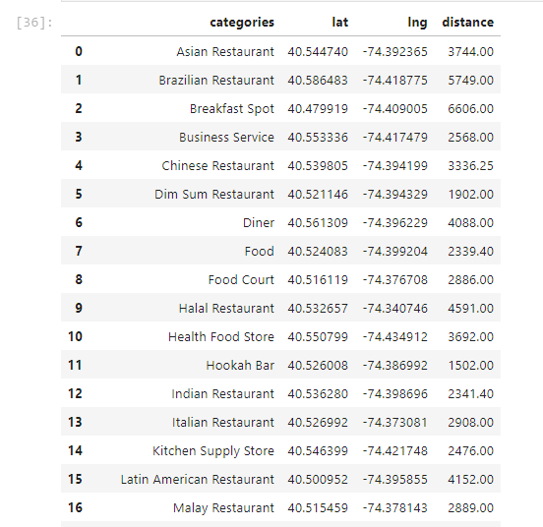

Clustered Labels

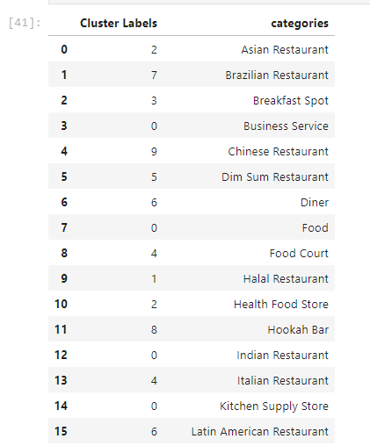

Demographic Numbers

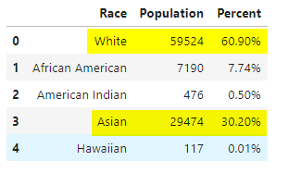

* White Americans populated at 60% of total population.
* Asians counts to 30% of population in Edison.