**Name:** Anshul Shirbhate

**Roll No:** 36

**Practical No:** 10

**Aim:** Develop the small system in Java which will analyze the selected data set for the specific data mining technique like, association, regression, or clustering.

**Program:**

import weka.core.Instances;

import weka.core.converters.ConverterUtils.DataSource;

public class DataMiningTechniqueSelector {

    public static void main(String[] args) {

        try {

            DataSource source = new DataSource("iris.arff");

            Instances data = source.getDataSet();

            int numAttributes = data.numAttributes();

            int numInstances = data.numInstances();

            System.out.println("Number of attributes: " + numAttributes);

            System.out.println("Number of instances: " + numInstances);

            System.out.println("Attribute names and types:");

            for (int i = 0; i < numAttributes; i++) {

                System.out.println(data.attribute(i).name() + " - " + data.attribute(i).type());

            }

            if (numAttributes == 5) {

                System.out.println("You may consider using Association or Regression.");

            } else {

                System.out.println("You may consider using Clustering.");

            }

        } catch (Exception e) {

            e.printStackTrace();

        }

    }

}

**Output:**

1. **Iris.arff Dataset**

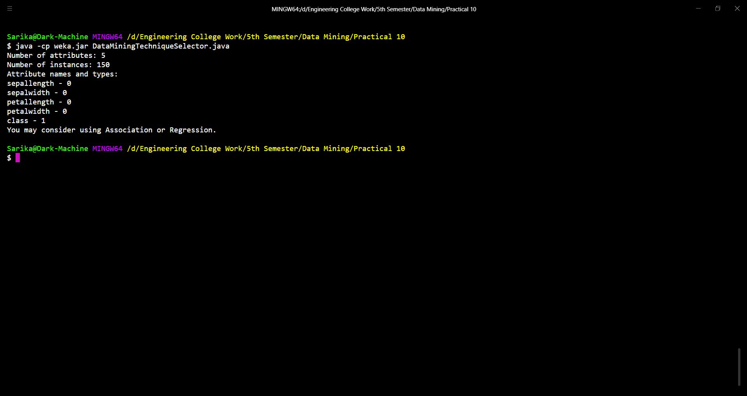

1. **Breast-cancer Dataset**

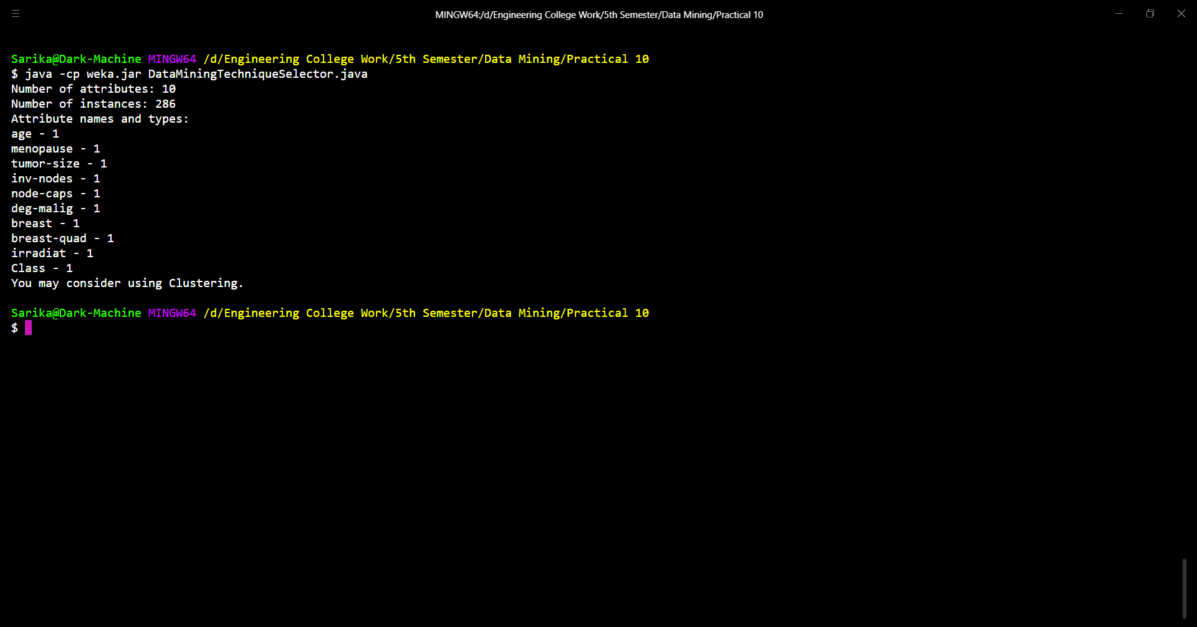

1. **CPU Dataset**

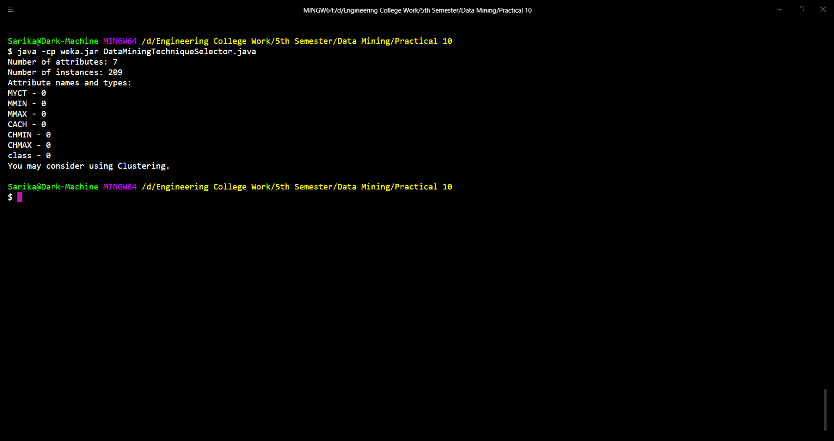

**Conclusion:**

The program is a simple yet effective tool for suggesting data mining techniques based on the number of attributes in a given dataset. It offers a quick initial assessment for data analysts and researchers, helping them make informed decisions about the most suitable data mining techniques. The program can be customized and extended to accommodate specific project requirements and is a valuable resource for preliminary analysis. However, the final choice of a data mining technique should consider the dataset's unique characteristics and research goals.