**Section 1: Practical Excel Questions**

1. How would you sum up the values of cells A1 to A10?

<https://docs.google.com/spreadsheets/d/14Cq1-KfJEq2kqt4IC8Euecvo_KULGnxO3vxj01mxWu0/edit?usp=sharing>

1. Write the formula for calculating the average value of the numbers in cells B1 to B5.

<https://docs.google.com/spreadsheets/d/14LfVw5kqpIZh5S7ShJPyhhV0zZUNdetPzQ6l27b7rn0/edit?usp=sharing>

1. Describe the steps to create a drop-down list in cell C1.

Step1 : go to C1 cell

Step2 : go to Data Tab

Step 3 : go to Data tool Section and in that Data Validation.

Step 4 : set something like following in the dialogue box visible :

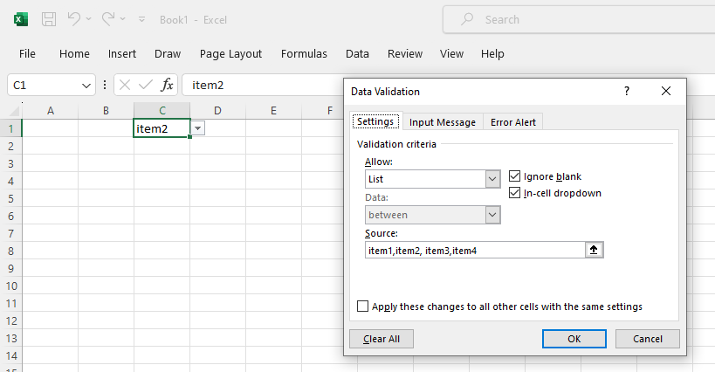

1. Explain how you would apply a filter to a dataset in Excel.

Open the data in excel. Go to Data tab and go to “sort and filter” section. Select Filter. The dropdown arrows in the column title will appear for filtering.

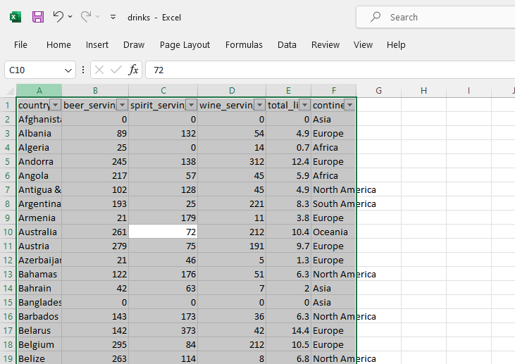

1. Write a formula that combines the text in cells A1 and B1 into cell C1.

Go to C1.

The formula =CONCAT(A1, B1)

**Section 2: Project-Related Excel Questions**

1. **You have a sales report with monthly sales data. How would you create a chart to display this data?**

Select the columns for which you want to add a graph.

Go to insert. Charts Section . Select Appropriate graph.

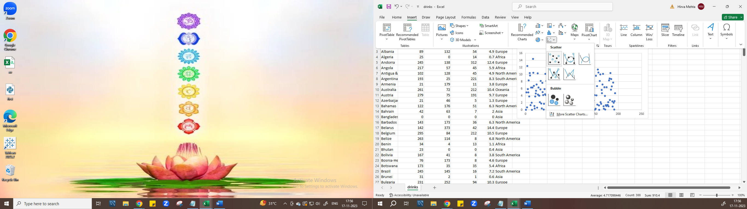

1. **Describe how you would use Excel to identify outliers in a dataset.**

* Sort the column first. Use the Quartile function For the first quartile (Q1): QUARTILE(A:A, 1). For the third quartile (Q3): QUARTILE(A:A, 3).
* Find the Interquantile Range by Q3 – Q1
* Find the Lower and Upper limit by (Q1 – 1.5 * IQR, Q3 + 1.5 * IQR)
* Any value which is out of this range will be considered as an outlier.
* We can highlight the outliers by conditional formatting.
* Select the column
* Go to Home tab and go to Conditional formatting and go to New Rule:
* 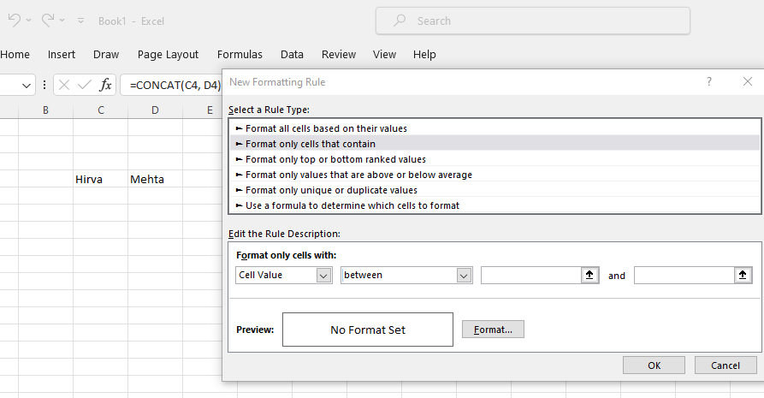

1. **If given a large dataset, how would you use Excel to find and remove duplicates?**

Go to Data tab. Select the data. Go to Data tools section. Go to remove Duplicates option. 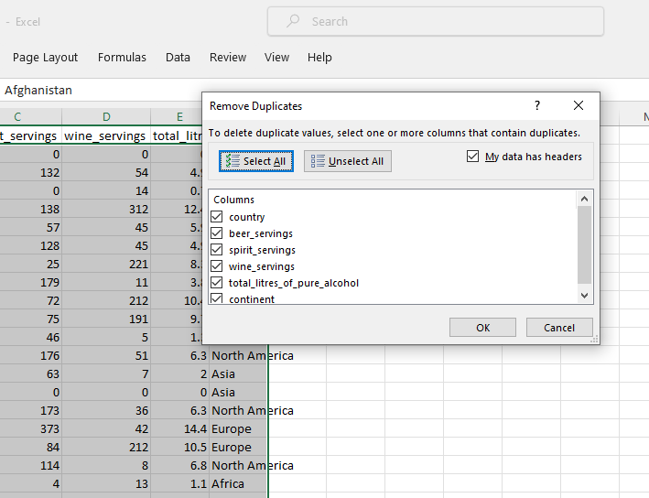

With the help of power query too we can delete it.

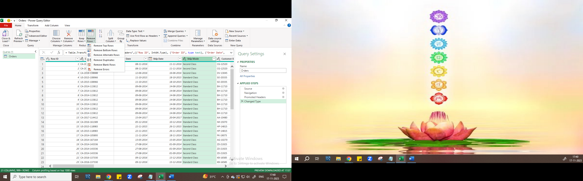

1. **Explain how you would use Excel to consolidate data from multiple worksheets into one summary sheet.**

We can use power-query append-query, merge-query option.

1. **Describe a scenario where you would use the IF function in project management.**

If the the data is having three columns like task (A), due_date(B) and priority

=IF(TODAY()+3>=B2, "High Priority", IF(TODAY()+7>=B2, "Medium Priority", "Low Priority"))

We can identify the tasks we should priorities. If only 3 days remaining for the task to complete it should be a high priority one. If more than 7 days remaining it should be a medium priority one.

**Section 3 : Project**

Make a Dashboard of Any Publically Available dataset on Excel.That Dashboard should replicate good analysis from dataset.

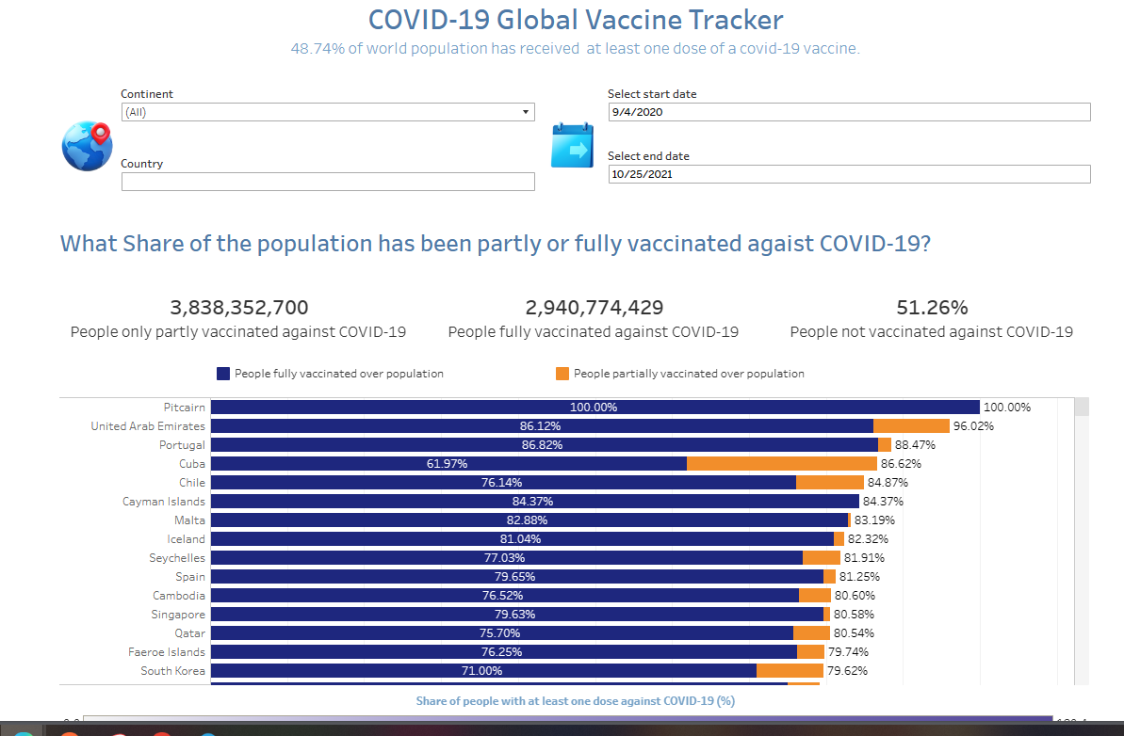

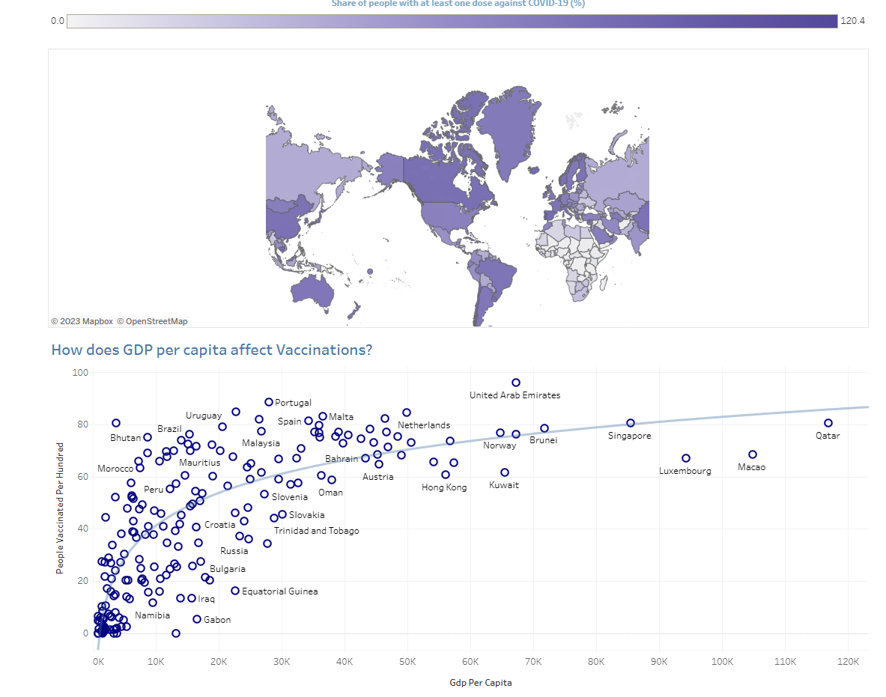

Attaching the file in the trailing email.