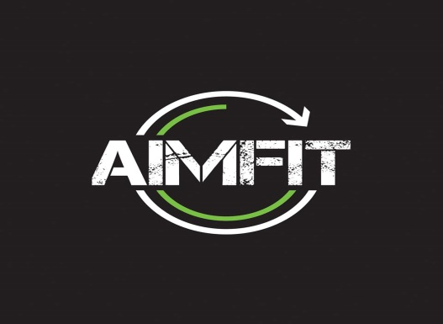

**Introduction**

Mahlaqa’s and Noor’s personal fitness journey began when they were both studying in oxford university, started rowing for their college. With 5 am morning running and rowing they hooked of with the fever of being healthy and fit. Upon their return they realized that Pakistan lacked in fitness motivation so they decided to provide these opportunities to Pakistani youth. So Aimfit was born in 2014. Both sisters created wonders in their classes and were overwhelmed by the response. Their promise is to deliver one of the high quality and effective service through qualified professionals.

Over the period of four years Aimfit has been able to have four branches. The Y Block, DHA Lahore, Garden Town Lahore, The Gym Islamabad, Phase 5 DHA Lahore.

The company has eight different types of core services that are being provided on their premises that include Dance Fit, Combo Fit, Lift, Body Blast, Yoga Flow, Spin Fit, Core Blast and Grit Fit.

**Core Services**

1. Dance Fit

Dance fit is one of the best substitutes to cardio training at a regular gym. Classes introduce various dancing routines, making sure that the customers have a joyful workout session along with keeping the heart beat in the cardio zone. Helping customers burn calories at a higher rates. The dance routines are same across all the classes with a few new routines introduced in every session. Dance fit is amongst the longest running and most famous classes at Aimfit. The duration for this particular class is about an hour, filled with extremely fun and challenging activities. These classes help our participants loose 500-700 calories in an hour.

1. Combo Fit.

Combo fit is classes designed for beginners and all those who have been out of touch with working out for a while. The instructor monitors every exercise to reduce chances of injuries. Various exercises are instructed by the trainer to keep our participants on the move and help them achieve their goals. The class has various routines to intensify cardio, every day a new body part is focused. The class is about an hour long and help burn 300- 500 calories.

1. Lift.

Lift is for customers who want to start weight training under professional guidance. As weight training strengthens the muscle it increases bone density, reduce pressure on joints, speeds up metabolism, and decreases fat while increasing muscle in the body. Lift is a level 3 workout and recommended at least twice a week for maximum results. The class is conducted with barbells and weight plates to ensure everyone is choosing weights accordingly. Lift is known to be the toughest weight training class in the world. The duration of the class is one hour and helps burn around 300 – 500 calories.

1. Body Blast.

Body blast is a level 2 and 3 exercise that is recommended to the customers 4 times a week, especially for those who are looking to loose fat, tone muscles and build strength, ability, relieve stress along with anxiety. This class is taught by international certified trainers to ensure maximum results. It’s a high intensity routine which compromises of aerobics, plyometric, sprint and athletic training. Body blast is known for its extremely high energy and intensity. It is an hour long class that helps burn around 600-800 calories.

1. Yoga flow.

Yoga flow is the perfect addition for the customers to their cardio and strength workouts. The class is combination of Tai-chi, yoga and palates. Ideal for the ones that experience joint or muscle pains after cardio exercises. It helps body recover from stress created through cardio and high intensity workout. Each class has dedicated core and back routine to help get rid of the fat in those difficult spots. It’s an hour long class help burning 300- 400 calories.

1. Spin fit.

Spin fity is an indoor cycling class designed to high to hit cardiovascular and lower body strength. Clients can achieve great toning in their lower body with this routine. This class is only being offered at DHA Phase 5 branch and has duration of 50 minutes and help burn 500-700 calories.

1. Core blast.

Its kind old myth when people talk about spot reduction. Core blast focuses on abdominal strength and conditioning. The program provides two benefits aiding the belly fat loss while n the other hand helping strengthen core resulting in stronger in over all strength. It’s a packed 45 minutes’ workout routine that expects to burn 400 – 500 calories and this program is limited to Lahore branches.

1. Grit fit.

It is an internal strength training that gives best results for fat loss and muscle gain. This class consists of usage of barbells and weights. The instructors help participants challenge their strengths for duration of 60 minutes and burning 500- 600 calories.

Supplementary services at aim fit are included of all the necessary equipment that is used during the class. Nutrition Programs is offered to clients who include expert advice on nutrition, diet and physique management. Personalized, macro- based meals are also available. For example in their HIIT program they provide their customers with 21 days challenge which is a diet plan coordinated with the exercises. Appointments can be made with trained and qualified physique coaches. The help line of the AimFit is available for customers from 9am to 8pm everyday. AIT program is a supplementary service provided for individuals who look forward to joining AimFit as a full time instructor.

Green house healthy fast-food chain franchise is situated in phase 4 which provides healthy shakes, healthy food everything is calorie counted there to the customers. It is also located in the phase 5 branch that provides healthy eating in side the premises.

Aimfits.

Aimfit also has their own water bottles with Aimfit printed on them. It is a 500 ml bottle which is available at every branch for Rs 500.

**Flower of service**

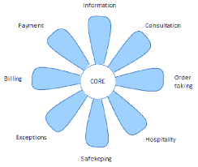

Flower of services is a combination of supplementary services that further divides the supplementary into two broad categories; the facilitating services that are things needed for the service delivery of the core product. And other is the enhancing services that help add extra value to the core product.

**Facilitating Services**

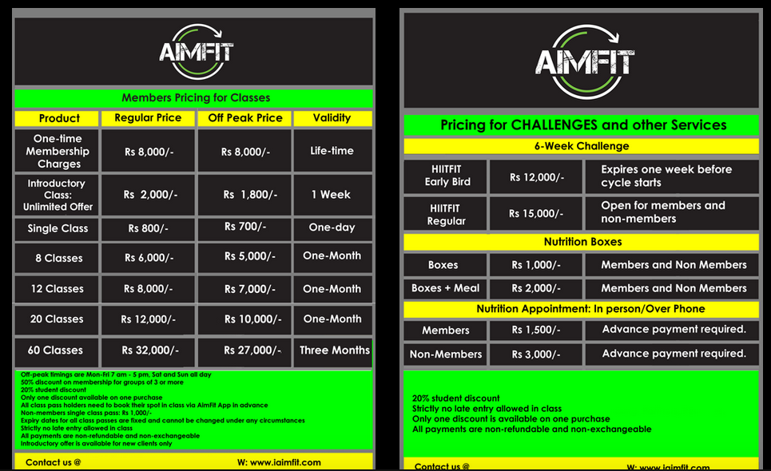

**Information**

AimFit provides information about the location of all their four branches that are spread all over Pakistan with three present in Lahore and one in Islamabad. Each branch has its own schedule for the programs offered which are updated every month and uploaded on all social media, their website and their application.

Pricing schedules for their programs and registration have been mentioned on their website and application with all the details and the customers that are willing to join the fitness program can visit their desired AimFit studio for more details from company’s representatives. Every new customer who applies for the program is registered in AimFit servers for Data keeping for future reference and maintains a profile of the customer for comparison and motivation purposes.

**Order Taking**

At AimFit customers have their own membership number that they have to budge in when they arrive for their desired class. There is a special 20% discount for students. AimFits offer a helpline service but the registrations for the programs are done at the reception of each studio. Online booking option is available on the website through where you could book a spot in the class but the payment is made at the studio.

It is encouraged to book a class on the application or on the website. Once when the customer reaches Aimfit they are given a chip on the reception desk for their class which is an indication that they’ve booked the class and will be attending the class. They then have to put the chip in the basket before entering the class.

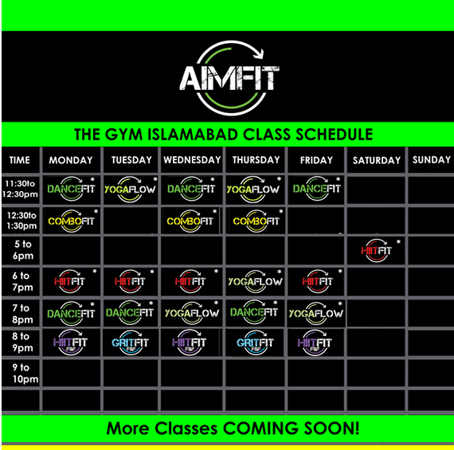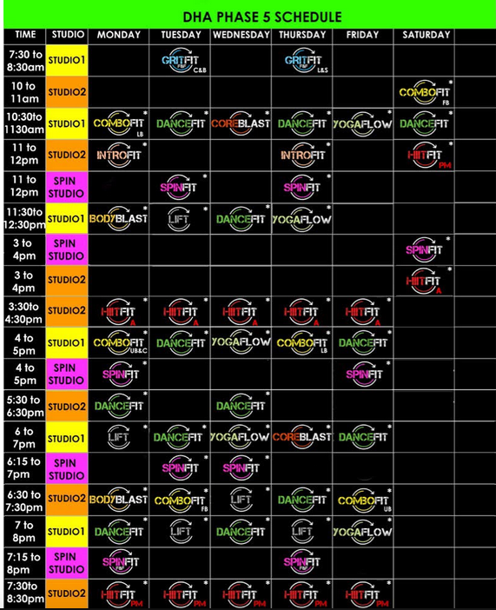

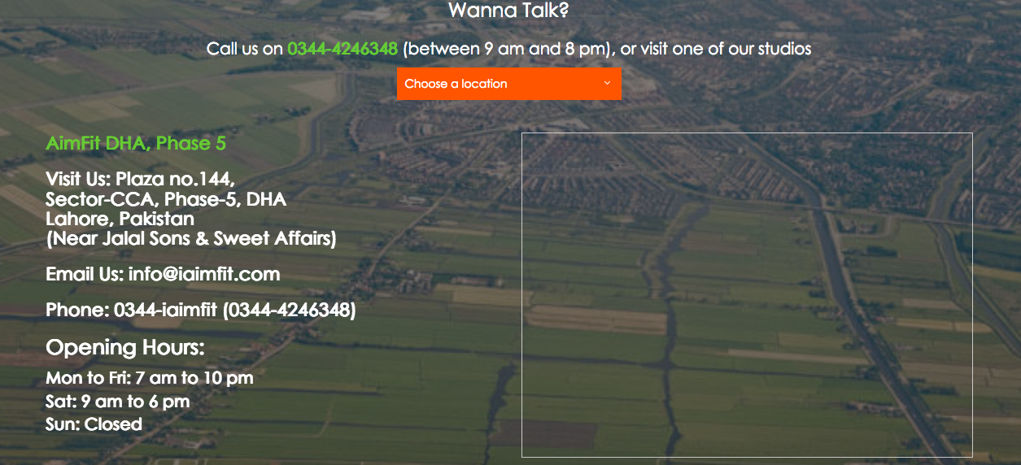

**Billing**

The billing at AimFit is done on the bases of the classes and time opted by the customers and each customer has its own preferred schedule so charges can vary from person to person. The computer system identifies the cost for the client when the desired schedule for the week has been selected or the rack rate mentioned on their brochures and online. Every month the attendance recorder indicates the payment due for the customers.

**Payment**

Payments at AimFit are accepted in form of plastic money or direct to payee or intermediary. All the financial collections at AimFit are done on human systems as the fees is collected at studio reception then entered in the company servers manually by the person in charge.

**Enhancing Services**

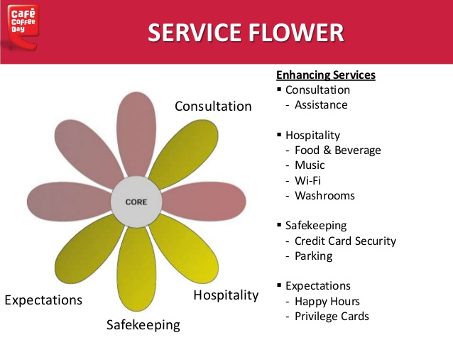

**Consultation**

This is a major supplementary service provided by AimFit. A Nutrition Programs is offered to clients that include expert advice on nutrition, diet and physique management. Personalized, macro- based meals are also available. Appointments can be made with trained and qualified physique coaches. These appointments can be booked online or can be done on call with the company’s professionals.



**Hospitality**

Hospitality services are provided at AimFit studios as they offer a cafeteria that provides essential protein shakes that are preferred by the clients. Green house healthy fast-food chain franchise is also located in the phase 5 branch that provides healthy eating inside the premises. Every branch has its own Wifi that is public and customers can use it as well. Also every branch has its own washrooms with shower facilities and changing rooms.



**Safe keeping**

AimFit provides parking facilities at their studios. Aimfit provides locker for their participants so that they can put away belongings during the class for safe keeping. AimFit provides a lift for its clients to save the hustle of climbing stairs to different studio classes and keep clients at ease and energetic for the programs.

**Exceptions**

These services at AimFit are provided by qualified personnel’s that offer diet plan for a healthy living for their participants at the studio so that they are energetic throughout the day and during the workout. AimFit have a guarantee of goal achievement if the participant abides by all the instructions provided by the personnel’s at AimFit. Ladies only classes are also offered for ladies who don’t feel comfortable exercising in a mixed group.

**Focus and branding strategy**

The youth of Pakistan missing out on the Fitness drug, lack of challenging by the people of Pakistan. Very less motivation regarding living a strong, healthy and fit life. Aimfit tries making these challenging yet fun, communal group fitness centers so that a movement of fitness can be started. AimFit promises to provide High Quality and Effective service delivery by trained professionals.