ClearReq AI
An AI-Assisted Requirements Translator for Ambiguity Detection and Clarification
Final Year Project — Development & Planning Document
Prepared by: [Team Member 1], [Team Member 2]
Supervisor: [Supervisor Name]
[University / Department Name]
[Month, Year]

Table of contents

Abstract
Software requirements gathered from clients are frequently informal, ambiguous, and open to multiple interpretations. Statements such as “the system should be fast” or “the system should be secure” carry no verifiable meaning until a human analyst manually resolves them, a process that is time-consuming, inconsistent across analysts, and difficult to audit. This project presents ClearReq AI, a requirements translation tool that assists requirement engineers, business analysts, and developers in converting informal client statements into clear, development-ready requirements.
ClearReq AI combines a rule-based ambiguity detector with an AI-assisted detector to flag vague terms in a submitted requirement, generates structured clarification questions for each detected ambiguity, records the analyst's answers, and produces a versioned, confidence-scored translation of the final requirement. Every translation is traceable back to the clarifications that produced it, and every version can be re-approved when the source requirement changes.
The system is built as a lightweight, cloud-assisted application using FastAPI, SQLite, and a free-tier large language model API, making it deployable without dedicated infrastructure or budget. The project's core contribution is an evaluation of rule-based versus AI-assisted ambiguity detection, measured using precision, recall, and F1 score against a labelled requirements dataset, demonstrating where each approach is strongest and how combining them improves overall detection quality. The result is a practical, evaluable tool that narrows the gap between what a client says and what a development team can actually build.

1. Introduction

1.1 Problem statement
Requirements engineering is one of the most error-prone stages of the software development lifecycle. Ambiguous requirements, if left unresolved, propagate into design, implementation, and testing, leading to rework, scope disputes, and client dissatisfaction. Existing tools largely focus on requirement management (storage, traceability, sign-off) rather than on the language quality of the requirements themselves.

1.2 Proposed solution
ClearReq AI addresses this gap by treating ambiguity detection and resolution as a first-class workflow: every requirement passes through detection, clarification, translation, and approval before it is considered development-ready, with a full history retained at every stage.

1.3 Objectives
- Detect ambiguous terms in informal client requirements using rule-based and AI-assisted methods.
- Generate structured clarification questions and capture attributable answers.
- Translate clarified requirements into clear, development-ready statements with a confidence score.
- Maintain a versioned, auditable history of every requirement from draft to approval.
- Quantitatively evaluate detection accuracy using precision, recall, and F1 score.

2. Tools and technologies
The stack is deliberately lightweight so the system runs entirely on standard student hardware with no paid infrastructure.
Layer | Technology | Purpose
Frontend | HTML / JS or Vite + React | Requirement input form, ambiguity list, clarification UI, translated output view
Backend | Python, FastAPI | REST API, request orchestration, business logic
Database | SQLite | Single-file relational storage for requirements, versions, and clarifications
AI layer (primary) | Google AI Studio — Gemini Flash API | Ambiguity detection, question generation, translation, confidence scoring
AI layer (fallback) | Groq API (Llama 3.3) | Fast fallback when the primary provider is rate-limited
Detection baseline | Python rule engine (regex / word lists) | Fast, explainable first-pass ambiguity detection for comparison against the AI approach
Version control | Git, GitHub | Source control, branching, pull-request review, contribution history
Evaluation | Python (pandas, scikit-learn) | Precision / recall / F1 computation against the labelled test dataset
Documentation | Markdown, draw.io / this document | Architecture notes, diagrams, thesis writing

2.1 Developer environment
- Laptop: 8 GB RAM, 256 GB storage — sufficient since all AI inference runs over the network.
- No local GPU or model hosting required.
- Free-tier API keys only — no billing account required for development or the final demo.

3. System architecture
The system is organised into four layers. The frontend collects the requirement and displays results; the FastAPI backend orchestrates each request; the intelligence layer runs the rule-based detector and the AI provider in parallel on the same input; and SQLite persists every result so it can be replayed, versioned, and evaluated.
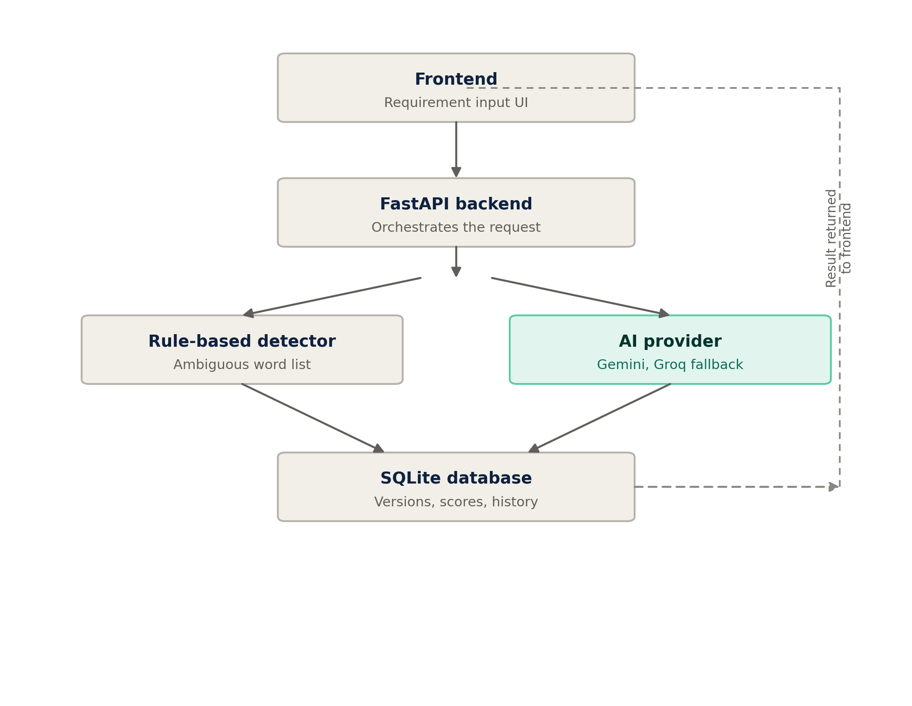
Figure 1. System architecture and data flow
Running detection through both paths on identical input is what makes the evaluation chapter possible — every requirement in the test set produces two independent sets of flagged ambiguities that can be scored against the same ground truth.

4. End-to-end workflow
From the user's perspective, a requirement moves through six stages, each of which is recorded in the database so the full history remains inspectable after the fact.
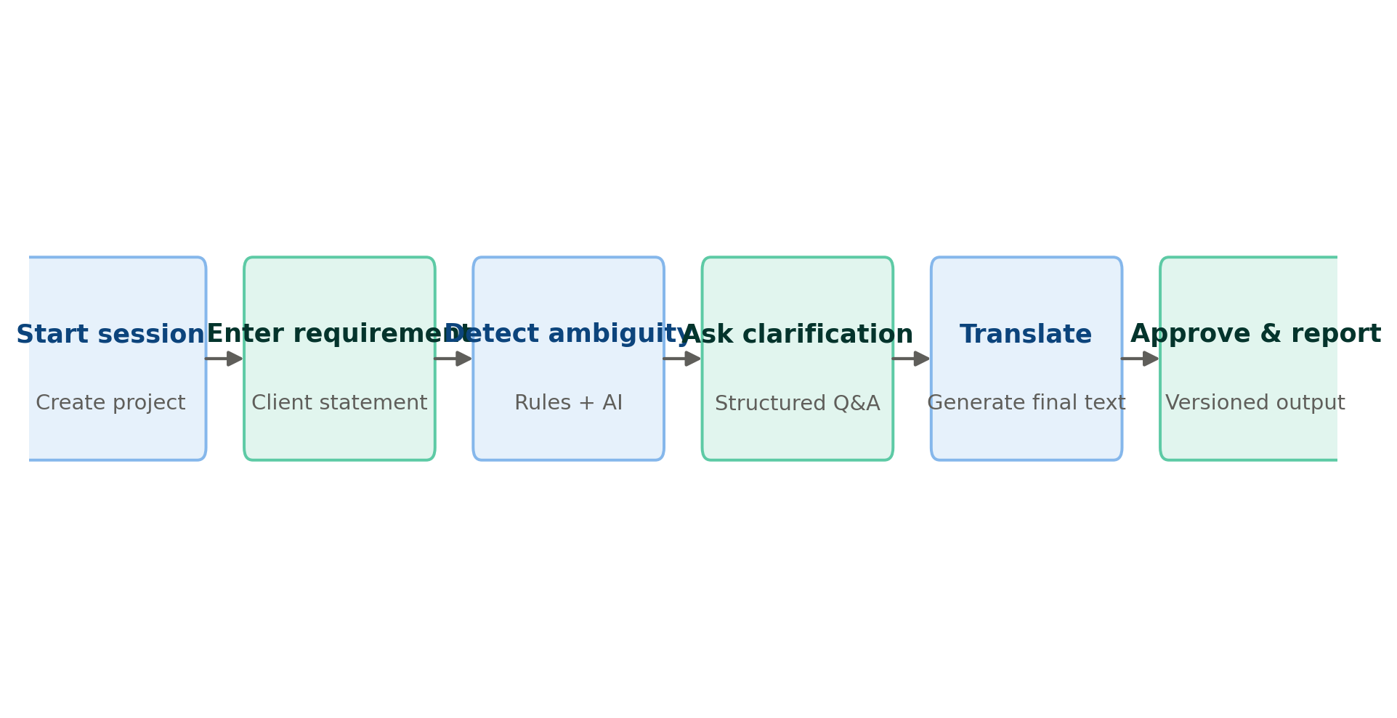
Figure 2. Requirement lifecycle, from session start to approved report

5. Database design
The schema is versioned by design: a requirement can be re-translated without losing the history of what it originally said, who clarified it, and who approved each version.
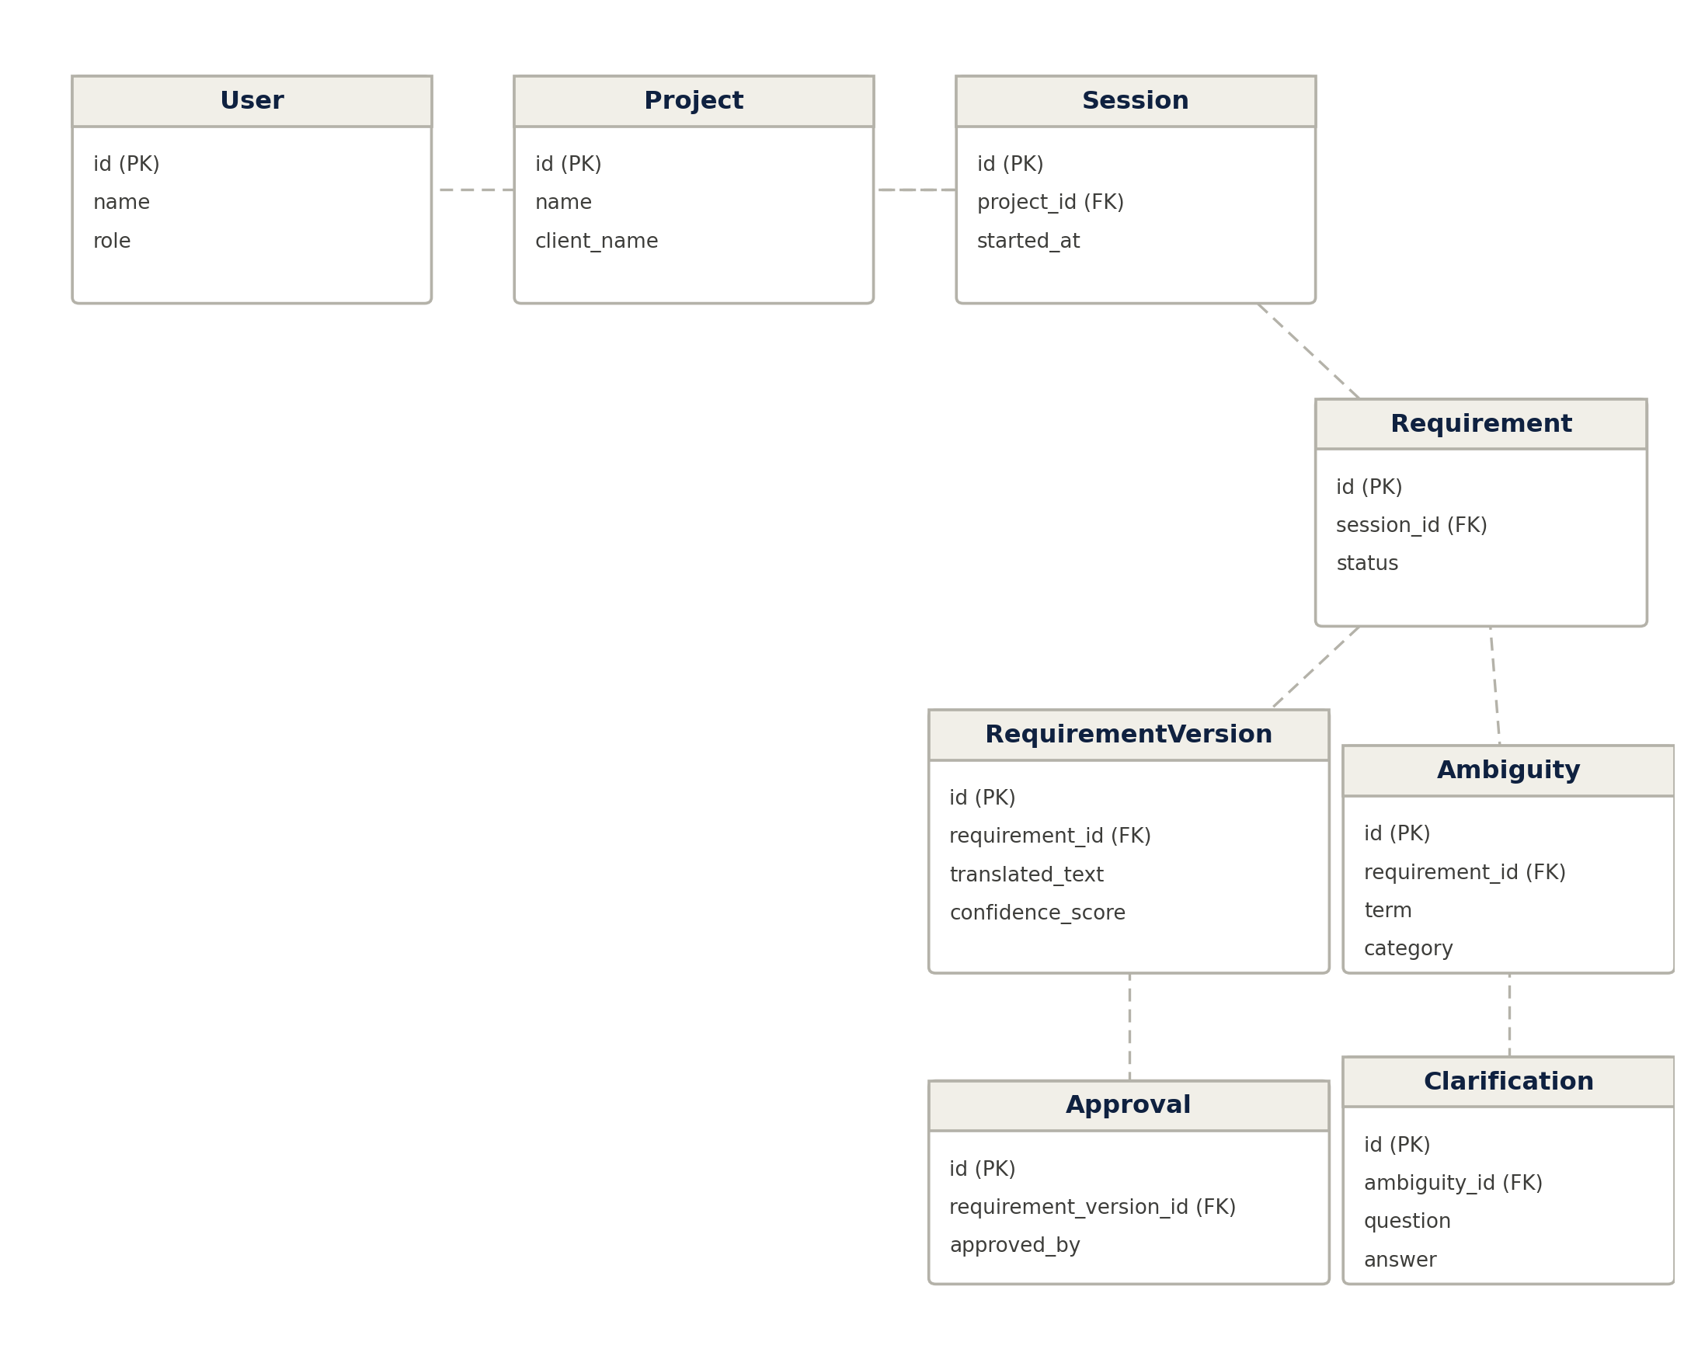
Figure 3. Entity-relationship diagram

5.1 Entity summary
Entity | Description
User | A team member using the system — analyst, reviewer, or admin.
Project | A client engagement that groups one or more requirement sessions.
Session | A single working session in which requirements are captured for a project.
Requirement | The original client statement and its current status (draft, clarifying, translated, approved).
RequirementVersion | A specific translated form of a requirement, with its confidence score and author.
Ambiguity | A flagged term within a requirement, its category, and which detector raised it.
Clarification | The question raised for an ambiguity and the attributed answer given.
Approval | A sign-off record for a specific requirement version.

6. Development timeline
Weeks | Milestone
1–2 | Finalise schema; set up FastAPI + SQLite skeleton; obtain Gemini and Groq API keys.
3–4 | Build the rule-based detector; assemble the labelled test dataset.
5–6 | Integrate the AI provider for detection and question generation; build the minimal UI.
7–8 | Build the translation engine and confidence scoring.
9–10 | Run the full evaluation (precision, recall, F1); document results.
11–12 | Polish the demo flow; prepare slides; rehearse with a recorded fallback.
Remaining | Buffer time and thesis write-up.

7. Team roles and repository workflow

7.1 Roles
- Member A — System and backend: FastAPI, SQLite schema, AI provider wrapper, rule-based detector.
- Member B — Evaluation and frontend: test dataset, precision/recall/F1 analysis, minimal UI.

7.2 GitHub workflow
- main stays demoable at all times; work happens on short-lived feature branches.
- Each feature branch is merged via a reviewed pull request, giving a contribution record for the thesis defence.
- Repository layout: backend/, frontend/, eval/, docs/, with API keys kept out of version control via .gitignore.

8. Evaluation plan
The rule-based and AI-assisted detectors are run against the same labelled set of requirements (drawn from a public requirements dataset or hand-labelled by the team). For each detector, precision, recall, and F1 score are computed against the known ambiguities, and the results are reported side by side. This comparison, rather than the application alone, forms the core research contribution of the project.

9. Expected outcomes
- A working, demoable requirement-translation tool covering the full lifecycle from input to approved output.
- A quantified comparison of rule-based versus AI-assisted ambiguity detection.
- A versioned, auditable data model suitable for extension beyond the scope of this project.
- A GitHub repository documenting individual contribution through commit and pull-request history.

