**Lab # 07**

**OBJECTIVE: TO UNDERSTAND MULTI-THREADING.**

**Task # 01:****Write the same code for matrix multiplication and divide the code into ten threads. Also note the timestamp at the start and end of the program. Give your conclusion.**

**Simple Matrix Multiplication Program:**

**MatrixMultiplicationExample.java**

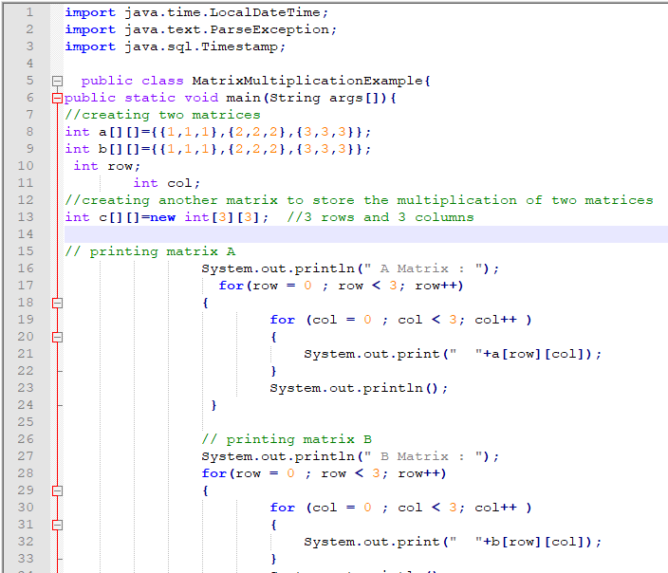

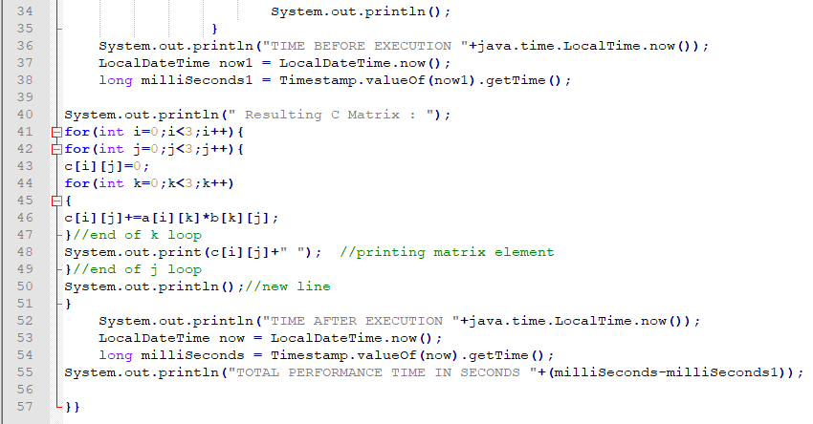

**OUTPUT: it takes 5 seconds for matrix multiplication.**

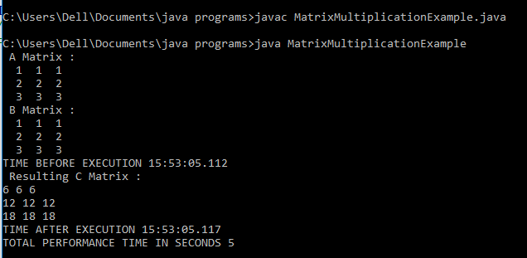

**Matrix Multiplication Using Threads:**

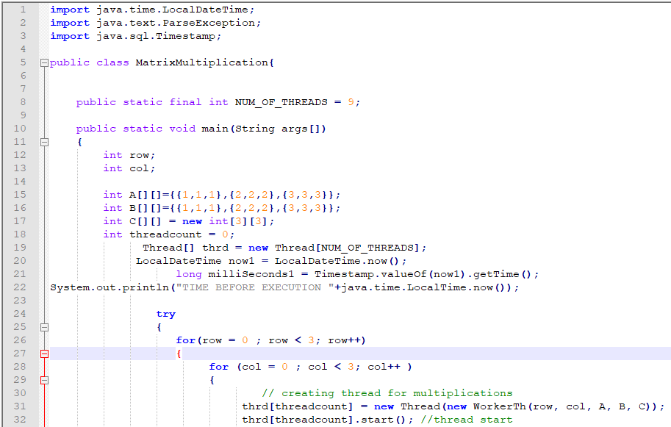

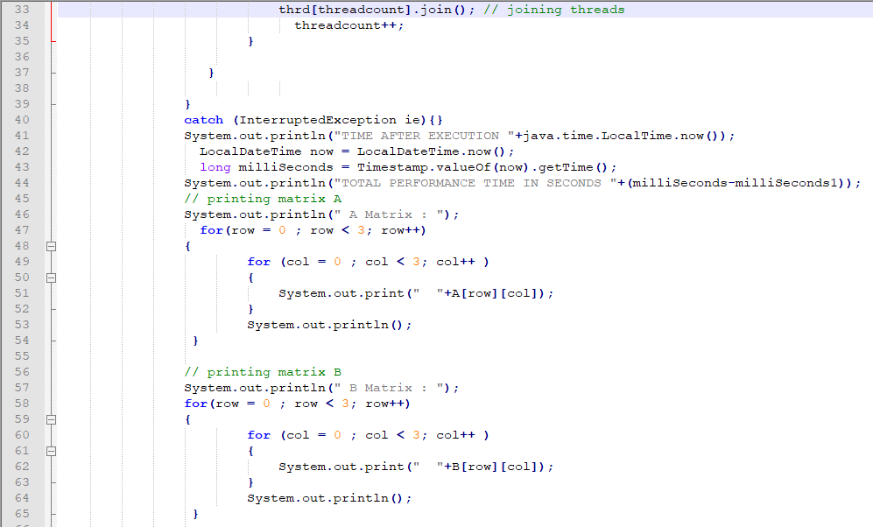

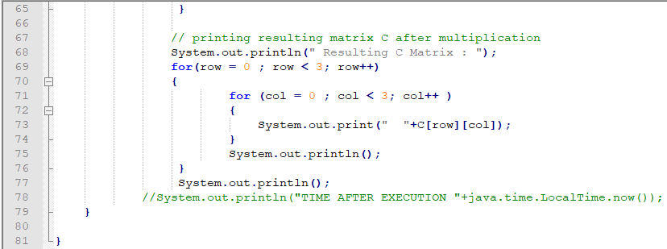

**Inner class named WorkerTh**

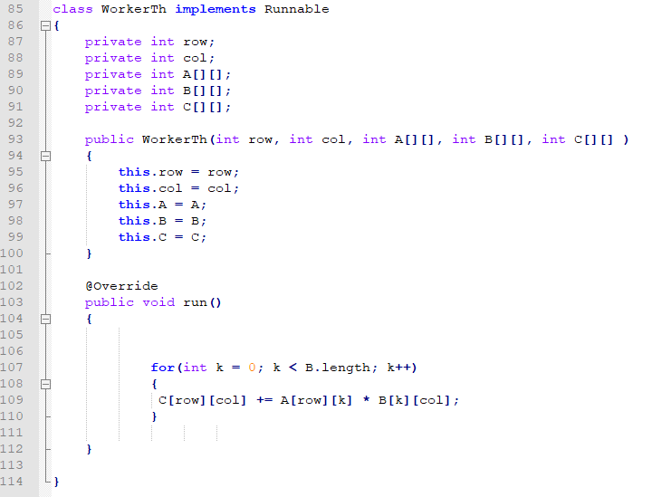

**OUTPUT: It takes 27 seconds in matrix multiplication.**

