Machine Learning Raman Classification of Nematic Chromonic Liquid Crystal Self-organisation on Different Substrates

Tanzeel Ul Rehman ¹, Hira Aman ¹, Antonio Francesco Mottese ¹, Domenico Rosaci ¹, Maria Penelope De Santo^{2,3,4}, Caterina Maria Tone³, Federica Ciuchi³, Nicola Lisi⁵, Giacomo Messina ¹, Giuliana Faggio ^{1*}

¹Department of Information Engineering, Infrastructures and Sustainable Energy (DIIES), University
‘Mediterranea’ of Reggio Calabria, 89122 Reggio Calabria, Italy
²Physics Department, University of Calabria, Ponte Bucci, Cubo 31C, 87036 Arcavacata di Rende, Italy
³CNR-Nanotec c/o Physics Department, University of Calabria, Ponte Bucci, Cubo 31C, 87036 Arcavacata di Rende, Italy
⁴Laboratorio di Preparazione di Campioni Biologici - Fisica, STAR IR, Via Tito Flavio, Università della Calabria, 87036 Rende (CS), Italy
⁵Agenzia nazionale per le nuove tecnologie, l'energia e lo sviluppo economico sostenibile (ENEA), Casaccia Research Centre, Roma 00123, Italy

* Corresponding author: gfaggio@unirc.it
Abstract
Lyotropic chromonic liquid crystals (LCLCs) such as Sunset Yellow (SSY) are highly sensitive reporters of interfacial chemistry; yet discriminating their Raman spectral fingerprints across substrates and interlayer configurations by conventional means is challenging due to the high inter-class spectral similarity. The performance of two machine learning models: Partial Least Squares Discriminant Analysis (PLS-DA) and Support Vector Machine with Radial Basis Function Kernel (SVM-RBF), was assessed using 5-fold stratified cross-validation and an independent external test. The models were tested on Raman spectra obtained from commercial chromonic thin films deposited on both organic and inorganic substrates, with or without graphene as intermediate layer. Both models had a low overall accuracy of 47.5% for the four-class classification owing to the high inter-class spectral similarity. The binary reformulation of the problem (organic vs. inorganic) significantly improved the performance. PLS-DA achieved a consistent 90.0% accuracy across all VIP thresholds when the external test set contained only graphene-coated samples, representing a 25% improvement over the mixed-test case. In contrast, the accuracy of SVM-RBF decreased from 70.0% to 60.0% as the number of VIPs increased. SVM-RBF also outperformed PLS-DA on the mixed external test (75% vs 65%). These findings indicate that the classification strategy should be adapted to the expected sample composition, with SVM-RBF preferred for heterogeneous populations and PLS-DA for graphene-enriched datasets.
Keywords: Raman spectroscopy, Sunset Yellow, graphene, machine learning, PLS-DA, SVM-RBF
Graphical Abstract
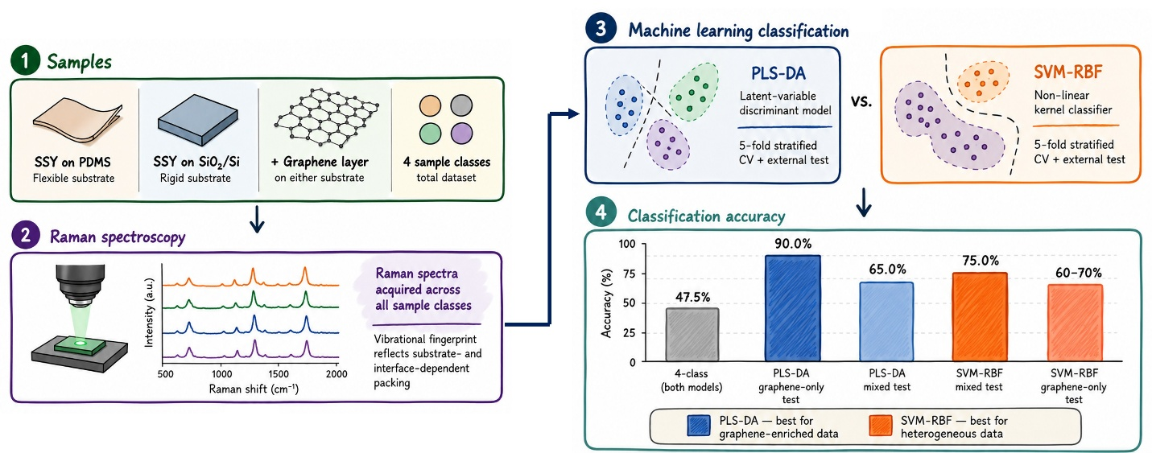

1. Introduction
Raman spectroscopy is a label-free and non-destructive vibrational technique capable of resolving subtle molecular-level changes in materials. It has become one of the most widely used analytical techniques for the structural characterization of soft matter systems such as liquid crystalline (LC) materials [1,2]. However, the Raman spectra collected from complex supramolecular assemblies are rarely straightforward to interpret, because the spectral differences induced by changes in molecular packing, surface interaction, and interfacial chemistry are frequently small, overlapping, and embedded within highly correlated, high-dimensional data [1,2]. Conventional characterization approaches based on visual comparison of spectra or manual peak fitting are inherently operator-dependent and may fail to capture variations that do not produce obvious differences in peak position or intensity [3]. Machine learning (ML) and chemometric methods have therefore emerged as powerful complements to conventional spectral analysis, enabling extraction of discriminative information from datasets where the number of spectral variables vastly exceeds the number of independent samples [1,4].
Lyotropic chromonic liquid crystals (LCLCs) are a fascinating class of soft matter in which plank-like aromatic molecules — including dyes, drug compounds, and nucleic acid derivatives — self-assemble in water into elongated, non-covalently bound columnar stacks [15]. Unlike conventional amphiphilic systems, LCLCs are intrinsically biocompatible, water-processable, and highly sensitive to ionic strength and interfacial conditions. These properties make them compelling candidates for biosensing platforms, water-based organic electronics, and optical alignment layers [15,16]. In particular, the controlled alignment of LCLC films on technologically relevant substrates is fundamental for device applications [17]. The vibrational fingerprints of LCLC molecules are sensitive not only to their intrinsic chemical structure but also to their local packing environment, intermolecular interactions and degree of orientational order, making Raman spectroscopy a particularly informative probe of their supramolecular organisation [18,19].
Characterization of LCLC films has historically relied on a battery of complementary techniques. Polarized optical microscopy (POM) provides direct visualization of mesophase textures but lacks molecular specificity. Small-angle X-ray scattering (SAXS) resolves the columnar stacking periodicity and inter-stack spacing with high precision, yet requires synchrotron access and is not easily performed in situ under ambient conditions. Differential scanning calorimetry (DSC) maps thermotropic phase boundaries but yields no structural information at the molecular level. Nuclear magnetic resonance (NMR) and UV–Vis absorption spectroscopy have been used to quantify aggregation equilibria and tautomeric ratios in dilute solution, but are poorly suited to film-state or substrate-resolved measurements [18,19]. Raman spectroscopy stands apart in this methodological landscape: it is non-destructive, requires no sample preparation, is compatible with diverse substrate configurations, and its vibrational fingerprint is directly sensitive to changes in molecular packing, intermolecular interactions and orientational order within chromonic aggregates [18,19]. Previous studies have reported orientational order parameters and self-assembly kinetics of chromonic dyes in aqueous solution using Raman spectroscopy, demonstrating its sensitivity to supramolecular organisation well beyond nominal chemical composition [18,19]. Despite this clear advantage, the application of Raman spectroscopy to substrate-resolved discrimination of LCLC organisation on technologically relevant surfaces remains largely unexplored. The key unresolved challenge is that the spectral differences imparted by substrate chemistry or the presence of a graphene interlayer are subtle, invisible to unaided visual inspection, and embedded within a highly correlated high-dimensional dataset that demands ML-based analysis.
Among supervised ML classifiers, Partial Least Squares Discriminant Analysis (PLS-DA) and Support Vector Machines with radial basis function kernel (SVM-RBF) are well established for the interpretation of Raman spectroscopic data [5,6]. PLS-DA is a latent variable approach that simultaneously decomposes the spectra and class label matrices to find directions of maximum covariance, yielding interpretable latent variable scores, loading profiles, and Variable Importance in Projection (VIP) scores [1,7,9]. VIP scores, derived from the PLS decomposition, provide a principled criterion for selecting the most discriminative spectral variables and are widely used as a preprocessing step before model training [8]. SVM-RBF finds a maximum-margin classification boundary in a kernel-induced feature space and is known to be robust in high-dimensional, small-sample settings — from biomedical diagnostics to polymer identification [7,10–13]. The selection of these two classifiers over alternatives such as random forests (RF), k-nearest neighbours (KNN), or convolutional neural networks (CNN) is deliberate: RF and KNN are vulnerable to the p >> n problem (p ≈ 2200 spectral points, n = 60–80 spectra) without aggressive dimensionality reduction, while CNN-based approaches require substantially larger labelled datasets than those available in a single proof-of-concept spectroscopic study. The VIP–PLS-DA–SVM-RBF pipeline therefore represents the methodological choice best matched to the dataset size and interpretability requirements of the present study [3,14]. Comparison with other classifiers is envisaged for future work as the dataset is expanded.
The choice of Sunset Yellow (SSY) as the model chromonic system rests on several converging reasons. (i) SSY is one of the most extensively characterized LCLCs, with a well-documented phase behaviour, aggregation mechanism, and vibrational spectrum [18–21], providing a reliable benchmark against which spectral assignments and classification outcomes can be validated. (ii) Its plank-like aromatic rigid core and well-resolved Raman-active modes offer a rich and chemically interpretable spectral fingerprint, unlike systems dominated by broad or weakly resolved bands [18,19]. (iii) SSY aggregates are highly sensitive to the physicochemical nature of the underlying surface during solvent evaporation and self-assembly [22], meaning that even minor differences in interfacial chemistry, polarity, and roughness between substrates may meaningfully affect the local vibrational environment of the stacked aromatic cores — changes too subtle to discern by visual inspection but potentially recognisable with ML algorithms [3,14].
The presence of a graphene interlayer introduces an additional and mechanistically distinct source of spectral perturbation. Graphene is not a passive, chemically inert spacer; it is an active partner in interfacial vibrational spectroscopy [23]. Non-covalent interactions — π–π stacking and ground-state charge transfer — between adsorbed aromatic molecules and graphene are known to modulate the vibrational response of molecules in close proximity to the graphene layers [23–27]. Since SSY possesses rigid aromatic cores that enable precisely these non-covalent interactions, insertion of graphene between the substrate and the SSY film is expected to modulate the chromonic vibrational fingerprint through a mechanism fundamentally different from the bare-substrate case. The spectral signature of each substrate–graphene combination is therefore expected to encode a distinct interfacial interaction regime, rather than a simple linear superposition of independent substrate and graphene contributions. This motivates a classification scheme capable of distinguishing not only between substrates but also between graphene-coated and bare surface configurations.
Collectively, the above considerations frame the present study as more than a methodological comparison between two ML models. The fundamental scientific question is whether ML-integrated Raman analysis can detect and discriminate the interface-dependent differences in the self-organisation of SSY arising from substrate chemistry and the presence of a graphene interlayer, particularly when such differences are invisible to direct visual inspection or conventional peak-to-peak comparison. The innovation of the present work is threefold: (i) it is among the first studies to apply a VIP–PLS-DA–SVM-RBF classification pipeline to substrate-resolved Raman spectra of a LCLC film; (ii) it systematically quantifies how VIP-based feature reduction affects model generalisation for this class of materials; and (iii) it demonstrates that the graphene interlayer introduces a structurally coherent spectral perturbation that is learnable by PLS-DA with high, VIP-threshold-independent accuracy. To this end, SSY was deposited on four substrate configurations: (i) bare polydimethylsiloxane (PDMS), (ii) graphene-coated PDMS, (iii) bare SiO₂/Si, and (iv) graphene-coated SiO₂/Si. Both classifiers were evaluated under a four-class and a binary (PDMS vs. SiO₂/Si) formulation, with VIP-based variable selection systematically varied across {1000, 1500, 1800, 2200} variables. This controlled scope is pivotal to establishing a rigorous proof of concept for ML-integrated Raman classification of chromonic self-organisation on different substrates.
2. Materials and Methods
2.1 Raman measurements and sample preparation
PDMS was spin coated and cured on a glass surface and 5 ml of SSY were drop casted on the polymer surface, as well as on the silicon one, as reported in ref [22]. Graphene was grown on copper foils by chemical vapour deposition using methane as the carbon precursor and was subsequently transferred onto PDMS and SiO₂/Si substrates by a cyclododecane-assisted transfer method. [24]. Micro-Raman measurements were performed by means of a HORIBA Scientific LabRAM HR Evolution Raman spectrometer with an integrated Olympus BX41 microscope using an 1800 lines/mm grating and a 10x objective. A laser excitation wavelength of 473 nm was focused on the sample surface. The laser power was kept below 1mW to minimize laser-induced heating effect, while an integration time of 15 s, and 5 spectral accumulations per acquisition were used for spectral collection. A total of 80 Raman spectra were recorded, corresponding to 20 spectra per class. The 1800 lines/mm grating provided a spectral resolution of approximately 1.2 cm⁻¹/pixel at 473 nm excitation, sufficient to resolve individual SSY vibrational bands in the fingerprint region (450–1800 cm⁻¹). We note that 20 spectra per class were collected from a single prepared sample per configuration, representing a controlled proof-of-concept dataset. Independent replicate preparations would be required to fully account for batch-to-batch variability and are planned for future work.
2.2 Data Pre-processing and Feature Selection
All data analysis was performed in Python (v3.x) version. Raw Raman spectra were cropped to the significant spectral region (450–1800 cm⁻¹) and then smoothed by Savitzky–Golay filtering (window = 7 points, polynomial order = 2) implemented in SciPy. Variable importance in projection (VIP) scores were computed from a preliminary 3-component PLS model fitted exclusively on scaled (zero mean, unit variance) training data. We kept the top-N highest-VIP variables for the training of the models, where N ∈ {1000, 1500, 1800, 2200}. All scaling and VIP calculation were performed only on training data to avoid information leakage. The specific thresholds N ∈ {1000, 1500, 1800, 2200} were chosen to systematically probe the sensitivity of model performance to the size of the VIP-selected feature space, ranging from a conservative selection (1000 variables, approximately 44.9% of the 2228-point spectral window, slightly above the 891 variables (40.0%) exceeding VIP > 1 in the preliminary model) to a near-complete retention (2200 variables, 98.7%). This range was designed to bracket the conventional VIP > 1 cutoff and assess whether stricter or more permissive selections systematically alter classification outcomes.
2.3 Classification Models
Two classifiers were evaluated: (i) PLS-DA implemented via PLSRegression with one-hot class matrices as Y and 5 latent variables (LVs) for the four-class problem and 3 LVs for binary analysis, with predictions assigned by argmax over the fitted response; (ii) SVM-RBF with C = 10, γ = ‘scale’, embedded in a standardisation pipeline. Both models were implemented in the scikit-learn library. Data handling and Excel export were performed using pandas, and all figures were generated with Matplotlib. The number of latent variables was selected via cross-validation on the training set: the RMSECV (root mean square error of cross-validation) was computed for LV counts ranging from 1 to 10, and the optimal number was identified as the point of diminishing returns on the RMSECV scree plot (i.e., the first LV after which additional components produced less than 1% further reduction in RMSECV). This procedure yielded 5 LVs as optimal for the four-class problem and 3 LVs for the binary formulation, consistent with the lower intrinsic dimensionality expected when only two substrate classes are considered.
2.4 Validation Protocol and Performance Metrics
The following three validation scenarios were evaluated: (i) All-dataset 4-class: 5-fold stratified cross-validation on all 80 spectra (n = 20 per class). (ii) Binary, mixed external test: stratified split, yielding 60 training and 20 external test spectra (10 PDMS-class + 10 SiO₂/Si-class extracted from both Gr and non-Gr samples); 5-fold CV on the training set. (iii) Binary, graphene-only external test: 10 non-Gr spectra per class were completely removed, 5 Gr spectra per class (10 in total) were used for the external test, and the remaining 60 spectra were used for training and 5-fold CV.
For all models and validation conditions, overall accuracy, per-class accuracy [Accuracyᵢ = (TPᵢ + TNᵢ) / Nₜₒₜₐₗ], per-class recall [Recallᵢ = TPᵢ / (TPᵢ + FNᵢ)], and macro-average recall were computed. For external-test results, 95% confidence intervals for classification accuracy were estimated using the Wilson score method. Permutation testing confirmed that these cross-validation performances were statistically significant. As reported in Supplementary Figure S1 (A) and (B), none of the 999 label-permuted models reached the observed accuracies, corresponding to a permutation-test p-value of p = 0.0010. This indicates that the observed classification performance is highly unlikely to result from random label assignments.
3. Results and Discussion
3.1 Micro-Raman Spectral Analysis
Figure 1 depicts the mean Raman spectra of four SSY substrate configurations in the range of 450–1800 cm⁻¹ over 80 measurements (±1 standard deviation, grey shading), plotted as a function of Raman shift (cm⁻¹). All dominant Raman bands are consistent with the literature for the keto-hydrazone tautomer of SSY, which dominates in the condensed film state [18,19,29]. The complete vibrational assignment, organised by spectral region, is as follows. In the out-of-plane skeletal region (450–700 cm⁻¹), the weak but reproducible bands arise from low-frequency collective motions of the molecular framework. Bands in the 460–490 cm⁻¹ range are attributed to out-of-plane ring deformation modes (γ ring) of the naphthalene (R1) system, corresponding to the wagging and torsion of the aromatic backbone characteristic of the keto-hydrazone geometry [19,21]. Bands in the 530–560 cm⁻¹ range are assigned to the symmetric SO₃⁻ deformation (δₛ SO₃⁻) and out-of-plane ring torsion of the naphthalene (R1) system, reflecting the sulfonation pattern characteristic of the keto-hydrazone geometry [18,19]. Bands in the 580–630 cm⁻¹ range are attributed to C–S stretching coupled with ring skeletal bending, while the 640–680 cm⁻¹ region encompasses C–H out-of-plane bending (γ C–H) of both the naphthalene (R1) and phenyl (R2) rings [19,21]. The C–H out-of-plane deformation and ring breathing region (700–1000 cm⁻¹) contains bands most sensitive to the ring substitution pattern and the tautomeric configuration. Bands near 700–730 cm⁻¹ are assigned to C–H out-of-plane wagging of the naphthalene ring coupled with ring skeletal deformation [19,21]. The spectral feature at 770–800 cm⁻¹ corresponds to the naphthalene ring breathing mode, together with C–H out-of-plane bending of the peri-substituted aromatic positions [18,19]. Bands around 830–870 cm⁻¹ arise from ring deformation and C–H out-of-plane bending of the para-substituted phenyl ring (R2) [19,21]. Importantly, the feature at approximately 960–990 cm⁻¹ is assigned to the N–N stretching vibration of the hydrazone linkage (ν N–N, hydrazone form), a band diagnostic of the keto-hydrazone tautomer that would be absent or shifted in the azo form [19]. Its presence confirms the hydrazone character of SSY in the deposited films across all four substrate configurations. In the 1000–1090 cm⁻¹ range, the observed bands are assigned to ring trigonal bending, C–H in-plane bending and skeletal ring vibrations, consistent with the in-plane deformation modes of the conjugated naphthalene–hydrazone–phenyl framework [18,19,29]. The fingerprint region I (1094–1229 cm⁻¹) encompasses bending and deformation vibration modes of the naphthalene (R1) and phenyl (R2) rings at 1094 and 1127 cm⁻¹, respectively, alongside SO₃ group activity and C–N stretching coupled with N–H and naphthalene deformation modes at 1182 and 1229 cm⁻¹, collectively reflecting the stability of the sulfonate substituents on all examined substrates [18,19,29]. In the fingerprint region II (1335–1480 cm⁻¹), vibrational modes of the naphthalene and phenyl rings coexist with C–N, N–H and N–N stretching contributions of the hydrazone tautomer, characteristic of the hydrazone linkage and the extended aromatic core of SSY [18,19]. The D band of graphene (∼1350 cm⁻¹) coincides with this N–N/C–N hydrazone stretching region in the graphene-coated spectra. In the high-frequency region (1501–1598 cm⁻¹), the bands at 1501 and 1549 cm⁻¹ arise from C=O and C–N stretching coupled with N–H in-plane bending and naphthalene skeletal vibrations, respectively, where the C=O stretching is a hallmark of the keto-hydrazone tautomeric form [18,19]. The most intense band at 1598 cm⁻¹ is assigned to symmetric C–C stretching of the naphthalene (R1) and phenyl (R2) rings, reflecting the extended π-conjugation of the SSY chromophore [18,19]. The graphene G band (∼1580 cm⁻¹) is superimposed on this region in the Gr-coated spectra and partially overlaps with the 1598 cm⁻¹ SSY band. By visual inspection, all four SSY spectra are virtually indistinguishable across the entire 450–1800 cm⁻¹ window despite the substrate-dependent interfacial environments. This high spectral similarity constitutes the fundamental analytical challenge and motivates the machine learning approach described in the following sections.
Raman Shift (cm⁻¹) | Vibrational Assignment | Ref.
460–490 | Out-of-plane ring deformation (γ ring) of naphthalene (R1); backbone wagging and torsion characteristic of the keto-hydrazone geometry | [19,21]
530–560 | SO₃⁻ symmetric deformation (δₛ SO₃⁻); out-of-plane ring torsion of naphthalene (R1) | [18,19]
580–630 | C–S stretching coupled with ring skeletal bending | [19,21]
640–680 | C–H out-of-plane bending (γ C–H) of naphthalene (R1) and phenyl (R2) rings | [19,21]
700–730 | C–H out-of-plane wagging of naphthalene; ring skeletal deformation | [19,21]
770–800 | Naphthalene ring breathing; C–H out-of-plane bending (peri-substituted positions) | [18,19]
830–870 | Ring deformation; C–H out-of-plane bending of para-substituted phenyl (R2) | [19,21]
960–990 | ν(N–N) hydrazone linkage — diagnostic band of the keto-hydrazone tautomer | [19]
1000–1090 | Ring trigonal bending; C–H in-plane bending; skeletal ring vibrations | [18,19,29]
1094 | Ring bending/deformation modes of naphthalene (R1) | [18,19]
1127 | Ring deformation of phenyl (R2) | [18,19]
1182 | SO₃ group activity; C–N stretching coupled with N–H deformation | [18,19,29]
1229 | C–N stretching coupled with N–H and naphthalene deformation modes | [18,19]
1335–1480 | C–N, N–H and N–N stretching (hydrazone tautomer); naphthalene and phenyl ring modes | [18,19]
∼1350 * | Graphene D band (defect-activated) — Gr-coated samples only | [30,31]
1501 | C=O stretching coupled with C–N; N–H in-plane bending — keto-hydrazone marker | [18,19]
1549 | C–N stretching; N–H in-plane bending; naphthalene skeletal vibrations | [18,19]
∼1580 * | Graphene G band (E₂g) — Gr-coated samples only; overlaps 1598 cm⁻¹ SSY band | [30,31]
1598 | Symmetric C–C stretching of naphthalene (R1) and phenyl (R2); extended π-conjugation (most intense band) | [18,19]
Table 1. Raman vibrational band assignments for SSY in the keto-hydrazone tautomeric form over the 450–1800 cm⁻¹ spectral window, based on DFT calculations and experimental literature data [18,19,21,29]. Entries marked * are attributed to the graphene interlayer and appear exclusively in Gr-coated sample configurations (highlighted in amber).
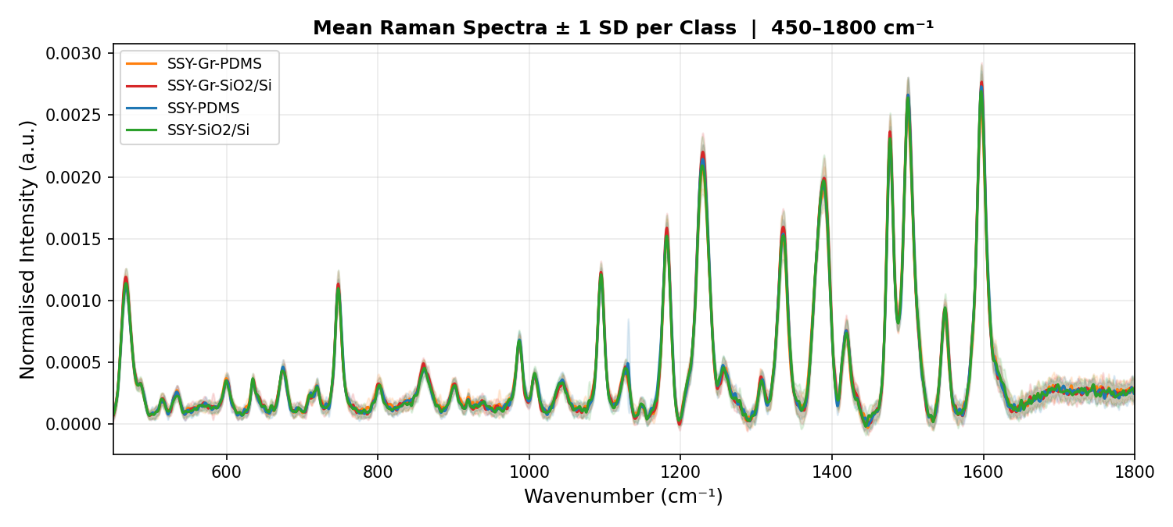
Figure 1: Mean Raman spectra (± 1 SD, shaded grey region) of four SSY samples after baseline correction, plotted as a function of Raman shift (cm⁻¹) over the analytical window 450–1800 cm⁻¹. Note: the x-axis in the original figure should be labelled 'Raman shift (cm⁻¹)'.
3.2 Four-Class Classification Performance of ML Models
PLS-DA and SVM-RBF confusion matrices obtained from 5-fold stratified cross-validation on all 80 spectra under the four-class formulation (2200 VIPs selected) are presented in Figure 2 (A & B). Both models achieved an identical marginal overall accuracy of 47.5%. Although 47.5% accuracy is insufficient for practical classification, it remains substantially above the 25% random-chance level expected for a balanced four-class problem. Nevertheless, this low performance confirms that the four classes are not well-separated in spectral feature space, consistent with the near-identical spectral profiles observed in Figure 1.
As depicted in Figure 2 (lower tables), upon examining per-class metrics, a systematic pattern emerges for both classifiers: the SSY-Gr-PDMS class yields the highest individual accuracy and recall values (PLS-DA: 82.5%/75.0%; SVM: 83.8%/65.0%). While the SSY-SiO₂/Si class exhibits the worst performance (PLS-DA: 65.0%/20.0%; SVM: 66.2%/40.0%), indicating its high susceptibility to misclassification as SSY-PDMS or SSY-Gr-SiO₂/Si. The confusion matrices reveal that the primary source of error is the cross-substrate confusion between PDMS-related and SiO₂/Si-related classes. For PLS-DA, 8 out of 20 SSY-SiO₂/Si spectra are assigned to the SSY-Gr-SiO₂/Si class, and 5 SSY-PDMS spectra are misclassified as SSY-SiO₂/Si. However, for SVM-RBF, the analogous cross-class confusions are even more pronounced for the SSY-PDMS class (7 out of 20 assigned to SSY-SiO₂/Si). These observations motivate a binary reformulation in which substrate type (PDMS vs. SiO₂/Si) is treated as the primary classification target.
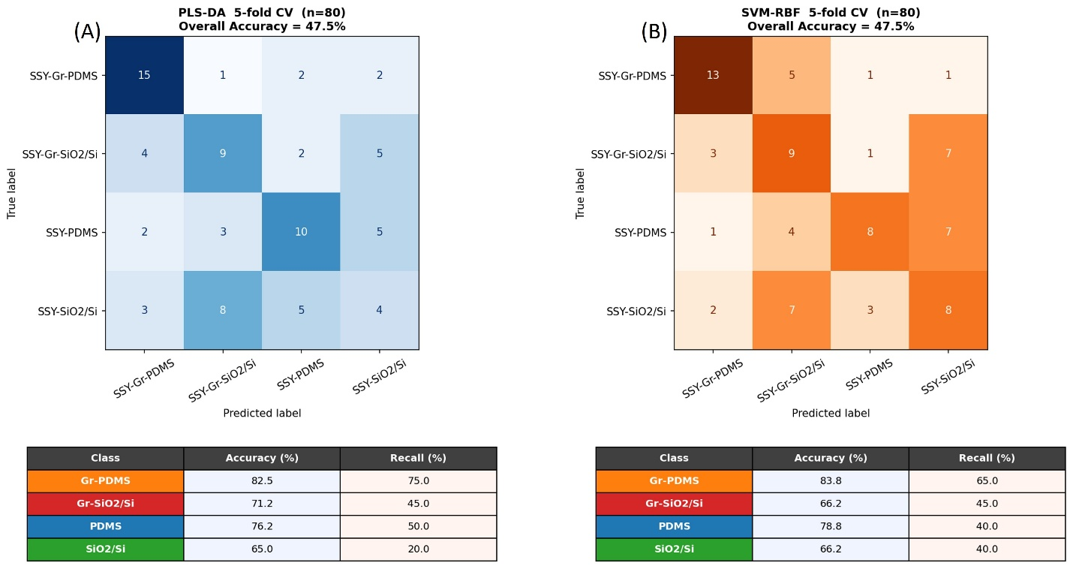
Figure 2: Confusion matrices and per-class accuracy/recall tables from 5-fold cross-validation (n = 80, 2200 VIPs) for PLS-DA (A) and SVM-RBF (B). Both models achieve an overall accuracy of 47.5%. Per-class metrics highlight SSY-Gr-PDMS as the best-discriminated class and SSY-SiO₂/Si as the worst for both classifiers.
Importantly, the three-dimensional PLS-DA score plot (LV1–LV2–LV3) in Figure 3 provides a clear mechanistic understanding of the spectral data structure. Critically, despite the partial intra-class overlap that limits four-class classification, the score plot reveals a tendency toward separation along the primary latent variable axis between PDMS-based samples (SSY-PDMS + SSY-Gr-PDMS; Class 1) and SiO₂/Si-based samples (SSY-SiO₂/Si + SSY-Gr-SiO₂/Si; Class 2). This geometrical separation in LV space directly justifies the binary reformulation: merging substrate-matched pairs exploits the dominant source of spectral variance and aligns the classification target with the natural data geometry.
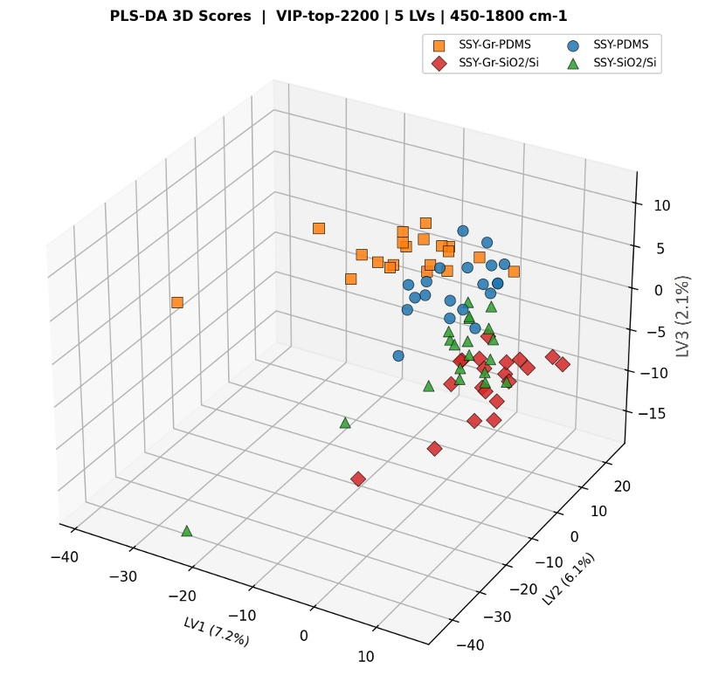
Figure 3: Three-dimensional PLS-DA score plot for all 80 SSY spectra. The data patterns naturally grouped into two clusters along the primary latent variable axis, corresponding to PDMS-based (Class 1) and SiO₂/Si-based (Class 2) sample groups.
3.3 Binary Classification and VIPs Selection
Figure 4 and Figure S2 (A,B,C,D) show the overall accuracy and macro-average recall, respectively, for the binary classification task (60 training / 20 external test spectra) across four VIP thresholds (1000, 1500, 1800, 2200 variables). The 5-fold cross-validation accuracy of PLS-DA (Figure 4) exhibited a monotonic profile with the highest accuracy at 1000 VIPs (CV = 93.3%), which progressively decreased at 1500 (88.3%), 1800 (85.0%) and 2200 VIPs (71.7%). SVM-RBF also follows a qualitatively similar trend, reaching its maximum CV accuracy of 86.7% at 1000 VIPs and minimizing it to 68.3% at 2200 VIPs. This steadily decreasing response is consistent with the fact that expanding the VIP-selected feature space beyond ~1000 variables reintroduces spectral noise, leading to gradually overfitted cross-validation models.
The VIP score profile obtained from the preliminary 3-LV PLS-DA model, computed exclusively on the training data, is shown in Figure 6. Of the 2228 spectral variables in the 450–1800 cm⁻¹ window, 891 (40.0%) exceed the conventional VIP > 1 threshold; the top-1000 variables used for classification (green rug marks, Figure 6) therefore encompass all of these informative bands plus approximately 109 variables at the VIP ≈ 1 boundary, collectively covering 44.9% of the spectral window. Four spectral regions account for the majority of high-VIP variables. (i) In the 450–700 cm⁻¹ region, multiple peaks exceed the threshold, corresponding to out-of-plane δ(C–C–C) ring deformation and δ(ring) skeletal modes of the naphthalene scaffold; the recurring VIP activity in this region suggests that substrate-induced changes in chromophore packing geometry are reflected in the low-frequency deformation landscape. (ii) The 1094–1229 cm⁻¹ window hosts several of the highest individual VIP values (pronounced maxima near 1127 and 1200 cm⁻¹), encompassing ν(C–N), ν(C–S), and δ(N–H) modes of the sulfonated hydrazone linkage; these modes are particularly sensitive to surface-mediated perturbations of the local electrostatic environment surrounding the sulfonate groups. (iii) The 1335–1480 cm⁻¹ region carries the global VIP maximum (≈ 2.6, near 1440–1450 cm⁻¹), attributed to ν(C=C) and δ(C–H) stretching modes of the naphthalene aromatic core; the pronounced VIP prominence here likely reflects substrate-polarity-driven differences in π–π inter-chromophore stacking distances. (iv) The 1501–1598 cm⁻¹ region, encompassing ν(C=N) and aromatic ν(C=C) modes of the conjugated chromophore system, contributes additional discriminant information consistent with substrate-dependent modulation of orientational order within chromonic aggregates [18,19]. The concentration of high-VIP variables in these chemically interpretable windows confirms that both classifiers exploit genuine molecular-level spectral variation tied to substrate identity, rather than baseline drift or instrumental noise.
The external test performance, on the other hand, is quite different. The PLS-DA test accuracy remains constant at 65.0% over all four VIP settings (1000-2200), suggesting no sensitivity to VIP threshold on independent data. The dissociation between cross-validation inflation and stable external performance is a behaviour suggestive of overfitting. In fact, the model memorises training-set patterns more effectively as features increase, but the underlying discriminative information extractable from unseen mixed spectra does not change. In the current scenario, the SVM-RBF model achieved better external test accuracy than PLS-DA (75.0% at 1000–1500 VIPs and 70.0% at 1800–2200 VIPs), indicating better generalization to heterogeneous test populations. The macro-average recall profiles (Figure S2) are fully consistent with the accuracy trends, as one would expect for a balanced binary classification problem.
These results identify that, for the mixed-test scenario, 1000 VIPs provided the most favourable balance between cross-validation and external-test performance. Because it provides the best balance between CV performance (PLS-DA 93.3%, SVM 86.7%) and external test accuracy (SVM 75.0%) while minimizing the CV-to-test performance gap. Moreover, despite comparable or higher CV accuracy, the observation that PLS-DA consistently underperforms SVM-RBF on external test in this mixed scenario reflects the sensitivity of PLS-DA latent variable structure to training-set spectral diversity.
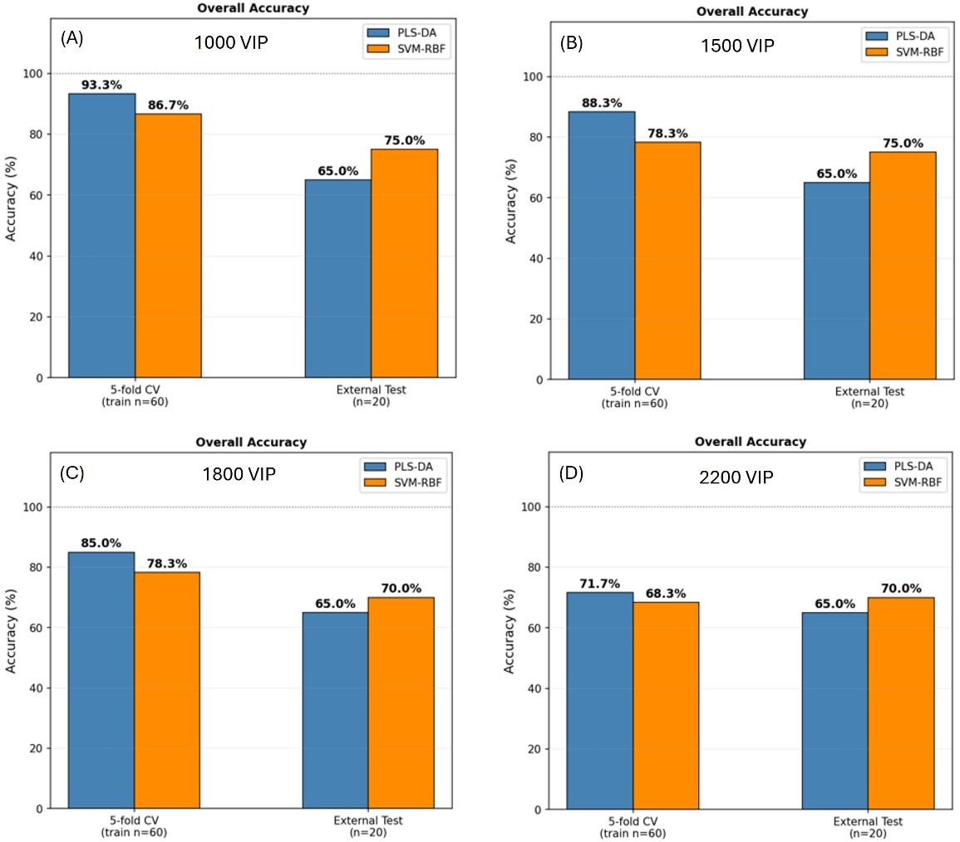
Figure 4: Overall accuracy of PLS-DA (blue bars) and SVM-RBF (orange bars) for binary substrate classification (60 train / 20 test spectra) at VIP thresholds: (A) 1000, (B) 1500, (C) 1800 and (D) 2200, respectively. Left bars= 5-fold CV on training dataset, while right bars= external test dataset.
3.4 Role of Graphene Interlayer: Graphene-Only External Test
Figure 5 and Figure S3 (A,B,C,D) depicts that the most significant finding of this study emerges from the graphene-only external test classification. In this configuration, 10 non-graphene spectra per class are excluded from the analysis and the external test set is composed exclusively of 10 graphene-based SSY spectra (5 SSY-Gr-PDMS + 5 SSY-Gr-SiO₂/Si). Nonetheless, the training set (n = 60) retains a balanced mixture of graphene and non-graphene samples, respectively.
In this phase the external test accuracy of PLS-DA rises to a stable 90.0% across all four VIP thresholds (1000–2200). This represents a 25%-point improvement over the mixed-test scenario (65.0%). Although the external accuracy reached 90% (9/10 correctly classified spectra), the test set consisted of only ten spectra. Consequently, the estimated accuracy is associated with substantial uncertainty (95% Wilson confidence interval: 59.6–98.2%) and should therefore be interpreted cautiously until validated on a larger independent dataset. Nevertheless, the invariance of this result with respect to VIP selection is noteworthy, as the PLS-DA model correctly classified the same 9 out of 10 graphene-based test spectra into the correct substrate class regardless of whether 1000 or 2200 spectral variables were used. This observation is compatible with the possibility that the graphene-containing samples may exhibit spectral features that are more consistently represented by the PLS-DA latent-variable structure. Such behaviour is compatible with substrate-dependent modifications of the Raman response arising from graphene-mediated interfacial interactions [30,31]. However, the present classification study does not directly identify the spectral variables responsible for this effect, and therefore, no specific mechanistic attribution can be established without additional VIP-profile and loading analyses. These observations indicate that a subset of discriminative spectral variables is consistently captured by the PLS-DA latent-variable decomposition irrespective of the size of the VIP-selected feature space. The specific spectral origin of these variables remains to be established.
In contrast, SVM-RBF achieves only 70.0% external test accuracy at 1000 VIPs, and then falls to 60.0% for VIP ≥ 1500, which is comparable to random binary classification. This divergence reflects a fundamental difference in interaction of the two models with the spectral features of graphene-based substrates. The PLS-DA latent-variable decomposition separates spectral variance according to its covariance with the class labels and may therefore emphasise systematic spectral patterns associated with substrate identity. Nevertheless, SVM-RBF operates as a kernel distance metric in the raw (or VIP-reduced) feature space. Thus, it is evidently less capable of identifying the structured graphene-based substrate covariance when the feature space expands to include additional potentially conflicting spectral variables.
The cross-validation performance in the Gr-only scenario (Figures 5 and S3) is significantly higher than the mixed-test scenario. PLS-DA CV ranges up to 96.7% (1000 VIPs, both accuracy and recall), and drops to 75.0% at 2200 VIPs, while SVM-RBF CV ranges from 91.7 to 78.3% in the same range of VIPs. The high CV performance confirms that the training set, which comprises both graphene and non-graphene samples, still contains enough spectral information to train robust binary models. The subsequent degradation with expanding VIP count is more pronounced for PLS-DA (96.7% → 75.0%) than for SVM-RBF (91.7% → 78.3%) in CV. This is again consistent with overfitting to non-informative spectral variables.
Taken together, SVM-RBF is the preferred classification ML model when the test population is heterogeneous (containing mixed Gr and non-Gr samples), achieving higher external accuracy and greater robustness to feature-space expansion (Figure S4). Nevertheless, PLS-DA appears preferable when graphene-based samples are explicitly targeted, yielding a stable, VIP-independent external test accuracy (Figure S5). These complementary findings motivate an integrated and sample-aware classification strategy.
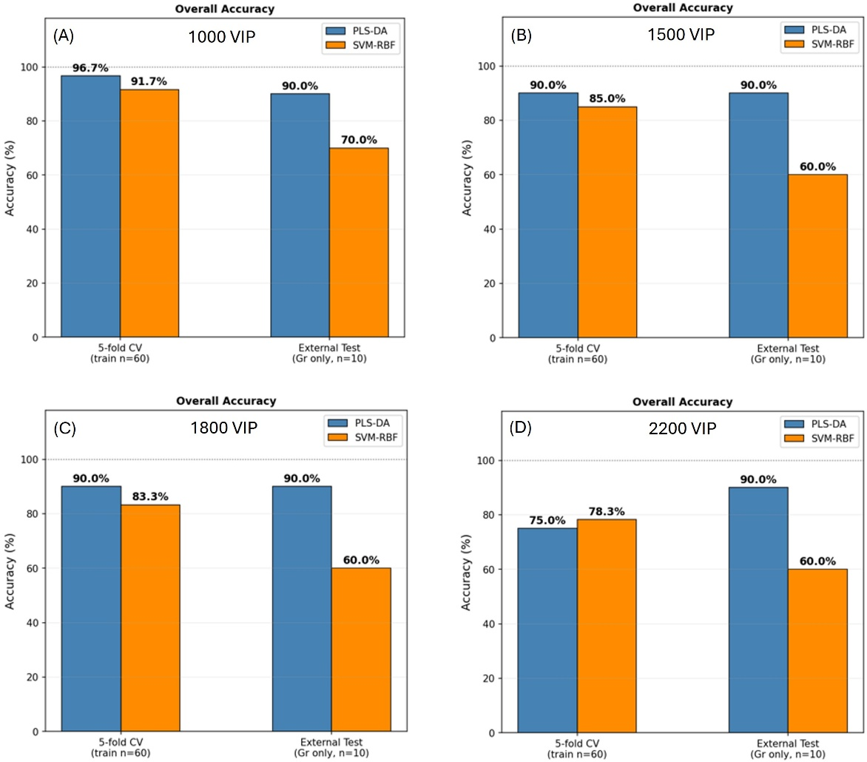
Figure 5: Overall accuracy of PLS-DA (blue bars) and SVM-RBF (orange bars) for binary substrate classification (60 train / 10 Gr-only test spectra) at VIP thresholds: (A) 1000, (B) 1500, (C) 1800 and (D) 2200, respectively.
4. Conclusions
We have systematically studied the ML-assisted classification of SSY Raman spectra recorded from four substrate configurations using PLS-DA and SVM-RBF models with VIP-based feature selection. In four-class classification, both models obtained an overall accuracy of 47.5%, which implies a high degree of spectral similarity that hinders substrate-based classification by conventional methods. Moreover, 3D PLS-DA score analysis displays a natural binary clustering structure. The task reformulation as a two-group (PDMS vs. SiO2/Si) significantly improves the classification performance. The central finding of this work is that classifiers' performance depends strongly on the composition of the test population. In particular, PLS-DA exhibited improved and remarkably stable performance when evaluated on graphene-containing samples. When the external test is restricted to graphene-based samples, PLS-DA achieves a stable 90.0% accuracy that remained unchanged in the present dataset across all VIP thresholds from 1000 to 2200 variables. However, since the graphene-only external test set consisted of only ten spectra, this result should be interpreted with caution and validated on a larger independent dataset. This stability suggests the presence of spectral characteristics that are more consistently captured by the PLS-DA latent-variable framework in graphene-containing samples. Further analysis of VIP profiles and latent-variable loadings would be required to identify the specific spectral features responsible for this behaviour.
Supporting Information
Supporting Information is available and includes permutation-test results, macro-average recall analyses and detailed binary-classification comparisons.

Acknowledgements
This work was funded by the Project CAL.HUB.RIA, funded by the Italian Ministry of Health, Project CUP: F63C22000530001.

MPDS, CMT and FC acknowledge financial support from the National Recovery and Resilience Plan (NRRP), Mission 4, Component 2, Investment 1.1, call for tender No.1409 published on 14.9.2022 by the Italian Ministry of University and Research (MUR), funded by the European Union-NextGenerationEU-PRIN Project “P2022HM5E4-Chirality induction in water based self-assembling materials”-CUPH53D23009120001.

References
[1] Khristoforova, Y.; Bratchenko, L.; Bratchenko, I. Combination of Raman spectroscopy and chemometrics: a review of recent studies published in the Spectrochimica Acta, Part A: Molecular and Biomolecular Spectroscopy journal. arXiv:2210.10051, 2022.
[2] Cardoso, R. M.; et al. Unraveling surface-enhanced Raman spectroscopy results through chemometrics and machine learning: principles, progress, and trends. Chemosensors 2023, 11 (2), 103. PMC9981450.
[3] Wang, Z.; Ranasinghe, J. C.; Wu, W.; Chan, D. C. Y.; Gomm, A.; Tanzi, R. E.; Zhang, C.; Zhang, N.; Allen, G. I.; Huang, S. Machine learning interpretation of optical spectroscopy using peak-sensitive logistic regression. ACS Nano 2025, 19 (16), 15457–15473. DOI: 10.1021/acsnano.4c16037.
[4] Pan, L.; Zhang, P.; Daengngam, C.; Chongcheawchamnan, M. A review of artificial intelligence methods combined with Raman spectroscopy to identify the composition of substances. J. Raman Spectrosc. 2022. DOI: 10.1002/jrs.6225 (arXiv:2104.04599, 2021).
[5] Brereton, R.G. and Lloyd, G.R., 2014. Partial least squares discriminant analysis: taking the magic away. Journal of Chemometrics, 28(4), pp.213-225.
[6] Sunil, M., Pallikkavaliyaveetil, N., Gopinath, A., Chidangil, S., Kumar, S. and Lukose, J., 2024. Machine learning assisted Raman spectroscopy: A viable approach for the detection of microplastics. Journal of Water Process Engineering, 60, p.105150.
[7] Cortes, C. and Vapnik, V., 1995. Support-vector networks. Machine learning, 20(3), pp.273-297.
[8] Chong, I.G. and Jun, C.H., 2005. Performance of some variable selection methods when multicollinearity is present. Chemometrics and intelligent laboratory systems, 78(1-2), pp.103-112.
[9] Jiao, X., Meng, Y., Wang, K., Huang, W., Li, N. and Liu, T.C.Y., 2019. Rapid detection of adulterants in whey protein supplement by Raman spectroscopy combined with multivariate analysis. Molecules, 24(10), p.1889.
[10] Malashin, I., Tynchenko, V., Gantimurov, A., Nelyub, V. and Borodulin, A., 2025. Support vector machines in polymer science: A review. Polymers, 17(4), p.491.
[11] Chen, X., Wu, X., Chen, C., Luo, C., Shi, Y., Li, Z., Lv, X., Chen, C., Su, J. and Wu, L., 2023. Raman spectroscopy combined with a support vector machine algorithm as a diagnostic technique for primary Sjögren’s syndrome. Scientific Reports, 13(1), p.5137.
[12] Liu, Y., Wu, Y., Wang, J., Qi, J., Zhou, C. and Xue, Y., 2026. Recent Advances in Raman Spectral Classification with Machine Learning. Sensors, 26(1), p.341.
[13] Tahir, M., Yude, B., Mehmood, T., Bashir, S., Zhenping, Y. and Awais, M., 2024. Classification of LAMOST spectra of B-type and hot subdwarf stars using kernel support vector machine. Scientific Reports, 14(1), p.16815.
[14] Martinez-Serra, A., Marchetti, G., D’Amico, F., Fenoglio, I., Rossi, B., Monopoli, M.P. and Franzese, G., 2025. A machine learning tool to analyse spectroscopic changes in high-dimensional data. International Journal of Biological Macromolecules, p.148095.
[15] Lydon, J., 2011. Chromonic liquid crystalline phases. Liquid Crystals, 38(11-12), pp.1663-1681.
[16] Shiyanovskii, S.V., Lavrentovich, O.D., Schneider, T., Ishikawa, T., Smalyukh, I.I., Woolverton, C.J., Niehaus, G.D. and Doane, K.J., 2005. Lyotropic chromonic liquid crystals for biological sensing applications. Molecular Crystals and Liquid Crystals, 434(1), pp.259-587.

[17] Tone, C.M., De Santo, M.P., Buonomenna, M.G., Golemme, G. and Ciuchi, F., 2012. Dynamical homeotropic and planar alignments of chromonic liquid crystals. Soft Matter, 8(32), pp.8478-8482.
[18] Yao, X., Nayani, K., Park, J.O. and Srinivasarao, M., 2016. Orientational order of a lyotropic chromonic liquid crystal measured by polarized Raman spectroscopy. The Journal of Physical Chemistry B, 120(19), pp.4508-4512.
[19] Kristinaitytė, K., Maršalka, A., Dagys, L., Aidas, K., Doroshenko, I., Vaskivskyi, Y., Chernolevska, Y., Pogorelov, V., Valevičienė, N.R. and Balevicius, V., 2018. NMR, Raman, and DFT study of lyotropic chromonic liquid crystals of biomedical interest: Tautomeric equilibrium and slow self-assembling in sunset yellow aqueous solutions. The Journal of Physical Chemistry B, 122(12), pp.3047-3055.
[20] Edwards, D.J., Jones, J.W., Lozman, O., Ormerod, A.P., Sintyureva, M. and Tiddy, G.J.T., 2008. Chromonic liquid crystal formation by Edicol Sunset Yellow. The Journal of Physical Chemistry B, 112(46), pp.14628-14636.
[21] Chami, F. and Wilson, M.R., 2010. Molecular order in a chromonic liquid crystal: a molecular simulation study of the anionic azo dye sunset yellow. Journal of the American Chemical Society, 132(22), pp.7794-7802.
[22] Spina, L., De Santo, M.P., Tone, C.M., Pisani, M., Vita, F., Barberi, R. and Ciuchi, F., 2022. Intercalation or external binding: How to torque chromonic Sunset Yellow. Journal of Molecular Liquids, 359, p.119265.
[23] Gnisci, A., Faggio, G., Messina, G., Kwon, J., Lee, J.-Y., Lee, G.-H., Dikonimos, T., Lisi, N. and Capasso, A. (2018) ‘Ethanol-CVD growth of sub-mm single-crystal graphene on flat Cu surfaces’, The Journal of Physical Chemistry C, 122(50), pp. 28830–28838.
[24] Faggio, G., Grillo, R., Lisi, N., Buonocore, F., Chierchia, R., Kim, M.J., Lee, G.H., Capasso, A. and Messina, G., 2022. Nanocrystalline graphene for ultrasensitive surface-enhanced Raman spectroscopy. Applied Surface Science, 599, p.154035.
[25] Xu, W., Ling, X., Xiao, J., Dresselhaus, M.S., Kong, J., Xu, H., Liu, Z. and Zhang, J., 2012. Surface enhanced Raman spectroscopy on a flat graphene surface. Proceedings of the National Academy of Sciences, 109(24), pp.9281-9286.
[26] Lombardi, J.R., 2022. The theory of surface-enhanced Raman spectroscopy on organic semiconductors: graphene. Nanomaterials, 12(16), p.2737.
[27] Xia, M., 2018. A Review on Applications of Two‐Dimensional Materials in Surface‐Enhanced Raman Spectroscopy. International Journal of Spectroscopy, 2018(1), p.4861472.
[28] Capasso, A., Salamandra, L., Faggio, G., Dikonimos, T., Buonocore, F., Morandi, V., Ortolani, L. and Lisi, N. (2016) ‘Chemical vapor deposited graphene-based derivative as high-performance hole transport material for organic photovoltaics’, ACS Applied Materials & Interfaces, 8(36), pp. 23844–23853.
[29] Xie, Y., Chen, T., Cheng, Y., Wang, H., Qian, H. and Yao, W., 2014. SiO2@ Au nanoshells-based SERS method for detection of sunset yellow and chrysoidine. Spectrochimica Acta Part A: Molecular and Biomolecular Spectroscopy, 132, pp.355-360.
[30] Lee, J.E., Ahn, G., Shim, J., Lee, Y.S. and Ryu, S., 2012. Optical separation of mechanical strain from charge doping in graphene. Nature communications, 3(1), p.1024.
[31] Zabel, J., Nair, R.R., Ott, A., Georgiou, T., Geim, A.K., Novoselov, K.S. and Casiraghi, C., 2012. Raman spectroscopy of graphene and bilayer under biaxial strain: bubbles and balloons. Nano letters, 12(2), pp.617-621.

