Graphical Comparison of Classification Performance
Slide 10 (Binary 60 Train / 20 Test — Mixed) vs. Slide 11 (Binary 60 Train / 10 Test — Gr-Only)

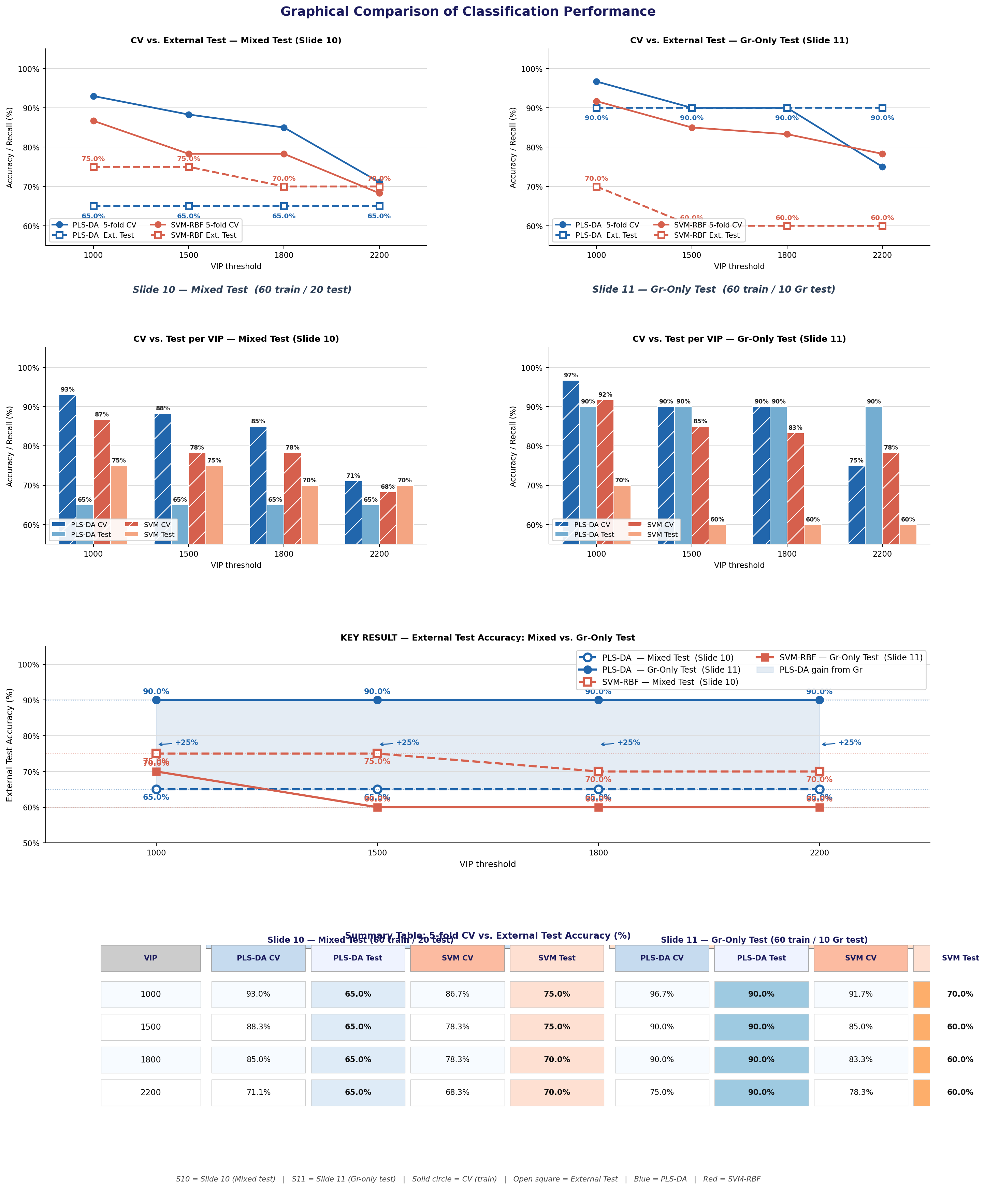
Figure. Graphical comparison of PLS-DA and SVM-RBF classification performance for Slide 10 (binary PDMS vs. SiO₂/Si, 60 train / 20 mixed-test spectra) and Slide 11 (60 train / 10 Gr-only test spectra). Rows 1–2: line plots and grouped bar charts of 5-fold CV vs. external test accuracy. Row 3 (Key Result): external test accuracy only — PLS-DA achieves a stable, VIP-independent 90.0% on graphene-coated samples (Slide 11) vs. 65.0% on mixed samples (Slide 10); SVM-RBF outperforms PLS-DA on mixed test (75% → 70%) but drops to 60% on the Gr-only test for VIP ≥ 1500. Row 4: colour-coded summary table of all reported values. Blue = PLS-DA; Red = SVM-RBF. Solid = CV (training); dashed/open markers = External Test.

Key Findings Summary
Finding | Slide 10 — Mixed Test | Slide 11 — Gr-Only Test
PLS-DA External Test | 65.0% (flat, all VIP) | 90.0% (flat, all VIP) ↑ +25%
SVM-RBF External Test | 75.0% (1000–1500) / 70.0% (1800–2200) | 70.0% (1000 VIP) → 60.0% (≥1500) ↓
Best CV accuracy | PLS-DA: 93.0% at 1000 VIP | PLS-DA: 96.7% at 1000 VIP
CV overfitting trend | PLS-DA: 93→71% | SVM: 87→68% | PLS-DA: 97→75% | SVM: 92→78%
Best model for test | SVM-RBF (75% > 65%) | PLS-DA (90% >> 60%)
VIP impact on test | None for PLS-DA; slight for SVM | None for PLS-DA; severe for SVM

Note: External test accuracy is the only metric relevant for model generalization. Cross-validation accuracy reflects training-set fit and is susceptible to overfitting as VIP count increases. Blue-highlighted cell: PLS-DA 90.0% stable on Gr-only test (central finding). Green: recommended model per scenario.

