SERS of Acacia Extracellular Vesicles and Nanovesicles on Ag/SiNWs
Data analysis: methods, models, results and figures
This document explains, step by step, how the SERS spectra of Acacia extracellular vesicles (EVs) and Acacia nanovesicles (NVs) were analysed, which models were used, how they were validated, and what the results are. Every number comes from the run of the analysis code (Acacia_Paper_All.py) on the original data in the CODE 005 folder; no value was typed by hand.
Software used for the run in this report: Python 3.13.16, numpy 2.5.3, scikit-learn 1.9.1, matplotlib 3.11.2. (Your own PyCharm run may use other versions; the numbers are the same.)

Contents
1. Data
2. Pre-processing of the spectra
3. Substrate comparison: CaF₂ vs Ag/SiNWs (Figure 1)
4. Mean spectra, peak shifts, band statistics and CH band fitting (Figure 2a-c, Table S1, Figure S2)
5. Principal component analysis (Figure 3 a, c; Figure 4)
6. Classification models: PCA-LDA and PLS-DA
7. Validation: site-grouped cross-validation and permutation test (Figure 5, Table 1, Figure S1)
8. Interpretation and limitations
9. Methods text (ready to adapt)
10. Code and output files

1. Data
Two Excel workbooks were analysed, one per sample type. Each workbook has six sheets (m1 to m6); every sheet is one measurement site on the Ag/SiNW substrate with 20 spectra recorded at different positions.
Sample | File | Sites | Spectra per site | Spectra
EV Acacia | EV_Acacia_Raman_Data.xlsx | 6 (m1-m6) | 20 | 120
NV Acacia | NV_Acacia_Raman_Data.xlsx | 6 (m1-m6) | 20 | 120

Independent units. The 20 spectra of one site are measured close together and resemble each other more than spectra from different sites. They are therefore not 20 independent samples. Throughout the analysis the measurement site (6 EV + 6 NV) is treated as the independent unit: statistical tests use site means, and in cross-validation all spectra of a site are always kept together.
Single spectra on CaF₂ (no enhancement) and on Ag/SiNWs were used only for Figure 1 (substrate comparison): S2 EV Acacia (CaF₂ and Ag/SiNW) and the NV Acacia spectra s1 (CaF₂) and s4a (Ag/SiNW), all recorded at 532 nm, 1800 gr/mm, BC200, 50× LF, 1 s, 4 accumulations.

2. Pre-processing of the spectra
Each of the 240 spectra was processed on its own, separately in two spectral windows: the fingerprint window (read 200-1800 cm⁻¹) and the CH-stretching window (read 2700-3100 cm⁻¹).
- Cosmic-ray removal. For each spectrum, the differences between neighbouring points were converted to a modified z-score (median and median absolute deviation). Points with |z| > 7 are spikes and were replaced by the mean of the non-spike points within ±3 points.
- Common wavenumber grid. Spectra were linearly interpolated onto a 2 cm⁻¹ grid (205-1795 and 2705-3095 cm⁻¹), so that all spectra share the same x values.
- Smoothing. Savitzky-Golay filter, 11 points, 3rd-order polynomial (reduces noise without shifting peaks).
- Baseline correction. Asymmetric least squares (ALS) baseline, λ = 10⁵, p = 0.01, 10 iterations, subtracted from the spectrum (removes fluorescence and substrate background).
- SNV normalisation. Within each window, every spectrum was centred on its own mean and divided by its own standard deviation (mean 0, SD 1). This removes differences in overall SERS signal strength between positions, so the analysis compares the shape of the spectra, i.e. relative composition.
Analysis regions: fingerprint 250-1790 cm⁻¹ (770 points) and CH-stretching 2760-3095 cm⁻¹ (168 points).

3. Substrate comparison: CaF₂ vs Ag/SiNWs (Figure 1)
Raw spectra are shown exactly as recorded (no smoothing, baseline correction or normalisation). On CaF₂ the vesicles give no detectable bands, while on Ag/SiNWs the protein, nucleic-acid and lipid bands appear, demonstrating the enhancement by the substrate. The EV Ag/SiNW trace is shifted up by 110 counts for display only. Peak positions are the most prominent local maximum within ±12 cm⁻¹ of the band (located on a lightly smoothed copy); the y-axis carries no values because the traces are compared by shape.
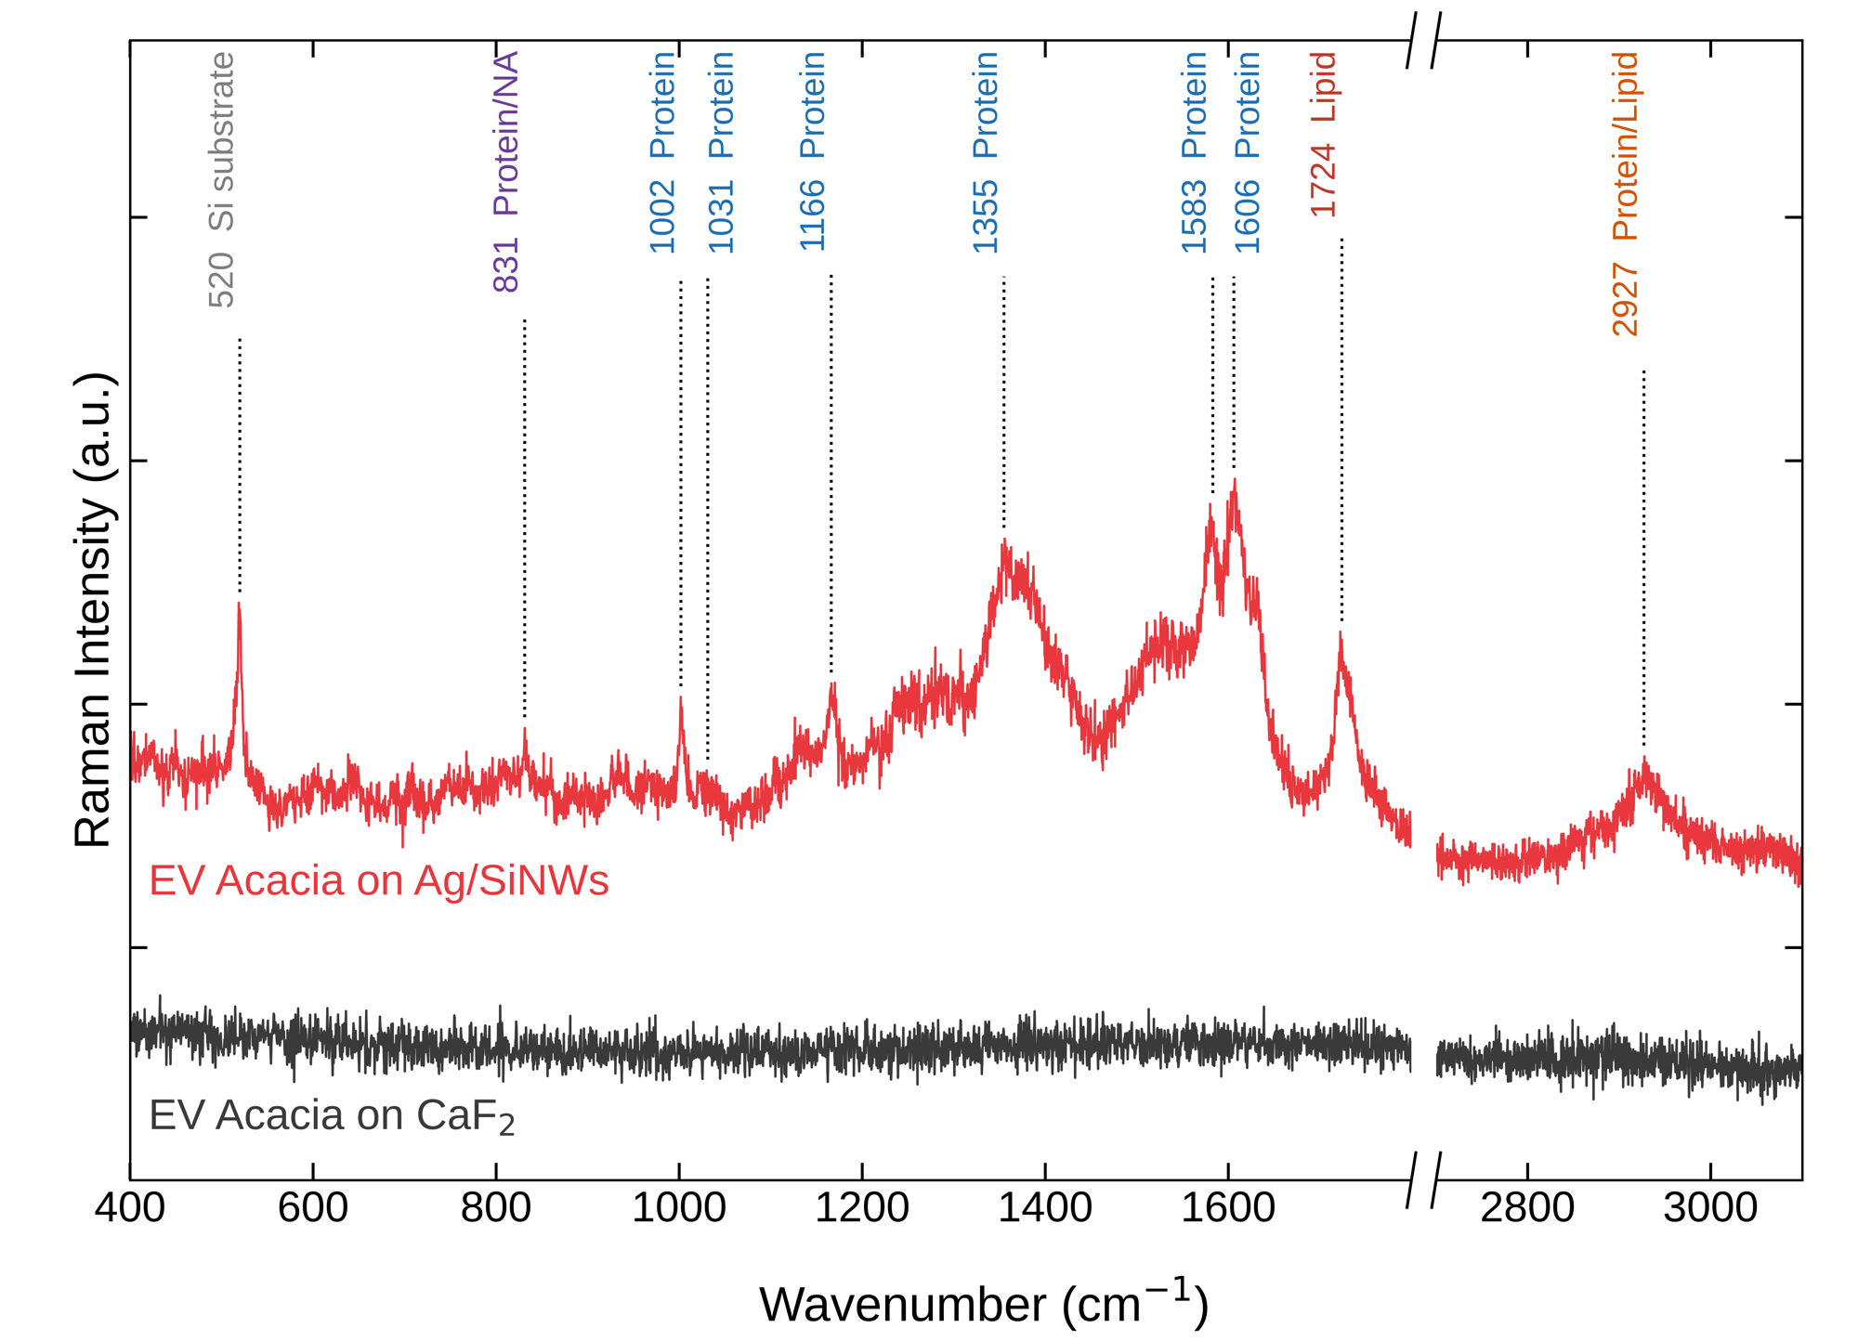
Figure 1a. EV Acacia on CaF₂ (grey) and on Ag/SiNWs (red), raw single spectra with band positions and classes.
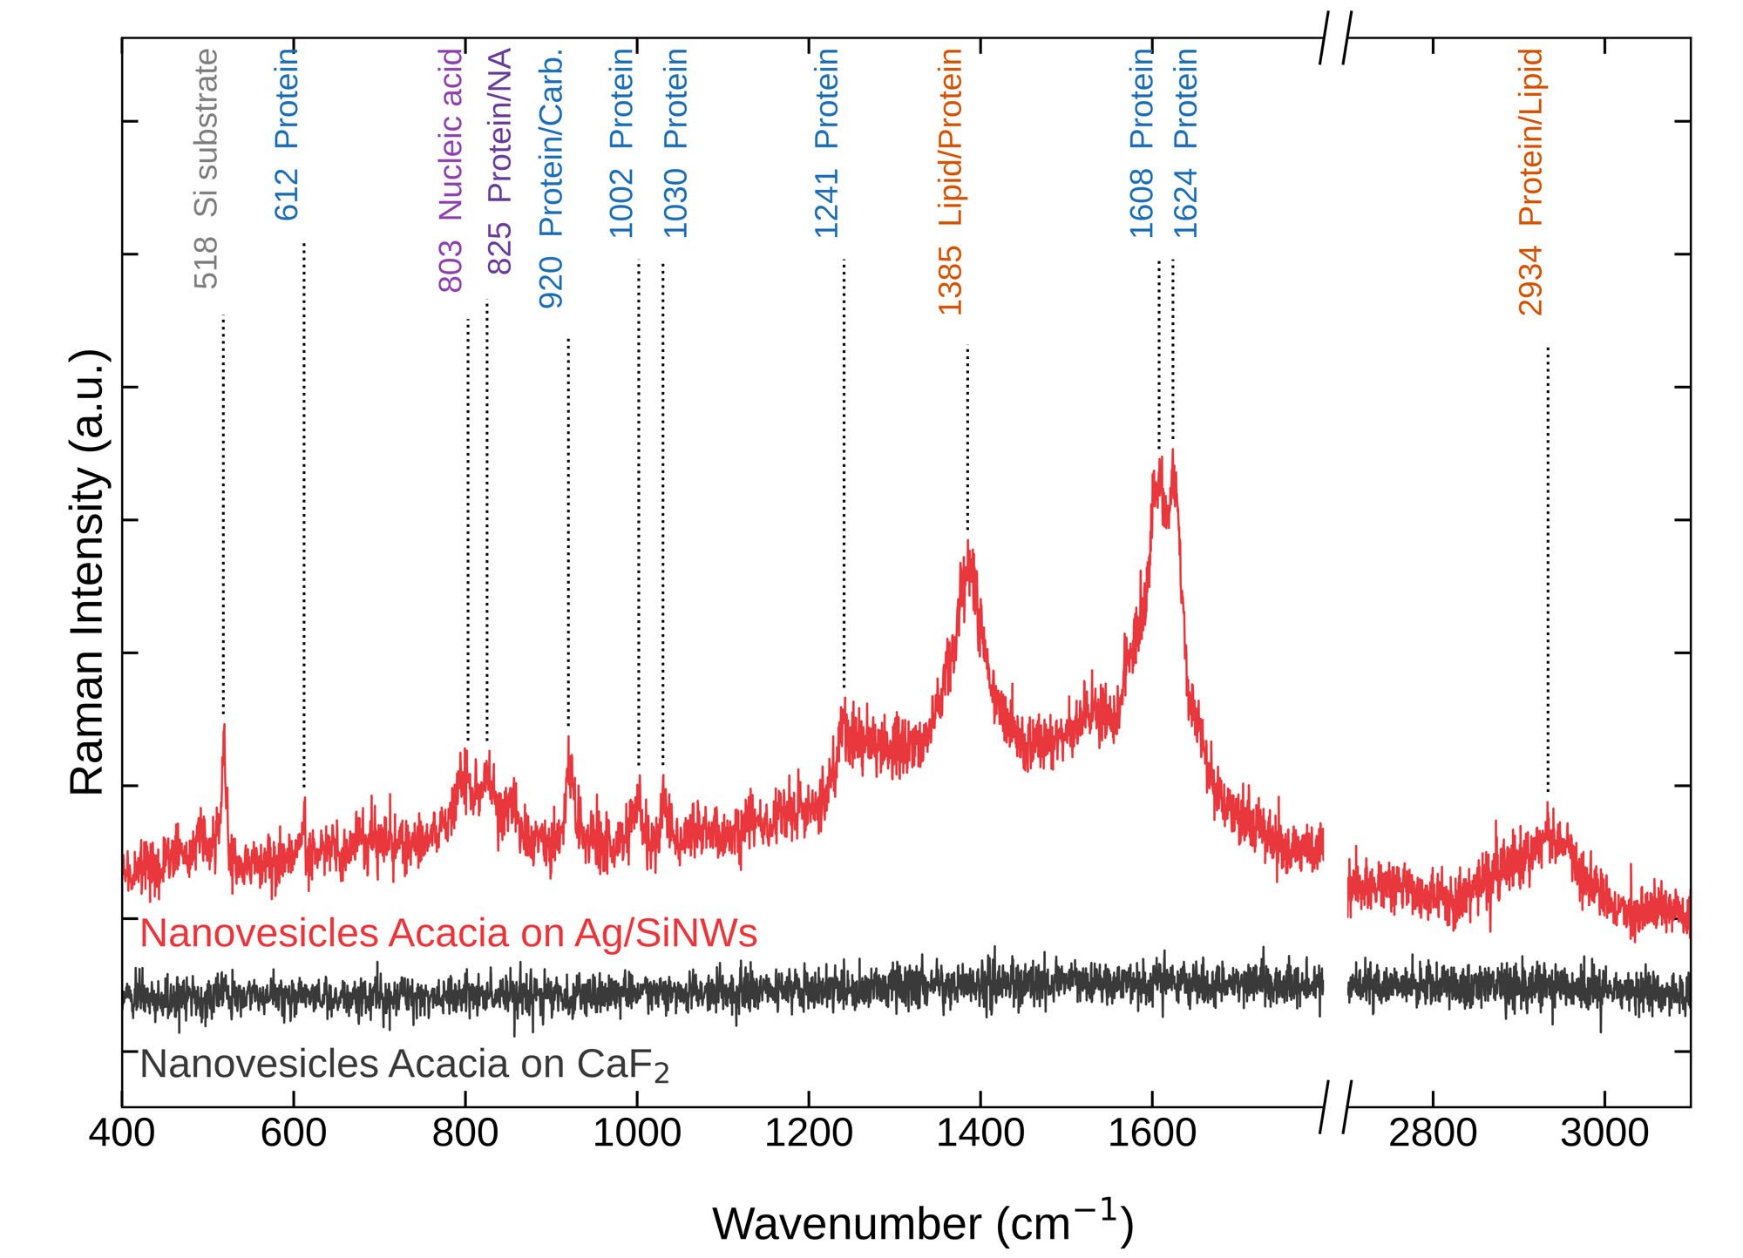
Figure 1b. Nanovesicles Acacia on CaF₂ (grey) and on Ag/SiNWs (red), raw single spectra with band positions and classes.

4. Mean spectra, peak shifts, band statistics and CH band fitting (Figure 2a-c, Table S1, Figure S2)

4.1 Mean ± SD spectra
For each group the mean of all 120 pre-processed spectra is plotted with ±1 standard deviation (sample SD, n - 1) shaded. The NV spectrum is shifted up for display. Each label is the maximum of the group mean spectrum near the band, refined by a parabola through the three highest points; in the CH region, shoulders were located as minima of the second derivative.
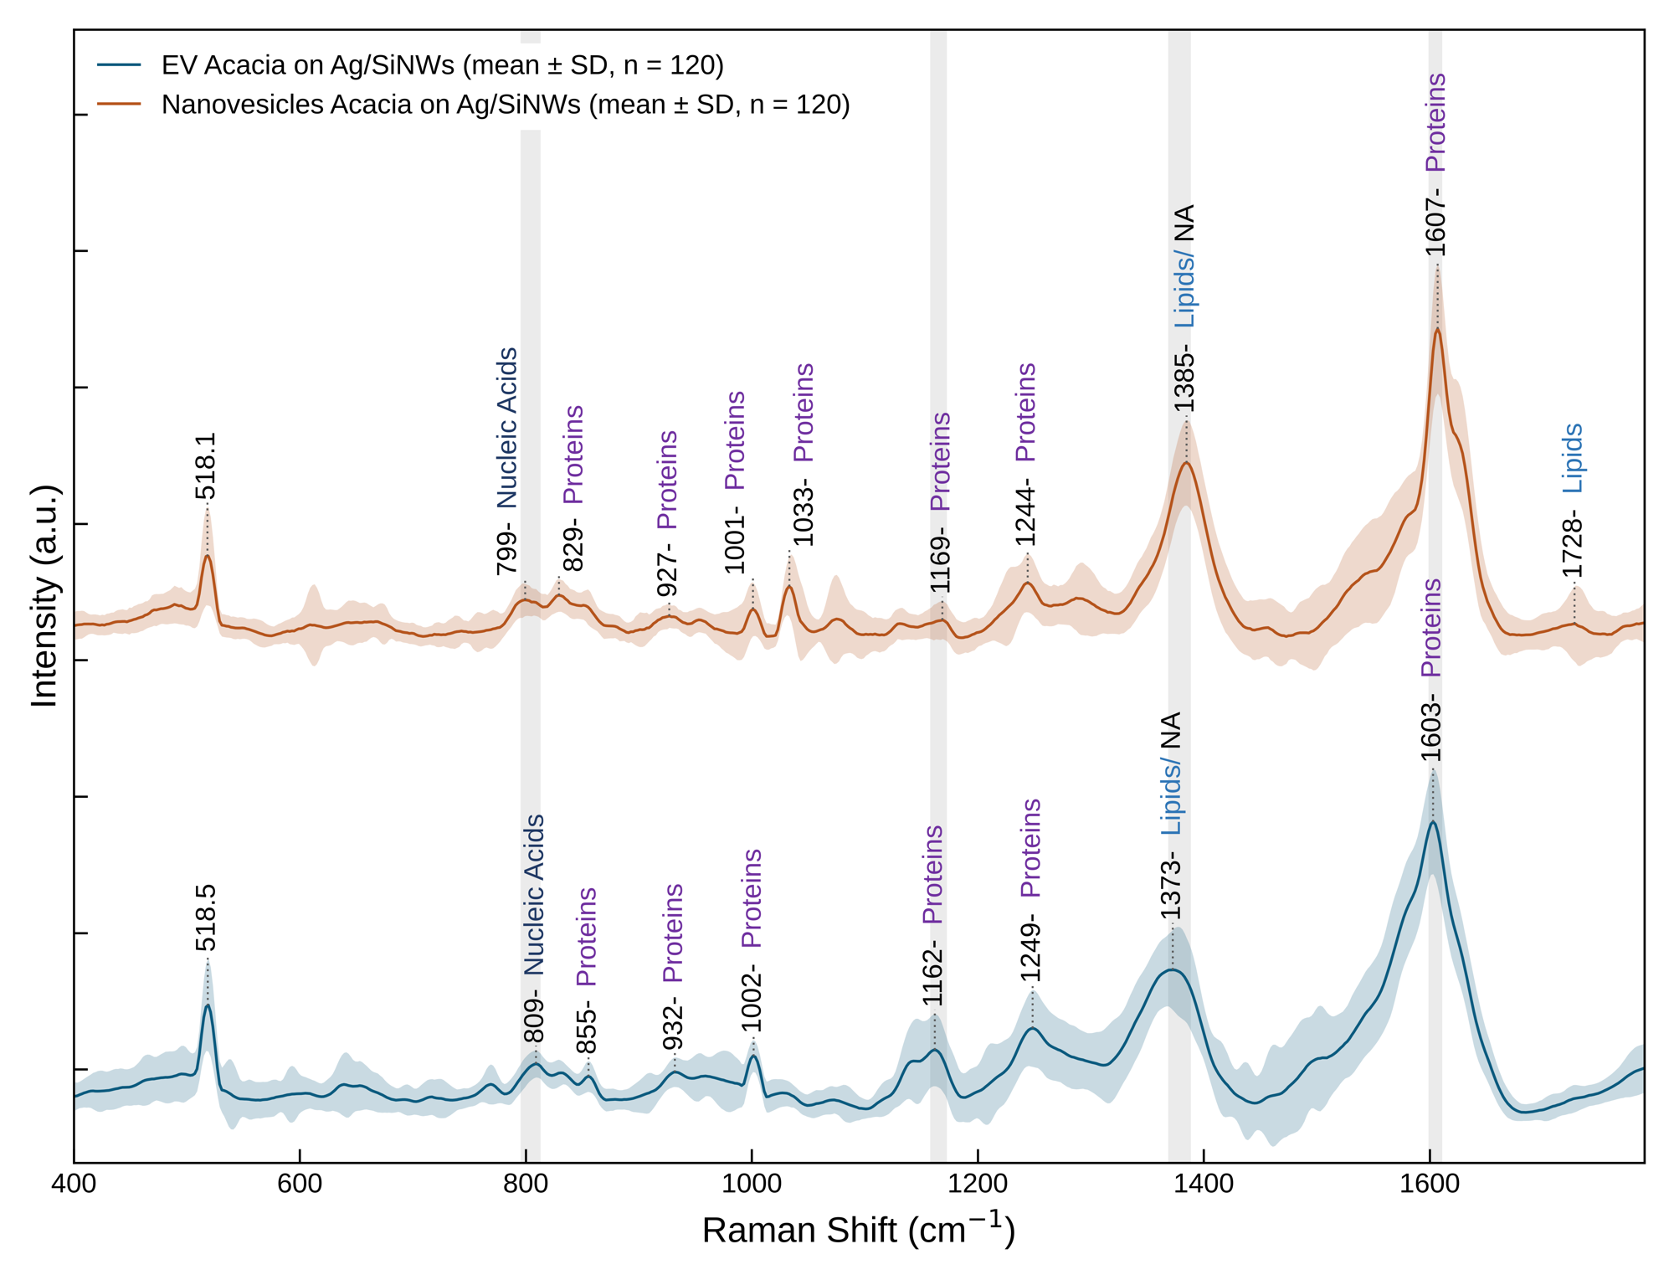
Figure 2a. Mean ± SD SERS spectra of EV Acacia and Nanovesicles Acacia on Ag/SiNWs, 400-1790 cm⁻¹ (n = 120 each). Grey shadows mark peak shifts that are consistent at all sites.
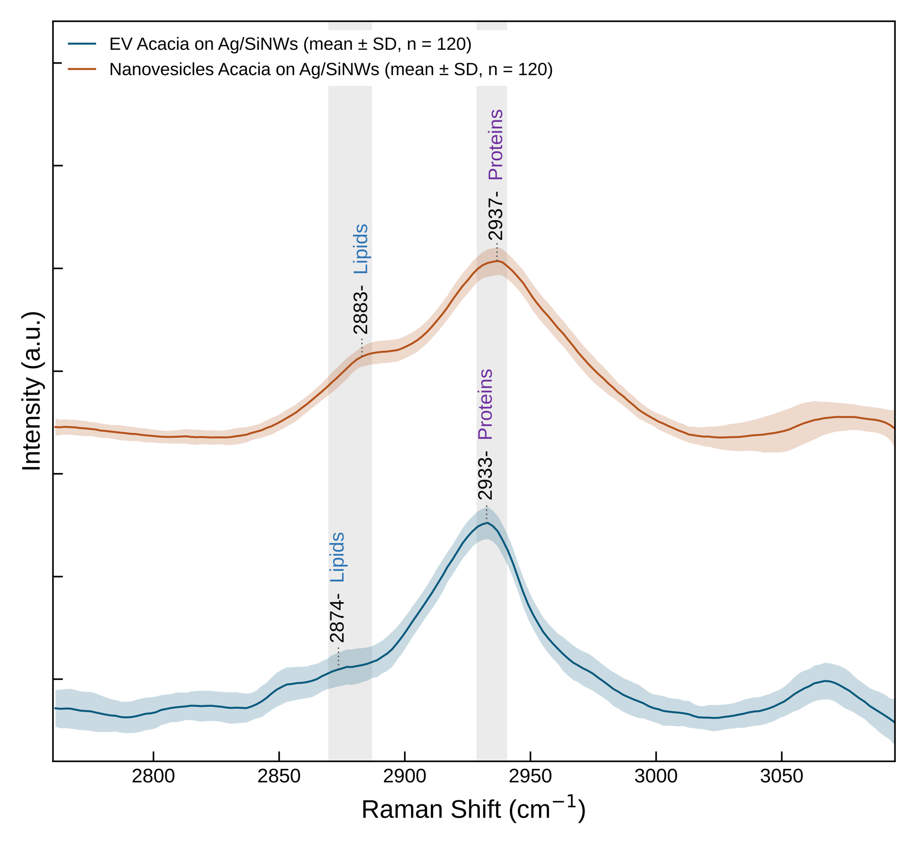
Figure 2b. Mean ± SD spectra in the CH-stretching region, 2760-3095 cm⁻¹. CH₂ lipid shoulder (located by the second derivative): 2874 cm⁻¹ (EVs, weak) and 2883 cm⁻¹ (NVs, stronger); main CH₃ band: 2933 vs 2937 cm⁻¹. Grey shadows: shifts consistent at all sites.
The CH₂ band (CH₂ asymmetric stretching, lipids) is present in both groups: the second derivative locates it in the mean spectrum and in every one of the 6 sites of each group (EVs 2871-2879, NVs 2880-2885 cm⁻¹). It is a weak shoulder at 2874 cm⁻¹ in EVs and a stronger shoulder at 2883 cm⁻¹ in NVs; the 9 cm⁻¹ shift is consistent at all sites (grey shadow), and the band is significantly stronger in NVs (Table S1, 2880 cm⁻¹ band, corrected p = 3.8 × 10⁻⁶).

4.2 Peak shifts
A shift between EVs and NVs was accepted as consistent only if the peak positions of the six EV site-mean spectra and of the six NV site-mean spectra do not overlap at all. The following shifts passed this test (all others are listed in Table S4 of the output):
Region | Method | EV (cm⁻¹) | NV (cm⁻¹) | Shift NV-EV | EV sites | NV sites
Fingerprint | maximum | 809.0 | 799.4 | -9.7 | 808.8-809.2 | 795.2-805.9
Fingerprint | maximum | 1161.8 | 1168.7 | 6.8 | 1157.0-1164.5 | 1165.1-1170.2
Fingerprint | maximum | 1372.6 | 1384.6 | 12.0 | 1359.2-1376.4 | 1383.3-1386.2
Fingerprint | maximum | 1603.0 | 1607.0 | 4.0 | 1598.3-1604.9 | 1606.5-1607.3
CH | shoulder | 2873.7 | 2883.0 | 9.4 | 2871.1-2878.5 (6/6) | 2879.5-2885.3 (6/6)
CH | maximum | 2932.6 | 2936.7 | 4.1 | 2931.2-2933.1 (6/6) | 2933.9-2937.5 (6/6)

Note on precision: the data have a point spacing of about 0.4-0.5 cm⁻¹; sharp bands are located to about ±1 cm⁻¹, broad bands (such as the EV band at 1373 cm⁻¹, which has a flat top) only to within a few cm⁻¹. The Si band (518.5 vs 518.1 cm⁻¹) shows that the two data sets are calibrated within about 0.5 cm⁻¹.

4.3 Band statistics (Table S1)
For 17 bands, the mean SNV intensity in a fixed interval was averaged per site (6 EV and 6 NV values) and compared with Welch's t-test; p-values were Bonferroni-corrected for the 17 tests. 11 of 17 bands differ significantly (corrected p < 0.05).
Band | Interval | EV mean ± SD | NV mean ± SD | Higher in | p (Bonferroni)
519 | 510-530 | 0.621 ± 0.125 | 0.461 ± 0.229 | EVs | 1.0
826 | 820-835 | -0.087 ± 0.105 | 0.131 ± 0.078 | NVs | 0.0443
855 | 850-862 | -0.178 ± 0.051 | -0.067 ± 0.084 | NVs | 0.399
1001 | 995-1008 | 0.108 ± 0.092 | -0.169 ± 0.112 | EVs | 0.0168
1031 | 1025-1040 | -0.461 ± 0.03 | 0.139 ± 0.109 | NVs | 0.000306
1160 | 1150-1175 | 0.209 ± 0.121 | -0.318 ± 0.026 | EVs | 0.00139
1245 | 1235-1255 | 0.631 ± 0.135 | 0.29 ± 0.159 | EVs | 0.0447
1380 | 1340-1420 | 1.126 ± 0.119 | 1.349 ± 0.056 | NVs | 0.0708
1520 | 1505-1535 | 0.407 ± 0.168 | 0.062 ± 0.187 | EVs | 0.126
1580 | 1570-1590 | 2.916 ± 0.149 | 1.588 ± 0.197 | EVs | 4.33e-06
1605 | 1598-1615 | 4.126 ± 0.487 | 4.487 ± 0.401 | NVs | 1.0
1725 | 1710-1735 | -0.58 ± 0.057 | -0.374 ± 0.165 | NVs | 0.458
2850 | 2840-2860 | -0.228 ± 0.087 | -0.482 ± 0.03 | EVs | 0.00798
2880 | 2870-2890 | 0.254 ± 0.056 | 0.634 ± 0.048 | NVs | 3.83e-06
2930 | 2920-2940 | 2.838 ± 0.061 | 2.436 ± 0.051 | EVs | 5.21e-06
2960 | 2950-2970 | 0.684 ± 0.049 | 1.396 ± 0.038 | NVs | 3.63e-09
3060 | 3050-3075 | -0.171 ± 0.057 | -0.489 ± 0.07 | EVs | 0.000127

4.4 Band fitting of the CH-stretching region (Figure 2c, Figure S2, Table S6)
How it was done. The mean spectrum of each group (2780-3095 cm⁻¹, after pre-processing) was described as a straight baseline plus five bands: I (~2850 cm⁻¹, CH₂ symmetric), II (~2880, CH₂ asymmetric, lipids), III (~2935, CH₃ symmetric), IV (~2965, CH₃ asymmetric) and V (~3065, aromatic =C-H). Each band had a free height, a position within ±12 cm⁻¹ and a width (FWHM) between 12 and 60 cm⁻¹; the parameters were found by non-linear least squares. The residual (data - fit) is shown above each panel in % of the band height.
Choice of line shape. Three line shapes were compared: Gaussian (G), Gaussian-Lorentzian sum (GL, pseudo-Voigt, one Lorentzian fraction fitted per spectrum) and Lorentzian (L). The comparison used the residual error and the Akaike and Bayesian information criteria (AIC, BIC; lower is better, and they penalise the extra parameter of GL):
Group | Line shape | R² | Max |residual| | AIC | BIC | Lorentzian fraction
EVs | Gaussian | 0.9973 | 3.8 % | -896.6 | -844.5 | 0.0
EVs | Gaussian-Lorentzian sum | 0.9978 | 2.9 % | -925.5 | -870.3 | 0.59
EVs | Lorentzian | 0.9977 | 3.0 % | -920.7 | -868.7 | 1.0
NVs | Gaussian | 0.9997 | 2.2 % | -1208.7 | -1156.6 | 0.0
NVs | Gaussian-Lorentzian sum | 0.9997 | 2.2 % | -1206.7 | -1151.6 | 0.0
NVs | Lorentzian | 0.9983 | 3.5 % | -959.1 | -907.1 | 1.0

The GL sum gives the best fit for EVs (AIC 29 lower than Gaussian, 5 lower than Lorentzian; Lorentzian fraction 0.59). For NVs the GL fit chooses a Lorentzian fraction of 0, i.e. it is identical to the Gaussian fit, which is the best fit for NVs (the Lorentzian fit is much worse, ΔAIC ≈ 150). Because GL contains both shapes and selects the mixture from the data, it is never worse than the better of the two and was used for the figure (Figure 2c); the comparison of all three line shapes is shown in Figure S2. Overlapping bands have no unique decomposition, so conclusions rest on what is the same for all line shapes.
Group | Line shape | Band II position | Band II FWHM | Band II area (%)
EVs | Gaussian | 2886.9 | 60.0 (limit) | 23.0
EVs | Gaussian-Lorentzian sum | 2880.8 | 60.0 (limit) | 15.9
EVs | Lorentzian | 2875.2 | 60.0 (limit) | 10.2
NVs | Gaussian | 2886.4 | 43.2 | 22.5
NVs | Gaussian-Lorentzian sum | 2886.4 | 43.2 | 22.5
NVs | Lorentzian | 2883.7 | 33.7 | 10.0

Result. In NVs, band II is a well-defined band at 2884-2886 cm⁻¹ with a width of 34-43 cm⁻¹ in all three fits (GL: 2886 cm⁻¹, 22.5 % of the CH band area). In EVs the fit also needs intensity at 2875-2887 cm⁻¹, but the five-band model cannot separate this weak shoulder from the main band, so it is absorbed into a broad component (width at the 60 cm⁻¹ limit). The second-derivative analysis, which is more sensitive to weak shoulders, does resolve it in EVs (2874 cm⁻¹, all 6 sites). Conclusion: the CH₂ band is present in both, weak in EVs and clearly stronger, sharper and shifted to higher wavenumber in NVs.
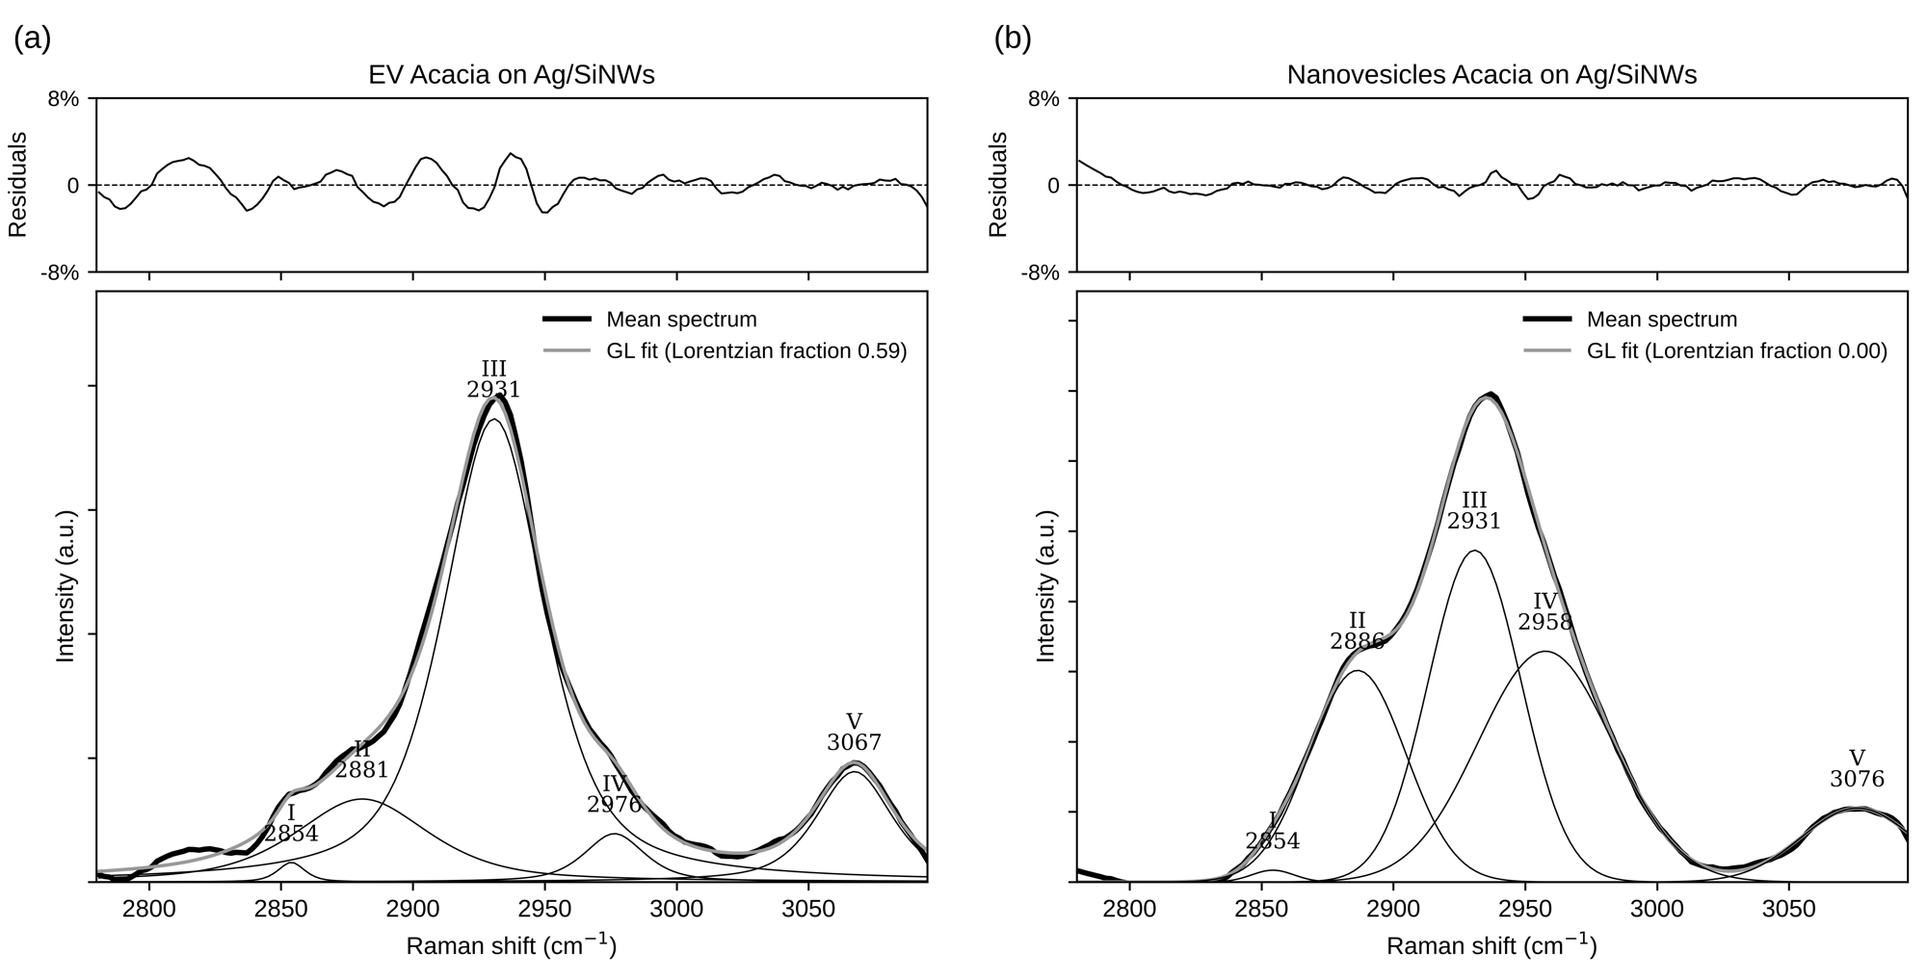
Figure 2c. Band fitting of the mean CH-stretching spectra with the Gaussian-Lorentzian sum: (a) EV Acacia, (b) Nanovesicles Acacia on Ag/SiNWs. Thick black: mean spectrum; grey: fit; thin: bands I-V with fitted positions (cm⁻¹); top: residuals in % of the band height.
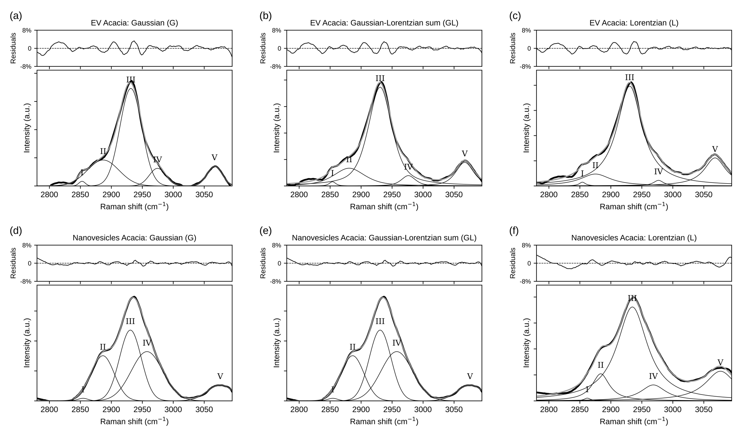
Figure S2. The same band fitting with Gaussian, Gaussian-Lorentzian sum and Lorentzian line shapes for EV Acacia (a-c) and Nanovesicles Acacia (d-f), showing that the conclusion on band II does not depend on the line shape.

5. Principal component analysis (Figure 3 a, c; Figure 4 a, b)
What PCA does. Each spectrum consists of hundreds of intensity values. PCA finds a small number of directions (principal components, PCs) along which the 240 spectra differ most. Every spectrum receives a score on each PC; the PCA score plot shows PC1 against PC2, one dot per spectrum. The percentage on each axis is the share of the total variance explained by that PC.
How it was applied. PCA (5 components, exact singular value decomposition, mean-centred) was fitted on all 240 SNV spectra of each region without the EV/NV labels. Because the sign of a PC is arbitrary, PC1 was oriented so that its loading is positive at 1580 cm⁻¹ (fingerprint) and 2960 cm⁻¹ (CH). Ellipses enclose 2 standard deviations of each group’s PC1/PC2 scores.
Region | Explained variance PC1-PC5 (%) | Sum (%)
Fingerprint (250-1790 cm⁻¹) | 16.8, 8.9, 5.8, 5.2, 4.3 | 41.0
CH-stretching (2760-3095 cm⁻¹) | 33.3, 14.0, 8.4, 5.9, 5.2 | 66.9

Result. Although PCA never used the labels, EVs and NVs lie on opposite sides of PC1 in both regions (fingerprint mean PC1 scores: EVs +4.76, NVs -4.76; CH: EVs -1.88, NVs +1.88). The largest natural difference in the data is therefore the EV/NV difference.
Loadings. A loading shows how strongly each wavenumber contributes to a PC. Bands with positive PC1 loading are relatively stronger in the group with positive PC1 scores. The difference spectrum (mean of the 6 NV site spectra minus mean of the 6 EV site spectra, ±2 standard errors from the site-to-site variation) gives the same bands independently:
Source | Region | Band (cm⁻¹) | Relatively stronger in
PC1 loading | Fingerprint | 1033 | NVs
PC1 loading | Fingerprint | 1159 | EVs
PC1 loading | Fingerprint | 1353 | EVs
PC1 loading | Fingerprint | 1389 | NVs
PC1 loading | Fingerprint | 1499 | EVs
PC1 loading | Fingerprint | 1587 | EVs
PC1 loading | Fingerprint | 1609 | NVs
PC1 loading | Fingerprint | 1629 | NVs
NV - EV difference | Fingerprint | 1033 | NVs
NV - EV difference | Fingerprint | 1161 | EVs
NV - EV difference | Fingerprint | 1355 | EVs
NV - EV difference | Fingerprint | 1391 | NVs
NV - EV difference | Fingerprint | 1497 | EVs
NV - EV difference | Fingerprint | 1589 | EVs
NV - EV difference | Fingerprint | 1609 | NVs
NV - EV difference | Fingerprint | 1629 | NVs
PC1 loading | CH | 2887 | NVs
PC1 loading | CH | 2925 | EVs
PC1 loading | CH | 2963 | NVs
PC1 loading | CH | 3063 | EVs
NV - EV difference | CH | 2885 | NVs
NV - EV difference | CH | 2925 | EVs
NV - EV difference | CH | 2957 | NVs
NV - EV difference | CH | 3067 | EVs

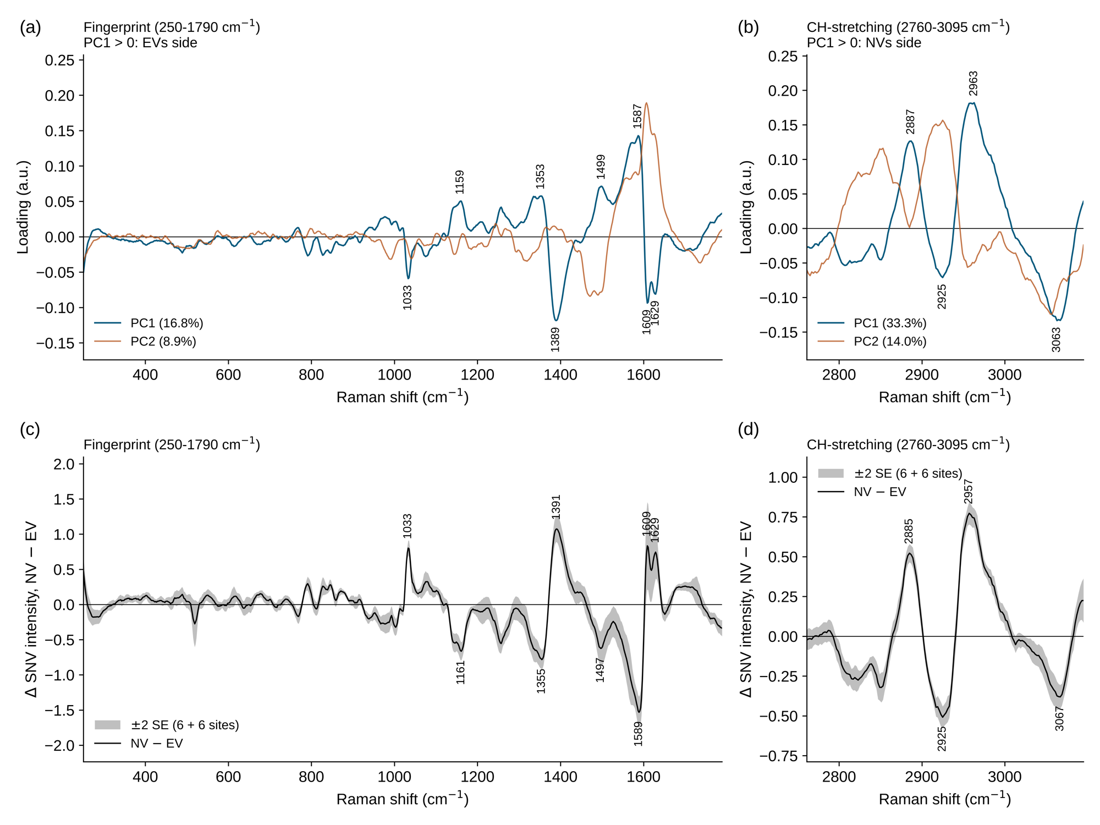
Figure 4. (a, b) PC1 and PC2 loadings; (c, d) difference spectrum NV - EV (site means) with ±2 SE. Positive = relatively stronger in NVs. After SNV, intensities are relative, not absolute amounts.

6. Classification models

6.1 PCA-LDA
Linear discriminant analysis (LDA, scikit-learn LinearDiscriminantAnalysis, default SVD solver, common covariance, priors equal to the class proportions) was applied to the first 5 PC scores of each spectrum. With two groups, LDA finds one direction, canonical variable 1, that separates EVs from NVs as well as possible (largest distance between group means relative to the spread within the groups). Using 5 PCs instead of all wavenumbers avoids fitting noise.
In Figure 3 b and d, LDA is fitted on all spectra to display the separation (NVs on the positive side). The difference between the 6 EV and 6 NV site means of canonical variable 1 was tested with Welch’s t-test (fingerprint p = 3.9 × 10⁻⁸; CH p = 2.3 × 10⁻¹¹). Because LDA was fitted on the same spectra, these p-values are descriptive; the classification performance is given by the cross-validation in section 7.
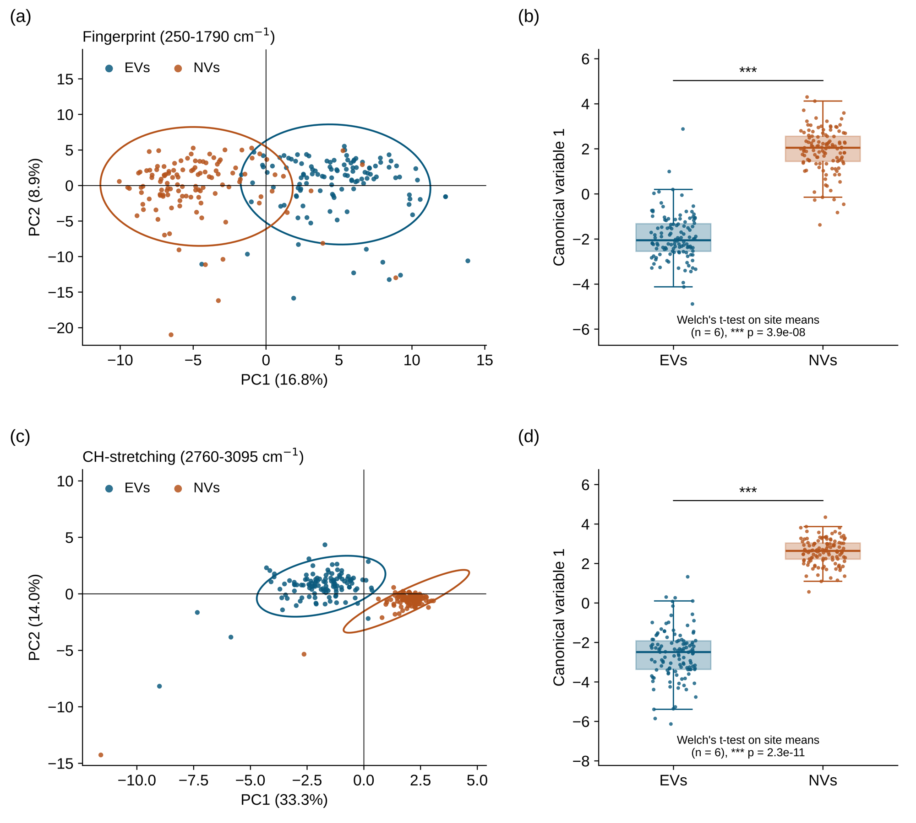
Figure 3. (a, c) PCA score plots with 2-SD ellipses; (b, d) canonical variable 1 of PCA-LDA (box: quartiles and median; whiskers: 1.5 × IQR; dots: individual spectra). p: Welch’s t-test on site means (n = 6).

6.2 PLS-DA
Partial least squares discriminant analysis works on all wavenumbers. The spectra were autoscaled (each wavenumber centred and divided by its SD, with the scaling learned on the training data only), and a PLS regression with 5 latent variables was fitted to the class code (0 = EV, 1 = NV). A predicted value above 0.5 is classified as NV. PLS-DA was used as a second, independent model: if both models give the same answer, the result does not depend on one method.

7. Validation

7.1 Site-grouped cross-validation (Figure 5, Table 1)
A model always performs well on the spectra it was trained on. The relevant question is whether it classifies spectra from sites it has never seen. Therefore:
- The 12 sites were split into 5 folds with StratifiedGroupKFold (shuffle, random_state = 0); all 20 spectra of a site always stay in the same fold, so no site is ever in training and test at the same time.
- The model was trained on 4 folds and predicted the spectra of the 5th fold; this was repeated 5 times so that every spectrum was predicted exactly once.
- For PCA-LDA, PCA (unsupervised, no labels) was computed on all spectra and LDA was trained on the training folds only; PLS-DA, including its scaling, was trained on the training folds only.
Fold | Test sites | Test spectra
1 | EVs-m2, EVs-m6, NVs-m1 | 60
2 | EVs-m1, NVs-m4, NVs-m6 | 60
3 | EVs-m5, NVs-m3 | 40
4 | EVs-m4, NVs-m5 | 40
5 | EVs-m3, NVs-m2 | 40

Sensitivity = NVs correctly classified as NV; specificity = EVs correctly classified as EV.
Region | Model | Accuracy (%) | Sensitivity (%) | Specificity (%) | EVs correct | NVs correct | Permutation p
Fingerprint | PCA-LDA | 95.4 | 95.0 | 95.8 | 115/120 | 114/120 | 0.0022
Fingerprint | PLS-DA | 95.4 | 95.0 | 95.8 | 115/120 | 114/120 | 0.0022
CH | PCA-LDA | 97.1 | 99.2 | 95.0 | 114/120 | 119/120 | 0.0022
CH | PLS-DA | 98.8 | 99.2 | 98.3 | 118/120 | 119/120 | 0.0022
Table 1. Cross-validated classification of sites not used for training.
Stricter check. PCA-LDA was repeated with PCA re-fitted inside every training fold (so that the test sites do not influence the PCA): 96.2% (fingerprint) and 96.7% (CH). The results are therefore not inflated by the pooled PCA.
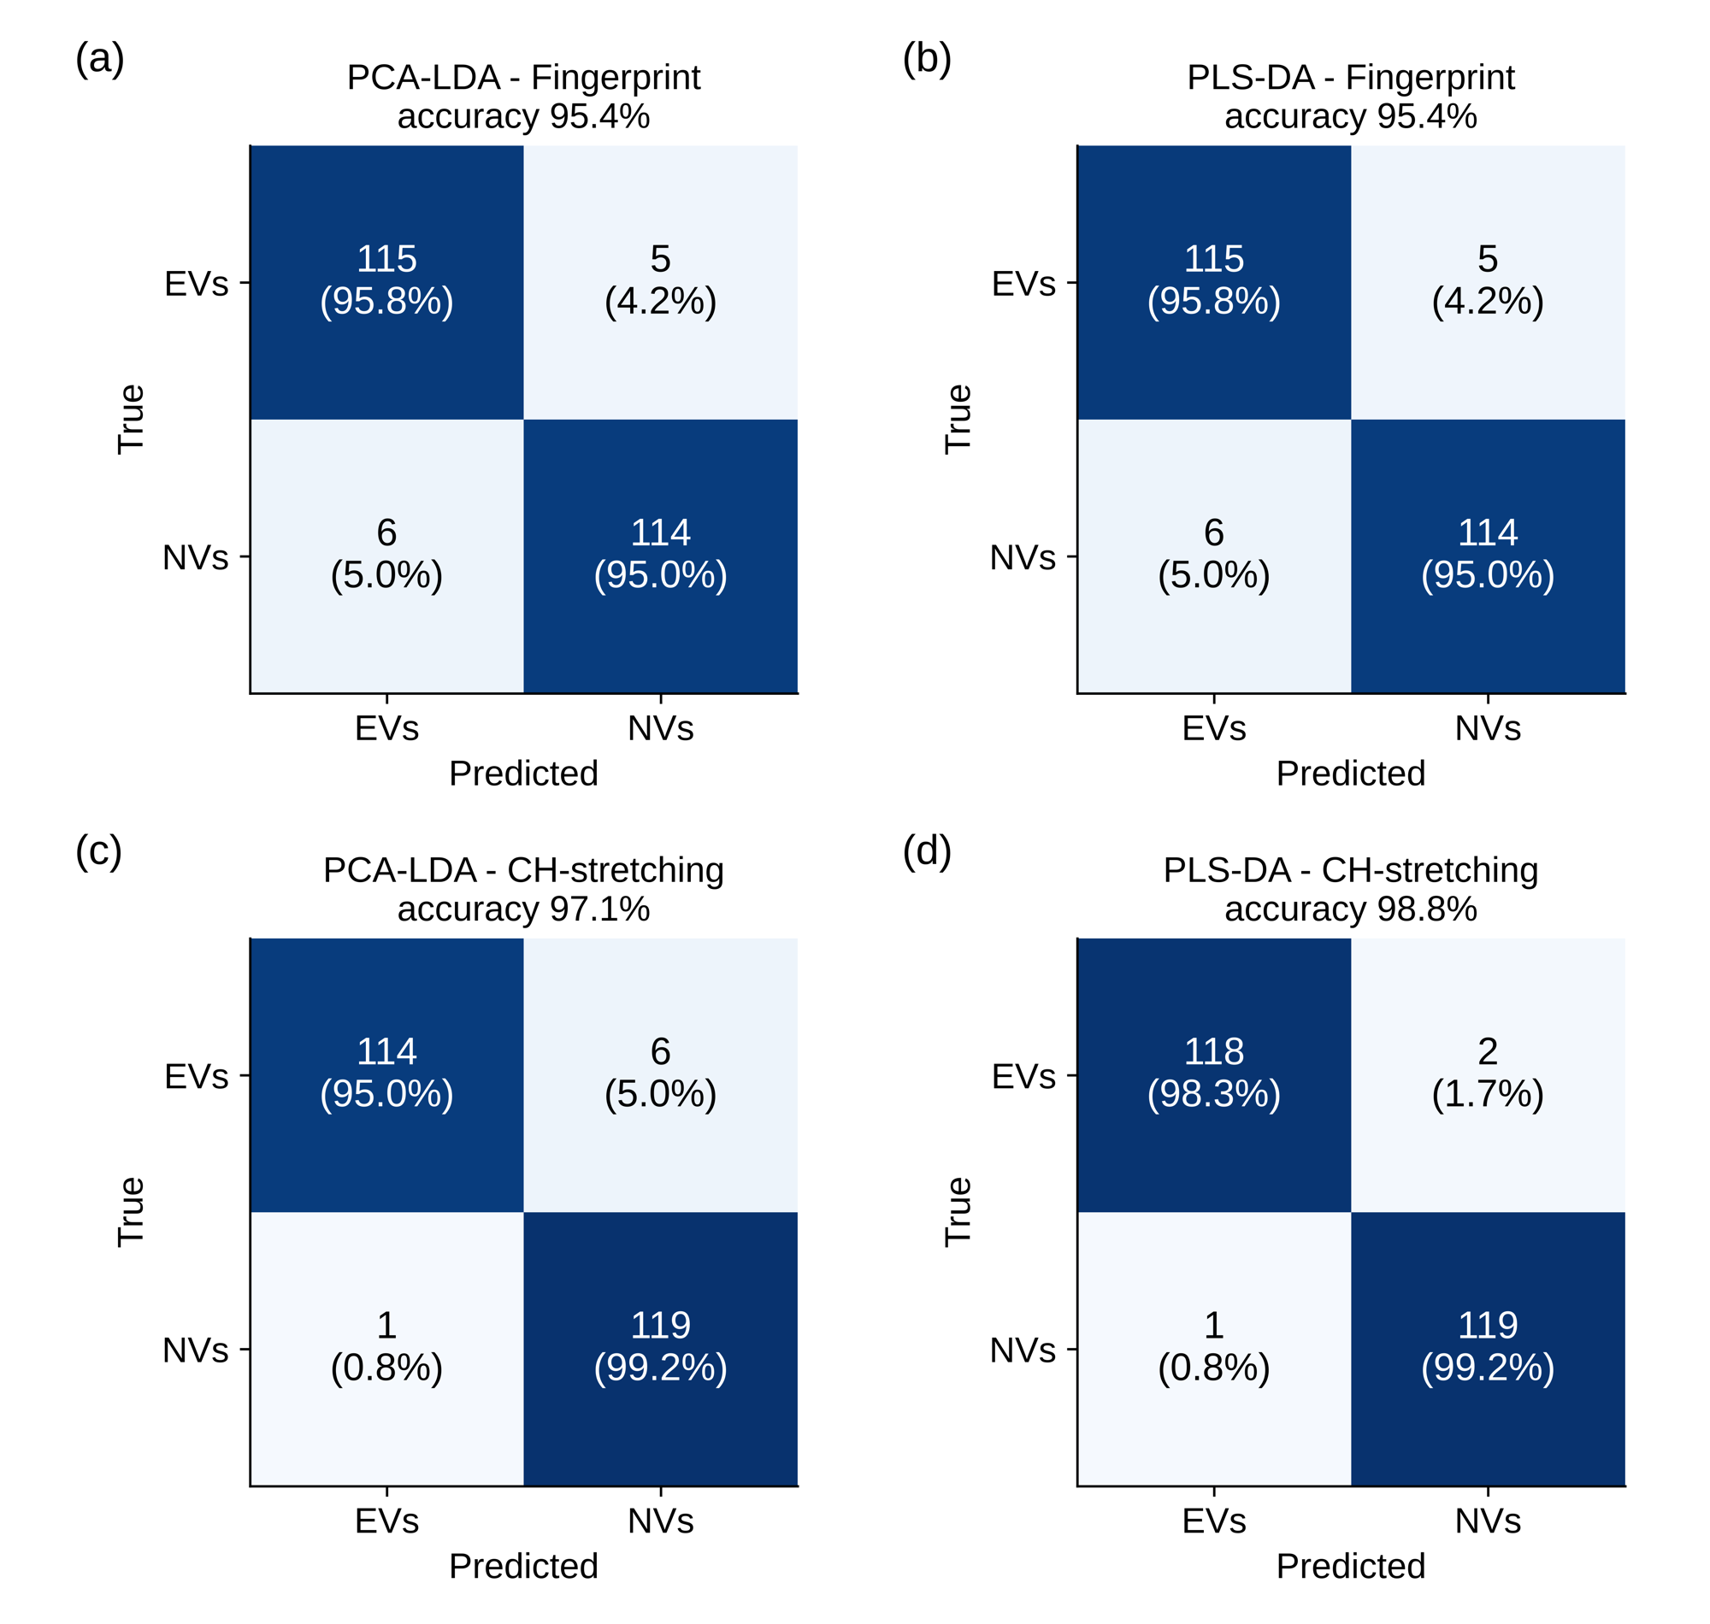
Figure 5. Cross-validated confusion matrices (rows: true group; columns: predicted group) for PCA-LDA and PLS-DA in both spectral regions.

7.2 Exact permutation (label-shuffling) test (Figure S1)
With only 12 sites, a high accuracy could in principle arise by chance. There are exactly 924 ways to call 6 of the 12 sites “EV” and the other 6 “NV”. For every one of them, the complete cross-validation was repeated. With wrong labels the median accuracy was about 50% (chance). Only the real labelling and its mirror image (EV and NV swapped, which gives the same accuracy) reached the real accuracy, so p = 2/924 = 0.0022 for every model and region. This is the smallest p-value that is possible with 6 + 6 sites.
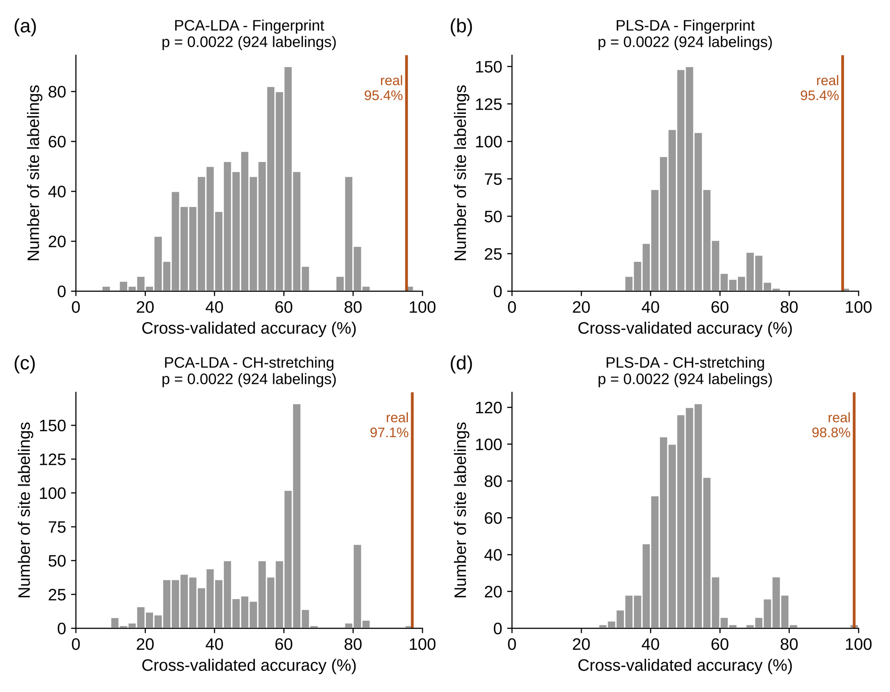
Figure S1. Cross-validated accuracies obtained with all 924 site labelings (grey) and the real accuracy (orange line).

8. Interpretation and limitations
What the analysis shows. EV and NV Acacia give reproducibly different SERS spectra on Ag/SiNWs. The difference is consistent at every measurement site, is visible without labels (PCA), is found by two independent models (PCA-LDA and PLS-DA, 95-99% accuracy on unseen sites), involves specific protein, lipid and nucleic-acid bands (loadings, difference spectrum, Table S1, peak shifts), and is far beyond chance (exact permutation p = 0.0022).
Limitations to state in the paper:
- The independent unit is the measurement site (6 per group), not the spectrum (240 in total).
- If all EV spectra come from one preparation and all NV spectra from another, preparation or measurement-session effects cannot be separated from EV-versus-NV biology. A second, independent preparation of each sample would address this.
- After SNV normalisation, band intensities are relative (composition), not absolute amounts.
- Canonical variable 1 in Figure 3 b, d is fitted on all spectra and is descriptive; classification performance is the cross-validation (Table 1, Figure 5).
- Two manuscript numbers should be updated to the values of the data: CH-region PC1/PC2 = 33.3/14.0% (draft: 33.6/13.8%) and CH-region PLS-DA accuracy = 98.8% (draft: 97.9%).

9. Methods text (ready to adapt)
Spectra were pre-processed in Python (numpy, scipy, scikit-learn). Each spectrum was despiked (modified z-score of first differences > 7), interpolated onto a 2 cm⁻¹ grid, smoothed (Savitzky-Golay, 11 points, 3rd order), baseline-corrected by asymmetric least squares (λ = 10⁵, p = 0.01, 10 iterations) and SNV-normalised, separately in the fingerprint (250-1790 cm⁻¹) and CH-stretching (2760-3095 cm⁻¹) regions. PCA (5 components) was computed on all spectra without class labels. Classification used PCA-LDA (LDA on the first 5 PC scores) and PLS-DA (autoscaled data, 5 latent variables, threshold 0.5). Performance was estimated by 5-fold cross-validation in which all spectra of a measurement site were kept in the same fold (StratifiedGroupKFold), so that every spectrum was predicted by a model that had not seen its site; accuracy, sensitivity (NV) and specificity (EV) are reported. Significance was assessed by an exact permutation test over all 924 assignments of the 12 sites to the two classes, repeating the full cross-validation for each. Band intensities were compared on site means (n = 6 per group) with Welch’s t-test and Bonferroni correction.

10. Code and output files
All results are produced by one script, Acacia_Paper_All.py (Word copy: Acacia_Paper_All_Code.docx). It reads the two Excel workbooks from C:\Users\Hira Aman\Downloads\CODE 005 (and the four single spectra from the folder “Single spectra” for Figure 1) and saves everything in CODE 005\PAPER:
File | Content
Fig1a, Fig1b | Single raw spectra, CaF₂ vs Ag/SiNWs (EV, NV)
Fig2a, Fig2b | Mean ± SD spectra, fingerprint and CH region
Fig3_PCA_LDA | PCA score plots and canonical variable 1
Fig4_Loadings_Difference | PC loadings and NV - EV difference spectra
Fig5_ConfusionMatrices | Cross-validated confusion matrices
FigS1_Permutation | Exact permutation test
Table1_Model_performance.csv | Accuracy, sensitivity, specificity, permutation p
TableS1_Band_statistics.csv | 17 bands, Welch on site means, Bonferroni
TableS2_Fold_results.csv | Result of every cross-validation fold
TableS3_Peak_positions.csv | All labelled peak positions
TableS4_Peak_shifts.csv | EV/NV peak positions per site and shifts
TableS5_Main_bands.csv | Main loading and difference bands
Fig2c_PeakFit_CH_GL | CH band fitting, Gaussian-Lorentzian sum (EV, NV)
FigS2_PeakFit_CH, TableS6_PeakFit_CH.csv | CH band fitting with 3 line shapes; fitted parameters, R2, AIC, BIC
Scores_fingerprint.csv, Scores_CH.csv | PC1-PC5 and canonical variable 1 of every spectrum
Model_details.txt | All settings and results
RESULTS_for_manuscript.txt | Results in words, numbers filled in

The calculations were verified independently: a separately written implementation (different Excel reader, banded ALS solver, numpy SVD, hand-written LDA and t-test) reproduced the pre-processed data (largest difference about 10⁻⁸), the PCA variances, the PCA-LDA predictions and the band t-tests, and the Word copy of the code reproduces every figure and table exactly.

