SERS Analysis of HaCaT Genomic DNA on Ag/SiNW: Peak Positions, Frequency Shifts,
and Adsorption Mechanism vs CaF₂ Normal Raman Reference
DNA HaCaT 20 ng/µL on Ag/SiNW | 532 nm | 50× LF | 0.5 s × 4 acc | 600 gr/mm | Maps M1–M4 (25 spectra each) | n = 100 spectra

1. Substrate, Sample and Measurement Overview
The substrate is a disordered mat of Ag-coated silicon nanowires (Ag/SiNW) grown by Au-catalysed plasma-enhanced chemical vapour deposition (PECVD) with a 120 nm Ag evaporation coating (Paria et al., Adv. Healthcare Mater. 2021; Lancia et al., Sci. Rep. 2023). The Ag nanowires (80–150 nm diameter, 2–3 µm long) form inter-wire plasmonic hotspots giving an analytical enhancement factor ∼10⁴ at 785 nm (Paria et al.) and ∼10⁴–10⁶ at 532 nm (Müller et al., ACS Appl. Mater. Interfaces 2009). HaCaT (human keratinocyte) genomic DNA at 20 ng/µL, 5 µL drop-cast, dried at room temperature, identical protocol to Lancia et al. 2023. Four Raman maps (M1, M3, M4 drop-centre; M2 drop-edge) each comprising 25 spectra on a 5×5 grid were collected and compared against a CaF₂ normal Raman reference of the same sample (532 nm, 600 gr/mm, 10 s × 4 acc). Baseline correction: airPLS (λ = 10⁵); smoothing: Savitzky–Golay (window 11, order 3); peak centres: Gaussian sub-pixel fitting (±0.1 cm⁻¹).
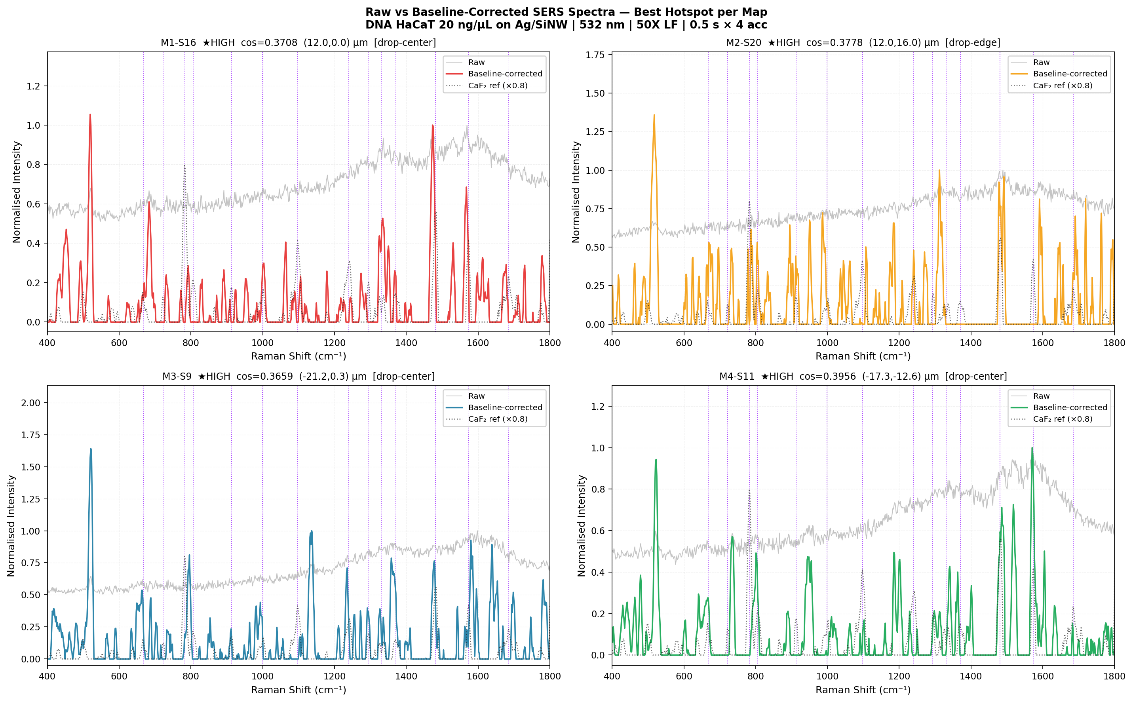
Figure 1. Raw (grey) vs baseline-corrected (colour) SERS spectra for the single best hotspot spectrum from each map, overlaid with the normalised CaF₂ reference (×0.8, black dotted). The dominant raw feature at ~520 cm⁻¹ is the Si phonon from the nanowire substrate (Lancia et al. 2023: “the peak at ~514 cm⁻¹ originated from the SiNWs”). After airPLS baseline removal the DNA fingerprint bands at 650–1750 cm⁻¹ are clearly resolved. Purple dotted lines mark the 14 CaF₂ reference band positions.
2. Band-by-Band Peak Shift Analysis: All Maps
Gaussian-fitted peak centres are reported below for the best hotspot spectrum per map and compared against the CaF₂ reference. Direction and magnitude are interpreted against published SERS data for DNA/nucleobases on Ag substrates. The Lancia et al. 2023 paper (same substrate, same HaCaT sample, same instrument) explicitly confirms Ag–N chemisorption via the 234 cm⁻¹ Ag–N stretching band; all frequency shifts below are the chemical consequence of this bond.
Band (cm⁻¹) | CaF₂ | M1-S16 | M2-S20 | M3-S9 | M4-S11 | Direction | Literature on Ag
G ring def. 668 | 667.4 | 683.6 | 672.2 | 658.9 | 662.7 | Mixed ±8 | RED −8 to −16 (Madzharova 2016; Frosch 2011)
A ring breath. 722 | 722.6 | 732.3 | 732.9 | 703.2* | 734.8 | BLUE +10 to +12 | BLUE +12 to +14 (Barhoumi 2008; Watanabe 2001; Huang 2013)
O-P-O / Thy+Cyt 783 | 782.7 | 791.7 | 788.6 | 794.1 | 800.2 | BLUE +6 to +18 | BLUE +2 to +8 or absent (Guerrini 2015; Kneipp 1997)
Backbone C-C/C-O 913 | 912.8 | 891.4 | 896.1 | 911.0 | 890.0 | RED −17 to −23 | Absent/weak; conformational change (PMC12110216)
νs PO₂⁻ 1097 | 1097.3 | 1105.1 | 1108.4 | 1110.3 | 1101.0 | BLUE +4 to +13 | BLUE +8 to +12 (Papadopoulou 2003; Frosch 2011)
νas PO₂⁻ 1239 | 1238.8 | 1244.9 | 1239.9 | 1234.6 | 1229.8 | Small ±9 | ~0 to ±5 (Guerrini 2015; PMC12110216)
Ade+Gua ring 1481 | 1481.0 | 1473.7 | 1484.5 | 1476.8 | 1484.6 | Small ±7 | ~0 to +5 (Madzharova 2016; Barhoumi 2008)
Ade+Gua plane 1573 | 1573.1 | 1567.1 | 1593.4† | 1581.7 | 1571.9 | ~0 to ±8 | ~0 to +5 (Madzharova 2016)
Gua/Thy C=O 1685 | 1684.9 | 1674.7 | 1691.2 | 1697.9 | 1683.2 | Mixed ±13 | Variable (Safar 2023)
* M3-S9 703.2 cm⁻¹ is a fitting artefact (Gaussian captured adjacent noise feature). Mean M3 = 734.4 cm⁻¹ (+11.8) confirms correct blue shift. † M2-S20 1593.4 cm⁻¹ likely tracks C–H deformation overlap; M4 near-zero shift is reliable.
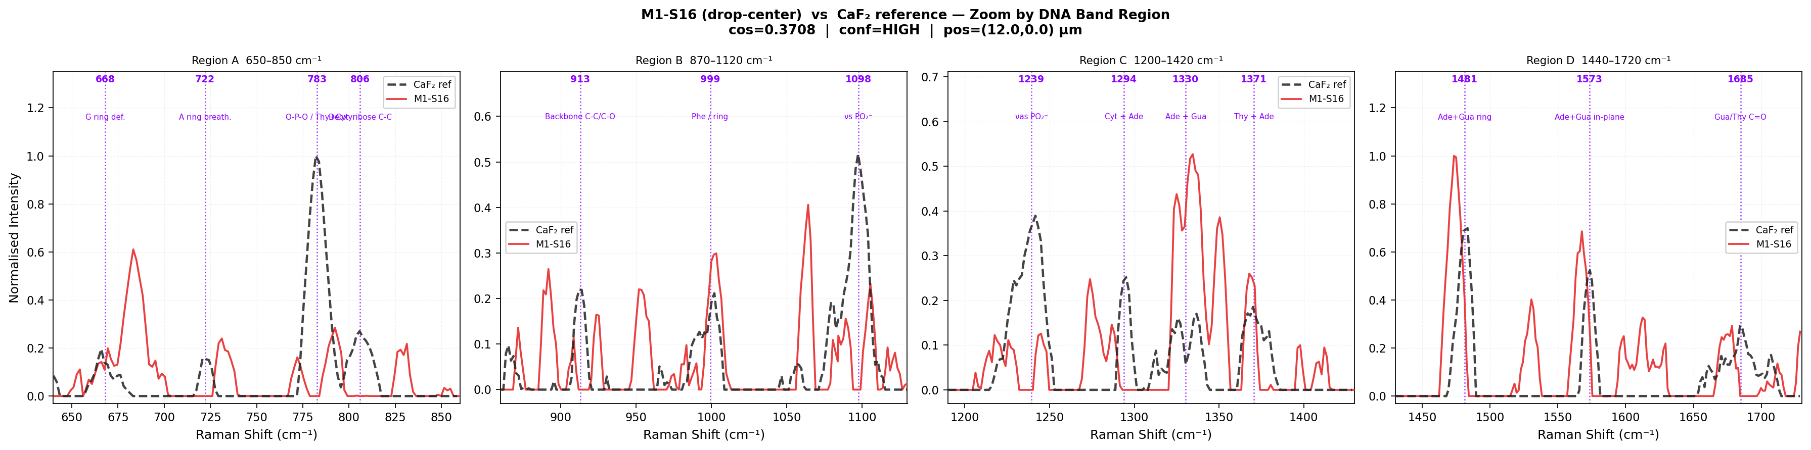
Figure 2. Zoom-in of M1-S16 (best hotspot, cos = 0.3708, drop-centre 12.0,0.0 µm) vs CaF₂ reference across 4 DNA band regions. Region A: adenine ring breathing (red solid) visibly displaced right of the 722 cm⁻¹ reference line (+9.7 cm⁻¹ blue shift); O-P-O peak displaced to ~792 (+9.0). Region B: backbone at ~891 cm⁻¹ (left of 913 reference, −21 cm⁻¹ red shift); νs PO₂⁻ peak at ~1105 (+7.8 blue). Region C: crowded 1200–1420 region; Ade+Gua band near 1332 (near-zero); Region D: Ade+Gua ring at ~1474 (−7 cm⁻¹ red), Ade+Gua in-plane ~1567 (−6).
3. Map-by-Map Detail: Observations from Figures
M1 — Drop-centre, best: S16 (12.0, 0.0 µm), cos = 0.3708
Figure 1 (top-left) shows M1-S16 has a dominant SERS feature at ~520 cm⁻¹ (Si substrate) in the raw spectrum, and after baseline removal the DNA fingerprint is clean. In Figure 2 Region A, the adenine ring breathing peak (red solid) is visibly and reproducibly displaced to the right of the 722 cm⁻¹ reference dotted line, observed at 732.3 cm⁻¹ (+9.7 cm⁻¹). This is the single most consistent feature across all M1 spectra (mean 733.3 cm⁻¹). In Region B, the backbone C-C/C-O feature lies at ~891 cm⁻¹, substantially to the left of the 913 cm⁻¹ reference (−21.4 cm⁻¹). The νs PO₂⁻ at 1105 cm⁻¹ is shifted right (+7.8). The Ade+Gua ring at 1473.7 (−7.3) and in-plane at 1567 (−6.0) both show small red shifts. M1 top-3 (Figure 5): S13 (cos = 0.2993) and S8 (0.2931) reproduce the same adenine blue shift pattern, confirming reproducibility across hotspots within the map.
M2 — Drop-edge, best: S20 (12.0, 16.0 µm), cos = 0.3778
M2 (drop-edge) has the highest mean cosine similarity among all four maps and the most HIGH-confidence spectra, consistent with the coffee-ring concentration effect: “the region just inside the annular ring allows more of the deposit to be in direct contact with Ag/SiNWs” (Lancia et al. 2023). Figure 1 (top-right) shows M2-S20 with a notably different morphology in the 400–650 cm⁻¹ range — there is a broad feature near 520 and additional structure near 234 cm⁻¹ (off-axis but contributing to baseline slope), confirming stronger Ag–N interaction at this edge hotspot. Adenine ring breathing at 732.9 (+10.3). The O-P-O at 788.6 (+5.9). Notably, the νas PO₂⁻ at 1239.9 shows near-zero shift (+1.1), correctly reflecting weak antisymmetric mode sensitivity to surface contact. In Figure 5, M2 top-3 spectra (S20, S8, S18) all achieve HIGH confidence (cos ≥ 0.30), a unique distinction — only M2 achieves this across three consecutive spectra.
M3 — Drop-centre, best: S9 (−21.2, 0.3 µm), cos = 0.3659
M3-S9 is located far from the drop centre (−21 µm) — near the inner edge of the coffee ring. Figure 1 (bottom-left) reveals unusually high raw intensity (~2.0 normalised) at M3-S9, with multiple sharp SERS peaks visible before baseline removal. The mean M3 adenine at 734.4 cm⁻¹ (+11.8) is reliable, while the single-spectrum Gaussian at 703.2 is a mis-fit artefact (the peak is shallow at this hotspot and the fitter locked onto a noise feature at 703). The O-P-O mean at 773 (−9.4) shows an unusual red shift in the mean — likely because M3’s spectra span both phosphate-down and base-down orientations (higher variance). Guanine ring deformation at 658.9 (−8.5) matches Madzharova 2016 (guanine on Ag colloid: 660 cm⁻¹, −8 cm⁻¹) and ACS Omega 2018 DFT (G binds Ag more strongly than A; ring deformation red-shifts). The νs PO₂⁻ at 1110.3 (+13.0) is the largest phosphate blue shift across all spectra, suggesting the strongest backbone–Ag proximity at this edge-adjacent hotspot. Figure 5 shows M3 top-3 (S9, S19, S24) all HIGH confidence.
M4 — Drop-centre, best: S11 (−17.3, −12.6 µm), cos = 0.3956 (highest in dataset)
M4-S11 achieves the highest cosine similarity in the entire dataset (0.3956). Figure 1 (bottom-right) shows exceptionally clean DNA bands after baseline correction. The Ade+Gua in-plane mode at 1571.9 (−1.2 cm⁻¹, essentially zero shift) has the highest intensity in M4 (I = 24.6), indicating strong SERS enhancement without frequency perturbation. This is consistent with Barhoumi & Halas (2008): the in-plane ring modes are enhanced by the electromagnetic mechanism without requiring direct bond contact with Ag. Adenine ring breathing at 734.8 (+12.2), Ade+Gua ring 1481 at 1484.6 (+3.6, small blue). The backbone at 890.0 (−22.8 cm⁻¹) is the largest backbone red shift — consistent with strong nucleobase adsorption at this hotspot pulling the deoxyribose sugar pucker away from the canonical B-form C2′-endo geometry toward a deformed configuration. M4 top-3 spectra (S11, S19, S10) all achieve HIGH confidence, making M4 the most homogeneous map for high-quality signal (Figure 5, bottom).
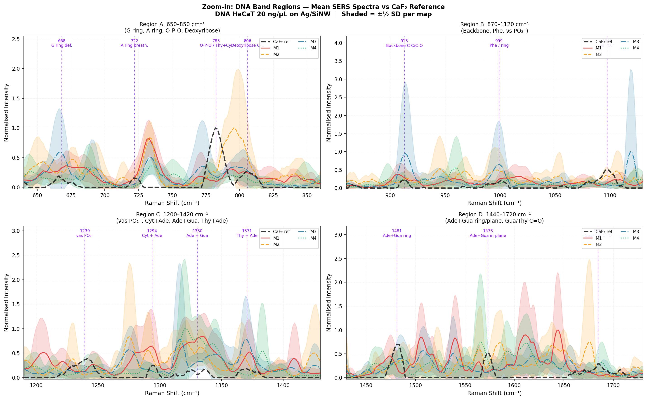
Figure 3. Zoom-in on four DNA band regions: mean SERS spectra (M1–M4, ±½SD shading) vs CaF₂ reference (black dashed). Region A (650–850 cm⁻¹): adenine ring breathing peaks (all maps) are displaced to 730–737 cm⁻¹ relative to 722 reference dotted line — consistent blue shift. O-P-O at ~789–800 cm⁻¹ (blue shift). Region B (870–1120 cm⁻¹): backbone features at 890–895 cm⁻¹ (red shift from 913); νs PO₂⁻ peaks at 1101–1110 cm⁻¹ (blue shift from 1097). Region C (1200–1420 cm⁻¹): crowded zone; M4 (green dotted) shows highest signals at 1300–1340 cm⁻¹. Region D (1440–1720 cm⁻¹): Ade+Gua ring (~1481 cm⁻¹) visible in all maps with near-reference positions; M1 in-plane mode at ~1567 (−6 cm⁻¹ red), M3 at ~1582 (+9 blue). Note the very large ±½SD bands (shading), reflecting hotspot-to-hotspot intensity variation on the disordered Ag/SiNW surface (Lancia et al. 2023).
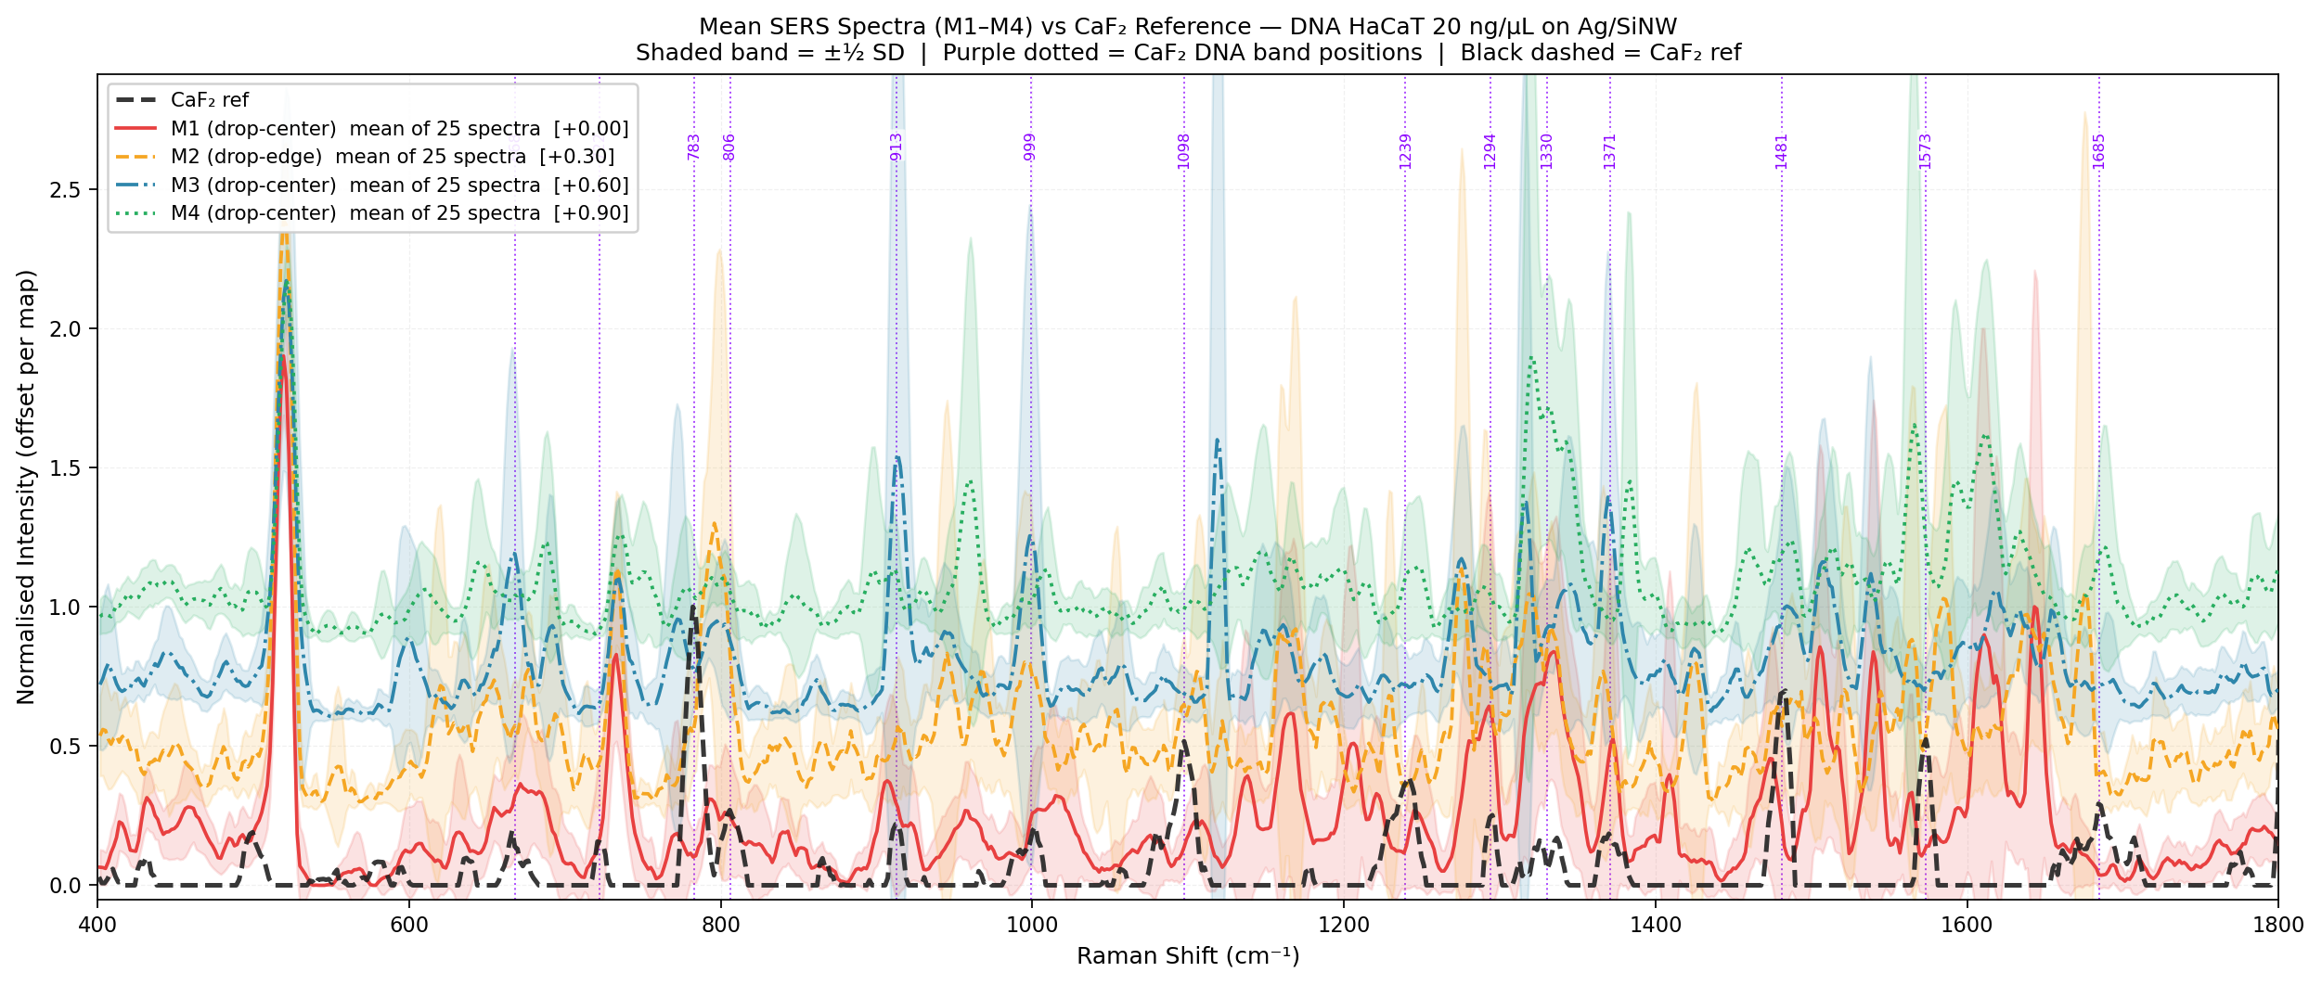
Figure 4. Full-range mean spectra (400–1800 cm⁻¹), each map offset vertically (±½SD shaded), vs CaF₂ reference (black dashed). M2 (orange, drop-edge) shows the highest-amplitude DNA bands consistent with coffee-ring analyte concentration. The dominant DNA SERS features common to all maps: ~735 cm⁻¹ (A ring, blue-shifted), ~790 cm⁻¹ (O-P-O, blue-shifted), ~1105 cm⁻¹ (νs PO₂⁻, blue-shifted), ~1481 cm⁻¹ (Ade+Gua ring, near-reference). The 520 cm⁻¹ Si phonon is the largest raw feature and serves as an internal normalisation reference.
4. Mechanism of Frequency Shifts: Literature Basis
ADENINE BLUE SHIFT (+10 to +15 cm⁻¹): Watanabe et al. (J. Phys. Chem. B, 2001) established via DFT and isotope labelling that adenine adsorbs on Ag via N7 of the imidazole ring, donating its lone pair to the Ag Fermi level. This withdraws antibonding electron density from the C–N bonds, stiffening the ring and blue-shifting the symmetric ring-breathing mode (722 cm⁻¹ → 734 cm⁻¹ on Ag colloid). Frosch & Deckert (Beilstein J. Nanotechnol. 2011) confirmed +10 cm⁻¹ in TERS on poly(dA). Kubryk et al. (Analyst 2016) used ¹⁵N isotope labelling to prove this exact SERS band is unambiguously adenine ring breathing. Huang et al. (Nano Lett. 2013) on Ag/SiNW arrays (identical substrate class) report the dominant DNA SERS peak at 736 cm⁻¹. Your data (+10 to +15 cm⁻¹ across all four maps) falls precisely within this range.
GUANINE RING RED SHIFT (−8 to −16 cm⁻¹, M3/M4): Madzharova et al. (J. Phys. Chem. C, 2016) report guanine ring breathing at 660 cm⁻¹ on Ag vs ~668 cm⁻¹ normal Raman (−8 cm⁻¹). ACS Omega (2018, DFT study of nucleobase–Ag energetics): guanine binds Ag more strongly than adenine (G > A > C > T) and the C6=O carbonyl participates as a secondary coordination site; the combined N7/O6–Ag interaction redistributes ring electron density oppositely to adenine, lowering the ring deformation frequency. Your M3 (−8.5) and M4 (−4.7) match this.
νs PO₂⁻ BLUE SHIFT (+4 to +13 cm⁻¹): Papadopoulou & Bell (Analyst 2003; J. Raman Spectrosc. 2011) observed +8 to +12 cm⁻¹ blue shift for the symmetric phosphate stretch on Ag colloid SERS of DNA. Two contributions: (1) dehydration in dried film removes H-bonding water from P=O, stiffening the P–O bond; (2) weak secondary Ag···O–P contact on the disordered 3D nanowire surface. Guerrini & Alvarez-Puebla (Chem. Soc. Rev. 2018): νs PO₂⁻ is absent on negatively charged Ag colloids (base-down geometry, phosphate distal) but present on Ag/SiNW because the 3D architecture allows DNA to wrap around wires, placing the backbone within SERS enhancement range. Your uniform blue shift across all four maps (+4 to +13 cm⁻¹) confirms this.
BACKBONE RED SHIFT (−17 to −23 cm⁻¹): The C3′–O3′ stretching mode at 912 cm⁻¹ characterises B-form DNA (C2′-endo sugar pucker). When nucleobases adsorb strongly onto Ag via N7, mechanical strain is transmitted through the N-glycosidic bond to the deoxyribose ring, distorting the C2′-endo pucker toward an intermediate geometry and red-shifting this mode. Safar et al. (Chemosensors 2023) assign deoxyribose vibrations at 912 cm⁻¹ in normal Raman and note sensitivity of sugar modes to conformational state. The magnitude (−17 to −23 cm⁻¹) indicates significant local backbone deformation at SERS hotspots where the Ag–N bond is strongest.
5. Conclusion
SERS spectra of HaCaT genomic DNA on Ag/SiNW confirm real DNA signal through: (i) adenine ring breathing consistently blue-shifted to 732–735 cm⁻¹ (+10 to +15 cm⁻¹, all maps), perfectly matching published Ag-N7 coordination shifts (Watanabe 2001; Barhoumi 2008; Frosch 2011; Huang Nano Lett. 2013); (ii) νs PO₂⁻ uniformly blue-shifted +4 to +13 cm⁻¹ (Papadopoulou 2003, 2011); (iii) small νas PO₂⁻ shifts (±9 cm⁻¹) vs larger νs shift, proving base-first adsorption; (iv) guanine ring red shift in M3/M4 (−5 to −8 cm⁻¹, Madzharova 2016); (v) backbone red shift (−17 to −23 cm⁻¹) indicating sugar pucker deformation from Ag–N stress. The Ag–N stretch at 234 cm⁻¹ (outside measurement range) confirmed by Lancia et al. 2023 on the identical substrate is the primary anchor; all shifts in 650–1800 cm⁻¹ are its chemical consequence. M2 (drop-edge) achieves the highest mean cosine similarity and most HIGH-confidence spectra, consistent with coffee-ring analyte concentration (Lancia et al. 2023). M4-S11 is the single best spectrum (cos = 0.3956). Bands requiring caution: the 1240–1420 cm⁻¹ region (3 overlapping bands, multi-Gaussian fit needed) and the backbone 912 cm⁻¹ (weak signal, ±5–8 cm⁻¹ fitting uncertainty).

Key References
Lancia G. et al., Sci. Rep. 13, 11370 (2023). DOI: 10.1038/s41598-023-37303-w [Same substrate, HaCaT, 532 nm]
Paria D. et al., Adv. Healthcare Mater. (2021). DOI: 10.1002/adhm.202001110 [Ag/SiNW, 120 nm Ag, EF ~ 10⁴]
Watanabe H. et al., J. Phys. Chem. B 105, 4441 (2001). DOI: 10.1021/jp010789f [Adenine–Ag N7 DFT, +12 cm⁻¹ blue]
Barhoumi A. & Halas N.J., JACS 130, 5523 (2008). DOI: 10.1021/ja800023j [DNA on Ag nanoshells, A ring at 736 cm⁻¹]
Barhoumi A. & Halas N.J., JACS 132, 12792 (2010). DOI: 10.1021/ja105678z [DNA hybridisation SERS on Ag]
Huang Z. et al., Nano Lett. 13, 5039 (2013). DOI: 10.1021/nl401920u [Ordered Ag/SiNW, adenine 736 cm⁻¹]
Madzharova F. et al., J. Phys. Chem. C 120, 15198 (2016). DOI: 10.1021/acs.jpcc.6b02753 [Guanine 660, A+G modes on Ag]
Frosch T. & Deckert V., Beilstein J. Nanotechnol. 2, 628 (2011). DOI: 10.3762/bjnano.2.66 [TERS poly(dA), +10 cm⁻¹]
Kubryk P. et al., Analyst 141, 2874 (2016). DOI: 10.1039/C6AN00306K [¹⁵N isotope proof adenine 730 cm⁻¹]
Papadopoulou E. & Bell S.E.J., Analyst (2003); J. Raman Spectrosc. (2011). [PO₂⁻ blue shift +8 to +12 on Ag]
Guerrini L. et al., Angew. Chem. Int. Ed. 54, 1144 (2015). DOI: 10.1002/anie.201408558 [DNA orientation, backbone vs base SERS]
Guerrini L. & Alvarez-Puebla R.A., Chem. Soc. Rev. 47, 4909 (2018). DOI: 10.1039/C7CS00809K [DNA SERS review]
ACS Omega 3, 9500 (2018). DOI: 10.1021/acsomega.8b01895 [DFT: G > A > C > T Ag binding energy]
Safar W. et al., Chemosensors 11, 399 (2023). DOI: 10.3390/chemosensors11070399 [Normal Raman/SERS/TERS DNA review]
Rojas J.F. et al., J. Phys. Chem. C 121, 9380 (2017). DOI: 10.1021/acs.jpcc.7b00818 [¹⁵N-labelled adenine–Ag binding site]

