Raman and SERS characterisation of
EV Acacia and EV nano Acacia
Plant extracellular vesicles vs plant-derived nanovesicles: background, experimental conditions and data interpretation
Spontaneous Raman on CaF₂ and SERS on silver-decorated silicon nanowires (AgSiNW), 532 nm
All spectral results are from raw data (no smoothing, no baseline correction)
September 2026

Contents
Summary
1. Background
1.1 Plant extracellular vesicles vs plant-derived nanovesicles
1.2 Where they are used
1.3 Acacia as a source
1.4 Why this work was done
2. Experimental conditions
2.1 Data processing
3. Results
3.1 EV Acacia: CaF₂ vs AgSiNW
3.2 EV nano Acacia: CaF₂ vs AgSiNW
3.3 EV Acacia vs EV nano Acacia on CaF₂
3.4 EV Acacia vs EV nano Acacia on AgSiNW
4. Interpretation
4.1 The two preparations are chemically different
4.2 Why the CaF₂ bands (1456, 1726 cm⁻¹) are missing on AgSiNW
4.3 What this means for possible uses
5. Limitations
6. Recommendations
References

Summary
Two vesicle preparations called EV Acacia and EV nano Acacia were received from another laboratory. The isolation protocol, plant species and plant organ were not provided. They were measured by spontaneous Raman spectroscopy on CaF₂ and by surface-enhanced Raman spectroscopy (SERS) on AgSiNW substrates. The main findings are:
- EV Acacia on CaF₂ gives a reproducible fingerprint across five replicate spectra (r = 0.96–0.99). It is dominated by CH₂/CH₃ deformation at ~1456 cm⁻¹, an ester C=O stretch at ~1729 cm⁻¹ and CH stretching at ~2937 cm⁻¹. Weaker protein (amide III, Phe/Tyr) and polysaccharide bands are also present. This is a lipid- and ester-rich vesicle signature.
- EV nano Acacia on CaF₂ has a different fingerprint. Its strongest band is at 1096 cm⁻¹ (C–O/C–C of carbohydrate, PO₂⁻, gauche C–C), with a saccharide C–O–C band at 900 cm⁻¹ and a CH band at ~2891 cm⁻¹. The ester C=O band is absent. Its correlation with the EV Acacia mean is only r = 0.77, against 0.96–0.99 between EV Acacia replicates.
- On AgSiNW (SERS) neither sample reproduces its CaF₂ fingerprint. The 1456 and 1726 cm⁻¹ bands were never found together in any of the 100 EV Acacia map spectra. SERS spectra of both samples are dominated by the Si phonon (519 cm⁻¹), Phe (1002 cm⁻¹), carboxylate and broad amorphous-carbon D/G bands (~1380 and ~1580–1607 cm⁻¹).
- This is explained by SERS hot-spot and orientation selectivity, a roughly 600-fold smaller photon budget in the AgSiNW settings, and photo-induced carbon on silver. It is not evidence that lipids are absent. CaF₂ is therefore the reliable basis for comparing the two samples.
- The CaF₂ difference fits the literature distinction (Section 1). True EVs are secreted, membrane-rich vesicles. Homogenisation-derived nanovesicles carry co-isolated biomass material; for Acacia this is abundant polysaccharide gums and polyphenols. This remains a hypothesis until the provider lab confirms the isolation methods.

1. Background

1.1 Plant extracellular vesicles vs plant-derived nanovesicles
Plants release membrane vesicles, and vesicle-like particles can also be made from plant tissue. Both are often called "plant exosomes", but the literature now separates two different materials [1–3]:
- Plant-derived extracellular vesicles (PDEVs, "true" plant EVs). Living cells actively secrete these into the extracellular space (apoplast). They are usually isolated from apoplastic washing fluid (vacuum infiltration followed by low-speed centrifugation), or from the medium of cell-suspension or callus cultures, then purified by ultracentrifugation, density gradients or size-exclusion chromatography [2,4,5]. Their cargo is loaded selectively and includes stress- and defence-related proteins, small RNAs and membrane lipids [1,4]. They take part in plant immunity and cross-kingdom RNA communication with pathogens [1].
- Plant-derived nanovesicles / nanoparticles (PDNVs, PDNPs, "exosome-like nanoparticles", ELNs). These form when tissue is juiced, blended or homogenised, and are then collected by differential centrifugation. Membranes of many compartments (plasma membrane, vacuole, organelles) break and reseal. The particles therefore reflect the bulk lipid and metabolite composition of the biomass rather than a selectively loaded cargo [1,3]. Yield is high, which makes them attractive for applications. However, they can be contaminated by co-isolated soluble material and intracellular membranes [2,3].
Pinedo et al. pointed out that the two terms are often used interchangeably. They called for rigorous reporting of the source and isolation method, because these determine what the particles are [2]. Table 1 summarises the differences.
Property | Plant EVs (PDEVs) | Plant nanovesicles (PDNVs / ELNs)
Origin | Actively secreted by living cells into the apoplast | Formed from membranes broken during tissue disruption
Typical source | Apoplastic washing fluid; cell-culture or callus medium | Juice or homogenate of fruit, root, rhizome, leaf
Cargo | Selective: defence proteins, sRNA, membrane lipids | Bulk: reflects the lipid and metabolite composition of the tissue
Yield / purity | Low yield, higher purity | High yield, more co-isolated proteins, metabolites and polysaccharides
Main research use | Plant immunity, cross-kingdom RNA transfer, engineered carriers | Oral delivery, gut / anti-inflammatory therapy, drug carriers, cosmetics
Key references | [1,2,4,5] | [1,3,6–9]
Table 1. Plant EVs and plant-derived nanovesicles compared, based on the cited reviews and primary studies.

1.2 Where they are used
Plant EVs are mainly used in fundamental plant biology. Rutter and Innes isolated EVs from the leaf apoplast of Arabidopsis and showed that they are enriched in stress-response proteins [4]. EVs are also being developed as biological carriers. Kocholatá et al. compared tobacco EVs from apoplastic fluid, calli and suspension cultures and loaded callus-derived vesicles with siRNA for delivery [5].
Plant nanovesicles are the most widely applied in biomedicine:
- Oral and gut applications. Edible exosome-like nanoparticles from grapefruit, ginger, grape and carrot are taken up by intestinal macrophages and stem cells and induce anti-inflammatory and protective genes. Their lipid composition depends on the source, e.g. phosphatidic-acid-rich ginger vs phosphatidylcholine-rich grapefruit particles [6].
- Inflammatory bowel disease. Orally given ginger-derived nanoparticles reduced colitis and colitis-associated cancer in mice [7].
- Anti-inflammatory activity. Vesicle-like nanoparticles from honey inhibit the NLRP3 inflammasome and protect against liver injury in mice [8].
- Drug delivery, skin and cosmetics, microbiome. Reviews describe PDNVs as natural carriers for drugs and nucleic acids, as skin and cosmetic actives, and as modulators of the gut microbiota [1,9].

1.3 Acacia as a source
Acacia nilotica (now Vachellia nilotica) is widely used in traditional medicine. Its main phytochemical classes are tannins, flavonoids and other polyphenols, alkaloids, fatty acids and polysaccharide gums. Its extracts show anti-inflammatory, antioxidant, antimicrobial, antidiarrhoeal and hypoglycaemic activity [10,11]. The exact Acacia species and organ used for these samples were not provided. The Acacia literature is cited here as general context. Our literature search found no published study of EVs or nanovesicles from Acacia. Vesicles from this plant are therefore a new subject, and a label-free chemical fingerprint is a useful first characterisation.

1.4 Why this work was done
Raman spectroscopy gives a label-free chemical fingerprint of EVs: lipids, proteins, nucleic acids and carbohydrates in a single measurement. It has been used to characterise and discriminate EV preparations [12,13]. CaF₂ is a standard low-background substrate for biological Raman spectroscopy [14], and SERS can raise sensitivity by orders of magnitude for very small sample amounts [13,15]. The aims of this analysis were therefore:
- to obtain a reliable Raman fingerprint of EV Acacia and EV nano Acacia on CaF₂;
- to test whether SERS on AgSiNW with a very small amount of sample (1 µL drop; 20 ng for EV nano Acacia) reproduces this fingerprint, in particular the lipid bands at 1456 and 1726 cm⁻¹;
- to find out whether the two preparations differ chemically, as the literature would predict for EVs vs nanovesicles.

2. Experimental conditions
The samples were received from another laboratory; the isolation protocol is unknown. All acquisition parameters below were read from the data file names; the software is LabSpec 6 (Horiba, *.l6s files). Codes whose meaning is not stated in the files are marked as interpretations.
Parameter | CaF₂ (spontaneous Raman) | AgSiNW (SERS)
Samples / spectra | EV Acacia: s1, s4, s5, s8, s9, s10 (6 spectra). EV nano Acacia: s1 (1 spectrum) | EV Acacia: maps m1–m5 (5 × 20 = 100 spectra) + single S1, S2. EV nano Acacia: maps m1, m6a (40 spectra) + single s3, s4, s4a
Deposition | Drop-cast ("dropCaF2") | 1 µL drop, measured at the drop centre; EV nano Acacia 20 ng
Laser | 532 nm | 532 nm
Grating | 1800 gr/mm | 1800 gr/mm
Objective | 100× | 50× long-working-distance ("50XLF")
Integration × accumulations | 60 s × 4 | 1 s × 4
Filter / power code | "100" (interpreted: 100 % laser power) | "10" (interpreted: 10 % laser power)
"BC" code | BC50 | BC200 (EV nano Acacia s3, s4: BC100)
Spectral range | ~200–3200 cm⁻¹ | 200–3200 cm⁻¹ (S1: 400–2000)
Table 2. Measurement conditions taken from the file names. If "100"/"10" are laser-power percentages, each AgSiNW spectrum collects about 60 s × 100 % / (1 s × 10 %) = 600 times fewer photon·seconds than a CaF₂ spectrum. The 50× objective also has a lower collection efficiency than the 100× objective.

2.1 Data processing
- All analysis was done on raw counts, with no smoothing, baseline correction or normalisation of the plotted spectra.
- Noise σ = 1.4826·MAD(first difference)/√2 of each spectrum. Peaks: local maxima with prominence ≥ 5σ and FWHM ≥ 4.5 cm⁻¹; narrow maxima were accepted only with SNR ≥ 7 and are flagged.
- Two independent re-checks were applied to every peak. (1) The raw maximum within ±6 cm⁻¹ must be the same data point and stand ≥ 3σ above a line drawn between the flank minima. (2) A repeated search with different settings (4σ, ±50 cm⁻¹ window) must find the peak again within ±2 cm⁻¹.
- On AgSiNW a noise-calibrated search was also used. A band had to exceed the 99th percentile that pure noise reaches in a band-free region (600–720 cm⁻¹) of the same spectrum. Spike-like maxima (cosmic rays) were kept only if reproduced in another spectrum.
- Bands in two spectra were counted as the same band if within ±8 cm⁻¹. Assignments follow standard biological Raman tables [16–19]. Si bands follow [20] and carbon D/G bands follow [21–24].

3. Results

3.1 EV Acacia: CaF₂ vs AgSiNW
On CaF₂ all five replicate spectra (s4–s10) passed the 1456 cm⁻¹ band in 10 of 10 detection checks (SNR 18–38, position 1454–1457 cm⁻¹). The ~1728 cm⁻¹ C=O band passed 9–10 checks (SNR 10–20, 1726–1730 cm⁻¹). Spectrum s1 was chosen for the slides (Figure 1, Table 3). Of the two AgSiNW single spectra, S2 reproduced the most CaF₂ bands (2 of 7) and was chosen.
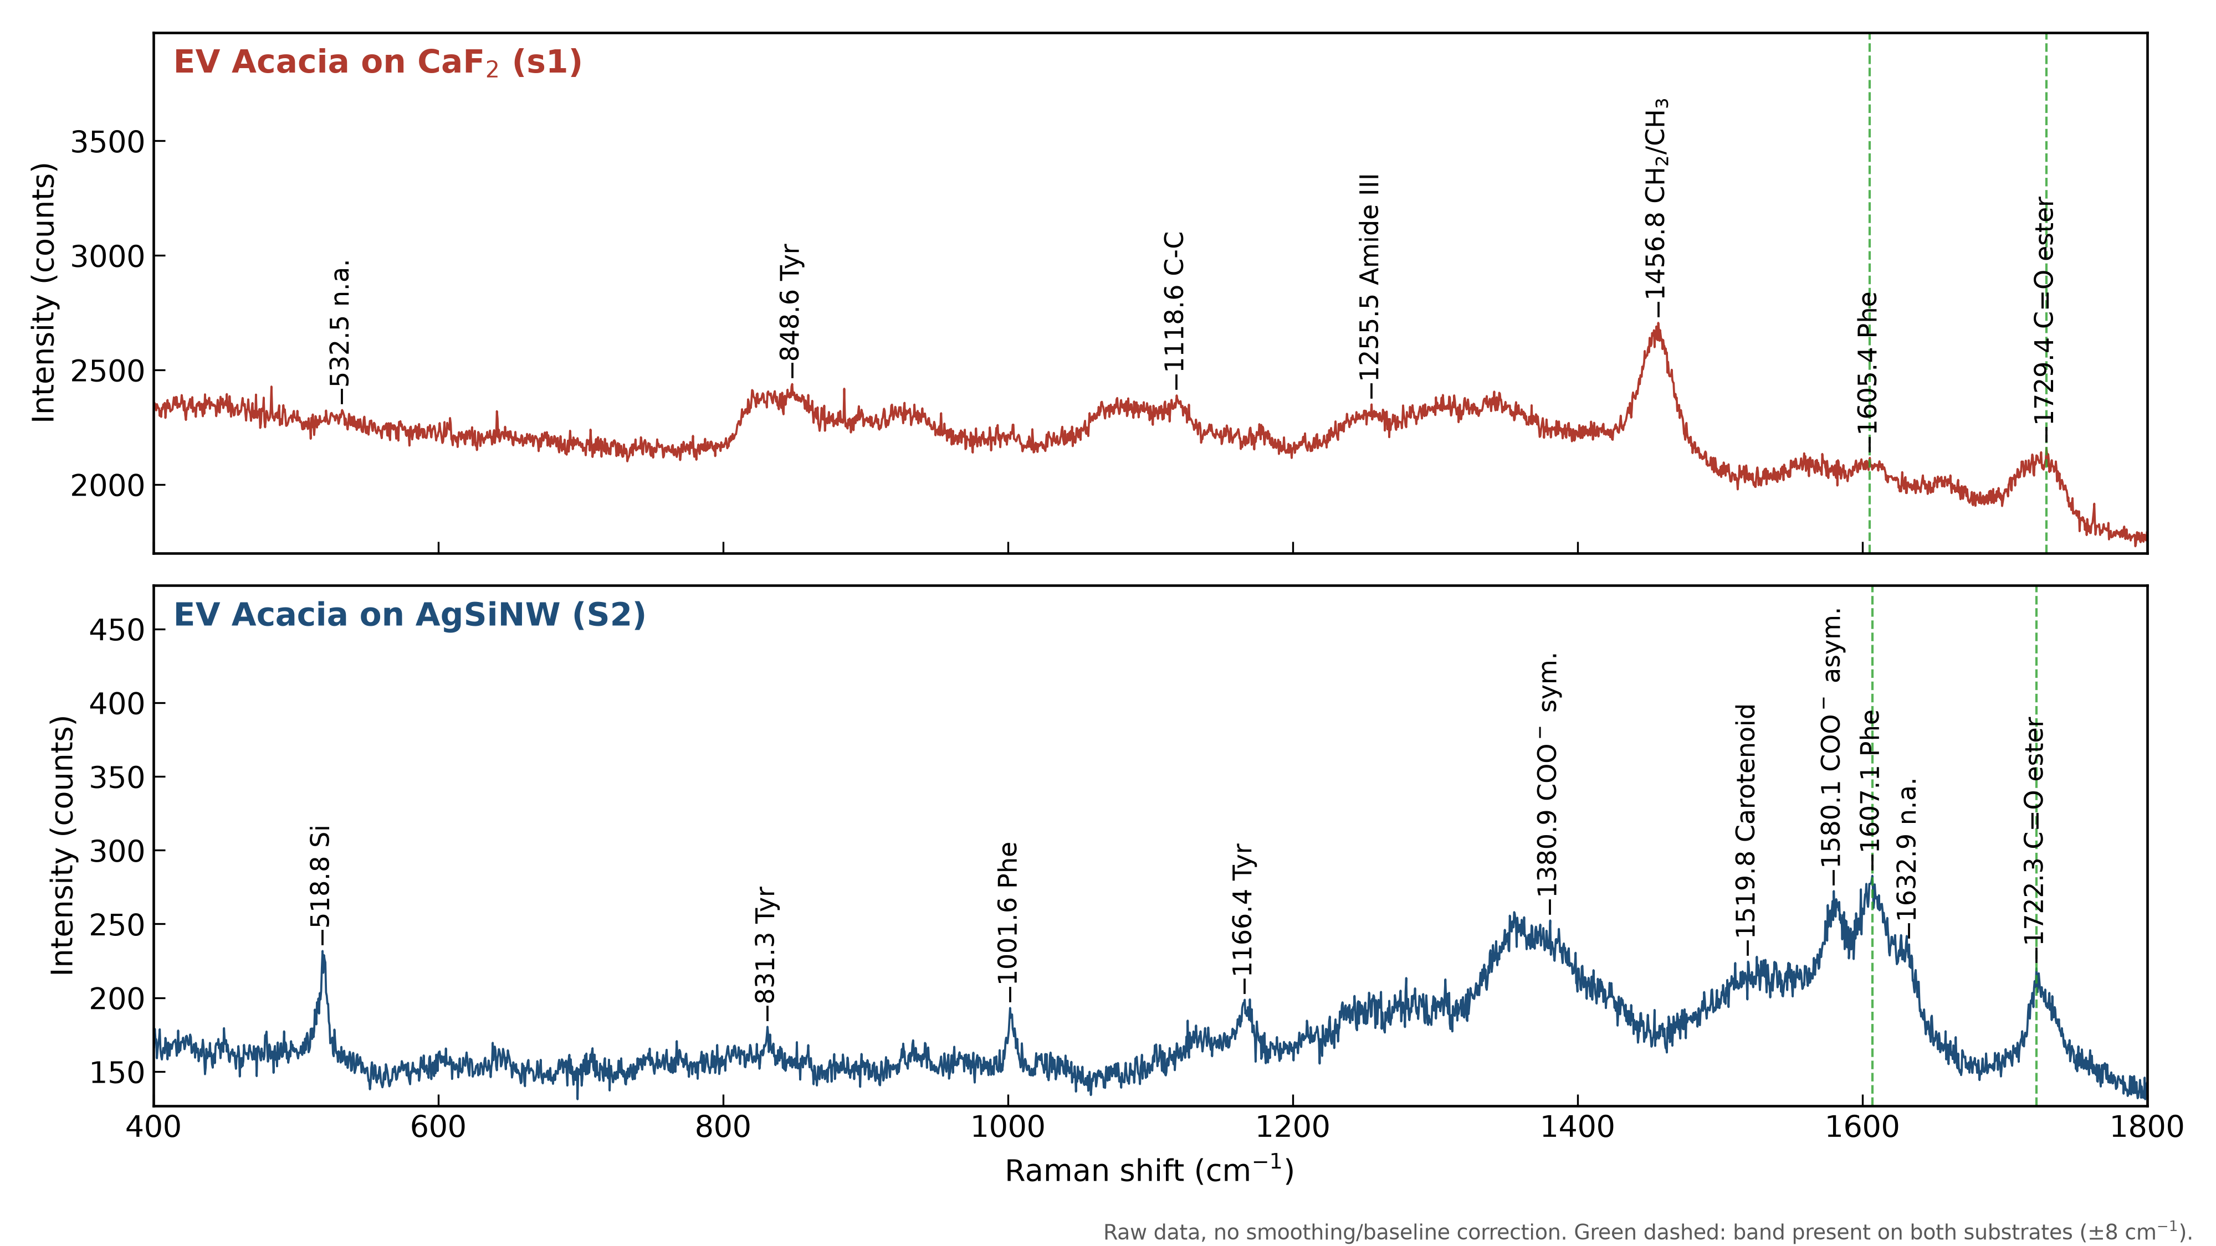
Figure 1. EV Acacia on CaF₂ (s1, top) and on AgSiNW (S2, bottom), raw counts, 400–1800 cm⁻¹. Green dashed lines mark bands present on both substrates (±8 cm⁻¹).
CaF₂ (cm⁻¹) | AgSiNW (cm⁻¹) | Status | Assignment
– | 518.8 | only AgSiNW | Si optical phonon (substrate)
532.5 | – | only CaF₂ | unassigned
– | 831.3 | only AgSiNW | Tyr Fermi doublet / O–P–O stretch
848.6 | – | only CaF₂ | Tyr ring / C–C (proline), polysaccharide C–O–C
– | 1001.6 | only AgSiNW | Phe ring breathing
1118.6 | – | only CaF₂ | C–C stretch (trans lipid) / C–N (protein)
– | 1166.4 | only AgSiNW | Tyr C–H bend
1255.5 | – | only CaF₂ | Amide III
– | 1380.9 | only AgSiNW | COO⁻ sym. stretch / CH₃ bend / carbon D band
1456.8 | – | only CaF₂ | CH₂/CH₃ deformation (lipid, protein)
– | 1519.8 | only AgSiNW | Carotenoid-type C=C stretch
– | 1580.1 | only AgSiNW | COO⁻ asym. stretch / carbon G band / Phe
1605.4 | 1607.1 | in both | Phe/Tyr ring C=C (on AgSiNW overlaps G band)
– | 1632.9 | only AgSiNW | unassigned
1729.4 | 1722.3 | in both | C=O stretch (ester, lipids)
Table 3. Confirmed bands of EV Acacia, 400–1800 cm⁻¹ (raw data). Green rows: band found on both substrates.
Search of the 100 AgSiNW map spectra for 1456 and 1726 cm⁻¹. The 1456 cm⁻¹ band reached SNR ≥ 5 in 7 spectra and the 1726 cm⁻¹ band in 6 spectra, but no spectrum showed both at SNR ≥ 5. The best pixel (m5, spectrum 12) reached only SNR 5.5 and 4.3. On CaF₂ the same bands have SNR 18–38 and 10–20. The C=O band appears at 1722 cm⁻¹ in S2, but without the 1456 cm⁻¹ band.
Carbon D/G bands. Fits of the 1200–1700 cm⁻¹ region of the SERS spectra (Table 4) show a broad D band (1360–1378 cm⁻¹, FWHM 89–227 cm⁻¹), a G band (1605–1608 cm⁻¹) and a D3 band (~1545 cm⁻¹). This is the typical signature of disordered or amorphous carbon [21–24]. None of these bands appears on CaF₂.
Spectrum | D (cm⁻¹) | D FWHM | G (cm⁻¹) | G FWHM | D3 (cm⁻¹) | I_{D}/I_{G} | R²
EV Acacia, mean of 100 map spectra | 1360.3 | 227 | 1604.9 | 64 | 1543.8 | 0.73 | 0.96
EV Acacia S1 | 1377.7 | 89 | 1608.3 | 75 | 1550.0 | 0.26 | 0.94
EV Acacia S2 | 1366.6 | 96 | 1607.4 | 50 | 1547.6 | 0.86 | 0.87
EV nano Acacia s3 | 1337.3 | – | 1620.0 | – | – | 1.52 | 0.75
EV nano Acacia s4 | 1385.1 | – | 1608.2 | – | – | 0.60 | 0.91
EV nano Acacia s4a | 1384.4 | – | 1614.4 | – | – | 0.61 | 0.94
EV nano Acacia, mean map m1 | 1381.5 | – | 1612.0 | – | – | 0.60 | 0.95
Table 4. Carbon D/G band fits of the SERS spectra (Lorentzian D, G and Gaussian D3 on a linear background).
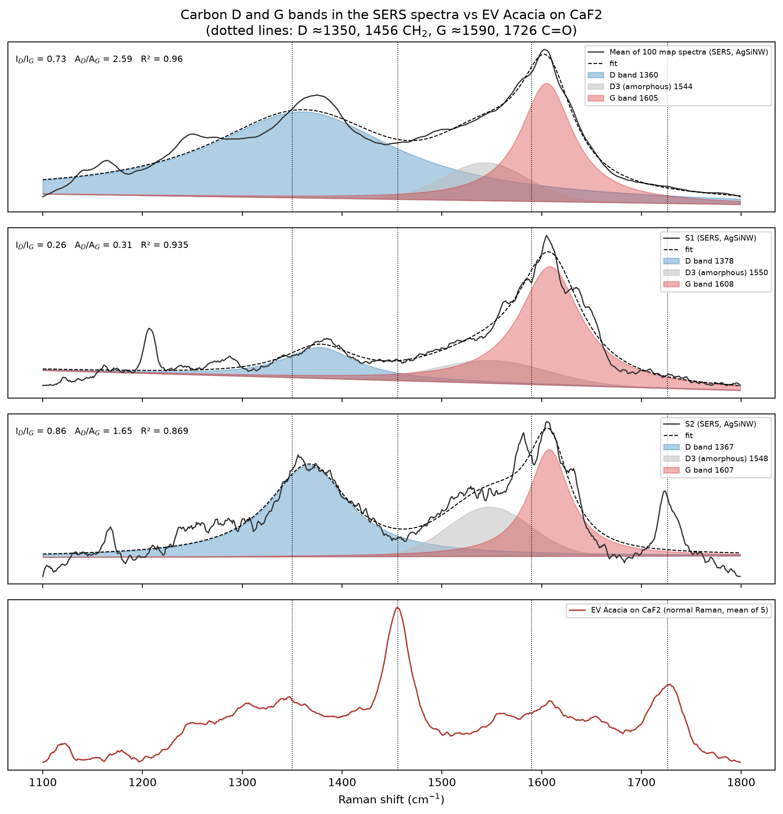
Figure 2. D/G band fits for EV Acacia on AgSiNW compared with the CaF₂ spectra.

3.2 EV nano Acacia: CaF₂ vs AgSiNW
Only one CaF₂ spectrum (s1) of EV nano Acacia was available. Of the three AgSiNW single spectra, s4 matched the most CaF₂ bands, but this was only 1 of 10 (Figure 3, Table 5). The 1456 and 1726 cm⁻¹ bands were not detected in any EV nano Acacia spectrum on AgSiNW (maximum SNR 3.4 for 1456 and 3.7 for 1726 cm⁻¹ over all 43 spectra).
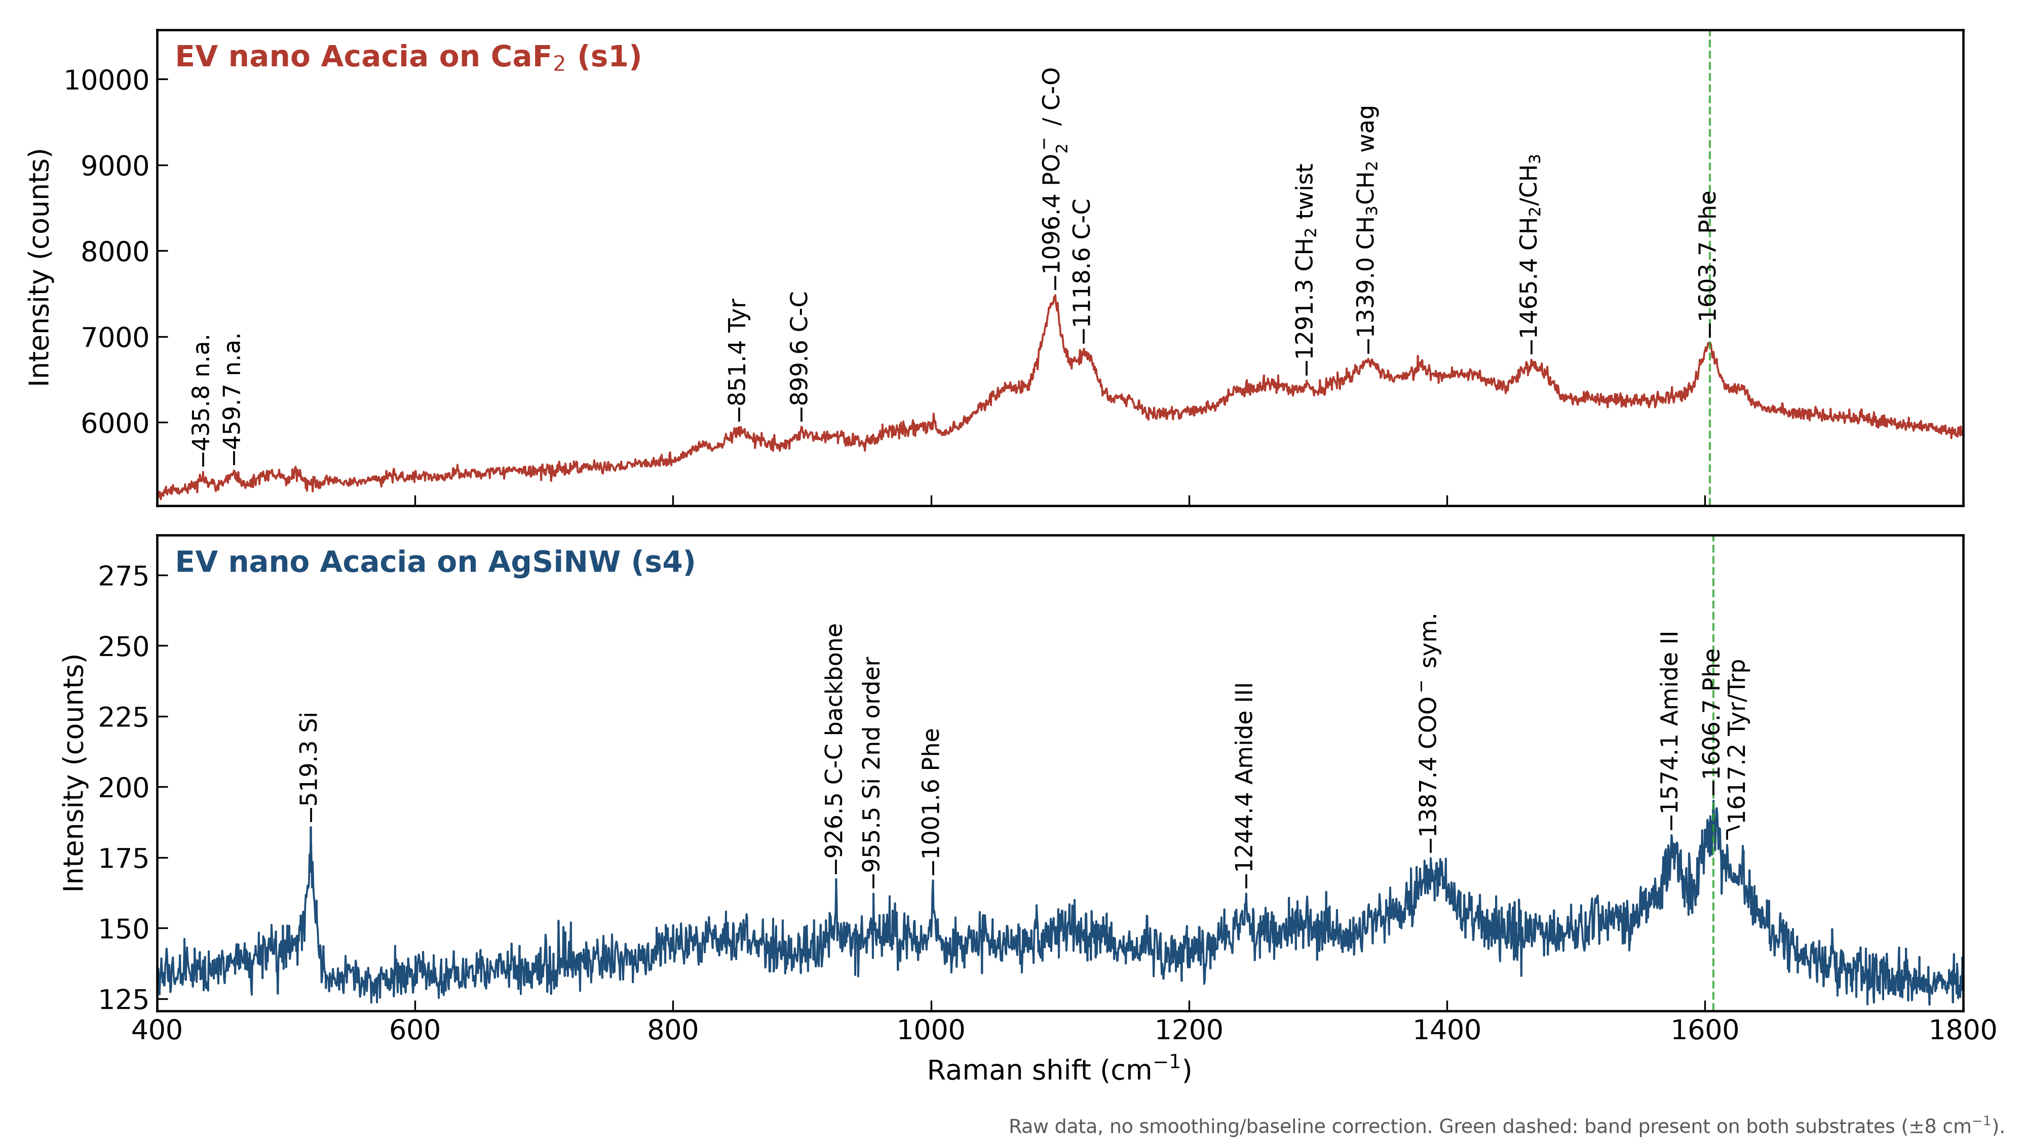
Figure 3. EV nano Acacia on CaF₂ (s1, top) and on AgSiNW (s4, bottom), raw counts, 400–1800 cm⁻¹.
CaF₂ (cm⁻¹) | AgSiNW (cm⁻¹) | Status | Assignment
435.8 | – | only CaF₂ | unassigned (skeletal deformation region)
459.7 | – | only CaF₂ | unassigned (skeletal deformation region)
– | 519.3 | only AgSiNW | Si optical phonon (substrate)
851.4 | – | only CaF₂ | Tyr ring / C–C (proline), polysaccharide C–O–C
899.6 | – | only CaF₂ | C–C / C–O–C (saccharide)
– | 926.5 | only AgSiNW | C–C stretch, protein backbone
– | 955.5 | only AgSiNW | Si 2nd-order phonon (substrate)
– | 1001.6 | only AgSiNW | Phe ring breathing
1096.4 | – | only CaF₂ | C–O/C–C (carbohydrate), PO₂⁻ sym., gauche C–C (strongest band, SNR 46)
1118.6 | – | only CaF₂ | C–C stretch (trans lipid) / C–N (protein)
– | 1244.4 | only AgSiNW | Amide III
1291.3 | – | only CaF₂ | CH₂ twist (lipid)
1339.0 | – | only CaF₂ | CH₃CH₂ wagging (protein, nucleic acid)
– | 1387.4 | only AgSiNW | COO⁻ sym. stretch / carbon D band
1465.4 | – | only CaF₂ | CH₂/CH₃ deformation
– | 1574.1 | only AgSiNW | Amide II / Trp / carbon G band region
1603.7 | 1606.7 | in both | Phe/Tyr ring C=C (on AgSiNW overlaps G band)
– | 1617.2 | only AgSiNW | Tyr/Trp ring C=C
Table 5. Confirmed bands of EV nano Acacia, 400–1800 cm⁻¹ (raw data).

3.3 EV Acacia vs EV nano Acacia on CaF₂
This is the most reliable comparison, because both samples were measured with identical settings on a low-background substrate. Bands were searched in all spectra of each sample (six EV Acacia, one EV nano Acacia) and placed at the strongest reproduced maximum. For this reason, some positions differ by a few cm⁻¹ from the single-spectrum lists in Tables 3 and 5.
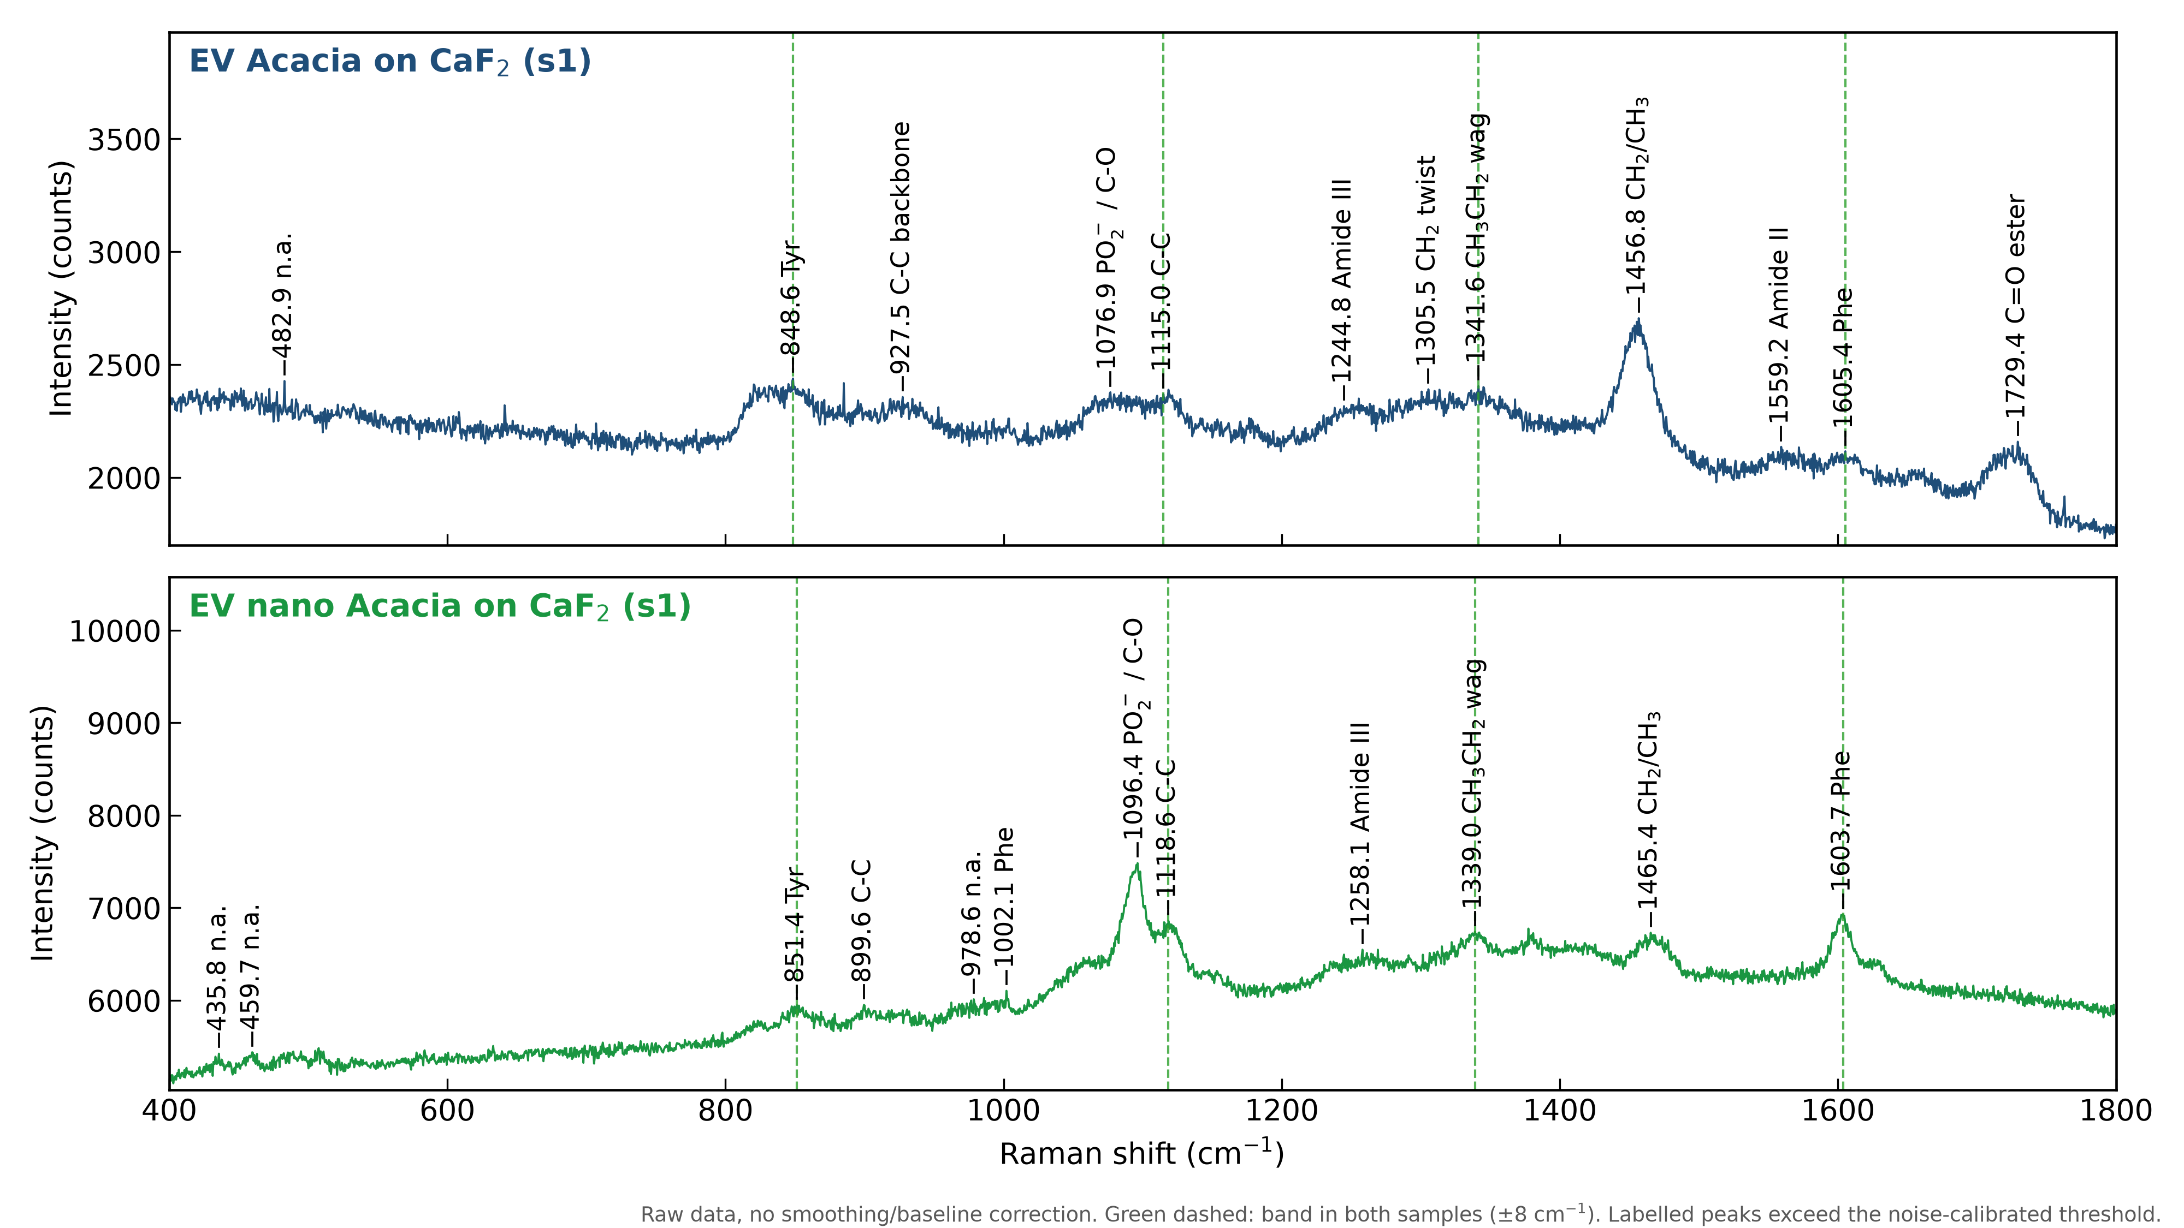
Figure 4. EV Acacia (top) and EV nano Acacia (bottom) on CaF₂, raw counts, 400–1800 cm⁻¹.
EV Acacia (cm⁻¹) | EV nano (cm⁻¹) | Status | Assignment
– | 435.8 | only nano | unassigned
– | 459.7 | only nano | unassigned
482.9 | – | only Acacia | unassigned
848.6 | 851.4 | in both | Tyr ring / C–C (proline), polysaccharide C–O–C
– | 899.6 | only nano | C–C / C–O–C (saccharide)
927.5 | – | only Acacia | C–C stretch, protein backbone
– | 978.6 | only nano | unassigned
– | 1002.1 | only nano | Phe ring breathing
1076.9 | – | only Acacia | PO₂⁻ sym. / gauche C–C / C–O
– | 1096.4 | only nano | C–O/C–C (carbohydrate), PO₂⁻ sym. (strongest nano band)
1115.0 | 1118.6 | in both | C–C stretch (trans lipid) / C–N (protein)
1244.8 | 1258.1 | only one each (Δ13) | Amide III
1305.5 | – | only Acacia | CH₂ twist (lipid)
1341.6 | 1339.0 | in both | CH₃CH₂ wagging (protein, nucleic acid)
1456.8 | 1465.4 | only one each (Δ8.6) | CH₂/CH₃ deformation
1559.2 | – | only Acacia | Amide II / Trp
1605.4 | 1603.7 | in both | Phe/Tyr ring C=C
1729.4 | – | only Acacia | C=O stretch (ester, lipids)
Table 6. EV Acacia vs EV nano Acacia on CaF₂. Only four bands are shared.
Whole-spectrum correlations with the EV Acacia mean spectrum confirm the difference. The EV Acacia replicates give r = 0.96–0.99 in the fingerprint region and ≥ 0.999 in the CH region (2750–3100 cm⁻¹). EV nano Acacia gives r = 0.77 and 0.89. In the CH region the EV Acacia maximum is at ~2937 cm⁻¹ (CH₃/CH₂ asymmetric, protein and lipid). The EV nano Acacia maximum is at ~2891 cm⁻¹ (CH₂ symmetric stretch or C–H of carbohydrate).

3.4 EV Acacia vs EV nano Acacia on AgSiNW
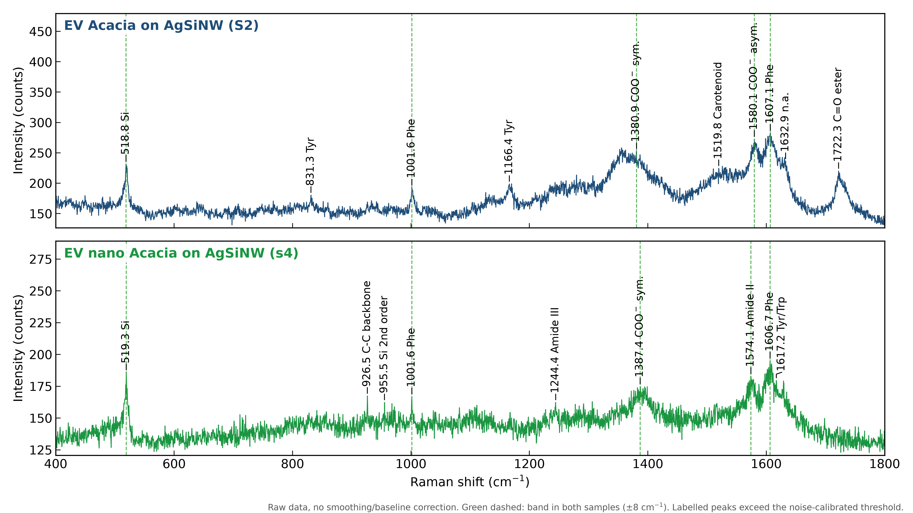
Figure 5. EV Acacia (S2, top) and EV nano Acacia (s4, bottom) on AgSiNW, raw counts, 400–1800 cm⁻¹.
EV Acacia (cm⁻¹) | EV nano (cm⁻¹) | Status | Assignment
518.8 | 519.3 | in both | Si optical phonon (substrate)
831.3 | – | only Acacia | Tyr Fermi doublet / O–P–O
– | 926.5 | only nano | C–C stretch, protein backbone
– | 955.5 | only nano | Si 2nd-order phonon (substrate)
1001.6 | 1001.6 | in both | Phe ring breathing
1166.4 | – | only Acacia | Tyr C–H bend
– | 1244.4 | only nano | Amide III
1380.9 | 1387.4 | in both | COO⁻ sym. stretch / carbon D band
1519.8 | – | only Acacia | Carotenoid-type C=C
1580.1 | 1574.1 | in both | COO⁻ asym. / carbon G band / Phe
1607.1 | 1606.7 | in both | Phe/Tyr ring C=C / carbon G band
– | 1617.2 | only nano | Tyr/Trp ring C=C
1632.9 | – | only Acacia | unassigned
1722.3 | – | only Acacia | C=O stretch (ester, lipids)
Table 7. EV Acacia vs EV nano Acacia on AgSiNW. The shared bands are the substrate, Phe and the carboxylate/carbon region.
On AgSiNW the two samples look more alike than on CaF₂. The shared bands (Si, Phe, COO⁻/D/G) are mostly substrate, aromatic amino acids adsorbed on silver, and photo-generated carbon. The only lipid marker, C=O at 1722 cm⁻¹, appears in EV Acacia and not in EV nano Acacia. This agrees in direction with the CaF₂ result.

4. Interpretation

4.1 The two preparations are chemically different
The CaF₂ data show that EV Acacia is rich in ester-containing lipids (C=O 1729, CH₂/CH₃ 1456, CH₂ twist 1305, CH 2937 cm⁻¹) and also contains protein (amide III 1245–1255, amide II/Trp 1559, Phe/Tyr 1605, C–C 927 cm⁻¹) [16–18]. This is what a membrane vesicle with phospholipid bilayer and associated proteins is expected to show. The narrow band positions and high replicate correlation also show that the preparation is homogeneous.
EV nano Acacia lacks the ester C=O band. Its strongest bands are at 1096 and 900 cm⁻¹, which are typical of C–O/C–C and glycosidic C–O–C vibrations of carbohydrates [19], and at 2891 cm⁻¹ in the CH region. Plant nanovesicles made by homogenisation carry co-isolated biomass material [1–3]. Acacia tissue and exudates are very rich in polysaccharide gums and polyphenols [10,11]. A carbohydrate-dominated spectrum without a strong ester band is therefore consistent with a homogenate-derived nanovesicle preparation. The 1096 cm⁻¹ band can also contain a phosphate (PO₂⁻) contribution. This interpretation is a hypothesis: the isolation methods are unknown and only one CaF₂ spectrum of EV nano Acacia exists.

4.2 Why the CaF₂ bands (1456, 1726 cm⁻¹) are missing on AgSiNW
- SERS is selective. Enhancement is strongest for molecules within a few nanometres of a silver hot spot. It also depends on their orientation relative to the surface (surface selection rules) [15,25,26]. Aromatic side chains (Phe, Tyr) and carboxylates adsorb on silver and dominate. The ester groups and alkyl chains inside a bilayer are further away and are not enhanced.
- Much smaller signal budget. 1 s at a 10 % power setting with a 50× LF objective, against 60 s at 100 % with 100×, gives about 600 times fewer photon·seconds before collection-efficiency losses. Bands at SNR 20–38 on CaF₂ fall to the noise level unless they are strongly enhanced.
- Photo-generated carbon. Laser heating at silver hot spots degrades organic material to amorphous carbon. This produces broad D (~1360–1385) and G (~1580–1610 cm⁻¹) bands [21–24], which were found in all SERS spectra (Table 4). They overlap the 1380–1610 cm⁻¹ region and raise the background near 1456 cm⁻¹.
- Substrate and dilution. Si phonons at 519 and ~955 cm⁻¹ [20] and a very small analyte amount (1 µL; 20 ng of EV nano Acacia) reduce the fraction of the spectrum carrying vesicle information.
The missing bands are therefore a property of the SERS measurement, not proof that the vesicles lack lipids. For compositional comparison the CaF₂ spectra should be used. SERS is useful as a sensitivity test and for protein/aromatic markers.

4.3 What this means for possible uses
If EV Acacia is an apoplastic or secreted EV preparation, its lipid- and protein-rich membrane signature suits studies of plant vesicle biology and use as natural carriers, where membrane integrity matters [1,4,5]. If EV nano Acacia is a homogenate-derived nanovesicle preparation, its carbohydrate and polyphenol load fits the application area where plant nanovesicles are most studied. That area is oral, gut and anti-inflammatory use [6–8], where Acacia's own anti-inflammatory and antioxidant compounds [10,11] could add to the effect. Both statements are conditional on the isolation methods being confirmed.

5. Limitations
- The isolation method, plant species and organ, particle concentration (except 20 ng for EV nano Acacia on AgSiNW) and storage history are unknown.
- EV nano Acacia on CaF₂ is a single spectrum, so its reproducibility cannot be tested.
- No blank-substrate spectra (bare CaF₂, bare AgSiNW) or buffer controls were provided.
- AgSiNW settings differ between spectra (BC100 vs BC200), and power/filter codes were interpreted from file names.
- No particle size, morphology or marker data (NTA, TEM, protein markers) were available, as MISEV2023 recommends [27].
- Band assignments are tentative; several bands (e.g. 1096, 1380, 1605 cm⁻¹) have overlapping contributions.

6. Recommendations
- Ask the provider lab for the isolation protocol (apoplastic wash or homogenisation; ultracentrifugation, SEC or density gradient), species, organ and particle concentration. Report them following MISEV2023 [27] and Pinedo et al. [2].
- Add NTA or DLS (size, concentration), TEM (morphology) and protein quantification for both samples.
- Record more CaF₂ spectra of EV nano Acacia (≥ 5 positions) and bare-substrate and buffer blanks.
- Measure reference compounds on CaF₂ under the same conditions: phosphatidylcholine, gum arabic (Acacia senegal gum) and tannic acid. These test the lipid vs polysaccharide/polyphenol assignment directly.
- For SERS, use lower laser power with longer integration to avoid carbonisation (check for the D/G bands), keep one BC setting, and consider aggregating the vesicles on the substrate or using a spacer-free Ag colloid.

References
- Alsaid et al. (2026). Plant-derived extracellular vesicles and nanoparticles: origins, functions, and applications. Frontiers in Bioengineering and Biotechnology. doi:10.3389/fbioe.2026.1758558
- Pinedo M., de la Canal L., de Marcos Lousa C. (2021). A call for Rigor and standardization in plant extracellular vesicle research. Journal of Extracellular Vesicles 10:e12048. doi:10.1002/jev2.12048
- Woith E., Guerriero G., Hausman J.-F., et al. (2021). Plant extracellular vesicles and nanovesicles: focus on secondary metabolites, proteins and lipids with perspectives on their potential and sources. International Journal of Molecular Sciences 22:3719. doi:10.3390/ijms22073719
- Rutter B.D., Innes R.W. (2017). Extracellular vesicles isolated from the leaf apoplast carry stress-response proteins. Plant Physiology 173:728–741. doi:10.1104/pp.16.01253
- Kocholatá M., Malý J., Kříženecká S., Janoušková O. (2024). Diversity of extracellular vesicles derived from calli, cell culture and apoplastic fluid of tobacco. Scientific Reports 14. doi:10.1038/s41598-024-81940-8
- Mu J., Zhuang X., Wang Q., et al. (2014). Interspecies communication between plant and mouse gut host cells through edible plant derived exosome-like nanoparticles. Molecular Nutrition & Food Research 58:1561–1573. doi:10.1002/mnfr.201300729
- Zhang M., Viennois E., Prasad M., et al. (2016). Edible ginger-derived nanoparticles: a novel therapeutic approach for the prevention and treatment of inflammatory bowel disease and colitis-associated cancer. Biomaterials 101:321–340. doi:10.1016/j.biomaterials.2016.06.018
- Chen X., Liu B., Li X., et al. (2021). Identification of anti-inflammatory vesicle-like nanoparticles in honey. Journal of Extracellular Vesicles 10:e12069. doi:10.1002/jev2.12069
- Lian M.Q., Chng W.H., Liang J., et al. (2022). Plant-derived extracellular vesicles: recent advancements and current challenges on their use for biomedical applications. Journal of Extracellular Vesicles 11:e12283. doi:10.1002/jev2.12283
- Rather L.J., Shahid-ul-Islam, Mohammad F. (2015). Acacia nilotica (L.): a review of its traditional uses, phytochemistry, and pharmacology. Sustainable Chemistry and Pharmacy 2:12–30. doi:10.1016/j.scp.2015.08.002
- Hafez L.O., et al. (2024). The Acacia (Vachellia nilotica (L.) P.J.H. Hurter & Mabb.): traditional uses and recent advances on its pharmacological attributes and potential activities. PMID 39770900; PMCID PMC11678605
- Gualerzi A., Niada S., Giannasi C., et al. (2017). Raman spectroscopy uncovers biochemical tissue-related features of extracellular vesicles from mesenchymal stromal cells. Scientific Reports 7:9820. doi:10.1038/s41598-017-10448-1
- Stremersch S., Marro M., Pinchasik B.-E., et al. (2016). Identification of individual exosome-like vesicles by surface enhanced Raman spectroscopy. Small 12:3292–3301. doi:10.1002/smll.201600393
- Kerr L.T., Byrne H.J., Hennelly B.M. (2015). Optimal choice of sample substrate and laser wavelength for Raman spectroscopic analysis of biological specimen. Analytical Methods 7:5041–5052. doi:10.1039/C5AY00327J
- Otto A. (2002). What is observed in single molecule SERS, and why? Journal of Raman Spectroscopy 33:593–598. doi:10.1002/jrs.879
- Movasaghi Z., Rehman S., Rehman I.U. (2007). Raman spectroscopy of biological tissues. Applied Spectroscopy Reviews 42:493–541. doi:10.1080/05704920701551530
- Czamara K., Majzner K., Pacia M.Z., et al. (2015). Raman spectroscopy of lipids: a review. Journal of Raman Spectroscopy 46:4–20. doi:10.1002/jrs.4607
- Rygula A., Majzner K., Marzec K.M., et al. (2013). Raman spectroscopy of proteins: a review. Journal of Raman Spectroscopy 44:1061–1076. doi:10.1002/jrs.4335
- Wiercigroch E., Szafraniec E., Czamara K., et al. (2017). Raman and infrared spectroscopy of carbohydrates: a review. Spectrochimica Acta A 185:317–335. doi:10.1016/j.saa.2017.05.045
- Temple P.A., Hathaway C.E. (1973). Multiphonon Raman spectrum of silicon. Physical Review B 7:3685–3697. doi:10.1103/PhysRevB.7.3685
- Tuinstra F., Koenig J.L. (1970). Raman spectrum of graphite. Journal of Chemical Physics 53:1126–1130. doi:10.1063/1.1674108
- Ferrari A.C., Robertson J. (2000). Interpretation of Raman spectra of disordered and amorphous carbon. Physical Review B 61:14095–14107. doi:10.1103/PhysRevB.61.14095
- Sadezky A., Muckenhuber H., Grothe H., Niessner R., Pöschl U. (2005). Raman microspectroscopy of soot and related carbonaceous materials: spectral analysis and structural information. Carbon 43:1731–1742. doi:10.1016/j.carbon.2005.02.018
- Kudelski A., Pettinger B. (2000). SERS on carbon chain segments: monitoring locally surface chemistry. Chemical Physics Letters 321:356–362. doi:10.1016/S0009-2614(00)00370-8
- Moskovits M. (1982). Surface selection rules. Journal of Chemical Physics 77:4408–4416. doi:10.1063/1.444442
- Moskovits M. (1985). Surface-enhanced spectroscopy. Reviews of Modern Physics 57:783–826. doi:10.1103/RevModPhys.57.783
- Welsh J.A., Goberdhan D.C.I., O'Driscoll L., et al. (2024). Minimal information for studies of extracellular vesicles (MISEV2023): from basic to advanced approaches. Journal of Extracellular Vesicles 13:e12404. doi:10.1002/jev2.12404

