SCD LAB TASK- 02 : GIT & GITHUB- PROJECT VERSION CONTROL
UNIVERSITY COURSE REGISTRATION SYSTEM
Submitted By : Hira Iqbal -131 (BSSE-5C)
Task to do:
Q1. Initial Version – Student Module
Create a Java project named UniversityCourseRegistration containing a Student class with the
attributes studentID, studentName, and department. Create a main class to create and display
a student object. Initialize Git, create the initial commit, and create a corresponding GitHub
repository.
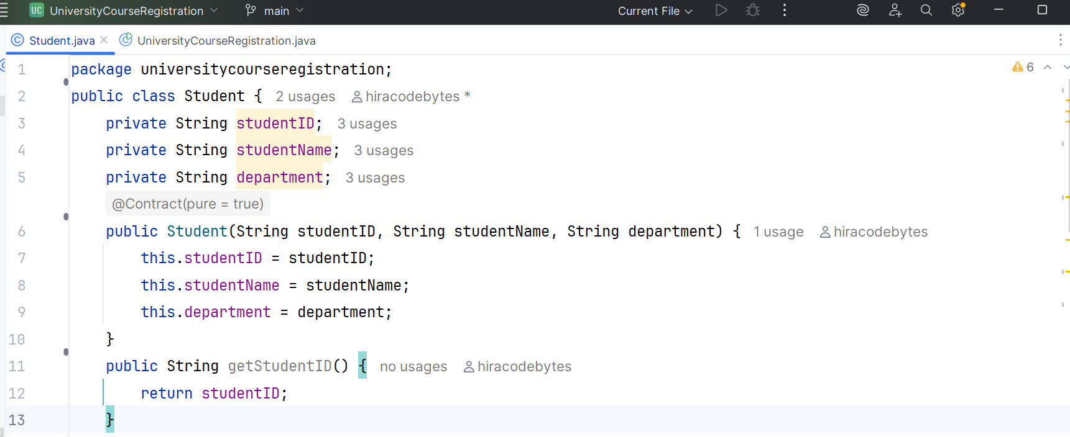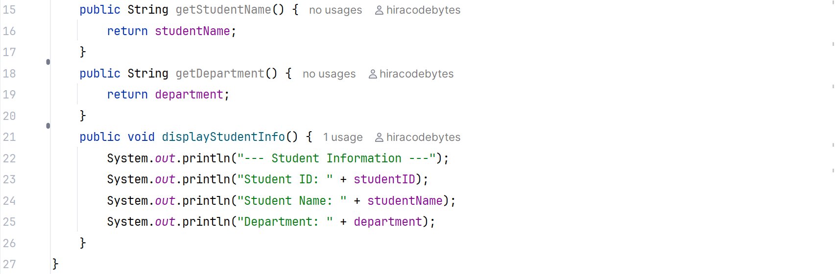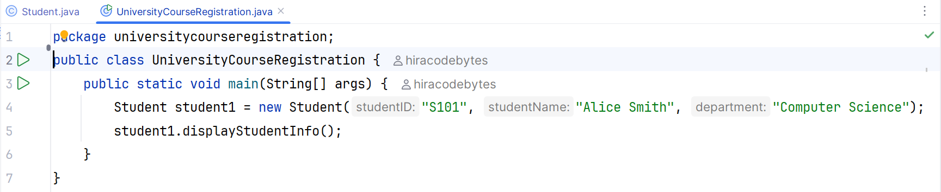
Output of version1 :
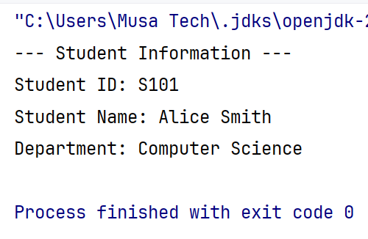
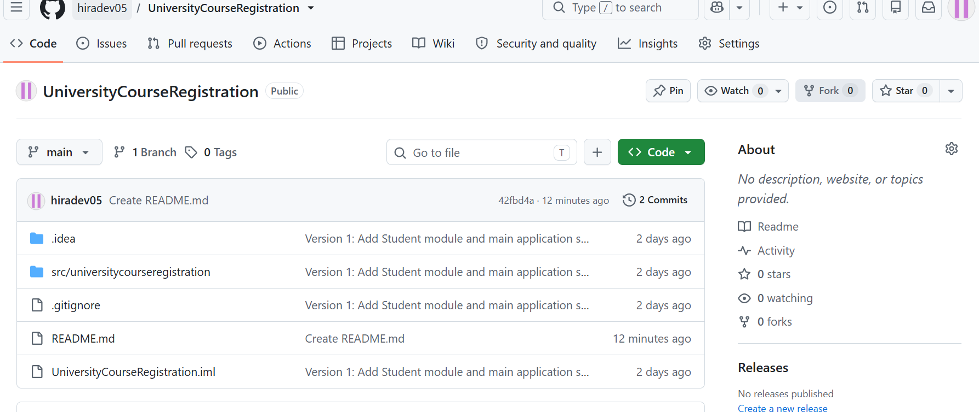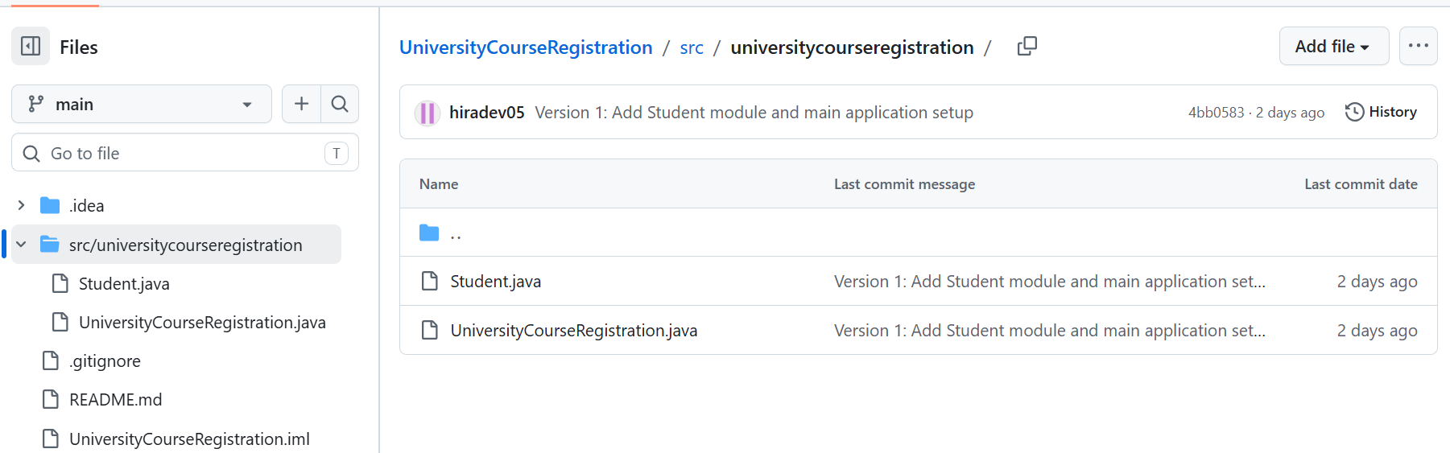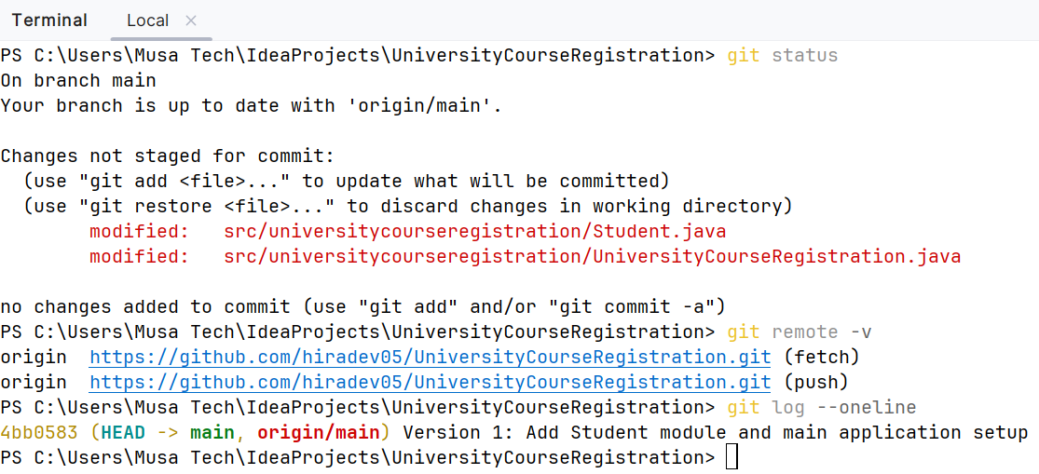
Q2. Second Version – Course Module
Add a new Course class containing courseCode, courseTitle, and creditHours. Update the
main program to create and display a course object along with the student information. Check the Git status, stage the changes, create a meaningful commit, and push the updated version to
GitHub.
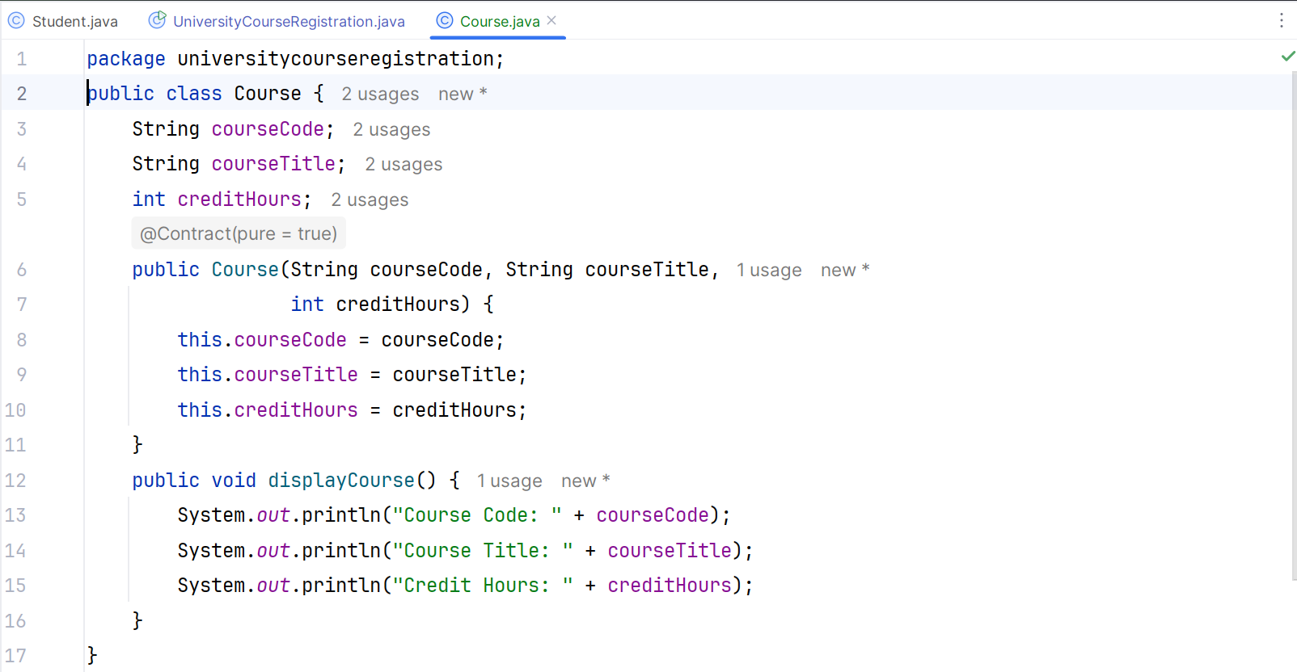
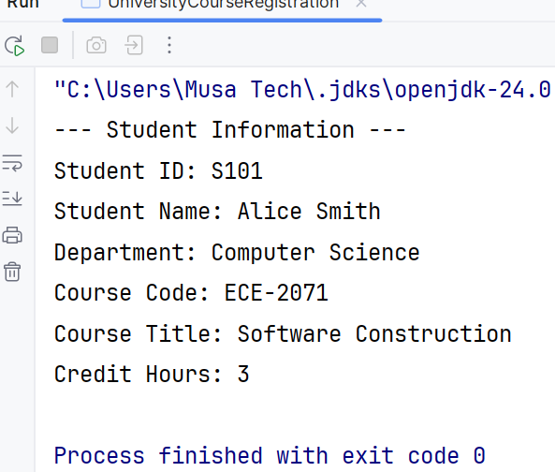
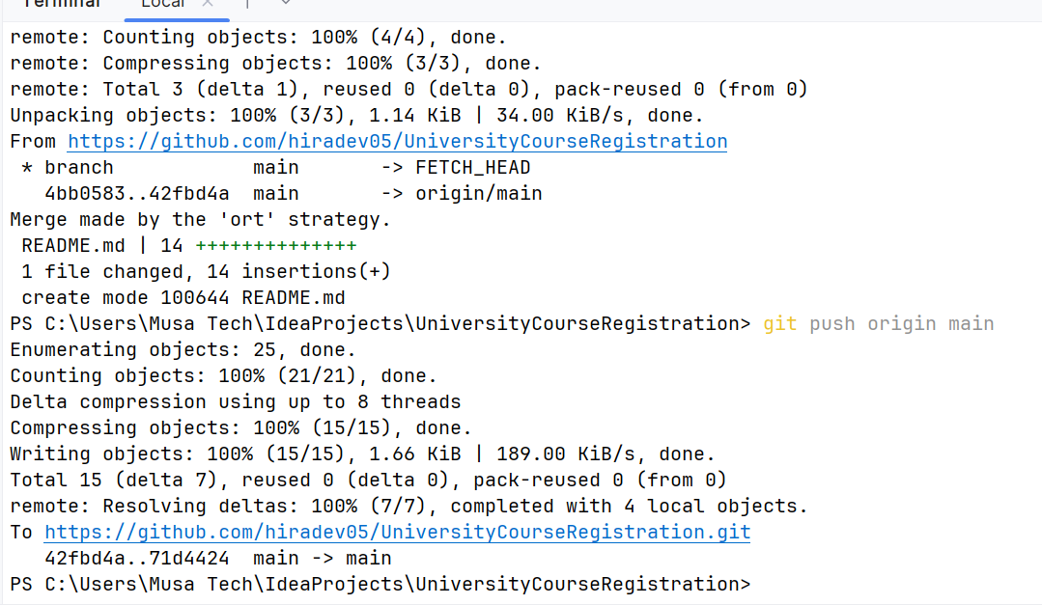
Q3. Third Version – Registration Module
Add a Registration class that associates a Student with a Course. Implement an appropriate
method such as displayRegistration() to display the student & registration details, including
student information and course information. Commit the changes with a meaningful message and push the new version to GitHub.
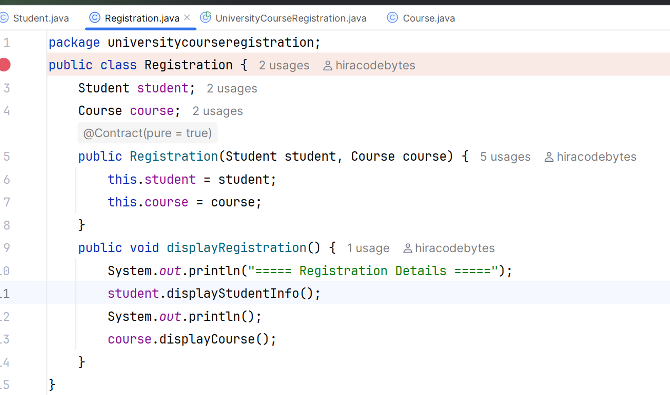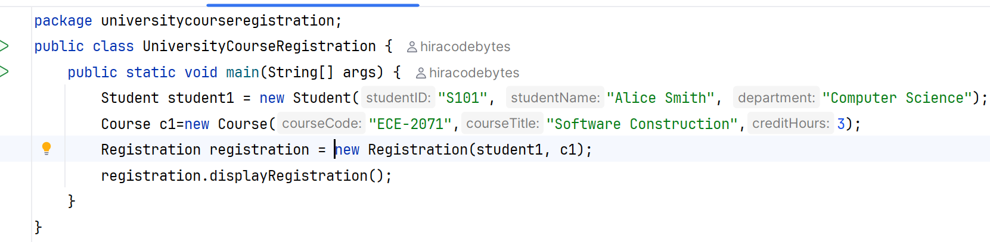
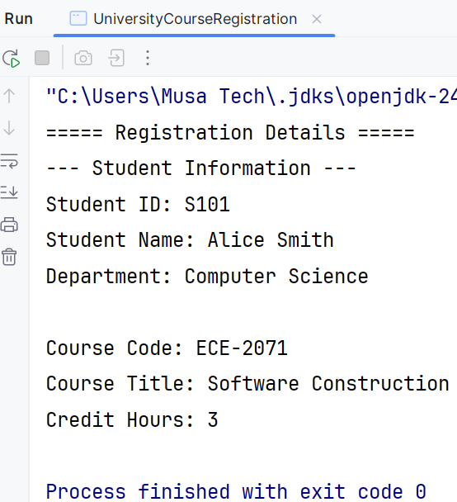
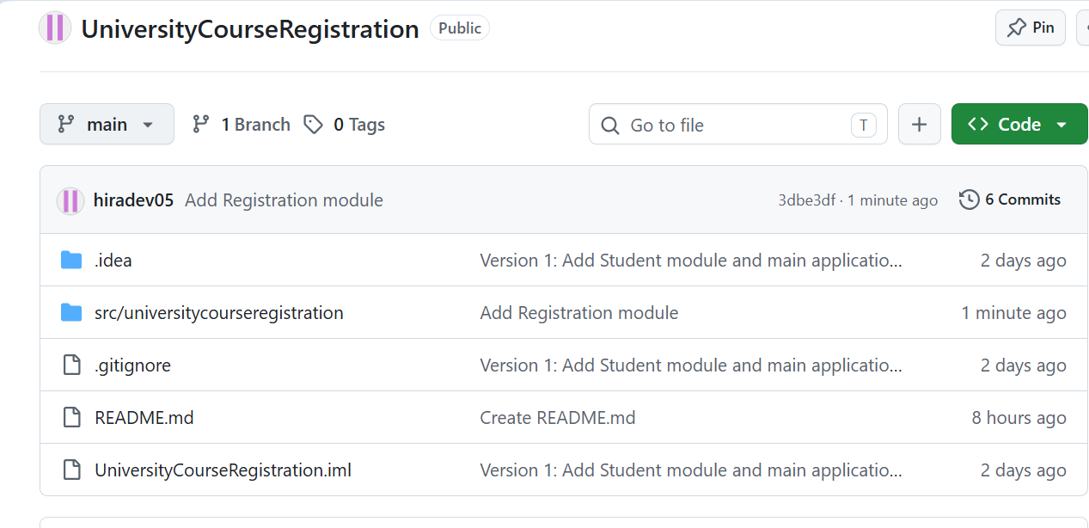
Q4. Clone and Extend the Project
Assume you are working on another computer. Clone the GitHub repository and open the project
in NetBeans. Add a new feature that allows the system to “display a registration confirmation
message” after a student is registered. Test the program, commit the changes, and push the
updated project to GitHub.
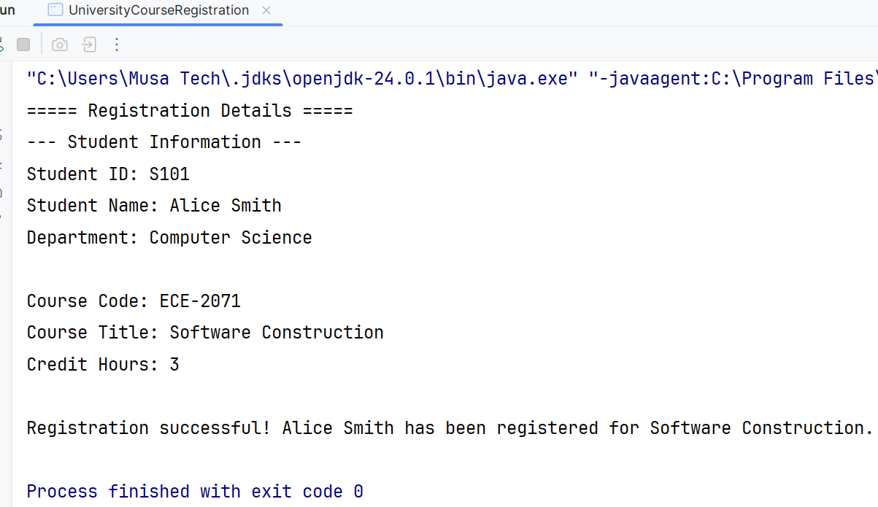
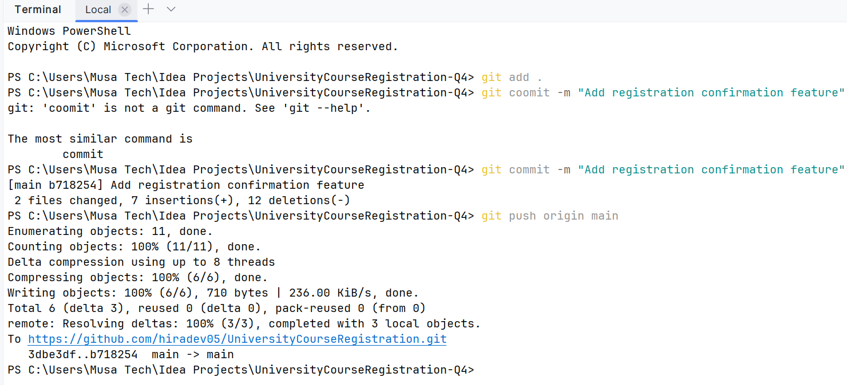
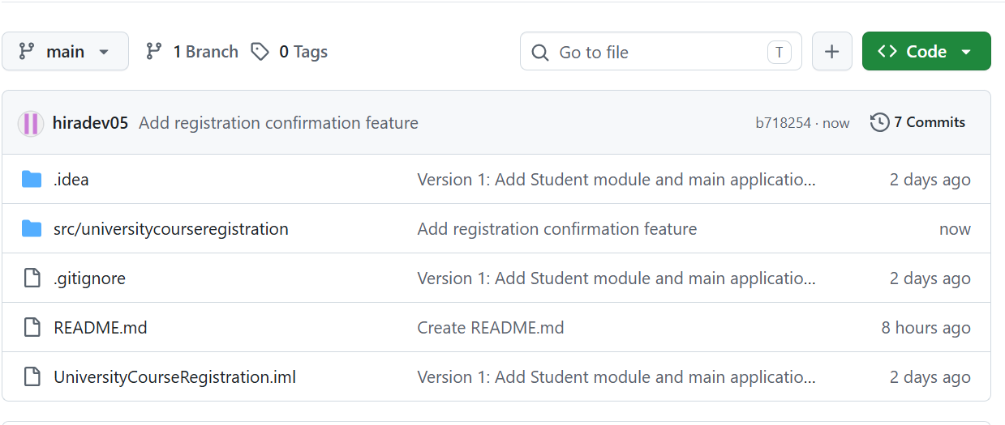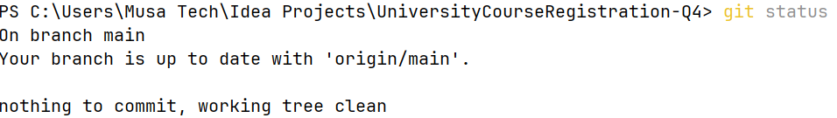

Q5. Verify Project Versions
Use Git commands to display the repository status and commit history. Verify that the GitHub
repository contains the complete development history:
Version 1 → Student Module
Version 2 → Course Module
Version 3 → Registration Module
Version 4 → Registration Confirmation Feature
Submit the GitHub repository link and screenshots showing the project, Git status, commit
history, and final GitHub repository.
