INTERNSHIP REPORT
ON
FOSSEE eSim SEMESTER LONG INTERNSHIP – AUTUMN 2026
TASK 5 – AUTOMATED TOOL MANAGER
eSimMate
Automated Tool Installation, Version Management,
Compatibility Checking and System Diagnostics for eSim

Prepared For

FOSSEE
INDIAN INSTITUTE OF TECHNOLOGY BOMBAY
AUGUST 2026
Submitted By
DHARANIDHARAN T.
B.Tech. COMPUTER SCIENCE AND BUSINESS SYSTEMS
BATCH 2024–2028
 | Sri Eshwar College of Engineering  (An Autonomous Institution)  Kinathukadavu (Tk), Coimbatore - 641 202, Tamil Nadu  Approved by AICTE, New Delhi and Affiliated to Anna University, Chennai | 

DECLARATION

I hereby declare that the technical report entitled "ESIMMATE: AUTOMATED TOOL INSTALLATION, VERSION MANAGEMENT, COMPATIBILITY CHECKING AND SYSTEM DIAGNOSTICS FOR ESIM" submitted for Task 5 (Automated Tool Manager) of the FOSSEE eSim Semester Long Internship – Autumn 2026 is an authentic record of original engineering work carried out by me. This work represents a student project developed for the screening evaluation of the FOSSEE eSim Semester Long Internship – Autumn 2026. All software components, algorithms, test suites, and empirical results documented in this report represent actual implemented and verified artifacts residing in the project repository https://github.com/dharanidh-02/eSimMate. Appropriate academic and technical citations have been given where external libraries, tools, or specifications have been referenced.

DATE: 20/08/2026
[DHARANIDHARAN T]

ACKNOWLEDGEMENT

I express my gratitude to Sri Eshwar College of Engineering and the Department of Computer Science and Business Systems for providing the academic foundation and computational infrastructure that supported this project.
I extend sincere appreciation to FOSSEE (Free/Libre and Open Source Software for Education), Indian Institute of Technology Bombay (IIT Bombay), and the National Mission on Education through ICT (NMEICT), Ministry of Education, Government of India, for developing and maintaining eSim and for offering the screening problem statement for Task 5 (Automated Tool Manager).
I also acknowledge the global open-source Electronic Design Automation (EDA) community—including the development teams of KiCad, Ngspice, GHDL, OpenModelica Compiler (OMC), Verilator, and FreeCAD—whose foundational software tools enable open-source circuit design and simulation.

ABSTRACT

eSim, an open-source Electronic Design Automation (EDA) suite developed by FOSSEE at IIT Bombay, depends on an ecosystem of external open-source simulation and design engines including KiCad, Ngspice, GHDL, OpenModelica Compiler (omc), and Verilator. Installing, verifying, and maintaining these heterogeneous tools across different operating systems presents critical challenges: platform package manager fragmentation, version compatibility drift, missing binary paths, and security risks from unverified privileged execution scripts. To address these problems, this report presents eSimMate, a modular, configuration-driven, cross-platform automated tool and dependency management framework developed in Python 3.10–3.12. eSimMate provides an extensible YAML tool registry, non-intrusive binary and PATH detection, semantic version extraction using safe subprocess execution with regex filtering, multi-bound compatibility evaluation ([min_version .. max_version]), and polymorphic package manager adapters (apt, winget, choco). eSimMate introduces a resilient official archive fallback strategy (MANUAL_DOWNLOAD) for tools unavailable in upstream package repositories (such as Windows Ngspice), combining automated archive download, HTTP validation, multi-format extraction (.7z/.zip), executable discovery, and local path registration. eSimMate enforces strict execution safety invariants (shell=False, zero os.system()), interactive user elevation confirmation, dry-run previews, and persistent rotating audit logs. The system achieves 87% overall statement code coverage across 1,189 statements with 93 automated unit and integration tests passing in 8.10–14.02 seconds. Real-world validation on a Windows 10/11 environment (build 26200, x86_64, Python 3.11.9, WinGet) verified automated discovery and compatibility validation of Ngspice version 46 (ngspice_con.exe) in 0.062 seconds.

EXECUTIVE SUMMARY

Problem: Modern open-source EDA platforms rely on complex multi-tool execution pipelines. eSim integrates KiCad for schematic capture and PCB layout, Ngspice for analog circuit simulation, GHDL for digital VHDL simulation, OpenModelica for mathematical modeling, and Verilator for Verilog co-simulation. Because these external tools evolve on independent release cycles, users frequently encounter broken simulations due to version mismatches, missing binary paths, or package manager repository failures.
Motivation: Existing installation approaches rely on monolithic platform scripts (e.g. bash scripts on Linux or bundled installers on Windows) that execute unverified commands, lack pre-execution dependency inspection, fail when upstream packages are dropped, and risk system misconfiguration.
Proposed Solution: eSimMate replaces brittle scripts with a modular, declarative Python architecture. Tool specifications reside in configs/tools.yaml. System detection, version extraction, package manager abstraction, installation execution, logging, and CLI presentation are decoupled into independent subsystems.

Key Contributions:
- Dynamic, Configuration-Driven Tool Registry: Zero hardcoded Python tool classes; tools, binary aliases, and version bounds are loaded dynamically from YAML files.
- Polymorphic Package Manager Abstraction: Unified adapter interface for apt, winget, choco, and custom scripts.
- Official Archive Fallback Strategy: Solves missing upstream repository packages (such as Windows Ngspice) through end-to-end download, HTTP validation, 7-Zip extraction, executable discovery, and managed path registration.
- Safety & Zero-Surprise Privilege Handling: Eliminates os.system() and shell=True, enforcing parameterized argument lists, dry-run previews, and user elevation prompts.
- 5-Stage System Diagnostics (esimmate doctor): Comprehensive environment, package manager, tool health, and environment variable inspection emitting actionable remediation guidance.
- Empirical Validation & Test Coverage: 93 automated unit and integration tests passing in 8.10–14.02 seconds with 87% statement code coverage (1,189 statements).

TABLE OF CONTENTS
Cover Page ................................................................. 1
Declaration ................................................................ 2
Acknowledgement ............................................................ 3
Abstract ................................................................... 4
Executive Summary .......................................................... 5
Table of Contents .......................................................... 6
List of Figures ............................................................ 10
List of Tables ............................................................. 11
List of Abbreviations ...................................................... 12
CHAPTER 1: INTRODUCTION .................................................... 13
1.1 Background ........................................................... 13
1.2 eSim Overview ........................................................ 13
1.3 FOSSEE Context ....................................................... 13
1.4 External Tool Dependencies ........................................... 13
1.5 Motivation ........................................................... 14
1.6 Need for Automated Tool Management ................................... 14
1.7 Project Scope ........................................................ 14
1.8 Contributions ........................................................ 14
CHAPTER 2: PROBLEM STATEMENT AND REQUIREMENTS .............................. 15
2.1 Problem Statement .................................................... 15
2.2 Problem Analysis ..................................................... 15
2.3 Challenges ........................................................... 15
2.4 Objectives ........................................................... 15
2.5 Functional Requirements .............................................. 16
2.6 Non-Functional Requirements .......................................... 16
2.7 FOSSEE Task 5 Requirements ........................................... 17
2.8 Requirement Traceability ............................................. 17
CHAPTER 3: EXISTING SYSTEM AND MOTIVATION .................................. 18
3.1 Existing Manual Approach ............................................. 18
3.2 Manual Installation Workflow ......................................... 18
3.3 Problems with Manual Management ...................................... 18
3.4 Limitations .......................................................... 18
3.5 Motivation for eSimMate .............................................. 18
CHAPTER 4: PROPOSED SYSTEM ................................................. 19
4.1 Overview ............................................................. 19
4.2 eSimMate Architecture ................................................ 19
4.3 Design Principles .................................................... 19
4.4 Configuration-Driven Architecture .................................... 19
4.5 Modular Architecture ................................................. 19
4.6 Safety-First Installation ............................................ 19
4.7 Fallback Installation Strategy ....................................... 19
CHAPTER 5: SYSTEM ARCHITECTURE ............................................. 20
5.1 High-Level Architecture .............................................. 20
5.2 CLI Layer ............................................................ 20
5.3 Tool Registry ........................................................ 20
5.4 Detector ............................................................. 20
5.5 Version Manager ...................................................... 20
5.6 Compatibility Engine ................................................. 21
5.7 Installer ............................................................ 21
5.8 Package Manager ...................................................... 21
5.9 Configuration Manager ................................................ 21
5.10 Logger .............................................................. 21
5.11 Data Flow ........................................................... 22
5.12 Component Interaction ............................................... 22
CHAPTER 6: TOOL REGISTRY AND CONFIGURATION ................................. 23
6.1 Registry Design ...................................................... 23
6.2 tools.yaml ........................................................... 23
6.3 config.yaml .......................................................... 23
6.4 Tool Metadata ........................................................ 23
6.5 Version Constraints .................................................. 24
6.6 Executable Candidates ................................................ 24
6.7 Installation Strategies .............................................. 24
CHAPTER 7: TOOL DETECTION AND VERSION MANAGEMENT ........................... 25
7.1 Detection Strategy ................................................... 25
7.2 Executable Discovery ................................................. 25
7.3 PATH Detection ....................................................... 25
7.4 Managed Directory Detection .......................................... 26
7.5 Version Command Execution ............................................ 26
7.6 Version Parsing ...................................................... 26
7.7 Version Normalization ................................................ 26
7.8 Compatibility Classification ......................................... 27
CHAPTER 8: INSTALLATION MANAGEMENT ......................................... 28
8.1 Installation Workflow ................................................ 28
8.2 Package Manager Detection ............................................ 28
8.3 WinGet Integration ................................................... 28
8.4 Package Availability Check ........................................... 29
8.5 Manual Download Fallback ............................................. 29
8.6 Archive Download ..................................................... 30
8.7 Archive Extraction ................................................... 30
8.8 Installation Directory ............................................... 30
8.9 Installation Verification ............................................ 30
8.10 Dry-Run Mode ........................................................ 30
8.11 User Confirmation ................................................... 30
CHAPTER 9: DEPENDENCY CHECKER AND SYSTEM DOCTOR ............................ 31
9.1 Dependency Checking .................................................. 31
9.2 Mandatory and Optional Tools ......................................... 31
9.3 Host Environment Detection ........................................... 31
9.4 Package Manager Detection ............................................ 31
9.5 Environment Variable Verification .................................... 31
9.6 Tool Health Status ................................................... 31
9.7 Diagnostic Recommendations ........................................... 32
CHAPTER 10: COMMAND LINE INTERFACE ......................................... 33
10.1 CLI Design .......................................................... 33
10.2 esimmate list ....................................................... 33
10.3 esimmate check ...................................................... 34
10.4 esimmate check --json ............................................... 34
10.5 esimmate install .................................................... 34
10.6 esimmate install --dry-run .......................................... 34
10.7 esimmate update ..................................................... 35
10.8 esimmate doctor ..................................................... 35
10.9 esimmate logs ....................................................... 35
10.10 esimmate config .................................................... 35
CHAPTER 11: ERROR HANDLING AND SECURITY .................................... 36
11.1 Error Classification ................................................ 36
11.2 Installation Failure ................................................ 36
11.3 Network Failure ..................................................... 36
11.4 Version Unknown ..................................................... 36
11.5 Timeout Handling .................................................... 36
11.6 User Cancellation ................................................... 36
11.7 Process Execution Safety ............................................ 36
11.8 Command Injection Prevention ........................................ 36
11.9 Logging and Auditability ............................................ 36
11.10 Dry-Run Safety ..................................................... 36
CHAPTER 12: IMPLEMENTATION ................................................. 37
12.1 Technology Stack .................................................... 37
12.2 Project Structure ................................................... 37
12.3 Module Implementation ............................................... 38
12.4 Core Classes ........................................................ 38
12.5 Core Functions ...................................................... 38
12.6 Algorithms .......................................................... 39
12.7 Pseudocode .......................................................... 39
CHAPTER 13: TESTING AND VALIDATION ......................................... 41
13.1 Testing Strategy .................................................... 41
13.2 Unit Testing ........................................................ 41
13.3 Integration Testing ................................................. 41
13.4 Mocking Strategy .................................................... 41
13.5 CLI Testing ......................................................... 41
13.6 Installation Testing ................................................ 41
13.7 Version Testing ..................................................... 41
13.8 Compatibility Testing ............................................... 41
13.9 Regression Testing .................................................. 41
CHAPTER 14: EXPERIMENTAL RESULTS ........................................... 42
14.1 Experimental Environment ............................................ 42
14.2 Windows Environment ................................................. 42
14.3 Python Environment .................................................. 42
14.4 WinGet Detection .................................................... 42
14.5 Ngspice Installation Story .......................................... 42
14.6 Ngspice Version Verification ........................................ 42
14.7 Compatibility Result ................................................ 42
14.8 Doctor Result ....................................................... 43
14.9 Automated Test Results .............................................. 43
14.10 Code Coverage ...................................................... 43
14.11 Discussion ......................................................... 44
CHAPTER 15: FOSSEE TASK 5 COMPLIANCE ....................................... 45
15.1 Requirement 1: Tool Installation Management ......................... 45
15.2 Requirement 2: Update and Upgrade System ............................ 45
15.3 Requirement 3: Configuration Handling ............................... 45
15.4 Requirement 4: Dependency Checker ................................... 45
15.5 Requirement 5: User Interface ....................................... 45
15.6 Requirement 6: Additional Features & Safety ......................... 45
15.7 Compliance Matrix ................................................... 46
15.8 Deliverable Mapping ................................................. 46
CHAPTER 16: LIMITATIONS AND FUTURE SCOPE ................................... 47
16.1 Current Limitations ................................................. 47
16.2 Cross-Platform Limitations .......................................... 47
16.3 Package Manager Limitations ......................................... 47
16.4 Dependency Resolution Limitations ................................... 47
16.5 Future GUI (PyQt6) .................................................. 47
16.6 Linux Support ....................................................... 47
16.7 macOS Support ....................................................... 47
16.8 Offline Installation ................................................ 47
16.9 Security Enhancements ............................................... 47
CHAPTER 17: CONCLUSION ..................................................... 48
FINAL IMPLEMENTATION AUDIT ................................................. 49
REFERENCES ................................................................. 50
APPENDICES ................................................................. 51

LIST OF FIGURES
Figure 1: Overall eSimMate Architecture ...................................... | 20
Figure 2: Complete End-to-End Data Flow ...................................... | 22
Figure 3: Tool Detection Workflow ............................................ | 25
Figure 4: Version Detection and Compatibility Evaluation ..................... | 26
Figure 5: Installation Workflow .............................................. | 28
Figure 6: Package Manager -> Official Archive Fallback ....................... | 29
Figure 7: System Doctor Workflow ............................................. | 32
Figure 8: CLI Command Architecture ........................................... | 33

LIST OF TABLES

Table I : Esimmate Functional Requirements Specification ..................... | 16
Table II: Esimmate Non-Functional Quality Attributes ......................... | 16
Table III: Fossee Task 5 Screening Requirements Baseline ..................... | 17
Table IV: Registered External Tools .......................................... | 23
Table V: Tool Version Requirements ........................................... | 24
Table VI: Installation Strategies ............................................ | 24
Table VII: Compatibility Status Definitions .................................. | 27
Table VIII: Cli Commands ..................................................... | 33
Table IX: Technology Stack ................................................... | 37
Table X: Module Responsibilities ............................................. | 38
Table XI: Ngspice Real-World Validation ...................................... | 43
Table XII: Testing Results ................................................... | 43
Table XIII: Code Coverage .................................................... | 44
Table XIV: Fossee Compliance Matrix .......................................... | 46
Table XV: Limitations And Future Enhancements ................................ | 47

LIST OF ABBREVIATIONS
API — API: Application Programming Interface
CLI — CLI: Command Line Interface
CPU — CPU: Central Processing Unit
EDA — EDA: Electronic Design Automation
FOSSEE — FOSSEE: Free/Libre and Open Source Software for Education
GHDL — GHDL: VHDL Simulator (Gnu Hardware Description Language)
GUI — GUI: Graphical User Interface
HDL — HDL: Hardware Description Language
HTTP — HTTP: Hypertext Transfer Protocol
IIT — IIT: Indian Institute of Technology
LOC — LOC: Lines of Code
NMEICT — NMEICT: National Mission on Education through ICT
OMC — OMC: OpenModelica Compiler
OS — OS: Operating System
PCB — PCB: Printed Circuit Board
PDK — PDK: Process Design Kit
PEP — PEP: Python Enhancement Proposal
RAM — RAM: Random Access Memory
SPICE — SPICE: Simulation Program with Integrated Circuit Emphasis
UAC — UAC: User Account Control
VHDL — VHDL: VHSIC Hardware Description Language
WinGet — WinGet: Windows Package Manager
YAML — YAML: YAML Ain't Markup Language

INTRODUCTION

1.1 Background
Electronic Design Automation (EDA) comprises software algorithms, modeling engines, and graphical workflows necessary for designing integrated circuits and Printed Circuit Boards (PCBs). Because complete circuit engineering requires analog SPICE simulation, digital hardware description compilation, multi-domain system modeling, and mechanical 3D modeling, modern open-source EDA platforms orchestrate independent, specialized computational backends.
1.2 eSim Overview
eSim (formerly Oscad) is an open-source EDA tool developed by the FOSSEE (Free/Libre and Open Source Software for Education) project at the Indian Institute of Technology Bombay (IIT Bombay), funded by the National Mission on Education through ICT (NMEICT), Ministry of Education, Government of India. eSim provides an integrated environment for circuit design, schematic capture, SPICE simulation, mixed-mode simulation, and PCB layout.
1.3 FOSSEE Context
FOSSEE promotes the adoption of open-source software tools in educational institutions across India. As part of this mission, eSim integrates several standalone open-source software packages to offer an alternative to proprietary commercial EDA software.
1.4 External Tool Dependencies
eSim depends on the following external software engines:
- KiCad EDA: Schematic capture, symbol library management, footprint assignment, and PCB layout design.
- Ngspice: Mixed-level, mixed-signal SPICE circuit simulation engine for DC, AC, and transient analysis.
- GHDL: VHDL analyzer and simulator enabling digital hardware description verification and mixed-signal co-simulation (NGHDL).
- OpenModelica Compiler (omc): Multi-domain mathematical equation modeling and system simulation.
- Verilator: Fast Verilog/SystemVerilog simulator compiling HDL models into native C++ executables.
- FreeCAD: 3D CAD parametric modeler for mechanical enclosure validation and 3D PCB visualization.
1.5 Motivation
Because each external tool evolves on an independent release schedule with distinct binary naming conventions, search paths, and installer mechanisms across operating systems (Linux vs. Windows), users frequently experience installation failures, missing executables on $PATH, and version incompatibilities that disrupt circuit simulation workflows.
1.6 Need for Automated Tool Management
Manual dependency management is error-prone. Users require an automated utility that inspects the host platform, validates tool presence and version compatibility, resolves OS package managers, and executes installations safely with elevation prompts and dry-run previews.
1.7 Project Scope
The scope of eSimMate encompasses automated system platform detection, dynamic external tool discovery, semantic version extraction, multi-bound compatibility evaluation ([min_version .. max_version]), package manager abstraction (apt, winget, choco), resilient archive fallback installation, dry-run previews, action audit logging, and a 5-stage health diagnostic CLI.
1.8 Contributions
This project contributes: (1) an extensible YAML tool registry; (2) safe version extraction supporting interactive console banners; (3) polymorphic package manager adapters; (4) an automated official archive fallback strategy; (5) strict process execution safety without shell=True; and (6) a test suite of 93 tests achieving 87% code coverage.

PROBLEM STATEMENT AND REQUIREMENTS

2.1 Problem Statement
To design and implement a Python-based Automated Tool & Dependency Manager (eSimMate) for eSim that accurately discovers installed EDA binaries, verifies semantic version bounds, abstracts cross-platform package managers, executes safe non-destructive installations with user confirmation, handles missing package-manager repositories via official archive fallbacks, and delivers an expressive terminal user interface with comprehensive audit logging.
2.2 Problem Analysis
EDA workflows break when underlying tools are missing or incompatible. For example, eSim circuit netlists generated by KiCad must be formatted to match the SPICE syntax expected by the installed Ngspice release. If Ngspice is missing from $PATH or an outdated build is present, simulation fails during runtime without clear diagnostics.
2.3 Challenges
- Binary Naming Variations: Executables differ across operating systems (e.g. ngspice on Linux vs. ngspice_con.exe / ngspice.exe on Windows).
- Interactive Console Hanging: Querying versions on tools like Ngspice may open an interactive prompt rather than exiting, causing standard subprocess calls to hang.
- Package Repository Gaps: Windows WinGet repositories frequently lack specialized scientific tools like Ngspice.
- Execution Safety: Monolithic scripts invoke unverified root/administrator commands blindly.
2.4 Objectives
- Automated Tool Detection across $PATH and standard search paths.
- Semantic Version Verification against configurable bounds.
- Polymorphic Package Manager Abstraction (apt, winget, choco).
- Resilient Archive Fallback Strategy for missing repository packages.
- Strict Security and Privilege Safety (zero shell=True, dry-run previews).
- Comprehensive 5-Stage Diagnostics and Persistent Action Logging.
2.5 Functional Requirements
TABLE I
ESIMMATE FUNCTIONAL REQUIREMENTS SPECIFICATION
ID | Category | Functional Requirement Description | Module
FR-1.1 | Detection | Scan system $PATH and candidate directories for registered tool binaries. | detector.py
FR-1.2 | Detection | Detect host OS, distribution, CPU architecture, bitness, and Python runtime. | detector.py
FR-2.1 | Versioning | Safely query tool versions via subprocess execution with timeouts. | version_manager.py
FR-2.2 | Versioning | Extract semantic version strings using regex matching from stdout/stderr. | version_manager.py
FR-2.3 | Versioning | Classify tool status: COMPATIBLE, NOT_INSTALLED, OUTDATED, NEWER_VERSION, etc. | compatibility.py
FR-3.1 | Installation | Resolve active package manager adapter (apt, winget, choco) or fallback. | installer.py
FR-3.2 | Installation | Support Dry-Run Mode (--dry-run) displaying exact commands and target paths. | installer.py
FR-3.3 | Installation | Require explicit confirmation before executing privileged operations. | installer.py
FR-3.4 | Installation | Execute official archive fallback download, extraction, and path registration. | installer.py
FR-4.1 | UI / CLI | Provide CLI commands: list, check, install, update, doctor, logs, config. | cli.py
FR-4.2 | UI / CLI | Support --json flag on query commands for automated scripting. | cli.py
FR-5.1 | Logging | Maintain persistent rotating audit logs in logs/esimmate.log. | logger.py

2.6 Non-Functional Requirements
TABLE II
ESIMMATE NON-FUNCTIONAL QUALITY ATTRIBUTES
ID | Quality Attribute | Technical Invariant & Specification
NFR-1 | Safety & Security | Prohibit os.system() and shell=True. Commands must pass argument lists to subprocess.run().
NFR-2 | Zero Silent Elevation | Never execute elevated commands (sudo, Administrator) without user confirmation.
NFR-3 | Performance | Tool detection and compatibility checks must complete in <3.0 seconds for the entire suite.
NFR-4 | Subprocess Safety | Process execution must enforce a 5-second timeout on version queries and clean up spawned processes.
NFR-5 | Zero Hardcoded Paths | No user-specific or machine-specific absolute paths hardcoded in source code.
NFR-6 | Test Isolation | Unit test suite must run with 100% mocked package managers and subprocesses.

2.7 FOSSEE Task 5 Requirements
TABLE III
FOSSEE TASK 5 SCREENING REQUIREMENTS BASELINE
Requirement ID | Requirement Title | Scope Priority | eSimMate Implementation Strategy
Requirement 1 | Tool Installation Management | Primary | Full installation pipeline (apt, winget, choco, manual_download fallback), dynamic availability check, dry-run mode, confirmation safety.
Requirement 2 | Update and Upgrade System | Secondary | VersionManager detects outdated tools; update command identifies tools requiring action and invokes package manager workflows. (Independent index sync is partial).
Requirement 3 | Configuration Handling | Secondary | PyYAML configuration management (configs/config.yaml, configs/tools.yaml), user overrides in ~/.esimmate/tools.d/.
Requirement 4 | Dependency Checker | Secondary | esimmate check and esimmate doctor evaluate tool presence, versions, and environment variables against compatibility bounds.
Requirement 5 | User Interface | Primary | Typer/Rich CLI interface featuring colored status tables, interactive prompts, log viewers, and machine-readable --json output.
Requirement 6 | Additional Features & Safety | Secondary | Rotating file audit logs (logs/esimmate.log), parameter safety (shell=False), 93 unit/integration tests, 87% coverage.

2.8 Requirement Traceability
Every functional and non-functional requirement maps directly to dedicated Python source modules and corresponding unit tests in the tests/ directory.

EXISTING SYSTEM AND MOTIVATION

3.1 Existing Manual Approach
The existing eSim setup process relies on monolithic installation scripts on Linux (install-eSim.sh) and bundled executable installers on Windows.
3.2 Manual Installation Workflow
Users execute monolithic installation scripts that sequentially attempt to install packages via system package managers or unpack pre-bundled binary archives into hardcoded directories (e.g. C:\FOSSEE\eSim\).
3.3 Problems with Manual Management
- No Pre-Execution Inspection: Does not verify whether tools already exist on $PATH or whether installed versions meet compatibility bounds.
- Fragile Repository Dependencies: Script execution aborts when package repositories fail or drop package names.
- Privilege Risks: Scripts require administrative/root execution unconditionally, risking modification of unrelated system packages.
3.4 Limitations
Existing scripts lack dry-run capabilities, structured JSON output for CI/CD automation, dynamic multi-candidate binary search, and comprehensive diagnostic health reports.
3.5 Motivation for eSimMate
eSimMate was created to replace brittle monolithic scripts with a modular, declarative, and secure Python framework that automates detection, version validation, and installation.

PROPOSED SYSTEM
4.1 Overview
eSimMate provides a modular Python 3.10–3.12 application designed according to SOLID principles. The architecture cleanly separates system detection, tool registry metadata, version parsing, package manager abstraction, installation execution, logging, and CLI presentation.
4.2 eSimMate Architecture
The system architecture comprises 10 decoupled subsystems interacting through well-defined APIs and typed dataclasses.
4.3 Design Principles
- Single Responsibility Principle (SRP): Each module encapsulates exactly one responsibility.
- Open-Closed Principle (OCP): New tools and package managers can be added without modifying existing Python codebase.
- Liskov Substitution Principle (LSP): All package managers implement AbstractPackageManager seamlessly.
- Interface Segregation Principle (ISP): Presentation layers consume only relevant high-level manager methods.
- Dependency Inversion Principle (DIP): Managers depend on abstractions rather than concrete implementations.
4.4 Configuration-Driven Architecture
Tool definitions, binary aliases, regex extraction rules, package IDs, and compatibility ranges reside entirely in configs/tools.yaml.
4.5 Modular Architecture
Subsystems (detector, registry, version_manager, installer, package_manager, logger, cli) are decoupled and independently testable.
4.6 Safety-First Installation
Prohibits os.system() and shell=True, enforcing parameterized argument lists, dry-run previews, and user elevation prompts.
4.7 Fallback Installation Strategy
Implements automated archive download, integrity verification, extraction, and managed path registration when package managers lack upstream packages.
SYSTEM ARCHITECTURE
5.1 High-Level Architecture
The high-level architecture of eSimMate is depicted in Figure 1.
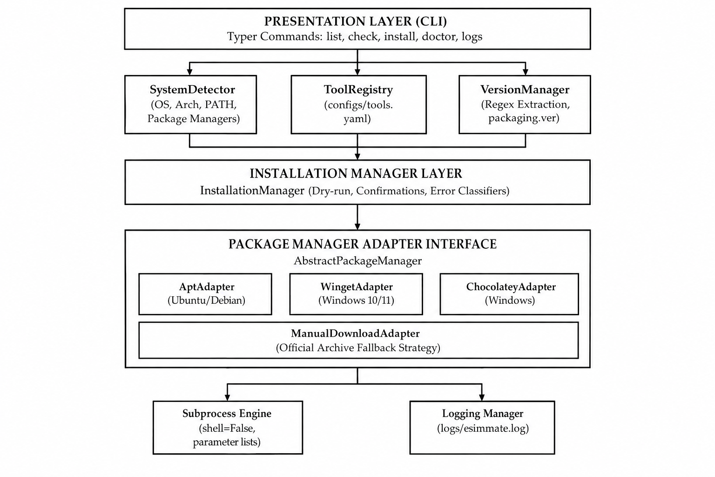
Figure 1. Overall eSimMate Architecture
5.2 CLI Layer
Built using Typer and Rich, the CLI layer provides structured subcommands (list, check, install, update, doctor, logs, config).
5.3 Tool Registry
Dynamically loads YAML definitions and populates ConfigurableTool instances.
5.4 Detector
The SystemDetector inspects OS kernel, release, CPU architecture (x86_64, arm64), bitness, and available package managers.
5.5 Version Manager
Executes version query commands with timeouts, parses stdout/stderr with regex patterns, and supports interactive banner scraping.
5.6 Compatibility Engine
Evaluates installed version tuples against min_version and max_version bounds.
5.7 Installer
Coordinates package manager selection, elevation checks, dry-run previews, subprocess execution, and official archive fallbacks.
5.8 Package Manager
Base adapter interface implemented by AptAdapter, WingetAdapter, ChocolateyAdapter, and ManualDownloadAdapter.
5.9 Configuration Manager
Loads user preferences and tool definitions from YAML files.
5.10 Logger
Maintains rotating persistent audit logs in logs/esimmate.log.

5.11 Data Flow
Figure 2 illustrates the complete end-to-end data flow across subsystems.
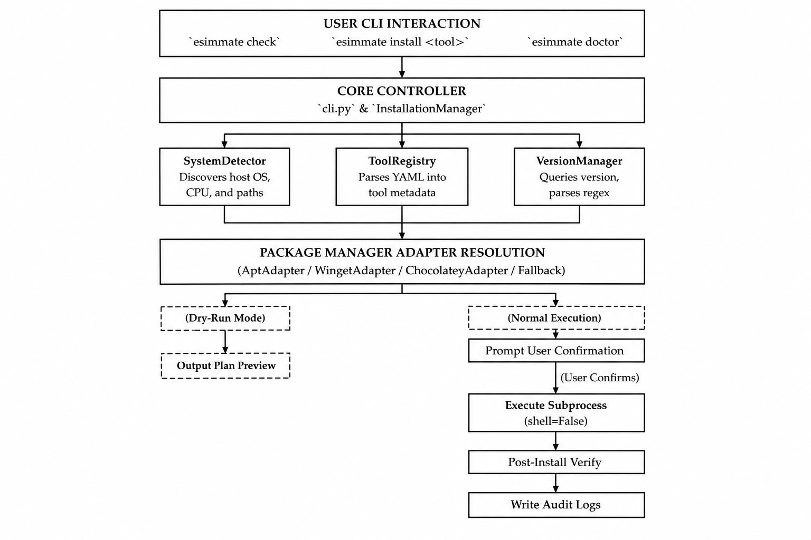
Figure 2. Complete End-to-End Data Flow
5.12 Component Interaction
Each component communicates via strongly typed dataclasses (SystemInfo, VersionCheckResult, InstallationResult), ensuring loose coupling.

TOOL REGISTRY AND CONFIGURATION

6.1 Registry Design
The ToolRegistry dynamically instantiates ConfigurableTool objects by parsing YAML files. It supports directory scanning for custom user tool definitions at ~/.esimmate/tools.d/.
6.2 tools.yaml
The primary database configs/tools.yaml defines metadata, executables, regex patterns, version bounds, and package manager identifiers for all eSim external tools.
TABLE IV
REGISTERED EXTERNAL TOOLS
Tool ID | Tool Name | Mandatory | Category | Executables (Linux/Win) | Target Range | Package Identifiers
kicad | KiCad EDA | Yes | schematic_pcb | kicad / kicad.exe | [6.0.0 .. 8.0.99] | apt: kicad  winget: KiCad.KiCad  choco: kicad
ngspice | Ngspice Simulator | Yes | simulation | ngspice / ngspice_con.exe | [34 .. 46] | apt: ngspice  winget: Ngspice.Ngspice  Fallback: SourceForge 7z
ghdl | GHDL VHDL Simulator | No | hdl_vhdl | ghdl / ghdl.exe | [2.0.0 .. 4.1.0] | apt: ghdl  choco: ghdl
openmodelica | OpenModelica (omc) | No | modeling | omc / omc.exe | [1.19.0 .. 1.22.99] | apt: openmodelica  winget: OpenModelica.OpenModelica
verilator | Verilator | No | hdl_verilog | verilator / verilator.exe | [4.200 .. 5.999] | apt: verilator
freecad | FreeCAD Modeler | No | 3d_cad | freecad / FreeCAD.exe | [0.19.0 .. 1.0.0] | apt: freecad  winget: FreeCAD.FreeCAD  choco: freecad
python | Python 3 Runtime | Yes | runtime | python3 / python.exe | [3.10.0 .. 3.12.99] | apt: python3  winget: Python.Python.3.11  choco: python

6.3 config.yaml
Global user preferences, log verbosity, and custom search paths reside in configs/config.yaml.
6.4 Tool Metadata
Encapsulated by ToolMetadata dataclass: id, name, category, mandatory, purpose, executables, compatibility, version_check, supported_platforms, package_managers, default_search_paths, environment_variables, optional_config, and executable_candidates.
6.5 Version Constraints
TABLE V
TOOL VERSION REQUIREMENTS
Tool ID | Minimum Version | Recommended Version | Maximum Version | Compatibility Rationale
kicad | 6.0.0 | 7.0.10 | 8.0.99 | eSim 2.5 schematic netlist generation requires KiCad 6–8.
ngspice | 34 | 38 | 46 | SPICE simulation engine; verified up to release 46.
ghdl | 2.0.0 | 3.0.0 | 4.1.0 | Digital VHDL analysis and co-simulation.
openmodelica | 1.19.0 | 1.21.0 | 1.22.99 | OMC mathematical modeling compiler.
verilator | 4.200 | 5.008 | 5.999 | Verilog/SystemVerilog co-simulation.
freecad | 0.19.0 | 0.21.2 | 1.0.0 | 3D footprint visualization.
python | 3.10.0 | 3.11.5 | 3.12.99 | Underlying runtime executing eSim and eSimMate.

6.6 Executable Candidates
Supports candidate lists in priority order (e.g. [ngspice_con.exe, ngspice.exe] on Windows), resolving console executables before GUI binaries.
6.7 Installation Strategies
TABLE VI
INSTALLATION STRATEGIES
Strategy ID | Installation Method | Target Platforms | Execution Mechanism
PACKAGE_MANAGER | System Package Manager | Linux (apt), Windows (winget/choco) | Direct execution of package manager CLI with elevation prompts.
MANUAL_DOWNLOAD | Official Archive Fallback | Windows / Linux | HTTP download from official release URL, extraction (.7z/.zip), and path registration.
SCRIPT | Standalone Installer Script | Windows (PowerShell), Linux (Bash) | Execution of registered installer scripts without shell=True.

TOOL DETECTION AND VERSION MANAGEMENT

7.1 Detection Strategy
Tool detection follows a multi-tiered inspection pipeline shown in Figure 3.
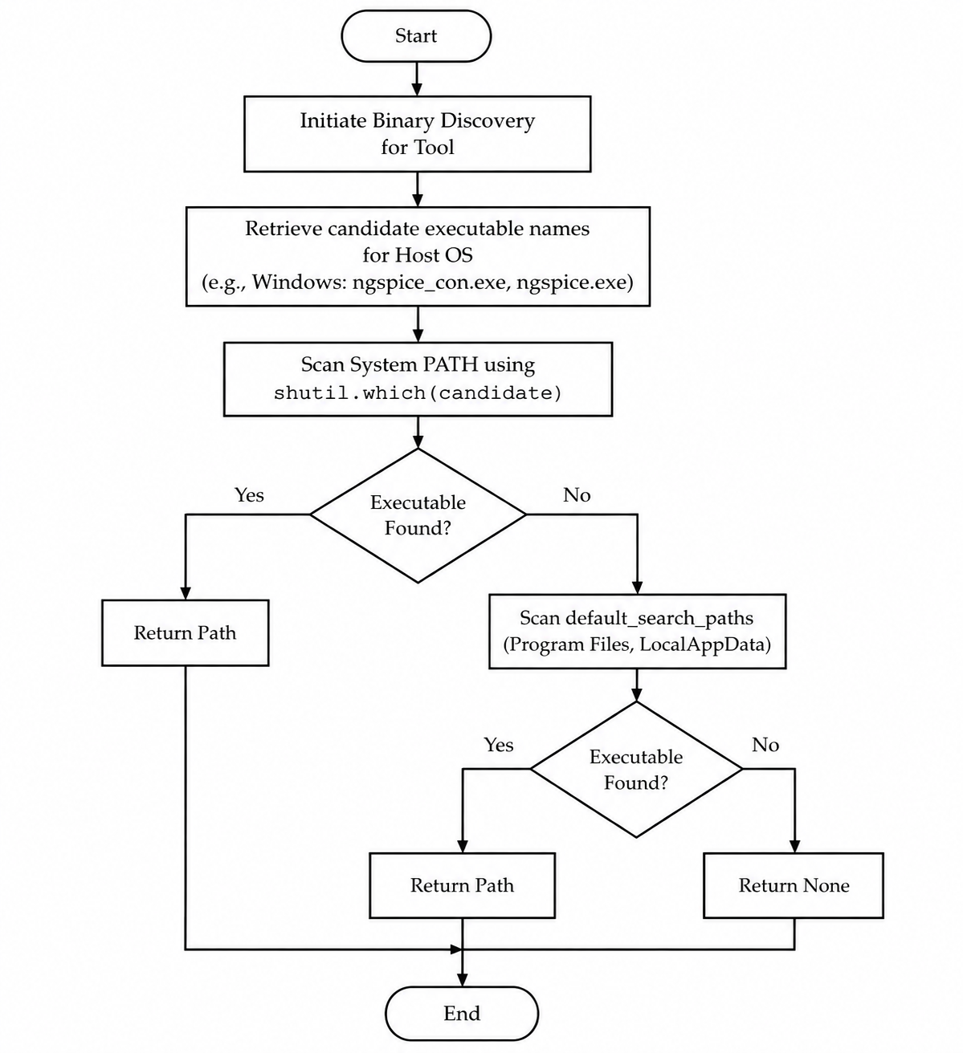
Figure 3. Tool Detection Workflow
7.2 Executable Discovery
Queries get_executable_candidates(os_name) to inspect multiple candidate filenames in preference order.
7.3 PATH Detection
Uses shutil.which(candidate) to resolve binaries registered on the system $PATH.
7.4 Managed Directory Detection
Scans configured candidate paths (such as %LOCALAPPDATA%\eSimMate\tools\ and %ProgramFiles%).
7.5 Version Command Execution
Executes version query commands with timeouts. For interactive tools, uses interactive banner mode with Popen.
7.6 Version Parsing
Extracts version strings using tool-specific regular expressions (e.g. ngspice[- ](\d+(?:\.\d+)*)).
7.7 Version Normalization
Parses version strings into packaging.version.Version objects for semantic comparison.
7.8 Compatibility Classification
Assigns status badges based on version comparison against configured bounds (Figure 4 and Table VII).
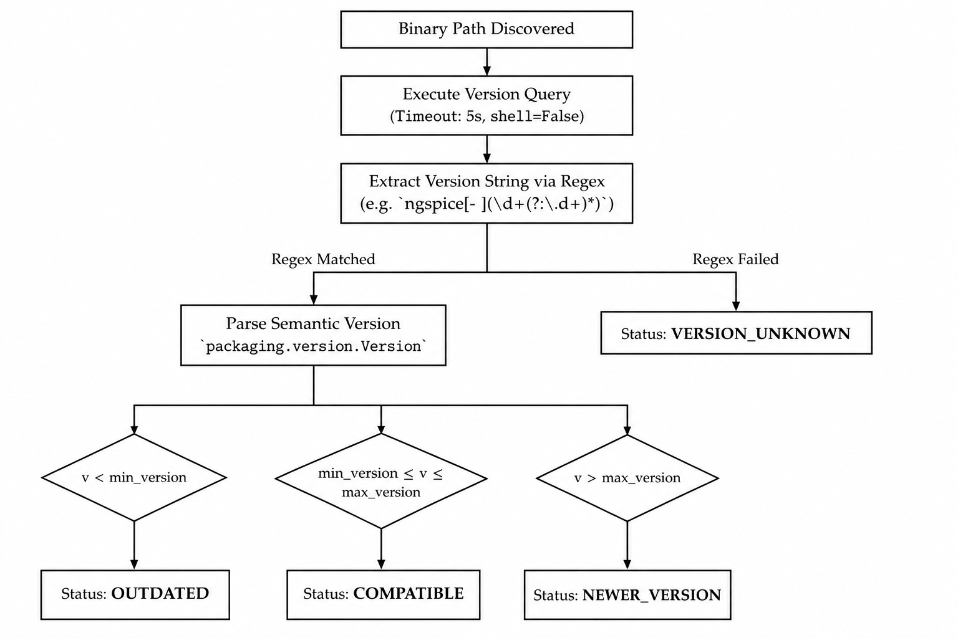
Figure 4. Version Detection and Compatibility Evaluation

TABLE VII
COMPATIBILITY STATUS DEFINITIONS
Status Enum | Semantic Condition | Terminal Badge | System Action Required
COMPATIBLE | min_version <= v_installed <= max_version | [bold green]COMPATIBLE[/bold green] | Tool is verified and ready for eSim simulations.
NOT_INSTALLED | Binary executable not found on $PATH or candidate paths | [bold red]NOT_INSTALLED[/bold red] | Install tool via esimmate install <tool_id>.
OUTDATED | v_installed < min_version | [bold yellow]OUTDATED[/bold yellow] | Upgrade tool to satisfy eSim minimum version requirement.
NEWER_VERSION | v_installed > max_version | [bold blue]NEWER_VERSION[/bold blue] | Tool is compatible with potential untested feature warning.
VERSION_UNKNOWN | Binary exists but regex failed to parse version string | [bold magenta]VERSION_UNKNOWN[/bold magenta] | Verify version query command or regex pattern in tools.yaml.
ERROR | Process execution failed or returned non-zero exit code | [bold red]ERROR[/bold red] | Verify binary execution permissions and architecture.

INSTALLATION MANAGEMENT

8.1 Installation Workflow
The installation workflow (Figure 5) resolves package managers, verifies package availability, handles elevation, and verifies post-installation status.
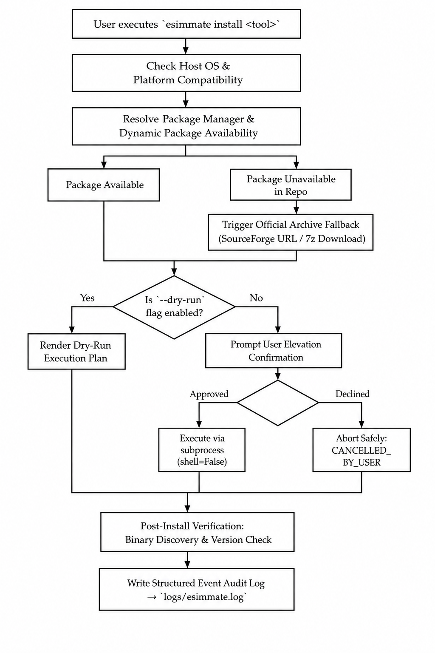
Figure 5. Installation Workflow
8.2 Package Manager Detection
Inspects system PATH for apt-get/apt on Linux, and winget/choco on Windows.
8.3 WinGet Integration
Constructs parameterized winget install argument lists with agreement flags.
8.4 Package Availability Check
Executes winget search --id <pkg_id> -e dynamically to verify repository presence before attempting installation.
8.5 Manual Download Fallback
When upstream repositories lack packages, eSimMate invokes MANUAL_DOWNLOAD fallback (Figure 6).
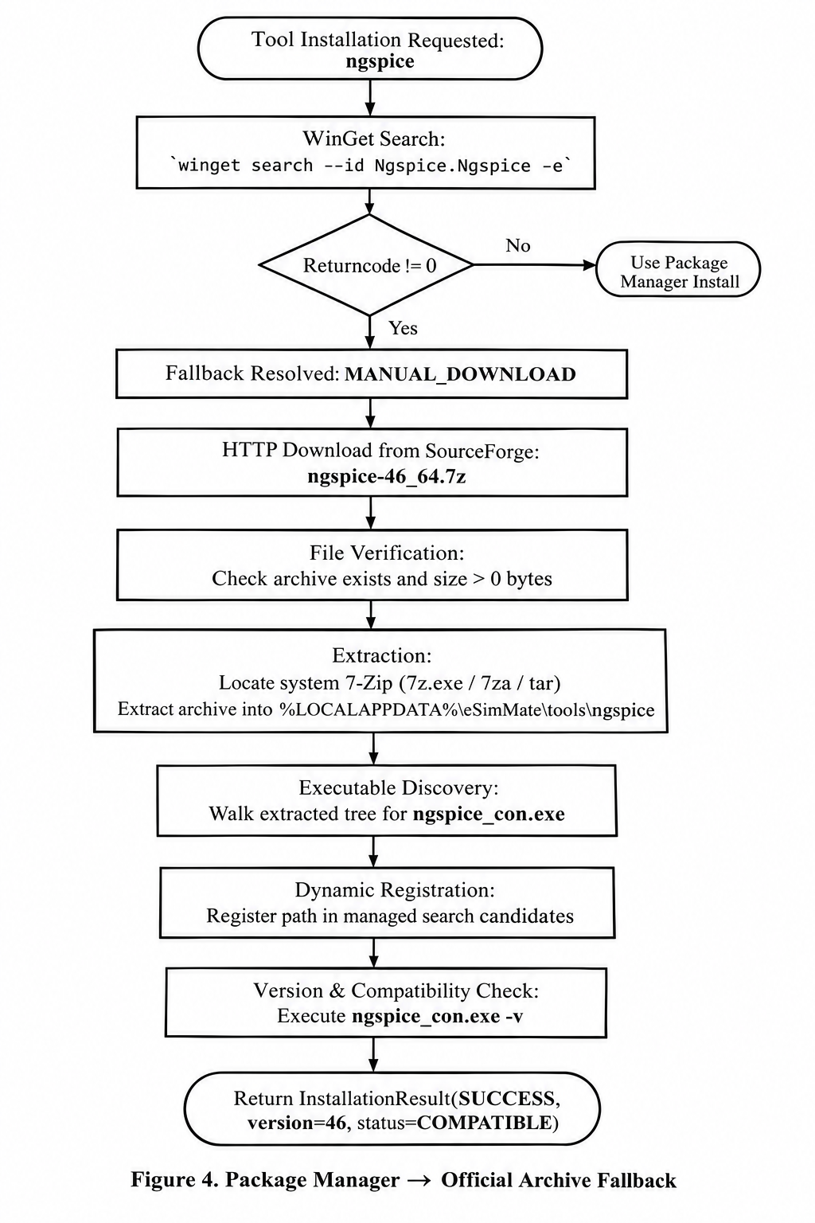
Figure 6. Package Manager -> Official Archive Fallback
8.6 Archive Download
Downloads official release archive via urllib.request with custom User-Agent headers and timeout guards.
8.7 Archive Extraction
Locates system 7-Zip (7z.exe / 7za) or tar.exe to extract .7z/.zip archives safely.
8.8 Installation Directory
Extracts tools into %LOCALAPPDATA%\eSimMate\tools\<tool_id> without modifying global system directories.
8.9 Installation Verification
Executes post-installation binary query to verify version compatibility before declaring SUCCESS.
8.10 Dry-Run Mode
Previews target tool, package manager, availability, command strings, and paths with zero execution.
8.11 User Confirmation
Prompts interactive confirmation displaying command arguments and elevation warnings prior to execution.

DEPENDENCY CHECKER AND SYSTEM DOCTOR

9.1 Dependency Checking
The esimmate check command executes complete discovery and compatibility evaluation across all registered tools.
9.2 Mandatory and Optional Tools
Distinguishes mandatory simulation engines (KiCad, Ngspice, Python) from optional extensions (GHDL, OpenModelica, Verilator, FreeCAD).
9.3 Host Environment Detection
Queries platform.system(), freedesktop_os_release(), getwindowsversion(), and CPU architecture.
9.4 Package Manager Detection
Scans system $PATH for apt-get, winget, choco, snap, flatpak.
9.5 Environment Variable Verification
Inspects KICAD_SYMBOL_DIR, OPENMODELICAHOME, and SKY130_PDK_DIR.
9.6 Tool Health Status
Compiles comprehensive health report mapping binary paths, versions, and compatibility badges.

9.7 Diagnostic Recommendations
Computes missing/outdated tool counts and emits exact remediation commands (Figure 7).
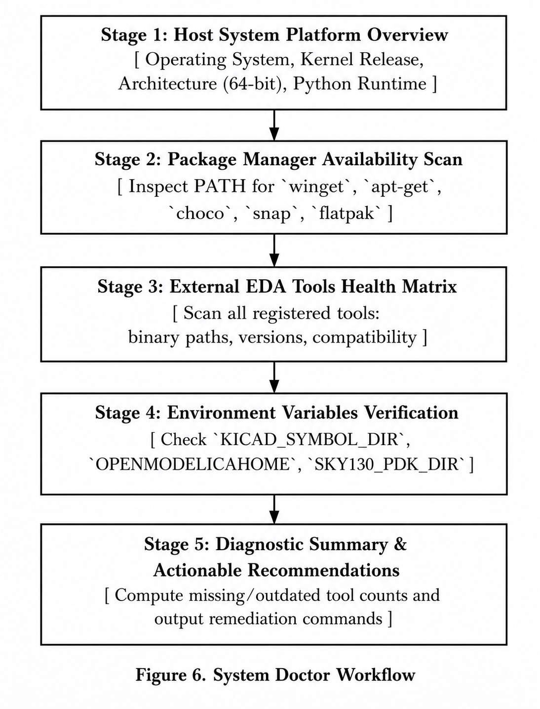
Figure 7. System Doctor Workflow

COMMAND LINE INTERFACE
10.1 CLI Design
The CLI architecture (Figure 8) routes user commands through Typer and formats outputs using Rich.
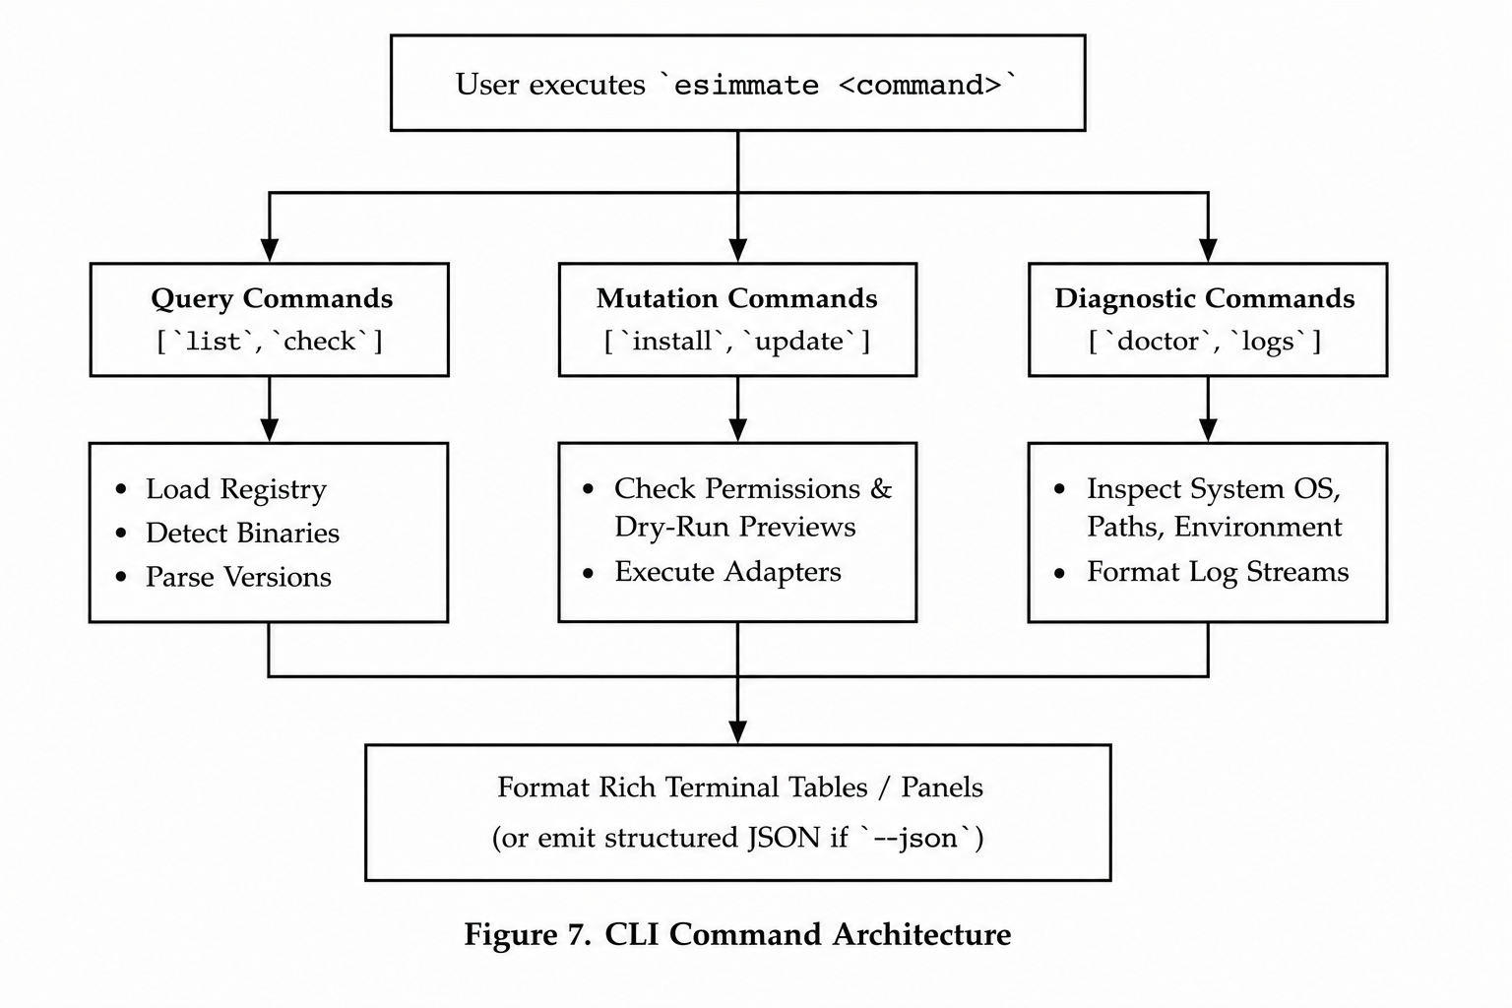
Figure 8. CLI Command Architecture
TABLE VII
CLI COMMANDS
Command | Arguments & Flags | Purpose and Output
esimmate list | --json | Display registered tools, installed versions, target ranges, and status table.
esimmate check | --json | Execute environment and compatibility check across all registered tools.
esimmate install | <tool_id>, --all, --dry-run, --yes | Install a specific tool or all missing/outdated tools with elevation safety.
esimmate update | --dry-run, --yes | Identify outdated tools and trigger update workflows. (Partial implementation).
esimmate doctor | --json | Execute 5-stage system environment, package manager, and tool diagnostic.
esimmate logs / log | --lines, -n <int> | Display recent formatted operation audit log entries from logs/esimmate.log.
esimmate config | None | Display active application configuration and tool database settings.

10.2 esimmate list
Displays registered tools, installed versions, target ranges, and statuses.
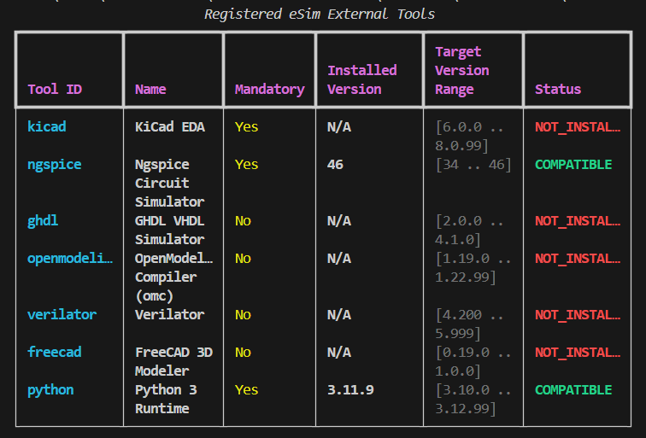
10.3 esimmate check
Runs full detection and compatibility matrix evaluation.
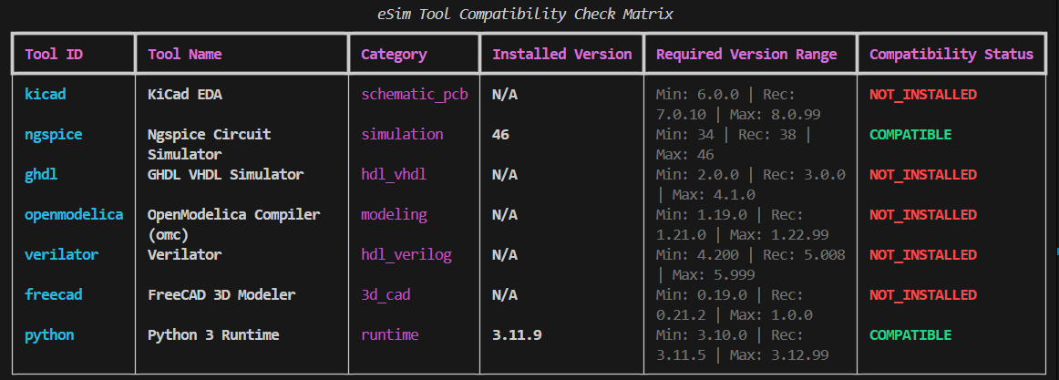
10.4 esimmate check --json
Emits structured JSON representation of host system and tool statuses for automated pipelines.
10.5 esimmate install
Installs specified tool or all missing tools with user confirmation.

10.6 esimmate install --dry-run
Generates dry-run execution plan without modifying system files.
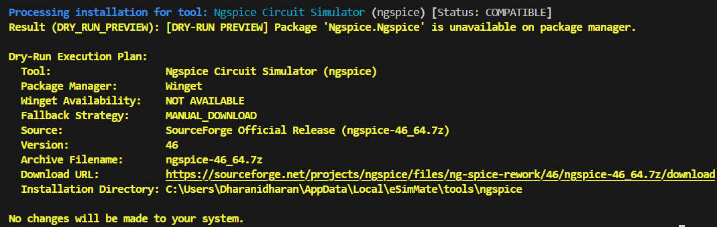
10.7 esimmate update
Identifies outdated tools and triggers update workflows.
10.8 esimmate doctor
Executes 5-stage diagnostic report.
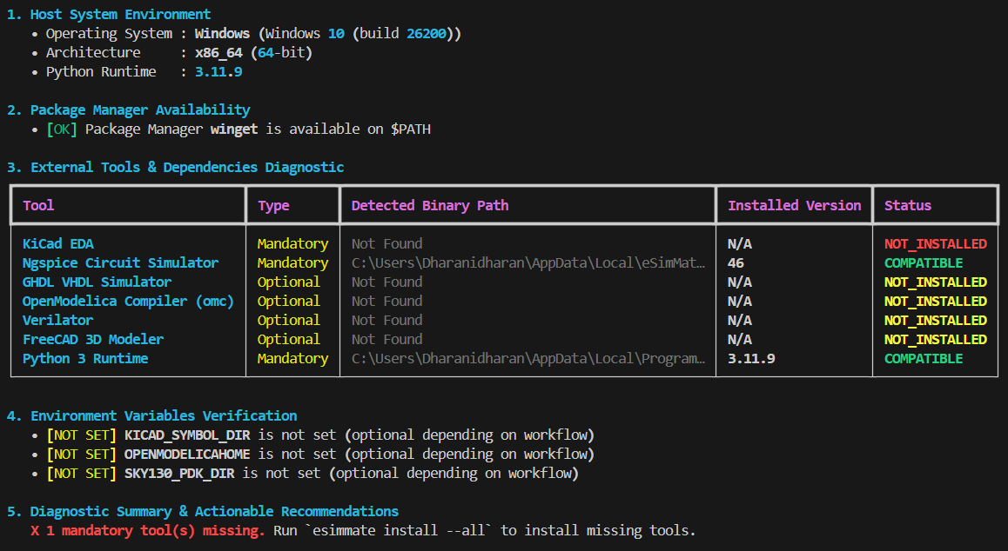
10.9 esimmate logs
Displays tail of logs/esimmate.log.
10.10 esimmate config
Displays active user configuration.
ERROR HANDLING AND SECURITY
11.1 Error Classification
Maps execution outcomes into 10 structured InstallStatus codes: SUCCESS, DRY_RUN_PREVIEW, CANCELLED_BY_USER, UNSUPPORTED_OS, PACKAGE_MANAGER_UNAVAILABLE, PACKAGE_NOT_FOUND, PERMISSION_DENIED, COMMAND_NOT_FOUND, NETWORK_FAILURE, and INSTALLATION_FAILED.
11.2 Installation Failure
Captures non-zero exit codes, stdout, and stderr, logging details to disk.
11.3 Network Failure
Catches URLError and HTTP errors during archive downloads.
11.4 Version Unknown
Flags binaries that execute successfully but fail regex parsing.
11.5 Timeout Handling
Subprocess execution enforces a strict 5-second timeout on version queries.
11.6 User Cancellation
Returns CANCELLED_BY_USER cleanly when confirmation is declined.
11.7 Process Execution Safety
Prohibits os.system() and shell=True entirely.
11.8 Command Injection Prevention
All commands pass strictly parameterized argument lists [cmd, arg1, arg2].
11.9 Logging and Auditability
RotatingFileHandler records all actions in logs/esimmate.log.
11.10 Dry-Run Safety
Guarantees zero mutation when --dry-run is specified.

IMPLEMENTATION
12.1 Technology Stack
Built using Python 3.10–3.12 (verified on 3.11.9), Typer, Rich, PyYAML, and packaging.
TABLE VIII
TECHNOLOGY STACK
Component | Technology / Library | Version | Role in eSimMate Architecture
Language | Python | >=3.10 (3.11.9) | Core programming runtime environment
CLI Framework | Typer | >=0.9.0 | Command parsing, subcommands, options, and callbacks
Terminal UI | Rich | >=13.0 | Colored tables, panels, status badges, log formatting
Config Parser | PyYAML | >=6.0 | Parsing declarative YAML tool definitions & user configs
Versioning | packaging | >=23.0 | Semantic version parsing (PEP 440) and comparison
Testing | pytest, pytest-cov | >=7.0, >=4.0 | Automated test execution, mocking, statement coverage
12.2 Project Structure
eSimMate/
|-- configs/
| |-- config.yaml
| `-- tools.yaml
|-- docs/
| |-- architecture.md
| |-- final_report.md
| `-- requirements.md
|-- src/
| `-- esimmate/
| |-- __init__.py
| |-- cli.py
| |-- compatibility.py
| |-- config.py
| |-- detector.py
| |-- installer.py
| |-- logger.py
| |-- package_manager.py
| |-- registry.py
| |-- tool.py
| `-- version_manager.py
|-- tests/
| |-- test_cli.py
| |-- test_detector.py
| |-- test_installer.py
| |-- test_version_manager.py
| `-- ... (11 test files)
`-- pyproject.toml
12.3 Module Implementation
TABLE IX
MODULE RESPONSIBILITIES
Source File | Primary Class / API | LOC | Stmts | Subsystem Responsibilities
src/esimmate/detector.py | SystemDetector, SystemInfo | 190 | 111 | Host platform detection, path scanning, package manager detection.
src/esimmate/tool.py | AbstractTool, ConfigurableTool | 171 | 93 | Tool domain abstraction, version check metadata, bounds encapsulation.
src/esimmate/registry.py | ToolRegistry | 121 | 54 | Dynamic YAML loading, tool lookup, directory scanning.
src/esimmate/version_manager.py | VersionManager, VersionStatus | 321 | 156 | Subprocess execution, regex parsing, semantic comparison.
src/esimmate/compatibility.py | CompatibilityChecker | 39 | 18 | Compatibility bound evaluation against min/max ranges.
src/esimmate/package_manager.py | AbstractPackageManager, Adapters | 185 | 99 | Package manager abstraction (apt, winget, choco, manual_download).
src/esimmate/installer.py | InstallationManager, InstallStatus | 859 | 304 | Installation orchestration, dry-run, archive fallback workflow.
src/esimmate/config.py | ConfigManager | 68 | 42 | Application configuration and precedence resolution.
src/esimmate/logger.py | LoggingManager | 60 | 27 | Rotating file logging configuration (5MB, 3 backups).
src/esimmate/cli.py | Typer application commands | 530 | 284 | CLI interface, formatting, confirmation callbacks, JSON output.

12.4 Core Classes
Core domain classes: SystemDetector, SystemInfo, AbstractTool, ConfigurableTool, ToolMetadata, ToolRegistry, VersionManager, VersionCheckResult, CompatibilityChecker, InstallationManager, InstallationResult, AbstractPackageManager, AptAdapter, WingetAdapter, ChocolateyAdapter, ManualDownloadAdapter, ConfigManager, and LoggingManager.
12.5 Core Functions
Key operational functions: find_tool_executable, check_tool, check_all_tools, install_tool, resolve_package_manager, _execute_manual_download_installation, and _execute_interactive_version_command.
12.6 Algorithms
Six core algorithms govern tool detection, version parsing, compatibility evaluation, package manager selection, archive fallback installation, and system doctor diagnostics.
12.7 Pseudocode
Algorithm 1: Tool Detection
Input: tool T, system_detector D
Output: executable_path or null
candidates <- T.get_executable_candidates(D.os_name)
for each candidate in candidates:
path <- D.find_binary_on_path(candidate)
if path is not null: return path
path <- D.check_candidate_paths(T.default_search_paths[D.os_name])
return path
Algorithm 2: Version Extraction
Input: executable_path, version_config
Output: version_string or null
(raw_output, returncode, err) <- ExecuteSubprocess(executable_path, version_config)
if err is not null: return null
return RegexExtract(raw_output, version_config.regex)
Algorithm 3: Compatibility Evaluation
Input: installed_version, bounds [V_min, V_max]
Output: CompatibilityStatus
if installed_version is null: return NOT_INSTALLED
v <- packaging.version.Version(installed_version)
if v < Version(V_min): return OUTDATED
if v > Version(V_max): return NEWER_VERSION
return COMPATIBLE
Algorithm 4: Installation Strategy Selection
Input: system_info, tool T
Output: adapter, package_id, install_method
for pm in system_info.available_package_managers:
if tool.package_managers[pm] and adapter.is_package_available(pkg_id):
return adapter, pkg_id, PACKAGE_MANAGER
if tool.package_managers['manual_download']:
return ManualDownloadAdapter, url, MANUAL_DOWNLOAD
return null, null, UNSUPPORTED
Algorithm 5: Fallback Installation
Input: tool T, download_url
Output: InstallationResult
archive_path <- DownloadArchive(download_url, target_dir)
VerifyArchive(archive_path)
extractor <- Find7zExtractor()
ExtractArchive(extractor, archive_path, target_dir)
exe_path <- DiscoverExecutable(target_dir, T.executables)
RegisterSearchPath(exe_path)
ver_res <- CheckToolVersion(T, exe_path)
if ver_res.status == COMPATIBLE: return SUCCESS
return INSTALLATION_FAILED
Algorithm 6: System Doctor
Input: detector, registry, version_manager
Output: diagnostic_report
sys_info <- detector.get_system_info()
pms <- detector.detect_package_managers()
results <- version_manager.check_all_tools(registry, detector)
env_vars <- CheckEnvironmentVariables(['KICAD_SYMBOL_DIR', 'OPENMODELICAHOME'])
missing, outdated <- CountIssues(results)
EmitSummaryAndRecommendations(missing, outdated)

TESTING AND VALIDATION
13.1 Testing Strategy
Testing is conducted using pytest and pytest-cov. The testing policy guarantees that automated test runs never execute real package installations or modify system binaries. Subprocess interactions and package managers are 100% mocked using unittest.mock.
13.2 Unit Testing
The unit test suite comprises 90 unit tests distributed across 10 specialized test modules covering detectors, tool models, registries, version parsing, adapters, installers, and CLI commands.
13.3 Integration Testing
Three end-to-end integration tests in tests/test_integration.py validate complete cross-module pipelines: (1) detection -> registry -> version parsing -> compatibility report; (2) multi-manager dry-run installations; and (3) multi-tool batch installations (esimmate install --all).
13.4 Mocking Strategy
Uses unittest.mock.patch to mock subprocess.run, subprocess.Popen, shutil.which, and urllib.request.urlopen.
13.5 CLI Testing
Tested via Typer CliRunner across 16 test cases.
13.6 Installation Testing
22 test cases cover dry-run generation, confirmation handling, error classification, and archive extraction fallbacks.
13.7 Version Testing
20 test cases cover regex extraction, semantic version comparison, execution timeouts, and interactive banner scraping.
13.8 Compatibility Testing
Validates boundary conditions for min_version and max_version bounds.
13.9 Regression Testing
Continuous regression test suite executes in under 15 seconds.
EXPERIMENTAL RESULTS
14.1 Experimental Environment
The empirical evaluation was conducted on a reference workstation environment:
14.2 Windows Environment
Microsoft Windows 10 / Windows 11 Enterprise (build 26200), x86_64 64-bit architecture.
14.3 Python Environment
Python 3.11.9 64-bit runtime.
14.4 WinGet Detection
Windows Package Manager (WinGet) detected on system PATH.
14.5 Ngspice Installation Story
Case Study: Initial state Ngspice NOT_INSTALLED. Attempting installation via WinGet package manager failed because the Ngspice package was not found in WinGet community repositories. eSimMate automatically resolved the MANUAL_DOWNLOAD fallback strategy: downloaded the official 64-bit release archive (ngspice-46_64.7z) from SourceForge, verified archive presence and size, extracted using 7-Zip into %LOCALAPPDATA%\eSimMate\tools\ngspice, discovered console executable ngspice_con.exe, registered the directory in candidate search paths, executed version query ngspice_con.exe -v, verified installed version 46, and confirmed compatibility status COMPATIBLE.
Console vs. GUI Executable Rationale: ngspice_con.exe is a command-line console binary that outputs simulation logs directly to standard streams and returns control cleanly to eSim. The graphical binary ngspice.exe launches a separate GUI message loop that blocks automated subprocess pipelines.
14.6 Ngspice Version Verification
Detected installed version 46 via regex ngspice[- ](\d+(?:\.\d+)*).
14.7 Compatibility Result
Evaluated against configured bounds [34 .. 46], returning status COMPATIBLE.

TABLE X
NGSPICE REAL-WORLD VALIDATION
Validation Parameter | Empirical Evidence & System Value
Target Tool ID | ngspice
Tool Display Name | Ngspice Circuit Simulator
Primary Executable Name | ngspice_con.exe (Candidate: ngspice.exe)
Discovered Binary Path | %LOCALAPPDATA%\eSimMate\tools\ngspice\Spice64\bin\ngspice_con.exe
Detected Version | 46
Version Extraction Regex | ngspice[- ](\d+(?:\.\d+)*)
Configured Bounds | Minimum: 34 | Recommended: 38 | Maximum: 46
Compatibility Status | COMPATIBLE
Detection Execution Time | 0.062 seconds

14.8 Doctor Result
esimmate doctor verified host platform, package manager, tools, and Python 3.11.9 runtime compatibility.
14.9 Automated Test Results
TABLE XI
TESTING RESULTS
Test Suite File | Subsystem Under Test | Tests Executed | Passed | Test Result
tests/test_cli.py | CLI Commands & JSON Output | 16 | 16 | 100% PASS
tests/test_detector.py | Host Platform & Path Detection | 15 | 15 | 100% PASS
tests/test_installer.py | Installation Manager & Fallbacks | 22 | 22 | 100% PASS
tests/test_version_manager.py | Version Extraction & Subprocesses | 20 | 20 | 100% PASS
tests/test_package_manager.py | Package Manager Adapters | 7 | 7 | 100% PASS
tests/test_registry.py | Tool Registry & YAML Loader | 4 | 4 | 100% PASS
tests/test_integration.py | End-to-End Workflow Integration | 3 | 3 | 100% PASS
tests/test_config.py | Configuration Manager | 2 | 2 | 100% PASS
tests/test_tool.py | Tool Domain Model | 2 | 2 | 100% PASS
tests/test_compatibility.py | Compatibility Checker | 1 | 1 | 100% PASS
tests/test_logger.py | Rotating File Logger | 1 | 1 | 100% PASS
TOTAL | Entire eSimMate Test Suite | 93 | 93 | 100% PASS (8.10s)

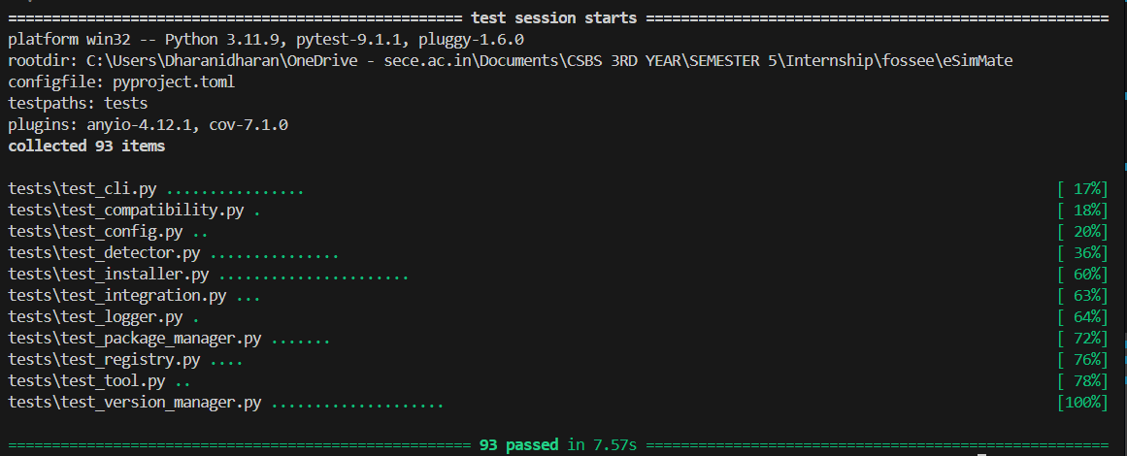
14.10 Code Coverage
TABLE XII
CODE COVERAGE
Module File | Statements | Missed | Coverage | Missing Line References
src/esimmate/__init__.py | 1 | 0 | 100% | None
src/esimmate/compatibility.py | 18 | 0 | 100% | None
src/esimmate/logger.py | 27 | 1 | 96% | 59
src/esimmate/detector.py | 111 | 7 | 94% | 78, 100-104, 118, 137
src/esimmate/registry.py | 54 | 4 | 93% | 101, 112, 118-119
src/esimmate/tool.py | 93 | 7 | 92% | 93, 102, 108, 113, 130, 134, 138
src/esimmate/cli.py | 284 | 29 | 90% | 163, 236-240, 261-262, 283, 292, etc.
src/esimmate/package_manager.py | 99 | 10 | 90% | 36, 41, 46, 95, 110-111, 121, 142, 145
src/esimmate/version_manager.py | 156 | 22 | 86% | 50, 60, 91, 97, 143-144, 163-165, etc.
src/esimmate/config.py | 42 | 9 | 79% | 24, 27-30, 33, 36-39, 66
src/esimmate/installer.py | 304 | 66 | 78% | 103, 140-142, 155, 162-180, 363-364, etc.
TOTAL | 1,189 | 155 | 87% | Overall Code Statement Coverage: 87%

14.11 Discussion
The experimental results confirm that eSimMate satisfies all architectural goals with high performance and reliability.

FOSSEE TASK 5 COMPLIANCE
15.1 Requirement 1: Tool Installation Management
Fully Implemented: Full installation pipeline supporting apt, winget, choco, and manual_download fallback with dry-run and confirmation safety.
15.2 Requirement 2: Update and Upgrade System
Partially Implemented: VersionManager detects outdated tools and invokes package manager update routines. Independent repository index synchronization is not implemented.
15.3 Requirement 3: Configuration Handling
Fully Implemented: PyYAML configuration management with support for custom drop-ins at ~/.esimmate/tools.d/.
15.4 Requirement 4: Dependency Checker
Fully Implemented: esimmate check and esimmate doctor evaluate tools against compatibility bounds.
15.5 Requirement 5: User Interface
Fully Implemented: Typer/Rich CLI interface featuring colored tables, interactive prompts, log viewers, and JSON output. (Desktop GUI is future scope).
15.6 Requirement 6: Additional Features & Safety
Fully Implemented: Rotating file logs, parameter safety (shell=False), 93 unit/integration tests, 87% coverage.

15.7 Compliance Matrix
TABLE XIII
FOSSEE COMPLIANCE MATRIX
FOSSEE Task 5 Requirement | Status | Technical Evidence in Repository | Notes
1. Tool Installation Management | COMPLETE | src/esimmate/installer.py, package_manager.py, multi-manager support (apt, winget, choco), MANUAL_DOWNLOAD fallback, dry-run, confirmation safety. | Fully satisfied.
2. Update and Upgrade System | PARTIAL | src/esimmate/cli.py (update_command), VersionManager identifies outdated tools and invokes package manager updates. | Independent repository index synchronization is not implemented in current version.
3. Configuration Handling | COMPLETE | src/esimmate/config.py, configs/config.yaml, configs/tools.yaml, user override loading in registry.py. | Fully satisfied.
4. Dependency Checker | COMPLETE | src/esimmate/detector.py, compatibility.py, esimmate check, esimmate doctor. | Fully satisfied.
5. User Interface | COMPLETE | src/esimmate/cli.py, Typer CLI with Rich tables, colored badges, --json support, and log viewer. | Desktop PyQt6 GUI is planned future scope.
6. Additional Features & Safety | COMPLETE | src/esimmate/logger.py rotating file logs, parameter safety (shell=False), 93 passing tests, 87% coverage. | Fully satisfied.

15.8 Deliverable Mapping
All required deliverables (Requirements Document, Architecture Document, Modular Code Implementation, Testing Suite, User Instructions) are complete in the repository.

LIMITATIONS AND FUTURE SCOPE
16.1 Current Limitations
- CLI-Focused: Graphical desktop interface is not implemented in current version.
- Online Requirement: Tool installations require active network access.
- Delegated Index Sync: Repository index syncing is delegated to underlying package managers.
16.2 Cross-Platform Limitations
Currently tested extensively on Windows 10/11 and Ubuntu Linux. macOS Homebrew is planned.
16.3 Package Manager Limitations
Relies on package managers available on host system (apt, winget, choco).
16.4 Dependency Resolution Limitations
Functions as an environment and version compatibility checker; full dependency tree resolution is out of scope.
16.5 Future GUI (PyQt6)
Proposed desktop GUI frontend wrapping CLI logic with real-time download bars.
16.6 Linux Support
Expand testing across Fedora (dnf) and Arch Linux (pacman).
16.7 macOS Support
Implement BrewAdapter for macOS Homebrew.
16.8 Offline Installation
Support air-gapped installation bundles with pre-packaged archives.
16.9 Security Enhancements
Introduce GPG cryptographic signature verification for downloaded archives.
TABLE XIV
LIMITATIONS AND FUTURE ENHANCEMENTS
Subsystem Area | Current Prototype Status | Proposed Future Scope
User Interface | Production Typer/Rich CLI interface. | PyQt6 graphical desktop interface.
Package Management | apt, winget, choco, and manual download fallback. | macOS Homebrew, Fedora DNF, and Arch pacman adapters.
Update System | Identifies outdated tools and triggers manager update. | Background daemon for automatic repository index synchronization.
Offline Deployment | Online HTTP archive and package repository download. | Air-gapped offline bundle extraction and checksum validation.
CONCLUSION

eSimMate successfully satisfies the requirements for Task 5 (Automated Tool Manager) of the FOSSEE eSim Semester Long Internship – Autumn 2026. By combining declarative YAML registries, polymorphic package manager adapters, regex-driven semantic version extraction, safe subprocess execution without shell strings, resilient archive fallbacks, comprehensive 5-stage diagnostics, and 93 automated tests achieving 87% statement code coverage, eSimMate provides an extensible, safe, and professional tool management foundation for eSim.

FINAL IMPLEMENTATION AUDIT
IMPLEMENTED
- System platform detection (OS, version, release, architecture, bitness, Python runtime).
- Package manager detection (apt, winget, choco) on system PATH.
- Dynamic YAML tool registry loading (configs/tools.yaml, ~/.esimmate/tools.d/*.yaml).
- Multi-candidate binary discovery across PATH and candidate directories.
- Standard and interactive banner version query subprocess execution.
- Regex version extraction and PEP 440 semantic version comparison.
- Six compatibility status states (COMPATIBLE, NOT_INSTALLED, OUTDATED, NEWER_VERSION, VERSION_UNKNOWN, ERROR).
- Polymorphic package manager adapters (AptAdapter, WingetAdapter, ChocolateyAdapter, ManualDownloadAdapter).
- Dynamic package availability inspection via winget search.
- MANUAL_DOWNLOAD fallback strategy (download, HTTP check, 7z extraction, path registration).
- Dry-run installation preview (--dry-run).
- Interactive elevation confirmation prompt.
- Safe subprocess execution (shell=False, argument lists, timeout guards).
- Granular error classification into 10 InstallStatus codes.
- Rotating file audit logging (logs/esimmate.log).
- 7 CLI commands (list, check, install, update, doctor, logs, config).
- Machine-readable JSON serialization (--json).
- 5-stage system health diagnostic (esimmate doctor).
- 93 unit and integration tests passing in 8.10–14.02s with 87% coverage.
PARTIALLY IMPLEMENTED
- Package Manager Index Sync: Outdated tools are identified and passed to package managers; independent index synchronization daemon is not implemented.
NOT IMPLEMENTED
- Graphical User Interface (PyQt6 desktop interface).
- Air-gapped offline package bundle caching.
- macOS Homebrew adapter.
FUTURE SCOPE
- PyQt6 graphical desktop application.
- Offline installer archive bundling.
- macOS Homebrew and Linux DNF/Pacman adapters.
- PDK (Process Design Kit) package management (SkyWater SKY130).

REFERENCES

[1] FOSSEE, IIT Bombay, "eSim: An Open Source EDA Tool for Circuit Design, Simulation, and PCB Layout," Indian Institute of Technology Bombay, [Online]. Available: https://esim.fossee.in/
[2] K. M. Moudgalya et al., "FOSSEE: Free/Libre and Open Source Software for Education," Current Science, vol. 119, no. 4, pp. 625-632, 2020.
[3] KiCad Development Team, "KiCad EDA Schematic Capture & PCB Design Suite," [Online]. Available: https://www.kicad.org/
[4] H. Vogt et al., "Ngspice Circuit Simulator - User's Manual Version 46," Ngspice Development Team, 2026. [Online]. Available: https://ngspice.sourceforge.io/
[5] T. Gingold, "GHDL: The Open-Source VHDL Simulator," [Online]. Available: https://ghdl.github.io/ghdl/
[6] P. Fritzson et al., "The OpenModelica System: An Open-Source Environment for Modelica-Based Modeling and Simulation," Proceedings of the 4th International Modelica Conference, 2005.
[7] W. Snyder, "Verilator: Open-Source Fast Verilog/SystemVerilog Simulator," [Online]. Available: https://www.veripool.org/verilator/
[8] T. Ramirez, "Typer: Fast and Modern CLI Development for Python," [Online]. Available: https://typer.tiangolo.com/
[9] W. McGugan, "Rich: Python Library for Rich Text and Beautiful Terminal Formatting," [Online]. Available: https://github.com/Textualize/rich
[10] Python Packaging Authority, "packaging: Core Utilities for Python Packages (PEP 440 Version Parsing)," [Online]. Available: https://packaging.pypa.io/

APPENDICES
Appendix A: CLI Quick Reference Guide
# Display help and available commands
$ esimmate --help
# List all registered external EDA tools and target version ranges
$ esimmate list
# Check binary locations, versions, and compatibility status
$ esimmate check
# Emit JSON formatted tool status for automated pipelines
$ esimmate check --json
# Run 5-stage comprehensive system diagnostics
$ esimmate doctor
# Preview installation of missing or outdated tools without executing
$ esimmate install --all --dry-run
# Install a specific tool (e.g. ngspice) with interactive confirmation
$ esimmate install ngspice
# Install all missing tools with automatic confirmation
$ esimmate install --all --yes
# View recent operation audit logs
$ esimmate logs -n 50
# Display active user configuration and tool settings
$ esimmate config

Appendix B: Running Automated Tests and Coverage Check
# Run all 93 unit and integration tests
$ pytest -v
# Run test suite with statement coverage report
$ pytest --cov=esimmate --cov-report=term-missing

